AI ACADEMY · TEACHER · ai-2/18

Missing Data
Project: Transparent Book Recommender

01. Missing Data

Teach the learning cycle
Primary target: Detect absent and unusable values
Session | Sequence and minutes | Resources
Session 1 · Understand · 45 min | 0–7: recall and prerequisite; 7–15: inspect the concrete case and predict; 15–30: teacher models the worked trace; 30–40: learners explain a step using the text and visual; 40–45: check the core idea. | Sections 1–6; record the brief recall in the workbook.
Session 2 · Practise · 45 min | 0–5: retrieve the procedure; 5–15: W2 completion practice; 15–23: explain and check with a partner; 23–30: each learner answers the misconception check; 30–40: targeted reteaching or a harder variation; 40–45: prepare the investigation. | Sections 7–10; use the matching workbook W2 and misconception check.
Session 3 · Investigate and transfer · 45 min | 0–5: retrieve the decision rule; 5–20: investigate or trace; 20–30: start the independent case; 30–38: connect the project; 38–43: act on feedback; 43–45: plan the return check. | Sections 9 and 11–14. Give extra time to finish the full task set; use Section 15 when the week includes a coding lab.
This is a starting allocation of 135 minutes, not a validated duration. Preserve all named topics. Schedule extra time for connected examples, the full investigation, independent cases and project building. Repeated copies of a case share one recorded attempt; they are not new evidence.

Retrieval answer guidance

Noise and Outliers
Without opening the old lesson, explain one key idea from Noise and Outliers. Give an example and a mistake that the idea helps you avoid.
Look for: Calculate mean and median
Reference example, not the only acceptable wording: Sum 30 divided by 5 gives 6.

Choose Informative Questions
Without opening the old lesson, explain one key idea from Choose Informative Questions. Give an example and a mistake that the idea helps you avoid.
Look for: Fit a root question and leaf predictions from training examples
Reference example, not the only acceptable wording: The root asks near, with branches 0 and 1. Leaves predict clear for 0 and blocked for 1. Depth is one. Training labels determined both leaf majorities and the error comparison that selected near rather than tall.

Accuracy as a Fraction
Without opening the old lesson, explain one key idea from Accuracy as a Fraction. Give an example and a mistake that the idea helps you avoid.
Look for: Explain why overall accuracy can hide failure on a less common class
Reference example, not the only acceptable wording: The training-majority rule always predicts clear. Matrix [[16,0],[4,0]] gives 16/20=80 percent, FP=0,FN=4. It misses all four blocked cases, so the overall score hides complete failure on that evaluated class.
Use the student module and workbook section with this exact week title. The worked case, independent question and answers below form one aligned lesson sequence.

What the learner must demonstrate
Scores award 2 for preferred genre and 1 for short length. A book matches genre but page count is missing. Compare rejecting it, assigning zero length points and asking for pages.

Concept to explain
A system needs an explicit policy for unknown fields.
Term | Meaning
missing data | Information that was not recorded or is unavailable, which is different from an observed zero.
default | The value or behaviour used when no alternative is specified.
abstain | Decline to make a prediction when the available evidence does not meet the decision rule.
impute | Replace a missing value using a stated method; an imputed value is an estimate, not an observation.

Prepare the class
Use the supplied scenario, student illustrations and blank paper. For numeric work, offer counters or a calculator after learners show the setup. Fictional records are supplied; personal data and paid accounts are unnecessary.
Allow 80 minutes: recall 8; explanation 12; worked demonstration 15; guided practice 20; independent assessment 15; project and reflection 10. Extend the lab into a second session when needed.

Preparation for the connected explanation
Teach Week 14 as a two-session investigation using fictional data. A fictional activity log contains an absent duration, a recorded zero and an out-of-range value. Our schema accepts exact integer minutes from 0 through 60. Keep rejected records visible for review instead of replacing their values with guesses. Assess the three stated outcomes through the independent task, not by copying the worked result.

Readiness answer
No. The first is text and the second is an integer.
Python 3 editor with a fresh local practice file
Paper trace table and the student workbook
Fictional input records from this lesson; no real student identifiers

End goal for the pictorial case
By the end, I can validate missing values without confusing zero with absent data.
This added worked case illustrates the week’s main idea. Retain all original and connected topics; schedule its practice within the teaching cycle.

02. Explain the mechanism

Explain the mechanism
Input → Process → Output
Trace the information. At each stage, ask what changed and how you could test it.
Which stage could fail even when the other two are correct? Explain:
Predict first. Then check each step. A correct answer without visible reasoning is incomplete evidence.
1. Reader’s length preference is missing.
2. Ask: best when the user can answer.
3. Abstain: safest if the field is essential; default: convenient but may misrepresent.
4. Record which policy was used so the explanation stays truthful.
Recalculate, retrace, or restate the reasoning in your own representation:
CHECK Did the evidence answer the exact question? Did the total, path, or source record stay consistent?

Concrete teaching case
Genre is known, but page count is missing and length affects recommendation score.
Choose transparent handling.

Exact explanation to model
Retrieve or ask for the count, or use a documented partial-score policy with uncertainty. Do not silently insert zero.

Explain the added worked example
A fictional activity log contains an absent duration, a recorded zero and an out-of-range value. Our schema accepts exact integer minutes from 0 through 60. Keep rejected records visible for review instead of replacing their values with guesses.
dict.get returns None when this key is absent. An explicit None also represents unknown in this dataset. append adds an item to the end of a list. The script prints [0, 12] and then 3. The exact type check prevents comparing None or text with the numeric range.

Key terms
Term | Meaning
Missing value | A value that was not recorded
Validation | Checking data against explicit rules
Rejection | Holding a record out because it fails a rule
Coverage | Which intended records or groups are represented

Model the reasoning aloud
Use the complete worked example below before asking learners to complete W2. Reveal a small part, invite a prediction, then explain the deciding step. These teacher notes contain solutions; do not reveal the independent case answer during modelling.

Add {"minutes": 60} and {"minutes": "5"}. Predict the accepted list and rejection count.
________________________________________________________________
________________________________________________________________
________________________________________________________________
________________________________________________________________
________________________________________________________________
________________________________________________________________
Thinking move | Teacher prompt
Plan | What is given? What is the question? Which procedure fits these facts?
Do | Point to each input and intermediate step in the worked trace. Name the rule that allows the next step.
Check | Does the output answer the question? Which assumption or limitation prevents a larger claim?
Use the diagram and verbal explanation together. Ask learners to match a sentence to a specific visual step; do not assign learners fixed visual or auditory learning styles.

A pictorial worked case: Missing Data
A fictional catalogue records counts of available copies under a strict input contract.

The facts we will use
Accept count only if type(value) is int and 0<=value<=8. Missing fields are invalid, and Booleans are not counts.
Rows have count 0, count 4, absent count, count "4", count True and count 9.
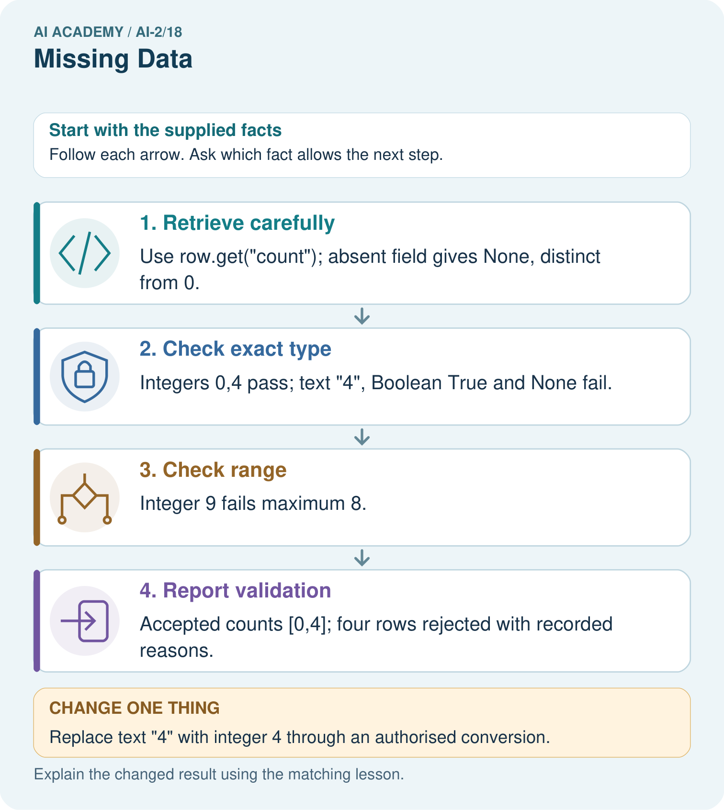

Read the picture one step at a time
Step | What happens and why
1. Retrieve carefully | Use row.get("count"); absent field gives None, distinct from 0.
2. Check exact type | Integers 0,4 pass; text "4", Boolean True and None fail.
3. Check range | Integer 9 fails maximum 8.
4. Report validation | Accepted counts [0,4]; four rows rejected with recorded reasons.
Match each pictured step to the supplied facts. This is a worked teaching case, not an independent assessment.

Why this result follows
Testing if value would wrongly discard zero, which is a real valid count. Python’s isinstance(True,int) is true, so the stated exact-integer contract uses type(value) is int to reject Boolean input. Keep missing, type-invalid and range-invalid reasons separate rather than turning every rejected value into zero.

What this example does not establish
Type and range checks cannot confirm whether the real shelf count was measured accurately.

Change one thing in the pictured case
Change: Replace text "4" with integer 4 through an authorised conversion.
Prediction: Accepted values become [0,4,4]; three rows remain rejected.
Reason: The converted value now satisfies both type and range checks.

Ask while showing the picture
Cover the result. Ask learners to name the inputs and predict the next step. Uncover one step, connect the icon to the actual procedure, and explain its evidence. Then change the supplied condition and compare. The picture is a representation; it does not document execution of a real AI model.

03. Demonstrate and guide practice

Demonstrate and guide practice

Board sequence
Write the given facts: Genre is known, but page count is missing and length affects recommendation score.
Write the question to explain: Choose transparent handling.
Reveal after predictions: Retrieve or ask for the count, or use a documented partial-score policy with uncertainty. Do not silently insert zero.
Keep for an independent attempt: A book's page count is blank. Is blank the same as zero? Give an honest way for a short-book recommender to respond.

Classroom dialogue
Ask: Which facts are given, and which would we have to assume? Learners mark relevant details before discussing answers.
Say: Predict first. Show the rule, information path or calculation that would produce the result. A correct guess is not yet an explanation.
Reveal reasoning one step at a time. Explain why a tempting alternative fails. Write units and denominators for arithmetic, trace conditions for decisions, and identify supporting sources for claims.
In pairs, one learner solves while the other checks evidence; exchange roles. Remove the worked answer before independent assessment.

Model these guided questions
Accepted [0, 12, 60]; 4 rejected. Text "5" fails our rule. Exit: The summary excludes three sessions, which may differ from accepted ones. Report the exclusion and reasons rather than implying full coverage.

Case-specific teaching sequence
Stage | Teacher action
Session 1 start to 7 minutes | Retrieve the prerequisite and explain the purpose in the opening section.
7 to 20 minutes | Read the worked example and diagram; ask learners to trace each step aloud.
20 to 33 minutes | Complete W1 and W2, then compare predictions with observed results.
33 to 45 minutes | Collect the guided prediction before running; discuss a mismatch and its cause.
Session 2 start to 8 minutes | Retrieve the main rule without showing the previous answer.
8 to 20 minutes | Use W3 to diagnose and repair the stated failure; rerun an earlier case.
20 to 35 minutes | Collect W4 independently, including code or plan, predictions and explanations, before hints.
35 to 45 minutes | Discuss W5 and the exit; use the fresh retry when support was needed.

Reduce help deliberately
Completion task: Predict accepted values and rejections for minutes 4, 0, 61 and "4".
Teacher check: Accepted [4, 0]; 2 rejected.
Start by identifying the given inputs together. Leave the intermediate steps blank. If needed, model one step, then withdraw that help on the next step. Move to a full trace only when the partial trace is understood. For partners, alternate explainer and checker; collect a response from every learner before discussion.

Individual reasoning check
Use the worked case for Missing values and validation. Proposed explanation: “A successful run proves the conclusion”. Decide whether this explanation is supported. Point to the step or supplied fact that decides; explain your repair if needed.
Expected correction: Rejection can change which sessions remain represented. Report 2 accepted of 5 supplied here. A summary of accepted rows does not automatically describe the missing or rejected sessions.
Collect explanations, not only yes/no votes. If a misunderstanding is common, re-model the relevant step for the class. If it affects a few learners, give a short targeted group explanation while others solve a more demanding variation.

Pictorial practice question
Why is the Boolean True rejected even though arithmetic can treat it like 1 in Python?

Reasoned teacher answer
The contract requires actual integer counts, not Boolean flags; type(True) is bool.
Changed-case reasoning: Accepted values become [0,4,4]; three rows remain rejected. The converted value now satisfies both type and range checks.
Collect each learner’s explanation before discussion. Use the first missing connection between input, deciding step and result to choose support. This question is worked-case practice, not fresh mastery evidence.

04. Run the weekly evidence lab

Run the weekly evidence lab
Words You Can Use to Reason
A definition matters when you can recognize the idea, use it, and contrast it with a near-miss.
Predict → Test → Record → Explain
Keep expected and actual results separate. Surprises are useful data when recorded honestly.
Run the same four incomplete profiles through ask, abstain, and default policies. Compare usefulness, risk, and user effort.
What did the hardest test teach you that the normal test did not?

Make the lab runnable
Use the concrete case as the shared normal case and the independent question as a second case. Each pair creates a boundary or missing-information case and predicts its result before testing. Keep the expected result separate from an observed mistake.
Record | What to capture
Input or evidence | Exact data, instruction or claim
Expected result | Answer or safe fallback declared before the run
Observed result | Actual result, including errors
Explanation | Rule, calculation or evidence explaining the outcome
Next test | One justified change and a new prediction

Diagnose and reteach
For guessing, return to given facts and request a trace. For vocabulary without application, use one example and one non-example. For arithmetic errors, check the setup before the calculation. Finish with a different uncoached case before recording mastery.

Address these additional misconceptions
A successful run proves the conclusion: Rejection can change which sessions remain represented. Report 2 accepted of 5 supplied here. A summary of accepted rows does not automatically describe the missing or rejected sessions.
Matching the example is enough: Require the new W4 case, explicit predictions and an explanation. Fresh retry: integer score 0 through 5 for 5, None, 0, 6 and True. Accept [5, 0]; reject 3. Exact type rejects Boolean True.
A convenient shortcut preserves meaning: Using if value would discard the legitimate zero and accept some invalid nonempty text. Test the written type and range rules explicitly. Filling an absent duration with 0 falsely claims an observed zero.

Match the support to the first error
What the response shows | Next teaching action
Missing or misread facts | Read the case aloud, mark supplied versus unknown facts, and let the learner restate it.
Wrong procedure | Return to the deciding step in the worked case. Contrast it with the proposed incorrect explanation.
Arithmetic or implementation error | Trace intermediate values or lines; preserve the first mismatch and retry that step.
Correct result without a reason | Ask for a trace and a changed case before marking independent understanding.
An unsupported wider claim | Ask which supplied evidence supports the claim and which further observation would be needed.
Offer an oral explanation, drawing, enlarged visual or fewer examples when that removes a reading/writing barrier. Keep the same reasoning goal. Stretch secure learners by changing a boundary or assumption and asking them to defend the effect, not simply by assigning more of the same questions.

05. Assess and explain the answers

Assess and explain the answers

Worked case answer
Retrieve or ask for the count, or use a documented partial-score policy with uncertainty. Do not silently insert zero.

Independent question
A book's page count is blank. Is blank the same as zero? Give an honest way for a short-book recommender to respond.

Expected independent answer
Blank means unknown, not zero. Ask for the page count or mark length unknown and avoid claiming it meets the short-book rule.

What counts as evidence
Criterion | 0 points | 1 point | 2 points
Result | Incorrect or absent | Partly correct | Correct with necessary conditions
Reasoning | No supporting trace | Some steps | Clear mechanism, calculation or source support
Limit | Overclaims certainty | Vague limitation | Relevant uncertainty or missing fact
Transfer | Copies without adapting | Adapts with prompts | Solves a changed case independently
Use 6/8 as a classroom checkpoint, with 2 required for both Result and Reasoning. This is a proposed teaching rule, not a validated certification threshold. Do not count a coached answer as independent mastery; correct unsafe or unsupported claims regardless of total.

Feedback
Ask the learner to find the evidence that challenges this claim: “Missing data means the numerical value is zero.” Keep the first attempt and an uncoached retry separate.

Original transfer answer
Rejecting may lose a good candidate; zero points treats unknown as no match and must be disclosed; asking can resolve uncertainty. A partial score is 2 with length unknown, not a confirmed complete score of 2. Choose a policy before evaluation.

Explanations for the additional workbook examples

W1 Distinguish zero and unknown
Explain the difference between {"minutes": 0}, {} and {"minutes": None}.
0 is a recorded allowed duration. The other two are unknown under this schema.

W2 Trace filtering
Predict accepted values and rejections for minutes 4, 0, 61 and "4".
Accepted [4, 0]; 2 rejected.
Process the four entries in order. The integers 4 and 0 have the required type and lie within 0 through 60, so keep [4, 0]. The integer 61 fails the upper boundary. The text "4" fails the exact integer type, even though its characters look numeric. That makes two rejected entries.

W3 Repair a condition
A program uses if value to accept durations. Give a counterexample and the correct rule.
0 is wrongly rejected; nonempty text can be accepted. Require exact integer type and 0 <= value <= 60.

W4 Validate independently
Write a filter for count values that must be integers from 0 to 10. Process {count: 3}, {}, {count: 0}, {count: 11}, {count: "3"}, using quoted keys in Python. Report accepted values and rejected count.
Use get, exact int check and inclusive bounds. Accept [3, 0]; reject 3 records. Do not invent values for missing entries.

W5 Report the limitation
Only 2 of 5 supplied durations were accepted. Why should the report include this?
The summary excludes three sessions, which may differ from accepted ones. Report the exclusion and reasons rather than implying full coverage.

Assess independent transfer
Selected case: Write a filter for count values that must be integers from 0 to 10. Process {count: 3}, {}, {count: 0}, {count: 11}, {count: "3"}, using quoted keys in Python. Report accepted values and rejected count.

Selected case answer
Use get, exact int check and inclusive bounds. Accept [3, 0]; reject 3 records. Do not invent values for missing entries.
Dimension | Evidence required
Explanation | Names the applicable idea or procedure and ties it to the supplied facts.
Trace and result | Preserves the given inputs and shows the relevant intermediate steps; distinguishes a prediction from an observed execution.
Limits | States the assumptions, missing evidence or conditions under which the result would change.
Record each dimension as not yet, with support, or independent. Accept a valid alternative procedure with a defensible trace. Do not penalise an honestly recorded model failure if the learner correctly explains its evidence and limits.

Feedback that the learner uses
Name the earliest unsupported step and give one action to repair it. Have the learner make that repair now and explain why. Then assess the relevant skill on a fresh, fully specified case. Confirm it was not previously practised with feedback; solve and check the new case before assigning it. A follow-up design prompt is a starting brief, not automatically an equivalent test.

06. Connect and extend learning

Connect and extend learning

Transparent Book Recommender
Use ‘no preference’ only when the reader confirms it; otherwise ask or explain uncertainty.
Keep the decision, input, result, explanation and remaining limitation in the project evidence record. Retrieve this record next week rather than restarting the project.

Support and stretch
Trace one record or condition at a time with counters and labelled columns. Stretch: introduce a tie, boundary or missing field and declare its handling policy before rerunning.

Exit reflection
Ask for one decision the learner can now justify and one situation requiring more evidence or human review. Confidence ratings are separate from correct independent performance.

Bridge to the next week
Next: Week 19: Sampling and Representation. Retrieve today’s evidence and identify what carries forward and what is new.

Support and fresh reassessment
Use three piles: accepted zero, accepted other and review. Extension: retain each rejected row with a reason instead of just counting it.
Independent W4 evidence: Use get, exact int check and inclusive bounds. Accept [3, 0]; reject 3 records. Do not invent values for missing entries. Record whether the learner needed no help, a hint or explanation. Fresh retry: integer score 0 through 5 for 5, None, 0, 6 and True. Accept [5, 0]; reject 3. Exact type rejects Boolean True.
Next week: Units conversions and data provenance. Reuse this week's explicit contracts and evidence.

Plan the delayed return
Suggested return points in this level: ai-2/19, ai-2/21, ai-2/24. Use actual classroom dates, adjusting for holidays and gaps. One, three and six teaching weeks are scheduling choices, not a claimed optimal spacing.
At a delayed check, ask for the idea from memory and a changed application. Compare with the earlier independent response and record support used. For a new level, revisit the previous capstone before checking the new prerequisites.
Record | Teacher evidence
Learner code and date
Concept and case used; prior exposure
Explanation / trace / limits
Support and first repair
Changed case and delayed outcome
Next teaching action
Use the evidence to choose reteaching or the next step. A completed page, confidence rating or attractive project does not by itself demonstrate understanding.

Project evidence from this case
Validate recommender stock and numeric features explicitly, recording zero stock as measured zero rather than missing.

07. Prepare, teach and assess
Teaching target: Detect absent and unusable values
Prepare the labelled worked-case picture, the matching workbook, fictional input cards and a place for individual responses. No paid AI account is required for the paper reasoning activities.
Session | Plan | Resources
Session 1 · Understand · 45 min | 0–7: recall and prerequisite; 7–15: inspect the concrete case and predict; 15–30: teacher models the worked trace; 30–40: learners explain a step using the text and visual; 40–45: check the core idea. | Sections 1–6; record the brief recall in the workbook.
Session 2 · Practise · 45 min | 0–5: retrieve the procedure; 5–15: W2 completion practice; 15–23: explain and check with a partner; 23–30: each learner answers the misconception check; 30–40: targeted reteaching or a harder variation; 40–45: prepare the investigation. | Sections 7–10; use the matching workbook W2 and misconception check.
Session 3 · Investigate and transfer · 45 min | 0–5: retrieve the decision rule; 5–20: investigate or trace; 20–30: start the independent case; 30–38: connect the project; 38–43: act on feedback; 43–45: plan the return check. | Sections 9 and 11–14. Give extra time to finish the full task set; use Section 15 when the week includes a coding lab.
Before class, solve the supported practice: Predict accepted values and rejections for minutes 4, 0, 61 and "4".
Reasoned practice answer: Accepted [4, 0]; 2 rejected.
Check every learner before discussion: Use the worked case for Missing values and validation. Proposed explanation: “A successful run proves the conclusion”. Decide whether this explanation is supported. Point to the step or supplied fact that decides; explain your repair if needed.
Misconception repair: Rejection can change which sessions remain represented. Report 2 accepted of 5 supplied here. A summary of accepted rows does not automatically describe the missing or rejected sessions.
Support: read the exact case aloud, enlarge the labelled picture, supply input cards and model only the first deciding step. Accept a spoken explanation or drawing; retain the reasoning goal.
Extension: Replace text "4" with integer 4 through an authorised conversion. Require a prediction and a reason before comparing. Expected result: Accepted values become [0,4,4]; three rows remain rejected. Reason: The converted value now satisfies both type and range checks.
Independent assessment: withhold the reserved answer until the learner has attempted the new case. Record support separately from correctness.
Criterion | Not yet | With support | Independent
Explanation | Names an answer without a deciding fact | Uses a hint to link fact and decision | Explains the deciding fact in own words
Trace or test | Cannot connect input and result | Completes steps with prompts | Traces or tests a changed case accurately
Limits and revision | Claims more than evidence supports | Names a limit after a prompt | States a defensible limit and useful next test
Project checkpoint: Test changed cases. Keep normal, boundary and failure cases; compare expected and observed results.
Use the weekly teacher answer for topic-specific reasoning. A saved progress tick is an activity record; judge mastery from the learner’s explanation and evidence.

