AI ACADEMY · TEACHER · ai-2/22

Nearest Neighbor Reasoning
Project: Transparent Book Recommender

01. Nearest-Neighbor Reasoning

Teach the learning cycle
Primary target: Compute absolute distances and rank training neighbours
Session | Sequence and minutes | Resources
Session 1 · Understand · 45 min | 0–7: recall and prerequisite; 7–15: inspect the concrete case and predict; 15–30: teacher models the worked trace; 30–40: learners explain a step using the text and visual; 40–45: check the core idea. | Sections 1–6; record the brief recall in the workbook.
Session 2 · Practise · 45 min | 0–5: retrieve the procedure; 5–15: W2 completion practice; 15–23: explain and check with a partner; 23–30: each learner answers the misconception check; 30–40: targeted reteaching or a harder variation; 40–45: prepare the investigation. | Sections 7–10; use the matching workbook W2 and misconception check.
Session 3 · Investigate and transfer · 45 min | 0–5: retrieve the decision rule; 5–20: investigate or trace; 20–30: start the independent case; 30–38: connect the project; 38–43: act on feedback; 43–45: plan the return check. | Sections 9 and 11–14. Give extra time to finish the full task set; use Section 15 when the week includes a coding lab.
This is a starting allocation of 135 minutes, not a validated duration. Preserve all named topics. Schedule extra time for connected examples, the full investigation, independent cases and project building. Repeated copies of a case share one recorded attempt; they are not new evidence.
Case exposure check: this source example appears in ai-2/22, ai-4/12. Reuse a familiar case for recall or modelling; verify that the case used to assess transfer has not already received feedback.

Retrieval answer guidance

Similarity by Selected Traits
Without opening the old lesson, explain one key idea from Similarity by Selected Traits. Give an example and a mistake that the idea helps you avoid.
Look for: Represent items with numeric features
Reference example, not the only acceptable wording: Energy 4, group work 1.

Sampling and Representation
Without opening the old lesson, explain one key idea from Sampling and Representation. Give an example and a mistake that the idea helps you avoid.
Look for: Define a question and target population
Reference example, not the only acceptable wording: Population: all Grade 7 students. Only lunch-club members or one friend group is an unsuitable basis for a whole-grade claim.

Overfitting Intuition
Without opening the old lesson, explain one key idea from Overfitting Intuition. Give an example and a mistake that the idea helps you avoid.
Look for: Compare training and validation evidence for model capacity
Reference example, not the only acceptable wording: Teacher explanation: Choose the line with validation MAE 3. The curve training MAE 0 does not compensate for validation MAE 8.
Use the student module and workbook section with this exact week title. The worked case, independent question and answers below form one aligned lesson sequence.

What the learner must demonstrate
A query has nearest books A and B at distance 1, with conflicting labels; C is distance 2. A program chooses whichever row occurs first. Explain the risk and define a reproducible alternative.

Concept to explain
A new item can be predicted from nearby labeled examples.
Term | Meaning
neighbor | An example close to another under a specified distance measure.
k | In k-nearest neighbours, the number of nearby examples considered in the prediction.
vote | A contribution to a choice, such as one neighbour's label in a classification decision.
tie rule | A predefined method for handling candidates with equal scores or conflicting nearest labels.

Prepare the class
Use the supplied scenario, student illustrations and blank paper. For numeric work, offer counters or a calculator after learners show the setup. Fictional records are supplied; personal data and paid accounts are unnecessary.
Allow 80 minutes: recall 8; explanation 12; worked demonstration 15; guided practice 20; independent assessment 15; project and reflection 10. Extend the lab into a second session when needed.

Preparation for the connected explanation
Teach two 45-minute sessions. Use a single numeric feature to make distance arithmetic visible, then distinguish neighbour selection from voting. Store only training rows. Alphabetical IDs settle equal distances for this classroom method; explain that it is a convention and other implementations can use different tie behavior.

Readiness answer
It stores a root question and leaf predictions learned from training. A new example follows the appropriate branch to a stored leaf prediction.
Printed lesson and workbook
Number line from 0 to 14 cm and five labelled training markers
Optional Python 3 editor with no packages required
Blank table for distances ordered IDs votes and predictions

End goal for the pictorial case
By the end, I can order training neighbours, apply k and keep query labels out of prediction.
This added worked case illustrates the week’s main idea. Retain all original and connected topics; schedule its practice within the teaching cycle.

02. Explain the mechanism

Explain the mechanism
Input → Process → Output
Trace the information. At each stage, ask what changed and how you could test it.
Which stage could fail even when the other two are correct? Explain:
Predict first. Then check each step. A correct answer without visible reasoning is incomplete evidence.
1. New book’s 3 nearest labels: adventure, adventure, mystery.
2. With k=3, adventure wins 2 votes to 1.
3. With k=1, the closest single book controls the result.
4. Choose k and tie rule before viewing the desired answer.
Recalculate, retrace, or restate the reasoning in your own representation:
CHECK Did the evidence answer the exact question? Did the total, path, or source record stay consistent?

Concrete teaching case
A=[1,1] liked, B=[1,0] disliked, C=[0,0] disliked; query=[0,1].
Find nearest neighbours using differing-trait distance and k=1.

Exact explanation to model
A and C tie at distance one; B is distance two. Conflicting nearest labels require a predefined tie policy or uncertainty.

Explain the added worked example
A nearest-neighbour classifier predicts using nearby training examples rather than following a fitted tree. This week we store labelled examples, measure how different their feature values are from a new query, and let selected neighbours vote. Nearby means close under our chosen feature and distance, not necessarily similar in every real-world way.
Our new fictional dataset has a distance reading in centimetres and a separately reviewed lane label. Each row comes from a distinct trip, and validation trips are separate. Only the numeric reading measures similarity. IDs identify rows and break distance ties; they are not numeric features. These invented readings are not a robot safety system.
For this one-dimensional feature, distance is abs(training reading minus query reading). abs removes the sign. Set k=3 and give each selected neighbour one vote. Order equal distances by ID alphabetically, declared before scoring. In this binary, three-vote exercise the label vote cannot tie, but the distances can.
For query 3, distances to A through E are 1,1,5,7,9 cm. sorted orders tuples by distance first, then the unique ID. ranked[:3] takes the first three rows. The output is ['A', 'B', 'C'] then clear: one blocked vote and two clear votes.
If k were 1 under the same distance tie rule, A would win and predict blocked. Changing k can change a prediction. We declared k=3 for this exercise; do not choose k after seeing the desired answer and pretend the method was unchanged.
The code assumes unique IDs, numeric readings, only clear or blocked labels and at least three training rows. It does not validate those conditions. A larger k than the stored row count would not produce the promised number of votes. Keep unresolved review labels under a separate documented policy.

Key terms
Term | Meaning
Distance | A numerical measure of difference between selected feature values
Neighbour | A stored training example close under the chosen distance
k | The number of neighbours selected for a prediction
Vote | A contribution of a selected neighbour’s label to the predicted class

Model the reasoning aloud
Use the complete worked example below before asking learners to complete W2. Reveal a small part, invite a prediction, then explain the deciding step. These teacher notes contain solutions; do not reveal the independent case answer during modelling.

Three selected neighbours for query 3
Stored example | Feature distance | One label vote
A at 2 cm | abs 2 minus 3 is 1 | blocked
B at 4 cm | abs 4 minus 3 is 1 | clear
C at 8 cm | abs 8 minus 3 is 5 | clear
Select neighbours by feature distance and the declared ID tie rule. Read their training labels to vote only after selecting them.
Store the training examples and the method settings. At prediction time, compare the query only with stored training examples. Do not add the query’s reference label or other validation labels to the neighbour pool. No cutoff or tree is fitted here, but retaining training examples is still part of the learning method.

Why do A and B tie for distance to query 3? Which wins for k=1 under our rule, and why does k=3 predict differently? Does the ID rule establish which label is true?
________________________________________________________________
________________________________________________________________
________________________________________________________________
________________________________________________________________
A vote share of two out of three describes these neighbours. It is not a verified two-thirds probability that the new scene is clear. A prediction can be wrong even when the nearest examples agree.
Thinking move | Teacher prompt
Plan | What is given? What is the question? Which procedure fits these facts?
Do | Point to each input and intermediate step in the worked trace. Name the rule that allows the next step.
Check | Does the output answer the question? Which assumption or limitation prevents a larger claim?
Use the diagram and verbal explanation together. Ask learners to match a sentence to a specific visual step; do not assign learners fixed visual or auditory learning styles.

A pictorial worked case: Nearest Neighbor Reasoning
A fictional one-feature classifier predicts compact or extended book format.

The facts we will use
Stored training rows: A at 2 units compact, B at 6 extended, C at 8 compact, D at 12 extended. Query is 7.
Distance is absolute difference; ties sort by ID; tied category vote chooses compact.
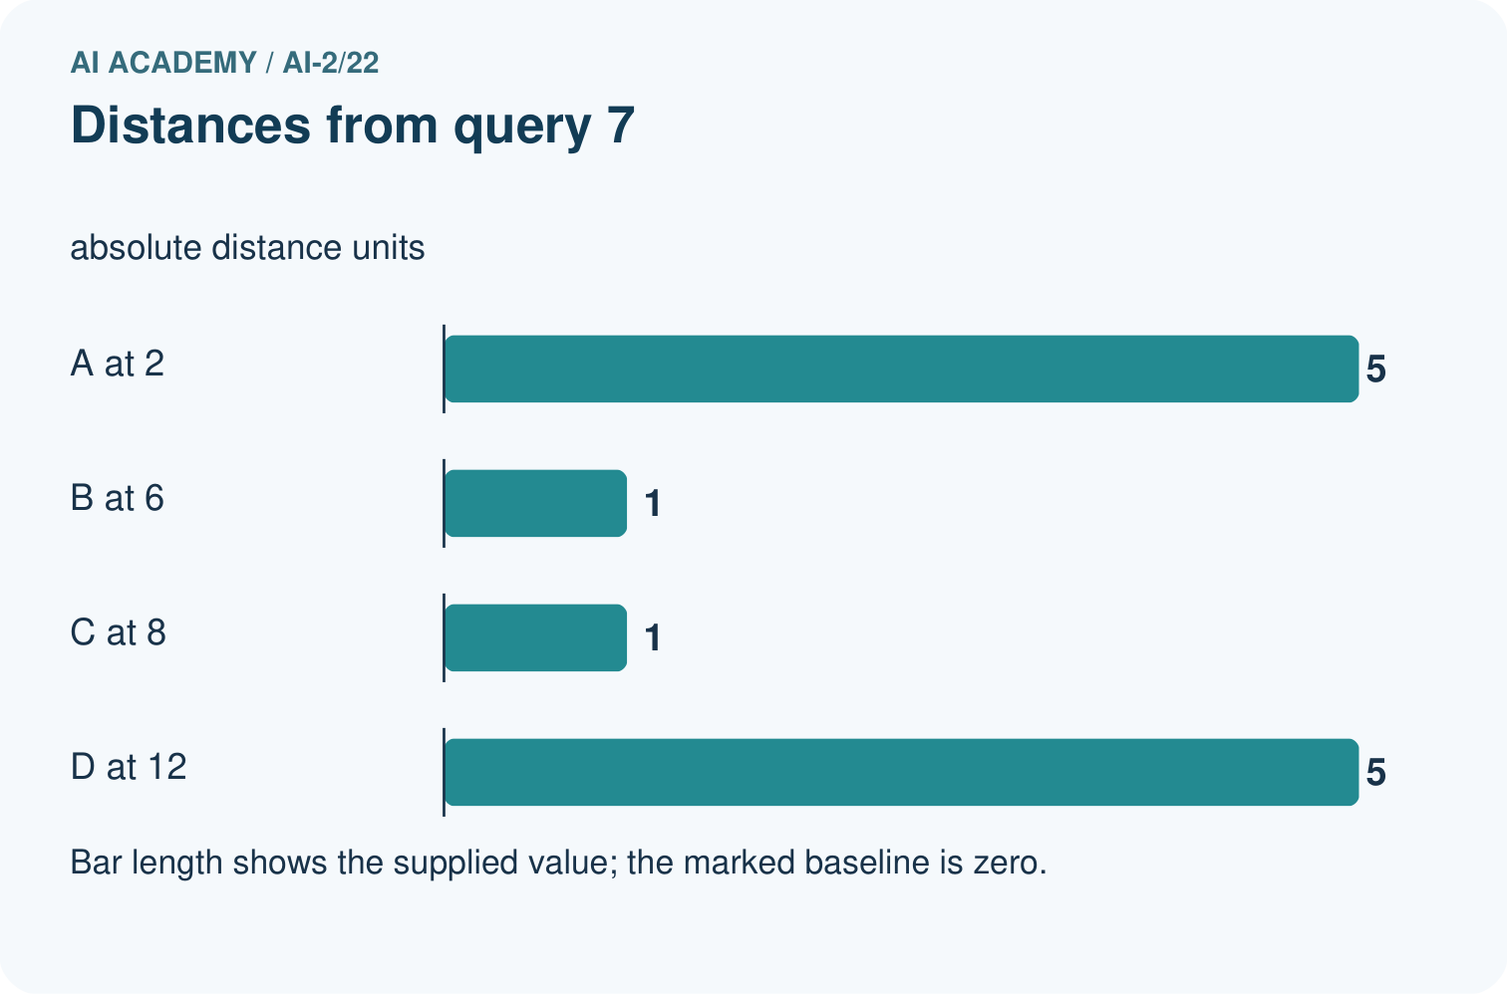
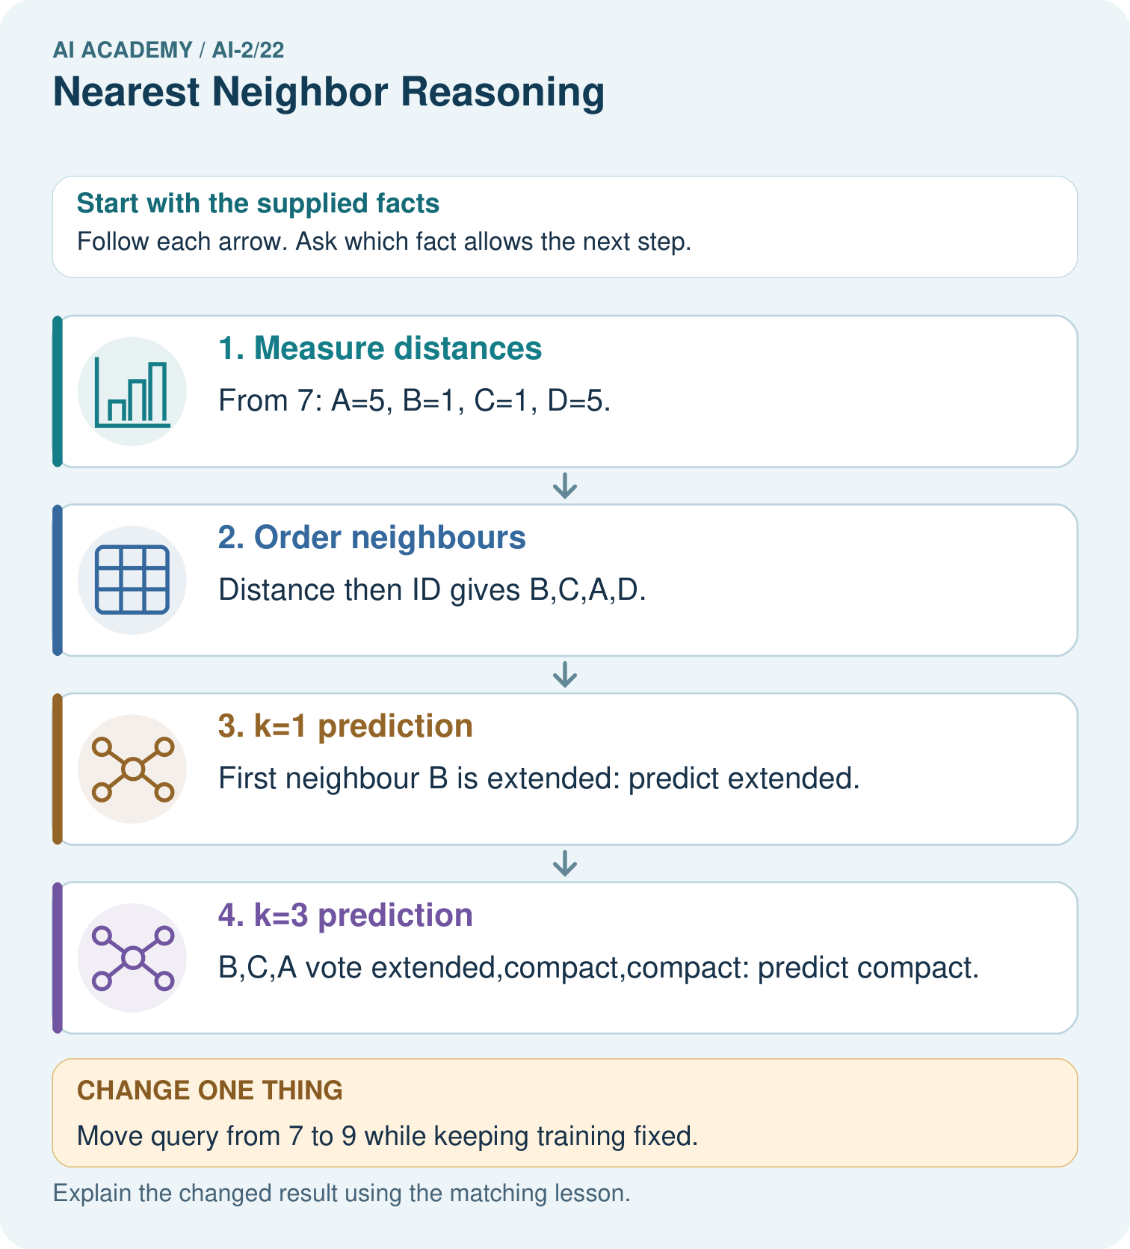

Read the picture one step at a time
Step | What happens and why
1. Measure distances | From 7: A=5, B=1, C=1, D=5.
2. Order neighbours | Distance then ID gives B,C,A,D.
3. k=1 prediction | First neighbour B is extended: predict extended.
4. k=3 prediction | B,C,A vote extended,compact,compact: predict compact.
Match each pictured step to the supplied facts. This is a worked teaching case, not an independent assessment.

Why this result follows
Changing k changes how many training neighbours vote, even though all distances remain fixed. The query’s reference label must not enter the stored pool before predicting. Tie policies make ordering reproducible; without them, list order could unexpectedly determine the single-neighbour result.

What this example does not establish
Nearest-neighbour votes depend on feature representation; they are not calibrated probabilities or guaranteed correct labels.

Change one thing in the pictured case
Change: Move query from 7 to 9 while keeping training fixed.
Prediction: Order becomes C,B,D,A; k=1 predicts compact and k=3 predicts extended.
Reason: Distances are C=1,B=3,D=3,A=7; B beats D by the ID tie rule.

Ask while showing the picture
Cover the result. Ask learners to name the inputs and predict the next step. Uncover one step, connect the icon to the actual procedure, and explain its evidence. Then change the supplied condition and compare. The picture is a representation; it does not document execution of a real AI model.

03. Demonstrate and guide practice

Demonstrate and guide practice

Board sequence
Write the given facts: A=[1,1] liked, B=[1,0] disliked, C=[0,0] disliked; query=[0,1].
Write the question to explain: Find nearest neighbours using differing-trait distance and k=1.
Reveal after predictions: A and C tie at distance one; B is distance two. Conflicting nearest labels require a predefined tie policy or uncertainty.
Keep for an independent attempt: Training items have one numeric feature: A=2 with label short, B=8 with label long. A new item has value 6. Use absolute distance to choose its nearest neighbour.

Classroom dialogue
Ask: Which facts are given, and which would we have to assume? Learners mark relevant details before discussing answers.
Say: Predict first. Show the rule, information path or calculation that would produce the result. A correct guess is not yet an explanation.
Reveal reasoning one step at a time. Explain why a tempting alternative fails. Write units and denominators for arithmetic, trace conditions for decisions, and identify supporting sources for claims.
In pairs, one learner solves while the other checks evidence; exchange roles. Remove the worked answer before independent assessment.

Model these guided questions
Guided: abs(2-3) and abs(4-3) both equal 1. For k=1 alphabetical tie order chooses A, blocked. k=3 adds B and C, whose clear votes win 2 to 1. ID order is a deterministic convention, not evidence of the query’s true label. Exit: using labelled validation examples in the neighbour pool leaks evaluation answers and may let a query select itself. Restore the original training-only pool and score every validation query without adding its label.

Case-specific teaching sequence
Stage | Teacher action
Session 1 start to 7 minutes | Retrieve tree storage and prediction. Introduce prediction from stored examples with a declared distance.
7 to 18 minutes | Place A through E on the number line. Calculate absolute distances to query 3 and complete W1.
18 to 32 minutes | Trace tuple sorting and list slicing. Complete W2; distinguish tied distances from a tied label vote.
32 to 45 minutes | Read the diagram and answer the guided question. Explain why ID order is not evidence of truth.
Session 2 start to 8 minutes | Retrieve the training-only neighbour pool. Ask why validation labels must remain outside it.
8 to 20 minutes | Compute the three validation predictions and complete W3. Compare the fixed training-majority baseline.
20 to 35 minutes | Collect W4 independently before support. Require ordered IDs, both k predictions and the full validation score.
35 to 45 minutes | Use W5 and the exit question. Offer the fresh retry after feedback and record support.

Reduce help deliberately
Completion task: For query 3, list the selected IDs and predictions for k=1 and k=3 using alphabetical ID order on equal distances. Explain what changes and what remains the same.
Teacher check: For k=1 select A and predict blocked. For k=3 select A,B,C and predict clear from two clear votes. Training data, distance and ID tie rule stay the same; the number of voting neighbours changes.
Start by identifying the given inputs together. Leave the intermediate steps blank. If needed, model one step, then withdraw that help on the next step. Move to a full trace only when the partial trace is understood. For partners, alternate explainer and checker; collect a response from every learner before discussion.

Individual reasoning check
Use the worked case for Nearest neighbours and distances. Proposed explanation: “A negative difference is a negative distance”. Decide whether this explanation is supported. Point to the step or supplied fact that decides; explain your repair if needed.
Expected correction: Take the absolute difference; in this example distance is nonnegative regardless of which reading is larger.
Collect explanations, not only yes/no votes. If a misunderstanding is common, re-model the relevant step for the class. If it affects a few learners, give a short targeted group explanation while others solve a more demanding variation.

Pictorial practice question
Why do k=1 and k=3 disagree for the original query?

Reasoned teacher answer
The closest tied neighbour selected by ID is extended B, while the first three include two compact votes.
Changed-case reasoning: Order becomes C,B,D,A; k=1 predicts compact and k=3 predicts extended. Distances are C=1,B=3,D=3,A=7; B beats D by the ID tie rule.
Collect each learner’s explanation before discussion. Use the first missing connection between input, deciding step and result to choose support. This question is worked-case practice, not fresh mastery evidence.

04. Run the weekly evidence lab

Run the weekly evidence lab
Words You Can Use to Reason
A definition matters when you can recognize the idea, use it, and contrast it with a near-miss.
Predict → Test → Record → Explain
Keep expected and actual results separate. Surprises are useful data when recorded honestly.
Measure distances, circle k=3 nearest, tally votes, apply a written tie rule, and test one point near the boundary.
What did the hardest test teach you that the normal test did not?

Make the lab runnable
Use the concrete case as the shared normal case and the independent question as a second case. Each pair creates a boundary or missing-information case and predicts its result before testing. Keep the expected result separate from an observed mistake.
Record | What to capture
Input or evidence | Exact data, instruction or claim
Expected result | Answer or safe fallback declared before the run
Observed result | Actual result, including errors
Explanation | Rule, calculation or evidence explaining the outcome
Next test | One justified change and a new prediction

Diagnose and reteach
For guessing, return to given facts and request a trace. For vocabulary without application, use one example and one non-example. For arithmetic errors, check the setup before the calculation. Finish with a different uncoached case before recording mastery.

Address these additional misconceptions
A negative difference is a negative distance: Take the absolute difference; in this example distance is nonnegative regardless of which reading is larger.
Odd k prevents every kind of tie: Three binary votes avoid a label tie, but neighbours can still tie in distance, including at the selection boundary.
An exact match proves the label: It matches the selected feature only. Other conditions, annotation errors or contradictory examples can remain.

Match the support to the first error
What the response shows | Next teaching action
Missing or misread facts | Read the case aloud, mark supplied versus unknown facts, and let the learner restate it.
Wrong procedure | Return to the deciding step in the worked case. Contrast it with the proposed incorrect explanation.
Arithmetic or implementation error | Trace intermediate values or lines; preserve the first mismatch and retry that step.
Correct result without a reason | Ask for a trace and a changed case before marking independent understanding.
An unsupported wider claim | Ask which supplied evidence supports the claim and which further observation would be needed.
Offer an oral explanation, drawing, enlarged visual or fewer examples when that removes a reading/writing barrier. Keep the same reasoning goal. Stretch secure learners by changing a boundary or assumption and asking them to defend the effect, not simply by assigning more of the same questions.

05. Assess and explain the answers

Assess and explain the answers

Worked case answer
A and C tie at distance one; B is distance two. Conflicting nearest labels require a predefined tie policy or uncertainty.

Independent question
Training items have one numeric feature: A=2 with label short, B=8 with label long. A new item has value 6. Use absolute distance to choose its nearest neighbour.

Expected independent answer
Distances are 4 to A and 2 to B, so nearest-neighbour prediction is long. This follows the supplied distance rule, not certainty about every future case.

What counts as evidence
Criterion | 0 points | 1 point | 2 points
Result | Incorrect or absent | Partly correct | Correct with necessary conditions
Reasoning | No supporting trace | Some steps | Clear mechanism, calculation or source support
Limit | Overclaims certainty | Vague limitation | Relevant uncertainty or missing fact
Transfer | Copies without adapting | Adapts with prompts | Solves a changed case independently
Use 6/8 as a classroom checkpoint, with 2 required for both Result and Reasoning. This is a proposed teaching rule, not a validated certification threshold. Do not count a coached answer as independent mastery; correct unsafe or unsupported claims regardless of total.

Feedback
Ask the learner to find the evidence that challenges this claim: “The first stored example is always the nearest.” Keep the first attempt and an uncoached retry separate.

Original transfer answer
Row-order choice makes predictions change when data is reordered. Predefine review for conflicting nearest labels, or a justified stable tie-breaker with disclosed limits. Do not select a tie policy after looking at the correct answer for the test case.

Explanations for the additional workbook examples

W1 Calculate feature distances
For query 3 cm, calculate distances to all five training rows. Explain why A and B tie even though their labels differ.
Distances to A,B,C,D,E are 1,1,5,7,9 cm. A and B are equally far from 3 on the numeric feature; their labels do not enter the distance calculation.

W2 Apply neighbour and tie rules
For query 3, list the selected IDs and predictions for k=1 and k=3 using alphabetical ID order on equal distances. Explain what changes and what remains the same.
For k=1 select A and predict blocked. For k=3 select A,B,C and predict clear from two clear votes. Training data, distance and ID tie rule stay the same; the number of voting neighbours changes.

W3 Keep evaluation examples separate
Why must the three validation reference labels not enter the neighbour pool? Give the fixed k=3 score and baseline score on the worked validation examples.
Adding validation labels uses evaluation answers to make predictions and changes the intended comparison with unseen trips. The fixed k=3 method predicts clear three times and gets 1/3. The training-majority clear baseline also gets 1/3.

W4 Find neighbours independently
New training rows are P at 1 cm clear, Q at 5 blocked, R at 7 blocked, S at 11 clear, T at 13 blocked. For query 6, give all distances, order the IDs by distance then alphabetically, and predict with k=1 and k=3. Using the same training pool and k=3, score validation (6,blocked),(10,clear),(12,blocked). Compare the training-majority baseline.
Query 6 distances P,Q,R,S,T are 5,1,1,5,7. Order Q,R,P,S,T. k=1 predicts blocked from Q; k=3 uses Q,R,P and also predicts blocked. For queries 6,10,12, selected triples are Q R P, S R T, S T R. All predict blocked, matching validation rows 1 and 3: 2/3. Training-majority blocked also scores 2/3.

W5 Interpret a vote and a match
Two of three neighbours vote clear. Does that prove a two-thirds chance of a correct prediction? Does an exact feature match guarantee a correct label? Explain both limits.
The vote fraction describes the selected training labels, not a verified probability of correctness. An exact match on one feature can still differ in omitted conditions or have a wrong or conflicting label. Separate evaluation and relevant features remain necessary.

Assess independent transfer
Selected case: New training rows are P at 1 cm clear, Q at 5 blocked, R at 7 blocked, S at 11 clear, T at 13 blocked. For query 6, give all distances, order the IDs by distance then alphabetically, and predict with k=1 and k=3. Using the same training pool and k=3, score validation (6,blocked),(10,clear),(12,blocked). Compare the training-majority baseline.

Selected case answer
Query 6 distances P,Q,R,S,T are 5,1,1,5,7. Order Q,R,P,S,T. k=1 predicts blocked from Q; k=3 uses Q,R,P and also predicts blocked. For queries 6,10,12, selected triples are Q R P, S R T, S T R. All predict blocked, matching validation rows 1 and 3: 2/3. Training-majority blocked also scores 2/3.
Dimension | Evidence required
Explanation | Names the applicable idea or procedure and ties it to the supplied facts.
Trace and result | Preserves the given inputs and shows the relevant intermediate steps; distinguishes a prediction from an observed execution.
Limits | States the assumptions, missing evidence or conditions under which the result would change.
Record each dimension as not yet, with support, or independent. Accept a valid alternative procedure with a defensible trace. Do not penalise an honestly recorded model failure if the learner correctly explains its evidence and limits.

Feedback that the learner uses
Name the earliest unsupported step and give one action to repair it. Have the learner make that repair now and explain why. Then assess the relevant skill on a fresh, fully specified case. Confirm it was not previously practised with feedback; solve and check the new case before assigning it. A follow-up design prompt is a starting brief, not automatically an equivalent test.

06. Connect and extend learning

Connect and extend learning

Transparent Book Recommender
Use neighboring liked books as evidence, while explaining which traits created closeness.
Keep the decision, input, result, explanation and remaining limitation in the project evidence record. Retrieve this record next week rather than restarting the project.

Support and stretch
Trace one record or condition at a time with counters and labelled columns. Stretch: introduce a tie, boundary or missing field and declare its handling policy before rerunning.

Exit reflection
Ask for one decision the learner can now justify and one situation requiring more evidence or human review. Confidence ratings are separate from correct independent performance.

Bridge to the next week
Next: Week 23: Recommendation Scores. Retrieve today’s evidence and identify what carries forward and what is new.

Support and fresh reassessment
Use physical steps on a number line before abs. Supply an empty distance table without the order. Extension: explain how renaming tied IDs can change a prediction under this policy while the measured features remain unchanged, and why the policy must be recorded.
Require W4 distances 5,1,1,5,7, order Q,R,P,S,T, both predictions blocked, and validation plus baseline scores 2/3. Fresh retry: L at 0 blocked, M at 4 clear, N at 6 clear, O at 10 blocked, P at 12 clear; query 5. Distances are 5,1,1,5,7; order M,N,L,O,P. k=1 is clear from M; k=3 is clear from M,N,L. Ask why L wins the third-place distance tie over O: alphabetical ID policy. Require a training-only pool and no probability claim.
Week 11 covers scaling without leakage. Carry forward training-only storage and explicit distance choices. Teacher reference: https://scikit-learn.org/stable/modules/neighbors.html (nearest-neighbour classification and tie considerations; reviewed 2026-09-27).

Plan the delayed return
Suggested return points in this level: ai-2/23, ai-2/25, ai-2/28. Use actual classroom dates, adjusting for holidays and gaps. One, three and six teaching weeks are scheduling choices, not a claimed optimal spacing.
At a delayed check, ask for the idea from memory and a changed application. Compare with the earlier independent response and record support used. For a new level, revisit the previous capstone before checking the new prerequisites.
Record | Teacher evidence
Learner code and date
Concept and case used; prior exposure
Explanation / trace / limits
Support and first repair
Changed case and delayed outcome
Next teaching action
Use the evidence to choose reteaching or the next step. A completed page, confidence rating or attractive project does not by itself demonstrate understanding.

Project evidence from this case
Retain recommender neighbour IDs, distances, k and tie decisions so similar-book explanations can be audited.

07. Prepare, teach and assess
Teaching target: Compute absolute distances and rank training neighbours
Prepare the labelled worked-case picture, the matching workbook, fictional input cards and a place for individual responses. No paid AI account is required for the paper reasoning activities.
Session | Plan | Resources
Session 1 · Understand · 45 min | 0–7: recall and prerequisite; 7–15: inspect the concrete case and predict; 15–30: teacher models the worked trace; 30–40: learners explain a step using the text and visual; 40–45: check the core idea. | Sections 1–6; record the brief recall in the workbook.
Session 2 · Practise · 45 min | 0–5: retrieve the procedure; 5–15: W2 completion practice; 15–23: explain and check with a partner; 23–30: each learner answers the misconception check; 30–40: targeted reteaching or a harder variation; 40–45: prepare the investigation. | Sections 7–10; use the matching workbook W2 and misconception check.
Session 3 · Investigate and transfer · 45 min | 0–5: retrieve the decision rule; 5–20: investigate or trace; 20–30: start the independent case; 30–38: connect the project; 38–43: act on feedback; 43–45: plan the return check. | Sections 9 and 11–14. Give extra time to finish the full task set; use Section 15 when the week includes a coding lab.
Before class, solve the supported practice: For query 3, list the selected IDs and predictions for k=1 and k=3 using alphabetical ID order on equal distances. Explain what changes and what remains the same.
Reasoned practice answer: For k=1 select A and predict blocked. For k=3 select A,B,C and predict clear from two clear votes. Training data, distance and ID tie rule stay the same; the number of voting neighbours changes.
Check every learner before discussion: Use the worked case for Nearest neighbours and distances. Proposed explanation: “A negative difference is a negative distance”. Decide whether this explanation is supported. Point to the step or supplied fact that decides; explain your repair if needed.
Misconception repair: Take the absolute difference; in this example distance is nonnegative regardless of which reading is larger.
Support: read the exact case aloud, enlarge the labelled picture, supply input cards and model only the first deciding step. Accept a spoken explanation or drawing; retain the reasoning goal.
Extension: Move query from 7 to 9 while keeping training fixed. Require a prediction and a reason before comparing. Expected result: Order becomes C,B,D,A; k=1 predicts compact and k=3 predicts extended. Reason: Distances are C=1,B=3,D=3,A=7; B beats D by the ID tie rule.
Independent assessment: withhold the reserved answer until the learner has attempted the new case. Record support separately from correctness.
Criterion | Not yet | With support | Independent
Explanation | Names an answer without a deciding fact | Uses a hint to link fact and decision | Explains the deciding fact in own words
Trace or test | Cannot connect input and result | Completes steps with prompts | Traces or tests a changed case accurately
Limits and revision | Claims more than evidence supports | Names a limit after a prompt | States a defensible limit and useful next test
Project checkpoint: Evaluate and revise. Compare with your starting method, explain errors and record a justified revision.
Use the weekly teacher answer for topic-specific reasoning. A saved progress tick is an activity record; judge mastery from the learner’s explanation and evidence.

