AI ACADEMY · TEACHER · ai-2/25

Text as Pieces
Project: Transparent Book Recommender

01. Text as Pieces

Teach the learning cycle
Primary target: Encode and decode text under an explicit toy vocabulary
Session | Sequence and minutes | Resources
Session 1 · Understand · 45 min | 0–7: recall and prerequisite; 7–15: inspect the concrete case and predict; 15–30: teacher models the worked trace; 30–40: learners explain a step using the text and visual; 40–45: check the core idea. | Sections 1–6; record the brief recall in the workbook.
Session 2 · Practise · 45 min | 0–5: retrieve the procedure; 5–15: W2 completion practice; 15–23: explain and check with a partner; 23–30: each learner answers the misconception check; 30–40: targeted reteaching or a harder variation; 40–45: prepare the investigation. | Sections 7–10; use the matching workbook W2 and misconception check.
Session 3 · Investigate and transfer · 45 min | 0–5: retrieve the decision rule; 5–20: investigate or trace; 20–30: start the independent case; 30–38: connect the project; 38–43: act on feedback; 43–45: plan the return check. | Sections 9 and 11–14. Give extra time to finish the full task set; use Section 15 when the week includes a coding lab.
This is a starting allocation of 135 minutes, not a validated duration. Preserve all named topics. Schedule extra time for connected examples, the full investigation, independent cases and project building. Repeated copies of a case share one recorded attempt; they are not new evidence.

Retrieval answer guidance

Feedback Loops
Without opening the old lesson, explain one key idea from Feedback Loops. Give an example and a mistake that the idea helps you avoid.
Look for: Implement a deterministic recommender
Reference example, not the only acceptable wording: Both score 8 and qualify; A is alphabetically first under the tie rule.

Nearest Neighbor Reasoning
Without opening the old lesson, explain one key idea from Nearest Neighbor Reasoning. Give an example and a mistake that the idea helps you avoid.
Look for: Compute absolute distances and rank training neighbours
Reference example, not the only acceptable wording: Distances to A,B,C,D,E are 1,1,5,7,9 cm. A and B are equally far from 3 on the numeric feature; their labels do not enter the distance calculation.

Sampling and Representation
Without opening the old lesson, explain one key idea from Sampling and Representation. Give an example and a mistake that the idea helps you avoid.
Look for: Define a question and target population
Reference example, not the only acceptable wording: Population: all Grade 7 students. Only lunch-club members or one friend group is an unsuitable basis for a whole-grade claim.
Use the student module and workbook section with this exact week title. The worked case, independent question and answers below form one aligned lesson sequence.

What the learner must demonstrate
Toy tokenizer A splits 'unhelpful' into un/help/ful; B keeps it whole. Count tokens for each and explain why a three-word sentence need not use three tokens.

Concept to explain
Language systems process tokens and patterns rather than whole human meanings.
Term | Meaning
token | A unit of encoded text processed by a language model, which may be a word, part of a word or punctuation.
tokenization | Converting text into the token units of a particular tokenizer.
context | Information available around a task that helps interpret or answer it.
pattern | A relationship or regularity observed in examples.

Prepare the class
Use the supplied scenario, student illustrations and blank paper. For numeric work, offer counters or a calculator after learners show the setup. Fictional records are supplied; personal data and paid accounts are unnecessary.
Allow 80 minutes: recall 8; explanation 12; worked demonstration 15; guided practice 20; independent assessment 15; project and reflection 10. Extend the lab into a second session when needed.

Preparation for the connected explanation
Use two 45-minute sessions. All model outputs and probability tables are constructed classroom examples. No hosted AI service, external API or student account is needed. Distinguish a model objective from factual support and system permissions. Collect independent work before discussing its solutions.

Readiness answer
The preceding token sequence, together with the model and any stated context. Changing segmentation changes that token sequence.
Printed lesson and workbook; paper and pencil
Calculator; optional local Python 3 interpreter
Prepare the independent task and fresh retry without displaying solutions

End goal for the pictorial case
By the end, I can encode and decode text using a specified vocabulary and matching rule.
This added worked case illustrates the week’s main idea. Retain all original and connected topics; schedule its practice within the teaching cycle.

02. Explain the mechanism

Explain the mechanism
Input → Process → Output
Trace the information. At each stage, ask what changed and how you could test it.
Which stage could fail even when the other two are correct? Explain:
Predict first. Then check each step. A correct answer without visible reasoning is incomplete evidence.
1. ‘unhelpful’ might split as ‘un’ + ‘help’ + ‘ful’.
2. A name or emoji may use unexpected token pieces.
3. Token boundaries need not match whole words.
4. Meaning emerges from patterns across context, not from one token acting like a dictionary.
Recalculate, retrace, or restate the reasoning in your own representation:
CHECK Did the evidence answer the exact question? Did the total, path, or source record stay consistent?

Concrete teaching case
Toy tokenizer A splits rainbows as [rain][bow][s]; B uses [rainbows].
Count tokens and state the limit of the example.

Exact explanation to model
Three versus one. Token count depends on tokenizer; tokens need not equal words or letters.

Explain the added worked example
Tokens need not be words. A classroom tokenizer can use an exact, case-sensitive vocabulary and greedily choose the longest matching token from left to right. This is a toy rule, not a claim about every production tokenizer. Define IDs: 0=end, 1=cat, 2=c, 3=a, 4=t, 5=s, 6=space, 7=sat. The space token represents one literal space. The end token is a special terminator, not ordinary text.
At each position choose the longest matching ordinary token. If no token matches, stop and report the unsupported character and its position. Do not delete the character or guess a replacement. IDs identify entries; a larger ID does not mean a token is more valuable or more similar.
The encoding of cats sat is [1,5,6,7], followed by [0] only if the protocol appends an end token. Decoding concatenates the ordinary token strings to recover cats sat. Count four text tokens, or five sequence items with the end marker included; always state the counting convention. The two written words do not imply two tokens.

Key terms
Term | Meaning
Token | An item in a model vocabulary, which may represent a word, part of a word or another text unit
Vocabulary | The permitted tokens and their identifiers
Encoding | Mapping source text into a token sequence under a specified rule
Decoding | Mapping a token sequence back to text under a specified rule

Model the reasoning aloud
Use the complete worked example below before asking learners to complete W2. Reveal a small part, invite a prediction, then explain the deciding step. These teacher notes contain solutions; do not reveal the independent case answer during modelling.
A character-only vocabulary c,a,t,s,space could encode cats sat as c,a,t,s,space,s,a,t: eight text tokens. The original vocabulary uses four. Both decode to the same source text. Sequence length is a property of the text, vocabulary and encoding rule together. Counts from different tokenizers are not automatically comparable.
In this vocabulary, sat is chosen over s because it is longer. The toy longest-match rule is defined explicitly. Real tokenizers may use different algorithms, byte encodings and special-token policies. Never infer an unknown tokenizer’s count from word count alone.
Thinking move | Teacher prompt
Plan | What is given? What is the question? Which procedure fits these facts?
Do | Point to each input and intermediate step in the worked trace. Name the rule that allows the next step.
Check | Does the output answer the question? Which assumption or limitation prevents a larger claim?
Use the diagram and verbal explanation together. Ask learners to match a sentence to a specific visual step; do not assign learners fixed visual or auditory learning styles.

A pictorial worked case: Text as Pieces
A fictional tokenizer converts a short catalogue phrase into tokens.

The facts we will use
Vocabulary entries: book, books and the space character. At each position choose the longest matching entry; preserve the actual space.
Text is “books book”. Exclamation marks have no token; zero-based character positions are used.
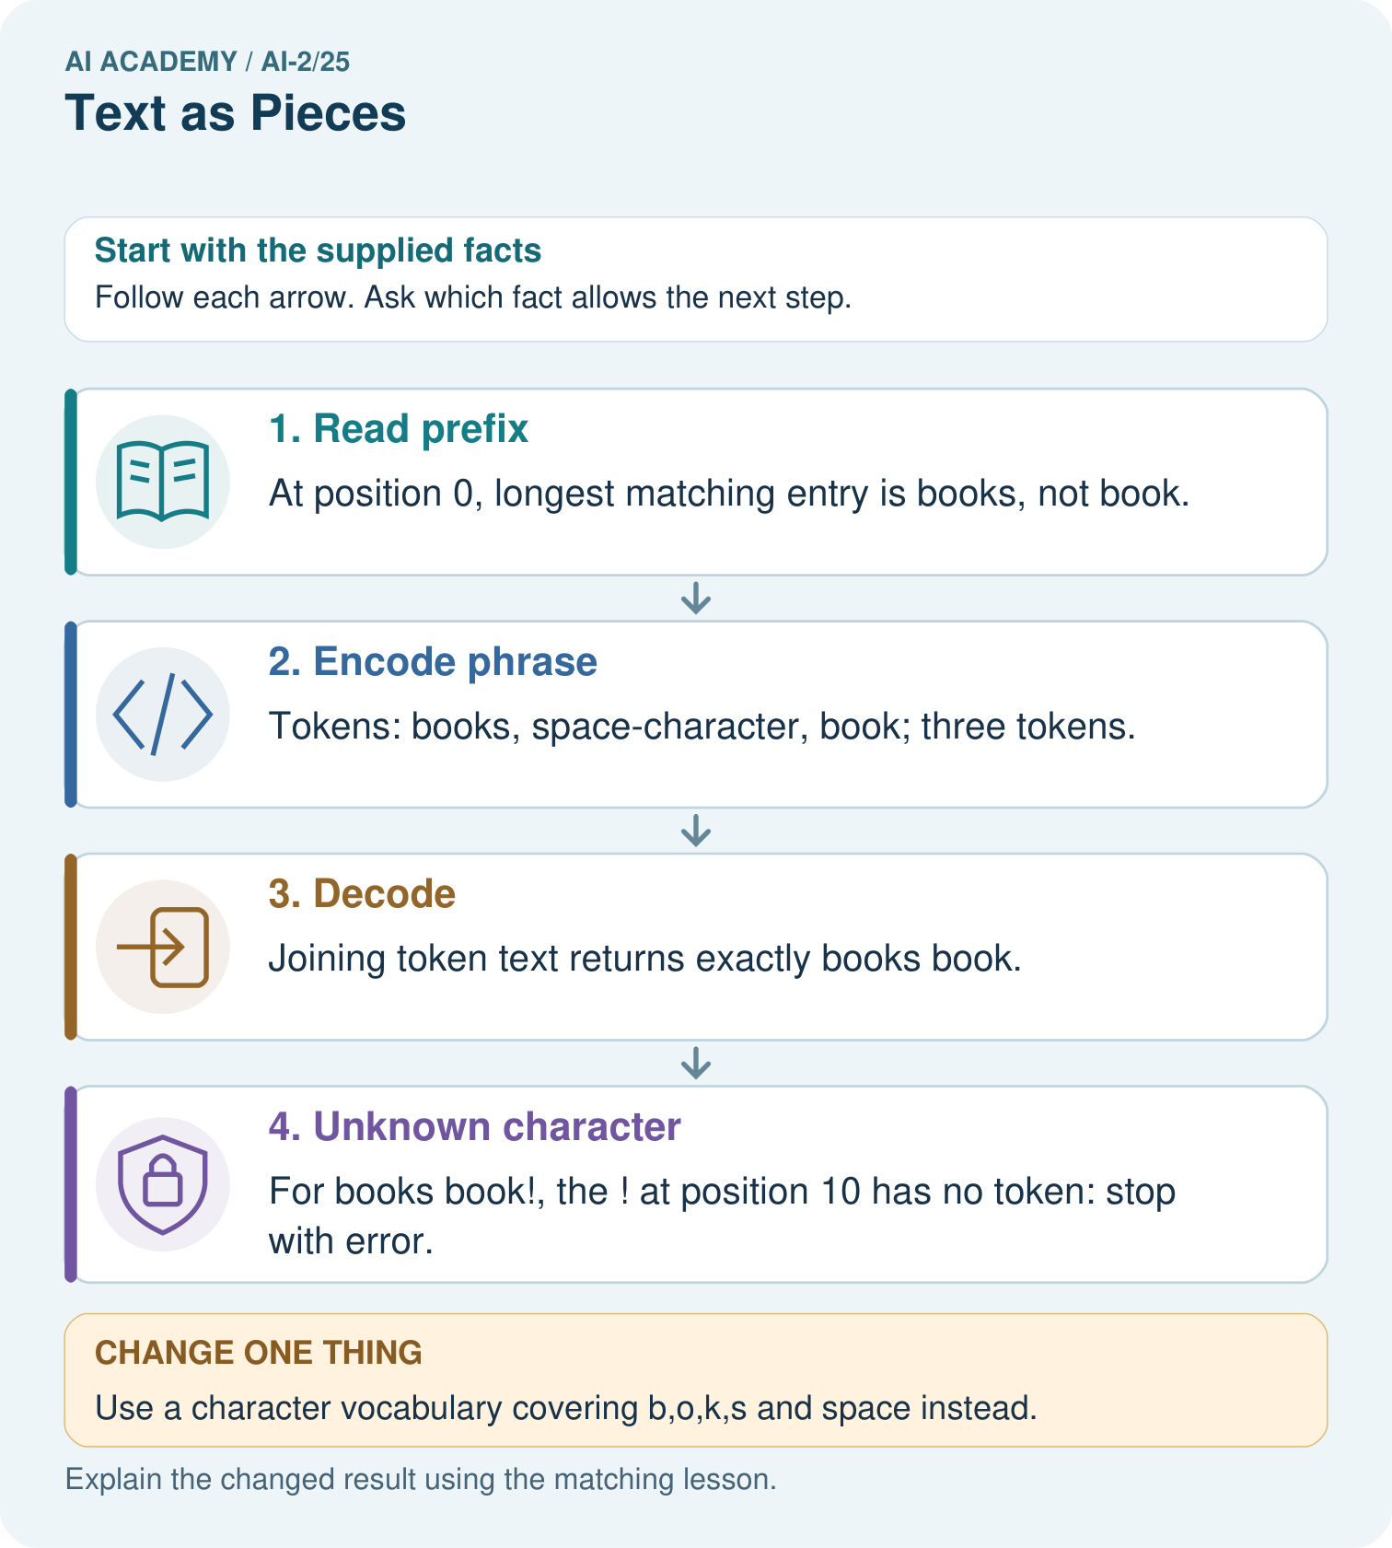

Read the picture one step at a time
Step | What happens and why
1. Read prefix | At position 0, longest matching entry is books, not book.
2. Encode phrase | Tokens: books, space-character, book; three tokens.
3. Decode | Joining token text returns exactly books book.
4. Unknown character | For books book!, the ! at position 10 has no token: stop with error.
Match each pictured step to the supplied facts. This is a worked teaching case, not an independent assessment.

Why this result follows
A token is defined by the vocabulary and encoding rule; it need not be one word or one character. Longest matching matters where vocabulary entries overlap. Counting text tokens here does not count letters. Preserve spaces during decoding so the reconstructed text matches the original exactly.

What this example does not establish
This deterministic toy tokenizer omits real subword training, Unicode handling and model-specific special tokens.

Change one thing in the pictured case
Change: Use a character vocabulary covering b,o,k,s and space instead.
Prediction: The same phrase uses ten character tokens.
Reason: There are five letters, one space and four letters; its decoded text remains unchanged.

Ask while showing the picture
Cover the result. Ask learners to name the inputs and predict the next step. Uncover one step, connect the icon to the actual procedure, and explain its evidence. Then change the supplied condition and compare. The picture is a representation; it does not document execution of a real AI model.

03. Demonstrate and guide practice

Demonstrate and guide practice

Board sequence
Write the given facts: Toy tokenizer A splits rainbows as [rain][bow][s]; B uses [rainbows].
Write the question to explain: Count tokens and state the limit of the example.
Reveal after predictions: Three versus one. Token count depends on tokenizer; tokens need not equal words or letters.
Keep for an independent attempt: A classroom tokenizer splits sunflower into sun and flower. How many pieces result? Must every real tokenizer split it the same way?

Classroom dialogue
Ask: Which facts are given, and which would we have to assume? Learners mark relevant details before discussing answers.
Say: Predict first. Show the rule, information path or calculation that would produce the result. A correct guess is not yet an explanation.
Reveal reasoning one step at a time. Explain why a tempting alternative fails. Write units and denominators for arithmetic, trace conditions for decisions, and identify supporting sources for claims.
In pairs, one learner solves while the other checks evidence; exchange roles. Remove the worked answer before independent assessment.

Model these guided questions
Guided: c at gives [2,6,3,4], four text tokens. cat! fails on ! at zero-based position 3 after partial [1]. Exit: deleting ! changes the input; report unsupported punctuation or use a separately specified preprocessing/versioned vocabulary.

Case-specific teaching sequence
Stage | Teacher action
Session 1 start to 7 minutes | Retrieve the prerequisite and distinguish a numerical claim from its interpretation.
7 to 18 minutes | Read section 1 and complete W1; ask for a reason alongside each answer.
18 to 32 minutes | Trace the worked case in section 2 and complete W2.
32 to 45 minutes | Discuss the diagram and complete W3 in pairs; record support.
Session 2 start to 8 minutes | Complete the guided response before sharing the answer.
8 to 20 minutes | Read the remaining sections and trace another constructed case.
20 to 35 minutes | Collect W4 independently, requiring calculations and a bounded conclusion.
35 to 45 minutes | Discuss W5 and the exit response. Provide feedback and a fresh retry.

Reduce help deliberately
Completion task: Encode cats sat using the given vocabulary, decode it, and count with and without an appended end marker.
Teacher check: Teacher explanation: Text IDs [1,5,6,7] decode cats sat. Four text tokens; five sequence items if the protocol appends end ID 0.
Start by identifying the given inputs together. Leave the intermediate steps blank. If needed, model one step, then withdraw that help on the next step. Move to a full trace only when the partial trace is understood. For partners, alternate explainer and checker; collect a response from every learner before discussion.

Individual reasoning check
Use the worked case for Tokenisation and vocabulary. Proposed explanation: “A token always equals a word”. Decide whether this explanation is supported. Point to the step or supplied fact that decides; explain your repair if needed.
Expected correction: The vocabulary contains both whole strings and character pieces, so one word can take multiple tokens.
Collect explanations, not only yes/no votes. If a misunderstanding is common, re-model the relevant step for the class. If it affects a few learners, give a short targeted group explanation while others solve a more demanding variation.

Pictorial practice question
Why is the unknown ! at position 10 rather than position 9?

Reasoned teacher answer
books occupies 0–4, space is 5, book is 6–9, so ! is character 10.
Changed-case reasoning: The same phrase uses ten character tokens. There are five letters, one space and four letters; its decoded text remains unchanged.
Collect each learner’s explanation before discussion. Use the first missing connection between input, deciding step and result to choose support. This question is worked-case practice, not fresh mastery evidence.

04. Run the weekly evidence lab

Run the weekly evidence lab
Words You Can Use to Reason
A definition matters when you can recognize the idea, use it, and contrast it with a near-miss.
Predict → Test → Record → Explain
Keep expected and actual results separate. Surprises are useful data when recorded honestly.
Cut sentence cards into two plausible tokenizations, compare piece counts, remove context, and predict which continuation becomes less certain.
What did the hardest test teach you that the normal test did not?

Make the lab runnable
Use the concrete case as the shared normal case and the independent question as a second case. Each pair creates a boundary or missing-information case and predicts its result before testing. Keep the expected result separate from an observed mistake.
Record | What to capture
Input or evidence | Exact data, instruction or claim
Expected result | Answer or safe fallback declared before the run
Observed result | Actual result, including errors
Explanation | Rule, calculation or evidence explaining the outcome
Next test | One justified change and a new prediction

Diagnose and reteach
For guessing, return to given facts and request a trace. For vocabulary without application, use one example and one non-example. For arithmetic errors, check the setup before the calculation. Finish with a different uncoached case before recording mastery.

Address these additional misconceptions
A token always equals a word: The vocabulary contains both whole strings and character pieces, so one word can take multiple tokens.
IDs measure semantic similarity: IDs are vocabulary indices; their numerical spacing does not establish meaning.
Dropping characters preserves an exact round trip: Deleted characters change the source and must not be hidden.

Match the support to the first error
What the response shows | Next teaching action
Missing or misread facts | Read the case aloud, mark supplied versus unknown facts, and let the learner restate it.
Wrong procedure | Return to the deciding step in the worked case. Contrast it with the proposed incorrect explanation.
Arithmetic or implementation error | Trace intermediate values or lines; preserve the first mismatch and retry that step.
Correct result without a reason | Ask for a trace and a changed case before marking independent understanding.
An unsupported wider claim | Ask which supplied evidence supports the claim and which further observation would be needed.
Offer an oral explanation, drawing, enlarged visual or fewer examples when that removes a reading/writing barrier. Keep the same reasoning goal. Stretch secure learners by changing a boundary or assumption and asking them to defend the effect, not simply by assigning more of the same questions.

05. Assess and explain the answers

Assess and explain the answers

Worked case answer
Three versus one. Token count depends on tokenizer; tokens need not equal words or letters.

Independent question
A classroom tokenizer splits sunflower into sun and flower. How many pieces result? Must every real tokenizer split it the same way?

Expected independent answer
Two pieces result under this supplied scheme. Real tokenizers use different vocabularies and rules, so their splits may differ.

What counts as evidence
Criterion | 0 points | 1 point | 2 points
Result | Incorrect or absent | Partly correct | Correct with necessary conditions
Reasoning | No supporting trace | Some steps | Clear mechanism, calculation or source support
Limit | Overclaims certainty | Vague limitation | Relevant uncertainty or missing fact
Transfer | Copies without adapting | Adapts with prompts | Solves a changed case independently
Use 6/8 as a classroom checkpoint, with 2 required for both Result and Reasoning. This is a proposed teaching rule, not a validated certification threshold. Do not count a coached answer as independent mastery; correct unsafe or unsupported claims regardless of total.

Feedback
Ask the learner to find the evidence that challenges this claim: “One word always equals one token.” Keep the first attempt and an uncoached retry separate.

Original transfer answer
A uses 3 tokens, B uses 1. Real tokenizers can split words, include spaces or punctuation and use different vocabularies. A word count alone cannot determine a token budget; these toy splits illustrate the idea rather than document a particular model.

Explanations for the additional workbook examples

W1 Read the contract
Explain why sat wins over s at the start of sat and why uppercase C is unsupported.
Teacher explanation: The rule chooses the longest matching ordinary token; sat has length three and s length one. Vocabulary and matching are case sensitive and contain no uppercase C.

W2 Encode and decode
Encode cats sat using the given vocabulary, decode it, and count with and without an appended end marker.
Teacher explanation: Text IDs [1,5,6,7] decode cats sat. Four text tokens; five sequence items if the protocol appends end ID 0.

W3 Compare sequence lengths
Encode cats sat with character tokens only. Explain the difference from four text tokens in the original vocabulary.
Teacher explanation: c,a,t,s,space,s,a,t is eight text tokens. Larger chunks in the original vocabulary compress this representation; the source text is unchanged.

W4 Trace a new input independently
Under the original vocabulary encode sat cats, decode it and count text tokens. Then trace sat cat! and state the exact failure position using zero-based character positions.
Teacher explanation: sat cats encodes [7,6,1,5], decodes exactly and has four text tokens. sat cat! has partial IDs [7,6,1] then unsupported ! at position 7. Report failure with the partial trace, not complete success.

W5 Audit silent repair
An encoder lowercases Cat and removes punctuation before encoding, but labels its output an exact encoding of the original. Explain what must be recorded or changed.
Teacher explanation: Lowercasing and punctuation removal alter the source. Record preprocessing separately and label the transformed text; an exact encoder under this contract must report unsupported characters rather than silently change them.

Assess independent transfer
Selected case: Under the original vocabulary encode sat cats, decode it and count text tokens. Then trace sat cat! and state the exact failure position using zero-based character positions.

Selected case answer
Teacher explanation: sat cats encodes [7,6,1,5], decodes exactly and has four text tokens. sat cat! has partial IDs [7,6,1] then unsupported ! at position 7. Report failure with the partial trace, not complete success.
Dimension | Evidence required
Explanation | Names the applicable idea or procedure and ties it to the supplied facts.
Trace and result | Preserves the given inputs and shows the relevant intermediate steps; distinguishes a prediction from an observed execution.
Limits | States the assumptions, missing evidence or conditions under which the result would change.
Record each dimension as not yet, with support, or independent. Accept a valid alternative procedure with a defensible trace. Do not penalise an honestly recorded model failure if the learner correctly explains its evidence and limits.

Feedback that the learner uses
Name the earliest unsupported step and give one action to repair it. Have the learner make that repair now and explain why. Then assess the relevant skill on a fresh, fully specified case. Confirm it was not previously practised with feedback; solve and check the new case before assigning it. A follow-up design prompt is a starting brief, not automatically an equivalent test.

06. Connect and extend learning

Connect and extend learning

Transparent Book Recommender
Tokenize book descriptions before any text-based matching, while preserving the original source text.
Keep the decision, input, result, explanation and remaining limitation in the project evidence record. Retrieve this record next week rather than restarting the project.

Support and stretch
Trace one record or condition at a time with counters and labelled columns. Stretch: introduce a tie, boundary or missing field and declare its handling policy before rerunning.

Exit reflection
Ask for one decision the learner can now justify and one situation requiring more evidence or human review. Confidence ratings are separate from correct independent performance.

Bridge to the next week
Next: Week 26: Image and Voice Pipelines. Retrieve today’s evidence and identify what carries forward and what is new.

Support and fresh reassessment
Provide labelled intermediate columns and allow a calculator. Ask students to state the meaning and denominator of a value before interpreting it. Extension: implement the classroom calculation locally and test boundary cases without using personal data.
W4 requires [7,6,1,5], four text tokens and unsupported ! at position 7. Fresh retry: cats cat encodes [1,5,6,1], four text tokens; cats Cat fails at uppercase C position 5 after [1,5,6]. Require exact decoding and an explicit failure.
Week 3 uses vocabulary alternatives to inspect next-token probability distributions and sequence probabilities.

Plan the delayed return
Suggested return points in this level: ai-2/26, ai-2/28, ai-2/31. Use actual classroom dates, adjusting for holidays and gaps. One, three and six teaching weeks are scheduling choices, not a claimed optimal spacing.
At a delayed check, ask for the idea from memory and a changed application. Compare with the earlier independent response and record support used. For a new level, revisit the previous capstone before checking the new prerequisites.
Record | Teacher evidence
Learner code and date
Concept and case used; prior exposure
Explanation / trace / limits
Support and first repair
Changed case and delayed outcome
Next teaching action
Use the evidence to choose reteaching or the next step. A completed page, confidence rating or attractive project does not by itself demonstrate understanding.

Project evidence from this case
Document the recommender’s text representation and unknown-token behavior rather than assuming every model counts words identically.

07. Prepare, teach and assess
Teaching target: Encode and decode text under an explicit toy vocabulary
Prepare the labelled worked-case picture, the matching workbook, fictional input cards and a place for individual responses. No paid AI account is required for the paper reasoning activities.
Session | Plan | Resources
Session 1 · Understand · 45 min | 0–7: recall and prerequisite; 7–15: inspect the concrete case and predict; 15–30: teacher models the worked trace; 30–40: learners explain a step using the text and visual; 40–45: check the core idea. | Sections 1–6; record the brief recall in the workbook.
Session 2 · Practise · 45 min | 0–5: retrieve the procedure; 5–15: W2 completion practice; 15–23: explain and check with a partner; 23–30: each learner answers the misconception check; 30–40: targeted reteaching or a harder variation; 40–45: prepare the investigation. | Sections 7–10; use the matching workbook W2 and misconception check.
Session 3 · Investigate and transfer · 45 min | 0–5: retrieve the decision rule; 5–20: investigate or trace; 20–30: start the independent case; 30–38: connect the project; 38–43: act on feedback; 43–45: plan the return check. | Sections 9 and 11–14. Give extra time to finish the full task set; use Section 15 when the week includes a coding lab.
Before class, solve the supported practice: Encode cats sat using the given vocabulary, decode it, and count with and without an appended end marker.
Reasoned practice answer: Teacher explanation: Text IDs [1,5,6,7] decode cats sat. Four text tokens; five sequence items if the protocol appends end ID 0.
Check every learner before discussion: Use the worked case for Tokenisation and vocabulary. Proposed explanation: “A token always equals a word”. Decide whether this explanation is supported. Point to the step or supplied fact that decides; explain your repair if needed.
Misconception repair: The vocabulary contains both whole strings and character pieces, so one word can take multiple tokens.
Support: read the exact case aloud, enlarge the labelled picture, supply input cards and model only the first deciding step. Accept a spoken explanation or drawing; retain the reasoning goal.
Extension: Use a character vocabulary covering b,o,k,s and space instead. Require a prediction and a reason before comparing. Expected result: The same phrase uses ten character tokens. Reason: There are five letters, one space and four letters; its decoded text remains unchanged.
Independent assessment: withhold the reserved answer until the learner has attempted the new case. Record support separately from correctness.
Criterion | Not yet | With support | Independent
Explanation | Names an answer without a deciding fact | Uses a hint to link fact and decision | Explains the deciding fact in own words
Trace or test | Cannot connect input and result | Completes steps with prompts | Traces or tests a changed case accurately
Limits and revision | Claims more than evidence supports | Names a limit after a prompt | States a defensible limit and useful next test
Project checkpoint: Prepare the demonstration. Gather reproducible instructions, evidence, access checks and remaining limitations.
Use the weekly teacher answer for topic-specific reasoning. A saved progress tick is an activity record; judge mastery from the learner’s explanation and evidence.

