AI ACADEMY · TEACHER · ai-3/2

A Distribution of Possibilities
Project: Verified Study Buddy

01. A Distribution of Possibilities

Teach the learning cycle
Primary target: Check whether a next-token table is a valid probability distribution
Session | Sequence and minutes | Resources
Session 1 · Understand · 45 min | 0–7: recall and prerequisite; 7–15: inspect the concrete case and predict; 15–30: teacher models the worked trace; 30–40: learners explain a step using the text and visual; 40–45: check the core idea. | Sections 1–6; record the brief recall in the workbook.
Session 2 · Practise · 45 min | 0–5: retrieve the procedure; 5–15: W2 completion practice; 15–23: explain and check with a partner; 23–30: each learner answers the misconception check; 30–40: targeted reteaching or a harder variation; 40–45: prepare the investigation. | Sections 7–10; use the matching workbook W2 and misconception check.
Session 3 · Investigate and transfer · 45 min | 0–5: retrieve the decision rule; 5–20: investigate or trace; 20–30: start the independent case; 30–38: connect the project; 38–43: act on feedback; 43–45: plan the return check. | Sections 9 and 11–14. Give extra time to finish the full task set; use Section 15 when the week includes a coding lab.
This is a starting allocation of 135 minutes, not a validated duration. Preserve all named topics. Schedule extra time for connected examples, the full investigation, independent cases and project building. Repeated copies of a case share one recorded attempt; they are not new evidence.

Retrieval answer guidance

Predictive and Generative AI
Without opening the old lesson, explain one key idea from Predictive and Generative AI. Give an example and a mistake that the idea helps you avoid.
Look for: Distinguish discriminative prediction from generation by inspecting the requested output
Reference example, not the only acceptable wording: Teacher explanation: Message labels are discriminative prediction; continuing a sequence is generation; record lookup is retrieval rather than learned generation by itself. One application can route a request, retrieve evidence and generate a response.
Use the student module and workbook section with this exact week title. The worked case, independent question and answers below form one aligned lesson sequence.

What the learner must demonstrate
A toy next-token distribution is sun=.5, rain=.3, snow=.2. Over ten samples, must sun occur exactly five times? Does the highest-probability token establish a true statement about weather?

Concept to explain
Week 2: A Distribution of Possibilities
Term | Meaning
distribution | A description of how values or probabilities are spread across possible outcomes.
likelihood | In this introductory context, how plausible an outcome is under a model; in statistics, likelihood has a more specific parameter-based meaning.
sample | A selected group of observations, or an outcome drawn from a distribution; the context identifies which meaning applies.
continuation | Text that follows an existing sequence.

Prepare the class
Use the supplied scenario, student illustrations and blank paper. For numeric work, offer counters or a calculator after learners show the setup. Fictional records are supplied; personal data and paid accounts are unnecessary.
Allow 80 minutes: recall 8; explanation 12; worked demonstration 15; guided practice 20; independent assessment 15; project and reflection 10. Extend the lab into a second session when needed.

Preparation for the connected explanation
Use two 45-minute sessions. All model outputs and probability tables are constructed classroom examples. No hosted AI service, external API or student account is needed. Distinguish a model objective from factual support and system permissions. Collect independent work before discussing its solutions.

Readiness answer
Different vocabularies and rules segment the same text differently; end markers may change the reported count.
Printed lesson and workbook; paper and pencil
Calculator; optional local Python 3 interpreter
Prepare the independent task and fresh retry without displaying solutions

Apply the connected idea: Embeddings and position
Use two 45-minute sessions. All model outputs and probability tables are constructed classroom examples. No hosted AI service, external API or student account is needed. Distinguish a model objective from factual support and system permissions. Collect independent work before discussing its solutions.

Readiness answer
No. IDs are indices. Similarity must refer to the embedding vectors and a defined comparison, not numerical ID distance.
Printed lesson and workbook; paper and pencil
Calculator; optional local Python 3 interpreter
Prepare the independent task and fresh retry without displaying solutions

End goal for the pictorial case
By the end, I can multiply conditional probabilities to compare paths instead of only first tokens.
This added worked case illustrates the week’s main idea. Retain all original and connected topics; schedule its practice within the teaching cycle.

02. Explain the mechanism

Explain the mechanism
Input → Process → Output
Trace the information. At each stage, ask what changed and how you could test it.
Which stage could fail even when the other two are correct? Explain:
Predict first. Then check each step. A correct answer without visible reasoning is incomplete evidence.
1. Possible next words have weights: clear 5, useful 3, magical 1.
2. Nine tokens in the spinner represent those relative weights.
3. Repeated sampling can produce different sequences.
4. One sample does not reveal the whole distribution or guarantee truth.
Recalculate, retrace, or restate the reasoning in your own representation:
CHECK Did the evidence answer the exact question? Did the total, path, or source record stay consistent?

Concrete teaching case
A toy next-token distribution is rain .5, sun .3, snow .2.
Check total and interpret the largest value.

Exact explanation to model
Total is 1. Rain is most likely, not guaranteed under sampling. Token probability is not whole-sentence truth.

Explain the added worked example
A constructed model uses prefix “Status:” and vocabulary alternatives ready, busy and unknown. Its next-token table is ready 0.5, busy 0.3, unknown 0.2. All entries are nonnegative and sum to 1. A probability belongs to a token under this prefix and model, not to that token in every situation. An omitted vocabulary alternative would make the interpretation incomplete unless its probability were explicitly zero.
A table containing 0.6,0.3,0.3 sums to 1.2 and is not already a probability distribution. If the values are nonnegative weights and the rule says normalise, divide each by 1.2. Do not silently treat weights as probabilities. Negative weights cannot be repaired by this simple normalisation rule.
The probability of ready followed by end is 0.5*0.8 = 0.4. Ready followed by today is 0.5*0.2 = 0.1. Busy followed by end is 0.3*0.5 = 0.15, and busy followed by today is 0.15. Unknown followed by end is 0.2 and unknown followed by today is 0. Together these six two-step paths sum to 1. These products are chain-rule calculations; they do not assume the second token is independent of the first.

Key terms
Term | Meaning
Probability distribution | Nonnegative probabilities over stated alternatives that sum to one
Conditional probability | A probability evaluated given specified information
Sequence probability | The product of successive conditional probabilities under an autoregressive model
Probability mass | The probability assigned to an alternative or a set of alternatives

Apply the connected idea: Embeddings and position
Use a two-token vocabulary: ID 1 means red with embedding [1,0]; ID 2 means blue with embedding [0,1]. This lookup table is constructed, not trained. The input red blue has embedding rows [1,0] and [0,1], so its shape is two sequence positions by two components. Reversing the text reverses the rows. ID 2 is not “twice as blue” as ID 1 is red.
A model needs a way to use order. A collection of vectors without any order-sensitive procedure may lose that distinction. We introduce one explicit toy scheme: add position vector [0,0] at position 0 and [2,0] at position 1. These invented values teach arithmetic; they are not a recommended production encoding.
The same red token now has [1,0] at position 0 and [3,0] at position 1. Both token identity and position affect the represented row. Addition requires equal widths; adding a three-component position vector to a two-component embedding violates the input contract. Record the position numbering and embedding-table version.
Guided: A B gives [2,1],[2,2]; B A gives [1,3],[3,0]. Both sums [4,3]. The summation discarded the row-order distinction. Exit: ID gaps are not vector similarity; repeating positions violates the stated table range.

Model the reasoning aloud
Use the complete worked example below before asking learners to complete W2. Reveal a small part, invite a prediction, then explain the deciding step. These teacher notes contain solutions; do not reveal the independent case answer during modelling.
Greedy decoding chooses the largest next-token probability at each step, with an explicit tie rule if needed. It does not always maximise the probability of a complete sequence. Counterexample: first-step A=0.6 and B=0.4. Given A, end=0.51 and x=0.49; given B, end=1. Greedy produces A,end with probability 0.306. The path B,end has probability 0.4, larger than 0.306. This comparison concerns exactly two-step paths; longer completion probabilities require the later conditionals too.
A high path probability measures the model’s preference over these specified paths. It is not evidence that a status claim matches a live observation. Format checks and source checks remain separate.
Thinking move | Teacher prompt
Plan | What is given? What is the question? Which procedure fits these facts?
Do | Point to each input and intermediate step in the worked trace. Name the rule that allows the next step.
Check | Does the output answer the question? Which assumption or limitation prevents a larger claim?
Use the diagram and verbal explanation together. Ask learners to match a sentence to a specific visual step; do not assign learners fixed visual or auditory learning styles.

A pictorial worked case: A Distribution of Possibilities
A fictional two-stage token tree illustrates next-token prediction.

The facts we will use
First token probabilities: sun 0.55, rain 0.45. Given sun: end 0.4, more 0.6. Given rain: end 0.9, more 0.1.
These are complete toy branches; end paths stop, more paths do not.
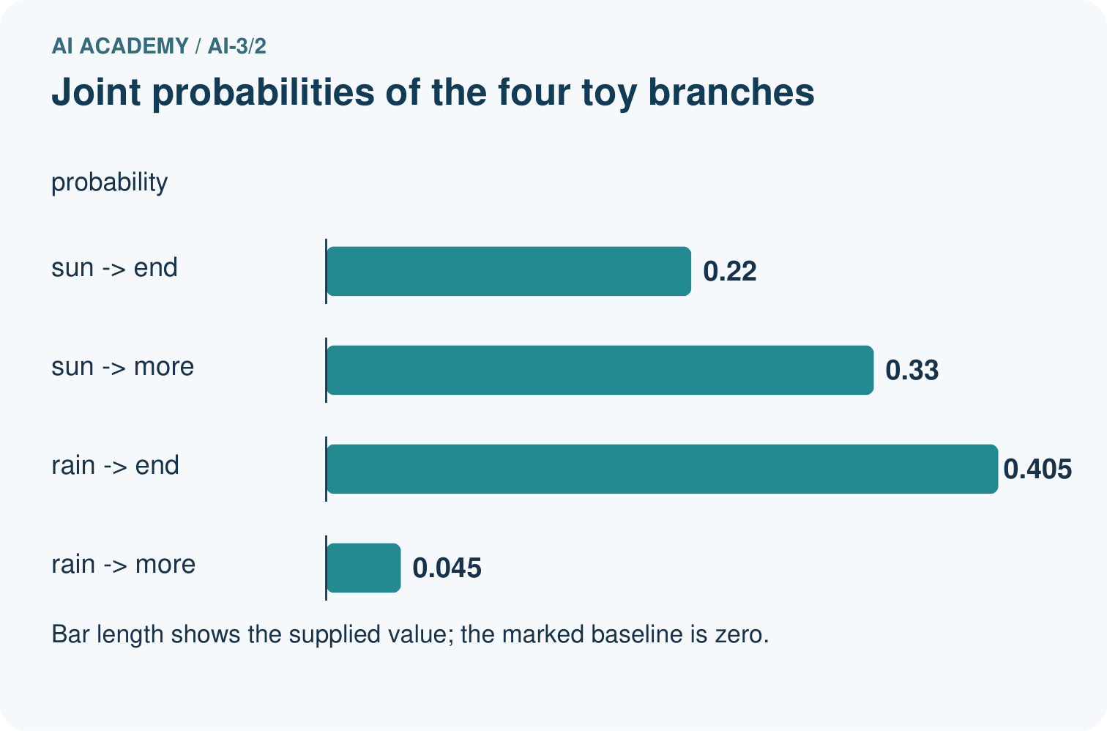
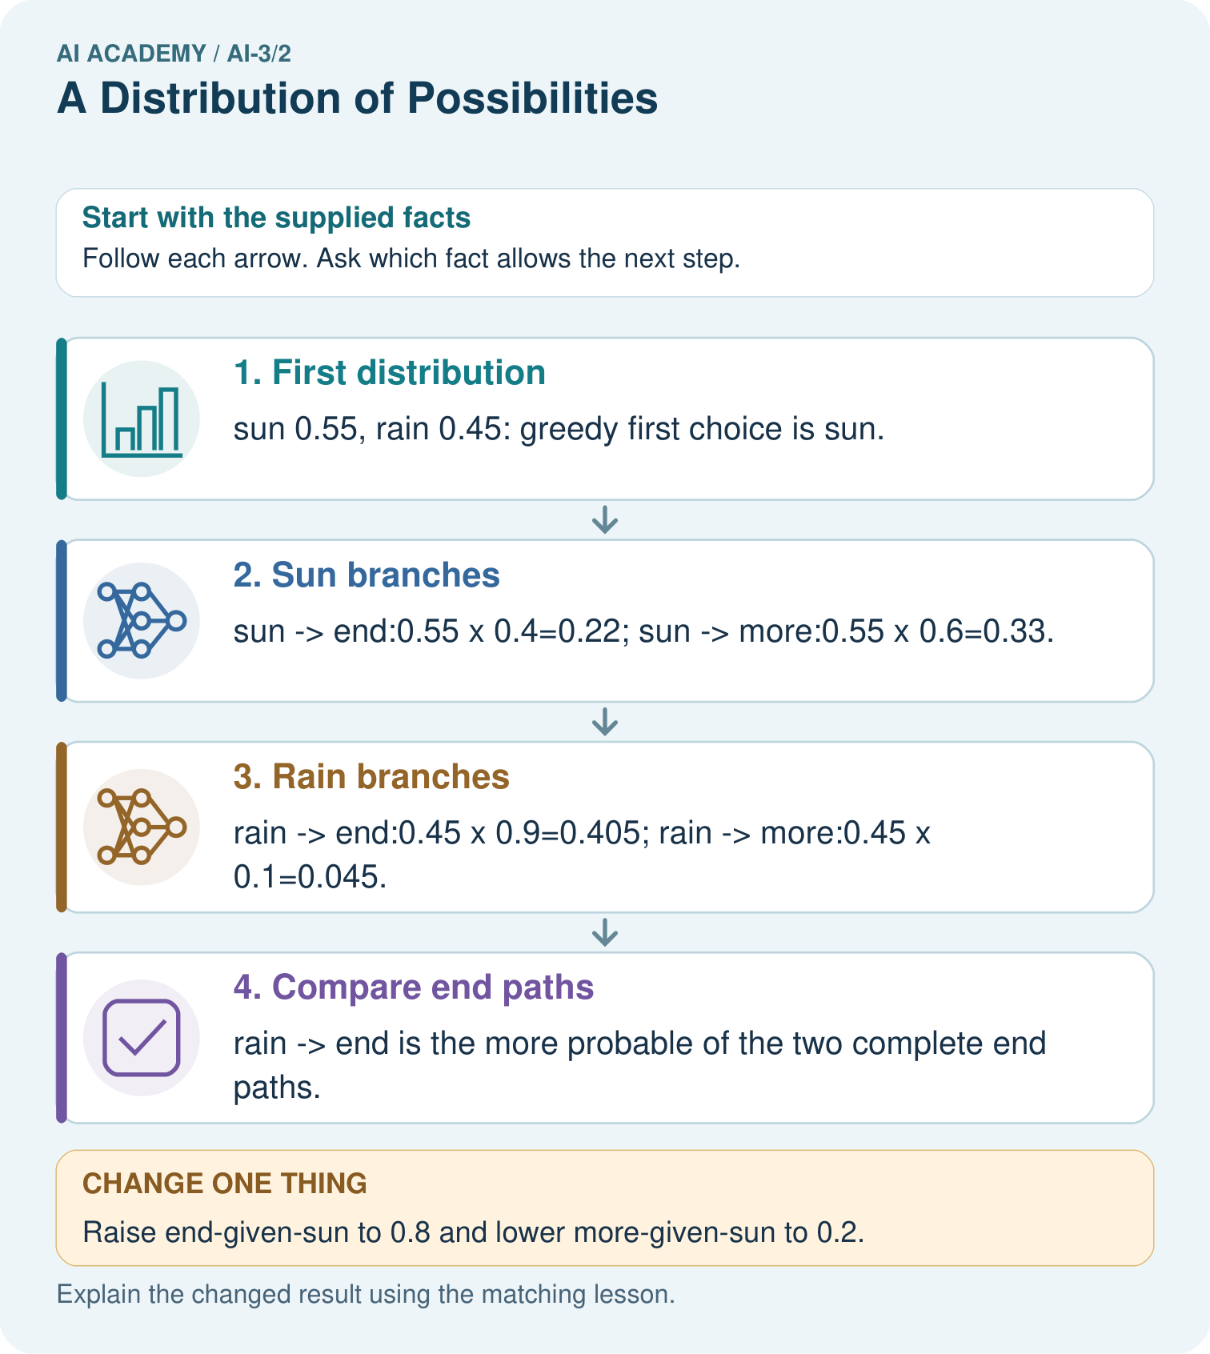

Read the picture one step at a time
Step | What happens and why
1. First distribution | sun 0.55, rain 0.45: greedy first choice is sun.
2. Sun branches | sun→end:0.55×0.4=0.22; sun→more:0.55×0.6=0.33.
3. Rain branches | rain→end:0.45×0.9=0.405; rain→more:0.45×0.1=0.045.
4. Compare end paths | rain→end is the more probable of the two complete end paths.
Match each pictured step to the supplied facts. This is a worked teaching case, not an independent assessment.

Why this result follows
Conditional probabilities describe what follows a particular prefix. Multiplying along a path gives its joint probability. The four branch products sum to 1, but the two end paths sum to 0.625 because more branches have not ended. Greedy decoding selects sun then more; it does not guarantee the most likely complete sequence.

What this example does not establish
These word labels and tiny tables are illustrative; path probability is not a measure of real-world truth.

Change one thing in the pictured case
Change: Raise end-given-sun to 0.8 and lower more-given-sun to 0.2.
Prediction: sun→end becomes 0.44, beating unchanged rain→end 0.405.
Reason: Changing one conditional distribution changes its path products while the first-token probabilities remain fixed.

Ask while showing the picture
Cover the result. Ask learners to name the inputs and predict the next step. Uncover one step, connect the icon to the actual procedure, and explain its evidence. Then change the supplied condition and compare. The picture is a representation; it does not document execution of a real AI model.

03. Demonstrate and guide practice

Demonstrate and guide practice

Board sequence
Write the given facts: A toy next-token distribution is rain .5, sun .3, snow .2.
Write the question to explain: Check total and interpret the largest value.
Reveal after predictions: Total is 1. Rain is most likely, not guaranteed under sampling. Token probability is not whole-sentence truth.
Keep for an independent attempt: A toy next-token distribution assigns cat 0.5, dog 0.3 and bird 0.2. Check the total and name the most likely token. Must it be selected every time when sampling?

Classroom dialogue
Ask: Which facts are given, and which would we have to assume? Learners mark relevant details before discussing answers.
Say: Predict first. Show the rule, information path or calculation that would produce the result. A correct guess is not yet an explanation.
Reveal reasoning one step at a time. Explain why a tempting alternative fails. Write units and denominators for arithmetic, trace conditions for decisions, and identify supporting sources for claims.
In pairs, one learner solves while the other checks evidence; exchange roles. Remove the worked answer before independent assessment.

Model these guided questions
Guided: red,end 0.4*0.9 = 0.36; blue,end 0.6*0.5 = 0.3. Blue is the preferred first token but red,end has the larger specified end-path probability. Exit: the complement includes unknown, and model next-token probabilities do not measure observed room-state frequency.

Case-specific teaching sequence
Stage | Teacher action
Session 1 start to 7 minutes | Retrieve the prerequisite and distinguish a numerical claim from its interpretation.
7 to 18 minutes | Read section 1 and complete W1; ask for a reason alongside each answer.
18 to 32 minutes | Trace the worked case in section 2 and complete W2.
32 to 45 minutes | Discuss the diagram and complete W3 in pairs; record support.
Session 2 start to 8 minutes | Complete the guided response before sharing the answer.
8 to 20 minutes | Read the remaining sections and trace another constructed case.
20 to 35 minutes | Collect W4 independently, requiring calculations and a bounded conclusion.
35 to 45 minutes | Discuss W5 and the exit response. Provide feedback and a fresh retry.

Teach the connected idea
Stage | Teacher action
Session 1 start to 7 minutes | Retrieve the prerequisite and distinguish a numerical claim from its interpretation.
7 to 18 minutes | Read section 1 and complete W1; ask for a reason alongside each answer.
18 to 32 minutes | Trace the worked case in section 2 and complete W2.
32 to 45 minutes | Discuss the diagram and complete W3 in pairs; record support.
Session 2 start to 8 minutes | Complete the guided response before sharing the answer.
8 to 20 minutes | Read the remaining sections and trace another constructed case.
20 to 35 minutes | Collect W4 independently, requiring calculations and a bounded conclusion.
35 to 45 minutes | Discuss W5 and the exit response. Provide feedback and a fresh retry.

Reduce help deliberately
Completion task: Compute ready,end; busy,end; unknown,end and their combined probability.
Teacher check: Teacher explanation: Path probabilities 0.4,0.15,0.2; combined probability of ending at step two is 0.75.
Start by identifying the given inputs together. Leave the intermediate steps blank. If needed, model one step, then withdraw that help on the next step. Move to a full trace only when the partial trace is understood. For partners, alternate explainer and checker; collect a response from every learner before discussion.

Individual reasoning check
Use the worked case for Next token distributions. Proposed explanation: “Conditional products assume independence”. Decide whether this explanation is supported. Point to the step or supplied fact that decides; explain your repair if needed.
Expected correction: Use a different conditional probability for each expanded prefix.
Collect explanations, not only yes/no votes. If a misunderstanding is common, re-model the relevant step for the class. If it affects a few learners, give a short targeted group explanation while others solve a more demanding variation.

Connected teaching cycle: Embeddings and position
Target: Look up token embeddings and add explicit position vectors
Reserve further sessions for this topic; the 135-minute primary plan does not absorb all added content.
Completion practice: Compute representations for red blue and blue red under the stated position table.
Teacher check: Teacher explanation: red blue rows [1,0],[2,1]; blue red rows [0,1],[3,0]. Addition is component by component.
Individual check: For Embeddings and position, use its worked case to evaluate this proposed explanation: “A position vector guarantees every summary preserves order”. Explain the deciding step.
Expected correction: The supplied sum counterexample loses the difference.
Apply the same support, independent transfer and delayed-review decisions to the named connected-topic workbook tasks.

Pictorial practice question
Why is 0.625 not a broken probability sum?

Reasoned teacher answer
It counts only the two paths ending now; the remaining 0.375 belongs to sun→more and rain→more.
Changed-case reasoning: sun→end becomes 0.44, beating unchanged rain→end 0.405. Changing one conditional distribution changes its path products while the first-token probabilities remain fixed.
Collect each learner’s explanation before discussion. Use the first missing connection between input, deciding step and result to choose support. This question is worked-case practice, not fresh mastery evidence.

04. Run the weekly evidence lab

Run the weekly evidence lab
Words You Can Use to Reason
A definition matters when you can recognize the idea, use it, and contrast it with a near-miss.
Predict → Test → Record → Explain
Keep expected and actual results separate. Surprises are useful data when recorded honestly.
Build a weighted token spinner, sample twenty times, tally outcomes, and compare observed counts with expected relative weights.
What did the hardest test teach you that the normal test did not?

Make the lab runnable
Use the concrete case as the shared normal case and the independent question as a second case. Each pair creates a boundary or missing-information case and predicts its result before testing. Keep the expected result separate from an observed mistake.
Record | What to capture
Input or evidence | Exact data, instruction or claim
Expected result | Answer or safe fallback declared before the run
Observed result | Actual result, including errors
Explanation | Rule, calculation or evidence explaining the outcome
Next test | One justified change and a new prediction

Diagnose and reteach
For guessing, return to given facts and request a trace. For vocabulary without application, use one example and one non-example. For arithmetic errors, check the setup before the calculation. Finish with a different uncoached case before recording mastery.

Address these additional misconceptions
Conditional products assume independence: Use a different conditional probability for each expanded prefix.
Greedy decoding maximises every full sequence: The supplied two-step counterexample disproves that general claim.
Not ready means busy: The stated alternatives also include unknown.

Check these misconceptions
A position vector guarantees every summary preserves order: The supplied sum counterexample loses the difference.
IDs are embedding coordinates: IDs select rows; vector components are separate data.
Any vector widths can be added: Elementwise addition requires equal widths.

Match the support to the first error
What the response shows | Next teaching action
Missing or misread facts | Read the case aloud, mark supplied versus unknown facts, and let the learner restate it.
Wrong procedure | Return to the deciding step in the worked case. Contrast it with the proposed incorrect explanation.
Arithmetic or implementation error | Trace intermediate values or lines; preserve the first mismatch and retry that step.
Correct result without a reason | Ask for a trace and a changed case before marking independent understanding.
An unsupported wider claim | Ask which supplied evidence supports the claim and which further observation would be needed.
Offer an oral explanation, drawing, enlarged visual or fewer examples when that removes a reading/writing barrier. Keep the same reasoning goal. Stretch secure learners by changing a boundary or assumption and asking them to defend the effect, not simply by assigning more of the same questions.

05. Assess and explain the answers

Assess and explain the answers

Worked case answer
Total is 1. Rain is most likely, not guaranteed under sampling. Token probability is not whole-sentence truth.

Independent question
A toy next-token distribution assigns cat 0.5, dog 0.3 and bird 0.2. Check the total and name the most likely token. Must it be selected every time when sampling?

Expected independent answer
The probabilities sum to 1.0. Cat is most likely, but sampling can also select dog or bird.

What counts as evidence
Criterion | 0 points | 1 point | 2 points
Result | Incorrect or absent | Partly correct | Correct with necessary conditions
Reasoning | No supporting trace | Some steps | Clear mechanism, calculation or source support
Limit | Overclaims certainty | Vague limitation | Relevant uncertainty or missing fact
Transfer | Copies without adapting | Adapts with prompts | Solves a changed case independently
Use 6/8 as a classroom checkpoint, with 2 required for both Result and Reasoning. This is a proposed teaching rule, not a validated certification threshold. Do not count a coached answer as independent mastery; correct unsafe or unsupported claims regardless of total.

Feedback
Ask the learner to find the evidence that challenges this claim: “The largest probability makes every other outcome impossible.” Keep the first attempt and an uncoached retry separate.

Original transfer answer
No. Five is the expected count under independent sampling from this fixed distribution, not a required result. Token probability describes continuation choices, not the truth of a weather claim. Actual forecasting requires relevant observations and evaluation.

Explanations for the additional workbook examples

W1 Validate the table
Check 0.5,0.3,0.2 as probabilities. Interpret their sum and the complement of ready.
Teacher explanation: Entries are nonnegative and sum to 1. Not ready has mass 0.3+0.2 = 0.5, including busy and unknown.

W2 Calculate the paths
Compute ready,end; busy,end; unknown,end and their combined probability.
Teacher explanation: Path probabilities 0.4,0.15,0.2; combined probability of ending at step two is 0.75.

W3 Test a greedy claim
Use A=0.6,B=0.4 and end conditional probabilities 0.51 and 1. Compare greedy A,end with B,end.
Teacher explanation: A,end probability 0.306 versus B,end 0.4. Greedy next-token choice does not guarantee the largest complete-path probability.

W4 Analyse a new table independently
First tokens go=0.4, wait=0.35, ask=0.25. End probabilities given them are 0.5,0.8,1 respectively; each branch has a complementary more token. Compute all three end-path probabilities and their sum. Which first token is greedy, which end path is largest, and does either verify a real status?
Teacher explanation: End-path probabilities 0.2,0.28,0.25; sum 0.73. Greedy first token is go, but wait,end is the largest of the specified end paths. Neither establishes a real status without appropriate evidence.

W5 Normalise with a stated rule
Weights are ready 6,busy 3,unknown 1. Convert them into probabilities. What if a weight is -1?
Teacher explanation: Total 10 yields 0.6,0.3,0.1. Negative weights violate this nonnegative-weight normalisation contract; reject rather than quietly normalise them.

Embeddings and position — W1 Look up vectors
For red blue name the IDs, embedding rows and shape before adding positions.
Teacher explanation: IDs [1,2]; rows [1,0],[0,1]; shape two positions by two components.

Embeddings and position — W2 Add positions
Compute representations for red blue and blue red under the stated position table.
Teacher explanation: red blue rows [1,0],[2,1]; blue red rows [0,1],[3,0]. Addition is component by component.

Embeddings and position — W3 Audit the sum
Sum the rows for both sequences. Does the sum establish that the original text had the same order?
Teacher explanation: Both sums [3,1]. Summing discards the ordered-row difference; equal summaries do not prove equal source sequences.

Embeddings and position — W4 Trace new vectors independently
Embeddings A=[1,2], B=[3,0], position 0=[0,1], position 1=[1,0]. Compute represented rows and sums for A B and B A. Explain what the equal sums mean.
Teacher explanation: A B rows [1,3],[4,0]; B A rows [3,1],[2,2]. Both sums [5,3]; the summaries lose the ordering difference while the ordered row representations differ.

Embeddings and position — W5 Handle a shape failure
An embedding has width two but its position vector has width three. The input also contains a third position absent from the table. Specify honest handling.
Teacher explanation: Reject mismatched vector widths and unsupported position explicitly. Do not truncate, wrap or invent values unless a separate documented contract defines that transformation.

Assess independent transfer
Selected case: First tokens go=0.4, wait=0.35, ask=0.25. End probabilities given them are 0.5,0.8,1 respectively; each branch has a complementary more token. Compute all three end-path probabilities and their sum. Which first token is greedy, which end path is largest, and does either verify a real status?

Selected case answer
Teacher explanation: End-path probabilities 0.2,0.28,0.25; sum 0.73. Greedy first token is go, but wait,end is the largest of the specified end paths. Neither establishes a real status without appropriate evidence.
Dimension | Evidence required
Explanation | Names the applicable idea or procedure and ties it to the supplied facts.
Trace and result | Preserves the given inputs and shows the relevant intermediate steps; distinguishes a prediction from an observed execution.
Limits | States the assumptions, missing evidence or conditions under which the result would change.
Record each dimension as not yet, with support, or independent. Accept a valid alternative procedure with a defensible trace. Do not penalise an honestly recorded model failure if the learner correctly explains its evidence and limits.

Feedback that the learner uses
Name the earliest unsupported step and give one action to repair it. Have the learner make that repair now and explain why. Then assess the relevant skill on a fresh, fully specified case. Confirm it was not previously practised with feedback; solve and check the new case before assigning it. A follow-up design prompt is a starting brief, not automatically an equivalent test.

06. Connect and extend learning

Connect and extend learning

Verified Study Buddy
Explain that Study Buddy responses come from possibilities, so important claims need checks.
Keep the decision, input, result, explanation and remaining limitation in the project evidence record. Retrieve this record next week rather than restarting the project.

Support and stretch
Provide one short approved passage; separate instruction, input, output and evidence. Stretch: introduce an unsupported claim or conflicting source and validate claim by claim with a fallback.

Exit reflection
Ask for one decision the learner can now justify and one situation requiring more evidence or human review. Confidence ratings are separate from correct independent performance.

Bridge to the next week
Next: Week 3: Tokens and Context. Retrieve today’s evidence and identify what carries forward and what is new.

Support and fresh reassessment
Provide labelled intermediate columns and allow a calculator. Ask students to state the meaning and denominator of a value before interpreting it. Extension: implement the classroom calculation locally and test boundary cases without using personal data.
W4 requires 0.2,0.28,0.25, sum 0.73, greedy go and largest end path wait,end with an evidence limit. Fresh retry: first A=0.45,B=0.3,C=0.25; end conditionals 0.4,0.9,1. Products 0.18,0.27,0.25 sum 0.70; greedy A, largest end path B,end.
Week 4 distinguishes greedy choice from sampling and computes the effect of temperature on a fixed toy distribution.

Readiness and reassessment for Embeddings and position
Provide labelled intermediate columns and allow a calculator. Ask students to state the meaning and denominator of a value before interpreting it. Extension: implement the classroom calculation locally and test boundary cases without using personal data.
W4 requires both row pairs and shared sum [5,3], with an information-loss explanation. Fresh retry: A=[2,0], B=[0,4], positions [1,0] and [0,2]. A B gives [3,0],[0,6]; B A gives [1,4],[2,2]; sums [3,6].

Plan the delayed return
Suggested return points in this level: ai-3/3, ai-3/5, ai-3/8. Use actual classroom dates, adjusting for holidays and gaps. One, three and six teaching weeks are scheduling choices, not a claimed optimal spacing.
At a delayed check, ask for the idea from memory and a changed application. Compare with the earlier independent response and record support used. For a new level, revisit the previous capstone before checking the new prerequisites.
Record | Teacher evidence
Learner code and date
Concept and case used; prior exposure
Explanation / trace / limits
Support and first repair
Changed case and delayed outcome
Next teaching action
Use the evidence to choose reteaching or the next step. A completed page, confidence rating or attractive project does not by itself demonstrate understanding.

Project evidence from this case
Explain Study Buddy generation as conditional choices, while checking the finished factual claims against sources.

07. Prepare, teach and assess
Teaching target: Check whether a next-token table is a valid probability distribution
Prepare the labelled worked-case picture, the matching workbook, fictional input cards and a place for individual responses. No paid AI account is required for the paper reasoning activities.
Session | Plan | Resources
Session 1 · Understand · 45 min | 0–7: recall and prerequisite; 7–15: inspect the concrete case and predict; 15–30: teacher models the worked trace; 30–40: learners explain a step using the text and visual; 40–45: check the core idea. | Sections 1–6; record the brief recall in the workbook.
Session 2 · Practise · 45 min | 0–5: retrieve the procedure; 5–15: W2 completion practice; 15–23: explain and check with a partner; 23–30: each learner answers the misconception check; 30–40: targeted reteaching or a harder variation; 40–45: prepare the investigation. | Sections 7–10; use the matching workbook W2 and misconception check.
Session 3 · Investigate and transfer · 45 min | 0–5: retrieve the decision rule; 5–20: investigate or trace; 20–30: start the independent case; 30–38: connect the project; 38–43: act on feedback; 43–45: plan the return check. | Sections 9 and 11–14. Give extra time to finish the full task set; use Section 15 when the week includes a coding lab.
Before class, solve the supported practice: Compute ready,end; busy,end; unknown,end and their combined probability.
Reasoned practice answer: Teacher explanation: Path probabilities 0.4,0.15,0.2; combined probability of ending at step two is 0.75.
Check every learner before discussion: Use the worked case for Next token distributions. Proposed explanation: “Conditional products assume independence”. Decide whether this explanation is supported. Point to the step or supplied fact that decides; explain your repair if needed.
Misconception repair: Use a different conditional probability for each expanded prefix.
Support: read the exact case aloud, enlarge the labelled picture, supply input cards and model only the first deciding step. Accept a spoken explanation or drawing; retain the reasoning goal.
Extension: Raise end-given-sun to 0.8 and lower more-given-sun to 0.2. Require a prediction and a reason before comparing. Expected result: sun→end becomes 0.44, beating unchanged rain→end 0.405. Reason: Changing one conditional distribution changes its path products while the first-token probabilities remain fixed.
Independent assessment: withhold the reserved answer until the learner has attempted the new case. Record support separately from correctness.
Criterion | Not yet | With support | Independent
Explanation | Names an answer without a deciding fact | Uses a hint to link fact and decision | Explains the deciding fact in own words
Trace or test | Cannot connect input and result | Completes steps with prompts | Traces or tests a changed case accurately
Limits and revision | Claims more than evidence supports | Names a limit after a prompt | States a defensible limit and useful next test
Project checkpoint: Frame the need. Name the user, the problem, allowed inputs and a safe simple starting method.
Use the weekly teacher answer for topic-specific reasoning. A saved progress tick is an activity record; judge mastery from the learner’s explanation and evidence.

