AI ACADEMY · TEACHER · ai-3/3

Tokens and Context
Project: Verified Study Buddy

01. Tokens and Context

Teach the learning cycle
Primary target: Account for fixed text, evidence and reserved output under a toy budget
Session | Sequence and minutes | Resources
Session 1 · Understand · 45 min | 0–7: recall and prerequisite; 7–15: inspect the concrete case and predict; 15–30: teacher models the worked trace; 30–40: learners explain a step using the text and visual; 40–45: check the core idea. | Sections 1–6; record the brief recall in the workbook.
Session 2 · Practise · 45 min | 0–5: retrieve the procedure; 5–15: W2 completion practice; 15–23: explain and check with a partner; 23–30: each learner answers the misconception check; 30–40: targeted reteaching or a harder variation; 40–45: prepare the investigation. | Sections 7–10; use the matching workbook W2 and misconception check.
Session 3 · Investigate and transfer · 45 min | 0–5: retrieve the decision rule; 5–20: investigate or trace; 20–30: start the independent case; 30–38: connect the project; 38–43: act on feedback; 43–45: plan the return check. | Sections 9 and 11–14. Give extra time to finish the full task set; use Section 15 when the week includes a coding lab.
This is a starting allocation of 135 minutes, not a validated duration. Preserve all named topics. Schedule extra time for connected examples, the full investigation, independent cases and project building. Repeated copies of a case share one recorded attempt; they are not new evidence.

Retrieval answer guidance

A Distribution of Possibilities
Without opening the old lesson, explain one key idea from A Distribution of Possibilities. Give an example and a mistake that the idea helps you avoid.
Look for: Check whether a next-token table is a valid probability distribution
Reference example, not the only acceptable wording: Teacher explanation: Entries are nonnegative and sum to 1. Not ready has mass 0.3+0.2 = 0.5, including busy and unknown.
Use the student module and workbook section with this exact week title. The worked case, independent question and answers below form one aligned lesson sequence.

What the learner must demonstrate
A toy system allows 12 tokens total for input and reserved output. Instructions use 3, a source uses 7 and the planned answer needs 4. Compute the excess and propose a revision that preserves evidence.

Concept to explain
Models operate on tokens within a limited context window.
Term | Meaning
token | A unit of encoded text processed by a language model, which may be a word, part of a word or punctuation.
tokenization | Converting text into the token units of a particular tokenizer.
context window | The bounded amount of token information a model can process together in a particular use.
truncation | Removing part of information, often because it exceeds a length or context limit.

Prepare the class
Use the supplied scenario, student illustrations and blank paper. For numeric work, offer counters or a calculator after learners show the setup. Fictional records are supplied; personal data and paid accounts are unnecessary.
Allow 80 minutes: recall 8; explanation 12; worked demonstration 15; guided practice 20; independent assessment 15; project and reflection 10. Extend the lab into a second session when needed.

Preparation for the connected explanation
Use two 45-minute sessions. All model outputs and probability tables are constructed classroom examples. No hosted AI service, external API or student account is needed. Distinguish a model objective from factual support and system permissions. Collect independent work before discussing its solutions.

Readiness answer
No. Evaluate retrieval and claim support directly using sources and task-specific criteria.
Printed lesson and workbook; paper and pencil
Calculator; optional local Python 3 interpreter
Prepare the independent task and fresh retry without displaying solutions

Apply the connected idea: Attention as weighted information selection
Use two 45-minute sessions. All model outputs and probability tables are constructed classroom examples. No hosted AI service, external API or student account is needed. Distinguish a model objective from factual support and system permissions. Collect independent work before discussing its solutions.

Readiness answer
Summation removes row order, so different ordered vectors may produce the same aggregate.
Printed lesson and workbook; paper and pencil
Calculator; optional local Python 3 interpreter
Prepare the independent task and fresh retry without displaying solutions

End goal for the pictorial case
By the end, I can budget context and preserve evidence needed to interpret a requested fact.
This added worked case illustrates the week’s main idea. Retain all original and connected topics; schedule its practice within the teaching cycle.

02. Explain the mechanism

Explain the mechanism
Input → Process → Output
Trace the information. At each stage, ask what changed and how you could test it.
Which stage could fail even when the other two are correct? Explain:
Predict first. Then check each step. A correct answer without visible reasoning is incomplete evidence.
1. A sentence becomes token pieces, not a stored human thought.
2. The model uses visible tokens to predict the next token.
3. Remove the definition from context: the same question becomes ambiguous.
4. More context helps only when it is relevant, accurate, and within the window.
Recalculate, retrace, or restate the reasoning in your own representation:
CHECK Did the evidence answer the exact question? Did the total, path, or source record stay consistent?

Concrete teaching case
A toy window holds eight tokens; prompt uses six and quotation uses three.
Does it fit? What should be preserved?

Exact explanation to model
Nine exceeds eight. Shorten or select material while preserving essential instructions and evidence. Real systems also have output-budget rules.

Explain the added worked example
For this lesson only, a fictional system allows 100 total token units for input plus reserved output. Its fixed instructions use 20 units, question 10 and output reserve 20. That leaves 50 units for evidence. These are supplied counts, not word counts or a claim about any deployed model. Other systems can use different input/output accounting, so read their exact contract.
The question is: “Which room is approved for the robotics meeting, and what is its capacity?” Evidence A, a current approval notice, costs 30 units and names room B. Evidence B, the current room register, costs 20 and gives room B capacity 12. Evidence C, an old approval notice, costs 25 and names room A.
A+B costs 50 and fits exactly. Together they support both requested claims. A+C costs 55 and exceeds the evidence budget, while C+B fits at 45 but supplies an outdated room decision. A cheap set is not necessarily an adequate set. Preserve document IDs, versions and dates alongside content.

Key terms
Term | Meaning
Context budget | The permitted input and output allocation under a stated model or classroom contract
Evidence selection | Choosing source material relevant to the requested claim
Reserved output | Capacity deliberately kept available for the response
Truncation | Removing part of a sequence to meet a limit

Apply the connected idea: Attention as weighted information selection
Attention computes a weighted combination of value vectors, with weights derived from query-key compatibility. Queries, keys and values are distinct roles even when they come from the same sequence. A weight is a numerical contribution in this computation, not proof of the source’s truth or permission. This week supplies weights directly; Week 7 calculates them from scores.
Use three values V1=[2,0], V2=[0,4], V3=[4,2] with weights 0.5,0.25,0.25. Values have equal width and weights are nonnegative with sum 1. Compute each coordinate separately. No token is literally copied by this combination.
Adding the weighted vectors gives [2,1.5]. The same weights applied to different values can give a different result; the same values with different weights can also change it. For example weights 0,1,0 yield V2=[0,4]. The result is a representation to be used by later operations, not automatically a generated word.
Guided: [6,0]/3 + 2*[0,3]/3 = [2,2]. Masking B leaves [6,0]. A masked source is excluded from the stated information path. Exit: coefficient size does not verify a document or grant instruction authority.

Model the reasoning aloud
Use the complete worked example below before asking learners to complete W2. Reveal a small part, invite a prediction, then explain the deciding step. These teacher notes contain solutions; do not reveal the independent case answer during modelling.
A source may contain an exception after a general statement. Cutting off the last paragraph can reverse its practical meaning. Selection should preserve the passages needed to interpret the requested fact, including scope, version and exceptions. If complete relevant evidence cannot fit, retrieve a smaller authoritative passage or request clarification rather than silently remove a qualifying condition.
Including a document in context does not prove the generated answer uses it correctly. After generation, check each claim against its source. A source’s instruction-like content also does not acquire authority just because it fits in the evidence budget.
Thinking move | Teacher prompt
Plan | What is given? What is the question? Which procedure fits these facts?
Do | Point to each input and intermediate step in the worked trace. Name the rule that allows the next step.
Check | Does the output answer the question? Which assumption or limitation prevents a larger claim?
Use the diagram and verbal explanation together. Ask learners to match a sentence to a specific visual step; do not assign learners fixed visual or auditory learning styles.

A pictorial worked case: Tokens and Context
A fictional assistant has a small context budget for answering an event-capacity question.

The facts we will use
Total budget 100 toy tokens; instructions 20, question 10, output reserve 25. Evidence capacity is the remainder.
Current capacity record A costs 18; its safety exception B costs 20; unrelated slogan C costs 12. A says 20 seats; B caps this event at 12.
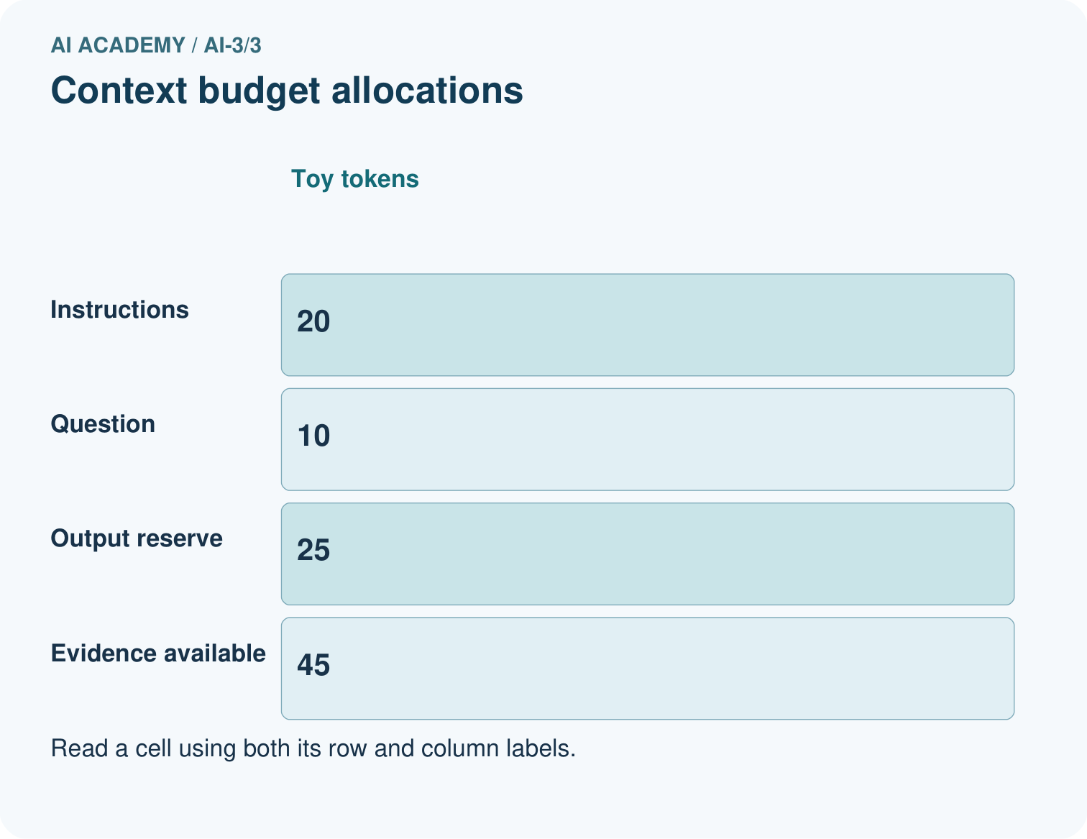
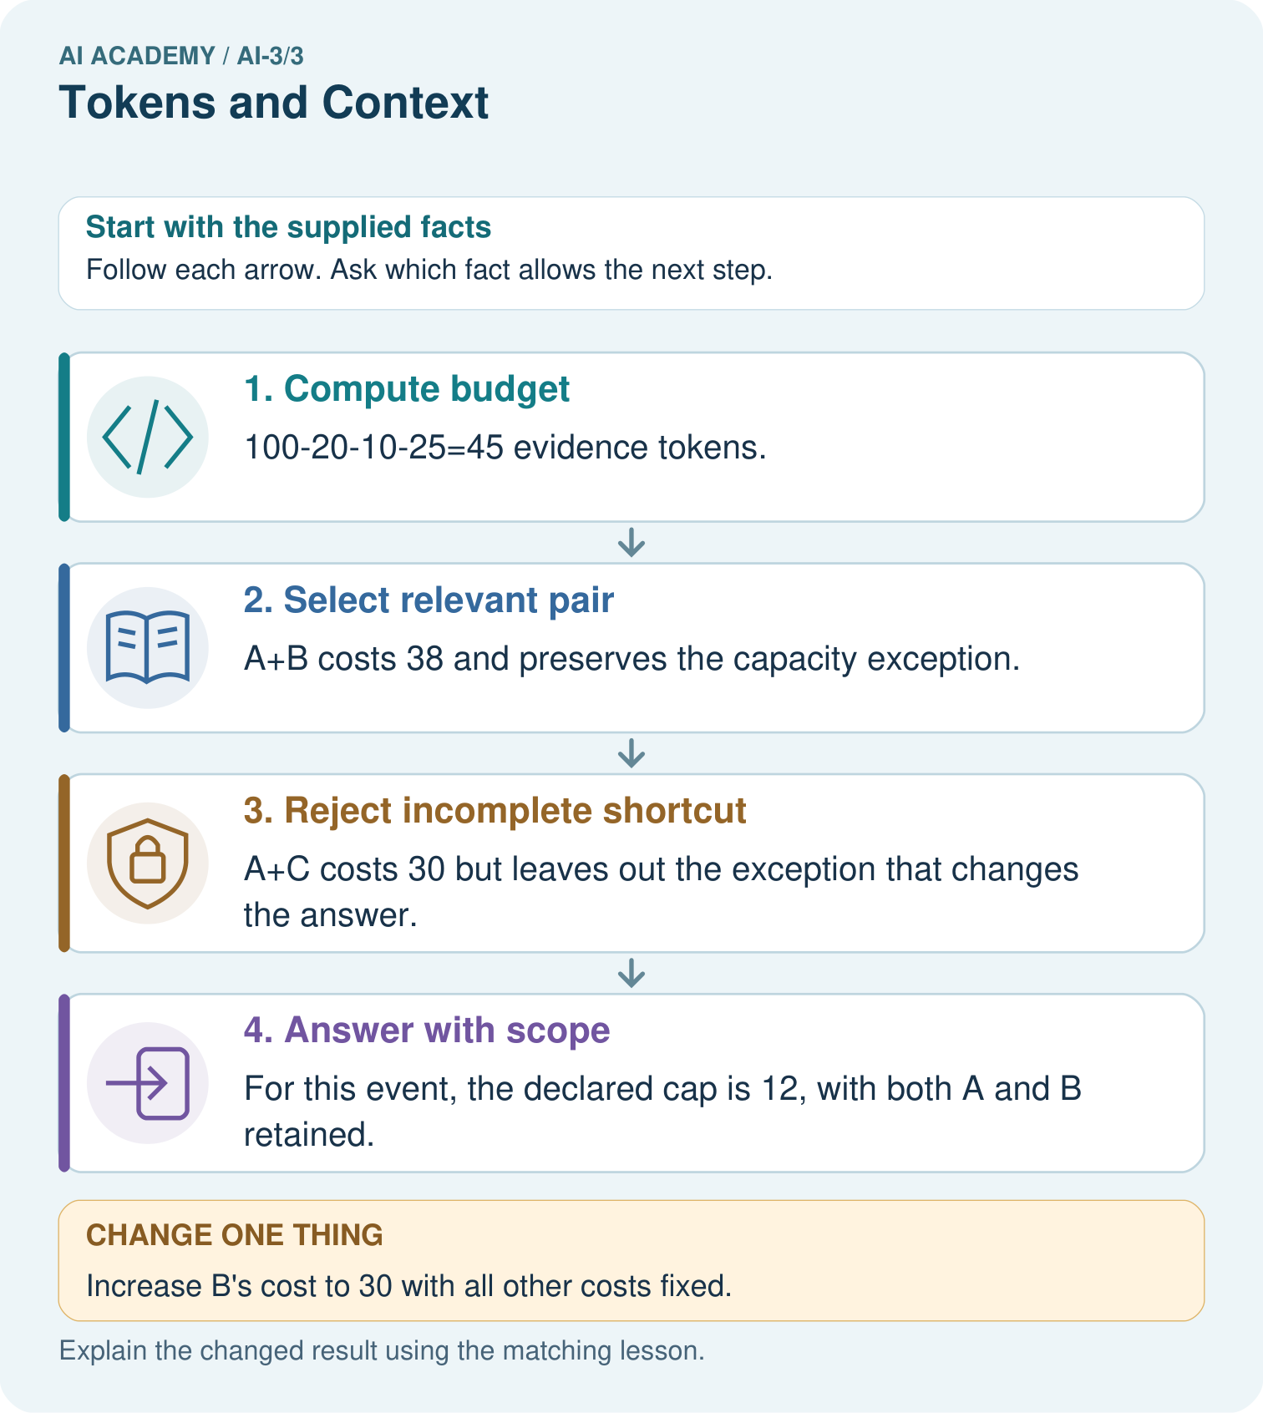

Read the picture one step at a time
Step | What happens and why
1. Compute budget | 100−20−10−25=45 evidence tokens.
2. Select relevant pair | A+B costs 38 and preserves the capacity exception.
3. Reject incomplete shortcut | A+C costs 30 but leaves out the exception that changes the answer.
4. Answer with scope | For this event, the declared cap is 12, with both A and B retained.
Match each pictured step to the supplied facts. This is a worked teaching case, not an independent assessment.

Why this result follows
A context window limits how much information is available in one model call. Selecting the shortest passage is not always sufficient: an exception can change the meaning of a general statement. Keep the relevant source relationship visible. Toy token costs are supplied here; real token counts depend on the model’s tokenizer.

What this example does not establish
Fitting in context does not guarantee attention, correct interpretation or accurate generation.

Change one thing in the pictured case
Change: Increase B’s cost to 30 with all other costs fixed.
Prediction: A+B costs 48 and no longer fits the 45-token evidence capacity.
Reason: Do not silently omit the exception; use an approved source-preserving summary, another retrieval step or an honest incomplete-evidence response.

Ask while showing the picture
Cover the result. Ask learners to name the inputs and predict the next step. Uncover one step, connect the icon to the actual procedure, and explain its evidence. Then change the supplied condition and compare. The picture is a representation; it does not document execution of a real AI model.

03. Demonstrate and guide practice

Demonstrate and guide practice

Board sequence
Write the given facts: A toy window holds eight tokens; prompt uses six and quotation uses three.
Write the question to explain: Does it fit? What should be preserved?
Reveal after predictions: Nine exceeds eight. Shorten or select material while preserving essential instructions and evidence. Real systems also have output-budget rules.
Keep for an independent attempt: A system can use only the last two messages. Message 1 says use centimetres; messages 2 and 3 discuss plants. What instruction may be lost, and how can the next request repair this?

Classroom dialogue
Ask: Which facts are given, and which would we have to assume? Learners mark relevant details before discussing answers.
Say: Predict first. Show the rule, information path or calculation that would produce the result. A correct guess is not yet an explanation.
Reveal reasoning one step at a time. Explain why a tempting alternative fails. Write units and denominators for arithmetic, trace conditions for decisions, and identify supporting sources for claims.
In pairs, one learner solves while the other checks evidence; exchange roles. Remove the worked answer before independent assessment.

Model these guided questions
Guided: 80-15-10-15 = 40; 18+22 fits. Claim support must still be checked. Exit: the register lists room B capacity 12, but current meeting approval is unavailable; request that approval before naming it as approved.

Case-specific teaching sequence
Stage | Teacher action
Session 1 start to 7 minutes | Retrieve the prerequisite and distinguish a numerical claim from its interpretation.
7 to 18 minutes | Read section 1 and complete W1; ask for a reason alongside each answer.
18 to 32 minutes | Trace the worked case in section 2 and complete W2.
32 to 45 minutes | Discuss the diagram and complete W3 in pairs; record support.
Session 2 start to 8 minutes | Complete the guided response before sharing the answer.
8 to 20 minutes | Read the remaining sections and trace another constructed case.
20 to 35 minutes | Collect W4 independently, requiring calculations and a bounded conclusion.
35 to 45 minutes | Discuss W5 and the exit response. Provide feedback and a fresh retry.

Teach the connected idea
Stage | Teacher action
Session 1 start to 7 minutes | Retrieve the prerequisite and distinguish a numerical claim from its interpretation.
7 to 18 minutes | Read section 1 and complete W1; ask for a reason alongside each answer.
18 to 32 minutes | Trace the worked case in section 2 and complete W2.
32 to 45 minutes | Discuss the diagram and complete W3 in pairs; record support.
Session 2 start to 8 minutes | Complete the guided response before sharing the answer.
8 to 20 minutes | Read the remaining sections and trace another constructed case.
20 to 35 minutes | Collect W4 independently, requiring calculations and a bounded conclusion.
35 to 45 minutes | Discuss W5 and the exit response. Provide feedback and a fresh retry.

Reduce help deliberately
Completion task: Compare A+B,A+C,C+B for fit and support of current approval and capacity.
Teacher check: Teacher explanation: A+B costs 50 and supports both. A+C costs 55 and fails budget; C+B costs 45 but uses old approval and fails current-approval support.
Start by identifying the given inputs together. Leave the intermediate steps blank. If needed, model one step, then withdraw that help on the next step. Move to a full trace only when the partial trace is understood. For partners, alternate explainer and checker; collect a response from every learner before discussion.

Individual reasoning check
Use the worked case for Context limits and evidence selection. Proposed explanation: “Token count equals word count”. Decide whether this explanation is supported. Point to the step or supplied fact that decides; explain your repair if needed.
Expected correction: The lesson uses supplied counts; actual counts depend on tokenizer and protocol.
Collect explanations, not only yes/no votes. If a misunderstanding is common, re-model the relevant step for the class. If it affects a few learners, give a short targeted group explanation while others solve a more demanding variation.

Connected teaching cycle: Attention as weighted information selection
Target: Calculate a weighted combination of value vectors
Reserve further sessions for this topic; the 135-minute primary plan does not absorb all added content.
Completion practice: Calculate the output from the three supplied values and weights.
Teacher check: Teacher explanation: Contributions [1,0],[0,1],[1,0.5] sum to [2,1.5].
Individual check: For Attention as weighted information selection, use its worked case to evaluate this proposed explanation: “Attention copies the highest-weight token”. Explain the deciding step.
Expected correction: The supplied procedure combines vectors from multiple positions.
Apply the same support, independent transfer and delayed-review decisions to the named connected-topic workbook tasks.

Pictorial practice question
Can A alone justify answering 20 seats after the exception is known?

Reasoned teacher answer
No. The relevant exception limits this event to 12; omitting it would knowingly lose decisive evidence.
Changed-case reasoning: A+B costs 48 and no longer fits the 45-token evidence capacity. Do not silently omit the exception; use an approved source-preserving summary, another retrieval step or an honest incomplete-evidence response.
Collect each learner’s explanation before discussion. Use the first missing connection between input, deciding step and result to choose support. This question is worked-case practice, not fresh mastery evidence.

04. Run the weekly evidence lab

Run the weekly evidence lab
Words You Can Use to Reason
A definition matters when you can recognize the idea, use it, and contrast it with a near-miss.
Predict → Test → Record → Explain
Keep expected and actual results separate. Surprises are useful data when recorded honestly.
Tokenize names, punctuation, emojis, and compound words; then hide different context cards and compare predicted continuations.
What did the hardest test teach you that the normal test did not?

Make the lab runnable
Use the concrete case as the shared normal case and the independent question as a second case. Each pair creates a boundary or missing-information case and predicts its result before testing. Keep the expected result separate from an observed mistake.
Record | What to capture
Input or evidence | Exact data, instruction or claim
Expected result | Answer or safe fallback declared before the run
Observed result | Actual result, including errors
Explanation | Rule, calculation or evidence explaining the outcome
Next test | One justified change and a new prediction

Diagnose and reteach
For guessing, return to given facts and request a trace. For vocabulary without application, use one example and one non-example. For arithmetic errors, check the setup before the calculation. Finish with a different uncoached case before recording mastery.

Address these additional misconceptions
Token count equals word count: The lesson uses supplied counts; actual counts depend on tokenizer and protocol.
The smallest set is the best evidence: A set can fit while lacking current support for the requested claims.
Included means verified: Generation may misread or ignore evidence; verify claims after generation.

Check these misconceptions
Attention copies the highest-weight token: The supplied procedure combines vectors from multiple positions.
Deleting one contribution preserves a normalised mixture: Renormalise permitted mass under the stated contract.
Attention weights are truth probabilities: They are coefficients derived from compatibility, with no source-truth guarantee.

Match the support to the first error
What the response shows | Next teaching action
Missing or misread facts | Read the case aloud, mark supplied versus unknown facts, and let the learner restate it.
Wrong procedure | Return to the deciding step in the worked case. Contrast it with the proposed incorrect explanation.
Arithmetic or implementation error | Trace intermediate values or lines; preserve the first mismatch and retry that step.
Correct result without a reason | Ask for a trace and a changed case before marking independent understanding.
An unsupported wider claim | Ask which supplied evidence supports the claim and which further observation would be needed.
Offer an oral explanation, drawing, enlarged visual or fewer examples when that removes a reading/writing barrier. Keep the same reasoning goal. Stretch secure learners by changing a boundary or assumption and asking them to defend the effect, not simply by assigning more of the same questions.

05. Assess and explain the answers

Assess and explain the answers

Worked case answer
Nine exceeds eight. Shorten or select material while preserving essential instructions and evidence. Real systems also have output-budget rules.

Independent question
A system can use only the last two messages. Message 1 says use centimetres; messages 2 and 3 discuss plants. What instruction may be lost, and how can the next request repair this?

Expected independent answer
The centimetres instruction may be outside the available context. Restate the required unit in the current request and check the output.

What counts as evidence
Criterion | 0 points | 1 point | 2 points
Result | Incorrect or absent | Partly correct | Correct with necessary conditions
Reasoning | No supporting trace | Some steps | Clear mechanism, calculation or source support
Limit | Overclaims certainty | Vague limitation | Relevant uncertainty or missing fact
Transfer | Copies without adapting | Adapts with prompts | Solves a changed case independently
Use 6/8 as a classroom checkpoint, with 2 required for both Result and Reasoning. This is a proposed teaching rule, not a validated certification threshold. Do not count a coached answer as independent mastery; correct unsafe or unsupported claims regardless of total.

Feedback
Ask the learner to find the evidence that challenges this claim: “All earlier conversation remains available forever.” Keep the first attempt and an uncoached retry separate.

Original transfer answer
Total=14, exceeding the toy limit by 2. Select a relevant 5-token source extract or shorten other material while retaining essential instructions and evidence. Real systems specify their own context and output limits; this toy policy must not be assumed universal.

Explanations for the additional workbook examples

W1 Compute available evidence
Under total 100, instructions 20, question 10 and output reserve 20, calculate evidence capacity.
Teacher explanation: 100-20-10-20 = 50 supplied token units.
Separate the total budget into its declared parts: 100 minus 20 instruction units minus 10 question units minus 20 reserved output units leaves 50 units for evidence. Preserve the output reserve before filling evidence space. These are the lesson’s supplied token units, not a universal word-to-token conversion.

W2 Choose complete support
Compare A+B,A+C,C+B for fit and support of current approval and capacity.
Teacher explanation: A+B costs 50 and supports both. A+C costs 55 and fails budget; C+B costs 45 but uses old approval and fails current-approval support.

W3 Preserve a qualifier
A passage says room B normally holds 12, except during maintenance when the approved limit is 8. Why is retaining only the first clause inadequate?
Teacher explanation: The exception changes the applicable capacity during maintenance. Preserve conditions and determine whether maintenance applies; do not report 12 unconditionally.

W4 Budget new evidence independently
Total 120, instructions 25, question 15, output reserve 30. Source D is current approval, cost 28; E is current capacity, cost 22; F is old approval, cost 18. Compute capacity, compare D+E and E+F, and state an honest fallback if D is missing.
Teacher explanation: Evidence capacity 50. D+E costs 50 and supplies both current claims. E+F costs 40 but old approval is insufficient. Without D, report the supported capacity and ask for current approval rather than infer it.

W5 Audit inclusion
A team says every claim is verified because all chosen documents fit in context. What further check is needed?
Teacher explanation: Check each generated claim against the actual source passage/version and preserve qualifiers. Budget fit and inclusion do not establish faithful use or current correctness.

Attention as weighted information selection — W1 Identify the roles
Explain query, key, value and weight without calling the largest weight a truth score.
Teacher explanation: The query compares keys, compatibility produces weights, and weights combine values. A weight is a computational coefficient, not a truth score.

Attention as weighted information selection — W2 Compute the mixture
Calculate the output from the three supplied values and weights.
Teacher explanation: Contributions [1,0],[0,1],[1,0.5] sum to [2,1.5].
Multiply each coordinate by its value’s weight: 0.5*[2,0]=[1,0], 0.25*[0,4]=[0,1], and 0.25*[4,2]=[1,0.5]. Add first coordinates to get 1+0+1=2 and second coordinates to get 0+1+0.5=1.5. The combined vector is [2,1.5], not a literal selection of one source token.

Attention as weighted information selection — W3 Mask and renormalise
Exclude V3 and calculate permitted weights and output. Explain the empty-mask case.
Teacher explanation: Retained total 0.75 gives weights 2/3,1/3,0 and output [4/3,4/3]. All-excluded gives zero total and must report no available value under this contract.

Attention as weighted information selection — W4 Combine a new case independently
Values A=[4,1],B=[0,5],C=[2,3]; weights 0.25,0.5,0.25. Compute the full output. Mask B, renormalise the remaining weights and compute the new output.
Teacher explanation: Full contributions [1,.25],[0,2.5],[.5,.75] give [1.5,3.5]. Retained total .5 gives A/C weights .5,.5 and output [3,2]. Masking changes available information; it does not verify sources.

Attention as weighted information selection — W5 Audit an explanation
A student claims the highest attention weight explains the entire model and authenticates a retrieved instruction. What additional reasoning is needed?
Teacher explanation: Inspect values and downstream computations, other heads and residual paths before explaining the whole model. Source truth and instruction authority require separate evidence and permissions; weight alone supplies neither.

Assess independent transfer
Selected case: Total 120, instructions 25, question 15, output reserve 30. Source D is current approval, cost 28; E is current capacity, cost 22; F is old approval, cost 18. Compute capacity, compare D+E and E+F, and state an honest fallback if D is missing.

Selected case answer
Teacher explanation: Evidence capacity 50. D+E costs 50 and supplies both current claims. E+F costs 40 but old approval is insufficient. Without D, report the supported capacity and ask for current approval rather than infer it.
Dimension | Evidence required
Explanation | Names the applicable idea or procedure and ties it to the supplied facts.
Trace and result | Preserves the given inputs and shows the relevant intermediate steps; distinguishes a prediction from an observed execution.
Limits | States the assumptions, missing evidence or conditions under which the result would change.
Record each dimension as not yet, with support, or independent. Accept a valid alternative procedure with a defensible trace. Do not penalise an honestly recorded model failure if the learner correctly explains its evidence and limits.

Feedback that the learner uses
Name the earliest unsupported step and give one action to repair it. Have the learner make that repair now and explain why. Then assess the relevant skill on a fresh, fully specified case. Confirm it was not previously practised with feedback; solve and check the new case before assigning it. A follow-up design prompt is a starting brief, not automatically an equivalent test.

06. Connect and extend learning

Connect and extend learning

Verified Study Buddy
Keep the learner’s question, approved source excerpt, and output rules inside the active context.
Keep the decision, input, result, explanation and remaining limitation in the project evidence record. Retrieve this record next week rather than restarting the project.

Support and stretch
Provide one short approved passage; separate instruction, input, output and evidence. Stretch: introduce an unsupported claim or conflicting source and validate claim by claim with a fallback.

Exit reflection
Ask for one decision the learner can now justify and one situation requiring more evidence or human review. Confidence ratings are separate from correct independent performance.

Bridge to the next week
Next: Week 4: Sampling and Variability. Retrieve today’s evidence and identify what carries forward and what is new.

Support and fresh reassessment
Provide labelled intermediate columns and allow a calculator. Ask students to state the meaning and denominator of a value before interpreting it. Extension: implement the classroom calculation locally and test boundary cases without using personal data.
W4 requires 50, exact D+E fit, E+F inadequacy and an explicit missing-approval fallback. Fresh retry: total 90,instructions 20,question 10,reserve 20 gives 40; current approval costs 24 and capacity 16, exactly fit. A cost-12 old approval does not replace current support.
Week 11 writes response specifications with explicit evidence requirements, output fields and fallback behaviour.

Readiness and reassessment for Attention as weighted information selection
Provide labelled intermediate columns and allow a calculator. Ask students to state the meaning and denominator of a value before interpreting it. Extension: implement the classroom calculation locally and test boundary cases without using personal data.
W4 requires [1.5,3.5] then [3,2] and explicit renormalisation. Fresh retry: A=[2,2], B=[6,0], C=[0,4], weights .5,.25,.25. Full output [2.5,2]; exclude A, remaining weights .5,.5 and output [3,2].

Plan the delayed return
Suggested return points in this level: ai-3/4, ai-3/6, ai-3/9. Use actual classroom dates, adjusting for holidays and gaps. One, three and six teaching weeks are scheduling choices, not a claimed optimal spacing.
At a delayed check, ask for the idea from memory and a changed application. Compare with the earlier independent response and record support used. For a new level, revisit the previous capstone before checking the new prerequisites.
Record | Teacher evidence
Learner code and date
Concept and case used; prior exposure
Explanation / trace / limits
Support and first repair
Changed case and delayed outcome
Next teaching action
Use the evidence to choose reteaching or the next step. A completed page, confidence rating or attractive project does not by itself demonstrate understanding.

Project evidence from this case
Design Study Buddy retrieval to preserve current facts, exceptions and source identity within its context budget.

07. Prepare, teach and assess
Teaching target: Account for fixed text, evidence and reserved output under a toy budget
Prepare the labelled worked-case picture, the matching workbook, fictional input cards and a place for individual responses. No paid AI account is required for the paper reasoning activities.
Session | Plan | Resources
Session 1 · Understand · 45 min | 0–7: recall and prerequisite; 7–15: inspect the concrete case and predict; 15–30: teacher models the worked trace; 30–40: learners explain a step using the text and visual; 40–45: check the core idea. | Sections 1–6; record the brief recall in the workbook.
Session 2 · Practise · 45 min | 0–5: retrieve the procedure; 5–15: W2 completion practice; 15–23: explain and check with a partner; 23–30: each learner answers the misconception check; 30–40: targeted reteaching or a harder variation; 40–45: prepare the investigation. | Sections 7–10; use the matching workbook W2 and misconception check.
Session 3 · Investigate and transfer · 45 min | 0–5: retrieve the decision rule; 5–20: investigate or trace; 20–30: start the independent case; 30–38: connect the project; 38–43: act on feedback; 43–45: plan the return check. | Sections 9 and 11–14. Give extra time to finish the full task set; use Section 15 when the week includes a coding lab.
Before class, solve the supported practice: Compare A+B,A+C,C+B for fit and support of current approval and capacity.
Reasoned practice answer: Teacher explanation: A+B costs 50 and supports both. A+C costs 55 and fails budget; C+B costs 45 but uses old approval and fails current-approval support.
Check every learner before discussion: Use the worked case for Context limits and evidence selection. Proposed explanation: “Token count equals word count”. Decide whether this explanation is supported. Point to the step or supplied fact that decides; explain your repair if needed.
Misconception repair: The lesson uses supplied counts; actual counts depend on tokenizer and protocol.
Support: read the exact case aloud, enlarge the labelled picture, supply input cards and model only the first deciding step. Accept a spoken explanation or drawing; retain the reasoning goal.
Extension: Increase B’s cost to 30 with all other costs fixed. Require a prediction and a reason before comparing. Expected result: A+B costs 48 and no longer fits the 45-token evidence capacity. Reason: Do not silently omit the exception; use an approved source-preserving summary, another retrieval step or an honest incomplete-evidence response.
Independent assessment: withhold the reserved answer until the learner has attempted the new case. Record support separately from correctness.
Criterion | Not yet | With support | Independent
Explanation | Names an answer without a deciding fact | Uses a hint to link fact and decision | Explains the deciding fact in own words
Trace or test | Cannot connect input and result | Completes steps with prompts | Traces or tests a changed case accurately
Limits and revision | Claims more than evidence supports | Names a limit after a prompt | States a defensible limit and useful next test
Project checkpoint: Frame the need. Name the user, the problem, allowed inputs and a safe simple starting method.
Use the weekly teacher answer for topic-specific reasoning. A saved progress tick is an activity record; judge mastery from the learner’s explanation and evidence.

