AI ACADEMY · TEACHER · ai-3/23

Block to Python Bridge
Project: Verified Study Buddy

01. Block-to-Python Bridge

Teach the learning cycle
Primary target: Translate a short paper calculation into a Python script
Session | Sequence and minutes | Resources
Session 1 · Understand · 45 min | 0–7: recall and prerequisite; 7–15: inspect the concrete case and predict; 15–30: teacher models the worked trace; 30–40: learners explain a step using the text and visual; 40–45: check the core idea. | Sections 1–6; record the brief recall in the workbook.
Session 2 · Practise · 45 min | 0–5: retrieve the procedure; 5–15: W2 completion practice; 15–23: explain and check with a partner; 23–30: each learner answers the misconception check; 30–40: targeted reteaching or a harder variation; 40–45: prepare the investigation. | Sections 7–10; use the matching workbook W2 and misconception check.
Session 3 · Investigate and transfer · 45 min | 0–5: retrieve the decision rule; 5–20: investigate or trace; 20–30: start the independent case; 30–38: connect the project; 38–43: act on feedback; 43–45: plan the return check. | Sections 9 and 11–14. Give extra time to finish the full task set; use Section 15 when the week includes a coding lab.
This is a starting allocation of 135 minutes, not a validated duration. Preserve all named topics. Schedule extra time for connected examples, the full investigation, independent cases and project building. Repeated copies of a case share one recorded attempt; they are not new evidence.
Case exposure check: this source example appears in ai-2/1, ai-3/23, python-bridge/1. Reuse a familiar case for recall or modelling; verify that the case used to assess transfer has not already received feedback.

Retrieval answer guidance

Requests Responses and JSON
Without opening the old lesson, explain one key idea from Requests Responses and JSON. Give an example and a mistake that the idea helps you avoid.
Look for: Parse JSON into Python records
Reference example, not the only acceptable wording: None and true, respectively.

Conversation State and Memory
Without opening the old lesson, explain one key idea from Conversation State and Memory. Give an example and a mistake that the idea helps you avoid.
Look for: Explain the mechanism and terminology of conversation state and retention
Reference example, not the only acceptable wording: Teacher explanation: Conversation state stores facts or prior interactions for later use. It needs scope, provenance, correction and retention rules rather than indefinite accumulation. This classroom assistant keeps an approved room ID only for the current session. A later correction replaces the active value but retains an audit event until session end. Do not persist private text merely because it appeared in conversation.

Model Memory vs Retrieval
Without opening the old lesson, explain one key idea from Model Memory vs Retrieval. Give an example and a mistake that the idea helps you avoid.
Look for: Explain the mechanism and terminology of retrieval and indexing
Reference example, not the only acceptable wording: Teacher explanation: Retrieval returns stored records selected for a query. An index is a searchable representation of a versioned corpus; generated wording is a later operation. Assign stable document IDs, versions and permitted access before indexing. Retrieve only authorised records. Preserve source references and define behaviour when a document is missing, outdated or access-restricted.
Use the student module and workbook section with this exact week title. The worked case, independent question and answers below form one aligned lesson sequence.

What the learner must demonstrate
Write Python that totals [3,5,7], then trace each total. Explain how indenting 'total=0' inside the loop changes the result.

Concept to explain
Variables, conditions, lists, loops, and functions carry the same logic across representations.
Term | Meaning
variable | A named reference to a value that can be used or changed in a program.
list | An ordered collection of items.
function | A named unit of code that performs a task, optionally receiving arguments and returning a value.
condition | A statement evaluated as true or false to help select an action.

Prepare the class
Use the supplied scenario, student illustrations and blank paper. For numeric work, offer counters or a calculator after learners show the setup. Fictional records are supplied; personal data and paid accounts are unnecessary.
Allow 80 minutes: recall 8; explanation 12; worked demonstration 15; guided practice 20; independent assessment 15; project and reflection 10. Extend the lab into a second session when needed.

Preparation for the connected explanation
This is a first encounter with saved Python scripts, not a compressed implementation of the Grade 6 adviser. Teach assignment, multiplication and print only as needed; values and types follow in Week 2. Use a fresh run to avoid hidden interactive state. Reference: Python tutorial, An Informal Introduction to Python, https://docs.python.org/3/tutorial/introduction.html (assignment, arithmetic and print).

Readiness answer
Record four and six, multiply them to get 24, then display 24. The order must make the required values available before use.
Teacher-prepared Python 3 editor with a new saved .py file and a visible output area; test Run before class
Paper counters or equal-group sketches and a blank expected/observed record
The printed script and workbook; no logins or personal data required

End goal for the pictorial case
By the end, I can explain block to python bridge using a traced example and a stated limitation.
This added worked case illustrates the week’s main idea. Retain all original and connected topics; schedule its practice within the teaching cycle.

02. Explain the mechanism

Explain the mechanism
Input → Process → Output
Trace the information. At each stage, ask what changed and how you could test it.
Which stage could fail even when the other two are correct? Explain:
Predict first. Then check each step. A correct answer without visible reasoning is incomplete evidence.
1. Block: for each passage, check relevance.
2. Python: for passage in passages: ...
3. Condition keeps passages with score ≥ threshold.
4. A function packages the selection logic and can be tested with normal and edge lists.
Recalculate, retrace, or restate the reasoning in your own representation:
CHECK Did the evidence answer the exact question? Did the total, path, or source record stay consistent?

Concrete teaching case
A block program sets total=0 and adds each value in [2,4,6].
Translate and trace.

Exact explanation to model
Python uses total=0, then an indented total += value inside for value in [2,4,6]. Totals are 2,6,12.

Explain the added worked example
In Grade 6 you traced rules on paper. Now you will write a small Python program and check what it actually does. Begin with a counter-packing calculation, not the whole activity adviser. The requirement is to find the total counters in equal packs and display that total. For this first program, the supplied quantities are whole, nonnegative numbers; it does not yet validate typed input.
Use a teacher-prepared Python 3 editor that can run a saved .py file. Open a new file called counters.py, type the code exactly as shown in the next section, save it, and use the editor’s Run command. Read the output area separately from the source editor. No account, AI tool, package installation or personal data is needed. If a device is unavailable, trace on paper and label the result predicted rather than executed.
Read the script from top to bottom. The equals sign assigns the value on its right to the name on its left. The star means multiplication. print(total) displays the value of total; it does not display the letters in the name. Type ordinary straight characters and keep the parentheses. The Python prompt symbols >>> are not part of this saved script.

Key terms
Term | Meaning
Algorithm | An ordered procedure for solving a stated problem
Program | Instructions written in a language a computer can execute
Interpreter | Software that executes Python instructions
Assignment | Binding a name to the value of an expression
Output | Information a program displays or returns

Model the reasoning aloud
Use the complete worked example below before asking learners to complete W2. Reveal a small part, invite a prediction, then explain the deciding step. These teacher notes contain solutions; do not reveal the independent case answer during modelling.
packs = 4 | packs is 4 | Nothing yet
per_pack = 6 | packs is 4; per_pack is 6 | Nothing yet
total = packs * per_pack | total is 24 | Nothing yet
print(total) | Values are unchanged | 24
Write 24 as the expected output before running. Then copy the actual output into a separate column. A matching result supports this case, not every possible input. A saved file may contain an old edit: save again and rerun the whole script. Do not type the expected number into the output record without running.

Why is there no displayed output after the third line? What changes if print(total) is placed first in a fresh run, before any assignment? Explain using which names exist.
________________________________________________________________
________________________________________________________________
________________________________________________________________
________________________________________________________________
________________________________________________________________
Thinking move | Teacher prompt
Plan | What is given? What is the question? Which procedure fits these facts?
Do | Point to each input and intermediate step in the worked trace. Name the rule that allows the next step.
Check | Does the output answer the question? Which assumption or limitation prevents a larger claim?
Use the diagram and verbal explanation together. Ask learners to match a sentence to a specific visual step; do not assign learners fixed visual or auditory learning styles.

A pictorial worked case: Block to Python Bridge
Translate a “count qualifying books” paper procedure into a Python-style trace.

The facts we will use
Page counts are [80, 150, 90]. Start count=0; for each pages value, add 1 only when pages<100.
All inputs and outcomes in this worked example are invented classroom data; no real model run is claimed.
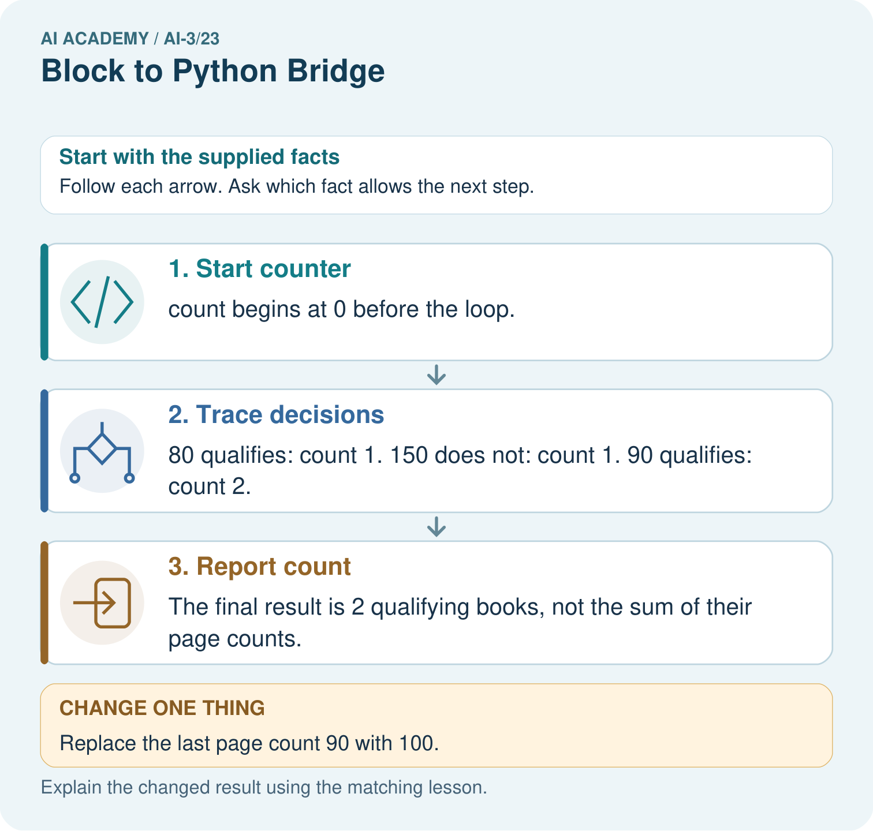

Read the picture one step at a time
Step | What happens and why
1. Start counter | count begins at 0 before the loop.
2. Trace decisions | 80 qualifies: count 1. 150 does not: count 1. 90 qualifies: count 2.
3. Report count | The final result is 2 qualifying books, not the sum of their page counts.
Match each pictured step to the supplied facts. This is a worked teaching case, not an independent assessment.

Why this result follows
Read the picture in order. The final result is 2 qualifying books, not the sum of their page counts. The arrows show which recorded input or intermediate result each decision uses. Explain the deciding step aloud before checking the changed case; pointing to the final answer alone does not show how it follows.

What this example does not establish
This deterministic loop counts a stated condition; it neither trains a model nor measures whether the books suit a reader.

Change one thing in the pictured case
Change: Replace the last page count 90 with 100.
Prediction: The final count becomes 1.
Reason: The comparison is strictly less than 100, so the boundary value does not qualify.

Ask while showing the picture
Cover the result. Ask learners to name the inputs and predict the next step. Uncover one step, connect the icon to the actual procedure, and explain its evidence. Then change the supplied condition and compare. The picture is a representation; it does not document execution of a real AI model.

03. Demonstrate and guide practice

Demonstrate and guide practice

Board sequence
Write the given facts: A block program sets total=0 and adds each value in [2,4,6].
Write the question to explain: Translate and trace.
Reveal after predictions: Python uses total=0, then an indented total += value inside for value in [2,4,6]. Totals are 2,6,12.
Keep for an independent attempt: Trace this Python: score = 2; then if score >= 2: score = score + 3. What is the final value, and what changes if the condition becomes score > 2?

Classroom dialogue
Ask: Which facts are given, and which would we have to assume? Learners mark relevant details before discussing answers.
Say: Predict first. Show the rule, information path or calculation that would produce the result. A correct guess is not yet an explanation.
Reveal reasoning one step at a time. Explain why a tempting alternative fails. Write units and denominators for arithmetic, trace conditions for decisions, and identify supporting sources for claims.
In pairs, one learner solves while the other checks evidence; exchange roles. Remove the worked answer before independent assessment.

Model these guided questions
The third line assigns total but does not call print, so nothing is displayed. A first-line print(total) raises NameError in a fresh run because total has not been assigned. Exit: 11 is wrong for five groups of six; addition is a likely cause, and multiplication should give 30. Retain the old result and check the repaired file with both pack counts. Record whether the work was executed or traced.

Case-specific teaching sequence
Stage | Teacher action
Session 1 start to 7 minutes | Retrieve equal-group multiplication and collect the prerequisite explanation.
7 to 20 minutes | Model source versus output, save counters.py and translate each paper step with the diagram.
20 to 33 minutes | Complete W1 and predict the trace before running the four-line program.
33 to 45 minutes | Start W2 and distinguish observation from the expected answer; record device access.
Session 2 start to 8 minutes | Rerun with five packs and compare the two records.
8 to 20 minutes | Use W3 and the guided question to diagnose a first-line print in a fresh run.
20 to 35 minutes | Collect W4 independently before hints; observe whether each pupil can explain zero trays.
35 to 45 minutes | Complete W5 and the exit. Save source and records; identify pupils needing editor support.

Reduce help deliberately
Completion task: Make records for 4 packs of 6, then 5 packs of 6. Predict before running. Record actual output, any error and what changed. If working on paper, label both results as traces.
Teacher check: Expected 24 then 30. Accept actual errors with an accurate account; do not replace observations. Record the changed pack count, saved file and run or trace status. Two matching cases do not show all inputs are handled.
Start by identifying the given inputs together. Leave the intermediate steps blank. If needed, model one step, then withdraw that help on the next step. Move to a full trace only when the partial trace is understood. For partners, alternate explainer and checker; collect a response from every learner before discussion.

Individual reasoning check
Use the worked case for From a paper algorithm to Python. Proposed explanation: “An equals sign displays the answer”. Decide whether this explanation is supported. Point to the step or supplied fact that decides; explain your repair if needed.
Expected correction: Assignment binds a name; print produces the displayed output.
Collect explanations, not only yes/no votes. If a misunderstanding is common, re-model the relevant step for the class. If it affects a few learners, give a short targeted group explanation while others solve a more demanding variation.

Pictorial practice question
Trace the changed list and identify where the result differs. Point to the relevant step in the picture, then write the changed result and the rule or evidence that supports it.

Reasoned teacher answer
80 increments to 1; 150 leaves 1; 100 leaves 1. The last comparison changed from true to false. Changed-case check: The final count becomes 1. The comparison is strictly less than 100, so the boundary value does not qualify.
Changed-case reasoning: The final count becomes 1. The comparison is strictly less than 100, so the boundary value does not qualify.
Collect each learner’s explanation before discussion. Use the first missing connection between input, deciding step and result to choose support. This question is worked-case practice, not fresh mastery evidence.

04. Run the weekly evidence lab

Run the weekly evidence lab
Words You Can Use to Reason
A definition matters when you can recognize the idea, use it, and contrast it with a near-miss.
Predict → Test → Record → Explain
Keep expected and actual results separate. Surprises are useful data when recorded honestly.
Translate five blocks, predict variable values, run or simulate, then test empty-list and missing-field cases.
What did the hardest test teach you that the normal test did not?

Make the lab runnable
Use the concrete case as the shared normal case and the independent question as a second case. Each pair creates a boundary or missing-information case and predicts its result before testing. Keep the expected result separate from an observed mistake.
Record | What to capture
Input or evidence | Exact data, instruction or claim
Expected result | Answer or safe fallback declared before the run
Observed result | Actual result, including errors
Explanation | Rule, calculation or evidence explaining the outcome
Next test | One justified change and a new prediction

Diagnose and reteach
For guessing, return to given facts and request a trace. For vocabulary without application, use one example and one non-example. For arithmetic errors, check the setup before the calculation. Finish with a different uncoached case before recording mastery.

Address these additional misconceptions
An equals sign displays the answer: Assignment binds a name; print produces the displayed output.
A successful run means the requirement was met: Compare the output with the paper rule and expected result.
Python guesses the intended order: A name must be assigned before this script reads it.
Typing a program trains an AI model: These statements apply an explicit multiplication rule.

Match the support to the first error
What the response shows | Next teaching action
Missing or misread facts | Read the case aloud, mark supplied versus unknown facts, and let the learner restate it.
Wrong procedure | Return to the deciding step in the worked case. Contrast it with the proposed incorrect explanation.
Arithmetic or implementation error | Trace intermediate values or lines; preserve the first mismatch and retry that step.
Correct result without a reason | Ask for a trace and a changed case before marking independent understanding.
An unsupported wider claim | Ask which supplied evidence supports the claim and which further observation would be needed.
Offer an oral explanation, drawing, enlarged visual or fewer examples when that removes a reading/writing barrier. Keep the same reasoning goal. Stretch secure learners by changing a boundary or assumption and asking them to defend the effect, not simply by assigning more of the same questions.

05. Assess and explain the answers

Assess and explain the answers

Worked case answer
Python uses total=0, then an indented total += value inside for value in [2,4,6]. Totals are 2,6,12.

Independent question
Trace this Python: score = 2; then if score >= 2: score = score + 3. What is the final value, and what changes if the condition becomes score > 2?

Expected independent answer
The original condition is true, so score becomes 5. With score > 2, the condition is false and score stays 2.

What counts as evidence
Criterion | 0 points | 1 point | 2 points
Result | Incorrect or absent | Partly correct | Correct with necessary conditions
Reasoning | No supporting trace | Some steps | Clear mechanism, calculation or source support
Limit | Overclaims certainty | Vague limitation | Relevant uncertainty or missing fact
Transfer | Copies without adapting | Adapts with prompts | Solves a changed case independently
Use 6/8 as a classroom checkpoint, with 2 required for both Result and Reasoning. This is a proposed teaching rule, not a validated certification threshold. Do not count a coached answer as independent mastery; correct unsafe or unsupported claims regardless of total.

Feedback
Ask the learner to find the evidence that challenges this claim: “Greater than and greater than or equal to behave identically at the boundary.” Keep the first attempt and an uncoached retry separate.

Original transfer answer
Use total=0, then for value in [3,5,7]: with indented total += value. Totals are 3,8,15. Resetting to zero inside each iteration leaves 7, the last value. Trace the empty list too: the correctly initialised result is 0.

Explanations for the additional workbook examples

W1 Connect the paper steps to Python
Write the complete four-line script for 4 packs of 6. Beside each line explain what it does. Which line displays information?
packs = 4; per_pack = 6; total = packs * per_pack; print(total), each on its own line. The first two bind quantities, the third computes 24 and the fourth displays 24. Assignment alone produces no displayed output in this script.

W2 Predict then observe
Make records for 4 packs of 6, then 5 packs of 6. Predict before running. Record actual output, any error and what changed. If working on paper, label both results as traces.
Expected 24 then 30. Accept actual errors with an accurate account; do not replace observations. Record the changed pack count, saved file and run or trace status. Two matching cases do not show all inputs are handled.

W3 Explain an order error
Move print(total) to the first line of a fresh script. Predict what happens and why. Put the lines back into an order that meets the requirement.
The first line tries to read total before it exists, causing NameError in a fresh run. Assign packs and per_pack, calculate total, then print it. Earlier values lingering in an interactive session can hide the problem; run the complete saved script afresh.

W4 Transfer the procedure independently
A fictional shelf has 3 trays of 7 tiles each. Write a four-line Python script using trays, per_tray and tiles. Predict its output. Then change only trays to 0 and predict again. Explain why adding the two quantities is wrong.
trays = 3; per_tray = 7; tiles = trays * per_tray; print(tiles), on separate lines. Outputs 21 and then 0. Zero trays contain zero tiles. Addition would give 10 then 7, not the number in equal groups.

W5 Keep an honest conclusion
Explain the difference between a successful run and a correct calculation. State one limit of this program and what you would keep so another person can check your work.
A successful run means the execution finished without a reported error; correctness requires matching the stated total-count rule. The script assumes supplied whole nonnegative quantities and does not validate arbitrary input. Keep source, quantities, expected and actual output and whether it was run or traced.

Assess independent transfer
Selected case: Set total=0, then for values2,4,9 perform total=total+value. Trace the result. What changes if total=0 moves inside the loop before that addition?

Selected case answer
Running totals are2,6,15. Resetting inside the loop produces2,4,9, leaving9. Initialization location changes the written procedure; neither version trains a model.
Dimension | Evidence required
Explanation | Names the applicable idea or procedure and ties it to the supplied facts.
Trace and result | Preserves the given inputs and shows the relevant intermediate steps; distinguishes a prediction from an observed execution.
Limits | States the assumptions, missing evidence or conditions under which the result would change.
Record each dimension as not yet, with support, or independent. Accept a valid alternative procedure with a defensible trace. Do not penalise an honestly recorded model failure if the learner correctly explains its evidence and limits.

Feedback that the learner uses
Name the earliest unsupported step and give one action to repair it. Have the learner make that repair now and explain why. Then assess the relevant skill on a fresh, fully specified case. Confirm it was not previously practised with feedback; solve and check the new case before assigning it. A follow-up design prompt is a starting brief, not automatically an equivalent test.

06. Connect and extend learning

Connect and extend learning

Verified Study Buddy
Implement small transparent functions for selection, validation, and citation formatting.
Keep the decision, input, result, explanation and remaining limitation in the project evidence record. Retrieve this record next week rather than restarting the project.

Support and stretch
Provide one short approved passage; separate instruction, input, output and evidence. Stretch: introduce an unsupported claim or conflicting source and validate claim by claim with a fallback.

Exit reflection
Ask for one decision the learner can now justify and one situation requiring more evidence or human review. Confidence ratings are separate from correct independent performance.

Bridge to the next week
Next: Week 24: Prototype a Grounded Assistant. Retrieve today’s evidence and identify what carries forward and what is new.

Support and fresh reassessment
Offer four separate line cards, a source/output label and a multiplication sketch. Allow a paper trace when devices are unavailable, with execution practice still pending. Do not supply the independent transfer numbers’ answers. Extension: explain why a plus-sign version can accidentally agree with multiplication for two packs of two, and why one passing example is weak evidence.
W4 must give a complete ordered script and explain outputs 21 and 0 using equal groups. Distinguish an independent paper trace from successful use of the editor; record both skills separately. After support, retry with 2 boxes of 9 pencils, then 0 boxes: 18 and 0. Ask for the print line and why it follows the calculation.
Week 2 studies values, variable names and types, including the difference between numeric data and text.

Plan the delayed return
Suggested return points in this level: ai-3/24, ai-3/26, ai-3/29. Use actual classroom dates, adjusting for holidays and gaps. One, three and six teaching weeks are scheduling choices, not a claimed optimal spacing.
At a delayed check, ask for the idea from memory and a changed application. Compare with the earlier independent response and record support used. For a new level, revisit the previous capstone before checking the new prerequisites.
Record | Teacher evidence
Learner code and date
Concept and case used; prior exposure
Explanation / trace / limits
Support and first repair
Changed case and delayed outcome
Next teaching action
Use the evidence to choose reteaching or the next step. A completed page, confidence rating or attractive project does not by itself demonstrate understanding.

Project evidence from this case
For your Verified Study Buddy, save the input, procedure, observed result and limitation of this check. Label this worked example as practice; use a different, previously unreviewed case when checking independent understanding.

07. Prepare, teach and assess
Teaching target: Translate a short paper calculation into a Python script
Prepare the labelled worked-case picture, the matching workbook, fictional input cards and a place for individual responses. No paid AI account is required for the paper reasoning activities.
Session | Plan | Resources
Session 1 · Understand · 45 min | 0–7: recall and prerequisite; 7–15: inspect the concrete case and predict; 15–30: teacher models the worked trace; 30–40: learners explain a step using the text and visual; 40–45: check the core idea. | Sections 1–6; record the brief recall in the workbook.
Session 2 · Practise · 45 min | 0–5: retrieve the procedure; 5–15: W2 completion practice; 15–23: explain and check with a partner; 23–30: each learner answers the misconception check; 30–40: targeted reteaching or a harder variation; 40–45: prepare the investigation. | Sections 7–10; use the matching workbook W2 and misconception check.
Session 3 · Investigate and transfer · 45 min | 0–5: retrieve the decision rule; 5–20: investigate or trace; 20–30: start the independent case; 30–38: connect the project; 38–43: act on feedback; 43–45: plan the return check. | Sections 9 and 11–14. Give extra time to finish the full task set; use Section 15 when the week includes a coding lab.
Before class, solve the supported practice: Make records for 4 packs of 6, then 5 packs of 6. Predict before running. Record actual output, any error and what changed. If working on paper, label both results as traces.
Reasoned practice answer: Expected 24 then 30. Accept actual errors with an accurate account; do not replace observations. Record the changed pack count, saved file and run or trace status. Two matching cases do not show all inputs are handled.
Check every learner before discussion: Use the worked case for From a paper algorithm to Python. Proposed explanation: “An equals sign displays the answer”. Decide whether this explanation is supported. Point to the step or supplied fact that decides; explain your repair if needed.
Misconception repair: Assignment binds a name; print produces the displayed output.
Support: read the exact case aloud, enlarge the labelled picture, supply input cards and model only the first deciding step. Accept a spoken explanation or drawing; retain the reasoning goal.
Extension: Replace the last page count 90 with 100. Require a prediction and a reason before comparing. Expected result: The final count becomes 1. Reason: The comparison is strictly less than 100, so the boundary value does not qualify.
Independent assessment: withhold the reserved answer until the learner has attempted the new case. Record support separately from correctness.
Criterion | Not yet | With support | Independent
Explanation | Names an answer without a deciding fact | Uses a hint to link fact and decision | Explains the deciding fact in own words
Trace or test | Cannot connect input and result | Completes steps with prompts | Traces or tests a changed case accurately
Limits and revision | Claims more than evidence supports | Names a limit after a prompt | States a defensible limit and useful next test
Project checkpoint: Evaluate and revise. Compare with your starting method, explain errors and record a justified revision.
Use the weekly teacher answer for topic-specific reasoning. A saved progress tick is an activity record; judge mastery from the learner’s explanation and evidence.

