AI ACADEMY · TEACHER · ai-4/8

Leakage
Project: Responsible Plant Classifier

01. Leakage

Teach the learning cycle
Primary target: Choose a split unit that matches the intended prediction claim
Session | Sequence and minutes | Resources
Session 1 · Understand · 45 min | 0–7: recall and prerequisite; 7–15: inspect the concrete case and predict; 15–30: teacher models the worked trace; 30–40: learners explain a step using the text and visual; 40–45: check the core idea. | Sections 1–6; record the brief recall in the workbook.
Session 2 · Practise · 45 min | 0–5: retrieve the procedure; 5–15: W2 completion practice; 15–23: explain and check with a partner; 23–30: each learner answers the misconception check; 30–40: targeted reteaching or a harder variation; 40–45: prepare the investigation. | Sections 7–10; use the matching workbook W2 and misconception check.
Session 3 · Investigate and transfer · 45 min | 0–5: retrieve the decision rule; 5–20: investigate or trace; 20–30: start the independent case; 30–38: connect the project; 38–43: act on feedback; 43–45: plan the return check. | Sections 9 and 11–14. Give extra time to finish the full task set; use Section 15 when the week includes a coding lab.
This is a starting allocation of 135 minutes, not a validated duration. Preserve all named topics. Schedule extra time for connected examples, the full investigation, independent cases and project building. Repeated copies of a case share one recorded attempt; they are not new evidence.
Case exposure check: this source example appears in ai-2/11, ai-4/8. Reuse a familiar case for recall or modelling; verify that the case used to assess transfer has not already received feedback.

Retrieval answer guidance

Sampling and Intended Use
Without opening the old lesson, explain one key idea from Sampling and Intended Use. Give an example and a mistake that the idea helps you avoid.
Look for: Inspect row meaning missing values and repeated records
Reference example, not the only acceptable wording: One row is intended to represent one indoor practice trip. The source is a teacher-authored fictional export for this lesson, duration uses minutes, and None means unknown rather than zero.

Inspect Before Modeling
Without opening the old lesson, explain one key idea from Inspect Before Modeling. Give an example and a mistake that the idea helps you avoid.
Look for: Inspect row meaning missing values and repeated records
Reference example, not the only acceptable wording: One row is intended to represent one indoor practice trip. The source is a teacher-authored fictional export for this lesson, duration uses minutes, and None means unknown rather than zero.

Features, Labels, Targets
Without opening the old lesson, explain one key idea from Features, Labels, Targets. Give an example and a mistake that the idea helps you avoid.
Look for: Separate prediction inputs from observed targets
Reference example, not the only acceptable wording: Candidate features are pages and queue_at_checkout. The target is returned_late and the tracking field is loan_id. days_to_return is known only after return and directly defines the target, so it must not enter checkout predictions.
Use the student module and workbook section with this exact week title. The worked case, independent question and answers below form one aligned lesson sequence.

What the learner must demonstrate
Five photos of each leaf are randomly split by file into train and test. Why can accuracy be optimistic? Give a corrected grouping rule.

Concept to explain
Leakage occurs when a feature exposes the target through information that would be unavailable, created later, or derived from the answer at real prediction time.
Term | Meaning
leakage | target information improperly enters features
prediction time | moment when real input is available
post-outcome feature | field recorded after the target occurs
split leakage | related records cross data splits

Prepare the class
Use the supplied scenario, student illustrations and blank paper. For numeric work, offer counters or a calculator after learners show the setup. Fictional records are supplied; personal data and paid accounts are unnecessary.
Allow 80 minutes: recall 8; explanation 12; worked demonstration 15; guided practice 20; independent assessment 15; project and reflection 10. Extend the lab into a second session when needed.

Preparation for the connected explanation
Teach two 45-minute sessions with fictional frame cards. Focus on the evaluation goal and unit of separation before percentages. The worked plan separates trips for an intended new-trip claim on a familiar route. It neither trains a model nor establishes performance. Distinguish frames, groups and sets, and retain Week 5 label-rule and review records.

Readiness answer
They can share the same mistake or use an unclear rule. Agreement counts matching labels; correctness requires checking the rule and evidence.
Printed lesson and workbook
Twelve frame cards A1 A2 A3 B1 B2 C1 D1 D2 E1 E2 F1 F2
Three trays or paper areas named training validation and test
Optional Python 3 editor with no extra packages

Apply the connected idea: Scaling without leakage
Teach two 45-minute sessions. Keep the two feature columns distinct and require students to state which rows supplied each fitted number. First compare hand calculations, then trace optional Python. Explain that min-max scaling is one preprocessing choice; a small demonstration cannot establish the best method for a real task.

Readiness answer
The selected features, distance measure and declared tie rule determine the nearest neighbour. Only training examples belong in the stored pool; validation reference labels must not enter it.
Printed lesson and workbook
Two coloured number lines for the feature columns
Optional Python 3 editor with no packages required
Blank table for minima ranges transformed pairs and distances

End goal for the pictorial case
By the end, I can explain leakage using a traced example and a stated limitation.
This added worked case illustrates the week’s main idea. Retain all original and connected topics; schedule its practice within the teaching cycle.

02. Explain the mechanism

Explain the mechanism
Trace the information, fitted behavior, and evaluation proof separately.
QUESTION Find and explain four leakage paths in a school-event dataset.
MODEL IDEA Leakage occurs when a feature exposes the target through information that would be unavailable, created later, or derived from the answer at real prediction time.
PROOF NEEDED Use an unseen case, visible calculation, error analysis, and a stated limitation.
UNDER THE HOOD A leaf file name contains 'diseased'—the answer is hidden in the input. Treatment outcome was recorded after diagnosis, so it is unavailable at prediction time.
Draw a fresh data → model → prediction → evaluation trace:
Predict first. Then check each step. A correct answer without visible evidence cannot be audited.
STEP 1 A leaf file name contains 'diseased'—the answer is hidden in the input.
STEP 2 Treatment outcome was recorded after diagnosis, so it is unavailable at prediction time.
STEP 3 Near-duplicate photos of one leaf appear in train and test.
STEP 4 Remove the leaking fields, group related photos before splitting, retrain, and reevaluate.
CHECK Verify the denominator, unit, split, class definition, and data version before interpreting a score.
Recalculate, retrace, or restate the evidence independently:

Concrete teaching case
Ten photos per leaf are randomly split so one leaf appears in train and test.
Explain and repair leakage.

Exact explanation to model
Related views make evaluation familiar. Split by leaf identity before fitting or learned preprocessing; keep all views together.

Explain the added worked example
A model may seem successful when its test examples closely resemble examples it already learned from. Imagine several pictures taken seconds apart during one robot trip. They have different picture IDs but share a route, lighting and objects. This week you will assign entire trips to separate sets and explain what the resulting evaluation could measure. No model is fitted in this lesson.
Our invented twelve-row dataset contains frame descriptions from six trips. Each row is one frame; the group is its trip ID. The proposed claim concerns new trips on the same practice route under similar conditions. We therefore keep all frames from a trip in one set. To claim success on new routes, grouping only by trip would not be enough.
This small fictional assignment is for learning split design, not evidence of real performance. Each frame belongs to one group and one set. Store frame and trip IDs as metadata for auditing; do not assume an ID is an appropriate prediction input.
Training data fits the model. Validation data helps compare choices such as candidate rules. Keep the test set for a final check after those choices are fixed. A learner who repeatedly changes the model after seeing test results has used that set for development; its score is no longer an untouched final check.
The first line of output is []: no trip ID is shared between any pair of sets. The second is 3 1 2: training, validation and test contain three, one and two trip groups. The symbol & finds shared values and | combines sets. These are group counts, not frame counts.
This audit assumes the lists correctly describe every frame assignment. It cannot find an omitted frame, a wrong trip ID, a copied image with a different ID or a feature containing the answer. Check the assignment table and source records too.

Key terms
Term | Meaning
Training set | Examples used to fit a model
Validation set | Separate examples used to compare choices during development
Test set | Held out examples used for final evaluation after choices are fixed
Group | Related examples that must stay together for a stated evaluation goal

Apply the connected idea: Scaling without leakage
Last week we compared one numeric feature. With two features, their numerical ranges can give one feature much more influence. Scaling changes those contributions. We will learn a minimum and range for each feature from training only, then reuse them for every example.
These fictional trips have a distance reading in cm, a brightness reading in sensor units and a reviewed lane label. Features are available before prediction; labels are separate evidence. Related trips have already been grouped before splitting. For this exercise use k=1, add absolute differences across the two features, and break equal distances by alphabetical ID.
For query (11,120), raw distances to A,B,C are 1+80=81, 9+20=29 and 9+80=89. B wins and predicts blocked. Adding these different units is an unscaled numerical choice; the large brightness range strongly affects it. Scaling offers another explicit distance choice, not proof of which features matter.
For each feature use scaled value = (value minus training minimum) divided by training range. range(2) visits feature positions 0 and 1. The code prints [10, 100] [10, 100], then [(0.0, 1.0), (1.0, 0.0), (1.0, 1.0)], then (0.1, 0.2). Each minimum becomes 0 and each maximum becomes 1.
The first calculations fit low and span from train. transform uses those stored values without learning new ones. The code assumes nonempty training rows with exactly two finite numeric features; it does not check all inputs. Its explicit zero-range guard stops division by zero so a constant feature can be reviewed. This is a classroom policy, not a claim that every library stops this way.
Guided: raw distances A,B,C are 81,29,89 so B predicts blocked; scaled distances are 0.9,1.1,1.7 so A predicts clear. Keep minima (10,100), ranges (10,100), feature order and method settings fixed. Exit: even unlabelled evaluation features affected the fitted transformation. Split first, fit minima and ranges on training, transform every split with those values, then evaluate frozen predictions.

Model the reasoning aloud
Use the complete worked example below before asking learners to complete W2. Reveal a small part, invite a prediction, then explain the deciding step. These teacher notes contain solutions; do not reveal the independent case answer during modelling.
Suppose A1 and A2 are in training while A3 is in test. The frame IDs differ, but A appears in both sets. Shuffling the rows does not remove this relationship. For our new-trip claim, move all A frames to one chosen role and record the revised assignment before evaluating a model. Do not copy A3 into both roles.
Audit that every source frame occurs exactly once, no group crosses roles and the assigned counts sum to the source count. In our worked plan the row counts are six training, two validation and four test: twelve total. A fixed random seed can reproduce a random split, but it cannot make a flawed grouping choice fair.

A learner moves D2 from validation to training but leaves D1 in validation. Give the new row counts and shared trip ID. Explain why different frame IDs and a fixed seed do not repair the overlap.
________________________________________________________________
________________________________________________________________
________________________________________________________________
________________________________________________________________
________________________________________________________________
A split record names the prediction goal, source version, group definition, exact assignments, row and group counts, date and any random method or seed used. For this hand-assigned example, record that there was no random sampling. Keep label-rule versions and unresolved review statuses traceable as in Week 5.
Thinking move | Teacher prompt
Plan | What is given? What is the question? Which procedure fits these facts?
Do | Point to each input and intermediate step in the worked trace. Name the rule that allows the next step.
Check | Does the output answer the question? Which assumption or limitation prevents a larger claim?
Use the diagram and verbal explanation together. Ask learners to match a sentence to a specific visual step; do not assign learners fixed visual or auditory learning styles.

A pictorial worked case: Leakage
Split by plant identity when testing generalisation to new plants.

The facts we will use
Plants Cedar, Elm and Fir each have three views. Aim: recognise previously unseen plants. Plan: Cedar and Elm train; Fir final test.
All inputs and outcomes in this worked example are invented classroom data; no real model run is claimed.
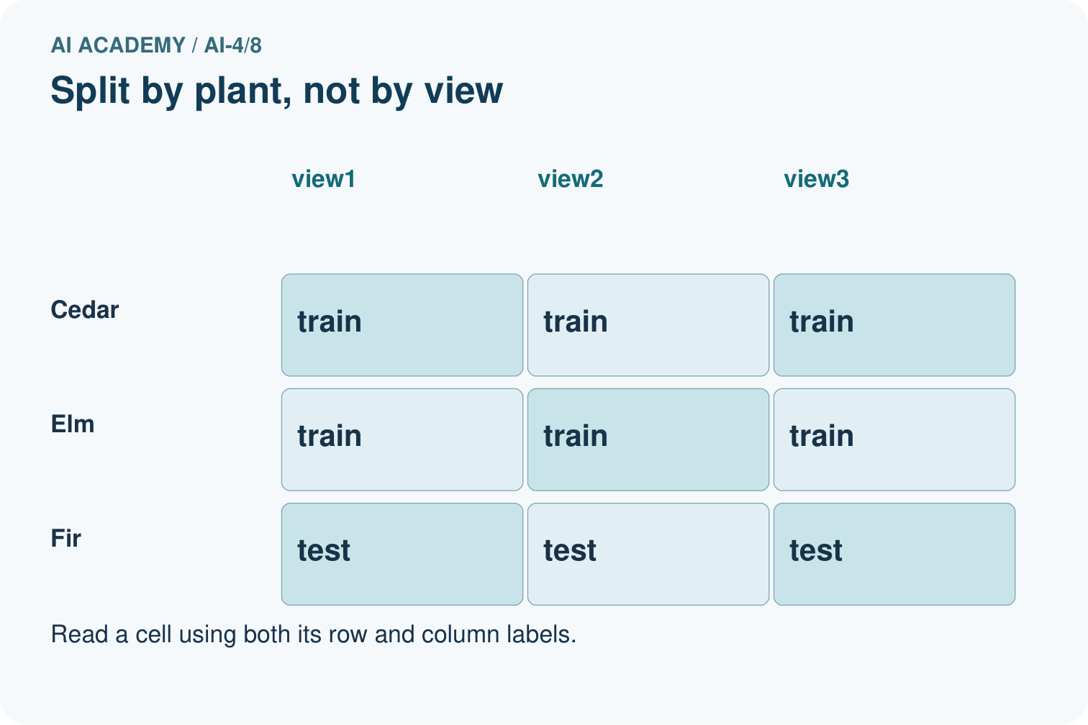
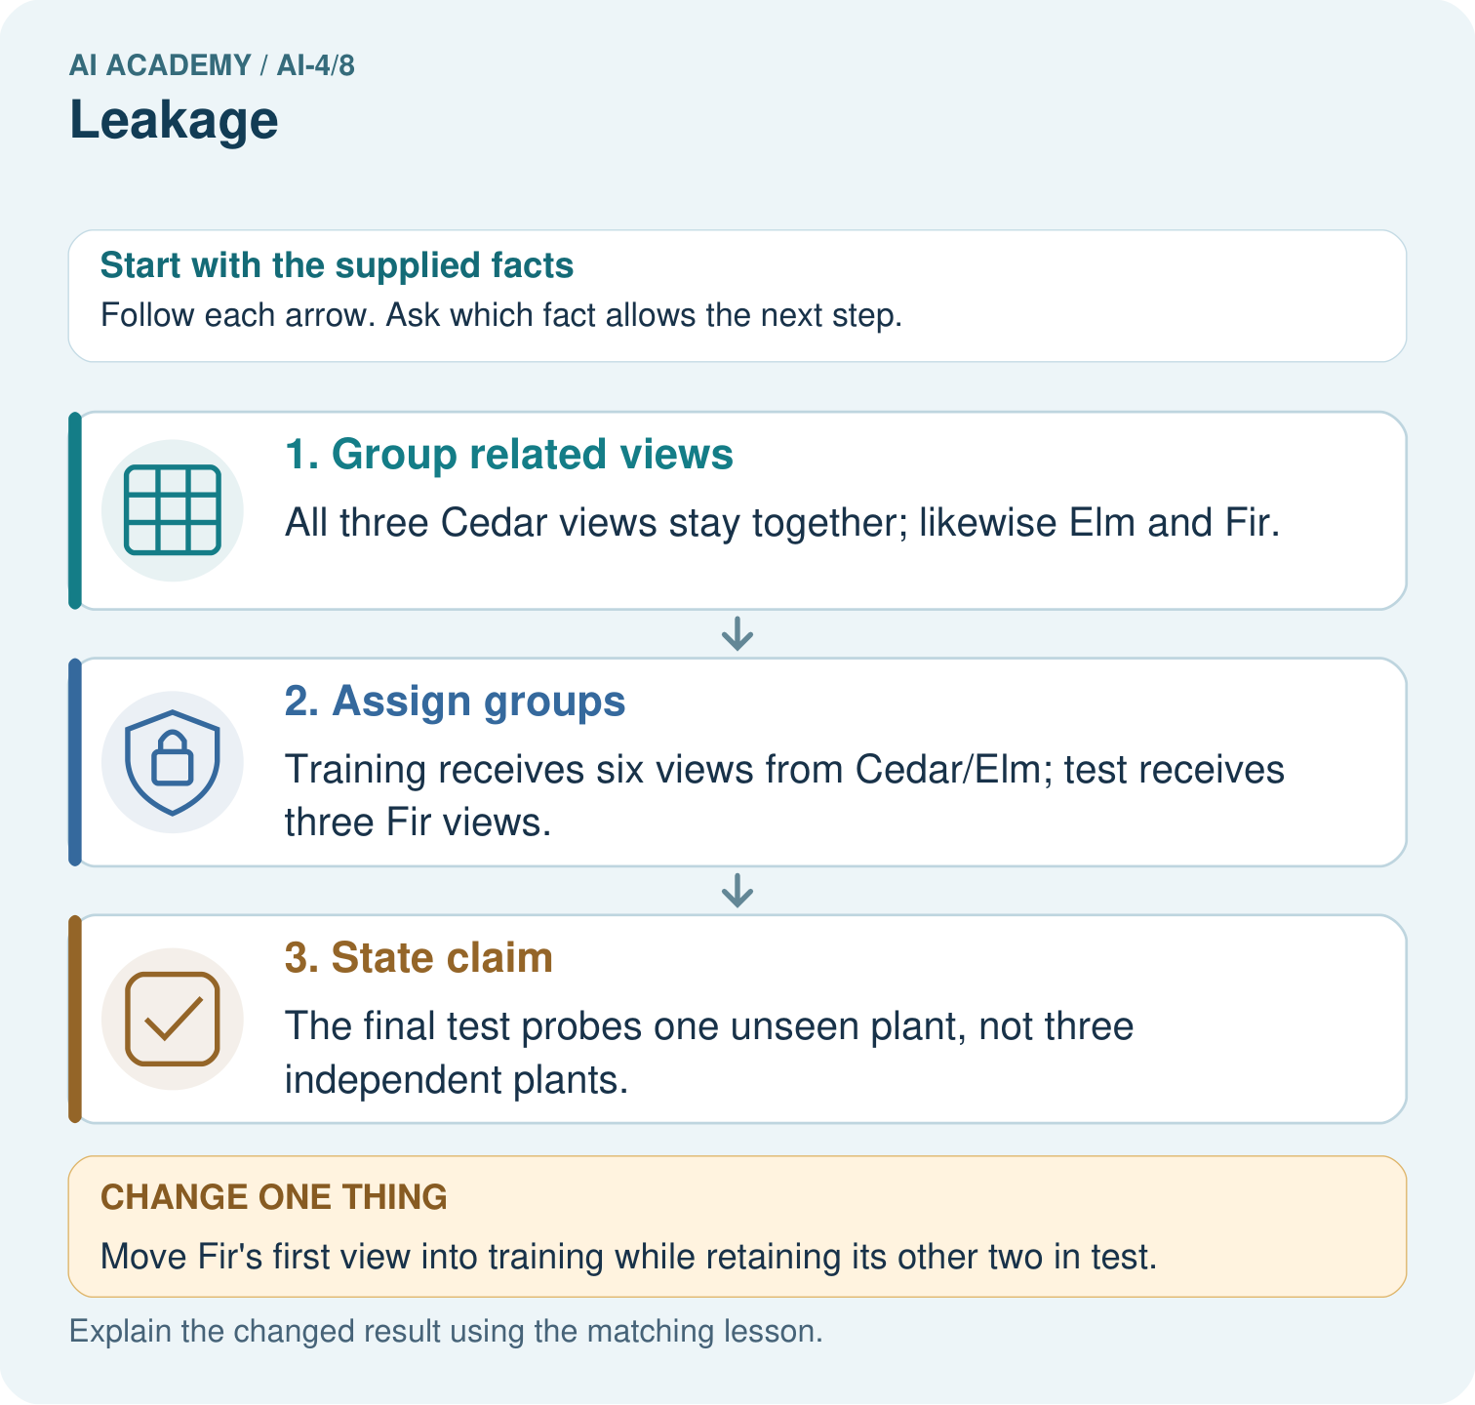

Read the picture one step at a time
Step | What happens and why
1. Group related views | All three Cedar views stay together; likewise Elm and Fir.
2. Assign groups | Training receives six views from Cedar/Elm; test receives three Fir views.
3. State claim | The final test probes one unseen plant, not three independent plants.
Match each pictured step to the supplied facts. This is a worked teaching case, not an independent assessment.

Why this result follows
Read the picture in order. The final test probes one unseen plant, not three independent plants. The arrows show which recorded input or intermediate result each decision uses. Explain the deciding step aloud before checking the changed case; pointing to the final answer alone does not show how it follows.

What this example does not establish
A correct group split still needs enough representative plants; this tiny exercise is not a reliable population estimate.

Change one thing in the pictured case
Change: Move Fir’s first view into training while retaining its other two in test.
Prediction: The unseen-plant evaluation is compromised.
Reason: Fir’s identity now appears in training; different view IDs do not remove the shared plant relationship.

Ask while showing the picture
Cover the result. Ask learners to name the inputs and predict the next step. Uncover one step, connect the icon to the actual procedure, and explain its evidence. Then change the supplied condition and compare. The picture is a representation; it does not document execution of a real AI model.

03. Demonstrate and guide practice

Demonstrate and guide practice

Board sequence
Write the given facts: Ten photos per leaf are randomly split so one leaf appears in train and test.
Write the question to explain: Explain and repair leakage.
Reveal after predictions: Related views make evaluation familiar. Split by leaf identity before fitting or learned preprocessing; keep all views together.
Keep for an independent attempt: A feature records the expert's final species decision, made after the prediction time. Why is this leakage, and what should happen to it?

Classroom dialogue
Ask: Which facts are given, and which would we have to assume? Learners mark relevant details before discussing answers.
Say: Predict first. Show the rule, information path or calculation that would produce the result. A correct guess is not yet an explanation.
Reveal reasoning one step at a time. Explain why a tempting alternative fails. Write units and denominators for arithmetic, trace conditions for decisions, and identify supporting sources for claims.
In pairs, one learner solves while the other checks evidence; exchange roles. Remove the worked answer before independent assessment.

Model these guided questions
Guided: the row counts become 7 training, 1 validation and 4 test. D is shared by training and validation because D1 and D2 are related frames from one trip. Unique frame IDs and a seed do not remove the shared trip. Return D2 to validation to recover the worked plan. Exit: separate trip IDs on one route do not test unseen routes. Hold out whole routes with all their trips, and collect enough routes and relevant conditions for the intended evaluation.

Case-specific teaching sequence
Stage | Teacher action
Session 1 start to 7 minutes | Retrieve why matching labels can share an error. State the new-trip evaluation goal and define one row and one group.
7 to 18 minutes | Use the frame cards to build the worked split. Count rows and groups separately and explain the three roles.
18 to 32 minutes | Trace the intersection audit. Complete W1 and W2; ask which metadata problems an empty overlap list could miss.
32 to 45 minutes | Move D2 into training and complete the guided question. Repair it by moving it back, then record the before and after counts.
Session 2 start to 8 minutes | Retrieve why shuffling and fixed seeds do not remove relationships. Ask what must stay together for a new-route claim.
8 to 20 minutes | Complete W3 and discuss group-based, route-based and time-respecting evaluation goals. Explain why percentages cannot decide the goal.
20 to 35 minutes | Collect W4 independently before hints. Require all three overlap checks, exact repaired frame lists and both count units.
35 to 45 minutes | Discuss W5 and the exit question. Use the fresh retry after support and record what help was needed.

Teach the connected idea
Stage | Teacher action
Session 1 start to 7 minutes | Retrieve k=1 prediction and training-only neighbour storage. Introduce two features with different ranges.
7 to 18 minutes | Calculate raw distances and discuss how units affect contributions. Complete W1 minima and ranges.
18 to 32 minutes | Transform A,B,C and the query. Trace fit versus transform in code and finish W1.
32 to 45 minutes | Complete W2 and the guided question. Use the diagram to follow the same stored scale across splits.
Session 2 start to 8 minutes | Retrieve the stored feature order, minima and ranges without recalculating from validation.
8 to 20 minutes | Transform and score all three validation rows. Complete W3 and explain values outside 0 to 1.
20 to 35 minutes | Collect W4 independently before giving support. Require raw and scaled arithmetic plus the new row.
35 to 45 minutes | Discuss W5 and the exit question. Use the fresh retry after feedback and record support.

Reduce help deliberately
Completion task: For the worked A through F plan, give training, validation and test counts first in groups and then in rows. Interpret [] from the code and state one problem it cannot detect.
Teacher check: Group counts are 3,1,2; row counts are 6,2,4. The empty list means no trip ID overlaps between any pair of the listed sets. The code cannot detect wrong metadata, an omitted frame, a disguised duplicate or an outcome feature.
Start by identifying the given inputs together. Leave the intermediate steps blank. If needed, model one step, then withdraw that help on the next step. Move to a full trace only when the partial trace is understood. For partners, alternate explainer and checker; collect a response from every learner before discussion.

Individual reasoning check
Use the worked case for Splits and related examples. Proposed explanation: “Different row IDs mean independent examples”. Decide whether this explanation is supported. Point to the step or supplied fact that decides; explain your repair if needed.
Expected correction: Different frames may share a trip or source. Choose group metadata based on the claim and verify it against the source.
Collect explanations, not only yes/no votes. If a misunderstanding is common, re-model the relevant step for the class. If it affects a few learners, give a short targeted group explanation while others solve a more demanding variation.

Connected teaching cycle: Scaling without leakage
Target: Calculate feature scales from training data only
Reserve further sessions for this topic; the 135-minute primary plan does not absorb all added content.
Completion practice: For query (11,120), calculate raw and scaled distances to A,B,C. Give both k=1 predictions. Does this prove that scaling always improves predictions?
Teacher check: Raw distances 81,29,89 select B blocked. Scaled distances 0.9,1.1,1.7 select A clear. The feature contributions changed. This single changed prediction does not establish better performance; evaluate separately and report limits.
Individual check: For Scaling without leakage, use its worked case to evaluate this proposed explanation: “Every transformed value must lie between 0 and 1”. Explain the deciding step.
Expected correction: Only the fitted training range maps to 0 through 1. New values outside that range can transform below 0 or above 1.
Apply the same support, independent transfer and delayed-review decisions to the named connected-topic workbook tasks.

Pictorial practice question
How many independently new plant identities are in the original test? Point to the relevant step in the picture, then write the changed result and the rule or evidence that supports it.

Reasoned teacher answer
One: Fir. Its three photos are related views, so report both photo count 3 and plant count 1. Changed-case check: The unseen-plant evaluation is compromised. Fir’s identity now appears in training; different view IDs do not remove the shared plant relationship.
Changed-case reasoning: The unseen-plant evaluation is compromised. Fir’s identity now appears in training; different view IDs do not remove the shared plant relationship.
Collect each learner’s explanation before discussion. Use the first missing connection between input, deciding step and result to choose support. This question is worked-case practice, not fresh mastery evidence.

04. Run the weekly evidence lab

Run the weekly evidence lab
Keep the test conditions fixed, record every result, and change only one planned factor.
1. Write the hypothesis and expected evidence before running.
2. Leakage Detective: draw a timeline for every suspicious field, inspect group identity, and repair the split before training.
3. Run one normal, one boundary, one missing, and one shifted case.
4. Calculate the metric from raw counts or row-level errors.
5. Interpret what changed, what did not, and what remains unsafe or unknown.

Make the lab runnable
Use the concrete case as the shared normal case and the independent question as a second case. Each pair creates a boundary or missing-information case and predicts its result before testing. Keep the expected result separate from an observed mistake.
Record | What to capture
Input or evidence | Exact data, instruction or claim
Expected result | Answer or safe fallback declared before the run
Observed result | Actual result, including errors
Explanation | Rule, calculation or evidence explaining the outcome
Next test | One justified change and a new prediction

Diagnose and reteach
MISCONCEPTION TO REPAIR A highly accurate feature should be kept even when it would not exist during real use.
For guessing, return to given facts and request a trace. For vocabulary without application, use one example and one non-example. For arithmetic errors, check the setup before the calculation. Finish with a different uncoached case before recording mastery.

Address these additional misconceptions
Different row IDs mean independent examples: Different frames may share a trip or source. Choose group metadata based on the claim and verify it against the source.
A fixed percentage guarantees a fair test: Percentages do not remove overlap or ensure enough groups and relevant cases. The goal and dependencies determine the split.
An empty overlap list proves there is no leakage: The audit checks listed group IDs only. Wrong metadata, copied content, outcome features or preprocessing fitted on all sets can still invalidate evaluation.

Check these misconceptions
Every transformed value must lie between 0 and 1: Only the fitted training range maps to 0 through 1. New values outside that range can transform below 0 or above 1.
No labels means no leakage: Held-out feature values can leak into a learned transformation. Fit preprocessing on the training split only.
Scale each split separately: Separate fits create different coordinates. Apply the same stored scale to training examples and queries.

Match the support to the first error
What the response shows | Next teaching action
Missing or misread facts | Read the case aloud, mark supplied versus unknown facts, and let the learner restate it.
Wrong procedure | Return to the deciding step in the worked case. Contrast it with the proposed incorrect explanation.
Arithmetic or implementation error | Trace intermediate values or lines; preserve the first mismatch and retry that step.
Correct result without a reason | Ask for a trace and a changed case before marking independent understanding.
An unsupported wider claim | Ask which supplied evidence supports the claim and which further observation would be needed.
Offer an oral explanation, drawing, enlarged visual or fewer examples when that removes a reading/writing barrier. Keep the same reasoning goal. Stretch secure learners by changing a boundary or assumption and asking them to defend the effect, not simply by assigning more of the same questions.

05. Assess and explain the answers

Assess and explain the answers

Worked case answer
Related views make evaluation familiar. Split by leaf identity before fitting or learned preprocessing; keep all views together.

Independent question
A feature records the expert's final species decision, made after the prediction time. Why is this leakage, and what should happen to it?

Expected independent answer
It exposes the answer or information unavailable at prediction time. Exclude it and reevaluate using only legitimately available features.

What counts as evidence
Criterion | 0 points | 1 point | 2 points
Result | Incorrect or absent | Partly correct | Correct with necessary conditions
Reasoning | No supporting trace | Some steps | Clear mechanism, calculation or source support
Limit | Overclaims certainty | Vague limitation | Relevant uncertainty or missing fact
Transfer | Copies without adapting | Adapts with prompts | Solves a changed case independently
Use 6/8 as a classroom checkpoint, with 2 required for both Result and Reasoning. This is a proposed teaching rule, not a validated certification threshold. Do not count a coached answer as independent mastery; correct unsafe or unsupported claims regardless of total.

Feedback
Ask the learner to find the evidence that challenges this claim: “Any recorded column is a valid predictor regardless of when it becomes available.” Keep the first attempt and an uncoached retry separate.

Original transfer answer
Views of the same leaf can appear in both sets, making evaluation familiar. Assign all views of each leaf to one partition before fitting or augmentation. If deployment concerns new plants or sites, consider grouping at that broader level too.

Explanations for the additional workbook examples

W1 Explain the three roles
Explain what training, validation and test sets are used for. What changes if you repeatedly choose a model using its test score?
Training fits the model; validation compares development choices; test evaluates after choices are fixed. Repeatedly selecting by the test score uses that set for development, so it is no longer an untouched final evaluation.

W2 Distinguish frames from groups
For the worked A through F plan, give training, validation and test counts first in groups and then in rows. Interpret [] from the code and state one problem it cannot detect.
Group counts are 3,1,2; row counts are 6,2,4. The empty list means no trip ID overlaps between any pair of the listed sets. The code cannot detect wrong metadata, an omitted frame, a disguised duplicate or an outcome feature.

W3 Repair a related example leak
A1 and A2 are in training and A3 is in test. Explain why unique frame IDs and a fixed random seed do not fix this. Propose a repair and what to record.
The frames share trip A, so the test contains a trip already represented in training. Unique frame IDs do not remove similarity; a seed only reproduces the assignment. Put every A frame in one role, keep each frame once and record the revised assignments and counts before model evaluation.

W4 Audit and repair independently
Eight frames come from trips P (P1 P2 P3), Q (Q1 Q2), R (R1), S (S1 S2). A proposed split is training P1 Q1 R1; validation P2 S1; test Q2 P3 S2. Identify shared groups for each pair of sets. Repair it by assigning P and Q to training, R to validation and S to test. List all frames in each role and give row and group counts. State one limit of the repaired plan.
Training/validation share P; training/test share P and Q; validation/test share P and S. Repaired training is P1 P2 P3 Q1 Q2 (5 rows,2 groups), validation R1 (1 row,1 group), test S1 S2 (2 rows,1 group). Every frame appears once and groups are disjoint. This tiny plan does not establish reliable performance, correct metadata, label coverage or success on new routes.

W5 Match separation to the claim
A model will be evaluated on new routes. Route North has trips A and B; route South has C and D. A proposed split trains on A and C and tests on B and D. Explain the problem and give a route-based alternative. Is this enough for a strong performance claim?
Both routes occur in training and test, so the plan does not hold out a new route. For illustration, keep A and B together for training and C and D together for test, or reverse the route roles. With only two routes there is too little evidence for a strong general claim and no separate route left for validation; obtain more routes for a fuller design.

Scaling without leakage — W1 Learn the scale from training
Using A,B,C, give the minimum, maximum and range for each feature. Transform all three training rows and query (11,120). Explain which rows supplied the scale.
Distance minimum 10 maximum 20 range 10; brightness minimum 100 maximum 200 range 100. A becomes (0,1), B (1,0), C (1,1), and query (0.1,0.2). Only A,B,C supplied the scale; the query did not.

Scaling without leakage — W2 Trace the changed prediction
For query (11,120), calculate raw and scaled distances to A,B,C. Give both k=1 predictions. Does this prove that scaling always improves predictions?
Raw distances 81,29,89 select B blocked. Scaled distances 0.9,1.1,1.7 select A clear. The feature contributions changed. This single changed prediction does not establish better performance; evaluate separately and report limits.

Scaling without leakage — W3 Keep one coordinate system
Transform (12,80) using the stored training scale. Explain the negative value and why validation must not fit its own scale. Give the worked validation and baseline scores.
(12,80) becomes (0.2,-0.2). Brightness is below the training minimum, so the negative result is valid under this formula. Refitting validation creates different coordinates; use the stored training transformation. Scaled k=1 scores 2/3 and the blocked baseline 1/3.

Scaling without leakage — W4 Scale a fresh dataset independently
New training rows are P (20,1000) clear, Q (40,600) blocked, R (40,1000) blocked. Fit minima and ranges. For query (22,680), show transformed features, raw and scaled distances to P,Q,R, and both k=1 predictions. Transform new row (50,520) with the same scale.
Minima (20,600), ranges (20,400). P,Q,R become (0,1),(1,0),(1,1); query becomes (0.1,0.2). Raw distances 322,98,338 select Q blocked. Scaled distances 0.9,1.1,1.7 select P clear. New row (50,520) becomes (1.5,-0.2); keep the fitted scale and do not silently clip.

Scaling without leakage — W5 Repair two preprocessing mistakes
A learner fits scales using training plus validation features but no labels. Another divides by a zero training range. Explain both problems and give a recorded repair for each.
Evaluation features influenced the first learned transformation, causing leakage even without labels. Split first, fit only on training and reuse those values for validation. A zero range causes division by zero. This code stops for review; one documented repair is to omit that feature consistently from every split and update the feature list.

Assess independent transfer
Selected case: Each of five plants has four photos. A random photo split puts different views of every plant in both training and test sets. Explain the problem and repair.

Selected case answer
Related views of the same plant cross the split, making the test less independent. Split by plant identity and keep all four views together. Unique filenames do not make plants independent; declare plant assignments before fitting or tuning.
Dimension | Evidence required
Explanation | Names the applicable idea or procedure and ties it to the supplied facts.
Trace and result | Preserves the given inputs and shows the relevant intermediate steps; distinguishes a prediction from an observed execution.
Limits | States the assumptions, missing evidence or conditions under which the result would change.
Record each dimension as not yet, with support, or independent. Accept a valid alternative procedure with a defensible trace. Do not penalise an honestly recorded model failure if the learner correctly explains its evidence and limits.

Feedback that the learner uses
Name the earliest unsupported step and give one action to repair it. Have the learner make that repair now and explain why. Then assess the relevant skill on a fresh, fully specified case. Confirm it was not previously practised with feedback; solve and check the new case before assigning it. A follow-up design prompt is a starting brief, not automatically an equivalent test.

06. Connect and extend learning

Connect and extend learning

Responsible Plant Classifier
Audit filenames, metadata, post-diagnosis fields, and duplicate plant identities; record every removed leakage path.
Keep the decision, input, result, explanation and remaining limitation in the project evidence record. Retrieve this record next week rather than restarting the project.

Support and stretch
Use a tiny labelled dataset, explicit units and a named positive class. Stretch: require a baseline, held-out evaluation and subgroup or shifted-condition analysis with denominators.

Exit reflection
Ask for one decision the learner can now justify and one situation requiring more evidence or human review. Confidence ratings are separate from correct independent performance.

Bridge to the next week
Next: Week 9: Dataset Cards. Retrieve today’s evidence and identify what carries forward and what is new.

Support and fresh reassessment
Keep a coloured border shared by cards from the same trip. Supply blank assignment tables without the correct roles. Extension: explain why a new-route evaluation with many frames but only two routes has limited evidence and cannot obtain three nonempty disjoint route sets.
Require W4 overlaps P; P and Q; P and S, in pair order, then exact repaired lists with rows 5,1,2 and groups 2,1,1. Fresh retry: U1 U2 belong to U, V1 to V, W1 W2 to W. Proposed training U1 V1, validation W1, test U2 W2 has shared U between training/test and W between validation/test; training/validation share none. Repair to all U in training, V in validation and all W in test: rows 2,1,2 and groups 1,1,1. Require an explicit small-sample limitation.
Week 7 introduces a baseline before a model. Carry forward the split record and keep the final test protected while comparing choices. Teacher reference: scikit-learn cross-validation documentation, grouped data section, https://scikit-learn.org/stable/modules/cross_validation.html (reviewed 2026-09-27).

Readiness and reassessment for Scaling without leakage
Colour each feature column separately and supply the formula with spaces for the training minimum and range. Let students use fractions before decimals. Extension: convert one entire feature to a different positive unit, refit on training only, and explain why the scaled values remain the same.
Require W4 minima (20,600), ranges (20,400), query (0.1,0.2), raw distances 322,98,338 and scaled distances 0.9,1.1,1.7. Predictions Q blocked and P clear; new row (1.5,-0.2). Fresh retry: L (5,80) blocked, M (15,40) clear, N (15,80) clear; query (6,48). Minima (5,40), ranges (10,40), query (0.1,0.2). Raw distances 33,17,41 select M clear; scaled distances 0.9,1.1,1.7 select L blocked. Require training-only fitting and consistent transformation.

Plan the delayed return
Suggested return points in this level: ai-4/9, ai-4/11, ai-4/14. Use actual classroom dates, adjusting for holidays and gaps. One, three and six teaching weeks are scheduling choices, not a claimed optimal spacing.
At a delayed check, ask for the idea from memory and a changed application. Compare with the earlier independent response and record support used. For a new level, revisit the previous capstone before checking the new prerequisites.
Record | Teacher evidence
Learner code and date
Concept and case used; prior exposure
Explanation / trace / limits
Support and first repair
Changed case and delayed outcome
Next teaching action
Use the evidence to choose reteaching or the next step. A completed page, confidence rating or attractive project does not by itself demonstrate understanding.

Project evidence from this case
For your Responsible Plant Classifier, save the input, procedure, observed result and limitation of this check. Label this worked example as practice; use a different, previously unreviewed case when checking independent understanding.

07. Prepare, teach and assess
Teaching target: Choose a split unit that matches the intended prediction claim
Prepare the labelled worked-case picture, the matching workbook, fictional input cards and a place for individual responses. Check a local Python 3 environment before class; have a paper-trace version ready.
Session | Plan | Resources
Session 1 · Understand · 45 min | 0–7: recall and prerequisite; 7–15: inspect the concrete case and predict; 15–30: teacher models the worked trace; 30–40: learners explain a step using the text and visual; 40–45: check the core idea. | Sections 1–6; record the brief recall in the workbook.
Session 2 · Practise · 45 min | 0–5: retrieve the procedure; 5–15: W2 completion practice; 15–23: explain and check with a partner; 23–30: each learner answers the misconception check; 30–40: targeted reteaching or a harder variation; 40–45: prepare the investigation. | Sections 7–10; use the matching workbook W2 and misconception check.
Session 3 · Investigate and transfer · 45 min | 0–5: retrieve the decision rule; 5–20: investigate or trace; 20–30: start the independent case; 30–38: connect the project; 38–43: act on feedback; 43–45: plan the return check. | Sections 9 and 11–14. Give extra time to finish the full task set; use Section 15 when the week includes a coding lab.
Before class, solve the supported practice: For the worked A through F plan, give training, validation and test counts first in groups and then in rows. Interpret [] from the code and state one problem it cannot detect.
Reasoned practice answer: Group counts are 3,1,2; row counts are 6,2,4. The empty list means no trip ID overlaps between any pair of the listed sets. The code cannot detect wrong metadata, an omitted frame, a disguised duplicate or an outcome feature.
Check every learner before discussion: Use the worked case for Splits and related examples. Proposed explanation: “Different row IDs mean independent examples”. Decide whether this explanation is supported. Point to the step or supplied fact that decides; explain your repair if needed.
Misconception repair: Different frames may share a trip or source. Choose group metadata based on the claim and verify it against the source.
Support: read the exact case aloud, enlarge the labelled picture, supply input cards and model only the first deciding step. Accept a spoken explanation or drawing; retain the reasoning goal.
Extension: Move Fir’s first view into training while retaining its other two in test. Require a prediction and a reason before comparing. Expected result: The unseen-plant evaluation is compromised. Reason: Fir’s identity now appears in training; different view IDs do not remove the shared plant relationship.
Independent assessment: withhold the reserved answer until the learner has attempted the new case. Record support separately from correctness.
Criterion | Not yet | With support | Independent
Explanation | Names an answer without a deciding fact | Uses a hint to link fact and decision | Explains the deciding fact in own words
Trace or test | Cannot connect input and result | Completes steps with prompts | Traces or tests a changed case accurately
Limits and revision | Claims more than evidence supports | Names a limit after a prompt | States a defensible limit and useful next test
Project checkpoint: Make a transparent first version. Keep a trace of how one input becomes an output; explain the rule or learned component.
Use the weekly teacher answer for topic-specific reasoning. A saved progress tick is an activity record; judge mastery from the learner’s explanation and evidence.

