AI ACADEMY · TEACHER · ai-4/20

Mean, Median, and Baselines
Project: Responsible Plant Classifier

01. Mean, Median, and Baselines

Teach the learning cycle
Primary target: Fit mean and median constant baselines on training targets
Session | Sequence and minutes | Resources
Session 1 · Understand · 45 min | 0–7: recall and prerequisite; 7–15: inspect the concrete case and predict; 15–30: teacher models the worked trace; 30–40: learners explain a step using the text and visual; 40–45: check the core idea. | Sections 1–6; record the brief recall in the workbook.
Session 2 · Practise · 45 min | 0–5: retrieve the procedure; 5–15: W2 completion practice; 15–23: explain and check with a partner; 23–30: each learner answers the misconception check; 30–40: targeted reteaching or a harder variation; 40–45: prepare the investigation. | Sections 7–10; use the matching workbook W2 and misconception check.
Session 3 · Investigate and transfer · 45 min | 0–5: retrieve the decision rule; 5–20: investigate or trace; 20–30: start the independent case; 30–38: connect the project; 38–43: act on feedback; 43–45: plan the return check. | Sections 9 and 11–14. Give extra time to finish the full task set; use Section 15 when the week includes a coding lab.
This is a starting allocation of 135 minutes, not a validated duration. Preserve all named topics. Schedule extra time for connected examples, the full investigation, independent cases and project building. Repeated copies of a case share one recorded attempt; they are not new evidence.

Retrieval answer guidance

Regression and Residuals
Without opening the old lesson, explain one key idea from Regression and Residuals. Give an example and a mistake that the idea helps you avoid.
Look for: Distinguish numeric prediction from classification
Reference example, not the only acceptable wording: Teacher explanation: Residuals -1, 1, 0 cm; the first record is overpredicted.

Precision and Recall
Without opening the old lesson, explain one key idea from Precision and Recall. Give an example and a mistake that the idea helps you avoid.
Look for: Choose the denominator that answers the question
Reference example, not the only acceptable wording: Teacher explanation: Predicted positives TP+FP=7; reference positives TP+FN=4.

Scores and Calibration Intuition
Without opening the old lesson, explain one key idea from Scores and Calibration Intuition. Give an example and a mistake that the idea helps you avoid.
Look for: Interpret calibration using groups of forecasts
Reference example, not the only acceptable wording: Teacher explanation: 2/10=.2 and 6/10=.6.
Use the student module and workbook section with this exact week title. The worked case, independent question and answers below form one aligned lesson sequence.

What the learner must demonstrate
For training targets [1,3,11], compute mean and median constant baselines. Compare total absolute training error for each. Where must final performance be measured?

Concept to explain
Mean and median are transparent regression baselines; outliers affect them differently.
Term | Meaning
mean | sum divided by count
median | middle ordered value
outlier | value far from most observations
location baseline | single typical value predicted for all cases

Prepare the class
Use the supplied scenario, student illustrations and blank paper. For numeric work, offer counters or a calculator after learners show the setup. Fictional records are supplied; personal data and paid accounts are unnecessary.
Allow 80 minutes: recall 8; explanation 12; worked demonstration 15; guided practice 20; independent assessment 15; project and reflection 10. Extend the lab into a second session when needed.

Preparation for the connected explanation
Teach two 45-minute sessions. This week focuses on constant prediction baselines. Model the worked example first, collect the new W 4 case independently before feedback, and use the fresh retry to check transfer. Award credit for traceable reasoning and bounded claims, including justified uncertainty.

Readiness answer
Opposite signs can cancel; a magnitude-based loss avoids that cancellation.
Printed student lesson and workbook
Paper, pencils and a calculator for fractions
The fictional examples and a blank evidence table
Optional Python 3 editor; no external packages or AI accounts required

End goal for the pictorial case
By the end, I can explain mean, median, and baselines using a traced example and a stated limitation.
This added worked case illustrates the week’s main idea. Retain all original and connected topics; schedule its practice within the teaching cycle.

02. Explain the mechanism

Explain the mechanism
Trace the information, fitted behavior, and evaluation proof separately.
QUESTION Choose and justify a baseline under an extreme value.
MODEL IDEA Mean and median are transparent regression baselines; outliers affect them differently.
PROOF NEEDED Use an unseen case, visible calculation, error analysis, and a stated limitation.
UNDER THE HOOD Heights are 10, 11, 12, 13, and 54 cm. Mean = 100 ÷ 5 = 20 cm.
Draw a fresh data → model → prediction → evaluation trace:
Predict first. Then check each step. A correct answer without visible evidence cannot be audited.
STEP 1 Heights are 10, 11, 12, 13, and 54 cm.
STEP 2 Mean = 100 ÷ 5 = 20 cm.
STEP 3 Median is 12 cm, the middle ordered value.
STEP 4 For typical-height absolute error, median is more robust; still report why 54 is present.
CHECK Verify the denominator, unit, split, class definition, and data version before interpreting a score.
Recalculate, retrace, or restate the evidence independently:

Concrete teaching case
Training heights are 2,4,12 cm. Compare constant mean and median baselines.
Compute both and training absolute errors.

Exact explanation to model
Mean=6, median=4. Mean errors 4,2,6 total12; median errors 2,0,8 total10. Median minimises absolute error here.

Explain the added worked example
Before a complex regression model, fit a simple constant predictor. A mean baseline uses the training average. A median baseline uses the middle training target. They ignore features but provide a comparison that is easy to reproduce. Evaluation targets must not determine the constants.
Use fictional classroom data throughout this investigation. Keep the task, units, reference labels and data split visible as you reason. Earlier weeks supplied the model-building process; this week examines constant prediction baselines.
Training targets [2, 4, 6, 12] have mean 24/4=6 and median (4+6)/2=5. On separate targets [4, 8], the mean baseline predicts [6, 6] with absolute errors [2, 2], averaging 2. The median baseline predicts [5, 5] with errors [1, 3], also averaging 2.
Trace the calculation on paper before running this optional Python check. Use the stated fictional inputs and compare intermediate values. The code checks this example; your independent workbook case uses different evidence.

Key terms
Term | Meaning
Constant baseline | One fixed prediction for every query
Training mean | Sum of training targets divided by their count
Training median | Middle value of sorted training targets
Absolute error | Magnitude of observed minus predicted

Model the reasoning aloud
Use the complete worked example below before asking learners to complete W2. Reveal a small part, invite a prediction, then explain the deciding step. These teacher notes contain solutions; do not reveal the independent case answer during modelling.

Constant prediction baselines at a glance
Part | Evidence or action | Interpretation
Training targets | Fit mean 6 | Freeze constant
Training targets | Fit median 5 | Freeze constant
Evaluation targets | Compare fixed predictions | Both MAE 2 here
Mean and median answer different training objectives. A mean minimizes total squared error among constants; a median minimizes total absolute error. This does not guarantee either wins on a new evaluation set. With extreme values, the mean can move much more than the median.

Calculate MAE for both baselines on [4, 8]. Explain the steps or evidence behind your response.
________________________________________________________________
________________________________________________________________
________________________________________________________________
________________________________________________________________
Thinking move | Teacher prompt
Plan | What is given? What is the question? Which procedure fits these facts?
Do | Point to each input and intermediate step in the worked trace. Name the rule that allows the next step.
Check | Does the output answer the question? Which assumption or limitation prevents a larger claim?
Use the diagram and verbal explanation together. Ask learners to match a sentence to a specific visual step; do not assign learners fixed visual or auditory learning styles.

A pictorial worked case: Mean, Median, and Baselines
Fit two constant height baselines and compare them on held-out examples.

The facts we will use
Training heights [2, 4, 6, 20] cm. Evaluation heights [4, 10] cm. Fit constants only from training.
All inputs and outcomes in this worked example are invented classroom data; no real model run is claimed.
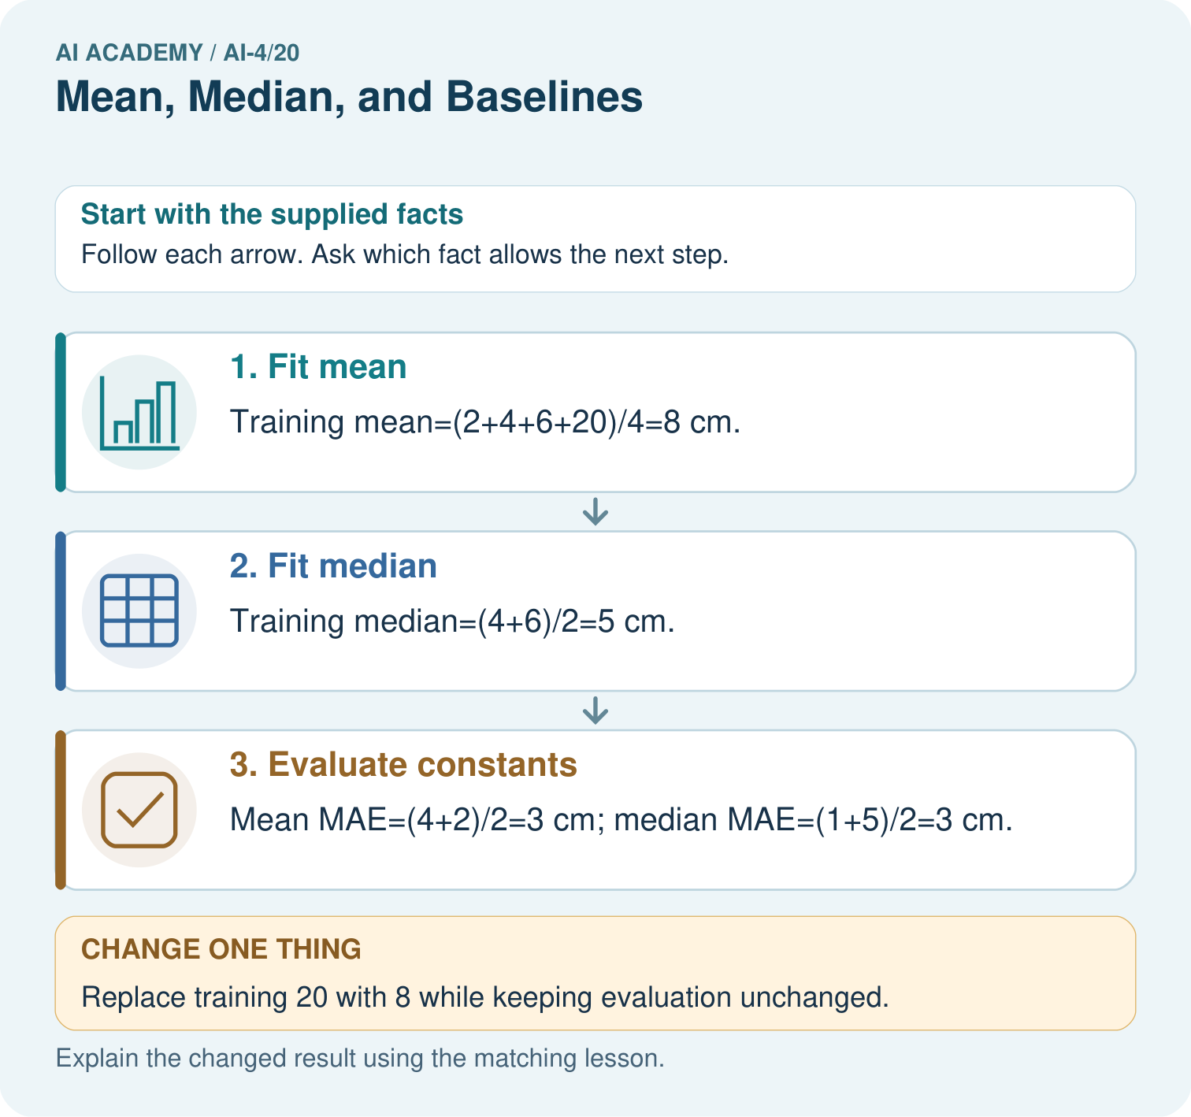

Read the picture one step at a time
Step | What happens and why
1. Fit mean | Training mean=(2+4+6+20)/4=8 cm.
2. Fit median | Training median=(4+6)/2=5 cm.
3. Evaluate constants | Mean MAE=(4+2)/2=3 cm; median MAE=(1+5)/2=3 cm.
Match each pictured step to the supplied facts. This is a worked teaching case, not an independent assessment.

Why this result follows
Read the picture in order. Mean MAE=(4+2)/2=3 cm; median MAE=(1+5)/2=3 cm. The arrows show which recorded input or intermediate result each decision uses. Explain the deciding step aloud before checking the changed case; pointing to the final answer alone does not show how it follows.

What this example does not establish
Mean and median have different loss properties, but their held-out performance depends on the particular evaluation cases.

Change one thing in the pictured case
Change: Replace training 20 with 8 while keeping evaluation unchanged.
Prediction: Both fitted constants become5 cm and both evaluation MAEs remain3 cm.
Reason: Mean is now20/4=5; median stays5. The earlier training outlier affected the mean.

Ask while showing the picture
Cover the result. Ask learners to name the inputs and predict the next step. Uncover one step, connect the icon to the actual procedure, and explain its evidence. Then change the supplied condition and compare. The picture is a representation; it does not document execution of a real AI model.

03. Demonstrate and guide practice

Demonstrate and guide practice

Board sequence
Write the given facts: Training heights are 2,4,12 cm. Compare constant mean and median baselines.
Write the question to explain: Compute both and training absolute errors.
Reveal after predictions: Mean=6, median=4. Mean errors 4,2,6 total12; median errors 2,0,8 total10. Median minimises absolute error here.
Keep for an independent attempt: For training heights 2, 3 and 10 cm, calculate mean and median. Which constant is less influenced by the high value?

Classroom dialogue
Ask: Which facts are given, and which would we have to assume? Learners mark relevant details before discussing answers.
Say: Predict first. Show the rule, information path or calculation that would produce the result. A correct guess is not yet an explanation.
Reveal reasoning one step at a time. Explain why a tempting alternative fails. Write units and denominators for arithmetic, trace conditions for decisions, and identify supporting sources for claims.
In pairs, one learner solves while the other checks evidence; exchange roles. Remove the worked answer before independent assessment.

Model these guided questions
Guided response: Both score 2; their per-record absolute errors differ. Exit response: It fits using evaluation answers and makes the baseline unavailable for genuinely unseen cases.

Case-specific teaching sequence
Stage | Teacher action
Session 1 start to 7 minutes | Use the prerequisite question: Why can signed residuals hide error size? Check the explanation before proceeding.
7 to 18 minutes | Read the opening and model the worked evidence. Ask students to identify constant baseline in context.
18 to 32 minutes | Complete W 1 and W 2 with support: fit two constants; score separately. Require the evidence, not only the final response.
32 to 45 minutes | Read the visual row by row. Collect the guided explanation and compare reasoning in pairs. Trace the Python check after the paper calculation.
Session 2 start to 8 minutes | Retrieve the distinction between constant baseline and training mean. Invite a counterexample to an overconfident claim.
8 to 20 minutes | Discuss the application and complete W 3: Replace 12 by 40. What changes?
20 to 35 minutes | Collect W4 independently before giving hints. Assess these outcomes: Fit mean and median constant baselines on training targets; Compare constant predictions on separate records. Record any support used.
35 to 45 minutes | Use W 5 and the exit response to assess limits. Give targeted feedback, then the fresh retry. Save evidence of independent understanding.

Reduce help deliberately
Completion task: Calculate MAE for both baselines on [4, 8].
Teacher check: Teacher explanation: Both score 2; their per-record absolute errors differ.
Start by identifying the given inputs together. Leave the intermediate steps blank. If needed, model one step, then withdraw that help on the next step. Move to a full trace only when the partial trace is understood. For partners, alternate explainer and checker; collect a response from every learner before discussion.

Individual reasoning check
Use the worked case for Constant prediction baselines. Proposed explanation: “A final answer is enough”. Decide whether this explanation is supported. Point to the step or supplied fact that decides; explain your repair if needed.
Expected correction: Ask for the relevant counts, units, procedure or saved record. For this week: Mean 6; median 5.
Collect explanations, not only yes/no votes. If a misunderstanding is common, re-model the relevant step for the class. If it affects a few learners, give a short targeted group explanation while others solve a more demanding variation.

Pictorial practice question
Does either original baseline win under evaluation MAE? Point to the relevant step in the picture, then write the changed result and the rule or evidence that supports it.

Reasoned teacher answer
No, both have3 cm MAE on the supplied evaluation set; do not claim a strict winner from the training statistic alone. Changed-case check: Both fitted constants become5 cm and both evaluation MAEs remain3 cm. Mean is now20/4=5; median stays5. The earlier training outlier affected the mean.
Changed-case reasoning: Both fitted constants become5 cm and both evaluation MAEs remain3 cm. Mean is now20/4=5; median stays5. The earlier training outlier affected the mean.
Collect each learner’s explanation before discussion. Use the first missing connection between input, deciding step and result to choose support. This question is worked-case practice, not fresh mastery evidence.

04. Run the weekly evidence lab

Run the weekly evidence lab
Keep the test conditions fixed, record every result, and change only one planned factor.
1. Write the hypothesis and expected evidence before running.
2. Baseline Tournament: compute mean and median, predict every case, compare MAE, and explain the outlier's effect.
3. Run one normal, one boundary, one missing, and one shifted case.
4. Calculate the metric from raw counts or row-level errors.
5. Interpret what changed, what did not, and what remains unsafe or unknown.

Make the lab runnable
Use the concrete case as the shared normal case and the independent question as a second case. Each pair creates a boundary or missing-information case and predicts its result before testing. Keep the expected result separate from an observed mistake.
Record | What to capture
Input or evidence | Exact data, instruction or claim
Expected result | Answer or safe fallback declared before the run
Observed result | Actual result, including errors
Explanation | Rule, calculation or evidence explaining the outcome
Next test | One justified change and a new prediction

Diagnose and reteach
MISCONCEPTION TO REPAIR The mean is always the fairest and most scientific summary.
For guessing, return to given facts and request a trace. For vocabulary without application, use one example and one non-example. For arithmetic errors, check the setup before the calculation. Finish with a different uncoached case before recording mastery.

Address these additional misconceptions
A final answer is enough: Ask for the relevant counts, units, procedure or saved record. For this week: Mean 6; median 5.
A stronger claim makes a stronger project: It fits using evaluation answers and makes the baseline unavailable for genuinely unseen cases.
The new case can be copied from the example: The independent task changes the evidence. Require a fresh explanation: Mean 6 and median 4. Mean errors [3, 3] MAE 3; median errors [1, 5] MAE 3.

Match the support to the first error
What the response shows | Next teaching action
Missing or misread facts | Read the case aloud, mark supplied versus unknown facts, and let the learner restate it.
Wrong procedure | Return to the deciding step in the worked case. Contrast it with the proposed incorrect explanation.
Arithmetic or implementation error | Trace intermediate values or lines; preserve the first mismatch and retry that step.
Correct result without a reason | Ask for a trace and a changed case before marking independent understanding.
An unsupported wider claim | Ask which supplied evidence supports the claim and which further observation would be needed.
Offer an oral explanation, drawing, enlarged visual or fewer examples when that removes a reading/writing barrier. Keep the same reasoning goal. Stretch secure learners by changing a boundary or assumption and asking them to defend the effect, not simply by assigning more of the same questions.

05. Assess and explain the answers

Assess and explain the answers

Worked case answer
Mean=6, median=4. Mean errors 4,2,6 total12; median errors 2,0,8 total10. Median minimises absolute error here.

Independent question
For training heights 2, 3 and 10 cm, calculate mean and median. Which constant is less influenced by the high value?

Expected independent answer
Mean is 15/3 = 5 cm; median is 3 cm. The median is less affected by the high value. Fit a baseline from training data only.

What counts as evidence
Criterion | 0 points | 1 point | 2 points
Result | Incorrect or absent | Partly correct | Correct with necessary conditions
Reasoning | No supporting trace | Some steps | Clear mechanism, calculation or source support
Limit | Overclaims certainty | Vague limitation | Relevant uncertainty or missing fact
Transfer | Copies without adapting | Adapts with prompts | Solves a changed case independently
Use 6/8 as a classroom checkpoint, with 2 required for both Result and Reasoning. This is a proposed teaching rule, not a validated certification threshold. Do not count a coached answer as independent mastery; correct unsafe or unsupported claims regardless of total.

Feedback
Ask the learner to find the evidence that challenges this claim: “Mean and median must always be equal.” Keep the first attempt and an uncoached retry separate.

Original transfer answer
Mean=5, median=3. Mean absolute-error total=4+2+6=12; median total=2+0+8=10. These are training results. Fit the constant using training targets and measure final performance on untouched test targets.

Explanations for the additional workbook examples

W1 Fit two constants
Find the mean and median of the worked training targets.
Teacher explanation: Mean 6; median 5.
For the mean baseline, sum the worked training targets and divide by their count to obtain 6. For the median baseline, sort the training targets and take the middle value, 5. Freeze these choices before examining evaluation targets; choosing a new constant from evaluation outcomes would contaminate the comparison.

W2 Score separately
Calculate MAE for both baselines on [4, 8].
Teacher explanation: Both score 2; their per-record absolute errors differ.
For constant 6, absolute errors on targets 4 and 8 are 2 and 2, so MAE is (2+2)/2 = 2. For constant 5, the errors are 1 and 3, so MAE is (1+3)/2 = 2. Equal averages can hide different per-record errors; retain the error table as well as the summary.

W3 Inspect an extreme value
Replace 12 by 40. What changes?
Teacher explanation: Mean becomes 13; median stays 5. Investigate validity before deciding treatment.

W4 Apply independently
Training [1, 3, 5, 15], evaluation [3, 9]. Fit both constants and calculate MAE.
Teacher explanation: Mean 6 and median 4. Mean errors [3, 3] MAE 3; median errors [1, 5] MAE 3.

W5 Prevent leakage
Why not predict the evaluation mean as the baseline?
Teacher explanation: It fits using evaluation answers and makes the baseline unavailable for genuinely unseen cases.

Assess independent transfer
Selected case: Training [1, 3, 5, 15], evaluation [3, 9]. Fit both constants and calculate MAE.

Selected case answer
Teacher explanation: Mean 6 and median 4. Mean errors [3, 3] MAE 3; median errors [1, 5] MAE 3.
Dimension | Evidence required
Explanation | Names the applicable idea or procedure and ties it to the supplied facts.
Trace and result | Preserves the given inputs and shows the relevant intermediate steps; distinguishes a prediction from an observed execution.
Limits | States the assumptions, missing evidence or conditions under which the result would change.
Record each dimension as not yet, with support, or independent. Accept a valid alternative procedure with a defensible trace. Do not penalise an honestly recorded model failure if the learner correctly explains its evidence and limits.

Feedback that the learner uses
Name the earliest unsupported step and give one action to repair it. Have the learner make that repair now and explain why. Then assess the relevant skill on a fresh, fully specified case. Confirm it was not previously practised with feedback; solve and check the new case before assigning it. A follow-up design prompt is a starting brief, not automatically an equivalent test.

06. Connect and extend learning

Connect and extend learning

Responsible Plant Classifier
Document any numeric baseline used in Plant Classifier feature checks, including unit, distribution, and outlier decision.
Keep the decision, input, result, explanation and remaining limitation in the project evidence record. Retrieve this record next week rather than restarting the project.

Support and stretch
Use a tiny labelled dataset, explicit units and a named positive class. Stretch: require a baseline, held-out evaluation and subgroup or shifted-condition analysis with denominators.

Exit reflection
Ask for one decision the learner can now justify and one situation requiring more evidence or human review. Confidence ratings are separate from correct independent performance.

Bridge to the next week
Next: Week 21: Absolute Error and MAE. Retrieve today’s evidence and identify what carries forward and what is new.

Support and fresh reassessment
Provide a blank evidence table and allow a verbal explanation before writing. Highlight the given conditions without supplying the W 4 conclusion. Use constant baseline and training mean in full sentences. Extension: alter one condition in the worked example and explain which conclusion changes and which remains supported.
For independent W 4, require: Mean 6 and median 4. Mean errors [3, 3] MAE 3; median errors [1, 5] MAE 3. Fresh retry training [2, 2, 8], evaluation [1, 7]: mean 4 median 2; MAE 3 for each. Require training-only fitting. Mark each criterion as independent, supported or not yet demonstrated. Reassess the reasoning after feedback; do not replace the first attempt silently.
Next week: Absolute and squared loss. Carry forward the saved evidence and the distinction between development choices and justified claims.

Plan the delayed return
Suggested return points in this level: ai-4/21, ai-4/23, ai-4/26. Use actual classroom dates, adjusting for holidays and gaps. One, three and six teaching weeks are scheduling choices, not a claimed optimal spacing.
At a delayed check, ask for the idea from memory and a changed application. Compare with the earlier independent response and record support used. For a new level, revisit the previous capstone before checking the new prerequisites.
Record | Teacher evidence
Learner code and date
Concept and case used; prior exposure
Explanation / trace / limits
Support and first repair
Changed case and delayed outcome
Next teaching action
Use the evidence to choose reteaching or the next step. A completed page, confidence rating or attractive project does not by itself demonstrate understanding.

Project evidence from this case
For your Responsible Plant Classifier, save the input, procedure, observed result and limitation of this check. Label this worked example as practice; use a different, previously unreviewed case when checking independent understanding.

07. Prepare, teach and assess
Teaching target: Fit mean and median constant baselines on training targets
Prepare the labelled worked-case picture, the matching workbook, fictional input cards and a place for individual responses. Check a local Python 3 environment before class; have a paper-trace version ready.
Session | Plan | Resources
Session 1 · Understand · 45 min | 0–7: recall and prerequisite; 7–15: inspect the concrete case and predict; 15–30: teacher models the worked trace; 30–40: learners explain a step using the text and visual; 40–45: check the core idea. | Sections 1–6; record the brief recall in the workbook.
Session 2 · Practise · 45 min | 0–5: retrieve the procedure; 5–15: W2 completion practice; 15–23: explain and check with a partner; 23–30: each learner answers the misconception check; 30–40: targeted reteaching or a harder variation; 40–45: prepare the investigation. | Sections 7–10; use the matching workbook W2 and misconception check.
Session 3 · Investigate and transfer · 45 min | 0–5: retrieve the decision rule; 5–20: investigate or trace; 20–30: start the independent case; 30–38: connect the project; 38–43: act on feedback; 43–45: plan the return check. | Sections 9 and 11–14. Give extra time to finish the full task set; use Section 15 when the week includes a coding lab.
Before class, solve the supported practice: Calculate MAE for both baselines on [4, 8].
Reasoned practice answer: Teacher explanation: Both score 2; their per-record absolute errors differ.
Check every learner before discussion: Use the worked case for Constant prediction baselines. Proposed explanation: “A final answer is enough”. Decide whether this explanation is supported. Point to the step or supplied fact that decides; explain your repair if needed.
Misconception repair: Ask for the relevant counts, units, procedure or saved record. For this week: Mean 6; median 5.
Support: read the exact case aloud, enlarge the labelled picture, supply input cards and model only the first deciding step. Accept a spoken explanation or drawing; retain the reasoning goal.
Extension: Replace training 20 with 8 while keeping evaluation unchanged. Require a prediction and a reason before comparing. Expected result: Both fitted constants become5 cm and both evaluation MAEs remain3 cm. Reason: Mean is now20/4=5; median stays5. The earlier training outlier affected the mean.
Independent assessment: withhold the reserved answer until the learner has attempted the new case. Record support separately from correctness.
Criterion | Not yet | With support | Independent
Explanation | Names an answer without a deciding fact | Uses a hint to link fact and decision | Explains the deciding fact in own words
Trace or test | Cannot connect input and result | Completes steps with prompts | Traces or tests a changed case accurately
Limits and revision | Claims more than evidence supports | Names a limit after a prompt | States a defensible limit and useful next test
Project checkpoint: Evaluate and revise. Compare with your starting method, explain errors and record a justified revision.
Use the weekly teacher answer for topic-specific reasoning. A saved progress tick is an activity record; judge mastery from the learner’s explanation and evidence.

