AI ACADEMY · TEACHER · ai-4/24

Train, Validation, Test
Project: Responsible Plant Classifier

01. Train, Validation, Test

Teach the learning cycle
Primary target: Select a model using a declared validation rule
Session | Sequence and minutes | Resources
Session 1 · Understand · 45 min | 0–7: recall and prerequisite; 7–15: inspect the concrete case and predict; 15–30: teacher models the worked trace; 30–40: learners explain a step using the text and visual; 40–45: check the core idea. | Sections 1–6; record the brief recall in the workbook.
Session 2 · Practise · 45 min | 0–5: retrieve the procedure; 5–15: W2 completion practice; 15–23: explain and check with a partner; 23–30: each learner answers the misconception check; 30–40: targeted reteaching or a harder variation; 40–45: prepare the investigation. | Sections 7–10; use the matching workbook W2 and misconception check.
Session 3 · Investigate and transfer · 45 min | 0–5: retrieve the decision rule; 5–20: investigate or trace; 20–30: start the independent case; 30–38: connect the project; 38–43: act on feedback; 43–45: plan the return check. | Sections 9 and 11–14. Give extra time to finish the full task set; use Section 15 when the week includes a coding lab.
This is a starting allocation of 135 minutes, not a validated duration. Preserve all named topics. Schedule extra time for connected examples, the full investigation, independent cases and project building. Repeated copies of a case share one recorded attempt; they are not new evidence.

Retrieval answer guidance

Hold Out Test Data
Without opening the old lesson, explain one key idea from Hold Out Test Data. Give an example and a mistake that the idea helps you avoid.
Look for: Freeze the full evaluation procedure before testing
Reference example, not the only acceptable wording: Teacher explanation: Accuracy 15/20, precision 3/5, recall 3/6. Report TN 12 FP 2 FN 3 TP 3 and blocked positive.

Absolute Error and MAE
Without opening the old lesson, explain one key idea from Absolute Error and MAE. Give an example and a mistake that the idea helps you avoid.
Look for: Calculate MAE MSE and RMSE
Reference example, not the only acceptable wording: Teacher explanation: (1+2+3)/3=2 cm.

Error Analysis
Without opening the old lesson, explain one key idea from Error Analysis. Give an example and a mistake that the idea helps you avoid.
Look for: Categorize development errors using evidence
Reference example, not the only acceptable wording: Teacher explanation: Dim 4/12 about 33.3 percent; bright 3/18 about 16.7 percent.
Use the student module and workbook section with this exact week title. The worked case, independent question and answers below form one aligned lesson sequence.

What the learner must demonstrate
You have 30 leaves with 3 views each. Allocate 18 leaves to train,6 to validation,6 to test. How many images are in each? Where is a learned normalisation mean fitted?

Concept to explain
Training fits parameters, validation chooses settings, and testing estimates final performance after choices are frozen.
Term | Meaning
training set | data used to fit parameters
validation set | data used to choose settings
test set | data used for final estimate
split strategy | rule assigning examples to sets

Prepare the class
Use the supplied scenario, student illustrations and blank paper. For numeric work, offer counters or a calculator after learners show the setup. Fictional records are supplied; personal data and paid accounts are unnecessary.
Allow 80 minutes: recall 8; explanation 12; worked demonstration 15; guided practice 20; independent assessment 15; project and reflection 10. Extend the lab into a second session when needed.

Preparation for the connected explanation
Teach two 45-minute sessions. This week focuses on validation and model selection. Model the worked example first, collect the new W 4 case independently before feedback, and use the fresh retry to check transfer. Award credit for traceable reasoning and bounded claims, including justified uncertainty.

Readiness answer
Training rows fitted parameters; separate validation rows compared performance.
Printed student lesson and workbook
Paper, pencils and a calculator for fractions
The fictional examples and a blank evidence table
Saved classroom project records for critique; no personal student dataset required

End goal for the pictorial case
By the end, I can explain train, validation, test using a traced example and a stated limitation.
This added worked case illustrates the week’s main idea. Retain all original and connected topics; schedule its practice within the teaching cycle.

02. Explain the mechanism

Explain the mechanism
Trace the information, fitted behavior, and evaluation proof separately.
QUESTION Assign every modeling decision and dataset use to the correct split.
MODEL IDEA Training fits parameters, validation chooses settings, and testing estimates final performance after choices are frozen.
PROOF NEEDED Use an unseen case, visible calculation, error analysis, and a stated limitation.
UNDER THE HOOD Fit two candidate trees on training rows. Choose depth and threshold using validation metrics and error slices.
Draw a fresh data → model → prediction → evaluation trace:
Predict first. Then check each step. A correct answer without visible evidence cannot be audited.
STEP 1 Fit two candidate trees on training rows.
STEP 2 Choose depth and threshold using validation metrics and error slices.
STEP 3 Freeze preprocessing, features, model, and decision threshold.
STEP 4 Evaluate once on test; do not return to tune and still call it final.
CHECK Verify the denominator, unit, split, class definition, and data version before interpreting a score.
Recalculate, retrace, or restate the evidence independently:

Concrete teaching case
Split 100 independent leaves into 60 train,20 validation,20 test.
Explain roles and preprocessing.

Exact explanation to model
Train fits parameters and learned transforms; validation chooses settings; final test evaluates the selected system. Group related records first.

Explain the added worked example
Fitting and selecting answer different questions. Training adjusts parameters. Validation helps choose settings or model families. A final test estimates the performance of the frozen development process on held-out examples. Keep related records in the same split when separate rows could reveal the same source.
Use fictional classroom data throughout this investigation. Keep the task, units, reference labels and data split visible as you reason. Earlier weeks supplied the model-building process; this week examines validation and model selection.
Three candidates have training MAE A=1, B=0, C=2 and validation MAE A=3, B=5, C=3. The declared rule is smallest validation MAE, then simpler model, with A simpler than C. Choose A. B fits training perfectly but does worse on validation. The final test remains unopened.
Before continuing, underline the decision rule and circle the evidence that supports the conclusion. Explain the example to a partner without replacing the counts or conditions with a stronger claim. Keep the distinction between an observed result and a proposed next step.

Key terms
Term | Meaning
Validation | Development evidence used to choose between options
Hyperparameter | A model setting chosen outside its fitted parameters
Selection rule | A declared method for choosing an option
Test set | Held-out evidence reserved for a final evaluation

Model the reasoning aloud
Use the complete worked example below before asking learners to complete W2. Reveal a small part, invite a prediction, then explain the deciding step. These teacher notes contain solutions; do not reveal the independent case answer during modelling.

Validation and model selection at a glance
Part | Evidence or action | Interpretation
Training | Fit each candidate | No test labels
Validation | Choose A by rule | Record every attempt
Final test | Frozen model only | Report after selection
A tie policy prevents a convenient choice after inspecting results. Equal validation scores do not prove equal future performance. Record candidate settings, split identifiers, preprocessing and the full comparison, including rejected options.

Where should parameter fitting, setting selection and final reporting occur? Explain the steps or evidence behind your response.
________________________________________________________________
________________________________________________________________
________________________________________________________________
________________________________________________________________
Thinking move | Teacher prompt
Plan | What is given? What is the question? Which procedure fits these facts?
Do | Point to each input and intermediate step in the worked trace. Name the rule that allows the next step.
Check | Does the output answer the question? Which assumption or limitation prevents a larger claim?
Use the diagram and verbal explanation together. Ask learners to match a sentence to a specific visual step; do not assign learners fixed visual or auditory learning styles.

A pictorial worked case: Train, Validation, Test
Assign a separate job to training, validation and final test evidence.

The facts we will use
Candidates A and B have training MAE1 and 0 cm; validation MAE2 and 3 cm. Selection rule is smallest validation MAE.
All inputs and outcomes in this worked example are invented classroom data; no real model run is claimed.
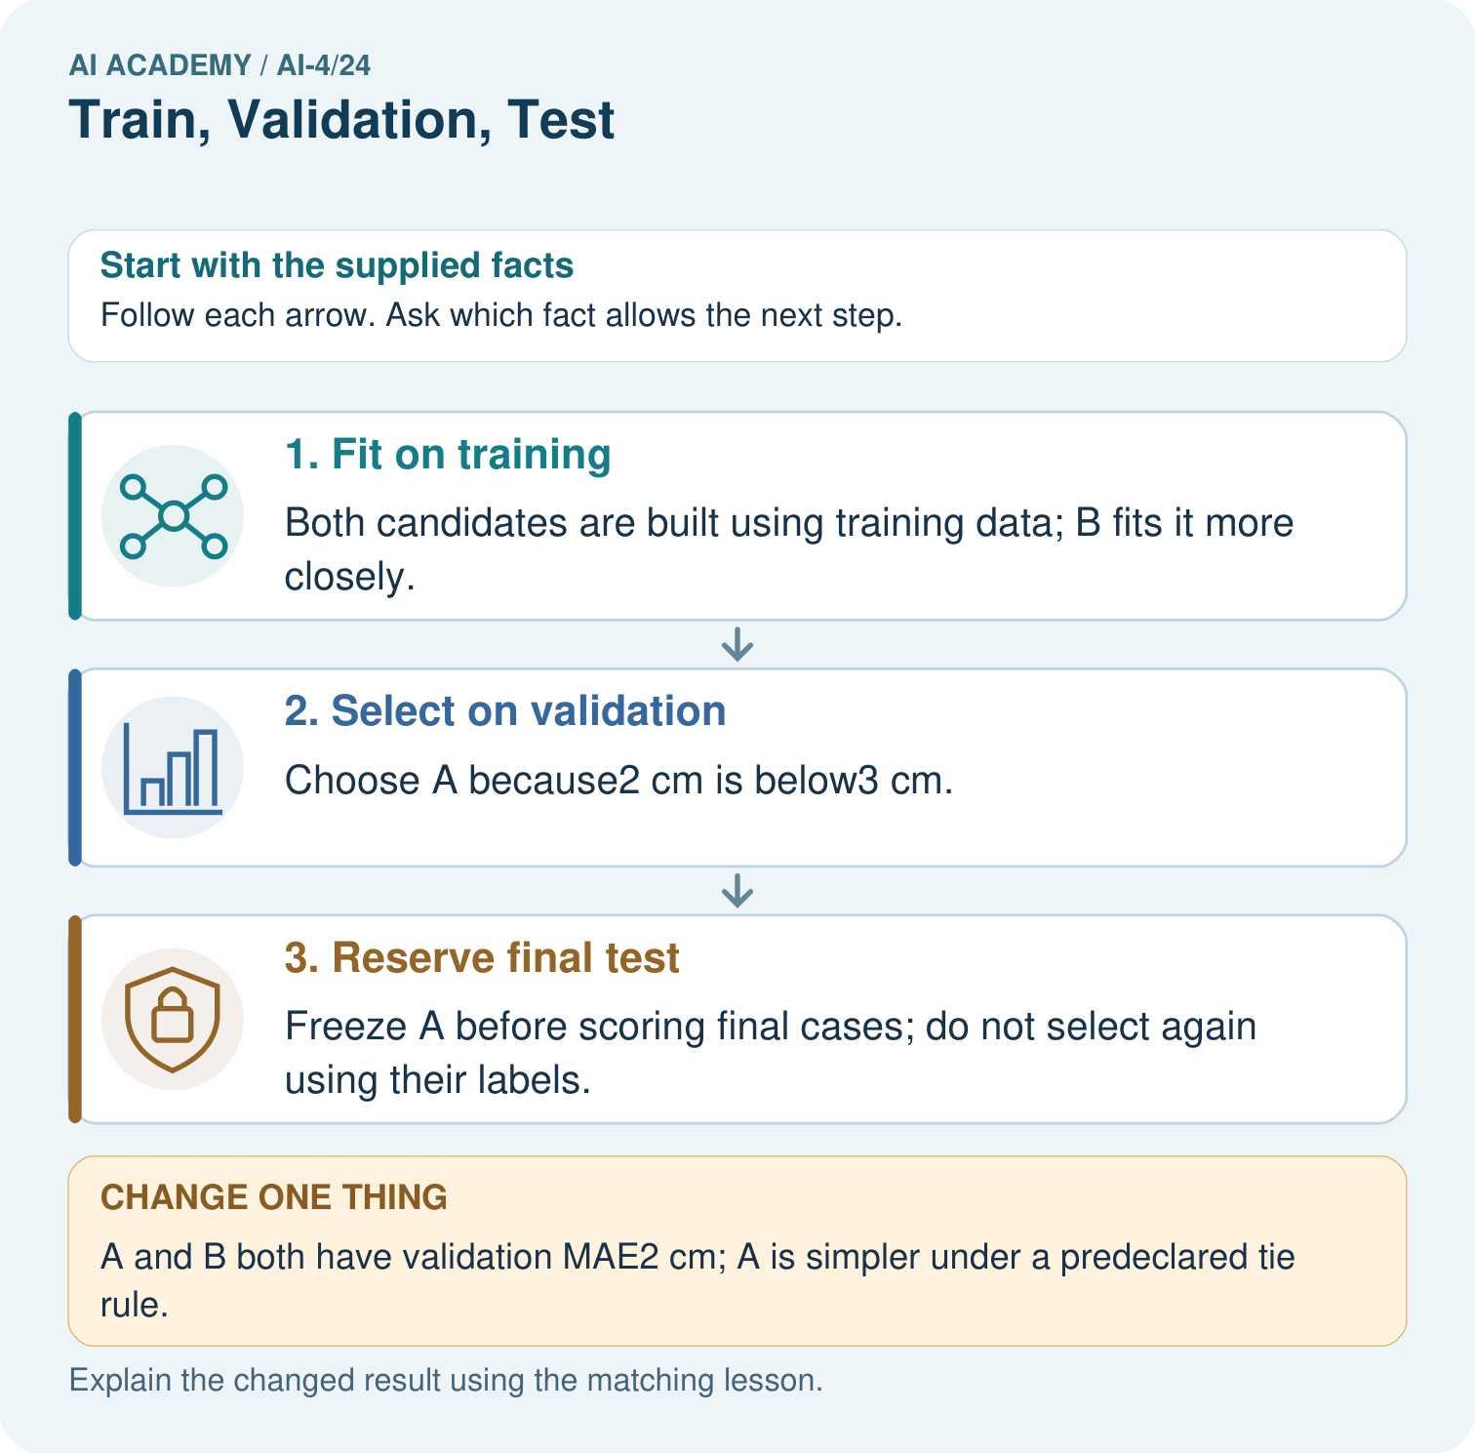

Read the picture one step at a time
Step | What happens and why
1. Fit on training | Both candidates are built using training data; B fits it more closely.
2. Select on validation | Choose A because2 cm is below3 cm.
3. Reserve final test | Freeze A before scoring final cases; do not select again using their labels.
Match each pictured step to the supplied facts. This is a worked teaching case, not an independent assessment.

Why this result follows
Read the picture in order. Freeze A before scoring final cases; do not select again using their labels. The arrows show which recorded input or intermediate result each decision uses. Explain the deciding step aloud before checking the changed case; pointing to the final answer alone does not show how it follows.

What this example does not establish
Repeated validation use can itself overfit model choices; keep a genuinely untouched final evaluation.

Change one thing in the pictured case
Change: A and B both have validation MAE2 cm; A is simpler under a predeclared tie rule.
Prediction: Select A using the predeclared simpler-model tie-break.
Reason: The validation errors tie, so the stated second a = ry rule decides without consulting final data.

Ask while showing the picture
Cover the result. Ask learners to name the inputs and predict the next step. Uncover one step, connect the icon to the actual procedure, and explain its evidence. Then change the supplied condition and compare. The picture is a representation; it does not document execution of a real AI model.

03. Demonstrate and guide practice

Demonstrate and guide practice

Board sequence
Write the given facts: Split 100 independent leaves into 60 train,20 validation,20 test.
Write the question to explain: Explain roles and preprocessing.
Reveal after predictions: Train fits parameters and learned transforms; validation chooses settings; final test evaluates the selected system. Group related records first.
Keep for an independent attempt: Assign roles: set A fits model parameters; B selects between two models; C is opened once after choices are fixed. Which is train, validation and test?

Classroom dialogue
Ask: Which facts are given, and which would we have to assume? Learners mark relevant details before discussing answers.
Say: Predict first. Show the rule, information path or calculation that would produce the result. A correct guess is not yet an explanation.
Reveal reasoning one step at a time. Explain why a tempting alternative fails. Write units and denominators for arithmetic, trace conditions for decisions, and identify supporting sources for claims.
In pairs, one learner solves while the other checks evidence; exchange roles. Remove the worked answer before independent assessment.

Model these guided questions
Guided response: Fit on training, select on validation, evaluate the frozen choice on held-out test; fit preprocessing only on training. Exit response: Selection used this sample, repeated attempts can adapt to it, and future conditions and sampling may differ.

Case-specific teaching sequence
Stage | Teacher action
Session 1 start to 7 minutes | Use the prerequisite question: Which data fitted the line last week? Check the explanation before proceeding.
7 to 18 minutes | Read the opening and model the worked evidence. Ask students to identify validation in context.
18 to 32 minutes | Complete W 1 and W 2 with support: choose a candidate; assign data roles. Require the evidence, not only the final response.
32 to 45 minutes | Read the visual row by row. Collect the guided explanation and compare reasoning in pairs. Connect each conclusion to the stated evidence.
Session 2 start to 8 minutes | Retrieve the distinction between validation and hyperparameter. Invite a counterexample to an overconfident claim.
8 to 20 minutes | Discuss the application and complete W 3: A team creates D after reading validation mistakes. What changes in the record?
20 to 35 minutes | Collect W4 independently before giving hints. Assess these outcomes: Select a model using a declared validation rule; Keep training, validation and test roles separate. Record any support used.
35 to 45 minutes | Use W 5 and the exit response to assess limits. Give targeted feedback, then the fresh retry. Save evidence of independent understanding.

Reduce help deliberately
Completion task: Where should parameter fitting, setting selection and final reporting occur?
Teacher check: Teacher explanation: Fit on training, select on validation, evaluate the frozen choice on held-out test; fit preprocessing only on training.
Start by identifying the given inputs together. Leave the intermediate steps blank. If needed, model one step, then withdraw that help on the next step. Move to a full trace only when the partial trace is understood. For partners, alternate explainer and checker; collect a response from every learner before discussion.

Individual reasoning check
Use the worked case for Validation and model selection. Proposed explanation: “A final answer is enough”. Decide whether this explanation is supported. Point to the step or supplied fact that decides; explain your repair if needed.
Expected correction: Ask for the relevant counts, units, procedure or saved record. For this week: Choose A: validation MAE 3 ties C, and A wins the simplicity tie. B has validation MAE 5 despite training MAE 0.
Collect explanations, not only yes/no votes. If a misunderstanding is common, re-model the relevant step for the class. If it affects a few learners, give a short targeted group explanation while others solve a more demanding variation.

Pictorial practice question
Why does B’s zero training MAE not settle the original choice? Point to the relevant step in the picture, then write the changed result and the rule or evidence that supports it.

Reasoned teacher answer
Model selection is based on held-out validation error here. Lower training error can reflect fitting the training details rather than better new-case prediction. Changed-case check: Select A using the predeclared simpler-model tie-break. The validation errors tie, so the stated second a = ry rule decides without consulting final data.
Changed-case reasoning: Select A using the predeclared simpler-model tie-break. The validation errors tie, so the stated second a = ry rule decides without consulting final data.
Collect each learner’s explanation before discussion. Use the first missing connection between input, deciding step and result to choose support. This question is worked-case practice, not fresh mastery evidence.

04. Run the weekly evidence lab

Run the weekly evidence lab
Keep the test conditions fixed, record every result, and change only one planned factor.
1. Write the hypothesis and expected evidence before running.
2. Role Assignment: sort twenty actions into train/validation/test, then group related examples before splitting.
3. Run one normal, one boundary, one missing, and one shifted case.
4. Calculate the metric from raw counts or row-level errors.
5. Interpret what changed, what did not, and what remains unsafe or unknown.

Make the lab runnable
Use the concrete case as the shared normal case and the independent question as a second case. Each pair creates a boundary or missing-information case and predicts its result before testing. Keep the expected result separate from an observed mistake.
Record | What to capture
Input or evidence | Exact data, instruction or claim
Expected result | Answer or safe fallback declared before the run
Observed result | Actual result, including errors
Explanation | Rule, calculation or evidence explaining the outcome
Next test | One justified change and a new prediction

Diagnose and reteach
MISCONCEPTION TO REPAIR Three random folders are enough even when photos of one plant appear in each.
For guessing, return to given facts and request a trace. For vocabulary without application, use one example and one non-example. For arithmetic errors, check the setup before the calculation. Finish with a different uncoached case before recording mastery.

Address these additional misconceptions
A final answer is enough: Ask for the relevant counts, units, procedure or saved record. For this week: Choose A: validation MAE 3 ties C, and A wins the simplicity tie. B has validation MAE 5 despite training MAE 0.
A stronger claim makes a stronger project: Selection used this sample, repeated attempts can adapt to it, and future conditions and sampling may differ.
The new case can be copied from the example: The independent task changes the evidence. Require a fresh explanation: Choose P with validation MAE 4; Q loses with 6. Keep the test unopened until settings and reporting rules are frozen.

Match the support to the first error
What the response shows | Next teaching action
Missing or misread facts | Read the case aloud, mark supplied versus unknown facts, and let the learner restate it.
Wrong procedure | Return to the deciding step in the worked case. Contrast it with the proposed incorrect explanation.
Arithmetic or implementation error | Trace intermediate values or lines; preserve the first mismatch and retry that step.
Correct result without a reason | Ask for a trace and a changed case before marking independent understanding.
An unsupported wider claim | Ask which supplied evidence supports the claim and which further observation would be needed.
Offer an oral explanation, drawing, enlarged visual or fewer examples when that removes a reading/writing barrier. Keep the same reasoning goal. Stretch secure learners by changing a boundary or assumption and asking them to defend the effect, not simply by assigning more of the same questions.

05. Assess and explain the answers

Assess and explain the answers

Worked case answer
Train fits parameters and learned transforms; validation chooses settings; final test evaluates the selected system. Group related records first.

Independent question
Assign roles: set A fits model parameters; B selects between two models; C is opened once after choices are fixed. Which is train, validation and test?

Expected independent answer
A is training, B is validation and C is final test. Keep C separate from fitting and model selection.

What counts as evidence
Criterion | 0 points | 1 point | 2 points
Result | Incorrect or absent | Partly correct | Correct with necessary conditions
Reasoning | No supporting trace | Some steps | Clear mechanism, calculation or source support
Limit | Overclaims certainty | Vague limitation | Relevant uncertainty or missing fact
Transfer | Copies without adapting | Adapts with prompts | Solves a changed case independently
Use 6/8 as a classroom checkpoint, with 2 required for both Result and Reasoning. This is a proposed teaching rule, not a validated certification threshold. Do not count a coached answer as independent mastery; correct unsafe or unsupported claims regardless of total.

Feedback
Ask the learner to find the evidence that challenges this claim: “Validation and final test data have interchangeable purposes during development.” Keep the first attempt and an uncoached retry separate.

Original transfer answer
Image counts are 54,18,18. Fit the mean on training images only, then apply the fixed transform to validation and test. Validation chooses settings; final test evaluates the selected system. Do not compute the mean from all 90 images.

Explanations for the additional workbook examples

W1 Choose a candidate
Apply the worked selection rule. Explain why B is not chosen.
Teacher explanation: Choose A: validation MAE 3 ties C, and A wins the simplicity tie. B has validation MAE 5 despite training MAE 0.

W2 Assign data roles
Where should parameter fitting, setting selection and final reporting occur?
Teacher explanation: Fit on training, select on validation, evaluate the frozen choice on held-out test; fit preprocessing only on training.

W3 Record another attempt
A team creates D after reading validation mistakes. What changes in the record?
Teacher explanation: Add D and its motivation to development history. Validation influenced D and is not untouched test evidence.

W4 Apply independently
Training errors P 2 Q 0 R 1; validation errors P 4 Q 6 R 4. Rule: smallest validation MAE, then simpler; P is simpler than R. Choose and state the test action.
Teacher explanation: Choose P with validation MAE 4; Q loses with 6. Keep the test unopened until settings and reporting rules are frozen.

W5 Limit a claim
Why is the winning validation score not a guaranteed future score?
Teacher explanation: Selection used this sample, repeated attempts can adapt to it, and future conditions and sampling may differ.

Assess independent transfer
Selected case: Training errors P 2 Q 0 R 1; validation errors P 4 Q 6 R 4. Rule: smallest validation MAE, then simpler; P is simpler than R. Choose and state the test action.

Selected case answer
Teacher explanation: Choose P with validation MAE 4; Q loses with 6. Keep the test unopened until settings and reporting rules are frozen.
Dimension | Evidence required
Explanation | Names the applicable idea or procedure and ties it to the supplied facts.
Trace and result | Preserves the given inputs and shows the relevant intermediate steps; distinguishes a prediction from an observed execution.
Limits | States the assumptions, missing evidence or conditions under which the result would change.
Record each dimension as not yet, with support, or independent. Accept a valid alternative procedure with a defensible trace. Do not penalise an honestly recorded model failure if the learner correctly explains its evidence and limits.

Feedback that the learner uses
Name the earliest unsupported step and give one action to repair it. Have the learner make that repair now and explain why. Then assess the relevant skill on a fresh, fully specified case. Confirm it was not previously practised with feedback; solve and check the new case before assigning it. A follow-up design prompt is a starting brief, not automatically an equivalent test.

06. Connect and extend learning

Connect and extend learning

Responsible Plant Classifier
Publish the grouped split strategy and counts for the Plant Classifier, including why plant identity stays within one split.
Keep the decision, input, result, explanation and remaining limitation in the project evidence record. Retrieve this record next week rather than restarting the project.

Support and stretch
Use a tiny labelled dataset, explicit units and a named positive class. Stretch: require a baseline, held-out evaluation and subgroup or shifted-condition analysis with denominators.

Exit reflection
Ask for one decision the learner can now justify and one situation requiring more evidence or human review. Confidence ratings are separate from correct independent performance.

Bridge to the next week
Next: Week 25: Metrics Match Consequences. Retrieve today’s evidence and identify what carries forward and what is new.

Support and fresh reassessment
Provide a blank evidence table and allow a verbal explanation before writing. Highlight the given conditions without supplying the W 4 conclusion. Use validation and hyperparameter in full sentences. Extension: alter one condition in the worked example and explain which conclusion changes and which remains supported.
For independent W 4, require: Choose P with validation MAE 4; Q loses with 6. Keep the test unopened until settings and reporting rules are frozen. Fresh retry: validation L 2 M 2 N 3, simplicity M before L. Choose M under the declared tie policy; do not use test scores to break the tie. Mark each criterion as independent, supported or not yet demonstrated. Reassess the reasoning after feedback; do not replace the first attempt silently.
Next week: Final testing and honest claims. Carry forward the saved evidence and the distinction between development choices and justified claims.

Plan the delayed return
Suggested return points in this level: ai-4/25, ai-4/27, ai-4/30. Use actual classroom dates, adjusting for holidays and gaps. One, three and six teaching weeks are scheduling choices, not a claimed optimal spacing.
At a delayed check, ask for the idea from memory and a changed application. Compare with the earlier independent response and record support used. For a new level, revisit the previous capstone before checking the new prerequisites.
Record | Teacher evidence
Learner code and date
Concept and case used; prior exposure
Explanation / trace / limits
Support and first repair
Changed case and delayed outcome
Next teaching action
Use the evidence to choose reteaching or the next step. A completed page, confidence rating or attractive project does not by itself demonstrate understanding.

Project evidence from this case
For your Responsible Plant Classifier, save the input, procedure, observed result and limitation of this check. Label this worked example as practice; use a different, previously unreviewed case when checking independent understanding.

07. Prepare, teach and assess
Teaching target: Select a model using a declared validation rule
Prepare the labelled worked-case picture, the matching workbook, fictional input cards and a place for individual responses. Check a local Python 3 environment before class; have a paper-trace version ready.
Session | Plan | Resources
Session 1 · Understand · 45 min | 0–7: recall and prerequisite; 7–15: inspect the concrete case and predict; 15–30: teacher models the worked trace; 30–40: learners explain a step using the text and visual; 40–45: check the core idea. | Sections 1–6; record the brief recall in the workbook.
Session 2 · Practise · 45 min | 0–5: retrieve the procedure; 5–15: W2 completion practice; 15–23: explain and check with a partner; 23–30: each learner answers the misconception check; 30–40: targeted reteaching or a harder variation; 40–45: prepare the investigation. | Sections 7–10; use the matching workbook W2 and misconception check.
Session 3 · Investigate and transfer · 45 min | 0–5: retrieve the decision rule; 5–20: investigate or trace; 20–30: start the independent case; 30–38: connect the project; 38–43: act on feedback; 43–45: plan the return check. | Sections 9 and 11–14. Give extra time to finish the full task set; use Section 15 when the week includes a coding lab.
Before class, solve the supported practice: Where should parameter fitting, setting selection and final reporting occur?
Reasoned practice answer: Teacher explanation: Fit on training, select on validation, evaluate the frozen choice on held-out test; fit preprocessing only on training.
Check every learner before discussion: Use the worked case for Validation and model selection. Proposed explanation: “A final answer is enough”. Decide whether this explanation is supported. Point to the step or supplied fact that decides; explain your repair if needed.
Misconception repair: Ask for the relevant counts, units, procedure or saved record. For this week: Choose A: validation MAE 3 ties C, and A wins the simplicity tie. B has validation MAE 5 despite training MAE 0.
Support: read the exact case aloud, enlarge the labelled picture, supply input cards and model only the first deciding step. Accept a spoken explanation or drawing; retain the reasoning goal.
Extension: A and B both have validation MAE2 cm; A is simpler under a predeclared tie rule. Require a prediction and a reason before comparing. Expected result: Select A using the predeclared simpler-model tie-break. Reason: The validation errors tie, so the stated second a = ry rule decides without consulting final data.
Independent assessment: withhold the reserved answer until the learner has attempted the new case. Record support separately from correctness.
Criterion | Not yet | With support | Independent
Explanation | Names an answer without a deciding fact | Uses a hint to link fact and decision | Explains the deciding fact in own words
Trace or test | Cannot connect input and result | Completes steps with prompts | Traces or tests a changed case accurately
Limits and revision | Claims more than evidence supports | Names a limit after a prompt | States a defensible limit and useful next test
Project checkpoint: Evaluate and revise. Compare with your starting method, explain errors and record a justified revision.
Use the weekly teacher answer for topic-specific reasoning. A saved progress tick is an activity record; judge mastery from the learner’s explanation and evidence.

