AI ACADEMY · TEACHER · ai-4/32

Proxy Features and Fairness
Project: Responsible Plant Classifier

01. Proxy Features and Fairness

Teach the learning cycle
Primary target: Identify possible proxy features
Session | Sequence and minutes | Resources
Session 1 · Understand · 45 min | 0–7: recall and prerequisite; 7–15: inspect the concrete case and predict; 15–30: teacher models the worked trace; 30–40: learners explain a step using the text and visual; 40–45: check the core idea. | Sections 1–6; record the brief recall in the workbook.
Session 2 · Practise · 45 min | 0–5: retrieve the procedure; 5–15: W2 completion practice; 15–23: explain and check with a partner; 23–30: each learner answers the misconception check; 30–40: targeted reteaching or a harder variation; 40–45: prepare the investigation. | Sections 7–10; use the matching workbook W2 and misconception check.
Session 3 · Investigate and transfer · 45 min | 0–5: retrieve the decision rule; 5–20: investigate or trace; 20–30: start the independent case; 30–38: connect the project; 38–43: act on feedback; 43–45: plan the return check. | Sections 9 and 11–14. Give extra time to finish the full task set; use Section 15 when the week includes a coding lab.
This is a starting allocation of 135 minutes, not a validated duration. Preserve all named topics. Schedule extra time for connected examples, the full investigation, independent cases and project building. Repeated copies of a case share one recorded attempt; they are not new evidence.

Retrieval answer guidance

Subgroup Performance
Without opening the old lesson, explain one key idea from Subgroup Performance. Give an example and a mistake that the idea helps you avoid.
Look for: Calculate subgroup results with sample sizes
Reference example, not the only acceptable wording: Teacher explanation: A 2/20=10 percent; B 3/5=60 percent; pooled 5/25=20 percent, a 50-point group gap.

Feature Engineering
Without opening the old lesson, explain one key idea from Feature Engineering. Give an example and a mistake that the idea helps you avoid.
Look for: Create features available at prediction time
Reference example, not the only acceptable wording: Teacher explanation: Areas 6, 8, 6 square cm; training mean 20/3 square cm.

Reproducible Experiments
Without opening the old lesson, explain one key idea from Reproducible Experiments. Give an example and a mistake that the idea helps you avoid.
Look for: Record enough detail to reproduce a run
Reference example, not the only acceptable wording: Teacher explanation: Mean 70 percent; range 80-60=20 percentage points, across the three declared runs.
Use the student module and workbook section with this exact week title. The worked case, independent question and answers below form one aligned lesson sequence.

What the learner must demonstrate
A leaf model performs well using location ID alone. Explain a possible proxy problem and design a diagnostic evaluation.

Concept to explain
A feature may indirectly encode sensitive identity or context, creating unjustified differences even when the original field is absent.
Term | Meaning
proxy feature | input correlated with another sensitive attribute
fairness | evaluate benefits and harms across affected groups
paired test | cases differing in one relevant factor
mitigation | control reducing an identified risk

Prepare the class
Use the supplied scenario, student illustrations and blank paper. For numeric work, offer counters or a calculator after learners show the setup. Fictional records are supplied; personal data and paid accounts are unnecessary.
Allow 80 minutes: recall 8; explanation 12; worked demonstration 15; guided practice 20; independent assessment 15; project and reflection 10. Extend the lab into a second session when needed.

Preparation for the connected explanation
Teach two 45-minute sessions. This week focuses on proxy features and fairness. Model the worked example first, collect the new W 4 case independently before feedback, and use the fresh retry to check transfer. Award credit for traceable reasoning and bounded claims, including justified uncertainty.

Readiness answer
No; examine errors, consequences, data and context.
Printed student lesson and workbook
Paper, pencils and a calculator for fractions
The fictional examples and a blank evidence table
Saved classroom project records for critique; no personal student dataset required

End goal for the pictorial case
By the end, I can explain proxy features and fairness using a traced example and a stated limitation.
This added worked case illustrates the week’s main idea. Retain all original and connected topics; schedule its practice within the teaching cycle.

02. Explain the mechanism

Explain the mechanism
Trace the information, fitted behavior, and evaluation proof separately.
QUESTION Trace suspicious proxies and compare model behavior after a controlled removal.
MODEL IDEA A feature may indirectly encode sensitive identity or context, creating unjustified differences even when the original field is absent.
PROOF NEEDED Use an unseen case, visible calculation, error analysis, and a stated limitation.
UNDER THE HOOD Photo background predicts classroom location and is correlated with camera quality. Model uses background as a shortcut for health labels.
Draw a fresh data → model → prediction → evaluation trace:
Predict first. Then check each step. A correct answer without visible evidence cannot be audited.
STEP 1 Photo background predicts classroom location and is correlated with camera quality.
STEP 2 Model uses background as a shortcut for health labels.
STEP 3 Create paired crops with the same leaf and different backgrounds; predictions change.
STEP 4 Crop backgrounds or improve data, retrain, and compare performance and subgroup gaps.
CHECK Verify the denominator, unit, split, class definition, and data version before interpreting a score.
Recalculate, retrace, or restate the evidence independently:

Concrete teaching case
Background colour tracks collection location, associated with plant types.
Explain proxy risk and test.

Exact explanation to model
Background can be a location shortcut rather than leaf evidence. Test leaf types across backgrounds and locations and compare slices.

Explain the added worked example
An input can carry information about a characteristic without naming it. In a fictional school-device dataset, device code may be associated with building or access to newer equipment. Removing a building field does not remove all related information. Do not infer a real student identity or protected characteristic in this exercise.
Use fictional classroom data throughout this investigation. Keep the task, units, reference labels and data split visible as you reason. Earlier weeks supplied the model-building process; this week examines proxy features and fairness.
Fictional records show device code X on 8 of 10 north-building examples and 2 of 10 south-building examples. Device and building are associated in this sample. This does not prove device causes model errors or that every X device comes from north. The remaining cases contradict such a universal rule.
Before continuing, underline the decision rule and circle the evidence that supports the conclusion. Explain the example to a partner without replacing the counts or conditions with a stronger claim. Keep the distinction between an observed result and a proposed next step.

Key terms
Term | Meaning
Proxy feature | A variable that can stand in for another characteristic
Correlation | An observed association, not proof of cause
Sensitive attribute | A characteristic requiring particular care in a context
Ablation | A comparison that removes a feature or component

Model the reasoning aloud
Use the complete worked example below before asking learners to complete W2. Reveal a small part, invite a prediction, then explain the deciding step. These teacher notes contain solutions; do not reveal the independent case answer during modelling.

Proxy features and fairness at a glance
Part | Evidence or action | Interpretation
North examples | 8 X of 10 | 2 other devices
South examples | 2 X of 10 | 8 other devices
Review question | What does code represent? | Check context and errors
A feature may be legitimate for one purpose and inappropriate for another. Ask what is measured, when it is available, why it predicts and who might be disadvantaged. A correlation alone neither authorizes use nor proves harm. Talk through the intended decision and available alternatives.

Why might removing building but keeping device code leave related information? Explain the steps or evidence behind your response.
________________________________________________________________
________________________________________________________________
________________________________________________________________
________________________________________________________________
Thinking move | Teacher prompt
Plan | What is given? What is the question? Which procedure fits these facts?
Do | Point to each input and intermediate step in the worked trace. Name the rule that allows the next step.
Check | Does the output answer the question? Which assumption or limitation prevents a larger claim?
Use the diagram and verbal explanation together. Ask learners to match a sentence to a specific visual step; do not assign learners fixed visual or auditory learning styles.

A pictorial worked case: Proxy Features and Fairness
Removing an obvious setting field may leave another field that carries the same information.

The facts we will use
Toy table has location=greenhouse/desk and camera_code=G/D. Every G record is greenhouse; every D record is desk. The team drops location.
All inputs and outcomes in this worked example are invented classroom data; no real model run is claimed.
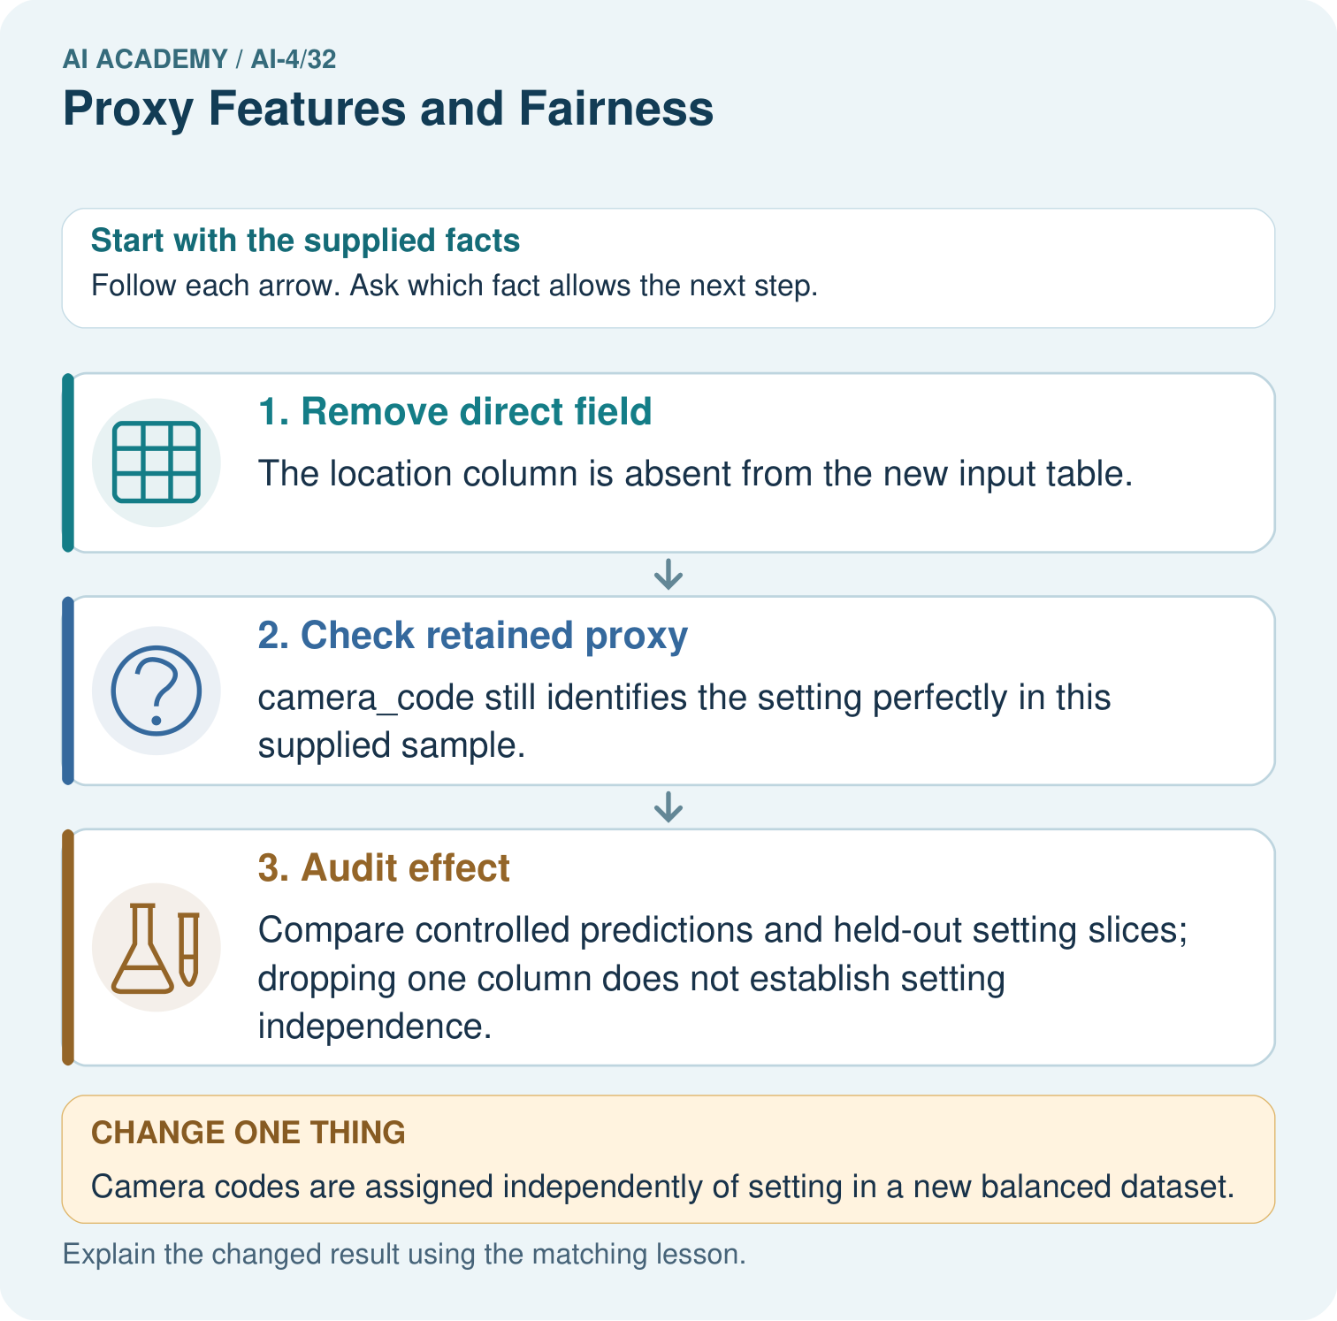

Read the picture one step at a time
Step | What happens and why
1. Remove direct field | The location column is absent from the new input table.
2. Check retained proxy | camera_code still identifies the setting perfectly in this supplied sample.
3. Audit effect | Compare controlled predictions and held-out setting slices; dropping one column does not establish setting independence.
Match each pictured step to the supplied facts. This is a worked teaching case, not an independent assessment.

Why this result follows
Read the picture in order. Compare controlled predictions and held-out setting slices; dropping one column does not establish setting independence. The arrows show which recorded input or intermediate result each decision uses. Explain the deciding step aloud before checking the changed case; pointing to the final answer alone does not show how it follows.

What this example does not establish
A correlated field is not necessarily harmful in every use; assess task relevance, consequences and actual model behaviour.

Change one thing in the pictured case
Change: Camera codes are assigned independently of setting in a new balanced dataset.
Prediction: camera_code no longer perfectly identifies setting in that dataset.
Reason: The observed mapping changed; other retained fields may still contain setting information.

Ask while showing the picture
Cover the result. Ask learners to name the inputs and predict the next step. Uncover one step, connect the icon to the actual procedure, and explain its evidence. Then change the supplied condition and compare. The picture is a representation; it does not document execution of a real AI model.

03. Demonstrate and guide practice

Demonstrate and guide practice

Board sequence
Write the given facts: Background colour tracks collection location, associated with plant types.
Write the question to explain: Explain proxy risk and test.
Reveal after predictions: Background can be a location shortcut rather than leaf evidence. Test leaf types across backgrounds and locations and compare slices.
Keep for an independent attempt: A plant classifier uses camera_model, and one species was photographed mostly on a single camera. What shortcut might it learn and how could you investigate?

Classroom dialogue
Ask: Which facts are given, and which would we have to assume? Learners mark relevant details before discussing answers.
Say: Predict first. Show the rule, information path or calculation that would produce the result. A correct guess is not yet an explanation.
Reveal reasoning one step at a time. Explain why a tempting alternative fails. Write units and denominators for arithmetic, trace conditions for decisions, and identify supporting sources for claims.
In pairs, one learner solves while the other checks evidence; exchange roles. Remove the worked answer before independent assessment.

Model these guided questions
Guided response: Device code is associated with building in the sample and may carry some of that information indirectly. Exit response: No. Other features can retain information and accuracy can hide different errors and consequences.

Case-specific teaching sequence
Stage | Teacher action
Session 1 start to 7 minutes | Use the prerequisite question: Does equal overall accuracy prove fair treatment? Check the explanation before proceeding.
7 to 18 minutes | Read the opening and model the worked evidence. Ask students to identify proxy feature in context.
18 to 32 minutes | Complete W 1 and W 2 with support: read an association; find a proxy risk. Require the evidence, not only the final response.
32 to 45 minutes | Read the visual row by row. Collect the guided explanation and compare reasoning in pairs. Connect each conclusion to the stated evidence.
Session 2 start to 8 minutes | Retrieve the distinction between proxy feature and correlation. Invite a counterexample to an overconfident claim.
8 to 20 minutes | Discuss the application and complete W 3: Describe a controlled with/without-code comparison.
20 to 35 minutes | Collect W4 independently before giving hints. Assess these outcomes: Identify possible proxy features; Explain why removing one field does not guarantee fairness. Record any support used.
35 to 45 minutes | Use W 5 and the exit response to assess limits. Give targeted feedback, then the fresh retry. Save evidence of independent understanding.

Reduce help deliberately
Completion task: Why might removing building but keeping device code leave related information?
Teacher check: Teacher explanation: Device code is associated with building in the sample and may carry some of that information indirectly.
Start by identifying the given inputs together. Leave the intermediate steps blank. If needed, model one step, then withdraw that help on the next step. Move to a full trace only when the partial trace is understood. For partners, alternate explainer and checker; collect a response from every learner before discussion.

Individual reasoning check
Use the worked case for Proxy features and fairness. Proposed explanation: “A final answer is enough”. Decide whether this explanation is supported. Point to the step or supplied fact that decides; explain your repair if needed.
Expected correction: Ask for the relevant counts, units, procedure or saved record. For this week: X occurs 8/10 north and 2/10 south in this sample. This supports an association, not a deterministic identity rule or a causal explanation.
Collect explanations, not only yes/no votes. If a misunderstanding is common, re-model the relevant step for the class. If it affects a few learners, give a short targeted group explanation while others solve a more demanding variation.

Pictorial practice question
What evidence contradicts the original “all setting information removed” claim? Point to the relevant step in the picture, then write the changed result and the rule or evidence that supports it.

Reasoned teacher answer
The retained G/D code maps exactly to greenhouse/desk, so the supplied table still exposes setting information. Changed-case check: camera_code no longer perfectly identifies setting in that dataset. The observed mapping changed; other retained fields may still contain setting information.
Changed-case reasoning: camera_code no longer perfectly identifies setting in that dataset. The observed mapping changed; other retained fields may still contain setting information.
Collect each learner’s explanation before discussion. Use the first missing connection between input, deciding step and result to choose support. This question is worked-case practice, not fresh mastery evidence.

04. Run the weekly evidence lab

Run the weekly evidence lab
Keep the test conditions fixed, record every result, and change only one planned factor.
1. Write the hypothesis and expected evidence before running.
2. Proxy Detective: map feature origins, run paired tests, remove one suspicious feature, and check both utility and gaps.
3. Run one normal, one boundary, one missing, and one shifted case.
4. Calculate the metric from raw counts or row-level errors.
5. Interpret what changed, what did not, and what remains unsafe or unknown.

Make the lab runnable
Use the concrete case as the shared normal case and the independent question as a second case. Each pair creates a boundary or missing-information case and predicts its result before testing. Keep the expected result separate from an observed mistake.
Record | What to capture
Input or evidence | Exact data, instruction or claim
Expected result | Answer or safe fallback declared before the run
Observed result | Actual result, including errors
Explanation | Rule, calculation or evidence explaining the outcome
Next test | One justified change and a new prediction

Diagnose and reteach
MISCONCEPTION TO REPAIR Removing a sensitive column guarantees the model cannot use related information.
For guessing, return to given facts and request a trace. For vocabulary without application, use one example and one non-example. For arithmetic errors, check the setup before the calculation. Finish with a different uncoached case before recording mastery.

Address these additional misconceptions
A final answer is enough: Ask for the relevant counts, units, procedure or saved record. For this week: X occurs 8/10 north and 2/10 south in this sample. This supports an association, not a deterministic identity rule or a causal explanation.
A stronger claim makes a stronger project: No. Other features can retain information and accuracy can hide different errors and consequences.
The new case can be copied from the example: The independent task changes the evidence. Require a fresh explanation: The claim is unsupported: school code may be associated with location. Review provenance and associations, compare ablations and group errors, and state unresolved proxy risks.

Match the support to the first error
What the response shows | Next teaching action
Missing or misread facts | Read the case aloud, mark supplied versus unknown facts, and let the learner restate it.
Wrong procedure | Return to the deciding step in the worked case. Contrast it with the proposed incorrect explanation.
Arithmetic or implementation error | Trace intermediate values or lines; preserve the first mismatch and retry that step.
Correct result without a reason | Ask for a trace and a changed case before marking independent understanding.
An unsupported wider claim | Ask which supplied evidence supports the claim and which further observation would be needed.
Offer an oral explanation, drawing, enlarged visual or fewer examples when that removes a reading/writing barrier. Keep the same reasoning goal. Stretch secure learners by changing a boundary or assumption and asking them to defend the effect, not simply by assigning more of the same questions.

05. Assess and explain the answers

Assess and explain the answers

Worked case answer
Background can be a location shortcut rather than leaf evidence. Test leaf types across backgrounds and locations and compare slices.

Independent question
A plant classifier uses camera_model, and one species was photographed mostly on a single camera. What shortcut might it learn and how could you investigate?

Expected independent answer
It may use camera artifacts as a proxy for species. Test across cameras with balanced species coverage and compare a model excluding the feature.

What counts as evidence
Criterion | 0 points | 1 point | 2 points
Result | Incorrect or absent | Partly correct | Correct with necessary conditions
Reasoning | No supporting trace | Some steps | Clear mechanism, calculation or source support
Limit | Overclaims certainty | Vague limitation | Relevant uncertainty or missing fact
Transfer | Copies without adapting | Adapts with prompts | Solves a changed case independently
Use 6/8 as a classroom checkpoint, with 2 required for both Result and Reasoning. This is a proposed teaching rule, not a validated certification threshold. Do not count a coached answer as independent mastery; correct unsafe or unsupported claims regardless of total.

Feedback
Ask the learner to find the evidence that challenges this claim: “A feature unrelated to plant biology cannot carry label-correlated information.” Keep the first attempt and an uncoached retry separate.

Original transfer answer
Location may encode class prevalence rather than leaf evidence. Evaluate leaf classes across new and shared locations, inspect coverage and use appropriate grouping. A correlated proxy can fail after deployment; high existing accuracy does not prove a useful causal feature.

Explanations for the additional workbook examples

W1 Read an association
What do the device counts support, and what do they not support?
Teacher explanation: X occurs 8/10 north and 2/10 south in this sample. This supports an association, not a deterministic identity rule or a causal explanation.

W2 Find a proxy risk
Why might removing building but keeping device code leave related information?
Teacher explanation: Device code is associated with building in the sample and may carry some of that information indirectly.

W3 Plan an ablation
Describe a controlled with/without-code comparison.
Teacher explanation: Use the same validation rows and metric, fit both versions only on training, and report overall and relevant subgroup errors with denominators.

W4 Apply independently
A team removes postcode but retains school code and claims all location-related information is gone. Evaluate the claim and request evidence.
Teacher explanation: The claim is unsupported: school code may be associated with location. Review provenance and associations, compare ablations and group errors, and state unresolved proxy risks.

W5 Limit the result
Does unchanged accuracy after removing a proxy prove fairness?
Teacher explanation: No. Other features can retain information and accuracy can hide different errors and consequences.

Assess independent transfer
Selected case: A team removes postcode but retains school code and claims all location-related information is gone. Evaluate the claim and request evidence.

Selected case answer
Teacher explanation: The claim is unsupported: school code may be associated with location. Review provenance and associations, compare ablations and group errors, and state unresolved proxy risks.
Dimension | Evidence required
Explanation | Names the applicable idea or procedure and ties it to the supplied facts.
Trace and result | Preserves the given inputs and shows the relevant intermediate steps; distinguishes a prediction from an observed execution.
Limits | States the assumptions, missing evidence or conditions under which the result would change.
Record each dimension as not yet, with support, or independent. Accept a valid alternative procedure with a defensible trace. Do not penalise an honestly recorded model failure if the learner correctly explains its evidence and limits.

Feedback that the learner uses
Name the earliest unsupported step and give one action to repair it. Have the learner make that repair now and explain why. Then assess the relevant skill on a fresh, fully specified case. Confirm it was not previously practised with feedback; solve and check the new case before assigning it. A follow-up design prompt is a starting brief, not automatically an equivalent test.

06. Connect and extend learning

Connect and extend learning

Responsible Plant Classifier
Document Plant Classifier proxy risks, paired-test evidence, mitigation, and remaining fairness limitation.
Keep the decision, input, result, explanation and remaining limitation in the project evidence record. Retrieve this record next week rather than restarting the project.

Support and stretch
Use a tiny labelled dataset, explicit units and a named positive class. Stretch: require a baseline, held-out evaluation and subgroup or shifted-condition analysis with denominators.

Exit reflection
Ask for one decision the learner can now justify and one situation requiring more evidence or human review. Confidence ratings are separate from correct independent performance.

Bridge to the next week
Next: Week 33: Model Cards and Human Review. Retrieve today’s evidence and identify what carries forward and what is new.

Support and fresh reassessment
Provide a blank evidence table and allow a verbal explanation before writing. Highlight the given conditions without supplying the W 4 conclusion. Use proxy feature and correlation in full sentences. Extension: alter one condition in the worked example and explain which conclusion changes and which remains supported.
For independent W 4, require: The claim is unsupported: school code may be associated with location. Review provenance and associations, compare ablations and group errors, and state unresolved proxy risks. Fresh retry: removing a device-brand field while retaining model number may leave brand-related information. Require a contextual association check and no automatic fairness claim. Mark each criterion as independent, supported or not yet demonstrated. Reassess the reasoning after feedback; do not replace the first attempt silently.
Next week: Model cards and review. Carry forward the saved evidence and the distinction between development choices and justified claims.

Plan the delayed return
Suggested return points in this level: ai-4/33, ai-4/35. Use actual classroom dates, adjusting for holidays and gaps. One, three and six teaching weeks are scheduling choices, not a claimed optimal spacing.
At a delayed check, ask for the idea from memory and a changed application. Compare with the earlier independent response and record support used. For a new level, revisit the previous capstone before checking the new prerequisites.
Record | Teacher evidence
Learner code and date
Concept and case used; prior exposure
Explanation / trace / limits
Support and first repair
Changed case and delayed outcome
Next teaching action
Use the evidence to choose reteaching or the next step. A completed page, confidence rating or attractive project does not by itself demonstrate understanding.

Project evidence from this case
For your Responsible Plant Classifier, save the input, procedure, observed result and limitation of this check. Label this worked example as practice; use a different, previously unreviewed case when checking independent understanding.

07. Prepare, teach and assess
Teaching target: Identify possible proxy features
Prepare the labelled worked-case picture, the matching workbook, fictional input cards and a place for individual responses. Check a local Python 3 environment before class; have a paper-trace version ready.
Session | Plan | Resources
Session 1 · Understand · 45 min | 0–7: recall and prerequisite; 7–15: inspect the concrete case and predict; 15–30: teacher models the worked trace; 30–40: learners explain a step using the text and visual; 40–45: check the core idea. | Sections 1–6; record the brief recall in the workbook.
Session 2 · Practise · 45 min | 0–5: retrieve the procedure; 5–15: W2 completion practice; 15–23: explain and check with a partner; 23–30: each learner answers the misconception check; 30–40: targeted reteaching or a harder variation; 40–45: prepare the investigation. | Sections 7–10; use the matching workbook W2 and misconception check.
Session 3 · Investigate and transfer · 45 min | 0–5: retrieve the decision rule; 5–20: investigate or trace; 20–30: start the independent case; 30–38: connect the project; 38–43: act on feedback; 43–45: plan the return check. | Sections 9 and 11–14. Give extra time to finish the full task set; use Section 15 when the week includes a coding lab.
Before class, solve the supported practice: Why might removing building but keeping device code leave related information?
Reasoned practice answer: Teacher explanation: Device code is associated with building in the sample and may carry some of that information indirectly.
Check every learner before discussion: Use the worked case for Proxy features and fairness. Proposed explanation: “A final answer is enough”. Decide whether this explanation is supported. Point to the step or supplied fact that decides; explain your repair if needed.
Misconception repair: Ask for the relevant counts, units, procedure or saved record. For this week: X occurs 8/10 north and 2/10 south in this sample. This supports an association, not a deterministic identity rule or a causal explanation.
Support: read the exact case aloud, enlarge the labelled picture, supply input cards and model only the first deciding step. Accept a spoken explanation or drawing; retain the reasoning goal.
Extension: Camera codes are assigned independently of setting in a new balanced dataset. Require a prediction and a reason before comparing. Expected result: camera_code no longer perfectly identifies setting in that dataset. Reason: The observed mapping changed; other retained fields may still contain setting information.
Independent assessment: withhold the reserved answer until the learner has attempted the new case. Record support separately from correctness.
Criterion | Not yet | With support | Independent
Explanation | Names an answer without a deciding fact | Uses a hint to link fact and decision | Explains the deciding fact in own words
Trace or test | Cannot connect input and result | Completes steps with prompts | Traces or tests a changed case accurately
Limits and revision | Claims more than evidence supports | Names a limit after a prompt | States a defensible limit and useful next test
Project checkpoint: Present and defend. Demonstrate the system, explain one failure and justify the next improvement with evidence.
Use the weekly teacher answer for topic-specific reasoning. A saved progress tick is an activity record; judge mastery from the learner’s explanation and evidence.

