AI ACADEMY · TEACHER · ai-4/35

Capstone Train, Analyze, Improve
Project: Responsible Plant Classifier

01. Capstone Train, Analyze, Improve

Teach the learning cycle
Primary target: Run a frozen final evaluation with complete accounting
Session | Sequence and minutes | Resources
Session 1 · Understand · 45 min | 0–7: recall and prerequisite; 7–15: inspect the concrete case and predict; 15–30: teacher models the worked trace; 30–40: learners explain a step using the text and visual; 40–45: check the core idea. | Sections 1–6; record the brief recall in the workbook.
Session 2 · Practise · 45 min | 0–5: retrieve the procedure; 5–15: W2 completion practice; 15–23: explain and check with a partner; 23–30: each learner answers the misconception check; 30–40: targeted reteaching or a harder variation; 40–45: prepare the investigation. | Sections 7–10; use the matching workbook W2 and misconception check.
Session 3 · Investigate and transfer · 45 min | 0–5: retrieve the decision rule; 5–20: investigate or trace; 20–30: start the independent case; 30–38: connect the project; 38–43: act on feedback; 43–45: plan the return check. | Sections 9 and 11–14. Give extra time to finish the full task set; use Section 15 when the week includes a coding lab.
This is a starting allocation of 135 minutes, not a validated duration. Preserve all named topics. Schedule extra time for connected examples, the full investigation, independent cases and project building. Repeated copies of a case share one recorded attempt; they are not new evidence.

Retrieval answer guidance

Capstone Dataset and Baseline
Without opening the old lesson, explain one key idea from Capstone Dataset and Baseline. Give an example and a mistake that the idea helps you avoid.
Look for: Define a feasible capstone question and acceptance criteria
Reference example, not the only acceptable wording: Teacher explanation: Compare a simple classifier with a training-majority baseline on the fictional parcel evaluation; no real handling or student decisions are supported.

Proxy Features and Fairness
Without opening the old lesson, explain one key idea from Proxy Features and Fairness. Give an example and a mistake that the idea helps you avoid.
Look for: Identify possible proxy features
Reference example, not the only acceptable wording: Teacher explanation: X occurs 8/10 north and 2/10 south in this sample. This supports an association, not a deterministic identity rule or a causal explanation.

Feature Engineering
Without opening the old lesson, explain one key idea from Feature Engineering. Give an example and a mistake that the idea helps you avoid.
Look for: Create features available at prediction time
Reference example, not the only acceptable wording: Teacher explanation: Areas 6, 8, 6 square cm; training mean 20/3 square cm.
Use the student module and workbook section with this exact week title. The worked case, independent question and answers below form one aligned lesson sequence.

What the learner must demonstrate
A new model reduces validation errors from 8 to 5 but the team also removed three hard cases. Can improvement be attributed to the model? Propose a repair to the experiment.

Concept to explain
One evidence-based improvement follows a reproducible training run, metric audit, error clusters, and subgroup analysis.
Term | Meaning
baseline run | first reproducible model result
error audit | systematic review of mistakes
before/after | same evaluation around one change
regression | previously passing case now fails

Prepare the class
Use the supplied scenario, student illustrations and blank paper. For numeric work, offer counters or a calculator after learners show the setup. Fictional records are supplied; personal data and paid accounts are unnecessary.
Allow 80 minutes: recall 8; explanation 12; worked demonstration 15; guided practice 20; independent assessment 15; project and reflection 10. Extend the lab into a second session when needed.

Preparation for the connected explanation
Teach two 45-minute sessions. This week focuses on capstone evaluation and revision. Model the worked example first, collect the new W 4 case independently before feedback, and use the fresh retry to check transfer. Award credit for traceable reasoning and bounded claims, including justified uncertainty.

Readiness answer
The inspected set becomes development evidence for the revised version.
Printed student lesson and workbook
Paper, pencils and a calculator for fractions
The fictional examples and a blank evidence table
Saved classroom project records for critique; no personal student dataset required

End goal for the pictorial case
By the end, I can explain capstone train, analyze, improve using a traced example and a stated limitation.
This added worked case illustrates the week’s main idea. Retain all original and connected topics; schedule its practice within the teaching cycle.

02. Explain the mechanism

Explain the mechanism
Trace the information, fitted behavior, and evaluation proof separately.
QUESTION Train, audit, change one factor, and compare against the same validation set.
MODEL IDEA One evidence-based improvement follows a reproducible training run, metric audit, error clusters, and subgroup analysis.
PROOF NEEDED Use an unseen case, visible calculation, error analysis, and a stated limitation.
UNDER THE HOOD Model v1 passes 14/20 validation cases; evening accuracy is 40%. The six failed cases are low-light cases. One of those same six also has a disputed reference label; that is an overlapping review flag, not a seventh failed case.
Draw a fresh data → model → prediction → evaluation trace:
Predict first. Then check each step. A correct answer without visible evidence cannot be audited.
STEP 1 Model v1 passes 14/20 validation cases; evening accuracy is 40%.
STEP 2 The six failed cases are low-light cases. One of those same six also has a disputed reference label; that is an overlapping review flag, not a seventh failed case.
STEP 3 Add reviewed low-light training examples while freezing features and model settings.
STEP 4 Model v2 passes 17/20; evening rises to 70%; inspect every old pass and record remaining limits.
CHECK Verify the denominator, unit, split, class definition, and data version before interpreting a score.
Recalculate, retrace, or restate the evidence independently:

Concrete teaching case
Baseline validation accuracy70%; model80%; most remaining errors are dim images.
Plan improvement evidence.

Exact explanation to model
Keep partitions fixed, inspect dim-image errors, change one factor and compare the same validation criteria/slices. Reserve final test.

Explain the added worked example
The teacher releases final-test labels only after checking the freeze record. Score baseline and candidate on the same planned rows. Save every prediction, denominator and failure. Do not edit a model while reading labels and then present only the edited version as the original test.
Use fictional classroom data throughout this investigation. Keep the task, units, reference labels and data split visible as you reason. Earlier weeks supplied the model-building process; this week examines capstone evaluation and revision.
Illustrative frozen test has 12 rows: candidate[[7, 1],[2, 2]], baseline[[8, 0],[4, 0]], blocked positive. Candidate accuracy 9/12=75 percent, precision 2/3 and recall 2/4; baseline accuracy 8/12 about 66.7 percent. The candidate adds one false alarm and misses two rather than four blocked cases.
Before continuing, underline the decision rule and circle the evidence that supports the conclusion. Explain the example to a partner without replacing the counts or conditions with a stronger claim. Keep the distinction between an observed result and a proposed next step.

Key terms
Term | Meaning
Final evaluation | Assessment of the frozen procedure on held-out evidence
Error audit | A documented inspection of mistakes and missing predictions
Revision log | A record of changes, reasons and affected evidence
Evidence status | Whether a result is development, untouched test or post-test reuse

Model the reasoning aloud
Use the complete worked example below before asking learners to complete W2. Reveal a small part, invite a prediction, then explain the deciding step. These teacher notes contain solutions; do not reveal the independent case answer during modelling.

Capstone evaluation and revision at a glance
Part | Evidence or action | Interpretation
Frozen version | Saved before labels | Candidate v 1
First test | 9 correct of 12 | Report full error table
Proposed revision | Uses observed errors | Needs fresh evaluation
Compare the result with validation without claiming they should be identical. Check error types and coverage. A one-case accuracy difference on twelve rows supports a cautious classroom comparison, not a general reliability guarantee. Keep the original prediction ledger unchanged.

What does the one-correct-case improvement establish? Explain the steps or evidence behind your response.
________________________________________________________________
________________________________________________________________
________________________________________________________________
________________________________________________________________
Thinking move | Teacher prompt
Plan | What is given? What is the question? Which procedure fits these facts?
Do | Point to each input and intermediate step in the worked trace. Name the rule that allows the next step.
Check | Does the output answer the question? Which assumption or limitation prevents a larger claim?
Use the diagram and verbal explanation together. Ask learners to match a sentence to a specific visual step; do not assign learners fixed visual or auditory learning styles.

A pictorial worked case: Capstone Train, Analyze, Improve
Choose the next capstone revision from explicit false alarms and misses.

The facts we will use
Positive=spotted. CandidateTP4, FN 2, FP 1, TN 9; baselineTP0, FN 6, FP 0, TN 10. Both evaluate the same16 cases.
All inputs and outcomes in this worked example are invented classroom data; no real model run is claimed.
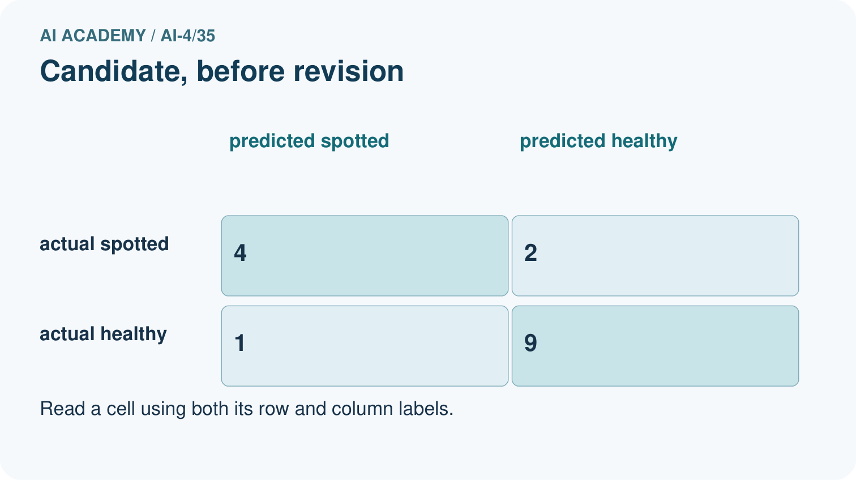
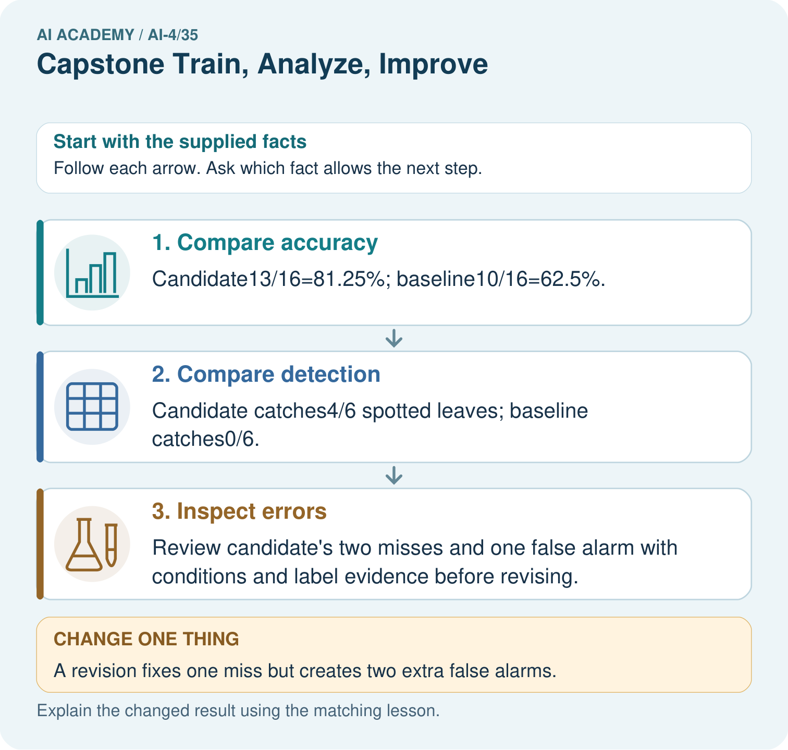

Read the picture one step at a time
Step | What happens and why
1. Compare accuracy | Candidate13/16=81.25%; baseline10/16=62.5%.
2. Compare detection | Candidate catches4/6 spotted leaves; baseline catches0/6.
3. Inspect errors | Review candidate’s two misses and one false alarm with conditions and label evidence before revising.
Match each pictured step to the supplied facts. This is a worked teaching case, not an independent assessment.

Why this result follows
Read the picture in order. Review candidate’s two misses and one false alarm with conditions and label evidence before revising. The arrows show which recorded input or intermediate result each decision uses. Explain the deciding step aloud before checking the changed case; pointing to the final answer alone does not show how it follows.

What this example does not establish
Any case-driven revision makes these records development evidence for that revision; reserve a fresh final set.

Change one thing in the pictured case
Change: A revision fixes one miss but creates two extra false alarms.
Prediction: TP 5, FN 1, FP 3, TN 7 gives 12/16=75% accuracy and 5/6 recall.
Reason: Recall rises while accuracy falls; the preferred revision depends on declared error consequences.

Ask while showing the picture
Cover the result. Ask learners to name the inputs and predict the next step. Uncover one step, connect the icon to the actual procedure, and explain its evidence. Then change the supplied condition and compare. The picture is a representation; it does not document execution of a real AI model.

03. Demonstrate and guide practice

Demonstrate and guide practice

Board sequence
Write the given facts: Baseline validation accuracy70%; model80%; most remaining errors are dim images.
Write the question to explain: Plan improvement evidence.
Reveal after predictions: Keep partitions fixed, inspect dim-image errors, change one factor and compare the same validation criteria/slices. Reserve final test.
Keep for an independent attempt: A revision raises overall validation accuracy from 80% to 84% but lowers dim-light accuracy from 60% to 40%. How should the improvement claim change?

Classroom dialogue
Ask: Which facts are given, and which would we have to assume? Learners mark relevant details before discussing answers.
Say: Predict first. Show the rule, information path or calculation that would produce the result. A correct guess is not yet an explanation.
Reveal reasoning one step at a time. Explain why a tempting alternative fails. Write units and denominators for arithmetic, trace conditions for decisions, and identify supporting sources for claims.
In pairs, one learner solves while the other checks evidence; exchange roles. Remove the worked answer before independent assessment.

Model these guided questions
Guided response: It establishes a difference on these 12 examples under the saved procedure, not reliable improvement for every future population. Exit response: Version 1 frozen results, reason for change, reused-evidence status and the fact that version 2 has no new independent final evaluation.

Case-specific teaching sequence
Stage | Teacher action
Session 1 start to 7 minutes | Use the prerequisite question: What changes after final-test labels inform a revision? Check the explanation before proceeding.
7 to 18 minutes | Verify each team freeze record before releasing final labels. Review the worked example and separate illustrative numbers from actual project evidence.
18 to 32 minutes | Teams run or trace frozen baseline and candidate predictions on all planned test cases. Save the unchanged prediction ledger and account for failures.
32 to 45 minutes | Teams calculate metrics and inspect error types. Use W1–W3 to check calculations and evidence status before writing claims.
Session 2 start to 8 minutes | Retrieve the distinction between final evaluation and error audit. Invite a counterexample to an overconfident claim.
8 to 20 minutes | Teams write an error audit and propose one follow-up tied to an observed limit. Keep version1 results unchanged.
20 to 35 minutes | Collect W4 independently. Teams then update their model card and clearly mark any revision as untested or supported only by reused development evidence.
35 to 45 minutes | Use W 5 and the exit response to assess limits. Give targeted feedback, then the fresh retry. Save evidence of independent understanding.

Reduce help deliberately
Completion task: What does the one-correct-case improvement establish?
Teacher check: Teacher explanation: It establishes a difference on these 12 examples under the saved procedure, not reliable improvement for every future population.
Start by identifying the given inputs together. Leave the intermediate steps blank. If needed, model one step, then withdraw that help on the next step. Move to a full trace only when the partial trace is understood. For partners, alternate explainer and checker; collect a response from every learner before discussion.

Individual reasoning check
Use the worked case for Capstone evaluation and revision. Proposed explanation: “A final answer is enough”. Decide whether this explanation is supported. Point to the step or supplied fact that decides; explain your repair if needed.
Expected correction: Ask for the relevant counts, units, procedure or saved record. For this week: Candidate accuracy 9/12=75 percent, precision 2/3, recall 2/4; baseline 8/12 about 66.7 percent, with all four blocked cases missed.
Collect explanations, not only yes/no votes. If a misunderstanding is common, re-model the relevant step for the class. If it affects a few learners, give a short targeted group explanation while others solve a more demanding variation.

Pictorial practice question
Why is “the revision is better” incomplete? Point to the relevant step in the picture, then write the changed result and the rule or evidence that supports it.

Reasoned teacher answer
It catches more spotted leaves but raises false alarms and lowers accuracy. Report both trade-offs and decide using predeclared use costs. Changed-case check: TP 5, FN 1, FP 3, TN 7 gives 12/16=75% accuracy and 5/6 recall. Recall rises while accuracy falls; the preferred revision depends on declared error consequences.
Changed-case reasoning: TP 5, FN 1, FP 3, TN 7 gives 12/16=75% accuracy and 5/6 recall. Recall rises while accuracy falls; the preferred revision depends on declared error consequences.
Collect each learner’s explanation before discussion. Use the first missing connection between input, deciding step and result to choose support. This question is worked-case practice, not fresh mastery evidence.

04. Run the weekly evidence lab

Run the weekly evidence lab
Keep the test conditions fixed, record every result, and change only one planned factor.
1. Write the hypothesis and expected evidence before running.
2. Capstone Gate 2: reproduce v1, cluster errors, approve one change, rerun fixed cases, and publish all gains and regressions.
3. Run one normal, one boundary, one missing, and one shifted case.
4. Calculate the metric from raw counts or row-level errors.
5. Interpret what changed, what did not, and what remains unsafe or unknown.

Make the lab runnable
Use the concrete case as the shared normal case and the independent question as a second case. Each pair creates a boundary or missing-information case and predicts its result before testing. Keep the expected result separate from an observed mistake.
Record | What to capture
Input or evidence | Exact data, instruction or claim
Expected result | Answer or safe fallback declared before the run
Observed result | Actual result, including errors
Explanation | Rule, calculation or evidence explaining the outcome
Next test | One justified change and a new prediction

Diagnose and reteach
MISCONCEPTION TO REPAIR A higher overall score proves every important aspect improved.
For guessing, return to given facts and request a trace. For vocabulary without application, use one example and one non-example. For arithmetic errors, check the setup before the calculation. Finish with a different uncoached case before recording mastery.

Address these additional misconceptions
A final answer is enough: Ask for the relevant counts, units, procedure or saved record. For this week: Candidate accuracy 9/12=75 percent, precision 2/3, recall 2/4; baseline 8/12 about 66.7 percent, with all four blocked cases missed.
A stronger claim makes a stronger project: Version 1 frozen results, reason for change, reused-evidence status and the fact that version 2 has no new independent final evaluation.
The new case can be copied from the example: The independent task changes the evidence. Require a fresh explanation: Candidate accuracy 9/12=75 percent, precision 3/5=60 percent, recall 3/4=75 percent. Baseline FP 0 FN 4 versus candidate FP 2 FN 1; baseline accuracy 8/12.

Match the support to the first error
What the response shows | Next teaching action
Missing or misread facts | Read the case aloud, mark supplied versus unknown facts, and let the learner restate it.
Wrong procedure | Return to the deciding step in the worked case. Contrast it with the proposed incorrect explanation.
Arithmetic or implementation error | Trace intermediate values or lines; preserve the first mismatch and retry that step.
Correct result without a reason | Ask for a trace and a changed case before marking independent understanding.
An unsupported wider claim | Ask which supplied evidence supports the claim and which further observation would be needed.
Offer an oral explanation, drawing, enlarged visual or fewer examples when that removes a reading/writing barrier. Keep the same reasoning goal. Stretch secure learners by changing a boundary or assumption and asking them to defend the effect, not simply by assigning more of the same questions.

05. Assess and explain the answers

Assess and explain the answers

Worked case answer
Keep partitions fixed, inspect dim-image errors, change one factor and compare the same validation criteria/slices. Reserve final test.

Independent question
A revision raises overall validation accuracy from 80% to 84% but lowers dim-light accuracy from 60% to 40%. How should the improvement claim change?

Expected independent answer
Report both results with counts and evaluate against intended-use criteria. The overall gain does not justify hiding the subgroup regression; investigate or limit use.

What counts as evidence
Criterion | 0 points | 1 point | 2 points
Result | Incorrect or absent | Partly correct | Correct with necessary conditions
Reasoning | No supporting trace | Some steps | Clear mechanism, calculation or source support
Limit | Overclaims certainty | Vague limitation | Relevant uncertainty or missing fact
Transfer | Copies without adapting | Adapts with prompts | Solves a changed case independently
Use 6/8 as a classroom checkpoint, with 2 required for both Result and Reasoning. This is a proposed teaching rule, not a validated certification threshold. Do not count a coached answer as independent mastery; correct unsafe or unsupported claims regardless of total.

Feedback
Ask the learner to find the evidence that challenges this claim: “Any increase in overall accuracy counts as improvement for every user and condition.” Keep the first attempt and an uncoached retry separate.

Original transfer answer
No. Reevaluate both versions on the same declared validation cases, including the hard cases unless an independently justified exclusion applies to both. Record exact changes and per-case predictions, then evaluate the selected version on untouched final data.

Explanations for the additional workbook examples

W1 Score the frozen test
Compute the worked candidate metrics and baseline accuracy.
Teacher explanation: Candidate accuracy 9/12=75 percent, precision 2/3, recall 2/4; baseline 8/12 about 66.7 percent, with all four blocked cases missed.

W2 Audit a difference
What does the one-correct-case improvement establish?
Teacher explanation: It establishes a difference on these 12 examples under the saved procedure, not reliable improvement for every future population.

W3 Label a revision
A threshold changes after test errors are read. Label its score on the same rows.
Teacher explanation: Post-test development or reused-test evidence for the revised version, not an untouched final test.

W4 Apply independently
Frozen candidate[[6, 2],[1, 3]] and baseline[[8, 0],[4, 0]] on 12 cases. Compute candidate metrics and compare error types.
Teacher explanation: Candidate accuracy 9/12=75 percent, precision 3/5=60 percent, recall 3/4=75 percent. Baseline FP 0 FN 4 versus candidate FP 2 FN 1; baseline accuracy 8/12.

W5 Update the card
What must remain visible when version 2 is proposed without a fresh test?
Teacher explanation: Version 1 frozen results, reason for change, reused-evidence status and the fact that version 2 has no new independent final evaluation.

Assess independent transfer
Selected case: Frozen candidate[[6, 2],[1, 3]] and baseline[[8, 0],[4, 0]] on 12 cases. Compute candidate metrics and compare error types.

Selected case answer
Teacher explanation: Candidate accuracy 9/12=75 percent, precision 3/5=60 percent, recall 3/4=75 percent. Baseline FP 0 FN 4 versus candidate FP 2 FN 1; baseline accuracy 8/12.
Dimension | Evidence required
Explanation | Names the applicable idea or procedure and ties it to the supplied facts.
Trace and result | Preserves the given inputs and shows the relevant intermediate steps; distinguishes a prediction from an observed execution.
Limits | States the assumptions, missing evidence or conditions under which the result would change.
Record each dimension as not yet, with support, or independent. Accept a valid alternative procedure with a defensible trace. Do not penalise an honestly recorded model failure if the learner correctly explains its evidence and limits.

Feedback that the learner uses
Name the earliest unsupported step and give one action to repair it. Have the learner make that repair now and explain why. Then assess the relevant skill on a fresh, fully specified case. Confirm it was not previously practised with feedback; solve and check the new case before assigning it. A follow-up design prompt is a starting brief, not automatically an equivalent test.

06. Connect and extend learning

Connect and extend learning

Responsible Plant Classifier
Finalize the Plant Classifier experiment record, confusion matrix, subgroup table, model card, and honest remaining-limit statement.
Keep the decision, input, result, explanation and remaining limitation in the project evidence record. Retrieve this record next week rather than restarting the project.

Support and stretch
Use a tiny labelled dataset, explicit units and a named positive class. Stretch: require a baseline, held-out evaluation and subgroup or shifted-condition analysis with denominators.

Exit reflection
Ask for one decision the learner can now justify and one situation requiring more evidence or human review. Confidence ratings are separate from correct independent performance.

Bridge to the next week
Next: Week 36: ML Builder Expo. Retrieve today’s evidence and identify what carries forward and what is new.

Support and fresh reassessment
Provide a blank evidence table and allow a verbal explanation before writing. Highlight the given conditions without supplying the W 4 conclusion. Use final evaluation and error audit in full sentences. Extension: alter one condition in the worked example and explain which conclusion changes and which remains supported.
For independent W 4, require: Candidate accuracy 9/12=75 percent, precision 3/5=60 percent, recall 3/4=75 percent. Baseline FP 0 FN 4 versus candidate FP 2 FN 1; baseline accuracy 8/12. Fresh retry candidate[[5, 1],[2, 2]] on 10 cases: accuracy 7/10, precision 2/3, recall 2/4. Require a test-status statement before any proposed tuning. Mark each criterion as independent, supported or not yet demonstrated. Reassess the reasoning after feedback; do not replace the first attempt silently.
Next week: Machine learning project defense. Carry forward the saved evidence and the distinction between development choices and justified claims.

Plan the delayed return
Suggested return points in this level: ai-4/36. Use actual classroom dates, adjusting for holidays and gaps. One, three and six teaching weeks are scheduling choices, not a claimed optimal spacing.
At a delayed check, ask for the idea from memory and a changed application. Compare with the earlier independent response and record support used. For a new level, revisit the previous capstone before checking the new prerequisites.
Record | Teacher evidence
Learner code and date
Concept and case used; prior exposure
Explanation / trace / limits
Support and first repair
Changed case and delayed outcome
Next teaching action
Use the evidence to choose reteaching or the next step. A completed page, confidence rating or attractive project does not by itself demonstrate understanding.

Project evidence from this case
For your Responsible Plant Classifier, save the input, procedure, observed result and limitation of this check. Label this worked example as practice; use a different, previously unreviewed case when checking independent understanding.

07. Prepare, teach and assess
Teaching target: Run a frozen final evaluation with complete accounting
Prepare the labelled worked-case picture, the matching workbook, fictional input cards and a place for individual responses. Check a local Python 3 environment before class; have a paper-trace version ready.
Session | Plan | Resources
Session 1 · Understand · 45 min | 0–7: recall and prerequisite; 7–15: inspect the concrete case and predict; 15–30: teacher models the worked trace; 30–40: learners explain a step using the text and visual; 40–45: check the core idea. | Sections 1–6; record the brief recall in the workbook.
Session 2 · Practise · 45 min | 0–5: retrieve the procedure; 5–15: W2 completion practice; 15–23: explain and check with a partner; 23–30: each learner answers the misconception check; 30–40: targeted reteaching or a harder variation; 40–45: prepare the investigation. | Sections 7–10; use the matching workbook W2 and misconception check.
Session 3 · Investigate and transfer · 45 min | 0–5: retrieve the decision rule; 5–20: investigate or trace; 20–30: start the independent case; 30–38: connect the project; 38–43: act on feedback; 43–45: plan the return check. | Sections 9 and 11–14. Give extra time to finish the full task set; use Section 15 when the week includes a coding lab.
Before class, solve the supported practice: What does the one-correct-case improvement establish?
Reasoned practice answer: Teacher explanation: It establishes a difference on these 12 examples under the saved procedure, not reliable improvement for every future population.
Check every learner before discussion: Use the worked case for Capstone evaluation and revision. Proposed explanation: “A final answer is enough”. Decide whether this explanation is supported. Point to the step or supplied fact that decides; explain your repair if needed.
Misconception repair: Ask for the relevant counts, units, procedure or saved record. For this week: Candidate accuracy 9/12=75 percent, precision 2/3, recall 2/4; baseline 8/12 about 66.7 percent, with all four blocked cases missed.
Support: read the exact case aloud, enlarge the labelled picture, supply input cards and model only the first deciding step. Accept a spoken explanation or drawing; retain the reasoning goal.
Extension: A revision fixes one miss but creates two extra false alarms. Require a prediction and a reason before comparing. Expected result: TP 5, FN 1, FP 3, TN 7 gives 12/16=75% accuracy and 5/6 recall. Reason: Recall rises while accuracy falls; the preferred revision depends on declared error consequences.
Independent assessment: withhold the reserved answer until the learner has attempted the new case. Record support separately from correctness.
Criterion | Not yet | With support | Independent
Explanation | Names an answer without a deciding fact | Uses a hint to link fact and decision | Explains the deciding fact in own words
Trace or test | Cannot connect input and result | Completes steps with prompts | Traces or tests a changed case accurately
Limits and revision | Claims more than evidence supports | Names a limit after a prompt | States a defensible limit and useful next test
Project checkpoint: Present and defend. Demonstrate the system, explain one failure and justify the next improvement with evidence.
Use the weekly teacher answer for topic-specific reasoning. A saved progress tick is an activity record; judge mastery from the learner’s explanation and evidence.

