AI ACADEMY · TEACHER · ai-5/20

Image tensors and channels
Project: Image-pattern Network Investigation

01. Prepare the purpose, prerequisites and materials

Teach the learning cycle
Primary target: Read a pixel using declared row column and channel axes
Session | Sequence and minutes | Resources
Session 1 · Understand · 45 min | 0–7: recall and prerequisite; 7–15: inspect the concrete case and predict; 15–30: teacher models the worked trace; 30–40: learners explain a step using the text and visual; 40–45: check the core idea. | Sections 1–6; record the brief recall in the workbook.
Session 2 · Practise · 45 min | 0–5: retrieve the procedure; 5–15: W2 completion practice; 15–23: explain and check with a partner; 23–30: each learner answers the misconception check; 30–40: targeted reteaching or a harder variation; 40–45: prepare the investigation. | Sections 7–10; use the matching workbook W2 and misconception check.
Session 3 · Investigate and transfer · 45 min | 0–5: retrieve the decision rule; 5–20: investigate or trace; 20–30: start the independent case; 30–38: connect the project; 38–43: act on feedback; 43–45: plan the return check. | Sections 9 and 11–14. Give extra time to finish the full task set; use Section 15 when the week includes a coding lab.
This is a starting allocation of 135 minutes, not a validated duration. Preserve all named topics. Schedule extra time for connected examples, the full investigation, independent cases and project building. Repeated copies of a case share one recorded attempt; they are not new evidence.

Retrieval answer guidance

Learned representations
Without opening the old lesson, explain one key idea from Learned representations. Give an example and a mistake that the idea helps you avoid.
Look for: Trace an input through a hidden representation and a decision rule
Reference example, not the only acceptable wording: Teacher explanation: The vectors are [5, 0], [0, 5] and [0, 0]. Predictions are 1, 0 and 0. Equal width and height does not satisfy strictly greater.

Initialisation and reproducibility
Without opening the old lesson, explain one key idea from Initialisation and reproducibility. Give an example and a mistake that the idea helps you avoid.
Look for: Trace how starting values affect a fixed training budget
Reference example, not the only acceptable wording: Teacher explanation: States are -2, 0 and 1. Final training MSE is 2.5. Each step halves the signed distance from 2.

Learning rate experiments
Without opening the old lesson, explain one key idea from Learning rate experiments. Give an example and a mistake that the idea helps you avoid.
Look for: Run a controlled comparison of learning rates
Reference example, not the only acceptable wording: Teacher explanation: First v = 0.5 with MSE 5.625. Second gradient -7.5 gives v = 0.875 and MSE 3.1640625. Distance is multiplied by 0.75 each step.
Use two 45-minute sessions. Draw the four-pixel image and label row, column and channel before writing nested brackets. Keep RGB ordering, zero-based indices and the 0 to 255 contract explicit. Distinguish an axis permutation from regrouping, and fixed scaling from fitted preprocessing. No external image files or student photographs are needed.

Outcomes
Read a pixel using declared row column and channel axes
Convert channel layout without changing pixel meaning
Distinguish fixed value scaling from information losing transformations

Preparation
Printed lesson and workbook; paper and pencil
Calculator and optional local Python 3 editor; no packages or AI accounts needed
Use the fictional examples supplied; prepare the fresh retry before class

Prerequisite answer
Different inputs can map to the same representation. The number of components alone does not guarantee that the original values can be recovered.

End goal for the pictorial case
By the end, I can explain image tensors and channels using a traced example and a stated limitation.
This added worked case illustrates the week’s main idea. Retain all original and connected topics; schedule its practice within the teaching cycle.

02. Explain and model the mechanism
A small fictional RGB image has height 2 pixels, width 2 pixels and three channels ordered red, green, blue. Store it as image[row][column][channel], abbreviated HWC. Use zero-based indices: the top row is 0, the left column is 0, and red, green and blue are channels 0, 1 and 2. Each stored component is an integer from 0 to 255.
The shape is 2 by 2 by 3. There are four pixels and twelve channel values. The blue component of the bottom-left pixel is image[1][0][2] = 255. A single channel is a plane of values across positions; it is not a separate photograph or a label.
Shape needs a schema. A grayscale image might be stored as H by W or H by W by 1. An RGB image uses three channels here; other formats can include additional channels. Declare the format instead of assuming every three-dimensional array means the same thing.
A channel-first layout uses image[channel][row][column], abbreviated CHW. Our image then has shape 3 by 2 by 2. A correct conversion preserves the rule chw[c][r][k] = hwc[r][k][c]. The code assumes a nonempty rectangular image with exactly three values per pixel.
Reading nested values in order and merely regrouping them into a new shape does not perform this axis conversion. The first four flattened HWC values are [255, 0, 0, 0]. A naive regrouping makes these the first channel plane, but the correct red plane is [[255, 0], [0, 255]]. Shape agreement alone cannot detect this mistake.
Term | Meaning
Tensor | A numerical array with a declared set of axes
Channel | One component plane of an image such as red green or blue
Axis order | The sequence of meanings assigned to array dimensions
Value scaling | A declared numerical conversion applied to stored values

The same pixels in three channel planes
Channel | Top row | Bottom row
Red c 0 | [255, 0] | [0, 255]
Green c 1 | [0, 255] | [0, 255]
Blue c 2 | [0, 0] | [255, 255]
Each row describes one channel plane. Within a plane the first listed row is the image top and the second is the bottom. Combining the three values at the same position recovers its RGB triplet.
Guided: top-right is [0, 255, 0] and bottom-right is [255, 255, 255]. The top-right green value is hwc[0][1][1] or chw[1][0][1], both 255. Exit: shape alone misses both errors. Check the top-left RGB pixel is red before scaling and that a raw value 255 becomes exactly 1 under one declared division, rather than approximately 0.00392.

Model the reasoning aloud
Use the complete worked example below before asking learners to complete W2. Reveal a small part, invite a prediction, then explain the deciding step. These teacher notes contain solutions; do not reveal the independent case answer during modelling.

The same pixels in three channel planes
Channel | Top row | Bottom row
Red c 0 | [255, 0] | [0, 255]
Green c 1 | [0, 255] | [0, 255]
Blue c 2 | [0, 0] | [255, 255]
Each row describes one channel plane. Within a plane the first listed row is the image top and the second is the bottom. Combining the three values at the same position recovers its RGB triplet.

Use the planes to reconstruct the top-right and bottom-right RGB pixels. Give both HWC and CHW indices for the top-right green value.
________________________________________________________________
________________________________________________________________
________________________________________________________________
________________________________________________________________
Thinking move | Teacher prompt
Plan | What is given? What is the question? Which procedure fits these facts?
Do | Point to each input and intermediate step in the worked trace. Name the rule that allows the next step.
Check | Does the output answer the question? Which assumption or limitation prevents a larger claim?
Use the diagram and verbal explanation together. Ask learners to match a sentence to a specific visual step; do not assign learners fixed visual or auditory learning styles.

A pictorial worked case: Image tensors and channels
Move colour values between tensor layouts without changing the pixels.

The facts we will use
Toy RGB image has 2 rows, 1 column. Top pixel [1, 4, 7]; bottom [2, 5, 8]. HWC means height, width, channel.
All inputs and outcomes in this worked example are invented classroom data; no real model run is claimed.
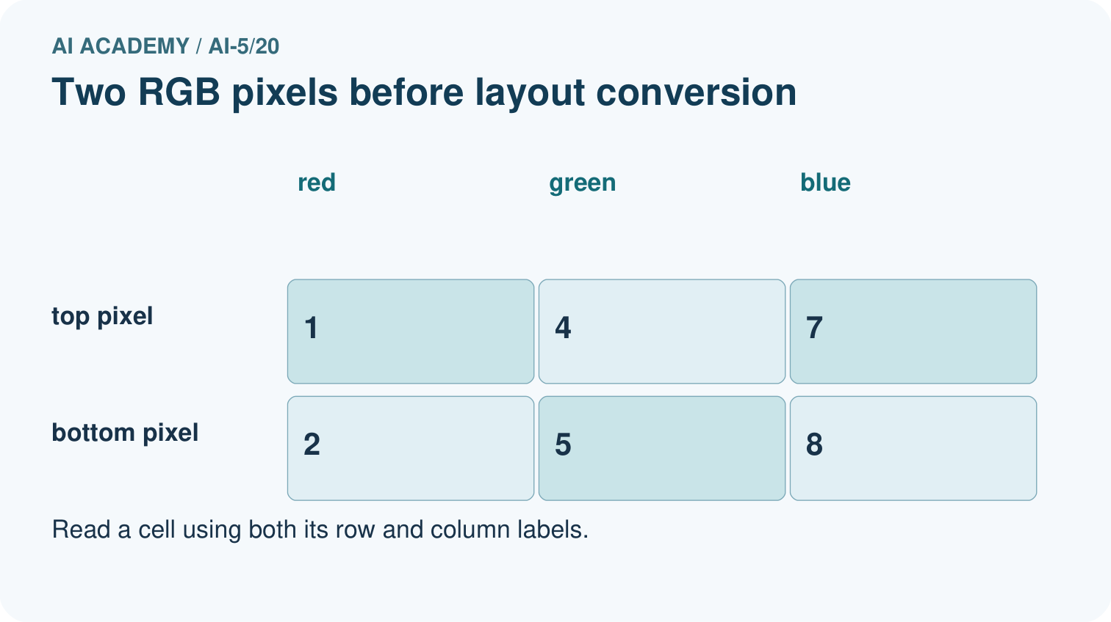
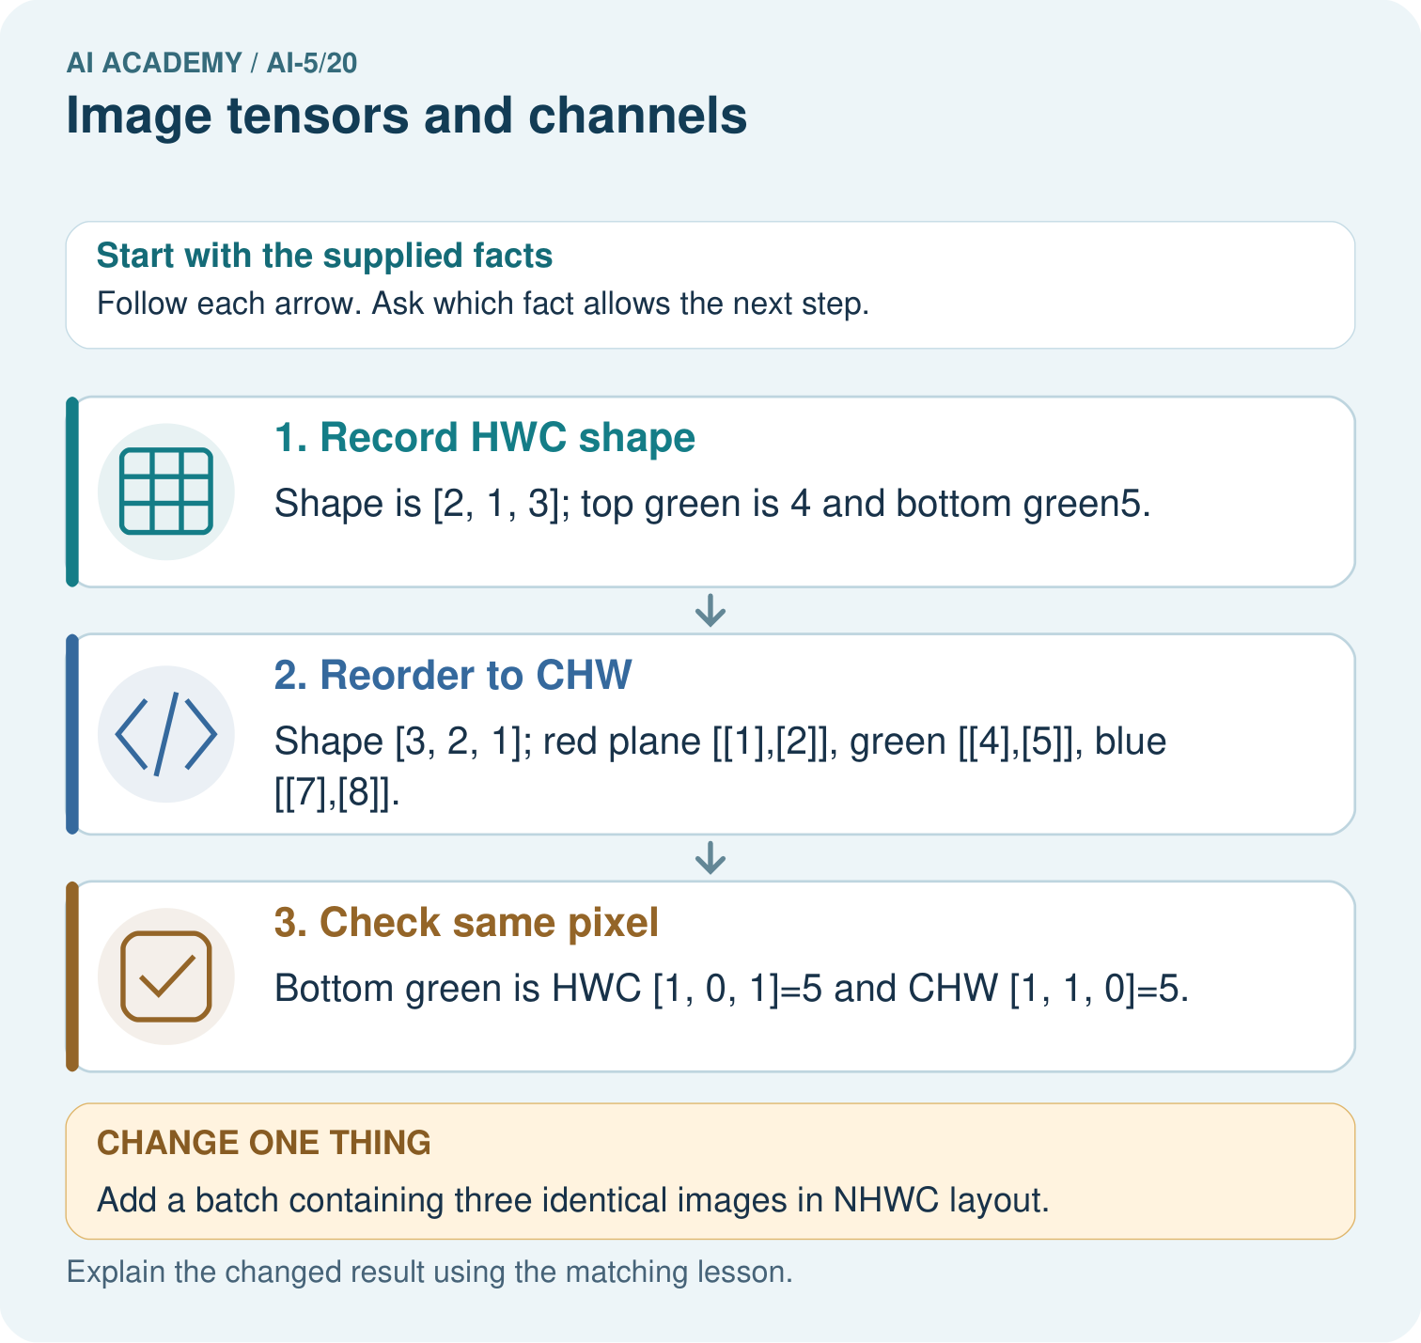

Read the picture one step at a time
Step | What happens and why
1. Record HWC shape | Shape is [2, 1, 3]; top green is 4 and bottom green5.
2. Reorder to CHW | Shape [3, 2, 1]; red plane [[1],[2]], green [[4],[5]], blue [[7],[8]].
3. Check same pixel | Bottom green is HWC [1, 0, 1]=5 and CHW [1, 1, 0]=5.
Match each pictured step to the supplied facts. This is a worked teaching case, not an independent assessment.

Why this result follows
A tensor is an array with named dimensions. HWC orders height, width and colour; CHW puts colour first. Rearranging the layout changes where values are stored, not the colour measurement itself. Trace a named pixel through both layouts using zero-based indices. Adding a batch dimension counts images and does not add a new colour channel.

What this example does not establish
Shape consistency does not prove correct colour order or value range; document channel names and preprocessing.

Change one thing in the pictured case
Change: Add a batch containing three identical images in NHWC layout.
Prediction: Batch shape is [3, 2, 1, 3].
Reason: The new first dimension counts images; it does not add a fourth colour channel.

Ask while showing the picture
Cover the result. Ask learners to name the inputs and predict the next step. Uncover one step, connect the icon to the actual procedure, and explain its evidence. Then change the supplied condition and compare. The picture is a representation; it does not document execution of a real AI model.

03. Demonstrate and guide practice
Time or stage | Teacher action
Session 1 start to 7 minutes | Retrieve information loss and label the four image positions with zero-based indices.
7 to 18 minutes | Count pixels and components, then use W1 to read a full pixel and one channel.
18 to 32 minutes | Trace the three channel planes and run or hand-trace the optional code.
32 to 45 minutes | Use W2 to expose naive regrouping with the bottom-right red component.
Session 2 start to 8 minutes | Reconstruct the guided pixels and locate the same green value in both layouts.
8 to 20 minutes | Use W3 to compare fixed scaling with colour averaging and discuss double scaling.
20 to 35 minutes | Collect W4 independently, checking the non-square shape and the leading batch axis.
35 to 45 minutes | Use W5 and the exit response to plan exact-value checks, then administer the fresh retry.
Use the worked example in Sections 3 and 6. Collect a prediction before revealing its result; ask the learner to point to each intermediate fact.
Use three labelled paper grids and a coordinate ledger; provide colour names so success does not depend on colour vision. Allow fraction answers for scaling. Extension: convert a rectangular image HWC to CHW and back, checking every coordinate, then construct two different colours with the same classroom channel mean.

Reduce help deliberately
Completion task: A program flattens the lesson HWC array and groups the first four values into a 2 by 2 red plane. Give that incorrect plane and the correct plane. Identify a position where they disagree.
Teacher check: Teacher explanation: The incorrect plane is [[255, 0], [0, 0]]. The correct red plane is [[255, 0], [0, 255]]. They disagree at row 1 column 1. Regrouping consecutive values does not transpose axes.
Start by identifying the given inputs together. Leave the intermediate steps blank. If needed, model one step, then withdraw that help on the next step. Move to a full trace only when the partial trace is understood. For partners, alternate explainer and checker; collect a response from every learner before discussion.

Individual reasoning check
Use the worked case for Image tensors and channels. Proposed explanation: “Three channels mean three images”. Decide whether this explanation is supported. Point to the step or supplied fact that decides; explain your repair if needed.
Expected correction: Channels are component planes at matching spatial positions in one image.
Collect explanations, not only yes/no votes. If a misunderstanding is common, re-model the relevant step for the class. If it affects a few learners, give a short targeted group explanation while others solve a more demanding variation.

Pictorial practice question
Where is the bottom green pixel in the first batched image? Point to the relevant step in the picture, then write the changed result and the rule or evidence that supports it.

Reasoned teacher answer
NHWC [0, 1, 0, 1]=5: image0, row1, column0, green channel1. The value is unchanged by batching. Changed-case check: Batch shape is [3, 2, 1, 3]. The new first dimension counts images; it does not add a fourth colour channel.
Changed-case reasoning: Batch shape is [3, 2, 1, 3]. The new first dimension counts images; it does not add a fourth colour channel.
Collect each learner’s explanation before discussion. Use the first missing connection between input, deciding step and result to choose support. This question is worked-case practice, not fresh mastery evidence.

04. Run the investigation and diagnose misconceptions
Three channels mean three images: Channels are component planes at matching spatial positions in one image.
Reshaping automatically changes axis meanings correctly: Axis permutation must preserve coordinate correspondence; regrouping a flattened list can mix positions and colours.
Every conversion to a smaller number preserves information: Exact fixed scaling differs from rounding and channel averaging, which can collapse distinct values.
Use Section 9 for the evidence ledger. Add a boundary or missing-input case and record the expected response before checking. More successful repeats of one case do not establish wider coverage.

Match the support to the first error
What the response shows | Next teaching action
Missing or misread facts | Read the case aloud, mark supplied versus unknown facts, and let the learner restate it.
Wrong procedure | Return to the deciding step in the worked case. Contrast it with the proposed incorrect explanation.
Arithmetic or implementation error | Trace intermediate values or lines; preserve the first mismatch and retry that step.
Correct result without a reason | Ask for a trace and a changed case before marking independent understanding.
An unsupported wider claim | Ask which supplied evidence supports the claim and which further observation would be needed.
Offer an oral explanation, drawing, enlarged visual or fewer examples when that removes a reading/writing barrier. Keep the same reasoning goal. Stretch secure learners by changing a boundary or assumption and asking them to defend the effect, not simply by assigning more of the same questions.

05. Assess and explain the answers

Guided and exit questions
Guided: top-right is [0, 255, 0] and bottom-right is [255, 255, 255]. The top-right green value is hwc[0][1][1] or chw[1][0][1], both 255. Exit: shape alone misses both errors. Check the top-left RGB pixel is red before scaling and that a raw value 255 becomes exactly 1 under one declared division, rather than approximately 0.00392.

W1 Read a pixel precisely
For the lesson image, give image[1][0], image[1][0][2], the HWC shape, pixel count and number of channel values.
Teacher explanation: The RGB pixel is [0, 0, 255]; its blue value is 255. Shape is 2 by 2 by 3, with four pixels and twelve channel values.

W2 Audit an axis conversion
A program flattens the lesson HWC array and groups the first four values into a 2 by 2 red plane. Give that incorrect plane and the correct plane. Identify a position where they disagree.
Teacher explanation: The incorrect plane is [[255, 0], [0, 0]]. The correct red plane is [[255, 0], [0, 255]]. They disagree at row 1 column 1. Regrouping consecutive values does not transpose axes.

W3 Check scaling and lost colour
Scale [255, 128, 0] by 255, keeping the middle value as a fraction. Then calculate the classroom RGB means of pure red and pure green. Which operation loses the distinction between those colours?
Teacher explanation: Scaling gives [1, 128/255, 0]. Both RGB means are 85, so averaging loses the red versus green distinction. Exact fixed scaling preserves the triplet distinction.

W4 Convert a new image independently
A one-row two-column RGB image has pixels [10, 20, 30] then [40, 50, 60]. State its HWC shape and all three CHW planes. Give the green value at row 0 column 1 in both layouts. A batch contains four copies: give its NHWC shape and total channel-value count.
Teacher explanation: HWC shape is 1 by 2 by 3. CHW planes are [[10, 40]], [[20, 50]], [[30, 60]], giving shape 3 by 1 by 2. hwc[0][1][1] and chw[1][0][1] both equal 50. Batch shape is 4 by 1 by 2 by 3, containing 24 values.

W5 Design revealing pipeline checks
The lesson image is loaded with red and blue exchanged, then scaled twice. Give two expected checks that would expose these errors even though the shape is correct.
Teacher explanation: Before scaling, the top-left pixel must be [255, 0, 0], not [0, 0, 255]. A known raw component of 255 must become 1 after scaling once; approximately 0.00392 indicates division twice. Test named values and positions as well as dimensions.

Independent assessment and fresh retry
W4 requires three planes, both coordinate references to value 50, NHWC shape 4 by 1 by 2 by 3 and 24 values. Fresh retry: a two-row one-column image contains [3, 6, 9] above [12, 15, 18]. HWC shape is 2 by 1 by 3. CHW planes are [[3], [12]], [[6], [15]], [[9], [18]]. The bottom blue component is hwc[1][0][2] = chw[2][1][0] = 18. A batch of three has NHWC shape 3 by 2 by 1 by 3 and 18 values.

Assess independent transfer
Selected case: A one-row two-column RGB image has pixels [10, 20, 30] then [40, 50, 60]. State its HWC shape and all three CHW planes. Give the green value at row 0 column 1 in both layouts. A batch contains four copies: give its NHWC shape and total channel-value count.

Selected case answer
Teacher explanation: HWC shape is 1 by 2 by 3. CHW planes are [[10, 40]], [[20, 50]], [[30, 60]], giving shape 3 by 1 by 2. hwc[0][1][1] and chw[1][0][1] both equal 50. Batch shape is 4 by 1 by 2 by 3, containing 24 values.
Dimension | Evidence required
Explanation | Names the applicable idea or procedure and ties it to the supplied facts.
Trace and result | Preserves the given inputs and shows the relevant intermediate steps; distinguishes a prediction from an observed execution.
Limits | States the assumptions, missing evidence or conditions under which the result would change.
Record each dimension as not yet, with support, or independent. Accept a valid alternative procedure with a defensible trace. Do not penalise an honestly recorded model failure if the learner correctly explains its evidence and limits.

Feedback that the learner uses
Name the earliest unsupported step and give one action to repair it. Have the learner make that repair now and explain why. Then assess the relevant skill on a fresh, fully specified case. Confirm it was not previously practised with feedback; solve and check the new case before assigning it. A follow-up design prompt is a starting brief, not automatically an equivalent test.

06. Connect the project, support and next lesson
Add a labelled image tensors and channels evidence sheet to Image-pattern Network Investigation. Show how you can read a pixel using declared row column and channel axes. Use the supplied fictional case and keep its inputs, intermediate steps, calculation or prediction, and limitation. Connect this record to last week’s record; a matching answer without a trace is insufficient.
Use three labelled paper grids and a coordinate ledger; provide colour names so success does not depend on colour vision. Allow fraction answers for scaling. Extension: convert a rectangular image HWC to CHW and back, checking every coordinate, then construct two different colours with the same classroom channel mean.
Week 21 introduces convolution as a local operation with explicit neighbourhoods and boundary rules.
Retain the project ledger and assess a changed case after support. Check the relevant prerequisite before carrying this component forward.

Plan the delayed return
Suggested return points in this level: ai-5/21, ai-5/23, ai-5/26. Use actual classroom dates, adjusting for holidays and gaps. One, three and six teaching weeks are scheduling choices, not a claimed optimal spacing.
At a delayed check, ask for the idea from memory and a changed application. Compare with the earlier independent response and record support used. For a new level, revisit the previous capstone before checking the new prerequisites.
Record | Teacher evidence
Learner code and date
Concept and case used; prior exposure
Explanation / trace / limits
Support and first repair
Changed case and delayed outcome
Next teaching action
Use the evidence to choose reteaching or the next step. A completed page, confidence rating or attractive project does not by itself demonstrate understanding.

Project evidence from this case
For your Image-pattern Network Investigation, save the input, procedure, observed result and limitation of this check. Label this worked example as practice; use a different, previously unreviewed case when checking independent understanding.

07. Prepare, teach and assess
Teaching target: Read a pixel using declared row column and channel axes
Prepare the labelled worked-case picture, the matching workbook, fictional input cards and a place for individual responses. Check a local Python 3 environment before class; have a paper-trace version ready.
Session | Plan | Resources
Session 1 · Understand · 45 min | 0–7: recall and prerequisite; 7–15: inspect the concrete case and predict; 15–30: teacher models the worked trace; 30–40: learners explain a step using the text and visual; 40–45: check the core idea. | Sections 1–6; record the brief recall in the workbook.
Session 2 · Practise · 45 min | 0–5: retrieve the procedure; 5–15: W2 completion practice; 15–23: explain and check with a partner; 23–30: each learner answers the misconception check; 30–40: targeted reteaching or a harder variation; 40–45: prepare the investigation. | Sections 7–10; use the matching workbook W2 and misconception check.
Session 3 · Investigate and transfer · 45 min | 0–5: retrieve the decision rule; 5–20: investigate or trace; 20–30: start the independent case; 30–38: connect the project; 38–43: act on feedback; 43–45: plan the return check. | Sections 9 and 11–14. Give extra time to finish the full task set; use Section 15 when the week includes a coding lab.
Before class, solve the supported practice: A program flattens the lesson HWC array and groups the first four values into a 2 by 2 red plane. Give that incorrect plane and the correct plane. Identify a position where they disagree.
Reasoned practice answer: Teacher explanation: The incorrect plane is [[255, 0], [0, 0]]. The correct red plane is [[255, 0], [0, 255]]. They disagree at row 1 column 1. Regrouping consecutive values does not transpose axes.
Check every learner before discussion: Use the worked case for Image tensors and channels. Proposed explanation: “Three channels mean three images”. Decide whether this explanation is supported. Point to the step or supplied fact that decides; explain your repair if needed.
Misconception repair: Channels are component planes at matching spatial positions in one image.
Support: read the exact case aloud, enlarge the labelled picture, supply input cards and model only the first deciding step. Accept a spoken explanation or drawing; retain the reasoning goal.
Extension: Add a batch containing three identical images in NHWC layout. Require a prediction and a reason before comparing. Expected result: Batch shape is [3, 2, 1, 3]. Reason: The new first dimension counts images; it does not add a fourth colour channel.
Independent assessment: withhold the reserved answer until the learner has attempted the new case. Record support separately from correctness.
Criterion | Not yet | With support | Independent
Explanation | Names an answer without a deciding fact | Uses a hint to link fact and decision | Explains the deciding fact in own words
Trace or test | Cannot connect input and result | Completes steps with prompts | Traces or tests a changed case accurately
Limits and revision | Claims more than evidence supports | Names a limit after a prompt | States a defensible limit and useful next test
Project checkpoint: Evaluate and revise. Compare with your starting method, explain errors and record a justified revision.
Use the weekly teacher answer for topic-specific reasoning. A saved progress tick is an activity record; judge mastery from the learner’s explanation and evidence.

