AI ACADEMY · TEACHER · ai-5/24

Augmentation and leakage
Project: Image-pattern Network Investigation

01. Prepare the purpose, prerequisites and materials

Teach the learning cycle
Primary target: Check whether a transformation preserves the task label
Session | Sequence and minutes | Resources
Session 1 · Understand · 45 min | 0–7: recall and prerequisite; 7–15: inspect the concrete case and predict; 15–30: teacher models the worked trace; 30–40: learners explain a step using the text and visual; 40–45: check the core idea. | Sections 1–6; record the brief recall in the workbook.
Session 2 · Practise · 45 min | 0–5: retrieve the procedure; 5–15: W2 completion practice; 15–23: explain and check with a partner; 23–30: each learner answers the misconception check; 30–40: targeted reteaching or a harder variation; 40–45: prepare the investigation. | Sections 7–10; use the matching workbook W2 and misconception check.
Session 3 · Investigate and transfer · 45 min | 0–5: retrieve the decision rule; 5–20: investigate or trace; 20–30: start the independent case; 30–38: connect the project; 38–43: act on feedback; 43–45: plan the return check. | Sections 9 and 11–14. Give extra time to finish the full task set; use Section 15 when the week includes a coding lab.
This is a starting allocation of 135 minutes, not a validated duration. Preserve all named topics. Schedule extra time for connected examples, the full investigation, independent cases and project building. Repeated copies of a case share one recorded attempt; they are not new evidence.

Retrieval answer guidance

Training a small image model
Without opening the old lesson, explain one key idea from Training a small image model. Give an example and a mistake that the idea helps you avoid.
Look for: Trace a complete image model with fixed features and one trained weight
Reference example, not the only acceptable wording: Teacher explanation: d = 2, h1 = 2 and h2 = 0. Score is 0.9, prediction class 1 and squared error (0.9 - 1) squared = 0.01.

Convolution as a local operation
Without opening the old lesson, explain one key idea from Convolution as a local operation. Give an example and a mistake that the idea helps you avoid.
Look for: Compute a local weighted sum at each valid image position
Reference example, not the only acceptable wording: Teacher explanation: Window rows are [2, 0] and [1, 3]. Products are 2, 0, 0 and 3, giving output 5.

Debugging shapes and gradients
Without opening the old lesson, explain one key idea from Debugging shapes and gradients. Give an example and a mistake that the idea helps you avoid.
Look for: Check dimension contracts before computing a layer
Reference example, not the only acceptable wording: Teacher explanation: No. Each weight row must have the same length as x. Confirm the intended feature schema, then supply a valid two-feature input or deliberately redesign and retrain the layer; do not silently discard a value.
Use two 45-minute sessions. This chapter explicitly revisits Week 23: different pixel arrays do not guarantee independent augmentation evaluation. Keep its original toy-domain claim narrow and use a new grouped plan for the new experiment. Use fictional source IDs rather than student photos. No new training framework is needed.

Outcomes
Check whether a transformation preserves the task label
Keep related examples in one split using source groups
Compare augmentation fairly without inflating independent evidence

Preparation
Printed lesson and workbook; paper and pencil
Calculator and optional local Python 3 editor; no packages or AI accounts needed
Use the fictional examples supplied; prepare the fresh retry before class

Prerequisite answer
Using final outcomes to choose parameters or settings makes that set part of model selection rather than unseen evidence for the selected model.

End goal for the pictorial case
By the end, I can explain augmentation and leakage using a traced example and a stated limitation.
This added worked case illustrates the week’s main idea. Retain all original and connected topics; schedule its practice within the teaching cycle.

02. Explain and model the mechanism
Return to the binary image task: class 1 means the left column sum is strictly larger than the right column sum; equal sums belong to class 0. Let d be left sum minus right sum. An augmentation is useful only under a stated task and transformation rule. More image files do not automatically mean more independent evidence.
Swapping rows preserves each column sum, so it preserves this task label for every valid image. Swapping columns changes d to -d. For nonzero d the class changes; for d = 0 it stays class 0. Blindly copying the original label after every flip would create incorrect training targets.
A transformation may be valid for one task and invalid for another. A crop can remove the evidence needed for a label. Choose allowed transformations using the task definition and training evidence, document the assumptions, and evaluate the choice on validation data.
This code assumes valid 2 by 2 binary lists. It constructs new lists instead of changing the input. The label function encodes the classroom task rule, not a general method for recovering unknown real-world labels.
If an allowed transformation changes a known target, the transformed example needs a justified new label. Do not invent labels for ambiguous cases. Keep the source ID, transformation and resulting label with every derived image so a teacher can audit what happened.
Term | Meaning
Augmentation | Creating transformed training examples under a declared procedure
Label preservation | A transformation leaving the correct target unchanged for the stated task
Source group | An identifier joining records that must stay together when splitting
Leakage | Information crossing an evaluation boundary in a way that undermines the intended independent check

Every variant stays with its source group
Source group | Assigned split | Derived records
A | Training | A original and A row swap
B | Validation | B original only
C | Final test | C original only
Assign source groups before generating training variants. A new filename does not make a derived image independent. Evaluation examples follow a fixed declared protocol, not random training augmentation.
Guided: the split is invalid for unseen-source evaluation because A2 derives from A regardless of filename. Keep the entire A group in training and replace the validation group, then rerun any affected selection. Exit: budgets are 180 versus 60 updates, so they are not matched. Predeclare an equal update budget and record repetition policies; 36 records still represent only 12 original source groups.

Model the reasoning aloud
Use the complete worked example below before asking learners to complete W2. Reveal a small part, invite a prediction, then explain the deciding step. These teacher notes contain solutions; do not reveal the independent case answer during modelling.

Every variant stays with its source group
Source group | Assigned split | Derived records
A | Training | A original and A row swap
B | Validation | B original only
C | Final test | C original only
Assign source groups before generating training variants. A new filename does not make a derived image independent. Evaluation examples follow a fixed declared protocol, not random training augmentation.

A training image has source ID A. Its row-swapped copy is called A2 and placed in validation. No filenames match across splits. Is the split valid for evaluating unseen source images? Describe the repair.
________________________________________________________________
________________________________________________________________
________________________________________________________________
________________________________________________________________
Thinking move | Teacher prompt
Plan | What is given? What is the question? Which procedure fits these facts?
Do | Point to each input and intermediate step in the worked trace. Name the rule that allows the next step.
Check | Does the output answer the question? Which assumption or limitation prevents a larger claim?
Use the diagram and verbal explanation together. Ask learners to match a sentence to a specific visual step; do not assign learners fixed visual or auditory learning styles.

A pictorial worked case: Augmentation and leakage
Keep every augmented image with its original source group.

The facts we will use
Fictional sources A, B, C, D each have original+horizontal-flip copies. A/B train, C validation, D final test.
All inputs and outcomes in this worked example are invented classroom data; no real model run is claimed.
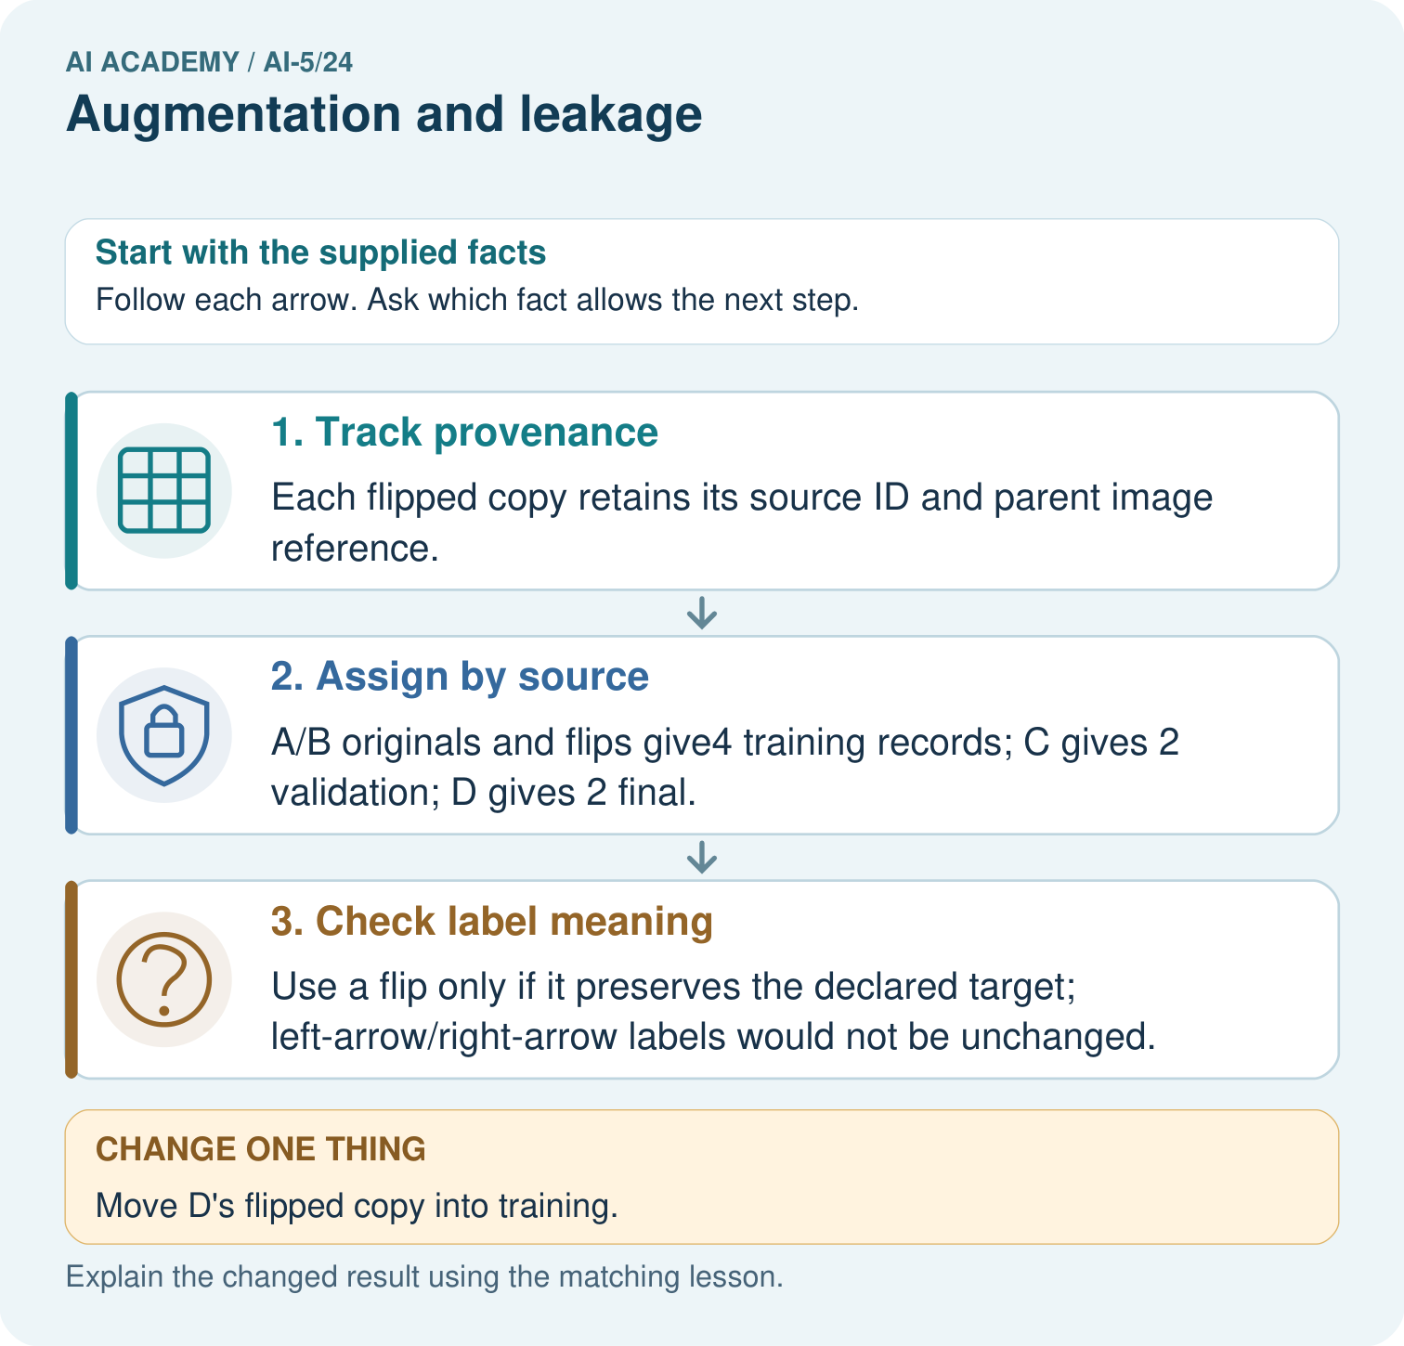

Read the picture one step at a time
Step | What happens and why
1. Track provenance | Each flipped copy retains its source ID and parent image reference.
2. Assign by source | A/B originals and flips give4 training records; C gives 2 validation; D gives 2 final.
3. Check label meaning | Use a flip only if it preserves the declared target; left-arrow/right-arrow labels would not be unchanged.
Match each pictured step to the supplied facts. This is a worked teaching case, not an independent assessment.

Why this result follows
An augmented image remains related to its source. A horizontal flip changes the view, not the identity of the original example. Assign source groups to training, validation and final evaluation before producing copies. Also check that the transformation preserves the target: flipping an arrow can change its correct direction label.

What this example does not establish
Augmentation validity is task-specific, and it cannot manufacture new independent plants or repair inadequate sampling.

Change one thing in the pictured case
Change: Move D’s flipped copy into training.
Prediction: Final-test group separation fails.
Reason: The transformed D image is still derived from the held-out source, despite a new filename.

Ask while showing the picture
Cover the result. Ask learners to name the inputs and predict the next step. Uncover one step, connect the icon to the actual procedure, and explain its evidence. Then change the supplied condition and compare. The picture is a representation; it does not document execution of a real AI model.

03. Demonstrate and guide practice
Time or stage | Teacher action
Session 1 start to 7 minutes | Retrieve frozen evaluation and restate the strict left-column task label.
7 to 18 minutes | Trace row and column swaps, then complete W1 and W2 including the equality boundary.
18 to 32 minutes | Run or hand-trace the transformation code and inspect source preservation.
32 to 45 minutes | Use the visual and guided case to keep lineage groups together before augmentation.
Session 2 start to 8 minutes | Audit the Week 23 transformation relationships and complete W3.
8 to 20 minutes | Distinguish source counts from record counts and work through the update-budget example.
20 to 35 minutes | Collect W4 independently, requiring source counts, retained counts and exclusions.
35 to 45 minutes | Use W5 and the exit response to propose a fair comparison, then administer the fresh retry.
Use the worked example in Sections 3 and 6. Collect a prediction before revealing its result; ask the learner to point to each intermediate fact.
Use cards with source ID and variant ID in separate columns. Provide a split ledger and distinguish original count, variant count and total record count. Extension: enumerate all sixteen binary images to verify row-swap preservation, count column-swap label changes, and identify the equality cases that defeat automatic label complementation.

Reduce help deliberately
Completion task: For rows [1, 0], [0, 1], compute d and class before and after a column swap. Why is always replacing a label by 1 minus the label incorrect?
Teacher check: Teacher explanation: Both differences are 0 and both labels are class 0. Complementing class 0 would give class 1, which is wrong for ties.
Start by identifying the given inputs together. Leave the intermediate steps blank. If needed, model one step, then withdraw that help on the next step. Move to a full trace only when the partial trace is understood. For partners, alternate explainer and checker; collect a response from every learner before discussion.

Individual reasoning check
Use the worked case for Augmentation and leakage. Proposed explanation: “Every image flip preserves the label”. Decide whether this explanation is supported. Point to the step or supplied fact that decides; explain your repair if needed.
Expected correction: Validity depends on the task; column swaps change non-tie labels here.
Collect explanations, not only yes/no votes. If a misunderstanding is common, re-model the relevant step for the class. If it affects a few learners, give a short targeted group explanation while others solve a more demanding variation.

Pictorial practice question
How many independent source groups are in the final test? Point to the relevant step in the picture, then write the changed result and the rule or evidence that supports it.

Reasoned teacher answer
One, D, with two related records. Count both source groups and image rows; never describe its flip as a new independent source. Changed-case check: Final-test group separation fails. The transformed D image is still derived from the held-out source, despite a new filename.
Changed-case reasoning: Final-test group separation fails. The transformed D image is still derived from the held-out source, despite a new filename.
Collect each learner’s explanation before discussion. Use the first missing connection between input, deciding step and result to choose support. This question is worked-case practice, not fresh mastery evidence.

04. Run the investigation and diagnose misconceptions
Every image flip preserves the label: Validity depends on the task; column swaps change non-tie labels here.
Different filenames prove independence: Lineage, shared subjects and identical content can connect different filenames.
More augmented files mean more independent examples: Variants retain dependence on their source; report both group and record counts.
Use Section 9 for the evidence ledger. Add a boundary or missing-input case and record the expected response before checking. More successful repeats of one case do not establish wider coverage.

Match the support to the first error
What the response shows | Next teaching action
Missing or misread facts | Read the case aloud, mark supplied versus unknown facts, and let the learner restate it.
Wrong procedure | Return to the deciding step in the worked case. Contrast it with the proposed incorrect explanation.
Arithmetic or implementation error | Trace intermediate values or lines; preserve the first mismatch and retry that step.
Correct result without a reason | Ask for a trace and a changed case before marking independent understanding.
An unsupported wider claim | Ask which supplied evidence supports the claim and which further observation would be needed.
Offer an oral explanation, drawing, enlarged visual or fewer examples when that removes a reading/writing barrier. Keep the same reasoning goal. Stretch secure learners by changing a boundary or assumption and asking them to defend the effect, not simply by assigning more of the same questions.

05. Assess and explain the answers

Guided and exit questions
Guided: the split is invalid for unseen-source evaluation because A2 derives from A regardless of filename. Keep the entire A group in training and replace the validation group, then rerun any affected selection. Exit: budgets are 180 versus 60 updates, so they are not matched. Predeclare an equal update budget and record repetition policies; 36 records still represent only 12 original source groups.

W1 Check the label after a transformation
For rows [0, 1], [0, 1], compute d and class before and after swapping rows and after swapping columns.
Teacher explanation: Original d = -2 and class 0. Row swapping leaves d = -2 and class 0. Column swapping gives rows [1, 0], [1, 0], d = 2 and class 1.

W2 Keep the equality boundary
For rows [1, 0], [0, 1], compute d and class before and after a column swap. Why is always replacing a label by 1 minus the label incorrect?
Teacher explanation: Both differences are 0 and both labels are class 0. Complementing class 0 would give class 1, which is wrong for ties.

W3 Audit related records
Training contains P original and Q original. Validation contains P crop and R original. Final test contains S original. P crop is derived from P original. Identify the overlap and explain what must be rerun if this validation set already selected a model.
Teacher explanation: Source P crosses training and validation. Keep all P records in one split and choose distinct evaluation groups. Rerun training and model selection on the corrected plan; the old validation score does not describe the repaired experiment.

W4 Design a grouped split independently
Six fictional source groups J, K, L, M, N and O each have one original and three derived records. Assign J, K and L to training, M to validation and N, O to final test. Keep all four records per training group but only originals for evaluation. Give source and retained-record counts per split, total retained records and excluded derived records.
Teacher explanation: Training: 3 groups and 12 records. Validation: 1 group and 1 record. Final test: 2 groups and 2 records. Total retained records are 15. Nine derived evaluation records are excluded. No group crosses splits; the small group counts still limit evaluation evidence.

W5 Match a training budget
Eight source images each have an original plus two variants. Compare four epochs of these 24 records with four epochs of the eight originals, using one-example batches. Give both update counts and one way to match budgets without using final outcomes.
Teacher explanation: Augmented run uses 96 updates; original-only run uses 32. Predeclare 96 updates for both, equivalent to 12 passes over the originals for the baseline. Record repetition and augmentation policies, use validation for choices and keep final evaluation reserved.

Independent assessment and fresh retry
W4 requires source counts 3, 1, 2 and retained counts 12, 1, 2, with 15 total records and 9 excluded derived records. Fresh retry: five groups A through E each have an original plus two variants. Train on A and B using all records, validate on C original and test on D and E originals. Source counts are 2, 1, 2; retained records are 6, 1, 2; total 9, with 6 derived evaluation records excluded. Three augmented epochs at batch size 1 use 18 updates, compared with 6 for three epochs over two originals.

Assess independent transfer
Selected case: Six fictional source groups J, K, L, M, N and O each have one original and three derived records. Assign J, K and L to training, M to validation and N, O to final test. Keep all four records per training group but only originals for evaluation. Give source and retained-record counts per split, total retained records and excluded derived records.

Selected case answer
Teacher explanation: Training: 3 groups and 12 records. Validation: 1 group and 1 record. Final test: 2 groups and 2 records. Total retained records are 15. Nine derived evaluation records are excluded. No group crosses splits; the small group counts still limit evaluation evidence.
Dimension | Evidence required
Explanation | Names the applicable idea or procedure and ties it to the supplied facts.
Trace and result | Preserves the given inputs and shows the relevant intermediate steps; distinguishes a prediction from an observed execution.
Limits | States the assumptions, missing evidence or conditions under which the result would change.
Record each dimension as not yet, with support, or independent. Accept a valid alternative procedure with a defensible trace. Do not penalise an honestly recorded model failure if the learner correctly explains its evidence and limits.

Feedback that the learner uses
Name the earliest unsupported step and give one action to repair it. Have the learner make that repair now and explain why. Then assess the relevant skill on a fresh, fully specified case. Confirm it was not previously practised with feedback; solve and check the new case before assigning it. A follow-up design prompt is a starting brief, not automatically an equivalent test.

06. Connect the project, support and next lesson
Add a labelled augmentation and leakage evidence sheet to Image-pattern Network Investigation. Show how you can check whether a transformation preserves the task label. Use the supplied fictional case and keep its inputs, intermediate steps, calculation or prediction, and limitation. Connect this record to last week’s record; a matching answer without a trace is insufficient.
Use cards with source ID and variant ID in separate columns. Provide a split ledger and distinguish original count, variant count and total record count. Extension: enumerate all sixteen binary images to verify row-swap preservation, count column-swap label changes, and identify the equality cases that defeat automatic label complementation.
Week 25 introduces sequence representations and the information preserved by order.
Retain the project ledger and assess a changed case after support. Check the relevant prerequisite before carrying this component forward.

Plan the delayed return
Suggested return points in this level: ai-5/25, ai-5/27, ai-5/30. Use actual classroom dates, adjusting for holidays and gaps. One, three and six teaching weeks are scheduling choices, not a claimed optimal spacing.
At a delayed check, ask for the idea from memory and a changed application. Compare with the earlier independent response and record support used. For a new level, revisit the previous capstone before checking the new prerequisites.
Record | Teacher evidence
Learner code and date
Concept and case used; prior exposure
Explanation / trace / limits
Support and first repair
Changed case and delayed outcome
Next teaching action
Use the evidence to choose reteaching or the next step. A completed page, confidence rating or attractive project does not by itself demonstrate understanding.

Project evidence from this case
For your Image-pattern Network Investigation, save the input, procedure, observed result and limitation of this check. Label this worked example as practice; use a different, previously unreviewed case when checking independent understanding.

07. Prepare, teach and assess
Teaching target: Check whether a transformation preserves the task label
Prepare the labelled worked-case picture, the matching workbook, fictional input cards and a place for individual responses. Check a local Python 3 environment before class; have a paper-trace version ready.
Session | Plan | Resources
Session 1 · Understand · 45 min | 0–7: recall and prerequisite; 7–15: inspect the concrete case and predict; 15–30: teacher models the worked trace; 30–40: learners explain a step using the text and visual; 40–45: check the core idea. | Sections 1–6; record the brief recall in the workbook.
Session 2 · Practise · 45 min | 0–5: retrieve the procedure; 5–15: W2 completion practice; 15–23: explain and check with a partner; 23–30: each learner answers the misconception check; 30–40: targeted reteaching or a harder variation; 40–45: prepare the investigation. | Sections 7–10; use the matching workbook W2 and misconception check.
Session 3 · Investigate and transfer · 45 min | 0–5: retrieve the decision rule; 5–20: investigate or trace; 20–30: start the independent case; 30–38: connect the project; 38–43: act on feedback; 43–45: plan the return check. | Sections 9 and 11–14. Give extra time to finish the full task set; use Section 15 when the week includes a coding lab.
Before class, solve the supported practice: For rows [1, 0], [0, 1], compute d and class before and after a column swap. Why is always replacing a label by 1 minus the label incorrect?
Reasoned practice answer: Teacher explanation: Both differences are 0 and both labels are class 0. Complementing class 0 would give class 1, which is wrong for ties.
Check every learner before discussion: Use the worked case for Augmentation and leakage. Proposed explanation: “Every image flip preserves the label”. Decide whether this explanation is supported. Point to the step or supplied fact that decides; explain your repair if needed.
Misconception repair: Validity depends on the task; column swaps change non-tie labels here.
Support: read the exact case aloud, enlarge the labelled picture, supply input cards and model only the first deciding step. Accept a spoken explanation or drawing; retain the reasoning goal.
Extension: Move D’s flipped copy into training. Require a prediction and a reason before comparing. Expected result: Final-test group separation fails. Reason: The transformed D image is still derived from the held-out source, despite a new filename.
Independent assessment: withhold the reserved answer until the learner has attempted the new case. Record support separately from correctness.
Criterion | Not yet | With support | Independent
Explanation | Names an answer without a deciding fact | Uses a hint to link fact and decision | Explains the deciding fact in own words
Trace or test | Cannot connect input and result | Completes steps with prompts | Traces or tests a changed case accurately
Limits and revision | Claims more than evidence supports | Names a limit after a prompt | States a defensible limit and useful next test
Project checkpoint: Evaluate and revise. Compare with your starting method, explain errors and record a justified revision.
Use the weekly teacher answer for topic-specific reasoning. A saved progress tick is an activity record; judge mastery from the learner’s explanation and evidence.

