AI ACADEMY · TEACHER · ai-5/29

Uncertainty and failure analysis
Project: Image-pattern Network Investigation

01. Prepare the purpose, prerequisites and materials

Teach the learning cycle
Primary target: Distinguish a predicted class, confidence score and observed correctness
Session | Sequence and minutes | Resources
Session 1 · Understand · 45 min | 0–7: recall and prerequisite; 7–15: inspect the concrete case and predict; 15–30: teacher models the worked trace; 30–40: learners explain a step using the text and visual; 40–45: check the core idea. | Sections 1–6; record the brief recall in the workbook.
Session 2 · Practise · 45 min | 0–5: retrieve the procedure; 5–15: W2 completion practice; 15–23: explain and check with a partner; 23–30: each learner answers the misconception check; 30–40: targeted reteaching or a harder variation; 40–45: prepare the investigation. | Sections 7–10; use the matching workbook W2 and misconception check.
Session 3 · Investigate and transfer · 45 min | 0–5: retrieve the decision rule; 5–20: investigate or trace; 20–30: start the independent case; 30–38: connect the project; 38–43: act on feedback; 43–45: plan the return check. | Sections 9 and 11–14. Give extra time to finish the full task set; use Section 15 when the week includes a coding lab.
This is a starting allocation of 135 minutes, not a validated duration. Preserve all named topics. Schedule extra time for connected examples, the full investigation, independent cases and project building. Repeated copies of a case share one recorded attempt; they are not new evidence.

Retrieval answer guidance

Transfer learning
Without opening the old lesson, explain one key idea from Transfer learning. Give an example and a mistake that the idea helps you avoid.
Look for: Trace a reused feature extractor and a newly fitted output head
Reference example, not the only acceptable wording: Teacher explanation: The extractor gives h = 6 and the head predicts 1. Weights [1, 1] and bias 0 stay frozen; only the threshold is fitted. h is a nonnegative sum of counts, with no probability mapping or calibration.

Embeddings and neighbourhoods
Without opening the old lesson, explain one key idea from Embeddings and neighbourhoods. Give an example and a mistake that the idea helps you avoid.
Look for: Look up a vector using a token ID and preserve sequence shape
Reference example, not the only acceptable wording: Teacher explanation: Vectors are [[1, 1], [0, 1], [0, 2], [0, 0]], mask [1, 1, 1, 0] and shape 4 by 2.

Training a small image model
Without opening the old lesson, explain one key idea from Training a small image model. Give an example and a mistake that the idea helps you avoid.
Look for: Trace a complete image model with fixed features and one trained weight
Reference example, not the only acceptable wording: Teacher explanation: d = 2, h1 = 2 and h2 = 0. Score is 0.9, prediction class 1 and squared error (0.9 - 1) squared = 0.01.
Use two 45-minute sessions. These are supplied classifier outputs for arithmetic and reasoning, not calibrated probabilities from a trained model. Keep overall accuracy, accepted-case accuracy and coverage visible together. Do not imply that review guarantees correction or that model confidence diagnoses the cause of uncertainty.

Outcomes
Distinguish a predicted class, confidence score and observed correctness
Calculate accuracy and coverage for a review policy
Investigate failure patterns without claiming an untested cause

Preparation
Printed lesson and workbook; paper and pencil
Calculator and optional local Python 3 editor; no packages or AI accounts needed
Use the fictional examples supplied; prepare the fresh retry before class

Prerequisite answer
Two constructed cases provide very limited evidence. New inputs can differ, and validation used to choose settings is not untouched final evaluation. Performance needs representative independent testing.

End goal for the pictorial case
By the end, I can explain uncertainty and failure analysis using a traced example and a stated limitation.
This added worked case illustrates the week’s main idea. Retain all original and connected topics; schedule its practice within the teaching cycle.

02. Explain and model the mechanism
A model can be confidently wrong. Use these supplied outputs for a fictional image classifier: class 1 means a triangle is present; class 0 means it is absent. The values p1 are probability estimates for class 1, invented for this exercise rather than produced by a trained model. Predict 1 when p1 >= 0.5 and 0 otherwise. The selected-class confidence is max(p1, 1 - p1).
A predicts 1 with confidence 0.95 and is correct. F predicts 0 with confidence 0.90 and is wrong: p1 = 0.10 is not low confidence in the selected class. Reference labels are supplied for this exercise; real investigations must check their quality too.
A score alone cannot establish reliability. Calibration asks whether, across many comparable cases, predictions assigned a probability such as 0.90 are correct about 90 percent of the time. One correct or incorrect case cannot answer that question.
The predictions for A through F are 1, 1, 1, 1, 0, 0. A, C and E are correct, so overall accuracy is 3 / 6 = 50 percent. There are two false positives (B and D), one false negative (F), two true positives and one true negative. Different errors can matter differently; a single accuracy number hides that distinction.
The function returns overall accuracy, coverage and accuracy among accepted cases. It assumes numeric scores and binary labels. None means no cases were accepted, so accepted-case accuracy is undefined, not zero or perfect. Keep counts with proportions and declare the comparison at the boundary.
Term | Meaning
Confidence score | The model’s score for its selected class, which may not match observed reliability
Calibration | Agreement between predicted probabilities and observed frequencies across many comparable cases
Abstention | Withholding an automatic prediction and following a declared alternative process
Coverage | The fraction of all cases on which a system makes an automatic prediction

Confidence does not remove every error
Cases | At cutoff 0.80 | Observed result
A, B, C, F | Accept automatically | 2 correct, 2 wrong
D, E | Defer for review | 1 correct, 1 wrong
The policy accepts confidence at least 0.80. Coverage is 4 / 6 and accepted-case accuracy is 2 / 4. The confident errors B and F remain.
Guided: only A is accepted. Coverage is 1 of 6; accepted accuracy is 1 of 1. This single constructed success, selected by a rule examined on these data, does not establish future reliability. Exit: report one correct automatic prediction out of one accepted, with five of six deferred and no reviewer outcomes. Require representative untouched evaluation, subgroup and calibration evidence, measured reviewer outcomes and workload, and a comparison with a declared baseline.

Model the reasoning aloud
Use the complete worked example below before asking learners to complete W2. Reveal a small part, invite a prediction, then explain the deciding step. These teacher notes contain solutions; do not reveal the independent case answer during modelling.

Confidence does not remove every error
Cases | At cutoff 0.80 | Observed result
A, B, C, F | Accept automatically | 2 correct, 2 wrong
D, E | Defer for review | 1 correct, 1 wrong
The policy accepts confidence at least 0.80. Coverage is 4 / 6 and accepted-case accuracy is 2 / 4. The confident errors B and F remain.
Deferred cases are not automatically repaired. A review workflow needs an assigned reviewer, suitable evidence, a decision record and an outcome check. Report review workload and the final system’s results separately; we have no reviewer outcomes here. Do not erase deferred cases from the report or count them as correct.

Raise the cutoff to 0.95 for the same six cases. Which cases are accepted, what are coverage and accepted-case accuracy, and why does that result not guarantee perfect future predictions?
________________________________________________________________
________________________________________________________________
________________________________________________________________
________________________________________________________________
Thinking move | Teacher prompt
Plan | What is given? What is the question? Which procedure fits these facts?
Do | Point to each input and intermediate step in the worked trace. Name the rule that allows the next step.
Check | Does the output answer the question? Which assumption or limitation prevents a larger claim?
Use the diagram and verbal explanation together. Ask learners to match a sentence to a specific visual step; do not assign learners fixed visual or auditory learning styles.

A pictorial worked case: Uncertainty and failure analysis
Keep positive-class probability separate from confidence in the chosen label.

The facts we will use
Supplied p(class 1): A: 0.9 reference 0; B: 0.6 reference 1; C: 0.2 reference 0. Predict class 1 at p>=0.5; confidence=max(p, 1-p).
All inputs and outcomes in this worked example are invented classroom data; no real model run is claimed.
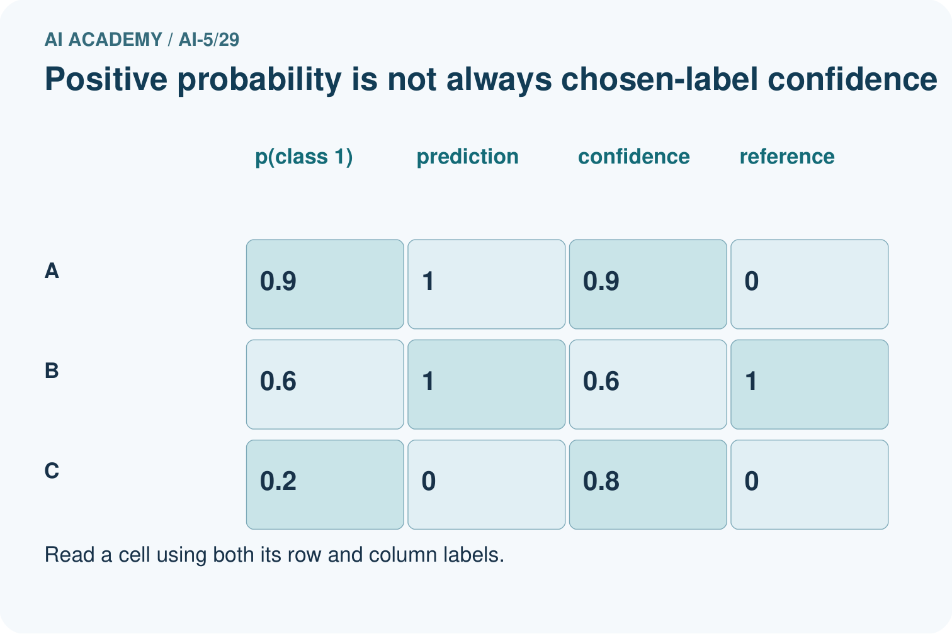
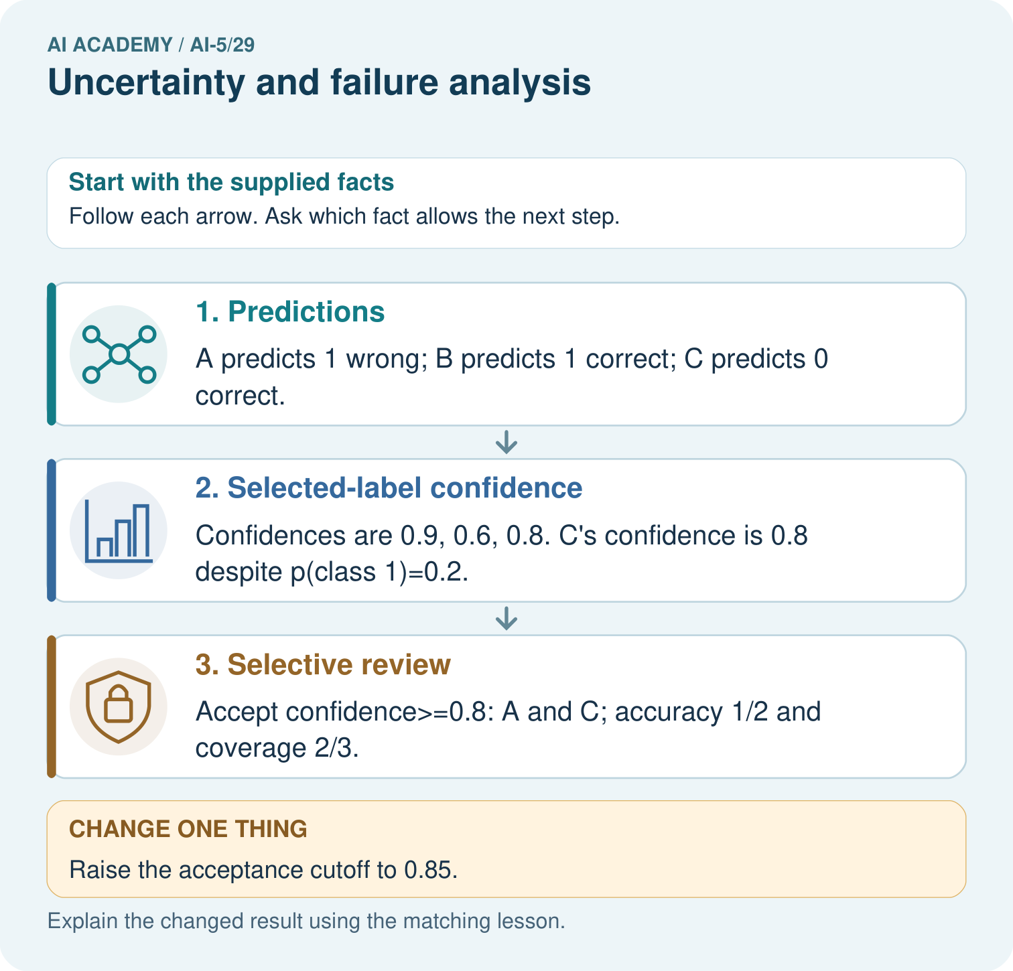

Read the picture one step at a time
Step | What happens and why
1. Predictions | A predicts 1 wrong; B predicts 1 correct; C predicts 0 correct.
2. Selected-label confidence | Confidences are 0.9, 0.6, 0.8. C’s confidence is 0.8 despite p(class 1)=0.2.
3. Selective review | Accept confidence>=0.8: A and C; accuracy 1/2 and coverage 2/3.
Match each pictured step to the supplied facts. This is a worked teaching case, not an independent assessment.

Why this result follows
Positive-class probability and confidence in the chosen label differ when the predicted class is zero. For C, a class-one probability of 0.2 gives class-zero confidence 0.8 under this toy rule. Selective accuracy counts only accepted cases; coverage counts how many were accepted. A stricter cutoff can retain a confidently wrong case and lower accuracy on this supplied set.

What this example does not establish
Supplied scores are not proven calibrated. Review policies need representative held-out evidence and clear handling of rejected cases.

Change one thing in the pictured case
Change: Raise the acceptance cutoff to 0.85.
Prediction: Only A is accepted: accuracy 0/1, coverage 1/3.
Reason: The most confident supplied case is wrong; a stricter cutoff is not guaranteed to improve this set’s accuracy.

Ask while showing the picture
Cover the result. Ask learners to name the inputs and predict the next step. Uncover one step, connect the icon to the actual procedure, and explain its evidence. Then change the supplied condition and compare. The picture is a representation; it does not document execution of a real AI model.

03. Demonstrate and guide practice
Time or stage | Teacher action
Session 1 start to 7 minutes | Retrieve the limits of the two-case validation result from Week 28. Define the triangle-present label.
7 to 18 minutes | Trace A and F, then complete W1 with selected-class confidence distinct from p1.
18 to 32 minutes | Build the error tally and complete W2. Trace the report function and its three returned quantities.
32 to 45 minutes | Use the visual and W3 to retain deferred cases in workload reporting and handle an empty accepted set.
Session 2 start to 8 minutes | Complete the guided cutoff 0.95 case and critique a perfect-accuracy claim.
8 to 20 minutes | Inspect the blur pattern and design a controlled comparison with source-grouped splits.
20 to 35 minutes | Collect W4 independently, including denominators and the worse accepted-subset result.
35 to 45 minutes | Use W5 and the exit response to evaluate causal and reliability claims. Give feedback, then the fresh retry.
Use the worked example in Sections 3 and 6. Collect a prediction before revealing its result; ask the learner to point to each intermediate fact.
Provide separate boxes for p1, predicted class, confidence, reference label and correctness. Use fractions before percentages. Extension: for A, B, C and F, mean confidence is 0.8875 while observed accuracy is 0.5. Discuss why this small grouped discrepancy motivates calibration study but cannot establish a population-wide calibration rate.

Reduce help deliberately
Completion task: For all six cases, list false positives and false negatives, count true positives and true negatives, and calculate overall accuracy. Why might a single accuracy hide useful information?
Teacher check: Teacher explanation: False positives are B and D; the false negative is F. A and C are the two true positives; E is the one true negative. Accuracy is 3 of 6, or 50 percent. It hides which errors occur and how their consequences differ.
Start by identifying the given inputs together. Leave the intermediate steps blank. If needed, model one step, then withdraw that help on the next step. Move to a full trace only when the partial trace is understood. For partners, alternate explainer and checker; collect a response from every learner before discussion.

Individual reasoning check
Use the worked case for Uncertainty and failure analysis. Proposed explanation: “A low p1 always means low confidence”. Decide whether this explanation is supported. Point to the step or supplied fact that decides; explain your repair if needed.
Expected correction: For a binary model, p1 = 0.10 selects class 0 with confidence 0.90.
Collect explanations, not only yes/no votes. If a misunderstanding is common, re-model the relevant step for the class. If it affects a few learners, give a short targeted group explanation while others solve a more demanding variation.

Pictorial practice question
What is C’s positive-class probability and chosen-label confidence? Point to the relevant step in the picture, then write the changed result and the rule or evidence that supports it.

Reasoned teacher answer
p(class 1)=0.2; predicted class 0 has selected-label confidence 0.8. These quantities answer different questions. Changed-case check: Only A is accepted: accuracy 0/1, coverage 1/3. The most confident supplied case is wrong; a stricter cutoff is not guaranteed to improve this set’s accuracy.
Changed-case reasoning: Only A is accepted: accuracy 0/1, coverage 1/3. The most confident supplied case is wrong; a stricter cutoff is not guaranteed to improve this set’s accuracy.
Collect each learner’s explanation before discussion. Use the first missing connection between input, deciding step and result to choose support. This question is worked-case practice, not fresh mastery evidence.

04. Run the investigation and diagnose misconceptions
A low p1 always means low confidence: For a binary model, p1 = 0.10 selects class 0 with confidence 0.90.
Reviewing uncertain cases fixes all errors: B and F remain confidently wrong; deferred outcomes also need measurement.
A shared condition proves the cause: A small error pattern motivates investigation; label checks, controlled examples and independent evaluation are still needed.
Use Section 9 for the evidence ledger. Add a boundary or missing-input case and record the expected response before checking. More successful repeats of one case do not establish wider coverage.

Match the support to the first error
What the response shows | Next teaching action
Missing or misread facts | Read the case aloud, mark supplied versus unknown facts, and let the learner restate it.
Wrong procedure | Return to the deciding step in the worked case. Contrast it with the proposed incorrect explanation.
Arithmetic or implementation error | Trace intermediate values or lines; preserve the first mismatch and retry that step.
Correct result without a reason | Ask for a trace and a changed case before marking independent understanding.
An unsupported wider claim | Ask which supplied evidence supports the claim and which further observation would be needed.
Offer an oral explanation, drawing, enlarged visual or fewer examples when that removes a reading/writing barrier. Keep the same reasoning goal. Stretch secure learners by changing a boundary or assumption and asking them to defend the effect, not simply by assigning more of the same questions.

05. Assess and explain the answers

Guided and exit questions
Guided: only A is accepted. Coverage is 1 of 6; accepted accuracy is 1 of 1. This single constructed success, selected by a rule examined on these data, does not establish future reliability. Exit: report one correct automatic prediction out of one accepted, with five of six deferred and no reviewer outcomes. Require representative untouched evaluation, subgroup and calibration evidence, measured reviewer outcomes and workload, and a comparison with a declared baseline.

W1 Separate confidence from correctness
For B, E and F, give the predicted class, selected-class confidence and correctness. Explain why p1 = 0.10 does not mean F has low confidence in its predicted class.
Teacher explanation: B predicts 1 with confidence 0.90 and is wrong. E predicts 0 with confidence 0.55 and is correct. F predicts 0 with confidence 0.90 and is wrong. F’s low score for class 1 corresponds to a high score for class 0, the class selected.

W2 Count both types of error
For all six cases, list false positives and false negatives, count true positives and true negatives, and calculate overall accuracy. Why might a single accuracy hide useful information?
Teacher explanation: False positives are B and D; the false negative is F. A and C are the two true positives; E is the one true negative. Accuracy is 3 of 6, or 50 percent. It hides which errors occur and how their consequences differ.

W3 Audit the review policy
At cutoff 0.80, list accepted and deferred cases, coverage and accepted-case accuracy. Can you calculate final accuracy after human review from the supplied data? What does the report function return for accepted-case accuracy at cutoff 0.99?
Teacher explanation: Accepted cases are A, B, C, F; deferred cases are D and E. Coverage is 4 of 6 and accepted accuracy is 2 of 4. No reviewer outcomes are supplied, so final system accuracy is unknown. At 0.99 no case is accepted; accepted accuracy is undefined and the function returns None.

W4 Analyse new outputs independently
Four new cases have (p1, reference label): K (0.85, 0), L (0.70, 1), M (0.30, 0), N (0.05, 0). Give predictions and confidences, overall accuracy, and accepted cases at cutoff 0.80. Calculate coverage and accepted-case accuracy. Does this policy improve accuracy on the accepted subset here?
Teacher explanation: Predictions are 1, 1, 0, 0; confidences are 0.85, 0.70, 0.70, 0.95. L, M and N are correct, so overall accuracy is 3 of 4. K and N are accepted; coverage is 2 of 4 and accepted accuracy is 1 of 2. Accepted accuracy is lower than overall accuracy in this example.

W5 Design a failure investigation
All three blurred cases are wrong. A team claims blur caused the errors and plans to put clear images in training and their blurred copies in final evaluation. Identify the unsupported claim and the split problem; propose a better investigation.
Teacher explanation: Three failures show a pattern, not a proven cause. Related clear and blurred copies across splits can leak source-image information. Check labels and preprocessing, then hold related versions together in reserved source groups and compare controlled blur variants within those groups. Choose changes before new final evaluation and report the small sample limitation.

Independent assessment and fresh retry
W4 requires predictions 1, 1, 0, 0; confidences 0.85, 0.70, 0.70, 0.95; accuracy 3 of 4; accepted K and N, coverage 2 of 4 and accepted accuracy 1 of 2. Fresh retry: (p1, label) values (0.90, 1), (0.65, 0), (0.35, 1), (0.10, 0). Predictions are 1, 1, 0, 0; confidences 0.90, 0.65, 0.65, 0.90. Overall accuracy is 2 of 4. At cutoff 0.80 accept first and fourth: coverage 2 of 4 and accepted accuracy 2 of 2. Require a limitation despite the perfect accepted subset.

Assess independent transfer
Selected case: Four new cases have (p1, reference label): K (0.85, 0), L (0.70, 1), M (0.30, 0), N (0.05, 0). Give predictions and confidences, overall accuracy, and accepted cases at cutoff 0.80. Calculate coverage and accepted-case accuracy. Does this policy improve accuracy on the accepted subset here?

Selected case answer
Teacher explanation: Predictions are 1, 1, 0, 0; confidences are 0.85, 0.70, 0.70, 0.95. L, M and N are correct, so overall accuracy is 3 of 4. K and N are accepted; coverage is 2 of 4 and accepted accuracy is 1 of 2. Accepted accuracy is lower than overall accuracy in this example.
Dimension | Evidence required
Explanation | Names the applicable idea or procedure and ties it to the supplied facts.
Trace and result | Preserves the given inputs and shows the relevant intermediate steps; distinguishes a prediction from an observed execution.
Limits | States the assumptions, missing evidence or conditions under which the result would change.
Record each dimension as not yet, with support, or independent. Accept a valid alternative procedure with a defensible trace. Do not penalise an honestly recorded model failure if the learner correctly explains its evidence and limits.

Feedback that the learner uses
Name the earliest unsupported step and give one action to repair it. Have the learner make that repair now and explain why. Then assess the relevant skill on a fresh, fully specified case. Confirm it was not previously practised with feedback; solve and check the new case before assigning it. A follow-up design prompt is a starting brief, not automatically an equivalent test.

06. Connect the project, support and next lesson
Add a labelled uncertainty and failure analysis evidence sheet to Image-pattern Network Investigation. Show how you can distinguish a predicted class, confidence score and observed correctness. Use the supplied fictional case and keep its inputs, intermediate steps, calculation or prediction, and limitation. Connect this record to last week’s record; a matching answer without a trace is insufficient.
Provide separate boxes for p1, predicted class, confidence, reference label and correctness. Use fractions before percentages. Extension: for A, B, C and F, mean confidence is 0.8875 while observed accuracy is 0.5. Discuss why this small grouped discrepancy motivates calibration study but cannot establish a population-wide calibration rate.
Week 30 studies dataset shift, comparing development and new-use conditions without assuming a familiar confidence score implies familiar data.
Retain the project ledger and assess a changed case after support. Check the relevant prerequisite before carrying this component forward.

Plan the delayed return
Suggested return points in this level: ai-5/30, ai-5/32, ai-5/35. Use actual classroom dates, adjusting for holidays and gaps. One, three and six teaching weeks are scheduling choices, not a claimed optimal spacing.
At a delayed check, ask for the idea from memory and a changed application. Compare with the earlier independent response and record support used. For a new level, revisit the previous capstone before checking the new prerequisites.
Record | Teacher evidence
Learner code and date
Concept and case used; prior exposure
Explanation / trace / limits
Support and first repair
Changed case and delayed outcome
Next teaching action
Use the evidence to choose reteaching or the next step. A completed page, confidence rating or attractive project does not by itself demonstrate understanding.

Project evidence from this case
For your Image-pattern Network Investigation, save the input, procedure, observed result and limitation of this check. Label this worked example as practice; use a different, previously unreviewed case when checking independent understanding.

07. Prepare, teach and assess
Teaching target: Distinguish a predicted class, confidence score and observed correctness
Prepare the labelled worked-case picture, the matching workbook, fictional input cards and a place for individual responses. Check a local Python 3 environment before class; have a paper-trace version ready.
Session | Plan | Resources
Session 1 · Understand · 45 min | 0–7: recall and prerequisite; 7–15: inspect the concrete case and predict; 15–30: teacher models the worked trace; 30–40: learners explain a step using the text and visual; 40–45: check the core idea. | Sections 1–6; record the brief recall in the workbook.
Session 2 · Practise · 45 min | 0–5: retrieve the procedure; 5–15: W2 completion practice; 15–23: explain and check with a partner; 23–30: each learner answers the misconception check; 30–40: targeted reteaching or a harder variation; 40–45: prepare the investigation. | Sections 7–10; use the matching workbook W2 and misconception check.
Session 3 · Investigate and transfer · 45 min | 0–5: retrieve the decision rule; 5–20: investigate or trace; 20–30: start the independent case; 30–38: connect the project; 38–43: act on feedback; 43–45: plan the return check. | Sections 9 and 11–14. Give extra time to finish the full task set; use Section 15 when the week includes a coding lab.
Before class, solve the supported practice: For all six cases, list false positives and false negatives, count true positives and true negatives, and calculate overall accuracy. Why might a single accuracy hide useful information?
Reasoned practice answer: Teacher explanation: False positives are B and D; the false negative is F. A and C are the two true positives; E is the one true negative. Accuracy is 3 of 6, or 50 percent. It hides which errors occur and how their consequences differ.
Check every learner before discussion: Use the worked case for Uncertainty and failure analysis. Proposed explanation: “A low p1 always means low confidence”. Decide whether this explanation is supported. Point to the step or supplied fact that decides; explain your repair if needed.
Misconception repair: For a binary model, p1 = 0.10 selects class 0 with confidence 0.90.
Support: read the exact case aloud, enlarge the labelled picture, supply input cards and model only the first deciding step. Accept a spoken explanation or drawing; retain the reasoning goal.
Extension: Raise the acceptance cutoff to 0.85. Require a prediction and a reason before comparing. Expected result: Only A is accepted: accuracy 0/1, coverage 1/3. Reason: The most confident supplied case is wrong; a stricter cutoff is not guaranteed to improve this set’s accuracy.
Independent assessment: withhold the reserved answer until the learner has attempted the new case. Record support separately from correctness.
Criterion | Not yet | With support | Independent
Explanation | Names an answer without a deciding fact | Uses a hint to link fact and decision | Explains the deciding fact in own words
Trace or test | Cannot connect input and result | Completes steps with prompts | Traces or tests a changed case accurately
Limits and revision | Claims more than evidence supports | Names a limit after a prompt | States a defensible limit and useful next test
Project checkpoint: Prepare the demonstration. Gather reproducible instructions, evidence, access checks and remaining limitations.
Use the weekly teacher answer for topic-specific reasoning. A saved progress tick is an activity record; judge mastery from the learner’s explanation and evidence.

