AI ACADEMY · TEACHER · ai-5/30

Dataset shift in neural models
Project: Image-pattern Network Investigation

01. Prepare the purpose, prerequisites and materials

Teach the learning cycle
Primary target: Explain how a changed input mix can change overall accuracy
Session | Sequence and minutes | Resources
Session 1 · Understand · 45 min | 0–7: recall and prerequisite; 7–15: inspect the concrete case and predict; 15–30: teacher models the worked trace; 30–40: learners explain a step using the text and visual; 40–45: check the core idea. | Sections 1–6; record the brief recall in the workbook.
Session 2 · Practise · 45 min | 0–5: retrieve the procedure; 5–15: W2 completion practice; 15–23: explain and check with a partner; 23–30: each learner answers the misconception check; 30–40: targeted reteaching or a harder variation; 40–45: prepare the investigation. | Sections 7–10; use the matching workbook W2 and misconception check.
Session 3 · Investigate and transfer · 45 min | 0–5: retrieve the decision rule; 5–20: investigate or trace; 20–30: start the independent case; 30–38: connect the project; 38–43: act on feedback; 43–45: plan the return check. | Sections 9 and 11–14. Give extra time to finish the full task set; use Section 15 when the week includes a coding lab.
This is a starting allocation of 135 minutes, not a validated duration. Preserve all named topics. Schedule extra time for connected examples, the full investigation, independent cases and project building. Repeated copies of a case share one recorded attempt; they are not new evidence.

Retrieval answer guidance

Uncertainty and failure analysis
Without opening the old lesson, explain one key idea from Uncertainty and failure analysis. Give an example and a mistake that the idea helps you avoid.
Look for: Distinguish a predicted class, confidence score and observed correctness
Reference example, not the only acceptable wording: Teacher explanation: B predicts 1 with confidence 0.90 and is wrong. E predicts 0 with confidence 0.55 and is correct. F predicts 0 with confidence 0.90 and is wrong. F’s low score for class 1 corresponds to a high score for class 0, the class selected.

Similarity and normalisation
Without opening the old lesson, explain one key idea from Similarity and normalisation. Give an example and a mistake that the idea helps you avoid.
Look for: Calculate vector length and normalise a nonzero vector
Reference example, not the only acceptable wording: Teacher explanation: Lengths are 5, 10 and 5. Unit vectors are [0.6, 0.8], [0.6, 0.8] and [-0.6, -0.8]. The length difference between Q and A disappears; the opposite direction of C is preserved.

Augmentation and leakage
Without opening the old lesson, explain one key idea from Augmentation and leakage. Give an example and a mistake that the idea helps you avoid.
Look for: Check whether a transformation preserves the task label
Reference example, not the only acceptable wording: Teacher explanation: Original d = -2 and class 0. Row swapping leaves d = -2 and class 0. Column swapping gives rows [1, 0], [1, 0], d = 2 and class 1.
Use two 45-minute sessions. Work from counts before percentages and keep the frozen model separate from the changing sample mix. The exact equal group rates are constructed for arithmetic; they do not establish a population law. A monitoring alert should lead to evidence gathering rather than an automatic causal claim or retraining decision.

Outcomes
Explain how a changed input mix can change overall accuracy
Calculate group and overall results with the correct denominators
Plan a shift investigation while preserving independent evaluation

Preparation
Printed lesson and workbook; paper and pencil
Calculator and optional local Python 3 editor; no packages or AI accounts needed
Use the fictional examples supplied; prepare the fresh retry before class

Prerequisite answer
No. Confidence is a model output, not a guarantee of familiarity or correctness. Check input conditions and independently verified outcomes rather than treating confidence as proof.

End goal for the pictorial case
By the end, I can explain dataset shift in neural models using a traced example and a stated limitation.
This added worked case illustrates the week’s main idea. Retain all original and connected topics; schedule its practice within the teaching cycle.

02. Explain and model the mechanism
A neural image classifier developed using mostly clear pictures may later receive mostly dim pictures. Its learned weights can stay unchanged while its overall results change. Dataset shift concerns changes in the data encountered, including inputs, label frequencies or the relationship between inputs and labels. A shift does not always reduce accuracy, and an accuracy change alone does not identify its cause.
Use the fictional audit below. Clear and dim are disjoint groups defined before the audit, and every case belongs to exactly one group. The same model checkpoint, preprocessing and prediction threshold are used throughout. Counts are constructed teaching data, not results from a deployed model. Both cohorts have checked reference labels.
Clear accuracy is 72 / 80 = 90 percent in development and 18 / 20 = 90 percent in new use. Dim accuracy is 10 / 20 = 50 percent and 40 / 80 = 50 percent. The observed group rates are unchanged, but the group proportions are different.
Development accuracy is (72 + 10) / (80 + 20) = 82 percent. New-use accuracy is (18 + 40) / (20 + 80) = 58 percent. The drop is 24 percentage points. Taking the unweighted mean of 90 and 50 gives 70 percent, which is not either cohort’s overall accuracy because neither cohort has equal group sizes.
Each pair is (cases, correct), and the function assumes integer counts for non-overlapping groups. It rejects empty inputs, groups with no cases and impossible correct counts. A group with no observed cases has an undefined empirical accuracy, not zero accuracy. Do not count the same example in two groups when forming an overall total.
Equivalently, weight each group accuracy by its share of cases: development is 0.80 times 0.90 + 0.20 times 0.50 = 0.82; new use is 0.20 times 0.90 + 0.80 times 0.50 = 0.58.
Term | Meaning
Dataset shift | A change in the distribution of inputs, labels or their relationship between settings
Subgroup | A declared subset of examples sharing a relevant condition
Group mix | The proportions of examples belonging to different groups
Monitoring | Repeatedly checking recorded inputs, outputs and available outcomes against a reference

The same group rates meet a different mix
Group | Development share | New-use share
Clear, 90% correct | 80 of 100 | 20 of 100
Dim, 50% correct | 20 of 100 | 80 of 100
The weaker group becomes more common. Overall mistakes rise from 18 of 100 to 42 of 100 without any change in these observed within-group accuracy rates.
Guided: 45 clear plus 25 dim cases are correct, giving 70 of 100 or 70 percent. This assumes exactly the stated group rates hold in that cohort. Exit: the mix change is observed, but accuracy is unknown without checked labels. Gather a labelled audit and check model/pipeline versions. Cases used to choose or fit a change cannot also provide independent final evidence. Reserve new appropriate cases and compare original and revised models on the same cases with group and overall results.

Model the reasoning aloud
Use the complete worked example below before asking learners to complete W2. Reveal a small part, invite a prediction, then explain the deciding step. These teacher notes contain solutions; do not reveal the independent case answer during modelling.

The same group rates meet a different mix
Group | Development share | New-use share
Clear, 90% correct | 80 of 100 | 20 of 100
Dim, 50% correct | 20 of 100 | 80 of 100
The weaker group becomes more common. Overall mistakes rise from 18 of 100 to 42 of 100 without any change in these observed within-group accuracy rates.
The arithmetic explains this constructed aggregate difference. It does not prove that dim lighting caused each real error or that these group rates will stay fixed in future samples. Report group counts and uncertainty about generalisation. Review specific errors and reference labels as in Week 29.

If a new cohort has 50 clear and 50 dim cases, and exactly 90 percent and 50 percent are correct respectively, how many correct cases and what overall accuracy result? State the assumption behind this calculation.
________________________________________________________________
________________________________________________________________
________________________________________________________________
________________________________________________________________
Thinking move | Teacher prompt
Plan | What is given? What is the question? Which procedure fits these facts?
Do | Point to each input and intermediate step in the worked trace. Name the rule that allows the next step.
Check | Does the output answer the question? Which assumption or limitation prevents a larger claim?
Use the diagram and verbal explanation together. Ask learners to match a sentence to a specific visual step; do not assign learners fixed visual or auditory learning styles.

A pictorial worked case: Dataset shift in neural models
Separate within-setting performance from changing setting proportions.

The facts we will use
Toy old-use mix: bright 40 cases32 correct; dim 10 cases5 correct. New-use mix: bright 10 cases8 correct; dim 40 cases20 correct.
All inputs and outcomes in this worked example are invented classroom data; no real model run is claimed.
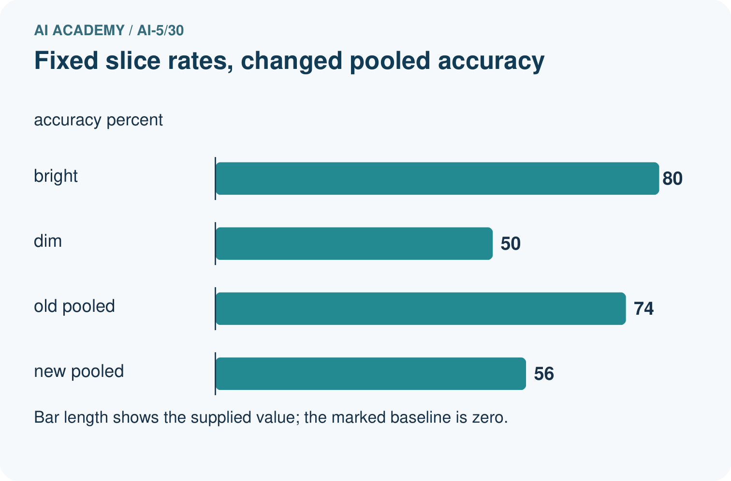
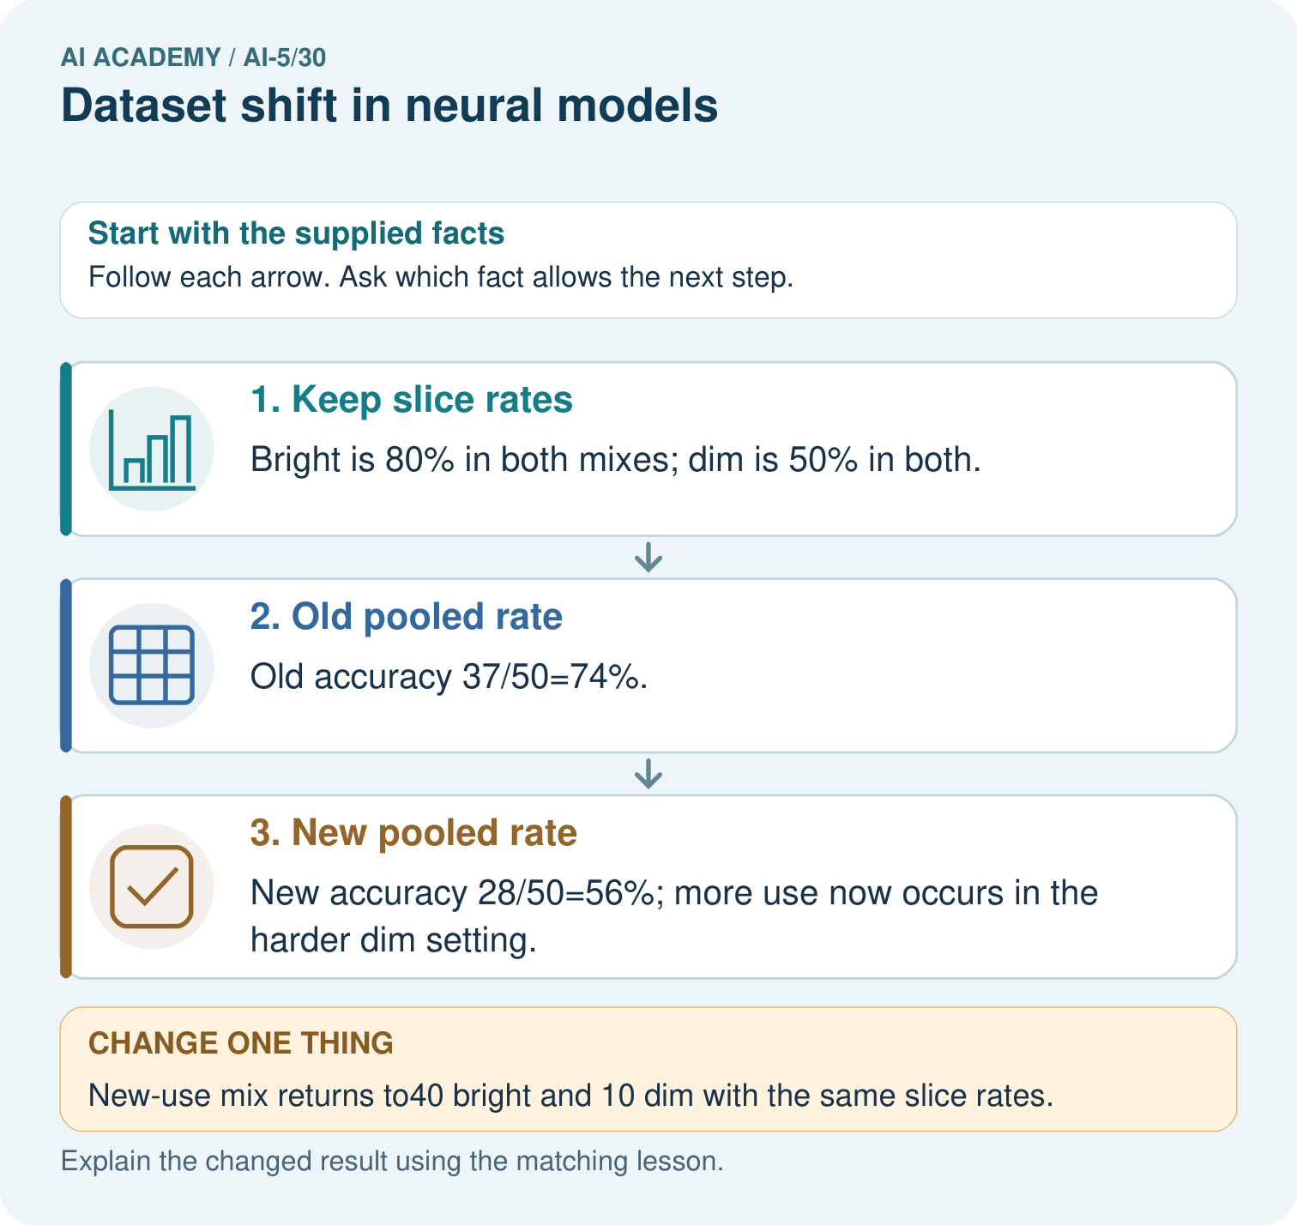

Read the picture one step at a time
Step | What happens and why
1. Keep slice rates | Bright is 80% in both mixes; dim is 50% in both.
2. Old pooled rate | Old accuracy 37/50=74%.
3. New pooled rate | New accuracy 28/50=56%; more use now occurs in the harder dim setting.
Match each pictured step to the supplied facts. This is a worked teaching case, not an independent assessment.

Why this result follows
A pooled rate depends on how often each condition appears as well as performance within that condition. Bright and dim accuracy stay fixed in this example. The new use contains more dim cases, so its pooled accuracy falls. Report both group counts and group rates before concluding that the network itself deteriorated.

What this example does not establish
Real shift can also change labels, sensors and within-slice behaviour; this toy decomposition isolates only mixture change.

Change one thing in the pictured case
Change: New-use mix returns to40 bright and 10 dim with the same slice rates.
Prediction: Pooled accuracy returns to74%.
Reason: The mixture weights change, while each slice’s conditional performance stays fixed.

Ask while showing the picture
Cover the result. Ask learners to name the inputs and predict the next step. Uncover one step, connect the icon to the actual procedure, and explain its evidence. Then change the supplied condition and compare. The picture is a representation; it does not document execution of a real AI model.

03. Demonstrate and guide practice
Time or stage | Teacher action
Session 1 start to 7 minutes | Retrieve Week 29’s warning that confident outputs can be wrong on unfamiliar inputs.
7 to 18 minutes | Read the cohort table and complete W1. Mark fixed checkpoint and pipeline versus changed mix.
18 to 32 minutes | Compute totals and W2. Compare the weighted result with the tempting unweighted average.
32 to 45 minutes | Trace the optional count function and the visual; explain why group sizes affect overall accuracy.
Session 2 start to 8 minutes | Complete the guided balanced cohort and name the fixed-rate assumption.
8 to 20 minutes | Complete W3 and discuss missing labels, pipeline changes and possible learned shortcuts.
20 to 35 minutes | Collect W4 independently, requiring counts, group rates, both totals and percentage points.
35 to 45 minutes | Use W5 and the exit response to protect independent evaluation. Give feedback, then a fresh retry.
Use the worked example in Sections 3 and 6. Collect a prediction before revealing its result; ask the learner to point to each intermediate fact.
Provide separate columns for cases, correct, errors and group share. Use 100 counters or a drawn 100-cell grid to change the mix while keeping group rates fixed. Extension: with clear share s and fixed rates 0.90 and 0.50, overall accuracy is 0.50 + 0.40*s. Test s = 0, 0.5 and 1, and explain why observed data need not keep those rates fixed.

Reduce help deliberately
Completion task: Calculate overall correct counts, accuracy and errors in both cohorts, plus the percentage-point drop. Explain why averaging 90 percent and 50 percent without weights gives the wrong overall result here.
Teacher check: Teacher explanation: Development has 82 correct and 18 errors out of 100, or 82 percent accuracy. New use has 58 correct and 42 errors out of 100, or 58 percent. The drop is 24 percentage points. An unweighted mean gives 70 percent and ignores the unequal group sizes.
Start by identifying the given inputs together. Leave the intermediate steps blank. If needed, model one step, then withdraw that help on the next step. Move to a full trace only when the partial trace is understood. For partners, alternate explainer and checker; collect a response from every learner before discussion.

Individual reasoning check
Use the worked case for Dataset shift in neural models. Proposed explanation: “Average the percentages regardless of group sizes”. Decide whether this explanation is supported. Point to the step or supplied fact that decides; explain your repair if needed.
Expected correction: Overall accuracy is total correct divided by total cases; group accuracies need weights proportional to group size.
Collect explanations, not only yes/no votes. If a misunderstanding is common, re-model the relevant step for the class. If it affects a few learners, give a short targeted group explanation while others solve a more demanding variation.

Pictorial practice question
Did the supplied model’s dim-light accuracy deteriorate? Point to the relevant step in the picture, then write the changed result and the rule or evidence that supports it.

Reasoned teacher answer
No, it remains50%. The pooled drop from 74% to56% reflects a larger proportion of dim cases, not changed within-slice rates. Changed-case check: Pooled accuracy returns to74%. The mixture weights change, while each slice’s conditional performance stays fixed.
Changed-case reasoning: Pooled accuracy returns to74%. The mixture weights change, while each slice’s conditional performance stays fixed.
Collect each learner’s explanation before discussion. Use the first missing connection between input, deciding step and result to choose support. This question is worked-case practice, not fresh mastery evidence.

04. Run the investigation and diagnose misconceptions
Average the percentages regardless of group sizes: Overall accuracy is total correct divided by total cases; group accuracies need weights proportional to group size.
A shift alert proves a loss of accuracy: Input changes may help, hurt or leave accuracy unchanged; verified outcomes are needed to measure performance.
An unchanged input summary proves nothing changed: A summary can miss relevant differences, and the input-label relationship or labelling policy can change without an obvious input shift.
Use Section 9 for the evidence ledger. Add a boundary or missing-input case and record the expected response before checking. More successful repeats of one case do not establish wider coverage.

Match the support to the first error
What the response shows | Next teaching action
Missing or misread facts | Read the case aloud, mark supplied versus unknown facts, and let the learner restate it.
Wrong procedure | Return to the deciding step in the worked case. Contrast it with the proposed incorrect explanation.
Arithmetic or implementation error | Trace intermediate values or lines; preserve the first mismatch and retry that step.
Correct result without a reason | Ask for a trace and a changed case before marking independent understanding.
An unsupported wider claim | Ask which supplied evidence supports the claim and which further observation would be needed.
Offer an oral explanation, drawing, enlarged visual or fewer examples when that removes a reading/writing barrier. Keep the same reasoning goal. Stretch secure learners by changing a boundary or assumption and asking them to defend the effect, not simply by assigning more of the same questions.

05. Assess and explain the answers

Guided and exit questions
Guided: 45 clear plus 25 dim cases are correct, giving 70 of 100 or 70 percent. This assumes exactly the stated group rates hold in that cohort. Exit: the mix change is observed, but accuracy is unknown without checked labels. Gather a labelled audit and check model/pipeline versions. Cases used to choose or fit a change cannot also provide independent final evidence. Reserve new appropriate cases and compare original and revised models on the same cases with group and overall results.

W1 Audit the two cohorts
From the table, calculate clear and dim accuracy in each cohort and the clear/dim proportions. Which observed quantities change, and which remain the same?
Teacher explanation: Clear accuracy is 90 percent in both cohorts; dim accuracy is 50 percent in both. Development has 80 percent clear and 20 percent dim; new use has 20 percent clear and 80 percent dim. The mix changes while observed group rates remain the same.

W2 Use the right denominator
Calculate overall correct counts, accuracy and errors in both cohorts, plus the percentage-point drop. Explain why averaging 90 percent and 50 percent without weights gives the wrong overall result here.
Teacher explanation: Development has 82 correct and 18 errors out of 100, or 82 percent accuracy. New use has 58 correct and 42 errors out of 100, or 58 percent. The drop is 24 percentage points. An unweighted mean gives 70 percent and ignores the unequal group sizes.

W3 Separate an alert from an outcome
New-use monitoring shows more dim images but reference labels have not arrived. What can you report now, what can you not calculate, and what checks should precede blaming the neural network?
Teacher explanation: Report the observed change in group proportions with counts and period. Current accuracy and error patterns need verified outcomes. Check checkpoint and preprocessing versions, group definitions, input quality and label policy; collect a representative labelled audit sample before concluding how performance changed.

W4 Analyse a new mixture independently
A separate audit has development groups P: 60 cases, 48 correct and Q: 40 cases, 20 correct. New-use groups are P: 20 cases, 16 correct and Q: 80 cases, 40 correct. Compute each group rate, both overall accuracies, and the percentage-point change. Under the same group rates, what accuracy would equal-sized P and Q groups have?
Teacher explanation: P is 80 percent correct and Q is 50 percent correct in both cohorts. Development accuracy is 68 of 100, or 68 percent; new-use accuracy is 56 of 100, or 56 percent. The drop is 12 percentage points. Equal-sized groups at those rates give 65 percent accuracy.

W5 Protect the comparison
A team retrains using new-use errors, then evaluates on those same images and their brightened copies. Explain why the score is not independent evidence and propose a comparison that includes the original model.
Teacher explanation: The evaluated cases influenced training, and transformed copies share source content. Keep related images in one split and reserve untouched source groups or an appropriate later period. Evaluate original and revised models on identical reserved examples, with checked labels, group counts and rates, overall accuracy, and documented preprocessing.

Independent assessment and fresh retry
W4 requires group rates 80 and 50 percent, overall accuracies 68 and 56 percent, a 12-percentage-point drop, and equal-group accuracy 65 percent. Fresh retry: development P has 75 cases with 60 correct; Q has 25 with 10 correct. New use P has 25 with 20 correct; Q has 75 with 30 correct. Group rates are 80 and 40 percent in both. Overall accuracy changes from 70 to 50 percent, a 20-percentage-point drop. Equal-sized groups at those rates give 60 percent.

Assess independent transfer
Selected case: A separate audit has development groups P: 60 cases, 48 correct and Q: 40 cases, 20 correct. New-use groups are P: 20 cases, 16 correct and Q: 80 cases, 40 correct. Compute each group rate, both overall accuracies, and the percentage-point change. Under the same group rates, what accuracy would equal-sized P and Q groups have?

Selected case answer
Teacher explanation: P is 80 percent correct and Q is 50 percent correct in both cohorts. Development accuracy is 68 of 100, or 68 percent; new-use accuracy is 56 of 100, or 56 percent. The drop is 12 percentage points. Equal-sized groups at those rates give 65 percent accuracy.
Dimension | Evidence required
Explanation | Names the applicable idea or procedure and ties it to the supplied facts.
Trace and result | Preserves the given inputs and shows the relevant intermediate steps; distinguishes a prediction from an observed execution.
Limits | States the assumptions, missing evidence or conditions under which the result would change.
Record each dimension as not yet, with support, or independent. Accept a valid alternative procedure with a defensible trace. Do not penalise an honestly recorded model failure if the learner correctly explains its evidence and limits.

Feedback that the learner uses
Name the earliest unsupported step and give one action to repair it. Have the learner make that repair now and explain why. Then assess the relevant skill on a fresh, fully specified case. Confirm it was not previously practised with feedback; solve and check the new case before assigning it. A follow-up design prompt is a starting brief, not automatically an equivalent test.

06. Connect the project, support and next lesson
Add a labelled dataset shift in neural models evidence sheet to Image-pattern Network Investigation. Show how you can explain how a changed input mix can change overall accuracy. Use the supplied fictional case and keep its inputs, intermediate steps, calculation or prediction, and limitation. Connect this record to last week’s record; a matching answer without a trace is insufficient.
Provide separate columns for cases, correct, errors and group share. Use 100 counters or a drawn 100-cell grid to change the mix while keeping group rates fixed. Extension: with clear share s and fixed rates 0.90 and 0.50, overall accuracy is 0.50 + 0.40*s. Test s = 0, 0.5 and 1, and explain why observed data need not keep those rates fixed.
Week 31 measures efficiency and resource use while keeping task quality, hardware and comparison conditions explicit.
Retain the project ledger and assess a changed case after support. Check the relevant prerequisite before carrying this component forward.

Plan the delayed return
Suggested return points in this level: ai-5/31, ai-5/33, ai-5/36. Use actual classroom dates, adjusting for holidays and gaps. One, three and six teaching weeks are scheduling choices, not a claimed optimal spacing.
At a delayed check, ask for the idea from memory and a changed application. Compare with the earlier independent response and record support used. For a new level, revisit the previous capstone before checking the new prerequisites.
Record | Teacher evidence
Learner code and date
Concept and case used; prior exposure
Explanation / trace / limits
Support and first repair
Changed case and delayed outcome
Next teaching action
Use the evidence to choose reteaching or the next step. A completed page, confidence rating or attractive project does not by itself demonstrate understanding.

Project evidence from this case
For your Image-pattern Network Investigation, save the input, procedure, observed result and limitation of this check. Label this worked example as practice; use a different, previously unreviewed case when checking independent understanding.

07. Prepare, teach and assess
Teaching target: Explain how a changed input mix can change overall accuracy
Prepare the labelled worked-case picture, the matching workbook, fictional input cards and a place for individual responses. Check a local Python 3 environment before class; have a paper-trace version ready.
Session | Plan | Resources
Session 1 · Understand · 45 min | 0–7: recall and prerequisite; 7–15: inspect the concrete case and predict; 15–30: teacher models the worked trace; 30–40: learners explain a step using the text and visual; 40–45: check the core idea. | Sections 1–6; record the brief recall in the workbook.
Session 2 · Practise · 45 min | 0–5: retrieve the procedure; 5–15: W2 completion practice; 15–23: explain and check with a partner; 23–30: each learner answers the misconception check; 30–40: targeted reteaching or a harder variation; 40–45: prepare the investigation. | Sections 7–10; use the matching workbook W2 and misconception check.
Session 3 · Investigate and transfer · 45 min | 0–5: retrieve the decision rule; 5–20: investigate or trace; 20–30: start the independent case; 30–38: connect the project; 38–43: act on feedback; 43–45: plan the return check. | Sections 9 and 11–14. Give extra time to finish the full task set; use Section 15 when the week includes a coding lab.
Before class, solve the supported practice: Calculate overall correct counts, accuracy and errors in both cohorts, plus the percentage-point drop. Explain why averaging 90 percent and 50 percent without weights gives the wrong overall result here.
Reasoned practice answer: Teacher explanation: Development has 82 correct and 18 errors out of 100, or 82 percent accuracy. New use has 58 correct and 42 errors out of 100, or 58 percent. The drop is 24 percentage points. An unweighted mean gives 70 percent and ignores the unequal group sizes.
Check every learner before discussion: Use the worked case for Dataset shift in neural models. Proposed explanation: “Average the percentages regardless of group sizes”. Decide whether this explanation is supported. Point to the step or supplied fact that decides; explain your repair if needed.
Misconception repair: Overall accuracy is total correct divided by total cases; group accuracies need weights proportional to group size.
Support: read the exact case aloud, enlarge the labelled picture, supply input cards and model only the first deciding step. Accept a spoken explanation or drawing; retain the reasoning goal.
Extension: New-use mix returns to40 bright and 10 dim with the same slice rates. Require a prediction and a reason before comparing. Expected result: Pooled accuracy returns to74%. Reason: The mixture weights change, while each slice’s conditional performance stays fixed.
Independent assessment: withhold the reserved answer until the learner has attempted the new case. Record support separately from correctness.
Criterion | Not yet | With support | Independent
Explanation | Names an answer without a deciding fact | Uses a hint to link fact and decision | Explains the deciding fact in own words
Trace or test | Cannot connect input and result | Completes steps with prompts | Traces or tests a changed case accurately
Limits and revision | Claims more than evidence supports | Names a limit after a prompt | States a defensible limit and useful next test
Project checkpoint: Prepare the demonstration. Gather reproducible instructions, evidence, access checks and remaining limitations.
Use the weekly teacher answer for topic-specific reasoning. A saved progress tick is an activity record; judge mastery from the learner’s explanation and evidence.

