AI ACADEMY · TEACHER · ai-5/36

Neural network experiment defense
Project: Image-pattern Network Investigation

01. Prepare the purpose, prerequisites and materials

Teach the learning cycle
Primary target: Defend a network experiment using traceable evidence
Session | Sequence and minutes | Resources
Session 1 · Understand · 45 min | 0–7: recall and prerequisite; 7–15: inspect the concrete case and predict; 15–30: teacher models the worked trace; 30–40: learners explain a step using the text and visual; 40–45: check the core idea. | Sections 1–6; record the brief recall in the workbook.
Session 2 · Practise · 45 min | 0–5: retrieve the procedure; 5–15: W2 completion practice; 15–23: explain and check with a partner; 23–30: each learner answers the misconception check; 30–40: targeted reteaching or a harder variation; 40–45: prepare the investigation. | Sections 7–10; use the matching workbook W2 and misconception check.
Session 3 · Investigate and transfer · 45 min | 0–5: retrieve the decision rule; 5–20: investigate or trace; 20–30: start the independent case; 30–38: connect the project; 38–43: act on feedback; 43–45: plan the return check. | Sections 9 and 11–14. Give extra time to finish the full task set; use Section 15 when the week includes a coding lab.
This is a starting allocation of 135 minutes, not a validated duration. Preserve all named topics. Schedule extra time for connected examples, the full investigation, independent cases and project building. Repeated copies of a case share one recorded attempt; they are not new evidence.

Retrieval answer guidance

Capstone limitations and revision
Without opening the old lesson, explain one key idea from Capstone limitations and revision. Give an example and a mistake that the idea helps you avoid.
Look for: Evaluate a frozen candidate and baseline on final rows
Reference example, not the only acceptable wording: Teacher explanation: Residuals 0,0,2,4; squared errors 0,0,4,16. The ReLU predictions for both negative inputs are zero.

Capstone hypothesis and baseline
Without opening the old lesson, explain one key idea from Capstone hypothesis and baseline. Give an example and a mistake that the idea helps you avoid.
Look for: Write a testable capstone hypothesis and a credible baseline
Reference example, not the only acceptable wording: Teacher explanation: Predict max(0, a*x) without bias; baseline a = 1; candidate starts at 1, learning rate 0.1, two full-batch updates on T1/T2. Hypothesis: candidate validation MSE on V1/V2 is strictly below the baseline MSE.

Dataset shift in neural models
Without opening the old lesson, explain one key idea from Dataset shift in neural models. Give an example and a mistake that the idea helps you avoid.
Look for: Explain how a changed input mix can change overall accuracy
Reference example, not the only acceptable wording: Teacher explanation: Clear accuracy is 90 percent in both cohorts; dim accuracy is 50 percent in both. Development has 80 percent clear and 20 percent dim; new use has 20 percent clear and 80 percent dim. The mix changes while observed group rates remain the same.
Use two 45-minute sessions. This capstone uses constructed scalar ReLU regression so every calculation is inspectable. It is an experiment in training and evidence, not a real-world deployment. Preserve written plans, data roles and raw predictions. Optional local Python requires no external packages or AI account. Do not expose independent-task solutions before collecting work.

Outcomes
Defend a network experiment using traceable evidence
Separate selection, final evaluation and revision claims
Answer a challenge with a calculation and a bounded conclusion

Preparation
Printed lesson and workbook; paper and pencil
Calculator; optional local Python 3 interpreter
Fictional data only; reserve the independent task and fresh retry until assessment

Prerequisite answer
No. They may support regression checks, but a revised procedure needs fresh reserved cases for independent evaluation.

End goal for the pictorial case
Explain neural network experiment defense with a traceable toy-network case and a bounded conclusion.
This added worked case illustrates the week’s main idea. Retain all original and connected topics; schedule its practice within the teaching cycle.

02. Explain and model the mechanism
A defense is not a sales pitch. Assemble the original question and criterion, data roles, baseline, model equation, settings, raw checkpoints, validation selection, frozen final predictions, limitations and revision history. Someone reading the record should be able to recompute a reported MSE and see which decisions each dataset informed.
For this capstone, two rates were compared under matched conditions. Rate 0.2 selected a = 2 with validation MSE 0 versus 0.78125 for rate 0.1. The frozen candidate then achieved final MSE 5 versus baseline 20.25 on four constructed cases. These are different comparisons and must not be collapsed into “the network was 100% accurate”.
Term | Meaning
Defense | An explanation of methods and claims supported by inspectable evidence
Evidence chain | The connection from inputs and procedure through raw outputs to a reported claim
Limitation | A condition restricting what evidence can establish
Reproduction | Repeating the documented procedure to check reported outputs

Keep the evidence roles separate
Plan or input | Procedure | Permitted conclusion
Question and settings | Replay calculations | Procedure can be checked
Frozen final predictions | Compare same four rows | Bounded baseline improvement
Known failures and changes | Preserve old results | Revision still needs evaluation
Every claim has an evidence source and a limit. A complete record is not a substitute for broader data.
Guided: 8 - 2 = 6 MSE units; 6/8 = 75% relative MSE reduction on four final rows. It is not classification accuracy. Exit: validation MSE 0 on two rows selected the candidate; frozen final MSE 5 versus 20.25 on four rows, with negative-output failures. Timing, stronger baselines and independent revised-model evaluation are absent.

Model the reasoning aloud
Use the complete worked example below before asking learners to complete W2. Reveal a small part, invite a prediction, then explain the deciding step. These teacher notes contain solutions; do not reveal the independent case answer during modelling.
Challenge: “Your validation error was zero, so why did the final test fail on negative targets?” Response: validation contained only positive inputs; the output max(0,a*x) cannot be negative. The final negative cases expose a coverage and architecture limitation. The overall criterion still passed, but that does not remove the failure.
Challenge: “Is a neural network better than linear regression?” Response: the supplied baseline was a fixed initial weight, not a fitted line. The evidence establishes improvement relative to that baseline only. A fitted signed line is a relevant additional comparison and needs a documented, fair evaluation. Challenge: “Was the candidate faster?” Response: no timing evidence was collected, so speed is unmeasured.
Thinking move | Teacher prompt
Plan | What is given? What is the question? Which procedure fits these facts?
Do | Point to each input and intermediate step in the worked trace. Name the rule that allows the next step.
Check | Does the output answer the question? Which assumption or limitation prevents a larger claim?
Use the diagram and verbal explanation together. Ask learners to match a sentence to a specific visual step; do not assign learners fixed visual or auditory learning styles.

A pictorial worked case: Neural network experiment defense
Defend an individual network calculation. At the defence, a team shows a single toy neuron before describing the whole image-pattern experiment.

The facts we will use
Inputs are [2,1]; weights [0.5,-1]; bias 0.2; activation is ReLU, max(0,z). This is a demonstration, not a probability model.
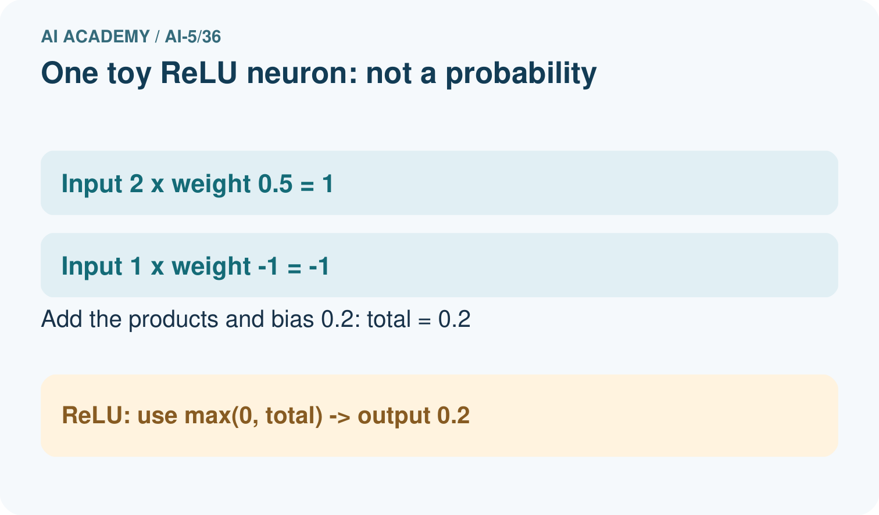
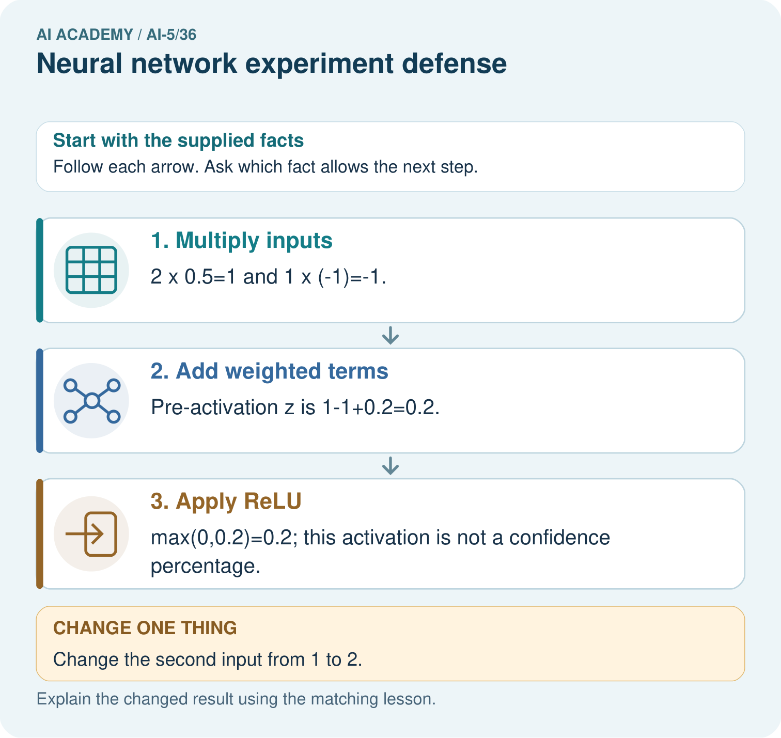

Read the picture one step at a time
Step | What happens and why
1. Multiply inputs | 2×0.5=1 and 1×(-1)=-1.
2. Add weighted terms | Pre-activation z is 1-1+0.2=0.2.
3. Apply ReLU | max(0,0.2)=0.2; this activation is not a confidence percentage.
Match each pictured step to the supplied facts. This is a worked teaching case, not an independent assessment.

Why this result follows
A defence should distinguish a traceable network calculation from a claim about classification quality. The neuron transforms supplied numbers; held-out labelled cases are needed to assess the complete system.

What this example does not establish
This one-neuron arithmetic does not establish how a trained image classifier generalises or why its full network makes a decision.

Change one thing in the pictured case
Change: Change the second input from 1 to 2.
Prediction: z becomes 1-2+0.2=-0.8 and ReLU returns 0.
Reason: The negative weighted term grows; ReLU clips a negative pre-activation to zero.

Ask while showing the picture
Cover the result. Ask learners to name the inputs and predict the next step. Uncover one step, connect the icon to the actual procedure, and explain its evidence. Then change the supplied condition and compare. The picture is a representation; it does not document execution of a real AI model.

03. Demonstrate and guide practice
Time or stage | Teacher action
Session 1 start to 7 minutes | Retrieve the prerequisite and ask students to explain the data roles.
7 to 18 minutes | Read section 1 and complete W1 with a recorded reason.
18 to 32 minutes | Trace section 2 and complete W2; compare raw values before conclusions.
32 to 45 minutes | Explain the diagram and complete W3 in pairs; record any support.
Session 2 start to 8 minutes | Complete the guided response and discuss why the evidence has limits.
8 to 20 minutes | Read the remaining explanation and prepare a concise experiment record.
20 to 35 minutes | Collect W4 independently. Require calculations and a bounded claim.
35 to 45 minutes | Use W5 and the exit response for feedback. Administer the fresh retry after feedback without the earlier solution.
Use the worked example in Sections 3 and 6. Collect a prediction before revealing its result; ask the learner to point to each intermediate fact.
Provide a frame with question, fixed settings, changed setting, data roles, raw predictions, metric, conclusion and limitation. Allow a calculator and explicit squared-error columns. Extension: implement the arithmetic locally, preserve the program version, and explain why a successful replay adds no independent test cases.

Reduce help deliberately
Completion task: State the validation selection and frozen final comparison using their correct metrics and scopes.
Teacher check: Teacher explanation: Rate 0.2 selected a = 2 with validation MSE 0 versus 0.78125 on two positive rows. Frozen final MSE was 5 versus baseline 20.25 on four constructed rows; negative-input candidate MSE was 10 on two rows.
Start by identifying the given inputs together. Leave the intermediate steps blank. If needed, model one step, then withdraw that help on the next step. Move to a full trace only when the partial trace is understood. For partners, alternate explainer and checker; collect a response from every learner before discussion.

Individual reasoning check
Use the worked case for Neural network experiment defense. Proposed explanation: “A polished demonstration is an evaluation”. Decide whether this explanation is supported. Point to the step or supplied fact that decides; explain your repair if needed.
Expected correction: A demonstration needs traceable data roles, metrics and raw results to support a performance claim.
Collect explanations, not only yes/no votes. If a misunderstanding is common, re-model the relevant step for the class. If it affects a few learners, give a short targeted group explanation while others solve a more demanding variation.

Pictorial practice question
Calculate both weighted terms, z and ReLU output. Predict the changed second input and explain why 0.2 cannot be called 20% accuracy.

Reasoned teacher answer
The products are 1 and -1; z=0.2 and ReLU=0.2. With second input 2, z=-0.8 and output=0. The activation is a neuron value, not an accuracy fraction or calibrated probability.
Changed-case reasoning: z becomes 1-2+0.2=-0.8 and ReLU returns 0. The negative weighted term grows; ReLU clips a negative pre-activation to zero.
Collect each learner’s explanation before discussion. Use the first missing connection between input, deciding step and result to choose support. This question is worked-case practice, not fresh mastery evidence.

04. Run the investigation and diagnose misconceptions
A polished demonstration is an evaluation: A demonstration needs traceable data roles, metrics and raw results to support a performance claim.
Relative MSE reduction is accuracy: Regression MSE and classification accuracy are different metrics.
A limitation invalidates every result: A limitation bounds a result; lower error on the measured rows can be true without a universal claim.
Use Section 9 for the evidence ledger. Add a boundary or missing-input case and record the expected response before checking. More successful repeats of one case do not establish wider coverage.

Match the support to the first error
What the response shows | Next teaching action
Missing or misread facts | Read the case aloud, mark supplied versus unknown facts, and let the learner restate it.
Wrong procedure | Return to the deciding step in the worked case. Contrast it with the proposed incorrect explanation.
Arithmetic or implementation error | Trace intermediate values or lines; preserve the first mismatch and retry that step.
Correct result without a reason | Ask for a trace and a changed case before marking independent understanding.
An unsupported wider claim | Ask which supplied evidence supports the claim and which further observation would be needed.
Offer an oral explanation, drawing, enlarged visual or fewer examples when that removes a reading/writing barrier. Keep the same reasoning goal. Stretch secure learners by changing a boundary or assumption and asking them to defend the effect, not simply by assigning more of the same questions.

05. Assess and explain the answers

Guided and exit questions
Guided: 8 - 2 = 6 MSE units; 6/8 = 75% relative MSE reduction on four final rows. It is not classification accuracy. Exit: validation MSE 0 on two rows selected the candidate; frozen final MSE 5 versus 20.25 on four rows, with negative-output failures. Timing, stronger baselines and independent revised-model evaluation are absent.

W1 Build the evidence inventory
Name eight items needed to check the capstone from question through final result.
Teacher explanation: Question/criterion, data and split IDs, baseline rule, architecture, initial values and learning rates, update count/loss, checkpoints and raw predictions, validation selection rule, frozen final record, limitations and revision history are acceptable items.

W2 Defend the result
State the validation selection and frozen final comparison using their correct metrics and scopes.
Teacher explanation: Rate 0.2 selected a = 2 with validation MSE 0 versus 0.78125 on two positive rows. Frozen final MSE was 5 versus baseline 20.25 on four constructed rows; negative-input candidate MSE was 10 on two rows.

W3 Challenge an unsupported claim
A presenter claims the experiment proves neural networks beat fitted lines and use less energy. What evidence is missing?
Teacher explanation: No fitted-line comparison or energy measurement was supplied. The initial-weight baseline comparison supports neither claim; specify a fair fitted-line procedure and measured resource boundary before comparing.

W4 Defend a new record independently
A separate experiment compares candidates C1 and C2 on two validation rows: MSE 1.5 and 1.0. The written rule selects lower MSE. After freezing C2, four fresh final rows give baseline squared errors 4,9,1,2 and C2 squared errors 1,1,2,0. Compute final MSE and relative reduction. Two condition-B rows are the last two rows; compare baseline and candidate MSE there. State what this record supports and what is unmeasured.
Teacher explanation: Select C2. Baseline final MSE 16/4 = 4; candidate MSE 4/4 = 1; absolute reduction 3 and relative reduction 75%. Condition B baseline MSE (1+2)/2 = 1.5 and candidate MSE (2+0)/2 = 1, though one condition-B row worsened from 1 to 2. The record supports lower MSE on these four final rows, not universal reliability or a classification-accuracy percentage. Speed and energy are unmeasured.

W5 Record the next investigation
Propose a fair next comparison with a fitted signed line. State how to preserve previous evidence and reserve new evaluation.
Teacher explanation: Keep the original plans, outputs and failures. Define and fit the signed-line baseline with development data, match task and evaluation metric, freeze both procedures, and use fresh reserved cases with positive and negative input coverage. Record revised settings and report all outcomes.

Independent assessment and fresh retry
W4 requires selection C2, MSE 4 and 1, 75% relative reduction, condition-B MSE 1.5 and 1 and recognition of the worsened row. Fresh retry: baseline squared errors 9,9,1,1; selected candidate errors 1,1,0,2. MSE 5 versus 1, relative reduction 80%; condition-B MSE both 1 with one worsened row. Require a bounded four-row conclusion.

Assess independent transfer
Selected case: A separate experiment compares candidates C1 and C2 on two validation rows: MSE 1.5 and 1.0. The written rule selects lower MSE. After freezing C2, four fresh final rows give baseline squared errors 4,9,1,2 and C2 squared errors 1,1,2,0. Compute final MSE and relative reduction. Two condition-B rows are the last two rows; compare baseline and candidate MSE there. State what this record supports and what is unmeasured.

Selected case answer
Teacher explanation: Select C2. Baseline final MSE 16/4 = 4; candidate MSE 4/4 = 1; absolute reduction 3 and relative reduction 75%. Condition B baseline MSE (1+2)/2 = 1.5 and candidate MSE (2+0)/2 = 1, though one condition-B row worsened from 1 to 2. The record supports lower MSE on these four final rows, not universal reliability or a classification-accuracy percentage. Speed and energy are unmeasured.
Dimension | Evidence required
Explanation | Names the applicable idea or procedure and ties it to the supplied facts.
Trace and result | Preserves the given inputs and shows the relevant intermediate steps; distinguishes a prediction from an observed execution.
Limits | States the assumptions, missing evidence or conditions under which the result would change.
Record each dimension as not yet, with support, or independent. Accept a valid alternative procedure with a defensible trace. Do not penalise an honestly recorded model failure if the learner correctly explains its evidence and limits.

Feedback that the learner uses
Name the earliest unsupported step and give one action to repair it. Have the learner make that repair now and explain why. Then assess the relevant skill on a fresh, fully specified case. Confirm it was not previously practised with feedback; solve and check the new case before assigning it. A follow-up design prompt is a starting brief, not automatically an equivalent test.

06. Connect the project, support and next lesson
For Image-pattern Network Investigation, use this week’s independent task as a rehearsal for the final evidence pack: A separate experiment compares candidates C1 and C2 on two validation rows: MSE 1.5 and 1.0. The written rule selects lower MSE. After freezing C2, four fresh final rows give baseline squared errors 4,9,1,2 and C2 squared errors 1,1,2,0. Compute final MSE and relative reduction. Two condition-B rows are the last two rows; compare baseline and candidate MSE there. State what this record supports and what is unmeasured. Keep actual observations separate from expected results, preserve failures, compare a baseline and explain the limits.
Provide a frame with question, fixed settings, changed setting, data roles, raw predictions, metric, conclusion and limitation. Allow a calculator and explicit squared-error columns. Extension: implement the arithmetic locally, preserve the program version, and explain why a successful replay adds no independent test cases.
AI 5 begins generative and predictive objectives. Check understanding of distributions and vector similarity before advancing; provide a targeted retrieval activity where evidence is incomplete.
Retain the project ledger and assess a changed case after support. Check the relevant prerequisite before carrying this component forward.

Plan the delayed return
Suggested return points in this level: plan a review after the level ends. Use actual classroom dates, adjusting for holidays and gaps. One, three and six teaching weeks are scheduling choices, not a claimed optimal spacing.
At a delayed check, ask for the idea from memory and a changed application. Compare with the earlier independent response and record support used. For a new level, revisit the previous capstone before checking the new prerequisites.
Record | Teacher evidence
Learner code and date
Concept and case used; prior exposure
Explanation / trace / limits
Support and first repair
Changed case and delayed outcome
Next teaching action
Use the evidence to choose reteaching or the next step. A completed page, confidence rating or attractive project does not by itself demonstrate understanding.

Project evidence from this case
For the Image-pattern Network Investigation, save the labelled trace and the changed-case explanation beside the experiment record. State exactly what this example supports before linking it to the wider capstone claim.

07. Prepare, teach and assess
Teaching target: Defend a network experiment using traceable evidence
Prepare the labelled worked-case picture, the matching workbook, fictional input cards and a place for individual responses. Check a local Python 3 environment before class; have a paper-trace version ready.
Session | Plan | Resources
Session 1 · Understand · 45 min | 0–7: recall and prerequisite; 7–15: inspect the concrete case and predict; 15–30: teacher models the worked trace; 30–40: learners explain a step using the text and visual; 40–45: check the core idea. | Sections 1–6; record the brief recall in the workbook.
Session 2 · Practise · 45 min | 0–5: retrieve the procedure; 5–15: W2 completion practice; 15–23: explain and check with a partner; 23–30: each learner answers the misconception check; 30–40: targeted reteaching or a harder variation; 40–45: prepare the investigation. | Sections 7–10; use the matching workbook W2 and misconception check.
Session 3 · Investigate and transfer · 45 min | 0–5: retrieve the decision rule; 5–20: investigate or trace; 20–30: start the independent case; 30–38: connect the project; 38–43: act on feedback; 43–45: plan the return check. | Sections 9 and 11–14. Give extra time to finish the full task set; use Section 15 when the week includes a coding lab.
Before class, solve the supported practice: State the validation selection and frozen final comparison using their correct metrics and scopes.
Reasoned practice answer: Teacher explanation: Rate 0.2 selected a = 2 with validation MSE 0 versus 0.78125 on two positive rows. Frozen final MSE was 5 versus baseline 20.25 on four constructed rows; negative-input candidate MSE was 10 on two rows.
Check every learner before discussion: Use the worked case for Neural network experiment defense. Proposed explanation: “A polished demonstration is an evaluation”. Decide whether this explanation is supported. Point to the step or supplied fact that decides; explain your repair if needed.
Misconception repair: A demonstration needs traceable data roles, metrics and raw results to support a performance claim.
Support: read the exact case aloud, enlarge the labelled picture, supply input cards and model only the first deciding step. Accept a spoken explanation or drawing; retain the reasoning goal.
Extension: Change the second input from 1 to 2. Require a prediction and a reason before comparing. Expected result: z becomes 1-2+0.2=-0.8 and ReLU returns 0. Reason: The negative weighted term grows; ReLU clips a negative pre-activation to zero.
Independent assessment: withhold the reserved answer until the learner has attempted the new case. Record support separately from correctness.
Criterion | Not yet | With support | Independent
Explanation | Names an answer without a deciding fact | Uses a hint to link fact and decision | Explains the deciding fact in own words
Trace or test | Cannot connect input and result | Completes steps with prompts | Traces or tests a changed case accurately
Limits and revision | Claims more than evidence supports | Names a limit after a prompt | States a defensible limit and useful next test
Project checkpoint: Present and defend. Demonstrate the system, explain one failure and justify the next improvement with evidence.
Use the weekly teacher answer for topic-specific reasoning. A saved progress tick is an activity record; judge mastery from the learner’s explanation and evidence.

