AI ACADEMY · TEACHER · ai-7/5

Replication and reproduction
Project: Reproducible AI Research Study

01. Prepare the purpose, prerequisites and materials

Teach the learning cycle
Primary target: Explain the mechanism and terminology of replication and reproduction
Session | Sequence and minutes | Resources
Session 1 · Understand · 45 min | 0–7: recall and prerequisite; 7–15: inspect the concrete case and predict; 15–30: teacher models the worked trace; 30–40: learners explain a step using the text and visual; 40–45: check the core idea. | Sections 1–6; record the brief recall in the workbook.
Session 2 · Practise · 45 min | 0–5: retrieve the procedure; 5–15: W2 completion practice; 15–23: explain and check with a partner; 23–30: each learner answers the misconception check; 30–40: targeted reteaching or a harder variation; 40–45: prepare the investigation. | Sections 7–10; use the matching workbook W2 and misconception check.
Session 3 · Investigate and transfer · 45 min | 0–5: retrieve the decision rule; 5–20: investigate or trace; 20–30: start the independent case; 30–38: connect the project; 38–43: act on feedback; 43–45: plan the return check. | Sections 9 and 11–14. Give extra time to finish the full task set; use Section 15 when the week includes a coding lab.
This is a starting allocation of 135 minutes, not a validated duration. Preserve all named topics. Schedule extra time for connected examples, the full investigation, independent cases and project building. Repeated copies of a case share one recorded attempt; they are not new evidence.

Retrieval answer guidance

Methods results and limitations
Without opening the old lesson, explain one key idea from Methods results and limitations. Give an example and a mistake that the idea helps you avoid.
Look for: Explain the mechanism and terminology of methods results and limitations
Reference example, not the only acceptable wording: Teacher explanation: Methods state what was done; results state observed outcomes; limitations state restrictions on interpretation. Mixing them hides missing evidence. Classify each statement by role and link results to the procedure and denominator. A proposed mechanism is an explanation to test, not an extra observation.

Reading a research claim
Without opening the old lesson, explain one key idea from Reading a research claim. Give an example and a mistake that the idea helps you avoid.
Look for: Explain the mechanism and terminology of reading a research claim
Reference example, not the only acceptable wording: Teacher explanation: Reading a claim requires its method, data, comparison and uncertainty. Titles and abstracts may omit conditions crucial to interpretation. Separate the claim from supplied evidence. Record dataset, unit, baseline, metric and limitations. Ask whether the statement extends beyond those observations.
Two 45-minute sessions. Reproducing a computation uses recorded artifacts; replication collects new evidence under a comparable question. Naming conventions vary, so define the terms in the project. Use the supplied constructed scenarios to make the mechanism inspectable. Collect W4 before sharing solutions. Students should name intermediate evidence and limitations; classroom pacing and learning effectiveness remain unvalidated.

Outcomes
Explain the mechanism and terminology of replication and reproduction
Apply the stated procedure to a new case with a traceable result
Identify an assumption or limitation and design a revealing follow-up

Preparation
Lesson and workbook; paper and pencil
Calculator and optional local Python 3 for arithmetic; no live API or private data
Prepare the fresh retry separately and withhold its solution until after collection

Prerequisite answer
A result depends on the inputs, procedure and conditions that produced it. Preserve data roles and distinguish observed outcomes from predictions or unmeasured conditions. If the prior concept cannot be explained, use a short retrieval activity before this chapter.

End goal for the pictorial case
Explain replication and reproduction using the records and boundaries of this fictional investigation.
This added worked case illustrates the week’s main idea. Retain all original and connected topics; schedule its practice within the teaching cycle.

02. Explain and model the mechanism
Reproducing a computation uses recorded artifacts; replication collects new evidence under a comparable question. Naming conventions vary, so define the terms in the project.
Begin by writing the question the procedure is intended to answer. Identify the information already supplied, the information it will produce and the information still missing. These are constructed classroom examples; they do not require live accounts, private records or an external service. Do not treat a plausible explanation as a measured outcome.
Here replay means same artifacts/procedure; new-data replication means newly collected eligible cases under the same plan. Preserve environment, data versions and raw results.
Before applying the procedure, write its units, denominator or decision boundary where relevant. A partner should be able to repeat each step using the same inputs. If a required input is absent or violates the stated contract, record that condition explicitly instead of quietly replacing it with a convenient value.
Term | Meaning
Replay | Repeating a computation with the recorded artifacts
Replication | A new evidence collection under a comparable declared question
Distinct unit | A separately eligible observation rather than a repeated copy

Replication and reproduction — evidence trace
Input and scope | Check or calculation | Conclusion and limit
Partner reruns the same eight cases and gets the same score. Team counts sixteen independent cases. | Here replay means same artifacts/procedure; new-data replication means newly collected eligible cases under the same plan. Preserve environment, data versions and raw results. | This is a successful replay on eight distinct cases, not sixteen new cases. It checks computation consistency.
The figure connects this chapter's worked input, declared procedure and result. Read the complete worked reasoning for qualifiers and intermediate steps; the abbreviated labels do not replace that reasoning.
Guided: This is a successful replay on eight distinct cases, not sixteen new cases. It checks computation consistency. Qualification: Exact replay can preserve the original design flaws; new data can change conditions and needs its own record. Exit: accept a concrete variation with its predicted outcome and a stated condition that would challenge the mechanism; reject a claim resting on unmeasured evidence.

Model the reasoning aloud
Use the complete worked example below before asking learners to complete W2. Reveal a small part, invite a prediction, then explain the deciding step. These teacher notes contain solutions; do not reveal the independent case answer during modelling.
Partner reruns the same eight cases and gets the same score. Team counts sixteen independent cases.
This is a successful replay on eight distinct cases, not sixteen new cases. It checks computation consistency.
Compare the intermediate evidence with the final statement. Explain why each number or decision follows from the stated inputs. The conclusion belongs to this scenario and procedure; changing the inputs, evaluation population or authority can change what it establishes. Retain the raw record so a later revision can be compared honestly.
Thinking move | Teacher prompt
Plan | What is given? What is the question? Which procedure fits these facts?
Do | Point to each input and intermediate step in the worked trace. Name the rule that allows the next step.
Check | Does the output answer the question? Which assumption or limitation prevents a larger claim?
Use the diagram and verbal explanation together. Ask learners to match a sentence to a specific visual step; do not assign learners fixed visual or auditory learning styles.

A pictorial worked case: Replication and reproduction
Same records versus new experiment. A team first reruns a supplied analysis, then collects new records with the same protocol.

The facts we will use
Original recorded labels: [1,0,1,1]. Analysis counts correct cases. New independent set: [1,1,0,0]. Binary entries mean 1=correct and 0=incorrect.
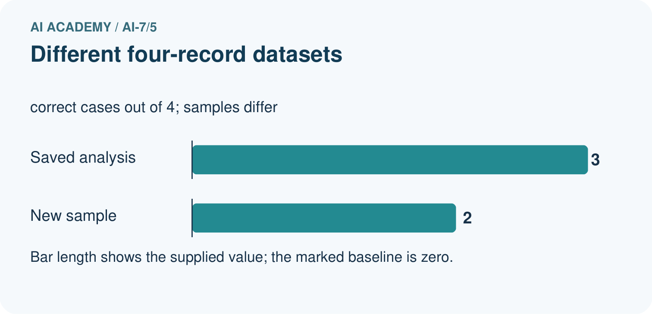
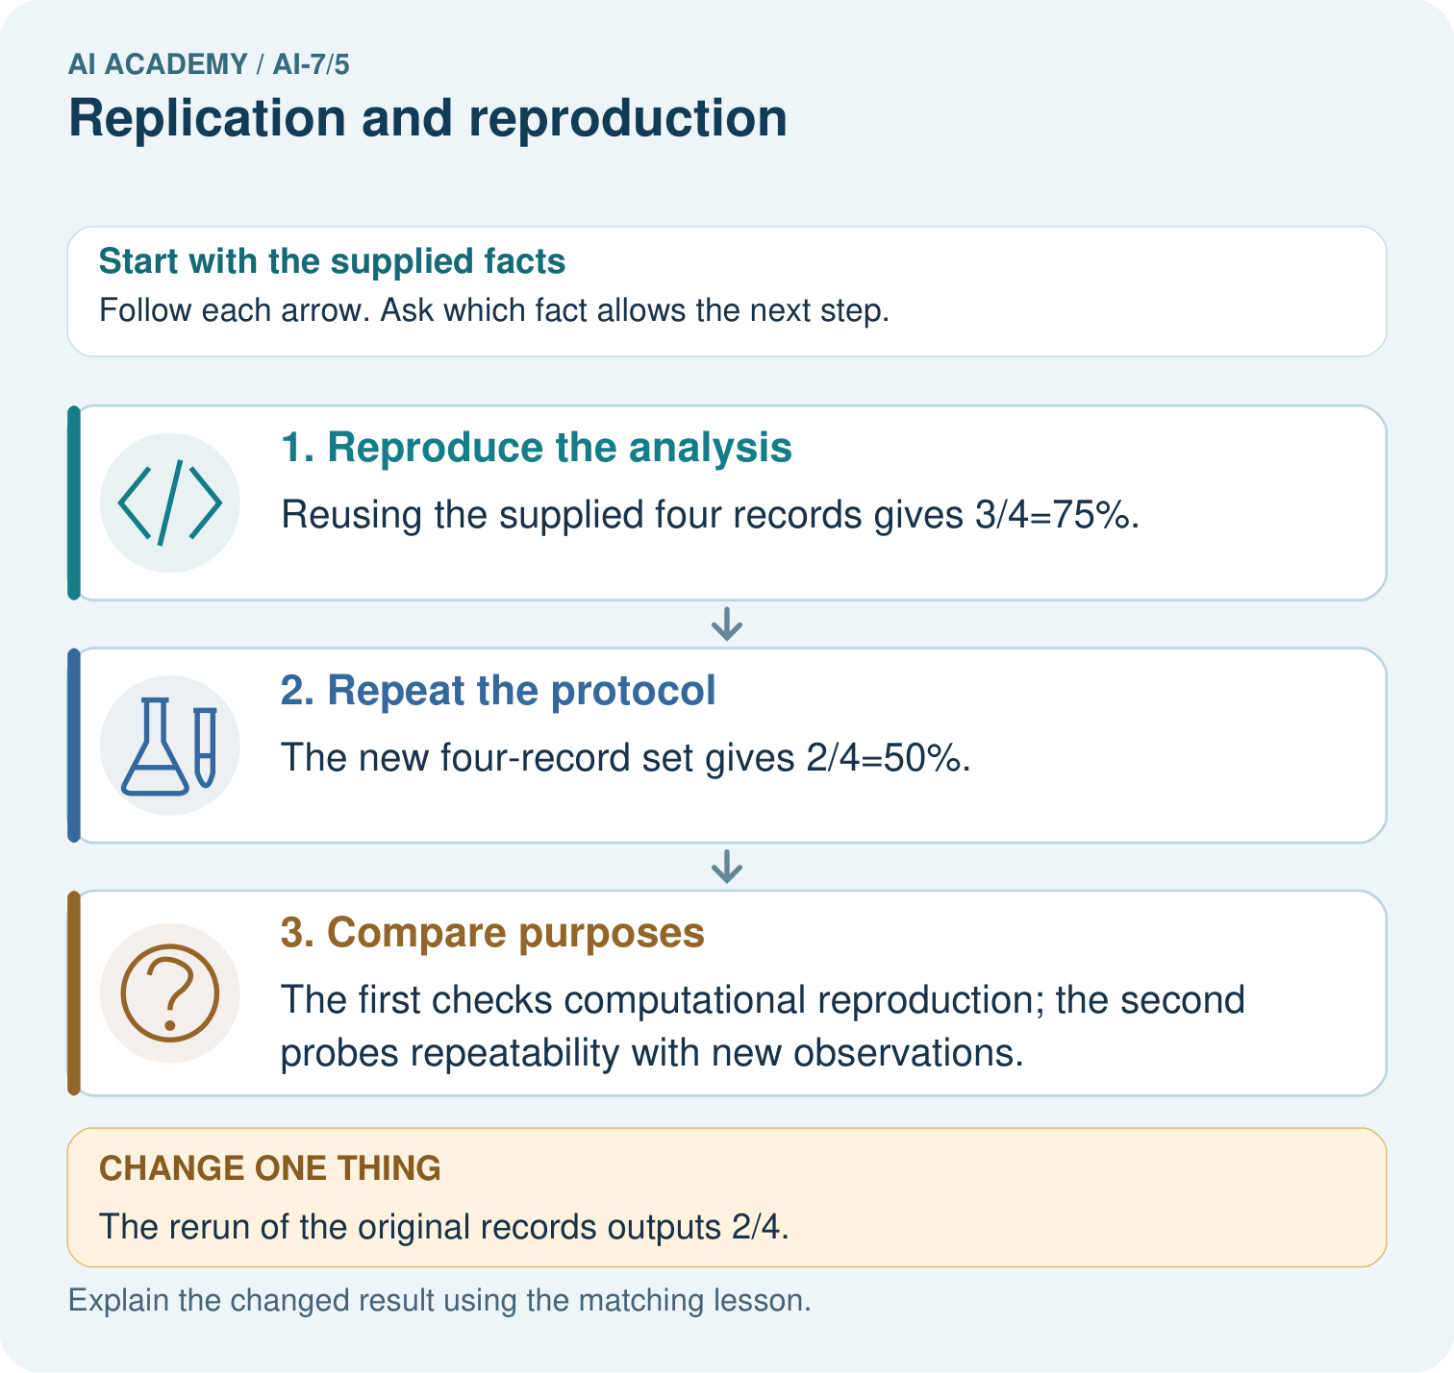

Read the picture one step at a time
Step | What happens and why
1. Reproduce the analysis | Reusing the supplied four records gives 3/4=75%.
2. Repeat the protocol | The new four-record set gives 2/4=50%.
3. Compare purposes | The first checks computational reproduction; the second probes repeatability with new observations.
Match each pictured step to the supplied facts. This is a worked teaching case, not an independent assessment.

Why this result follows
Reusing data and collecting new data answer different questions. A different new-sample result can arise without a code error; inspect both protocols and variability.

What this example does not establish
Four-case samples are illustrative; neither result alone establishes broad reliability.

Change one thing in the pictured case
Change: The rerun of the original records outputs 2/4.
Prediction: Investigate code, version, input or scoring differences.
Reason: The same fixed records should give the same deterministic count.

Ask while showing the picture
Cover the result. Ask learners to name the inputs and predict the next step. Uncover one step, connect the icon to the actual procedure, and explain its evidence. Then change the supplied condition and compare. The picture is a representation; it does not document execution of a real AI model.

03. Demonstrate and guide practice
Time or stage | Teacher action
Session 1: 0–7 minutes | Retrieve the prerequisite; identify the input, procedure and evidence source.
7–18 minutes | Explain section 1 and vocabulary. Complete W1 with a mechanism-based explanation.
18–32 minutes | Trace the declared procedure and worked case. Complete W2, recording intermediate steps.
32–45 minutes | Discuss the diagram with the worked input; use W3 to distinguish measured claims and limitations.
Session 2: 0–8 minutes | Retrieve the worked reasoning and collect the guided response before discussing it.
8–20 minutes | Compare a proposed boundary variant with the original case; identify what remains fixed.
20–35 minutes | Collect W4 independently. Require the procedure trace and the bounded conclusion.
35–45 minutes | Use W5 and exit responses for feedback. Administer the fresh retry after feedback and preserve both attempts.
Use the worked example in Sections 3 and 6. Collect a prediction before revealing its result; ask the learner to point to each intermediate fact.
Provide an input/procedure/result/limit frame and a calculator when needed. Ask students to identify the first step before completing the whole trace. Extension: compare two concrete variants of this mechanism while holding unrelated conditions fixed; report both successful and unsuccessful outcomes.

Reduce help deliberately
Completion task: Partner reruns the same eight cases and gets the same score. Team counts sixteen independent cases. Show the intermediate steps and give the conclusion with its scope.
Teacher check: Teacher explanation: This is a successful replay on eight distinct cases, not sixteen new cases. It checks computation consistency.
Start by identifying the given inputs together. Leave the intermediate steps blank. If needed, model one step, then withdraw that help on the next step. Move to a full trace only when the partial trace is understood. For partners, alternate explainer and checker; collect a response from every learner before discussion.

Individual reasoning check
Use the worked case for Replication and reproduction. Proposed explanation: “The worked result establishes every future case”. Decide whether this explanation is supported. Point to the step or supplied fact that decides; explain your repair if needed.
Expected correction: Exact replay can preserve the original design flaws; new data can change conditions and needs its own record.
Collect explanations, not only yes/no votes. If a misunderstanding is common, re-model the relevant step for the class. If it affects a few learners, give a short targeted group explanation while others solve a more demanding variation.

Pictorial practice question
Calculate the scores from the original and new four-record sets. Which activity reproduces saved analysis, which repeats the protocol, and why does a different rerun of the original data need investigation?

Reasoned teacher answer
Reusing the supplied four records gives 3/4=75%. The new four-record set gives 2/4=50%. The first checks computational reproduction; the second probes repeatability with new observations. Changed case: Investigate code, version, input or scoring differences. The same fixed records should give the same deterministic count.
Changed-case reasoning: Investigate code, version, input or scoring differences. The same fixed records should give the same deterministic count.
Collect each learner’s explanation before discussion. Use the first missing connection between input, deciding step and result to choose support. This question is worked-case practice, not fresh mastery evidence.

04. Run the investigation and diagnose misconceptions
The worked result establishes every future case: Exact replay can preserve the original design flaws; new data can change conditions and needs its own record.
A missing input may be replaced without recording the change: A replacement changes the evidence or contract. Record the change and its justification; do not silently turn unknown into a measured value.
Repeating an assessed case is new independent evidence: A replay checks consistency. An example used for feedback or revision cannot later be described as untouched final evaluation.
Use Section 9 for the evidence ledger. Add a boundary or missing-input case and record the expected response before checking. More successful repeats of one case do not establish wider coverage.

Match the support to the first error
What the response shows | Next teaching action
Missing or misread facts | Read the case aloud, mark supplied versus unknown facts, and let the learner restate it.
Wrong procedure | Return to the deciding step in the worked case. Contrast it with the proposed incorrect explanation.
Arithmetic or implementation error | Trace intermediate values or lines; preserve the first mismatch and retry that step.
Correct result without a reason | Ask for a trace and a changed case before marking independent understanding.
An unsupported wider claim | Ask which supplied evidence supports the claim and which further observation would be needed.
Offer an oral explanation, drawing, enlarged visual or fewer examples when that removes a reading/writing barrier. Keep the same reasoning goal. Stretch secure learners by changing a boundary or assumption and asking them to defend the effect, not simply by assigning more of the same questions.

05. Assess and explain the answers

Guided and exit questions
Guided: This is a successful replay on eight distinct cases, not sixteen new cases. It checks computation consistency. Qualification: Exact replay can preserve the original design flaws; new data can change conditions and needs its own record. Exit: accept a concrete variation with its predicted outcome and a stated condition that would challenge the mechanism; reject a claim resting on unmeasured evidence.

W1 Explain the mechanism
Explain the weekly mechanism in your own words. Use the worked scenario to name its input, decision rule and output.
Teacher explanation: Reproducing a computation uses recorded artifacts; replication collects new evidence under a comparable question. Naming conventions vary, so define the terms in the project. Here replay means same artifacts/procedure; new-data replication means newly collected eligible cases under the same plan. Preserve environment, data versions and raw results.

W2 Trace the worked case
Partner reruns the same eight cases and gets the same score. Team counts sixteen independent cases. Show the intermediate steps and give the conclusion with its scope.
Teacher explanation: This is a successful replay on eight distinct cases, not sixteen new cases. It checks computation consistency.

W3 Audit the limit
A report omits this qualification: Exact replay can preserve the original design flaws; new data can change conditions and needs its own record. Explain how omitting it could change a reader's interpretation, and write an accurate replacement.
Teacher explanation: Exact replay can preserve the original design flaws; new data can change conditions and needs its own record. State the observed result separately from the unverified or out-of-scope claim; preserve the original evidence rather than inventing a missing fact.

W4 Apply a new case independently
Team repeats old six queries, then evaluates four newly reserved queries. How many distinct cases and which are new evidence?
Teacher explanation: Ten distinct total; four are new. Replays of six old cases are not additional observations for population coverage.

W5 Design a revealing follow-up
For the worked scenario, propose one additional case that could reveal a failure, describe its expected outcome before running it, and explain what would need to remain fixed for a fair comparison. Do not reuse W4 as a new final test after receiving feedback.
Teacher explanation: Accept a concrete variant of the worked input or a missing/conflicting/boundary condition, with an expectation derived from the declared procedure. Require preserved settings, original outputs and data roles. Exact replay can preserve the original design flaws; new data can change conditions and needs its own record. The new case should test this particular mechanism rather than merely restate the original result.

Independent assessment and fresh retry
W4: Ten distinct total; four are new. Replays of six old cases are not additional observations for population coverage. Require intermediate reasoning and the stated scope. Fresh retry: Old dataset ten rows rerun three times, new set five rows. Expected reasoning: Fifteen distinct rows; repeated old runs may study run variability but do not add new cases. If students need support, record it and reassess with another new case rather than awarding independence to a copied answer.

Assess independent transfer
Selected case: Team repeats old six queries, then evaluates four newly reserved queries. How many distinct cases and which are new evidence?

Selected case answer
Teacher explanation: Ten distinct total; four are new. Replays of six old cases are not additional observations for population coverage.
Dimension | Evidence required
Explanation | Names the applicable idea or procedure and ties it to the supplied facts.
Trace and result | Preserves the given inputs and shows the relevant intermediate steps; distinguishes a prediction from an observed execution.
Limits | States the assumptions, missing evidence or conditions under which the result would change.
Record each dimension as not yet, with support, or independent. Accept a valid alternative procedure with a defensible trace. Do not penalise an honestly recorded model failure if the learner correctly explains its evidence and limits.

Feedback that the learner uses
Name the earliest unsupported step and give one action to repair it. Have the learner make that repair now and explain why. Then assess the relevant skill on a fresh, fully specified case. Confirm it was not previously practised with feedback; solve and check the new case before assigning it. A follow-up design prompt is a starting brief, not automatically an equivalent test.

06. Connect the project, support and next lesson
Add a labelled replication and reproduction evidence sheet to Reproducible AI Research Study. Show how you can explain the mechanism and terminology of replication and reproduction. Use the supplied fictional case and keep its inputs, intermediate steps, calculation or prediction, and limitation. Connect this record to last week’s record; a matching answer without a trace is insufficient.
Provide an input/procedure/result/limit frame and a calculator when needed. Ask students to identify the first step before completing the whole trace. Extension: compare two concrete variants of this mechanism while holding unrelated conditions fixed; report both successful and unsuccessful outcomes.
Next connection: A literature comparison matrix. Preserve the current case record and retrieve its evidence boundary before moving on.
Retain the project ledger and assess a changed case after support. Check the relevant prerequisite before carrying this component forward.

Plan the delayed return
Suggested return points in this level: ai-7/6, ai-7/8, ai-7/11. Use actual classroom dates, adjusting for holidays and gaps. One, three and six teaching weeks are scheduling choices, not a claimed optimal spacing.
At a delayed check, ask for the idea from memory and a changed application. Compare with the earlier independent response and record support used. For a new level, revisit the previous capstone before checking the new prerequisites.
Record | Teacher evidence
Learner code and date
Concept and case used; prior exposure
Explanation / trace / limits
Support and first repair
Changed case and delayed outcome
Next teaching action
Use the evidence to choose reteaching or the next step. A completed page, confidence rating or attractive project does not by itself demonstrate understanding.

Project evidence from this case
For the Reproducible AI Research Study, retain an annotated worked trace and the changed-case reasoning. Connect the claim to its records, units and assumptions so another investigator can challenge or reproduce it.

07. Prepare, teach and assess
Teaching target: Explain the mechanism and terminology of replication and reproduction
Prepare the labelled worked-case picture, the matching workbook, fictional input cards and a place for individual responses. Check a local Python 3 environment before class; have a paper-trace version ready.
Session | Plan | Resources
Session 1 · Understand · 45 min | 0–7: recall and prerequisite; 7–15: inspect the concrete case and predict; 15–30: teacher models the worked trace; 30–40: learners explain a step using the text and visual; 40–45: check the core idea. | Sections 1–6; record the brief recall in the workbook.
Session 2 · Practise · 45 min | 0–5: retrieve the procedure; 5–15: W2 completion practice; 15–23: explain and check with a partner; 23–30: each learner answers the misconception check; 30–40: targeted reteaching or a harder variation; 40–45: prepare the investigation. | Sections 7–10; use the matching workbook W2 and misconception check.
Session 3 · Investigate and transfer · 45 min | 0–5: retrieve the decision rule; 5–20: investigate or trace; 20–30: start the independent case; 30–38: connect the project; 38–43: act on feedback; 43–45: plan the return check. | Sections 9 and 11–14. Give extra time to finish the full task set; use Section 15 when the week includes a coding lab.
Before class, solve the supported practice: Partner reruns the same eight cases and gets the same score. Team counts sixteen independent cases. Show the intermediate steps and give the conclusion with its scope.
Reasoned practice answer: Teacher explanation: This is a successful replay on eight distinct cases, not sixteen new cases. It checks computation consistency.
Check every learner before discussion: Use the worked case for Replication and reproduction. Proposed explanation: “The worked result establishes every future case”. Decide whether this explanation is supported. Point to the step or supplied fact that decides; explain your repair if needed.
Misconception repair: Exact replay can preserve the original design flaws; new data can change conditions and needs its own record.
Support: read the exact case aloud, enlarge the labelled picture, supply input cards and model only the first deciding step. Accept a spoken explanation or drawing; retain the reasoning goal.
Extension: The rerun of the original records outputs 2/4. Require a prediction and a reason before comparing. Expected result: Investigate code, version, input or scoring differences. Reason: The same fixed records should give the same deterministic count.
Independent assessment: withhold the reserved answer until the learner has attempted the new case. Record support separately from correctness.
Criterion | Not yet | With support | Independent
Explanation | Names an answer without a deciding fact | Uses a hint to link fact and decision | Explains the deciding fact in own words
Trace or test | Cannot connect input and result | Completes steps with prompts | Traces or tests a changed case accurately
Limits and revision | Claims more than evidence supports | Names a limit after a prompt | States a defensible limit and useful next test
Project checkpoint: Frame the need. Name the user, the problem, allowed inputs and a safe simple starting method.
Use the weekly teacher answer for topic-specific reasoning. A saved progress tick is an activity record; judge mastery from the learner’s explanation and evidence.

