AI ACADEMY · TEACHER · ai-7/14

Statistical tests and assumptions
Project: Reproducible AI Research Study

01. Prepare the purpose, prerequisites and materials

Teach the learning cycle
Primary target: Explain the mechanism and terminology of statistical tests and assumptions
Session | Sequence and minutes | Resources
Session 1 · Understand · 45 min | 0–7: recall and prerequisite; 7–15: inspect the concrete case and predict; 15–30: teacher models the worked trace; 30–40: learners explain a step using the text and visual; 40–45: check the core idea. | Sections 1–6; record the brief recall in the workbook.
Session 2 · Practise · 45 min | 0–5: retrieve the procedure; 5–15: W2 completion practice; 15–23: explain and check with a partner; 23–30: each learner answers the misconception check; 30–40: targeted reteaching or a harder variation; 40–45: prepare the investigation. | Sections 7–10; use the matching workbook W2 and misconception check.
Session 3 · Investigate and transfer · 45 min | 0–5: retrieve the decision rule; 5–20: investigate or trace; 20–30: start the independent case; 30–38: connect the project; 38–43: act on feedback; 43–45: plan the return check. | Sections 9 and 11–14. Give extra time to finish the full task set; use Section 15 when the week includes a coding lab.
This is a starting allocation of 135 minutes, not a validated duration. Preserve all named topics. Schedule extra time for connected examples, the full investigation, independent cases and project building. Repeated copies of a case share one recorded attempt; they are not new evidence.

Retrieval answer guidance

Effect size and practical importance
Without opening the old lesson, explain one key idea from Effect size and practical importance. Give an example and a mistake that the idea helps you avoid.
Look for: Explain the mechanism and terminology of effect size and practical importance
Reference example, not the only acceptable wording: Teacher explanation: Effect size describes magnitude on a stated scale. Practical importance depends on task requirements, not merely a nonzero difference. For paired response durations compute baseline minus candidate per case and average the differences. Positive means faster candidate. Compare with a prespecified minimum useful gain.

Sampling variability
Without opening the old lesson, explain one key idea from Sampling variability. Give an example and a mistake that the idea helps you avoid.
Look for: Explain the mechanism and terminology of sampling variability
Reference example, not the only acceptable wording: Teacher explanation: Sampling variability means different eligible samples can give different estimates even under the same population. Separate this from procedure changes. Consider finite population values1, 1, 3, 3 with distinct IDs. Enumerate the six unordered samples of size2 without replacement. Their means are1, 2, 2, 2, 2, 3.

Baselines and fair comparisons
Without opening the old lesson, explain one key idea from Baselines and fair comparisons. Give an example and a mistake that the idea helps you avoid.
Look for: Explain the mechanism and terminology of baselines and fair comparisons
Reference example, not the only acceptable wording: Teacher explanation: Fair baselines use credible procedures on matched evidence and resource conditions. A weak arbitrary reference can exaggerate improvement. For a room-reporting study use manual authoritative lookup or a deterministic same-room rule, not random room names. Match cases, available sources and scoring.
Two 45-minute sessions. A statistical test compares observed evidence with a specified null model. A p-value is not the probability that the null hypothesis is true. Use the supplied constructed scenarios to make the mechanism inspectable. Collect W4 before sharing solutions. Students should name intermediate evidence and limitations; classroom pacing and learning effectiveness remain unvalidated.

Outcomes
Explain the mechanism and terminology of statistical tests and assumptions
Apply the stated procedure to a new case with a traceable result
Identify an assumption or limitation and design a revealing follow-up

Preparation
Lesson and workbook; paper and pencil
Calculator and optional local Python 3 for arithmetic; no live API or private data
Prepare the fresh retry separately and withhold its solution until after collection

Prerequisite answer
A result depends on the inputs, procedure and conditions that produced it. Preserve data roles and distinguish observed outcomes from predictions or unmeasured conditions. If the prior concept cannot be explained, use a short retrieval activity before this chapter.

End goal for the pictorial case
Explain statistical tests and assumptions using the records and boundaries of this fictional investigation.
This added worked case illustrates the week’s main idea. Retain all original and connected topics; schedule its practice within the teaching cycle.

02. Explain and model the mechanism
A statistical test compares observed evidence with a specified null model. A p-value is not the probability that the null hypothesis is true.
Begin by writing the question the procedure is intended to answer. Identify the information already supplied, the information it will produce and the information still missing. These are constructed classroom examples; they do not require live accounts, private records or an external service. Do not treat a plausible explanation as a measured outcome.
Toy paired sign-flip test assumes independent paired differences whose signs are exchangeable under a symmetric zero-effect null. Enumerate all2^n sign assignments, holding magnitudes fixed. Two-sided p is fraction with absolute mean at least the observed absolute mean; use inclusive ties.
Before applying the procedure, write its units, denominator or decision boundary where relevant. A partner should be able to repeat each step using the same inputs. If a required input is absent or violates the stated contract, record that condition explicitly instead of quietly replacing it with a convenient value.
Term | Meaning
Null model | The probability model used for a test comparison
P-value | The null-model chance of an outcome at least as extreme under the defined statistic
Exchangeability | An assumption permitting the declared rearrangements

Statistical tests and assumptions — evidence trace
Input and scope | Check or calculation | Conclusion and limit
Differences1, 1, 1 have observed mean1. Enumerate8 assignments. | Toy paired sign-flip test assumes independent paired differences whose signs are exchangeable under a symmetric zero-effect null. Enumerate all2^n sign assignments, holding magnitudes fixed. Two-sided p is fraction with absolute mean at least the observed absolute mean; use inclusive ties. | Only all-plus and all-minus have absolute mean1; others have1/3. Exact p=2/8=.25. At alpha .05 do not reject; this does not prove zero effect.
The figure connects this chapter's worked input, declared procedure and result. Read the complete worked reasoning for qualifiers and intermediate steps; the abbreviated labels do not replace that reasoning.
Guided: Only all-plus and all-minus have absolute mean1; others have1/3. Exact p=2/8=.25. At alpha .05 do not reject; this does not prove zero effect. Qualification: The test requires its sign-exchangeability and independence assumptions; do not apply it blindly to clustered or asymmetric differences. Exit: accept a concrete variation with its predicted outcome and a stated condition that would challenge the mechanism; reject a claim resting on unmeasured evidence.

Model the reasoning aloud
Use the complete worked example below before asking learners to complete W2. Reveal a small part, invite a prediction, then explain the deciding step. These teacher notes contain solutions; do not reveal the independent case answer during modelling.
Differences1, 1, 1 have observed mean1. Enumerate8 assignments.
Only all-plus and all-minus have absolute mean1; others have1/3. Exact p=2/8=.25. At alpha .05 do not reject; this does not prove zero effect.
Compare the intermediate evidence with the final statement. Explain why each number or decision follows from the stated inputs. The conclusion belongs to this scenario and procedure; changing the inputs, evaluation population or authority can change what it establishes. Retain the raw record so a later revision can be compared honestly.
Optional local lab: predict the printed result before running this standalone Python 3 example. Change one relevant boundary input, record the outcome and state the contract or statistical assumptions. The program uses fictional values and the Python standard library; it performs no external operations.
from itertools import product
def sign_flip_p(differences):
"""Two-sided exact test under independent symmetric sign exchangeability.
Tiny n only; hold absolute magnitudes fixed and include equal extremes.
A p-value is not a posterior probability that the null is true.
"""
if not differences or len(differences) > 16:
raise ValueError('require 1–16 paired units')
threshold = abs(sum(differences))
count = 0
for signs in product((-1, 1), repeat=len(differences)):
simulated = abs(sum((s * abs(d) for (s, d) in zip(signs, differences))))
if simulated >= threshold - 1e-12:
count += 1
return count / 2 ** len(differences)
print(sign_flip_p([1, 1, 1]))
Thinking move | Teacher prompt
Plan | What is given? What is the question? Which procedure fits these facts?
Do | Point to each input and intermediate step in the worked trace. Name the rule that allows the next step.
Check | Does the output answer the question? Which assumption or limitation prevents a larger claim?
Use the diagram and verbal explanation together. Ask learners to match a sentence to a specific visual step; do not assign learners fixed visual or auditory learning styles.

A pictorial worked case: Statistical tests and assumptions
A small exact paired sign-flip test. Compare three independent task pairs under a null that permits each difference’s sign to flip independently with equal probability.

The facts we will use
A times [5,8,4] seconds; B [4,6,3]. Differences B−A are [-1,-2,-1]. Use a two-sided statistic: absolute sum of differences. Assume the stated sign-symmetry null is appropriate.
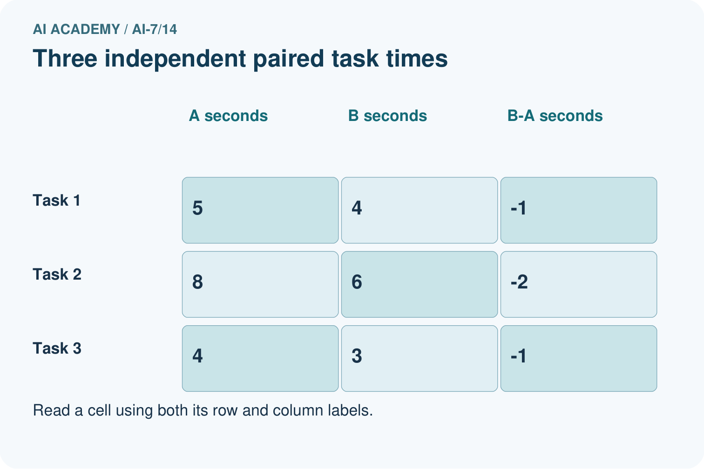
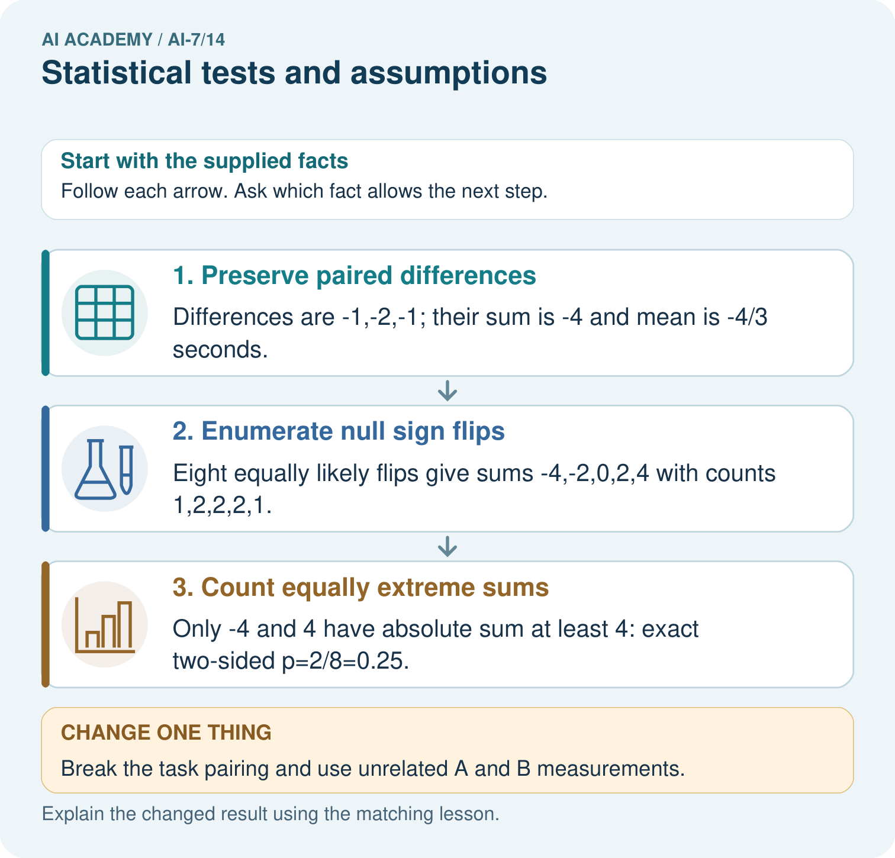

Read the picture one step at a time
Step | What happens and why
1. Preserve paired differences | Differences are -1,-2,-1; their sum is -4 and mean is -4/3 seconds.
2. Enumerate null sign flips | Eight equally likely flips give sums -4,-2,0,2,4 with counts 1,2,2,2,1.
3. Count equally extreme sums | Only -4 and 4 have absolute sum at least 4: exact two-sided p=2/8=0.25.
Match each pictured step to the supplied facts. This is a worked teaching case, not an independent assessment.

Why this result follows
A test compares an observed statistic with outcomes under a specified null model. Here the sign-flip assumptions make eight arrangements equally likely. At a predeclared 0.05 threshold, p=0.25 does not reject the null; it does not prove no difference.

What this example does not establish
Three pairs provide coarse evidence. The p-value is not the probability that the null is true; invalid independence or symmetry assumptions invalidate this test.

Change one thing in the pictured case
Change: Break the task pairing and use unrelated A and B measurements.
Prediction: This paired sign-flip calculation is no longer justified by the stated design.
Reason: Its differences must come from the same task, with the declared independent sign-symmetry assumptions.

Ask while showing the picture
Cover the result. Ask learners to name the inputs and predict the next step. Uncover one step, connect the icon to the actual procedure, and explain its evidence. Then change the supplied condition and compare. The picture is a representation; it does not document execution of a real AI model.

03. Demonstrate and guide practice
Time or stage | Teacher action
Session 1: 0–7 minutes | Retrieve the prerequisite; identify the input, procedure and evidence source.
7–18 minutes | Explain section 1 and vocabulary. Complete W1 with a mechanism-based explanation.
18–32 minutes | Trace the declared procedure and worked case. Complete W2, recording intermediate steps.
32–45 minutes | Discuss the diagram with the worked input; use W3 to distinguish measured claims and limitations.
Session 2: 0–8 minutes | Retrieve the worked reasoning and collect the guided response before discussing it.
8–20 minutes | Compare a proposed boundary variant with the original case; identify what remains fixed.
20–35 minutes | Collect W4 independently. Require the procedure trace and the bounded conclusion.
35–45 minutes | Use W5 and exit responses for feedback. Administer the fresh retry after feedback and preserve both attempts.
Use the worked example in Sections 3 and 6. Collect a prediction before revealing its result; ask the learner to point to each intermediate fact.
Provide an input/procedure/result/limit frame and a calculator when needed. Ask students to identify the first step before completing the whole trace. Extension: compare two concrete variants of this mechanism while holding unrelated conditions fixed; report both successful and unsuccessful outcomes.

Reduce help deliberately
Completion task: Differences1, 1, 1 have observed mean1. Enumerate8 assignments. Show the intermediate steps and give the conclusion with its scope.
Teacher check: Teacher explanation: Only all-plus and all-minus have absolute mean1; others have1/3. Exact p=2/8=.25. At alpha .05 do not reject; this does not prove zero effect.
Start by identifying the given inputs together. Leave the intermediate steps blank. If needed, model one step, then withdraw that help on the next step. Move to a full trace only when the partial trace is understood. For partners, alternate explainer and checker; collect a response from every learner before discussion.

Individual reasoning check
Use the worked case for Statistical tests and assumptions. Proposed explanation: “The worked result establishes every future case”. Decide whether this explanation is supported. Point to the step or supplied fact that decides; explain your repair if needed.
Expected correction: The test requires its sign-exchangeability and independence assumptions; do not apply it blindly to clustered or asymmetric differences.
Collect explanations, not only yes/no votes. If a misunderstanding is common, re-model the relevant step for the class. If it affects a few learners, give a short targeted group explanation while others solve a more demanding variation.

Pictorial practice question
Calculate each paired difference and the observed sum. Count null arrangements with absolute sum at least four, compute p, and explain the decision at threshold 0.05.

Reasoned teacher answer
The differences are -1,-2,-1 and sum to -4. Two of eight sign arrangements have absolute sum at least 4, so p=0.25. This exceeds 0.05: do not reject under the stated null. This is not proof of equality.
Changed-case reasoning: This paired sign-flip calculation is no longer justified by the stated design. Its differences must come from the same task, with the declared independent sign-symmetry assumptions.
Collect each learner’s explanation before discussion. Use the first missing connection between input, deciding step and result to choose support. This question is worked-case practice, not fresh mastery evidence.

04. Run the investigation and diagnose misconceptions
The worked result establishes every future case: The test requires its sign-exchangeability and independence assumptions; do not apply it blindly to clustered or asymmetric differences.
A missing input may be replaced without recording the change: A replacement changes the evidence or contract. Record the change and its justification; do not silently turn unknown into a measured value.
Repeating an assessed case is new independent evidence: A replay checks consistency. An example used for feedback or revision cannot later be described as untouched final evaluation.
Use Section 9 for the evidence ledger. Add a boundary or missing-input case and record the expected response before checking. More successful repeats of one case do not establish wider coverage.

Match the support to the first error
What the response shows | Next teaching action
Missing or misread facts | Read the case aloud, mark supplied versus unknown facts, and let the learner restate it.
Wrong procedure | Return to the deciding step in the worked case. Contrast it with the proposed incorrect explanation.
Arithmetic or implementation error | Trace intermediate values or lines; preserve the first mismatch and retry that step.
Correct result without a reason | Ask for a trace and a changed case before marking independent understanding.
An unsupported wider claim | Ask which supplied evidence supports the claim and which further observation would be needed.
Offer an oral explanation, drawing, enlarged visual or fewer examples when that removes a reading/writing barrier. Keep the same reasoning goal. Stretch secure learners by changing a boundary or assumption and asking them to defend the effect, not simply by assigning more of the same questions.

05. Assess and explain the answers

Guided and exit questions
Guided: Only all-plus and all-minus have absolute mean1; others have1/3. Exact p=2/8=.25. At alpha .05 do not reject; this does not prove zero effect. Qualification: The test requires its sign-exchangeability and independence assumptions; do not apply it blindly to clustered or asymmetric differences. Exit: accept a concrete variation with its predicted outcome and a stated condition that would challenge the mechanism; reject a claim resting on unmeasured evidence.

W1 Explain the mechanism
Explain the weekly mechanism in your own words. Use the worked scenario to name its input, decision rule and output.
Teacher explanation: A statistical test compares observed evidence with a specified null model. A p-value is not the probability that the null hypothesis is true. Toy paired sign-flip test assumes independent paired differences whose signs are exchangeable under a symmetric zero-effect null. Enumerate all2^n sign assignments, holding magnitudes fixed. Two-sided p is fraction with absolute mean at least the observed absolute mean; use inclusive ties.

W2 Trace the worked case
Differences1, 1, 1 have observed mean1. Enumerate8 assignments. Show the intermediate steps and give the conclusion with its scope.
Teacher explanation: Only all-plus and all-minus have absolute mean1; others have1/3. Exact p=2/8=.25. At alpha .05 do not reject; this does not prove zero effect.

W3 Audit the limit
A report omits this qualification: The test requires its sign-exchangeability and independence assumptions; do not apply it blindly to clustered or asymmetric differences. Explain how omitting it could change a reader's interpretation, and write an accurate replacement.
Teacher explanation: The test requires its sign-exchangeability and independence assumptions; do not apply it blindly to clustered or asymmetric differences. State the observed result separately from the unverified or out-of-scope claim; preserve the original evidence rather than inventing a missing fact.

W4 Apply a new case independently
Differences2, 2, 2 under the same null. Compute two-sided exact p and interpret.
Teacher explanation: Two of eight assignments are at least as extreme, so p=.25. Magnitude alone does not overcome the three-unit test resolution.

W5 Design a revealing follow-up
For the worked scenario, propose one additional case that could reveal a failure, describe its expected outcome before running it, and explain what would need to remain fixed for a fair comparison. Do not reuse W4 as a new final test after receiving feedback.
Teacher explanation: Accept a concrete variant of the worked input or a missing/conflicting/boundary condition, with an expectation derived from the declared procedure. Require preserved settings, original outputs and data roles. The test requires its sign-exchangeability and independence assumptions; do not apply it blindly to clustered or asymmetric differences. The new case should test this particular mechanism rather than merely restate the original result.

Independent assessment and fresh retry
W4: Two of eight assignments are at least as extreme, so p=.25. Magnitude alone does not overcome the three-unit test resolution. Require intermediate reasoning and the stated scope. Fresh retry: Differences1, 1, 1, 1; enumerate16 sign assignments. Expected reasoning: Only two attain absolute mean1, p=2/16=.125; do not reject at .05. If students need support, record it and reassess with another new case rather than awarding independence to a copied answer.

Assess independent transfer
Selected case: Differences2, 2, 2 under the same null. Compute two-sided exact p and interpret.

Selected case answer
Teacher explanation: Two of eight assignments are at least as extreme, so p=.25. Magnitude alone does not overcome the three-unit test resolution.
Dimension | Evidence required
Explanation | Names the applicable idea or procedure and ties it to the supplied facts.
Trace and result | Preserves the given inputs and shows the relevant intermediate steps; distinguishes a prediction from an observed execution.
Limits | States the assumptions, missing evidence or conditions under which the result would change.
Record each dimension as not yet, with support, or independent. Accept a valid alternative procedure with a defensible trace. Do not penalise an honestly recorded model failure if the learner correctly explains its evidence and limits.

Feedback that the learner uses
Name the earliest unsupported step and give one action to repair it. Have the learner make that repair now and explain why. Then assess the relevant skill on a fresh, fully specified case. Confirm it was not previously practised with feedback; solve and check the new case before assigning it. A follow-up design prompt is a starting brief, not automatically an equivalent test.

06. Connect the project, support and next lesson
Add a labelled statistical tests and assumptions evidence sheet to Reproducible AI Research Study. Show how you can explain the mechanism and terminology of statistical tests and assumptions. Use the supplied fictional case and keep its inputs, intermediate steps, calculation or prediction, and limitation. Connect this record to last week’s record; a matching answer without a trace is insufficient.
Provide an input/procedure/result/limit frame and a calculator when needed. Ask students to identify the first step before completing the whole trace. Extension: compare two concrete variants of this mechanism while holding unrelated conditions fixed; report both successful and unsuccessful outcomes.
Next connection: Multiple comparisons. Preserve the current case record and retrieve its evidence boundary before moving on.
Retain the project ledger and assess a changed case after support. Check the relevant prerequisite before carrying this component forward.

Plan the delayed return
Suggested return points in this level: ai-7/15, ai-7/17, ai-7/20. Use actual classroom dates, adjusting for holidays and gaps. One, three and six teaching weeks are scheduling choices, not a claimed optimal spacing.
At a delayed check, ask for the idea from memory and a changed application. Compare with the earlier independent response and record support used. For a new level, revisit the previous capstone before checking the new prerequisites.
Record | Teacher evidence
Learner code and date
Concept and case used; prior exposure
Explanation / trace / limits
Support and first repair
Changed case and delayed outcome
Next teaching action
Use the evidence to choose reteaching or the next step. A completed page, confidence rating or attractive project does not by itself demonstrate understanding.

Project evidence from this case
For the Reproducible AI Research Study, save paired differences, the null assumptions, all eight sign arrangements and the decision rule.

07. Prepare, teach and assess
Teaching target: Explain the mechanism and terminology of statistical tests and assumptions
Prepare the labelled worked-case picture, the matching workbook, fictional input cards and a place for individual responses. Check a local Python 3 environment before class; have a paper-trace version ready.
Session | Plan | Resources
Session 1 · Understand · 45 min | 0–7: recall and prerequisite; 7–15: inspect the concrete case and predict; 15–30: teacher models the worked trace; 30–40: learners explain a step using the text and visual; 40–45: check the core idea. | Sections 1–6; record the brief recall in the workbook.
Session 2 · Practise · 45 min | 0–5: retrieve the procedure; 5–15: W2 completion practice; 15–23: explain and check with a partner; 23–30: each learner answers the misconception check; 30–40: targeted reteaching or a harder variation; 40–45: prepare the investigation. | Sections 7–10; use the matching workbook W2 and misconception check.
Session 3 · Investigate and transfer · 45 min | 0–5: retrieve the decision rule; 5–20: investigate or trace; 20–30: start the independent case; 30–38: connect the project; 38–43: act on feedback; 43–45: plan the return check. | Sections 9 and 11–14. Give extra time to finish the full task set; use Section 15 when the week includes a coding lab.
Before class, solve the supported practice: Differences1, 1, 1 have observed mean1. Enumerate8 assignments. Show the intermediate steps and give the conclusion with its scope.
Reasoned practice answer: Teacher explanation: Only all-plus and all-minus have absolute mean1; others have1/3. Exact p=2/8=.25. At alpha .05 do not reject; this does not prove zero effect.
Check every learner before discussion: Use the worked case for Statistical tests and assumptions. Proposed explanation: “The worked result establishes every future case”. Decide whether this explanation is supported. Point to the step or supplied fact that decides; explain your repair if needed.
Misconception repair: The test requires its sign-exchangeability and independence assumptions; do not apply it blindly to clustered or asymmetric differences.
Support: read the exact case aloud, enlarge the labelled picture, supply input cards and model only the first deciding step. Accept a spoken explanation or drawing; retain the reasoning goal.
Extension: Break the task pairing and use unrelated A and B measurements. Require a prediction and a reason before comparing. Expected result: This paired sign-flip calculation is no longer justified by the stated design. Reason: Its differences must come from the same task, with the declared independent sign-symmetry assumptions.
Independent assessment: withhold the reserved answer until the learner has attempted the new case. Record support separately from correctness.
Criterion | Not yet | With support | Independent
Explanation | Names an answer without a deciding fact | Uses a hint to link fact and decision | Explains the deciding fact in own words
Trace or test | Cannot connect input and result | Completes steps with prompts | Traces or tests a changed case accurately
Limits and revision | Claims more than evidence supports | Names a limit after a prompt | States a defensible limit and useful next test
Project checkpoint: Test changed cases. Keep normal, boundary and failure cases; compare expected and observed results.
Use the weekly teacher answer for topic-specific reasoning. A saved progress tick is an activity record; judge mastery from the learner’s explanation and evidence.

