AI ACADEMY · TEACHER · python-bridge/3

Expressions and operator order
Project: Python readiness portfolio

01. Prepare the purpose, prerequisites and materials

Teach the learning cycle
Primary target: Evaluate numeric expressions using Python’s grouping rules
Session | Sequence and minutes | Resources
Session 1 · Understand · 45 min | 0–7: recall and prerequisite; 7–15: inspect the concrete case and predict; 15–30: teacher models the worked trace; 30–40: learners explain a step using the text and visual; 40–45: check the core idea. | Sections 1–6; record the brief recall in the workbook.
Session 2 · Practise · 45 min | 0–5: retrieve the procedure; 5–15: W2 completion practice; 15–23: explain and check with a partner; 23–30: each learner answers the misconception check; 30–40: targeted reteaching or a harder variation; 40–45: prepare the investigation. | Sections 7–10; use the matching workbook W2 and misconception check.
Session 3 · Investigate and transfer · 45 min | 0–5: retrieve the decision rule; 5–20: investigate or trace; 20–30: start the independent case; 30–38: connect the project; 38–43: act on feedback; 43–45: plan the return check. | Sections 9 and 11–14. Give extra time to finish the full task set; use Section 15 when the week includes a coding lab.
This is a starting allocation of 135 minutes, not a validated duration. Preserve all named topics. Schedule extra time for connected examples, the full investigation, independent cases and project building. Repeated copies of a case share one recorded attempt; they are not new evidence.

Retrieval answer guidance

Values variables and types
Without opening the old lesson, explain one key idea from Values variables and types. Give an example and a mistake that the idea helps you avoid.
Look for: Distinguish integer, floating-point, text and Boolean values
Reference example, not the only acceptable wording: 12 is int; 1.5 is float; "12" is str; False is bool; "False" is str. Quotes mark text even when the characters spell a Boolean name.
Teach grouping through meaning before mnemonic rules. Multiplication and division share precedence; addition and subtraction share precedence. This lesson deliberately limits whole-group examples to nonnegative integers and positive divisors. Reference: Python tutorial arithmetic, https://docs.python.org/3/tutorial/introduction.html, and expression precedence, https://docs.python.org/3/reference/expressions.html#operator-precedence.

Outcomes
Evaluate numeric expressions using Python’s grouping rules
Use parentheses to express the intended calculation
Distinguish ordinary division, whole groups and a remainder

Preparation
Python 3 editor with expressions.py and separate source/output areas
Counters or sketches of packs with separate loose items
Blank expression, grouping, expected and observed columns

Prerequisite answer
Numeric addition gives 10; text concatenation gives the string 82. This week uses numeric values.

End goal for the pictorial case
Trace expressions and operator order and explain the changed program before running it.
This added worked case illustrates the week’s main idea. Retain all original and connected topics; schedule its practice within the teaching cycle.

02. Explain and model the mechanism
Three packs each contain eight counters, with two more loose counters. First count the packed counters, then add the loose ones. A program needs that structure, not just the right numbers. This week you will predict expressions, make grouping visible and check division against a physical interpretation.
Use numeric values in a fresh Python 3 script called expressions.py. Keep expected and observed results separate as before. Multiplication and division group more tightly than addition and subtraction. Parentheses let you state a different grouping. A correct calculation still depends on correct quantities and units.
The script displays 26. Replacing the total expression with packs * (per_pack + loose) displays 30, because it adds two to every pack. Parentheses are not decoration: they can change the represented situation. Write a brief phrase for each group before running.
Term | Meaning
Expression | Code evaluated to produce a value
Operator | A symbol such as + or * that specifies an operation
Precedence | Rules that determine how an expression is grouped
Parentheses | Symbols that make a grouping explicit
Remainder | The amount left after forming whole groups

Two expressions with different meanings
Expression | First calculation | Final value
3 * 8 + 2 | 3 * 8 is 24 | 24 + 2 is 26
3 * (8 + 2) | 8 + 2 is 10 | 3 * 10 is 30
(3 * 8) + 2 | 3 * 8 is 24 | 24 + 2 is 26
Adding two inside every pack differs from adding two loose counters once.
In 18 - 4 * 3 multiplication groups first, giving 18 - 12 = 6. In (18 - 4) * 3 the parentheses give 14 * 3 = 42. Exit: 23 // 4 gives 5 trays and 23 % 4 gives 3 tiles; 5 * 4 + 3 = 23. / gives 5.75, a ratio rather than both requested whole-number counts.

Model the reasoning aloud
Use the complete worked example below before asking learners to complete W2. Reveal a small part, invite a prediction, then explain the deciding step. These teacher notes contain solutions; do not reveal the independent case answer during modelling.
print(20 - 6 - 2)
print(20 - (6 - 2))
print(12 / 3 * 2)
The first line groups subtraction from left to right: (20 - 6) - 2 gives 12. The second gives 16. Multiplication and division share a precedence level, so 12 / 3 * 2 groups as (12 / 3) * 2 and displays 8.0, not 2.0. Ordinary / division produces a float, even when the result is mathematically whole.

Explain why 18 - 4 * 3 gives 6 while (18 - 4) * 3 gives 42. Which operation is grouped first in each expression?
________________________________________________________________
________________________________________________________________
________________________________________________________________
________________________________________________________________
________________________________________________________________
Thinking move | Teacher prompt
Plan | What is given? What is the question? Which procedure fits these facts?
Do | Point to each input and intermediate step in the worked trace. Name the rule that allows the next step.
Check | Does the output answer the question? Which assumption or limitation prevents a larger claim?
Use the diagram and verbal explanation together. Ask learners to match a sentence to a specific visual step; do not assign learners fixed visual or auditory learning styles.

A pictorial worked case: Expressions and operator order
Parentheses change an expression. A toy shelf calculator compares adding a fixed cost after multiplication with multiplying an entire group.

The facts we will use
Python 3: print(3+2*5); print((3+2)*5). Inputs are dimensionless for this arithmetic exercise.
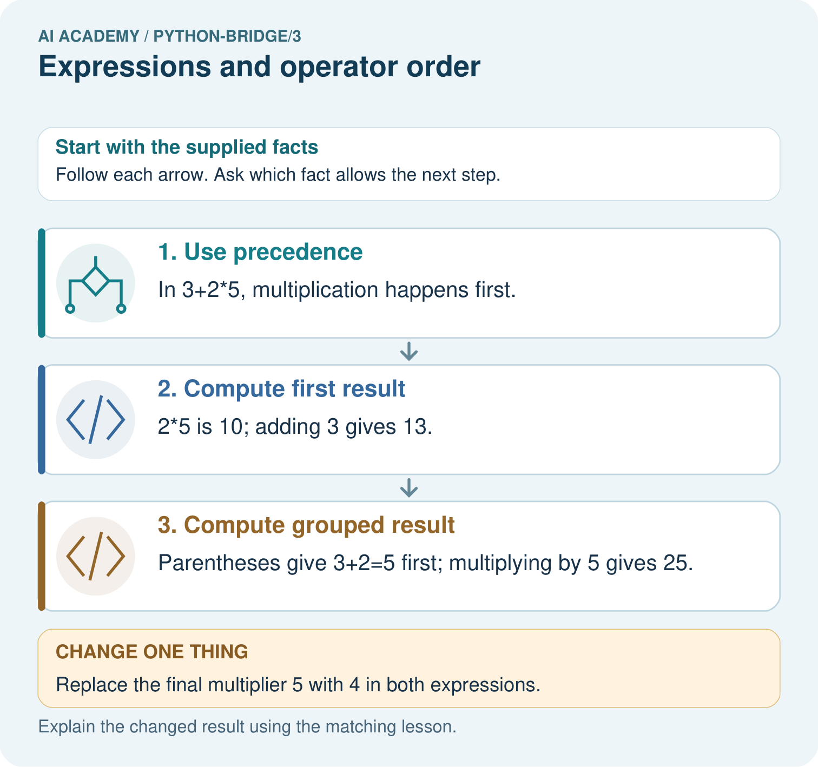

Read the picture one step at a time
Step | What happens and why
1. Use precedence | In 3+2*5, multiplication happens first.
2. Compute first result | 2*5 is 10; adding 3 gives 13.
3. Compute grouped result | Parentheses give 3+2=5 first; multiplying by 5 gives 25.
Match each pictured step to the supplied facts. This is a worked teaching case, not an independent assessment.

Why this result follows
Parentheses explicitly group an operation. Without them, Python multiplication takes priority over addition; the same numerals can therefore describe different procedures.

What this example does not establish
Arithmetic correctness does not decide which expression matches a real problem; the written model must define the intended quantities.

Change one thing in the pictured case
Change: Replace the final multiplier 5 with 4 in both expressions.
Prediction: The first result is 11; the grouped result is 20.
Reason: 3+2*4=3+8; (3+2)*4=5*4.

Ask while showing the picture
Cover the result. Ask learners to name the inputs and predict the next step. Uncover one step, connect the icon to the actual procedure, and explain its evidence. Then change the supplied condition and compare. The picture is a representation; it does not document execution of a real AI model.

03. Demonstrate and guide practice
Time or stage | Teacher action
Session 1 start to 7 minutes | Retrieve numeric addition versus text joining.
7 to 20 minutes | Model packs and loose counters with the diagram; complete W1.
20 to 33 minutes | Read equal-precedence expressions from left to right and predict W2.
33 to 45 minutes | Run W2, compare results and collect the guided explanation.
Session 2 start to 8 minutes | Revisit one grouping disagreement with counters or brackets.
8 to 20 minutes | Model 17 counters in groups of five and complete W3.
20 to 35 minutes | Collect W4 independently, including the reconstruction check.
35 to 45 minutes | Complete W5 and the exit, recording input assumptions and units.
Use the worked example in Sections 3 and 6. Collect a prediction before revealing its result; ask the learner to point to each intermediate fact.
Colour the pack calculation and loose quantity separately, then use the same grouping in code. Provide an operation legend without doing W4. Extension: devise two different expressions that agree for one input and differ for another, and explain the testing consequence.

Reduce help deliberately
Completion task: Predict 16 - 5 - 3, 16 - (5 - 3), and 18 / 3 * 2. Write the grouping, run each line and record actual results separately.
Teacher check: (16 - 5) - 3 is 8; 16 - (5 - 3) is 14; (18 / 3) * 2 is 12.0. Record any observed discrepancy and check the saved expression rather than copying expected results.
Start by identifying the given inputs together. Leave the intermediate steps blank. If needed, model one step, then withdraw that help on the next step. Move to a full trace only when the partial trace is understood. For partners, alternate explainer and checker; collect a response from every learner before discussion.

Individual reasoning check
Use the worked case for Expressions and operator order. Proposed explanation: “All operations are read left to right regardless of precedence”. Decide whether this explanation is supported. Point to the step or supplied fact that decides; explain your repair if needed.
Expected correction: Establish grouping first; only operations at the same applicable precedence level group left to right here.
Collect explanations, not only yes/no votes. If a misunderstanding is common, re-model the relevant step for the class. If it affects a few learners, give a short targeted group explanation while others solve a more demanding variation.

Pictorial practice question
Trace the operation order in both expressions. Identify which picture step changes with parentheses and predict both results when the multiplier becomes four.

Reasoned teacher answer
Without grouping, multiply before adding: 13. With grouping, add before multiplying: 25. Changing the multiplier to 4 gives 11 and 20 respectively.
Changed-case reasoning: The first result is 11; the grouped result is 20. 3+2*4=3+8; (3+2)*4=5*4.
Collect each learner’s explanation before discussion. Use the first missing connection between input, deciding step and result to choose support. This question is worked-case practice, not fresh mastery evidence.

04. Run the investigation and diagnose misconceptions
All operations are read left to right regardless of precedence: Establish grouping first; only operations at the same applicable precedence level group left to right here.
Parentheses never change a value: Compare the two packs expressions and their different stories.
Ordinary division always returns an integer: / produces a float for these integer operands.
A remainder can be as large as the group size: For this positive whole-group case, another complete group would then be possible.
Use Section 9 for the evidence ledger. Add a boundary or missing-input case and record the expected response before checking. More successful repeats of one case do not establish wider coverage.

Match the support to the first error
What the response shows | Next teaching action
Missing or misread facts | Read the case aloud, mark supplied versus unknown facts, and let the learner restate it.
Wrong procedure | Return to the deciding step in the worked case. Contrast it with the proposed incorrect explanation.
Arithmetic or implementation error | Trace intermediate values or lines; preserve the first mismatch and retry that step.
Correct result without a reason | Ask for a trace and a changed case before marking independent understanding.
An unsupported wider claim | Ask which supplied evidence supports the claim and which further observation would be needed.
Offer an oral explanation, drawing, enlarged visual or fewer examples when that removes a reading/writing barrier. Keep the same reasoning goal. Stretch secure learners by changing a boundary or assumption and asking them to defend the effect, not simply by assigning more of the same questions.

05. Assess and explain the answers

Guided and exit questions
In 18 - 4 * 3 multiplication groups first, giving 18 - 12 = 6. In (18 - 4) * 3 the parentheses give 14 * 3 = 42. Exit: 23 // 4 gives 5 trays and 23 % 4 gives 3 tiles; 5 * 4 + 3 = 23. / gives 5.75, a ratio rather than both requested whole-number counts.

W1 State the intended grouping
Write an expression for three packs of eight counters plus two loose counters. Explain why adding two within the parentheses for every pack describes a different situation.
3 * 8 + 2 or (3 * 8) + 2 gives 26. 3 * (8 + 2) gives 30 and adds two to each of three packs, not two once.

W2 Predict then test expressions
Predict 16 - 5 - 3, 16 - (5 - 3), and 18 / 3 * 2. Write the grouping, run each line and record actual results separately.
(16 - 5) - 3 is 8; 16 - (5 - 3) is 14; (18 / 3) * 2 is 12.0. Record any observed discrepancy and check the saved expression rather than copying expected results.

W3 Explain whole groups
For 17 counters in groups of 5, explain /, // and %. Show a multiplication-and-addition check for the complete groups and remainder.
/ gives 3.4; // gives 3; % gives 2. The reconstruction is 3 * 5 + 2 = 17, with remainder 2 less than group size 5. Only three complete groups can be made.

W4 Translate a new situation independently
Four trays hold six tiles each and five tiles are loose. Write and evaluate the total expression. Then pack the total into complete groups of four and find the remainder. Explain why 4 * (6 + 5) is wrong for this story.
4 * 6 + 5 gives 29 tiles; 29 // 4 gives 7 groups and 29 % 4 gives 1 left. 7 * 4 + 1 reconstructs 29. 4 * (6 + 5) gives 44, adding five to every tray instead of once.

W5 Check a limit
Explain why a group size of zero must be excluded. State the assumptions that let complete groups and a remainder describe the packing task.
A zero-size group cannot define how many groups consume the counters; Python division by zero raises ZeroDivisionError. The physical task uses whole nonnegative counters and a positive whole group size, so the remainder is between zero and one less than group size.

Independent assessment and fresh retry
W4 needs 29, 7 and 1 with the meaning of the extra five and a reconstruction. After support, retry three trays of seven plus four loose: 25 total; groups of six give 4 complete groups and 1 left. Require an expression and explanation before a device result.

Assess independent transfer
Selected case: Predict each line. Explain which calculation groups addition before division. What would (17+5)%5 return, and how do /, // and % differ for the supplied positive integers?
print((17 + 5) // 5)
print(17 + 5 // 5)
print(17 / 5, 17 // 5, 17 % 5)

Selected case answer
The first line is4 because22//5=4. The second is18 because5//5 is evaluated before adding17. The final line is3.4 3 2: ordinary division, whole quotient and remainder for17 divided by5. (17+5)%5 is2. Parentheses choose the grouped calculation; they are not optional when that meaning is intended.
Dimension | Evidence required
Explanation | Names the applicable idea or procedure and ties it to the supplied facts.
Trace and result | Preserves the given inputs and shows the relevant intermediate steps; distinguishes a prediction from an observed execution.
Limits | States the assumptions, missing evidence or conditions under which the result would change.
Record each dimension as not yet, with support, or independent. Accept a valid alternative procedure with a defensible trace. Do not penalise an honestly recorded model failure if the learner correctly explains its evidence and limits.

Feedback that the learner uses
Name the earliest unsupported step and give one action to repair it. Have the learner make that repair now and explain why. Then assess the relevant skill on a fresh, fully specified case. Confirm it was not previously practised with feedback; solve and check the new case before assigning it. A follow-up design prompt is a starting brief, not automatically an equivalent test.

06. Connect the project, support and next lesson
Add a labelled expressions and operator order evidence sheet to Python readiness portfolio. Show how you can evaluate numeric expressions using python’s grouping rules. Use the supplied fictional case and keep its inputs, intermediate steps, calculation or prediction, and limitation. Connect this record to last week’s record; a matching answer without a trace is insufficient.
Colour the pack calculation and loose quantity separately, then use the same grouping in code. Provide an operation legend without doing W4. Extension: devise two different expressions that agree for one input and differ for another, and explain the testing consequence.
Week 4 introduces comparisons and Boolean conditions that express whether requirements hold.
Retain the project ledger and assess a changed case after support. Check the relevant prerequisite before carrying this component forward.

Plan the delayed return
Suggested return points in this level: python-bridge/4, python-bridge/6, python-bridge/9. Use actual classroom dates, adjusting for holidays and gaps. One, three and six teaching weeks are scheduling choices, not a claimed optimal spacing.
At a delayed check, ask for the idea from memory and a changed application. Compare with the earlier independent response and record support used. For a new level, revisit the previous capstone before checking the new prerequisites.
Record | Teacher evidence
Learner code and date
Concept and case used; prior exposure
Explanation / trace / limits
Support and first repair
Changed case and delayed outcome
Next teaching action
Use the evidence to choose reteaching or the next step. A completed page, confidence rating or attractive project does not by itself demonstrate understanding.

Project evidence from this case
For Python readiness before the Responsible Plant Classifier, retain a trace of the values, the predicted outputs and the changed-case explanation. Use actual Python 3 results to check the prediction after reasoning first.

07. Prepare, teach and assess
Teaching target: Evaluate numeric expressions using Python’s grouping rules
Prepare the labelled worked-case picture, the matching workbook, fictional input cards and a place for individual responses. Check a local Python 3 environment before class; have a paper-trace version ready.
Session | Plan | Resources
Session 1 · Understand · 45 min | 0–7: recall and prerequisite; 7–15: inspect the concrete case and predict; 15–30: teacher models the worked trace; 30–40: learners explain a step using the text and visual; 40–45: check the core idea. | Sections 1–6; record the brief recall in the workbook.
Session 2 · Practise · 45 min | 0–5: retrieve the procedure; 5–15: W2 completion practice; 15–23: explain and check with a partner; 23–30: each learner answers the misconception check; 30–40: targeted reteaching or a harder variation; 40–45: prepare the investigation. | Sections 7–10; use the matching workbook W2 and misconception check.
Session 3 · Investigate and transfer · 45 min | 0–5: retrieve the decision rule; 5–20: investigate or trace; 20–30: start the independent case; 30–38: connect the project; 38–43: act on feedback; 43–45: plan the return check. | Sections 9 and 11–14. Give extra time to finish the full task set; use Section 15 when the week includes a coding lab.
Before class, solve the supported practice: Predict 16 - 5 - 3, 16 - (5 - 3), and 18 / 3 * 2. Write the grouping, run each line and record actual results separately.
Reasoned practice answer: (16 - 5) - 3 is 8; 16 - (5 - 3) is 14; (18 / 3) * 2 is 12.0. Record any observed discrepancy and check the saved expression rather than copying expected results.
Check every learner before discussion: Use the worked case for Expressions and operator order. Proposed explanation: “All operations are read left to right regardless of precedence”. Decide whether this explanation is supported. Point to the step or supplied fact that decides; explain your repair if needed.
Misconception repair: Establish grouping first; only operations at the same applicable precedence level group left to right here.
Support: read the exact case aloud, enlarge the labelled picture, supply input cards and model only the first deciding step. Accept a spoken explanation or drawing; retain the reasoning goal.
Extension: Replace the final multiplier 5 with 4 in both expressions. Require a prediction and a reason before comparing. Expected result: The first result is 11; the grouped result is 20. Reason: 3+2*4=3+8; (3+2)*4=5*4.
Independent assessment: withhold the reserved answer until the learner has attempted the new case. Record support separately from correctness.
Criterion | Not yet | With support | Independent
Explanation | Names an answer without a deciding fact | Uses a hint to link fact and decision | Explains the deciding fact in own words
Trace or test | Cannot connect input and result | Completes steps with prompts | Traces or tests a changed case accurately
Limits and revision | Claims more than evidence supports | Names a limit after a prompt | States a defensible limit and useful next test
Project checkpoint: Python readiness portfolio. Keep runnable code, predictions, actual outputs, one repaired error and an explanation of a function on changed inputs.
Use the weekly teacher answer for topic-specific reasoning. A saved progress tick is an activity record; judge mastery from the learner’s explanation and evidence.

