AI ACADEMY · TEACHER · python-bridge/4

Boolean conditions
Project: Python readiness portfolio

01. Prepare the purpose, prerequisites and materials

Teach the learning cycle
Primary target: Translate stated requirements into comparisons
Session | Sequence and minutes | Resources
Session 1 · Understand · 45 min | 0–7: recall and prerequisite; 7–15: inspect the concrete case and predict; 15–30: teacher models the worked trace; 30–40: learners explain a step using the text and visual; 40–45: check the core idea. | Sections 1–6; record the brief recall in the workbook.
Session 2 · Practise · 45 min | 0–5: retrieve the procedure; 5–15: W2 completion practice; 15–23: explain and check with a partner; 23–30: each learner answers the misconception check; 30–40: targeted reteaching or a harder variation; 40–45: prepare the investigation. | Sections 7–10; use the matching workbook W2 and misconception check.
Session 3 · Investigate and transfer · 45 min | 0–5: retrieve the decision rule; 5–20: investigate or trace; 20–30: start the independent case; 30–38: connect the project; 38–43: act on feedback; 43–45: plan the return check. | Sections 9 and 11–14. Give extra time to finish the full task set; use Section 15 when the week includes a coding lab.
This is a starting allocation of 135 minutes, not a validated duration. Preserve all named topics. Schedule extra time for connected examples, the full investigation, independent cases and project building. Repeated copies of a case share one recorded attempt; they are not new evidence.

Retrieval answer guidance

Expressions and operator order
Without opening the old lesson, explain one key idea from Expressions and operator order. Give an example and a mistake that the idea helps you avoid.
Look for: Evaluate numeric expressions using Python’s grouping rules
Reference example, not the only acceptable wording: 3 * 8 + 2 or (3 * 8) + 2 gives 26. 3 * (8 + 2) gives 30 and adds two to each of three packs, not two once.

From a paper algorithm to Python
Without opening the old lesson, explain one key idea from From a paper algorithm to Python. Give an example and a mistake that the idea helps you avoid.
Look for: Translate a short paper calculation into a Python script
Reference example, not the only acceptable wording: packs = 4; per_pack = 6; total = packs * per_pack; print(total), each on its own line. The first two bind quantities, the third computes 24 and the fourth displays 24. Assignment alone produces no displayed output in this script.
Use fictional activities and Boolean operands throughout. Do not equate suitability with permission or claim that a programmed condition learns from data. Reference for teacher precision: https://docs.python.org/3/library/stdtypes.html#boolean-operations-and-or-not. Python and/or may return operands of other types; this lesson deliberately confines them to Booleans.

Outcomes
Translate stated requirements into comparisons
Combine Boolean values with and or and not
Choose a case that distinguishes two conditions

Preparation
Python 3 editor and conditions.py
True and False cards and written activity requirements
Blank input, separate checks, expected and observed columns

Prerequisite answer
False is a Boolean value; "False" is text. This week uses actual Boolean values for yes-or-no flags.

End goal for the pictorial case
Trace boolean conditions and explain the changed program before running it.
This added worked case illustrates the week’s main idea. Retain all original and connected topics; schedule its practice within the teaching cycle.

02. Explain and model the mechanism
A fictional activity must take at most 12 minutes and be quiet. An activity taking exactly 12 minutes meets the time requirement. A quiet 15-minute activity does not. Before writing code, underline each requirement and decide whether all requirements must hold or whether alternatives are allowed.
Use a fresh conditions.py file with nonnegative integer minutes and an actual Boolean quiet flag. A comparison produces True or False for these values. The expression minutes <= 12 includes 12; minutes < 12 excludes it. Use == for equality and != for inequality. A single = assigns a value to a name; it does not ask whether two values are equal.
The script prints True then False. The first result concerns time only. The second requires time_ok and quiet. These are separate claims. Trace each input before explaining the combined result; a result without its conditions can be misleading.
Term | Meaning
Comparison | An expression that checks a relation between values
Boolean | A type with the values True and False
Conjunction | A requirement that both conditions hold
Inclusive or | A condition satisfied when either or both parts hold
Counterexample | A case that shows a claim or rule is wrong

Two requirements must both hold
Input case | Time check | Combined result
12 min, quiet False | 12 <= 12 is True | True and False is False
12 min, quiet True | 12 <= 12 is True | True and True is True
15 min, quiet True | 15 <= 12 is False | False and True is False
Passing only one requirement does not make the activity suitable.
Inclusive or accepts both available; exactly one would reject both. Exit: (12, True) should pass and reveals <= changed to <. (8, False) should fail and reveals and changed to or. Other inputs are acceptable if they distinguish the versions.

Model the reasoning aloud
Use the complete worked example below before asking learners to complete W2. Reveal a small part, invite a prediction, then explain the deciding step. These teacher notes contain solutions; do not reveal the independent case answer during modelling.
False | False | False | False
False | True | False | True
True | False | False | True
True | True | True | True
With Boolean operands, and needs both parts True. Inclusive or needs at least one True, so both True is allowed. not reverses a Boolean: not True is False and not False is True. Python can also apply and and or to other types; keep operands Boolean here so this table directly describes the result.

A game requires a pencil or a crayon. If both are available, does inclusive or accept the case? Explain how this differs from requiring exactly one.
________________________________________________________________
________________________________________________________________
________________________________________________________________
________________________________________________________________
________________________________________________________________
Thinking move | Teacher prompt
Plan | What is given? What is the question? Which procedure fits these facts?
Do | Point to each input and intermediate step in the worked trace. Name the rule that allows the next step.
Check | Does the output answer the question? Which assumption or limitation prevents a larger claim?
Use the diagram and verbal explanation together. Ask learners to match a sentence to a specific visual step; do not assign learners fixed visual or auditory learning styles.

A pictorial worked case: Boolean conditions
Two conditions for entry. A toy club accepts integer ages from 12 through 15 inclusive.

The facts we will use
Python 3: age=15; allowed=(age>=12) and (age<=15); print(allowed). No type validation is implemented here.
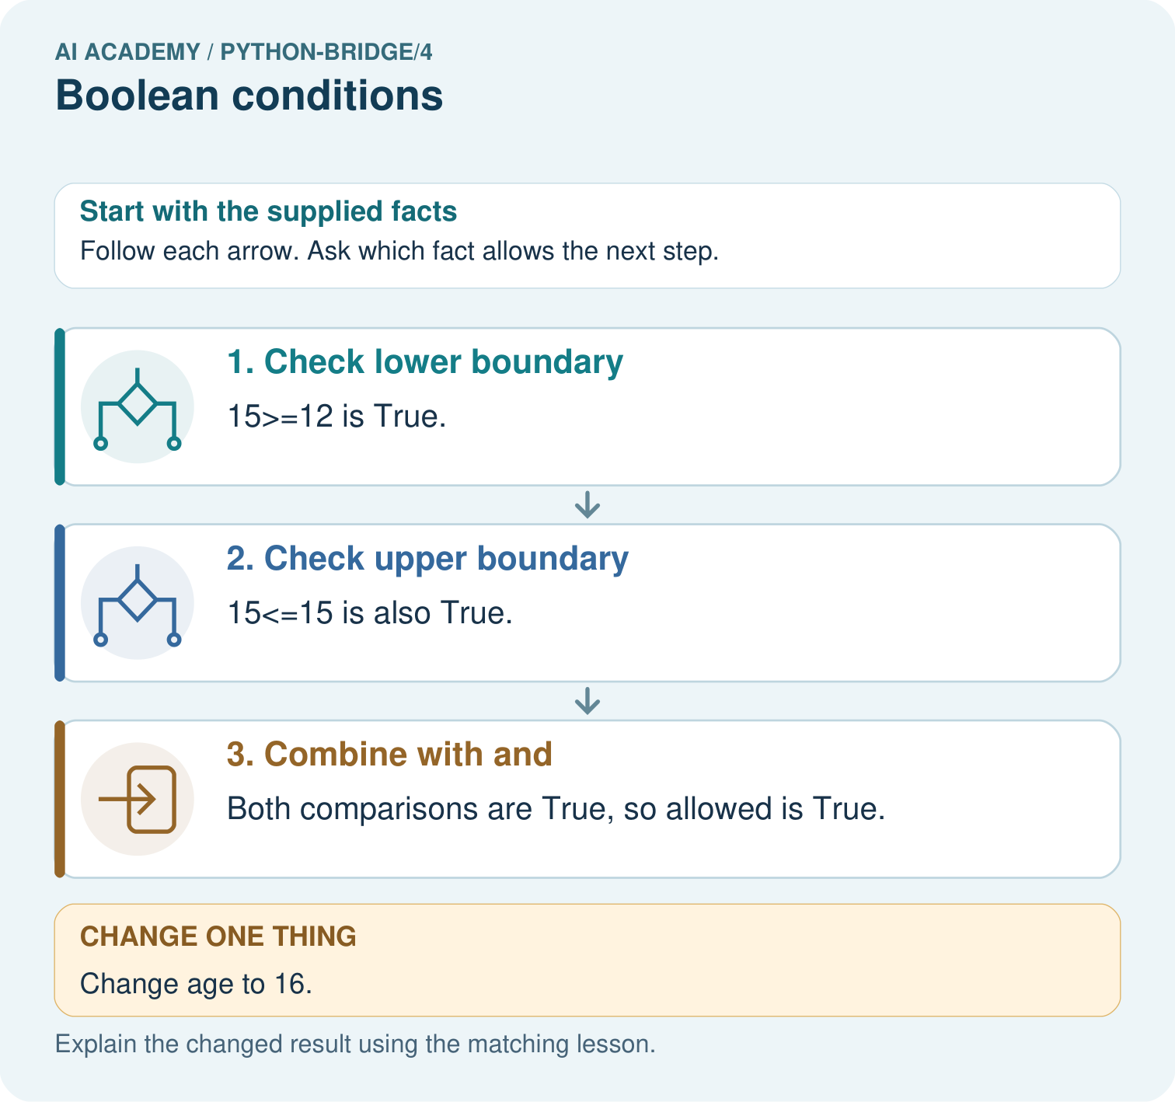

Read the picture one step at a time
Step | What happens and why
1. Check lower boundary | 15>=12 is True.
2. Check upper boundary | 15<=15 is also True.
3. Combine with and | Both comparisons are True, so allowed is True.
Match each pictured step to the supplied facts. This is a worked teaching case, not an independent assessment.

Why this result follows
A Boolean condition represents a yes-or-no result. And requires both conditions; checking only one boundary would accept values outside the intended interval.

What this example does not establish
This condition checks a declared numeric interval, not identity or authorisation; unexpected input types need separate handling.

Change one thing in the pictured case
Change: Change age to 16.
Prediction: The result becomes False.
Reason: The lower condition remains True, but the upper condition fails.

Ask while showing the picture
Cover the result. Ask learners to name the inputs and predict the next step. Uncover one step, connect the icon to the actual procedure, and explain its evidence. Then change the supplied condition and compare. The picture is a representation; it does not document execution of a real AI model.

03. Demonstrate and guide practice
Time or stage | Teacher action
Session 1 start to 7 minutes | Check Boolean versus text with the prerequisite.
7 to 20 minutes | Underline the two requirements and complete W1.
20 to 33 minutes | Model the diagram and trace the two printed values.
33 to 45 minutes | Complete W2 with predictions before running.
Session 2 start to 8 minutes | Retrieve an inclusive boundary and a one-condition failure.
8 to 20 minutes | Build the four-row truth table and complete W3 and the guided question.
20 to 35 minutes | Collect W4 independently, including a counterexample.
35 to 45 minutes | Discuss W5 and use the exit to diagnose boundary and logic errors.
Use the worked example in Sections 3 and 6. Collect a prediction before revealing its result; ask the learner to point to each intermediate fact.
Use separate cards for each comparison, then combine them. Read at most and at least aloud with number lines. Extension: explain why not ((minutes >= 5) and (minutes <= 9)) identifies out-of-range numeric values under the stated input contract.

Reduce help deliberately
Completion task: For (minutes, quiet) cases (11, True), (12, False), and (13, True), write the time comparison and final suitability values before running the program.
Teacher check: Time results are True, True, False. Combined results are True, False, False; the second case fails quiet and the third fails time.
Start by identifying the given inputs together. Leave the intermediate steps blank. If needed, model one step, then withdraw that help on the next step. Move to a full trace only when the partial trace is understood. For partners, alternate explainer and checker; collect a response from every learner before discussion.

Individual reasoning check
Use the worked case for Boolean conditions. Proposed explanation: “At most excludes the boundary”. Decide whether this explanation is supported. Point to the step or supplied fact that decides; explain your repair if needed.
Expected correction: At most 12 includes 12; compare < and <= at exactly 12.
Collect explanations, not only yes/no votes. If a misunderstanding is common, re-model the relevant step for the class. If it affects a few learners, give a short targeted group explanation while others solve a more demanding variation.

Pictorial practice question
Give both comparison results for ages 11, 15 and 16. Which comparison rejects each outside value, and why does and matter?

Reasoned teacher answer
Age 11 gives False/True, so False. Age 15 gives True/True, so True. Age 16 gives True/False, so False. Both interval boundaries must hold.
Changed-case reasoning: The result becomes False. The lower condition remains True, but the upper condition fails.
Collect each learner’s explanation before discussion. Use the first missing connection between input, deciding step and result to choose support. This question is worked-case practice, not fresh mastery evidence.

04. Run the investigation and diagnose misconceptions
At most excludes the boundary: At most 12 includes 12; compare < and <= at exactly 12.
or means exactly one: Inclusive or also accepts two True values.
A single equals sign tests equality: = assigns; == compares.
A True result proves a fact about the world: It establishes only that the supplied values satisfy this expression.
Use Section 9 for the evidence ledger. Add a boundary or missing-input case and record the expected response before checking. More successful repeats of one case do not establish wider coverage.

Match the support to the first error
What the response shows | Next teaching action
Missing or misread facts | Read the case aloud, mark supplied versus unknown facts, and let the learner restate it.
Wrong procedure | Return to the deciding step in the worked case. Contrast it with the proposed incorrect explanation.
Arithmetic or implementation error | Trace intermediate values or lines; preserve the first mismatch and retry that step.
Correct result without a reason | Ask for a trace and a changed case before marking independent understanding.
An unsupported wider claim | Ask which supplied evidence supports the claim and which further observation would be needed.
Offer an oral explanation, drawing, enlarged visual or fewer examples when that removes a reading/writing barrier. Keep the same reasoning goal. Stretch secure learners by changing a boundary or assumption and asking them to defend the effect, not simply by assigning more of the same questions.

05. Assess and explain the answers

Guided and exit questions
Inclusive or accepts both available; exactly one would reject both. Exit: (12, True) should pass and reveals <= changed to <. (8, False) should fail and reveals and changed to or. Other inputs are acceptable if they distinguish the versions.

W1 Translate the requirement
Write a condition for an activity taking at most 12 minutes and being quiet. Explain why exactly 12 minutes is included.
(minutes <= 12) and quiet. At most includes equality, so <= is required; the nonnegative integer and Boolean input contract still applies.

W2 Trace separate checks
For (minutes, quiet) cases (11, True), (12, False), and (13, True), write the time comparison and final suitability values before running the program.
Time results are True, True, False. Combined results are True, False, False; the second case fails quiet and the third fails time.

W3 Distinguish alternatives
Complete all four Boolean combinations for pencil or crayon. Explain the both-available case and the effect of not pencil.
or gives False, True, True, True for FF, FT, TF, TT. Both available is accepted. not pencil is True when pencil is False and False when pencil is True.

W4 Write a new rule independently
A fictional puzzle qualifies when its duration is at least 5 and at most 9 minutes and its available flag is True. Write the condition. Predict results for (5, True), (9, True), (10, True), and (7, False). Choose a case that detects replacing and with or between the range check and available.
(minutes >= 5) and (minutes <= 9) and available. Results True, True, False, False. (7, False) distinguishes (range_check and available) from (range_check or available): correct False versus faulty True.

W5 Separate a check from a guarantee
Explain why a True suitability result does not prove that the supplied duration is accurate or that a child has permission to start the activity.
The expression checks supplied values against stated conditions. Inaccurate input can still pass. Permission is a separate human decision and must not be inferred from suitability.

Independent assessment and fresh retry
W4 requires both inclusive bounds, the available flag, all four outcomes and a distinguishing case with reasoning. After support, retry a 2-to-4-minute inclusive rule with an open flag: (2, True) passes, (4, False) fails and (5, True) fails. Record initial independent work before the retry.

Assess independent transfer
Selected case: Predict all four booleans. Eligibility requires science AND at most100 pages AND availability. Repeat with genre="history" and all other values unchanged. Which OR result could wrongly suggest the genre requirement passed?
pages = 90
genre = "science"
available = False
print(genre == "science" and pages <= 100)
print((genre == "science" and pages <= 100) and available)
print(not available)
print(genre == "science" or pages <= 100)

Selected case answer
Original results: True, False, True, True. Full eligibility is False because availability is False. With history: False, False, True, True. The final OR remains True because90<=100; it does not establish that the science requirement passed. NOT available is True in both traces.
Dimension | Evidence required
Explanation | Names the applicable idea or procedure and ties it to the supplied facts.
Trace and result | Preserves the given inputs and shows the relevant intermediate steps; distinguishes a prediction from an observed execution.
Limits | States the assumptions, missing evidence or conditions under which the result would change.
Record each dimension as not yet, with support, or independent. Accept a valid alternative procedure with a defensible trace. Do not penalise an honestly recorded model failure if the learner correctly explains its evidence and limits.

Feedback that the learner uses
Name the earliest unsupported step and give one action to repair it. Have the learner make that repair now and explain why. Then assess the relevant skill on a fresh, fully specified case. Confirm it was not previously practised with feedback; solve and check the new case before assigning it. A follow-up design prompt is a starting brief, not automatically an equivalent test.

06. Connect the project, support and next lesson
Add a labelled boolean conditions evidence sheet to Python readiness portfolio. Show how you can translate stated requirements into comparisons. Use the supplied fictional case and keep its inputs, intermediate steps, calculation or prediction, and limitation. Connect this record to last week’s record; a matching answer without a trace is insufficient.
Use separate cards for each comparison, then combine them. Read at most and at least aloud with number lines. Extension: explain why not ((minutes >= 5) and (minutes <= 9)) identifies out-of-range numeric values under the stated input contract.
Week 5 uses conditions in if elif and else branches, then tests exact boundaries.
Retain the project ledger and assess a changed case after support. Check the relevant prerequisite before carrying this component forward.

Plan the delayed return
Suggested return points in this level: python-bridge/5, python-bridge/7, python-bridge/10. Use actual classroom dates, adjusting for holidays and gaps. One, three and six teaching weeks are scheduling choices, not a claimed optimal spacing.
At a delayed check, ask for the idea from memory and a changed application. Compare with the earlier independent response and record support used. For a new level, revisit the previous capstone before checking the new prerequisites.
Record | Teacher evidence
Learner code and date
Concept and case used; prior exposure
Explanation / trace / limits
Support and first repair
Changed case and delayed outcome
Next teaching action
Use the evidence to choose reteaching or the next step. A completed page, confidence rating or attractive project does not by itself demonstrate understanding.

Project evidence from this case
For Python readiness before the Responsible Plant Classifier, retain a trace of the values, the predicted outputs and the changed-case explanation. Use actual Python 3 results to check the prediction after reasoning first.

07. Prepare, teach and assess
Teaching target: Translate stated requirements into comparisons
Prepare the labelled worked-case picture, the matching workbook, fictional input cards and a place for individual responses. Check a local Python 3 environment before class; have a paper-trace version ready.
Session | Plan | Resources
Session 1 · Understand · 45 min | 0–7: recall and prerequisite; 7–15: inspect the concrete case and predict; 15–30: teacher models the worked trace; 30–40: learners explain a step using the text and visual; 40–45: check the core idea. | Sections 1–6; record the brief recall in the workbook.
Session 2 · Practise · 45 min | 0–5: retrieve the procedure; 5–15: W2 completion practice; 15–23: explain and check with a partner; 23–30: each learner answers the misconception check; 30–40: targeted reteaching or a harder variation; 40–45: prepare the investigation. | Sections 7–10; use the matching workbook W2 and misconception check.
Session 3 · Investigate and transfer · 45 min | 0–5: retrieve the decision rule; 5–20: investigate or trace; 20–30: start the independent case; 30–38: connect the project; 38–43: act on feedback; 43–45: plan the return check. | Sections 9 and 11–14. Give extra time to finish the full task set; use Section 15 when the week includes a coding lab.
Before class, solve the supported practice: For (minutes, quiet) cases (11, True), (12, False), and (13, True), write the time comparison and final suitability values before running the program.
Reasoned practice answer: Time results are True, True, False. Combined results are True, False, False; the second case fails quiet and the third fails time.
Check every learner before discussion: Use the worked case for Boolean conditions. Proposed explanation: “At most excludes the boundary”. Decide whether this explanation is supported. Point to the step or supplied fact that decides; explain your repair if needed.
Misconception repair: At most 12 includes 12; compare < and <= at exactly 12.
Support: read the exact case aloud, enlarge the labelled picture, supply input cards and model only the first deciding step. Accept a spoken explanation or drawing; retain the reasoning goal.
Extension: Change age to 16. Require a prediction and a reason before comparing. Expected result: The result becomes False. Reason: The lower condition remains True, but the upper condition fails.
Independent assessment: withhold the reserved answer until the learner has attempted the new case. Record support separately from correctness.
Criterion | Not yet | With support | Independent
Explanation | Names an answer without a deciding fact | Uses a hint to link fact and decision | Explains the deciding fact in own words
Trace or test | Cannot connect input and result | Completes steps with prompts | Traces or tests a changed case accurately
Limits and revision | Claims more than evidence supports | Names a limit after a prompt | States a defensible limit and useful next test
Project checkpoint: Python readiness portfolio. Keep runnable code, predictions, actual outputs, one repaired error and an explanation of a function on changed inputs.
Use the weekly teacher answer for topic-specific reasoning. A saved progress tick is an activity record; judge mastery from the learner’s explanation and evidence.

