AI ACADEMY · TEACHER · python-bridge/8

Functions and arguments
Project: Python readiness portfolio

01. Prepare the purpose, prerequisites and materials

Teach the learning cycle
Primary target: Distinguish a function definition from a function call
Session | Sequence and minutes | Resources
Session 1 · Understand · 45 min | 0–7: recall and prerequisite; 7–15: inspect the concrete case and predict; 15–30: teacher models the worked trace; 30–40: learners explain a step using the text and visual; 40–45: check the core idea. | Sections 1–6; record the brief recall in the workbook.
Session 2 · Practise · 45 min | 0–5: retrieve the procedure; 5–15: W2 completion practice; 15–23: explain and check with a partner; 23–30: each learner answers the misconception check; 30–40: targeted reteaching or a harder variation; 40–45: prepare the investigation. | Sections 7–10; use the matching workbook W2 and misconception check.
Session 3 · Investigate and transfer · 45 min | 0–5: retrieve the decision rule; 5–20: investigate or trace; 20–30: start the independent case; 30–38: connect the project; 38–43: act on feedback; 43–45: plan the return check. | Sections 9 and 11–14. Give extra time to finish the full task set; use Section 15 when the week includes a coding lab.
This is a starting allocation of 135 minutes, not a validated duration. Preserve all named topics. Schedule extra time for connected examples, the full investigation, independent cases and project building. Repeated copies of a case share one recorded attempt; they are not new evidence.
Case exposure check: this source example appears in ai-2/2, python-bridge/8. Reuse a familiar case for recall or modelling; verify that the case used to assess transfer has not already received feedback.

Retrieval answer guidance

Lists and indexing
Without opening the old lesson, explain one key idea from Lists and indexing. Give an example and a mistake that the idea helps you avoid.
Look for: Distinguish a list index from the value stored at that position
Reference example, not the only acceptable wording: Length 3; indices 0, 1, 2; counts[1] is 7. The equal values occupy different positions, indices 0 and 2.

Branching and boundary tests
Without opening the old lesson, explain one key idea from Branching and boundary tests. Give an example and a mistake that the idea helps you avoid.
Look for: Trace the selected branch in an if elif else chain
Reference example, not the only acceptable wording: if tests negative first; elif checks <= 12 only after that fails; else handles the rest. Unindented print runs after any selected branch, whose assignment gives label a value.

Values variables and types
Without opening the old lesson, explain one key idea from Values variables and types. Give an example and a mistake that the idea helps you avoid.
Look for: Distinguish integer, floating-point, text and Boolean values
Reference example, not the only acceptable wording: 12 is int; 1.5 is float; "12" is str; False is bool; "False" is str. Quotes mark text even when the characters spell a Boolean name.
Teach definition, call, parameter and positional argument as distinct ideas. Keep inputs scalar and avoid mutable-list aliasing in this first function lesson. Reference: https://docs.python.org/3/tutorial/controlflow.html#defining-functions. These functions print results; reusable return values and local state are taught in Week 9.

Outcomes
Distinguish a function definition from a function call
Match positional arguments to parameters in order
Reuse one function and test that it uses the supplied values

Preparation
Python 3 editor and functions.py
Parameter cards labelled capacity and used
Call cards and a table for expected and observed output

Prerequisite answer
8. Subtraction is ordered: reversing these values would produce -8.

End goal for the pictorial case
Trace functions and arguments and explain the changed program before running it.
This added worked case illustrates the week’s main idea. Retain all original and connected topics; schedule its practice within the teaching cycle.

02. Explain and model the mechanism
A fictional supply cupboard records capacity and the number of occupied spaces. The remaining-space calculation is capacity minus used. Instead of copying the same instructions for every cupboard, define one function and call it with different values. A function makes a procedure reusable; its name alone does not guarantee that its instructions are correct.
Our input contract requires nonnegative integer counts with used no greater than capacity. The example assumes these conditions; it does not validate them. This week the function prints its result. Week 9 will show how to return a value for later calculations.
def introduces the definition. The function name is followed by parameter names in parentheses and a colon. Four-space indentation marks the body. Executing the definition creates the function but does not run its body. The two unindented calls then run it, producing 8 and 3 on separate lines. A blank line helps readability; indentation determines the block.
Term | Meaning
Function | A named block of reusable instructions that runs when called
Definition | Code that creates a function and specifies its body
Call | An instruction that runs a function with supplied arguments
Parameter | A name in a function definition that receives an argument
Argument | A value supplied when calling a function

Arguments matched in order
Call | Parameter values | Printed output
show_remaining(12, 4) | capacity 12; used 4 | 8
show_remaining(10, 7) | capacity 10; used 7 | 3
Each call runs the same body with the values supplied for that call.
The calls print 0 then 9. capacity receives 9 in both calls; used receives 9 then 0. Removing both calls leaves a definition with no printed output. Exit: show_remaining(10, 7) should print 3 but the faulty version prints 8. Passing two cases does not establish correctness for all allowed inputs or validate the input contract.

Model the reasoning aloud
Use the complete worked example below before asking learners to complete W2. Reveal a small part, invite a prediction, then explain the deciding step. These teacher notes contain solutions; do not reveal the independent case answer during modelling.
Execute the definition | Create the function; no output yet
Call with 12 and 4 | Match parameters; subtract; print 8
Call with 10 and 7 | Match new values; subtract; print 3
After the second call | Continue with the next statement
In show_remaining(12, 4), 12 and 4 are arguments; capacity and used are parameters. Positional arguments match from left to right. show_remaining(4, 12) produces -8, showing why order matters; it also violates our written input contract. Use a fresh file with the definition before its calls.

Predict the output of show_remaining(9, 9) followed by show_remaining(9, 0). Name the parameter receiving each argument. What would be printed if both calls were removed?
________________________________________________________________
________________________________________________________________
________________________________________________________________
________________________________________________________________
________________________________________________________________
Thinking move | Teacher prompt
Plan | What is given? What is the question? Which procedure fits these facts?
Do | Point to each input and intermediate step in the worked trace. Name the rule that allows the next step.
Check | Does the output answer the question? Which assumption or limitation prevents a larger claim?
Use the diagram and verbal explanation together. Ask learners to match a sentence to a specific visual step; do not assign learners fixed visual or auditory learning styles.

A pictorial worked case: Functions and arguments
Match arguments to parameters. A function prints the difference between capacity and reserved spaces.

The facts we will use
Python 3: def show_free(capacity,reserved): print(capacity-reserved). Calls: show_free(11,3); show_free(3,11).
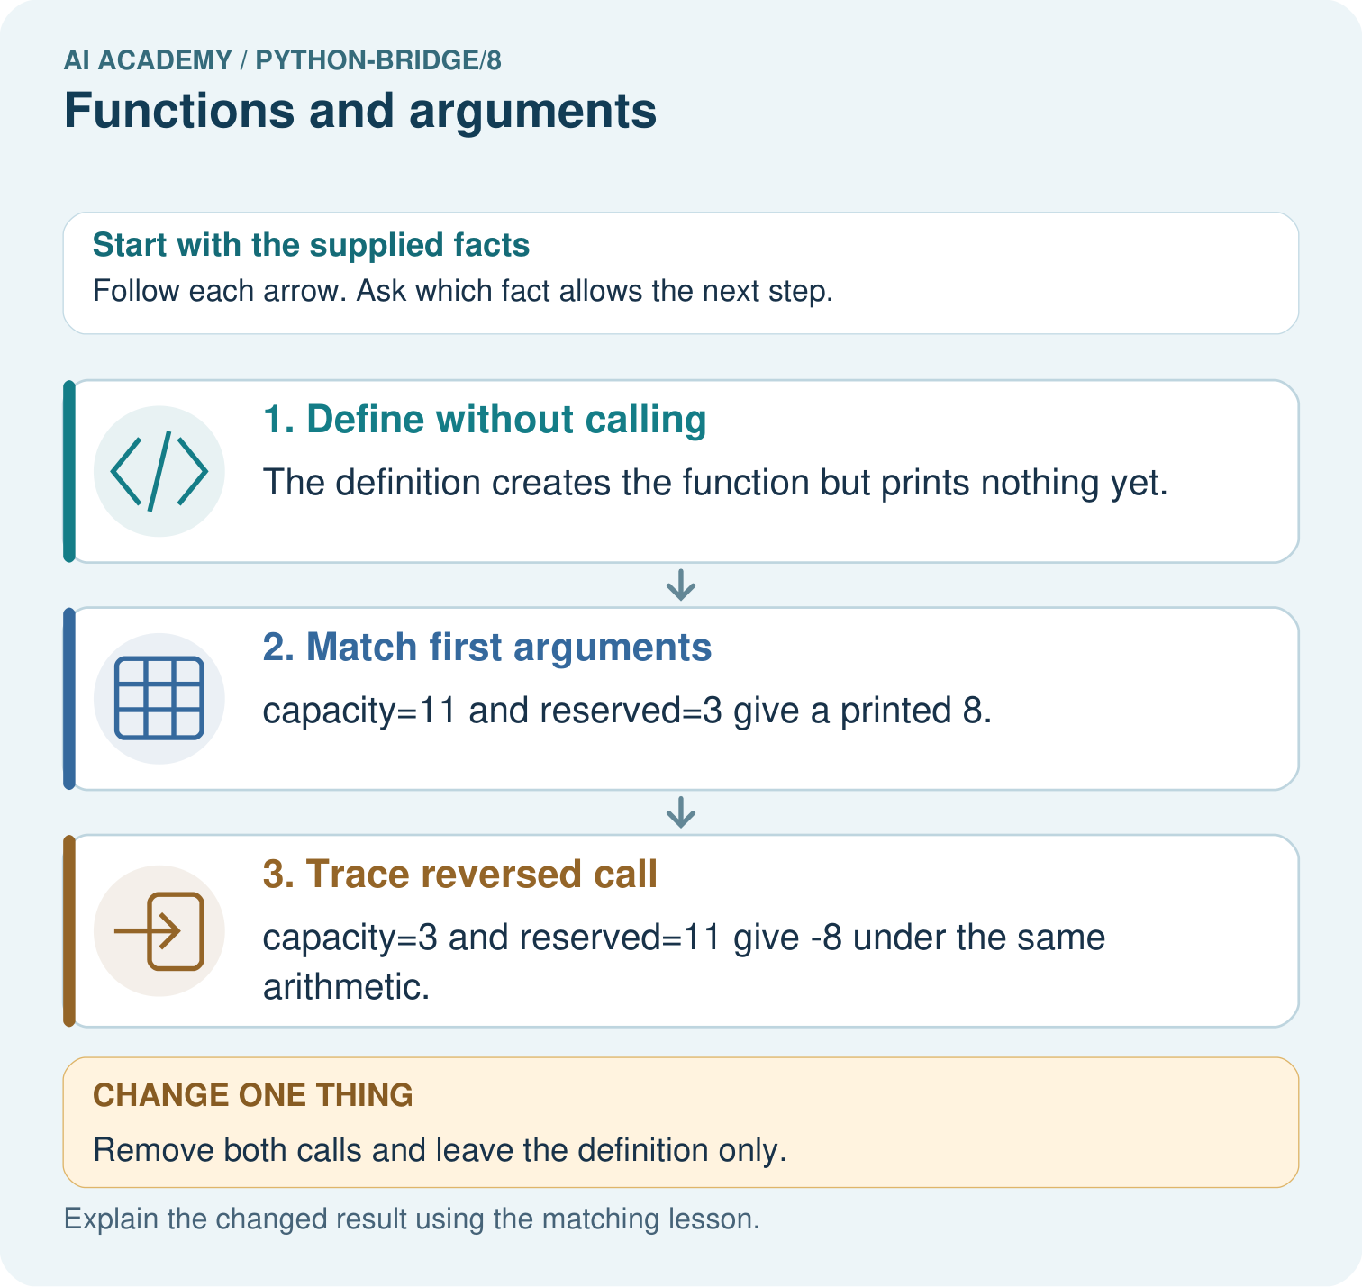

Read the picture one step at a time
Step | What happens and why
1. Define without calling | The definition creates the function but prints nothing yet.
2. Match first arguments | capacity=11 and reserved=3 give a printed 8.
3. Trace reversed call | capacity=3 and reserved=11 give -8 under the same arithmetic.
Match each pictured step to the supplied facts. This is a worked teaching case, not an independent assessment.

Why this result follows
Positional arguments match parameter names in order. A function definition is not an execution of its body; separate calls supply separate input values.

What this example does not establish
The arithmetic permits negative results; a real capacity contract may reject reserved>capacity instead of treating it as free space.

Change one thing in the pictured case
Change: Remove both calls and leave the definition only.
Prediction: No output is printed.
Reason: The body runs only when the function is called.

Ask while showing the picture
Cover the result. Ask learners to name the inputs and predict the next step. Uncover one step, connect the icon to the actual procedure, and explain its evidence. Then change the supplied condition and compare. The picture is a representation; it does not document execution of a real AI model.

03. Demonstrate and guide practice
Time or stage | Teacher action
Session 1 start to 7 minutes | Retrieve ordered subtraction with the prerequisite.
7 to 20 minutes | Read the contract and label the definition and calls for W1.
20 to 33 minutes | Match argument cards to parameters and trace the worked calls.
33 to 45 minutes | Complete W2 and the guided question before running the file.
Session 2 start to 8 minutes | Retrieve why a definition alone prints nothing.
8 to 20 minutes | Run the fixed-number bug, complete W3 and rerun the earlier case after repair.
20 to 35 minutes | Collect the independent W4 function and predictions before hints.
35 to 45 minutes | Discuss W5 and use the exit to assess the limits of passing tests.
Use the worked example in Sections 3 and 6. Collect a prediction before revealing its result; ask the learner to point to each intermediate fact.
Use two labelled parameter spaces and place argument cards left to right. Permit an oral execution trace alongside code. Extension: add an if check inside show_remaining that prints Invalid when used exceeds capacity, otherwise prints the difference; test (4, 5) and (4, 4). This checks only that one constraint.

Reduce help deliberately
Completion task: Using the correct definition, predict show_remaining(8, 3), show_remaining(8, 8) and show_remaining(8, 0) in that order. Explain what happens if the file contains only the definition.
Teacher check: The calls print 5, 0 and 8 on separate lines. A definition alone creates the function but prints nothing because its body has not been called.
Start by identifying the given inputs together. Leave the intermediate steps blank. If needed, model one step, then withdraw that help on the next step. Move to a full trace only when the partial trace is understood. For partners, alternate explainer and checker; collect a response from every learner before discussion.

Individual reasoning check
Use the worked case for Functions and arguments. Proposed explanation: “Writing def runs the body immediately”. Decide whether this explanation is supported. Point to the step or supplied fact that decides; explain your repair if needed.
Expected correction: The definition creates the function; a call runs its body.
Collect explanations, not only yes/no votes. If a misunderstanding is common, re-model the relevant step for the class. If it affects a few learners, give a short targeted group explanation while others solve a more demanding variation.

Pictorial practice question
Match every argument to a parameter for the two calls. Why do outputs differ, and what prints when both calls are removed?

Reasoned teacher answer
The first call binds 11 to capacity and 3 to reserved, printing 8. The second reverses those bindings and prints -8. A definition with no calls prints nothing.
Changed-case reasoning: No output is printed. The body runs only when the function is called.
Collect each learner’s explanation before discussion. Use the first missing connection between input, deciding step and result to choose support. This question is worked-case practice, not fresh mastery evidence.

04. Run the investigation and diagnose misconceptions
Writing def runs the body immediately: The definition creates the function; a call runs its body.
Arguments and parameters are interchangeable labels: Parameters are names in the definition; arguments supply values at a call.
Swapping arguments never matters: Different parameter roles can give different results when values are swapped.
A correct first example proves the function is reusable: Fixed numbers can match one case while ignoring later arguments.
Use Section 9 for the evidence ledger. Add a boundary or missing-input case and record the expected response before checking. More successful repeats of one case do not establish wider coverage.

Match the support to the first error
What the response shows | Next teaching action
Missing or misread facts | Read the case aloud, mark supplied versus unknown facts, and let the learner restate it.
Wrong procedure | Return to the deciding step in the worked case. Contrast it with the proposed incorrect explanation.
Arithmetic or implementation error | Trace intermediate values or lines; preserve the first mismatch and retry that step.
Correct result without a reason | Ask for a trace and a changed case before marking independent understanding.
An unsupported wider claim | Ask which supplied evidence supports the claim and which further observation would be needed.
Offer an oral explanation, drawing, enlarged visual or fewer examples when that removes a reading/writing barrier. Keep the same reasoning goal. Stretch secure learners by changing a boundary or assumption and asking them to defend the effect, not simply by assigning more of the same questions.

05. Assess and explain the answers

Guided and exit questions
The calls print 0 then 9. capacity receives 9 in both calls; used receives 9 then 0. Removing both calls leaves a definition with no printed output. Exit: show_remaining(10, 7) should print 3 but the faulty version prints 8. Passing two cases does not establish correctness for all allowed inputs or validate the input contract.

W1 Label the parts
In def show_remaining(capacity, used), identify the function name and parameters. In show_remaining(15, 6), identify the arguments and their matching parameters.
Name show_remaining; parameters capacity and used. Arguments 15 and 6 match capacity = 15 and used = 6. Expected printed result 9.

W2 Follow the execution order
Using the correct definition, predict show_remaining(8, 3), show_remaining(8, 8) and show_remaining(8, 0) in that order. Explain what happens if the file contains only the definition.
The calls print 5, 0 and 8 on separate lines. A definition alone creates the function but prints nothing because its body has not been called.

W3 Repair ignored arguments
The faulty body calculates 12 - 4 regardless of the call. State the output and expected output for show_remaining(11, 2). Repair the expression and name an earlier call to rerun.
Faulty output 8; expected 9. Use capacity - used. Rerun show_remaining(12, 4), expecting 8, as well as the revealing call.

W4 Create a new function independently
Each sealed box contains 6 counters. Define show_stock(boxes, loose) to print the total counters using its two parameters. Assume nonnegative integer arguments. Call it with (3, 2), (0, 2) and (3, 0). Predict each output and explain why show_stock(2, 3) is a different case.
The body prints boxes * 6 + loose. Outputs are 20, 2 and 18. show_stock(2, 3) gives 15 because boxes and loose have different roles. Define once and use three calls; do not hard-code one answer.

W5 State the input assumption
The correct subtraction function prints -1 for show_remaining(4, 5). Does successful execution make this a valid cupboard record? Explain what the function assumes and what needs checking.
No. used exceeds capacity and violates the contract. The function calculates with supplied values but does not check the contract. A separate validation check or guarded function is needed to reject invalid records.

Independent assessment and fresh retry
W4 must define one function, use both parameters, call it three times and predict 20, 2, 18; the swapped case must give 15. After support, retry show_tiles(packs, singles) with 4 tiles per pack: calls (2, 3), (0, 3), (2, 0) print 11, 3, 8; swapped (3, 2) prints 14. Record assistance and collect new predictions before execution.

Assess independent transfer
Selected case: Predict both returned and printed values, showing which argument supplies first and second. What is displayed if the program contains only the function definition and no calls? Why does swapping these arguments change the result?
def difference(first, second):
return first - second
print(difference(11, 4))
print(difference(4, 11))

Selected case answer
The first call returns and prints7; the second returns and prints−7. Positional arguments fill first then second, and subtraction is ordered. A definition alone displays nothing and does not execute its body. The same function uses the supplied values for each call.
Dimension | Evidence required
Explanation | Names the applicable idea or procedure and ties it to the supplied facts.
Trace and result | Preserves the given inputs and shows the relevant intermediate steps; distinguishes a prediction from an observed execution.
Limits | States the assumptions, missing evidence or conditions under which the result would change.
Record each dimension as not yet, with support, or independent. Accept a valid alternative procedure with a defensible trace. Do not penalise an honestly recorded model failure if the learner correctly explains its evidence and limits.

Feedback that the learner uses
Name the earliest unsupported step and give one action to repair it. Have the learner make that repair now and explain why. Then assess the relevant skill on a fresh, fully specified case. Confirm it was not previously practised with feedback; solve and check the new case before assigning it. A follow-up design prompt is a starting brief, not automatically an equivalent test.

06. Connect the project, support and next lesson
Add a labelled functions and arguments evidence sheet to Python readiness portfolio. Show how you can distinguish a function definition from a function call. Use the supplied fictional case and keep its inputs, intermediate steps, calculation or prediction, and limitation. Connect this record to last week’s record; a matching answer without a trace is insufficient.
Use two labelled parameter spaces and place argument cards left to right. Permit an oral execution trace alongside code. Extension: add an if check inside show_remaining that prints Invalid when used exceeds capacity, otherwise prints the difference; test (4, 5) and (4, 4). This checks only that one constraint.
Week 9 returns results to the caller and explains local variables and fresh state on each call.
Retain the project ledger and assess a changed case after support. Check the relevant prerequisite before carrying this component forward.

Plan the delayed return
Suggested return points in this level: python-bridge/9, python-bridge/11. Use actual classroom dates, adjusting for holidays and gaps. One, three and six teaching weeks are scheduling choices, not a claimed optimal spacing.
At a delayed check, ask for the idea from memory and a changed application. Compare with the earlier independent response and record support used. For a new level, revisit the previous capstone before checking the new prerequisites.
Record | Teacher evidence
Learner code and date
Concept and case used; prior exposure
Explanation / trace / limits
Support and first repair
Changed case and delayed outcome
Next teaching action
Use the evidence to choose reteaching or the next step. A completed page, confidence rating or attractive project does not by itself demonstrate understanding.

Project evidence from this case
For Python readiness before the Responsible Plant Classifier, retain a trace of the values, the predicted outputs and the changed-case explanation. Use actual Python 3 results to check the prediction after reasoning first.

07. Prepare, teach and assess
Teaching target: Distinguish a function definition from a function call
Prepare the labelled worked-case picture, the matching workbook, fictional input cards and a place for individual responses. Check a local Python 3 environment before class; have a paper-trace version ready.
Session | Plan | Resources
Session 1 · Understand · 45 min | 0–7: recall and prerequisite; 7–15: inspect the concrete case and predict; 15–30: teacher models the worked trace; 30–40: learners explain a step using the text and visual; 40–45: check the core idea. | Sections 1–6; record the brief recall in the workbook.
Session 2 · Practise · 45 min | 0–5: retrieve the procedure; 5–15: W2 completion practice; 15–23: explain and check with a partner; 23–30: each learner answers the misconception check; 30–40: targeted reteaching or a harder variation; 40–45: prepare the investigation. | Sections 7–10; use the matching workbook W2 and misconception check.
Session 3 · Investigate and transfer · 45 min | 0–5: retrieve the decision rule; 5–20: investigate or trace; 20–30: start the independent case; 30–38: connect the project; 38–43: act on feedback; 43–45: plan the return check. | Sections 9 and 11–14. Give extra time to finish the full task set; use Section 15 when the week includes a coding lab.
Before class, solve the supported practice: Using the correct definition, predict show_remaining(8, 3), show_remaining(8, 8) and show_remaining(8, 0) in that order. Explain what happens if the file contains only the definition.
Reasoned practice answer: The calls print 5, 0 and 8 on separate lines. A definition alone creates the function but prints nothing because its body has not been called.
Check every learner before discussion: Use the worked case for Functions and arguments. Proposed explanation: “Writing def runs the body immediately”. Decide whether this explanation is supported. Point to the step or supplied fact that decides; explain your repair if needed.
Misconception repair: The definition creates the function; a call runs its body.
Support: read the exact case aloud, enlarge the labelled picture, supply input cards and model only the first deciding step. Accept a spoken explanation or drawing; retain the reasoning goal.
Extension: Remove both calls and leave the definition only. Require a prediction and a reason before comparing. Expected result: No output is printed. Reason: The body runs only when the function is called.
Independent assessment: withhold the reserved answer until the learner has attempted the new case. Record support separately from correctness.
Criterion | Not yet | With support | Independent
Explanation | Names an answer without a deciding fact | Uses a hint to link fact and decision | Explains the deciding fact in own words
Trace or test | Cannot connect input and result | Completes steps with prompts | Traces or tests a changed case accurately
Limits and revision | Claims more than evidence supports | Names a limit after a prompt | States a defensible limit and useful next test
Project checkpoint: Python readiness portfolio. Keep runnable code, predictions, actual outputs, one repaired error and an explanation of a function on changed inputs.
Use the weekly teacher answer for topic-specific reasoning. A saved progress tick is an activity record; judge mastery from the learner’s explanation and evidence.

