AI ACADEMY · WORKBOOK · ai-1/1

AI or Not?
Project: Helpful Classroom Sorter

01. Recall and choose your starting point
Try the recall before opening notes. Then use a different colour or a labelled second line to correct your explanation.
A classroom clock speaks the time. Write one thing you observed and one thing you cannot determine just from hearing it.

My starting explanation
________________________________________________________________
________________________________________________________________
________________________________________________________________

02. Practise with fading help
Use W2: Complete the photo library explanation for Evidence and decision mechanisms. Record the answer once; the lesson and workbook refer to the same attempt.
Given inputs | Procedure I chose | Middle steps | Result and check

The step I completed without help, and the hint I needed
________________________________________________________________
________________________________________________________________
________________________________________________________________

03. Individual reasoning check
Use the worked case for Evidence and decision mechanisms. Proposed explanation: “All rules are outside AI”. Decide whether this explanation is supported. Point to the step or supplied fact that decides; explain your repair if needed.

My explanation before partner discussion
________________________________________________________________
________________________________________________________________
________________________________________________________________
________________________________________________________________

04. Independent transfer case

Independent case: Investigate a new hybrid system
A school greenhouse estimates tomorrow's temperature using a model fitted on historical weather. A written rule displays CHECK PLANTS above 30 degrees C. A caretaker chooses whether to open a vent. Identify each mechanism and explain why a correct CHECK PLANTS message would not prove an accurate temperature prediction.

My independent explanation, trace and limits
________________________________________________________________
________________________________________________________________
________________________________________________________________
________________________________________________________________
________________________________________________________________
________________________________________________________________
________________________________________________________________
Attempt this case before feedback. Record any help. Earlier examples below are further practice; a case already practised with feedback cannot establish fresh transfer.

05. Your learning target
A bus displays a delay prediction learned from past journeys. A written rule turns the display red above 10 minutes. A driver can override the message. Identify all three mechanisms. Would seeing a red display prove that learning occurred?

06. Solve the given case
Six devices are a motion-triggered lamp, a trained photo sorter, a remote-controlled car, a calculator, an unspecified smart speaker and an unspecified robot vacuum.
Classify all six using mechanism evidence. Which two need more information?
Show your trace, calculation or evidence

Write or draw your reasoning and evidence.
________________________________________________________________
________________________________________________________________
________________________________________________________________
________________________________________________________________
________________________________________________________________

07. Check a changed case
A toy follows your steering buttons. A photo app learned from labelled pictures. A talking clock follows a written timetable. Which uses a learned model? What evidence supports each classification?
My independent answer and reason

Write or draw your reasoning and evidence.
________________________________________________________________
________________________________________________________________
________________________________________________________________
________________________________________________________________
________________________________________________________________

Week 1 Test and reflect

08. Design a revealing test
Create a changed input, boundary case or missing-information case. Write the expected answer or safe response before testing.
Test record | My evidence
Changed input or condition
Expected answer or fallback
Observed result
Why the result occurred

09. Project checkpoint
Choose whether the Helpful Classroom Sorter needs a person, fixed rule, or learned model; justify the smallest safe solution.
The project change and evidence I will keep

Write or draw your reasoning and evidence.
________________________________________________________________
________________________________________________________________
________________________________________________________________
________________________________________________________________
________________________________________________________________

10. Self check
I can explain the mechanism. I can show evidence. I can handle a changed case. I can name a limit. Mark each as not yet, with help or independently, and attach supporting work.
Teacher review ____________________ Next step ____________________

11. Transfer practice from the original programme
A bus displays a delay prediction learned from past journeys. A written rule turns the display red above 10 minutes. A driver can override the message. Identify all three mechanisms. Would seeing a red display prove that learning occurred?

My independently reasoned answer
________________________________________________________________
________________________________________________________________
________________________________________________________________
________________________________________________________________
________________________________________________________________
________________________________________________________________
________________________________________________________________
Record support used: none, hint or teacher explanation.

12. W1 Separate observations from explanations
A door opens when a visitor approaches. Its label says intelligent entrance. List two observations and write one mechanism question whose answer would help classify the opening decision.

My reasoning and evidence
________________________________________________________________
________________________________________________________________
________________________________________________________________
________________________________________________________________
________________________________________________________________

13. W2 Complete the photo library explanation
Use the photo-library case from the lesson. Classify the prediction, album-placement rule and owner move. A bicycle photo is in the wrong album. Name the first two records you would inspect.

My reasoning and evidence
________________________________________________________________
________________________________________________________________
________________________________________________________________
________________________________________________________________
________________________________________________________________
________________________________________________________________

14. W3 Challenge an unsupported conclusion
Maya says a vacuum must learn because it changes direction after hitting a chair. Give two different mechanisms consistent with that observation. What evidence would distinguish them?

My reasoning and evidence
________________________________________________________________
________________________________________________________________
________________________________________________________________
________________________________________________________________
________________________________________________________________

15. W4 Investigate a new hybrid system
A school greenhouse estimates tomorrow's temperature using a model fitted on historical weather. A written rule displays CHECK PLANTS above 30 degrees C. A caretaker chooses whether to open a vent. Identify each mechanism and explain why a correct CHECK PLANTS message would not prove an accurate temperature prediction.

My reasoning and evidence
________________________________________________________________
________________________________________________________________
________________________________________________________________
________________________________________________________________
________________________________________________________________
________________________________________________________________
________________________________________________________________
________________________________________________________________

16. W5 Design an evidence card
Invent one product containing two mechanisms. State the supplied facts, draw an information path and write one claim the facts support and one they do not. Do not use real classmates' personal information.

My reasoning and evidence
________________________________________________________________
________________________________________________________________
________________________________________________________________
________________________________________________________________
________________________________________________________________
________________________________________________________________
________________________________________________________________
________________________________________________________________

17. Feedback, return check and learning record
Evidence | My record
Worked alone / hint / model
First step I repaired and why
New case checked later; date and result
What I can now explain without notes
One remaining question
Revisit this idea with your teacher after a delay. Familiarity is different from explaining and using it on a changed case.

18. Pictorial case practice: AI or Not?
A fictional school umbrella display shows TAKE ONE before lunch. What produced that advice?
A weather model was fitted on earlier weather records; its forecast is 70% rain.
A written rule shows TAKE ONE at rain forecasts of 60% or more. The teacher decides whether to distribute umbrellas.
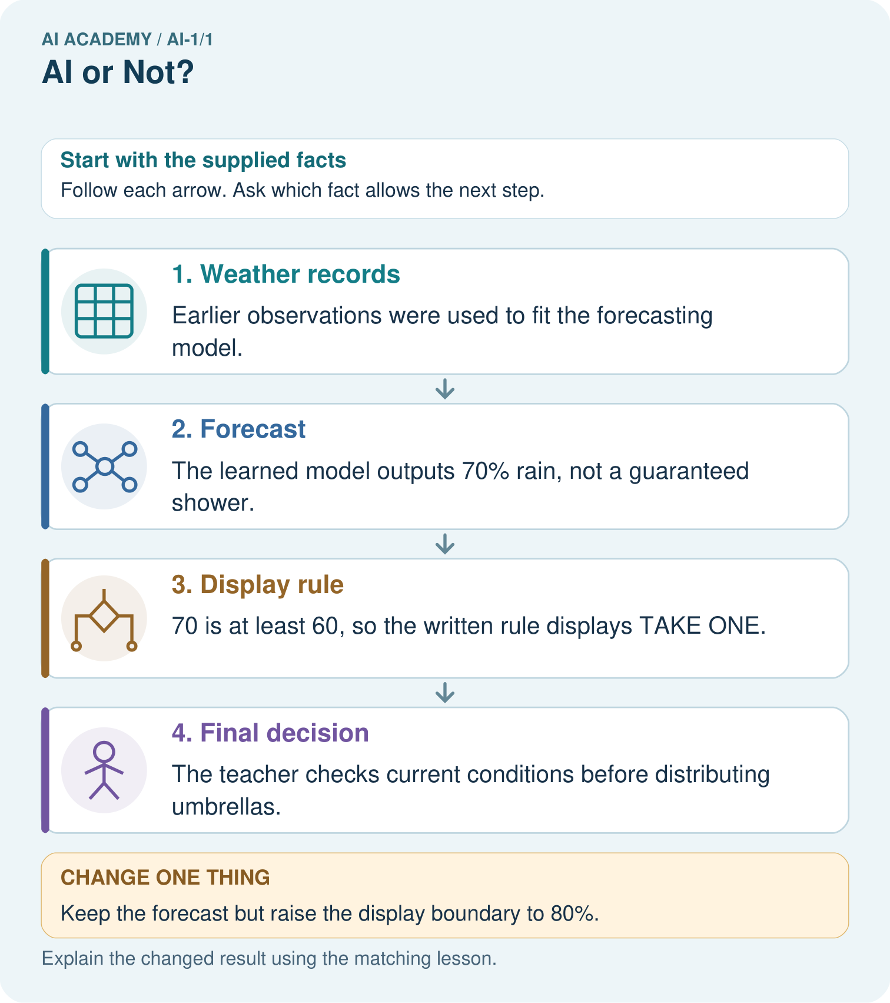
Point to the learned stage. Does the changed display prove the weather forecast changed?

My picture-based explanation and changed-case prediction
________________________________________________________________
________________________________________________________________
________________________________________________________________
________________________________________________________________
________________________________________________________________
________________________________________________________________
Support used: alone / hint / worked example. This record is practice evidence.
Project connection: For the Helpful Classroom Sorter, annotate which decisions follow written instructions and which, if any, were fitted from examples.

19. Project portfolio milestone
Project: Helpful Classroom Sorter
Current milestone: Frame the need. Name the user, the problem, allowed inputs and a safe simple starting method.
For the Helpful Classroom Sorter, annotate which decisions follow written instructions and which, if any, were fitted from examples.
Evidence to keep | My record
This week’s input and deciding step
Prediction and actual result (or labelled paper trace)
One change since the previous checkpoint and why
One error or limit and the next test

Explain what this week adds to your project. Reuse last week’s record rather than starting again.
________________________________________________________________
________________________________________________________________
________________________________________________________________
________________________________________________________________
________________________________________________________________

