AI ACADEMY · WORKBOOK · ai-1/2

Input, Process, Output
Project: Helpful Classroom Sorter

01. Recall and choose your starting point
Try the recall before opening notes. Then use a different colour or a labelled second line to correct your explanation.

AI or Not?
Without opening the old lesson, explain one key idea from AI or Not?. Give an example and a mistake that the idea helps you avoid.

My remembered idea, example and correction
________________________________________________________________
________________________________________________________________
________________________________________________________________

02. Practise with fading help
Use W2: Finish the visitor example for Representations and information paths. Record the answer once; the lesson and workbook refer to the same attempt.
Given inputs | Procedure I chose | Middle steps | Result and check

The step I completed without help, and the hint I needed
________________________________________________________________
________________________________________________________________
________________________________________________________________

03. Individual reasoning check
Use the worked case for Representations and information paths. Proposed explanation: “Every output is the final action”. Decide whether this explanation is supported. Point to the step or supplied fact that decides; explain your repair if needed.

My explanation before partner discussion
________________________________________________________________
________________________________________________________________
________________________________________________________________
________________________________________________________________

04. Independent transfer case

Independent case: Investigate a new loss of information
A classroom device receives four scores and stores only their total, 20. A student claims that every score must be 5. Give two different lists of four nonnegative whole-number scores with total 20. Explain precisely what the stored total establishes and what it does not.

My independent explanation, trace and limits
________________________________________________________________
________________________________________________________________
________________________________________________________________
________________________________________________________________
________________________________________________________________
________________________________________________________________
________________________________________________________________
Attempt this case before feedback. Record any help. Earlier examples below are further practice; a case already practised with feedback cannot establish fresh transfer.

05. Your learning target
A library kiosk receives 'mystery', filters a catalogue by genre and displays three titles. No speaker is attached. Draw its information path. A visitor says it read three books aloud. Which stage contradicts that claim?

06. Solve the given case
A playlist helper receives a mood, matches song tags and displays three titles.
Name input, process and output. Is displaying titles the same as playing audio?
Show your trace, calculation or evidence

Write or draw your reasoning and evidence.
________________________________________________________________
________________________________________________________________
________________________________________________________________
________________________________________________________________
________________________________________________________________

07. Check a changed case
A classroom fan receives a temperature reading, compares it with 25 degrees C, and turns on. Name the input, process and output. What should happen if the reading is missing?
My independent answer and reason

Write or draw your reasoning and evidence.
________________________________________________________________
________________________________________________________________
________________________________________________________________
________________________________________________________________
________________________________________________________________

Week 2 Test and reflect

08. Design a revealing test
Create a changed input, boundary case or missing-information case. Write the expected answer or safe response before testing.
Test record | My evidence
Changed input or condition
Expected answer or fallback
Observed result
Why the result occurred

09. Project checkpoint
Draw the Classroom Sorter's first input-process-output map and show where a person may review the result.
The project change and evidence I will keep

Write or draw your reasoning and evidence.
________________________________________________________________
________________________________________________________________
________________________________________________________________
________________________________________________________________
________________________________________________________________

10. Self check
I can explain the mechanism. I can show evidence. I can handle a changed case. I can name a limit. Mark each as not yet, with help or independently, and attach supporting work.
Teacher review ____________________ Next step ____________________

11. Transfer practice from the original programme
A library kiosk receives 'mystery', filters a catalogue by genre and displays three titles. No speaker is attached. Draw its information path. A visitor says it read three books aloud. Which stage contradicts that claim?

My independently reasoned answer
________________________________________________________________
________________________________________________________________
________________________________________________________________
________________________________________________________________
________________________________________________________________
________________________________________________________________
________________________________________________________________
Record support used: none, hint or teacher explanation.

12. W1 Trace a request
The kiosk receives genre=science and maximum pages=120. The catalogue contains A science 80 pages, B science 150 pages and C mystery 90 pages. It keeps records with the requested genre and no more than 120 pages. Draw the input, process and output, naming the surviving record.

My reasoning and evidence
________________________________________________________________
________________________________________________________________
________________________________________________________________
________________________________________________________________
________________________________________________________________
________________________________________________________________

13. W2 Finish the visitor example
A record stores only total visitors=3. Give two different arrival schedules that produce this total. Can the total tell us the busiest hour? Explain.

My reasoning and evidence
________________________________________________________________
________________________________________________________________
________________________________________________________________
________________________________________________________________
________________________________________________________________

14. W3 Choose a sufficient representation
For each task, choose the information needed: decide whether a book is under 120 pages; quote its first sentence exactly; decide whether a copy is available now. Explain why a genre tag alone is insufficient for all three.

My reasoning and evidence
________________________________________________________________
________________________________________________________________
________________________________________________________________
________________________________________________________________
________________________________________________________________
________________________________________________________________

15. W4 Investigate a new loss of information
A classroom device receives four scores and stores only their total, 20. A student claims that every score must be 5. Give two different lists of four nonnegative whole-number scores with total 20. Explain precisely what the stored total establishes and what it does not.

My reasoning and evidence
________________________________________________________________
________________________________________________________________
________________________________________________________________
________________________________________________________________
________________________________________________________________
________________________________________________________________
________________________________________________________________

16. W5 Diagnose before repairing
A voice calculator receives a spoken request for 16 divided by 4. Its transcript says 60 divided by 4 and its calculator returns 15. Identify the first incorrect stage, show the intended result and propose a check before calculation.

My reasoning and evidence
________________________________________________________________
________________________________________________________________
________________________________________________________________
________________________________________________________________
________________________________________________________________
________________________________________________________________

17. Feedback, return check and learning record
Evidence | My record
Worked alone / hint / model
First step I repaired and why
New case checked later; date and result
What I can now explain without notes
One remaining question
Revisit this idea with your teacher after a delay. Familiarity is different from explaining and using it on a changed case.

18. Pictorial case practice: Input, Process, Output
A fictional classroom cupboard records coloured pencils, then reports just a total.
Box A has 2 red and 4 blue pencils. Box B has 5 red and 1 blue.
The process adds colour counts and stores only the total, not the two counts.
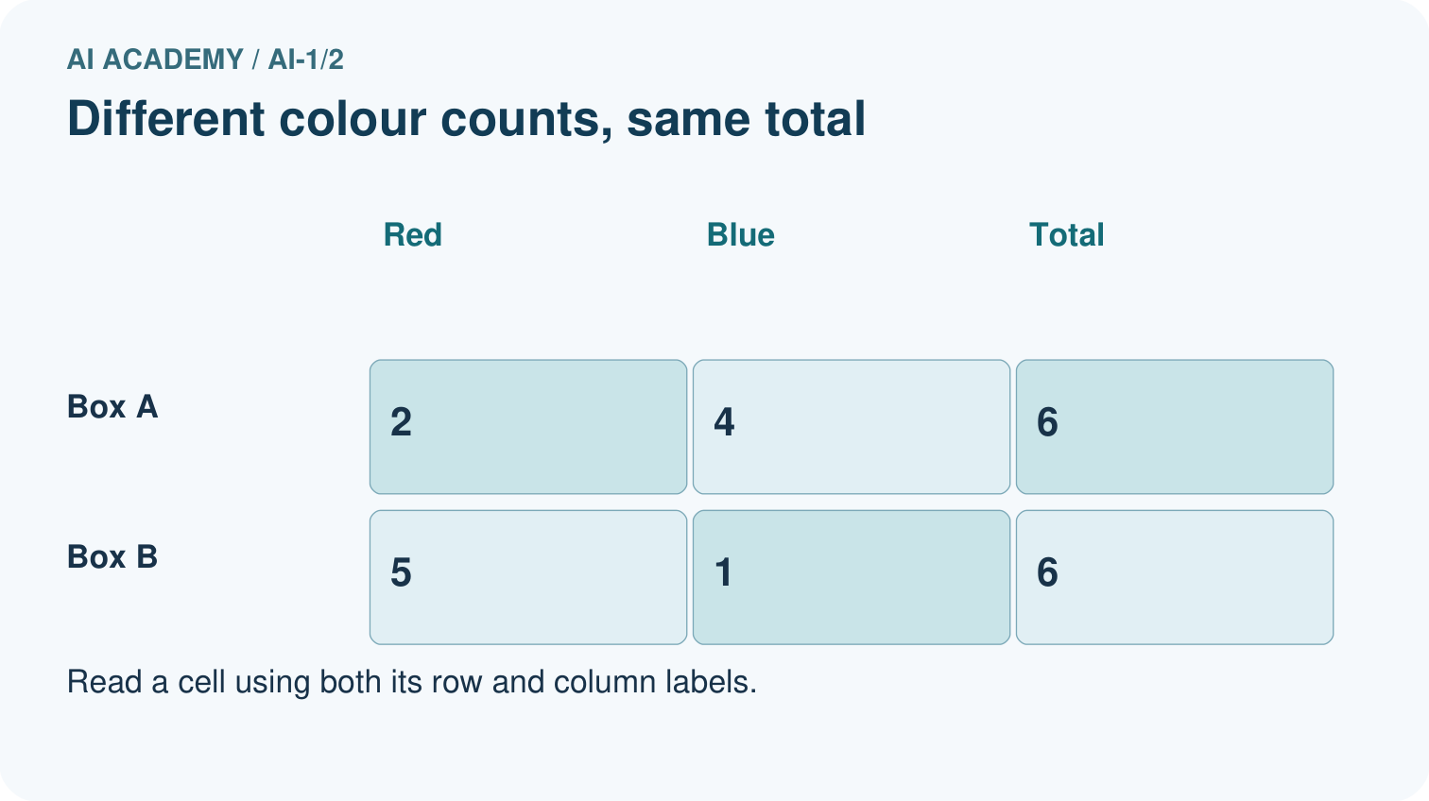
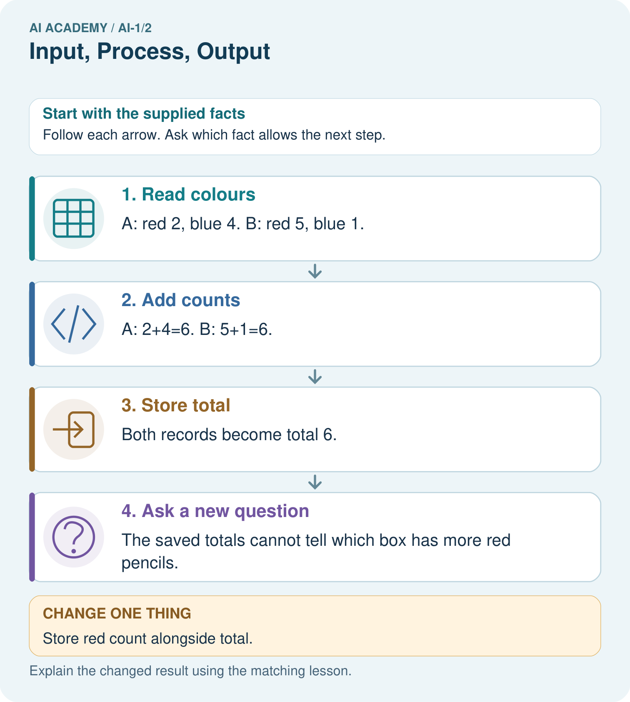
Use the richer record to find blue pencils in Box B. Explain why total alone was insufficient.

My picture-based explanation and changed-case prediction
________________________________________________________________
________________________________________________________________
________________________________________________________________
________________________________________________________________
________________________________________________________________
________________________________________________________________
Support used: alone / hint / worked example. This record is practice evidence.
Project connection: Choose sorter inputs that retain the clues needed for its decision; draw the transformation and identify discarded details.

19. Project portfolio milestone
Project: Helpful Classroom Sorter
Current milestone: Frame the need. Name the user, the problem, allowed inputs and a safe simple starting method.
Choose sorter inputs that retain the clues needed for its decision; draw the transformation and identify discarded details.
Evidence to keep | My record
This week’s input and deciding step
Prediction and actual result (or labelled paper trace)
One change since the previous checkpoint and why
One error or limit and the next test

Explain what this week adds to your project. Reuse last week’s record rather than starting again.
________________________________________________________________
________________________________________________________________
________________________________________________________________
________________________________________________________________
________________________________________________________________

