AI ACADEMY · WORKBOOK · ai-1/6

Sound Becomes a Signal
Project: Helpful Classroom Sorter

01. Recall and choose your starting point
Try the recall before opening notes. Then use a different colour or a labelled second line to correct your explanation.

Pictures Become Numbers
Without opening the old lesson, explain one key idea from Pictures Become Numbers. Give an example and a mistake that the idea helps you avoid.

My remembered idea, example and correction
________________________________________________________________
________________________________________________________________
________________________________________________________________

Sensors Are Messengers
Without opening the old lesson, explain one key idea from Sensors Are Messengers. Give an example and a mistake that the idea helps you avoid.

My remembered idea, example and correction
________________________________________________________________
________________________________________________________________
________________________________________________________________

02. Practise with fading help
Use W2: Inspect what was discarded for Sound as sampled information. Record the answer once; the lesson and workbook refer to the same attempt.
Given inputs | Procedure I chose | Middle steps | Result and check

The step I completed without help, and the hint I needed
________________________________________________________________
________________________________________________________________
________________________________________________________________

03. Individual reasoning check
Use the worked case for Sound as sampled information. Proposed explanation: “Five samples make five gaps”. Decide whether this explanation is supported. Point to the step or supplied fact that decides; explain your repair if needed.

My explanation before partner discussion
________________________________________________________________
________________________________________________________________
________________________________________________________________
________________________________________________________________

04. Independent transfer case

Independent case: Construct a new hidden change
A record keeps values 0 at times 0,3,6 milliseconds. Construct two seven-sample sequences for every whole-millisecond time from 0 through 6 that agree with those retained values but differ at omitted times. Explain why the retained record cannot prove that nothing changed between measurements.

My independent explanation, trace and limits
________________________________________________________________
________________________________________________________________
________________________________________________________________
________________________________________________________________
________________________________________________________________
________________________________________________________________
________________________________________________________________
Attempt this case before feedback. Record any help. Earlier examples below are further practice; a case already practised with feedback cannot establish fresh transfer.

05. Your learning target
A whisper recorded close to a microphone has larger sample amplitudes than a shout recorded far away. Does the recording prove the whisper was louder at its source? Propose one controlled follow-up.

06. Solve the given case
A microphone records quiet and loud claps at the same distance and settings.
What waveform difference is expected? Does it reveal a spoken word?
Show your trace, calculation or evidence

Write or draw your reasoning and evidence.
________________________________________________________________
________________________________________________________________
________________________________________________________________
________________________________________________________________
________________________________________________________________

07. Check a changed case
Two recordings contain the same word: one quiet and one loud. Which device receives the sound? Does a larger wave automatically mean a different word? Explain.
My independent answer and reason

Write or draw your reasoning and evidence.
________________________________________________________________
________________________________________________________________
________________________________________________________________
________________________________________________________________
________________________________________________________________

Week 6 Test and reflect

08. Design a revealing test
Create a changed input, boundary case or missing-information case. Write the expected answer or safe response before testing.
Test record | My evidence
Changed input or condition
Expected answer or fallback
Observed result
Why the result occurred

09. Project checkpoint
If the sorter uses sound, specify the exact sound pattern needed and test whether classroom noise makes that input unreliable.
The project change and evidence I will keep

Write or draw your reasoning and evidence.
________________________________________________________________
________________________________________________________________
________________________________________________________________
________________________________________________________________
________________________________________________________________

10. Self check
I can explain the mechanism. I can show evidence. I can handle a changed case. I can name a limit. Mark each as not yet, with help or independently, and attach supporting work.
Teacher review ____________________ Next step ____________________

11. Transfer practice from the original programme
A whisper recorded close to a microphone has larger sample amplitudes than a shout recorded far away. Does the recording prove the whisper was louder at its source? Propose one controlled follow-up.

My independently reasoned answer
________________________________________________________________
________________________________________________________________
________________________________________________________________
________________________________________________________________
________________________________________________________________
________________________________________________________________
________________________________________________________________
Record support used: none, hint or teacher explanation.

12. W1 Read samples and gaps
Five samples have values 0,3,0,1,0 at times 0,2,4,6,8 milliseconds. State the sample count, interval and elapsed time from first to last. Explain why there are four gaps.

My reasoning and evidence
________________________________________________________________
________________________________________________________________
________________________________________________________________
________________________________________________________________
________________________________________________________________

13. W2 Inspect what was discarded
Retain only times 0,4,8 from W1. Write the retained values. Give one claim about the original signal that these retained values do not justify.

My reasoning and evidence
________________________________________________________________
________________________________________________________________
________________________________________________________________
________________________________________________________________
________________________________________________________________

14. W3 Compare equal summaries
Sequences A=0,2,0,2,0 and B=0,0,2,0,0 use the same time interval. State their maximum values and one difference the maximum discards. Name information that would preserve that difference.

My reasoning and evidence
________________________________________________________________
________________________________________________________________
________________________________________________________________
________________________________________________________________
________________________________________________________________
________________________________________________________________

15. W4 Construct a new hidden change
A record keeps values 0 at times 0,3,6 milliseconds. Construct two seven-sample sequences for every whole-millisecond time from 0 through 6 that agree with those retained values but differ at omitted times. Explain why the retained record cannot prove that nothing changed between measurements.

My reasoning and evidence
________________________________________________________________
________________________________________________________________
________________________________________________________________
________________________________________________________________
________________________________________________________________
________________________________________________________________
________________________________________________________________
________________________________________________________________

16. W5 Check a speech pipeline
A recording says Set the timer for fourteen minutes. A transcript says forty minutes and the timer is set to 40. Name the first mismatch, propose a confirmation step and explain why the transcript cannot be treated as a complete copy of the recording.

My reasoning and evidence
________________________________________________________________
________________________________________________________________
________________________________________________________________
________________________________________________________________
________________________________________________________________
________________________________________________________________

17. Feedback, return check and learning record
Evidence | My record
Worked alone / hint / model
First step I repaired and why
New case checked later; date and result
What I can now explain without notes
One remaining question
Revisit this idea with your teacher after a delay. Familiarity is different from explaining and using it on a changed case.

18. Pictorial case practice: Sound Becomes a Signal
A fictional microphone display records five samples during a short classroom tap.
Times are 0,1,2,3,4 ms in order.
Signal A: 0,3,0,1,0. Signal B: 0,1,0,3,0. Toy values are signed measurement units; these happen to be nonnegative.
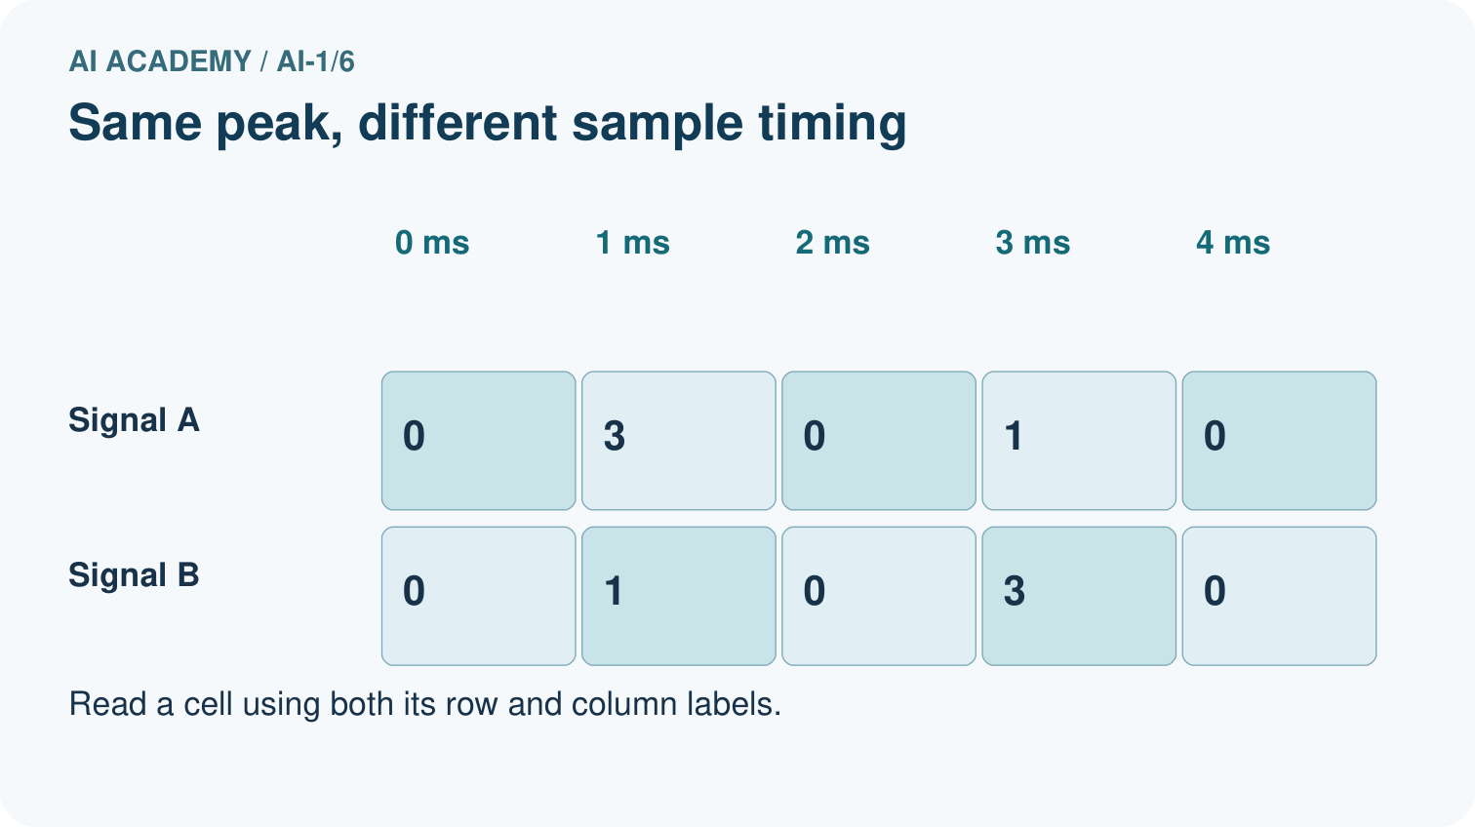
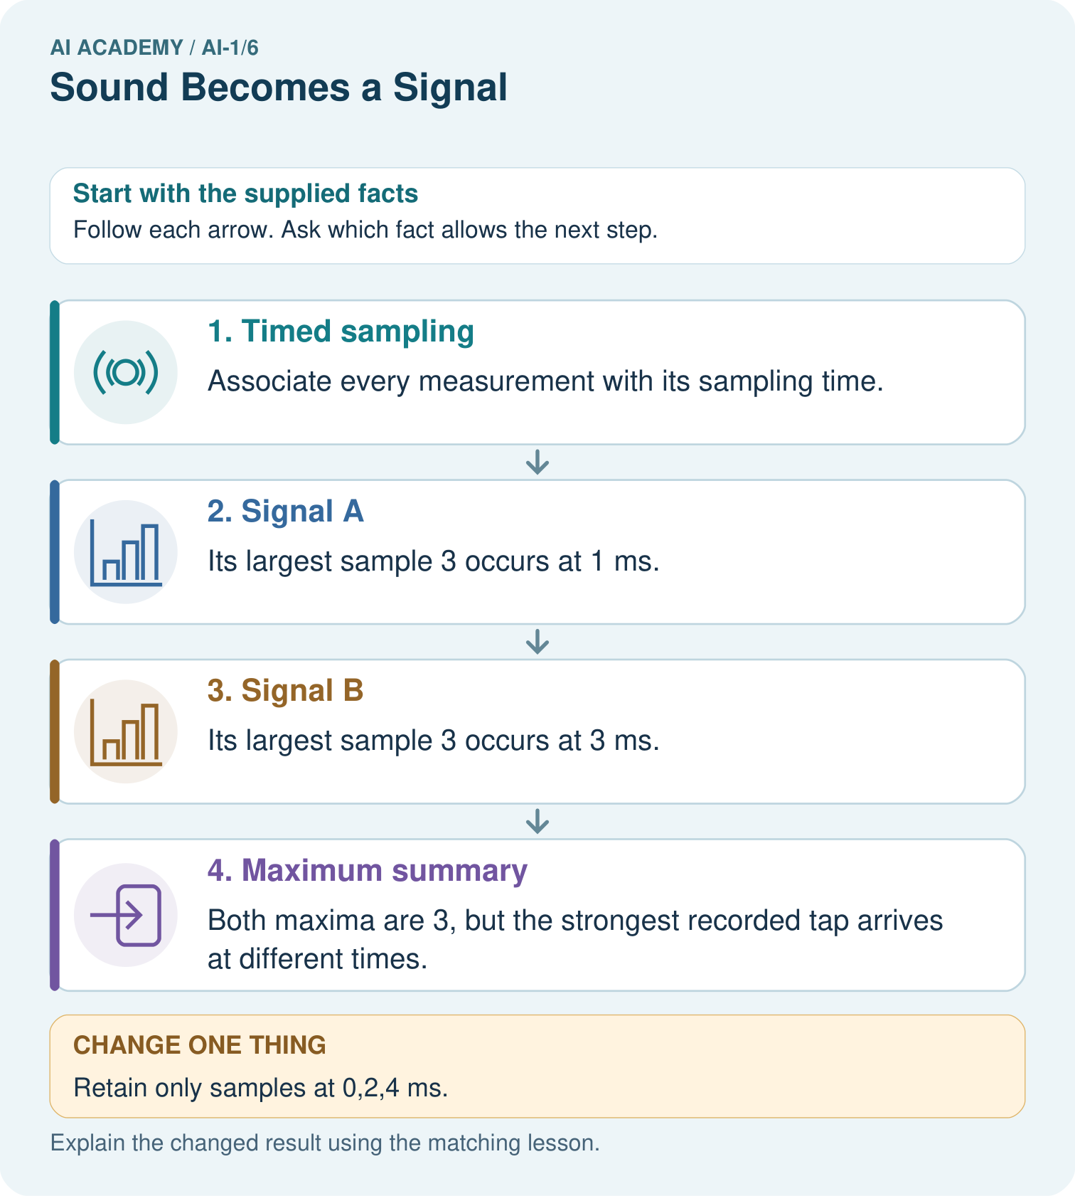
Does the all-zero retained record prove the full signal was silent? Use the picture.

My picture-based explanation and changed-case prediction
________________________________________________________________
________________________________________________________________
________________________________________________________________
________________________________________________________________
________________________________________________________________
________________________________________________________________
Support used: alone / hint / worked example. This record is practice evidence.
Project connection: Record the sorter’s sampling interval and retain relevant sequences when a decision depends on changes over time.

19. Project portfolio milestone
Project: Helpful Classroom Sorter
Current milestone: Frame the need. Name the user, the problem, allowed inputs and a safe simple starting method.
Record the sorter’s sampling interval and retain relevant sequences when a decision depends on changes over time.
Evidence to keep | My record
This week’s input and deciding step
Prediction and actual result (or labelled paper trace)
One change since the previous checkpoint and why
One error or limit and the next test

Explain what this week adds to your project. Reuse last week’s record rather than starting again.
________________________________________________________________
________________________________________________________________
________________________________________________________________
________________________________________________________________
________________________________________________________________

