AI ACADEMY · WORKBOOK · ai-1/12

Debug the Cause
Project: Helpful Classroom Sorter

01. Recall and choose your starting point
Try the recall before opening notes. Then use a different colour or a labelled second line to correct your explanation.

Repeating Efficiently
Without opening the old lesson, explain one key idea from Repeating Efficiently. Give an example and a mistake that the idea helps you avoid.

My remembered idea, example and correction
________________________________________________________________
________________________________________________________________
________________________________________________________________

Algorithms as Recipes
Without opening the old lesson, explain one key idea from Algorithms as Recipes. Give an example and a mistake that the idea helps you avoid.

My remembered idea, example and correction
________________________________________________________________
________________________________________________________________
________________________________________________________________

Sound Becomes a Signal
Without opening the old lesson, explain one key idea from Sound Becomes a Signal. Give an example and a mistake that the idea helps you avoid.

My remembered idea, example and correction
________________________________________________________________
________________________________________________________________
________________________________________________________________

02. Practise with fading help
Use W2: Choose between two explanations for Debugging with revealing tests. Record the answer once; the lesson and workbook refer to the same attempt.
Given inputs | Procedure I chose | Middle steps | Result and check

The step I completed without help, and the hint I needed
________________________________________________________________
________________________________________________________________
________________________________________________________________

03. Individual reasoning check
Use the worked case for Debugging with revealing tests. Proposed explanation: “The last wrong number locates the fault”. Decide whether this explanation is supported. Point to the step or supplied fact that decides; explain your repair if needed.

My explanation before partner discussion
________________________________________________________________
________________________________________________________________
________________________________________________________________
________________________________________________________________

04. Independent transfer case

Independent case: Debug a new ticket rule
A paper ticket rule must add 1 to the input count. If the updated count is at least 5, report Group; otherwise report Single. A copied version says above 5. Choose the smallest three consecutive nonnegative starting counts that test just below, exactly at and just above the comparison boundary. Predict both versions, identify the revealing start and state the repair and retests.

My independent explanation, trace and limits
________________________________________________________________
________________________________________________________________
________________________________________________________________
________________________________________________________________
________________________________________________________________
________________________________________________________________
________________________________________________________________
Attempt this case before feedback. Record any help. Earlier examples below are further practice; a case already practised with feedback cannot establish fresh transfer.

05. Your learning target
Starting at square 0, the target is square 3. Program: repeat twice {MOVE 1}; STOP. A teammate changes the target to 2 and calls the bug fixed. Repair the program and give two tests.

06. Solve the given case
A robot should go from square one to square three. Its program is MOVE ONE, STOP.
Find the cause and repair one thing.
Show your trace, calculation or evidence

Write or draw your reasoning and evidence.
________________________________________________________________
________________________________________________________________
________________________________________________________________
________________________________________________________________
________________________________________________________________

07. Check a changed case
A sorting rule says blue goes left. A blue card goes right. The reader correctly reports blue, but the direction rule says blue goes right. Which part should you fix first?
My independent answer and reason

Write or draw your reasoning and evidence.
________________________________________________________________
________________________________________________________________
________________________________________________________________
________________________________________________________________
________________________________________________________________

Week 12 Test and reflect

08. Design a revealing test
Create a changed input, boundary case or missing-information case. Write the expected answer or safe response before testing.
Test record | My evidence
Changed input or condition
Expected answer or fallback
Observed result
Why the result occurred

09. Project checkpoint
When the sorter fails, log the first wrong stage and change only the responsible rule, input, or label.
The project change and evidence I will keep

Write or draw your reasoning and evidence.
________________________________________________________________
________________________________________________________________
________________________________________________________________
________________________________________________________________
________________________________________________________________

10. Self check
I can explain the mechanism. I can show evidence. I can handle a changed case. I can name a limit. Mark each as not yet, with help or independently, and attach supporting work.
Teacher review ____________________ Next step ____________________

11. Transfer practice from the original programme
The requirement is to move exactly three squares forward from any valid starting square, then stop. Starting at square 0, repeat twice {MOVE 1}; STOP ends at 2. A teammate reduces the required distance to two squares. Repair the program without changing the requirement; test starts 0 and 2.

My independently reasoned answer
________________________________________________________________
________________________________________________________________
________________________________________________________________
________________________________________________________________
________________________________________________________________
________________________________________________________________
________________________________________________________________
Record support used: none, hint or teacher explanation.

12. W1 Locate the first difference
A procedure must add 2, double the updated value, then subtract 1. Starting at 3, an observed trace is 3, 5, 8, 7. Write the expected trace, identify the first difference and explain why the final subtraction is not necessarily a separate fault.

My reasoning and evidence
________________________________________________________________
________________________________________________________________
________________________________________________________________
________________________________________________________________
________________________________________________________________
________________________________________________________________
________________________________________________________________

13. W2 Choose between two explanations
In W1 the faulty middle step may add 3, or add the original starting value. Both explain 5 becoming 8 when the start is 3. Choose start 1 or start 3 for a revealing new test. Predict the final result under each explanation and under the intended procedure.

My reasoning and evidence
________________________________________________________________
________________________________________________________________
________________________________________________________________
________________________________________________________________
________________________________________________________________
________________________________________________________________

14. W3 Reject a repair that hides the symptom
A learner repairs the original points machine by reporting 12 for every input, because 12 is correct from start 4. Give a different starting input and its expected output under add 3, double, subtract 2. Explain why the constant report is not a valid repair and what earlier evidence should be preserved.

My reasoning and evidence
________________________________________________________________
________________________________________________________________
________________________________________________________________
________________________________________________________________
________________________________________________________________
________________________________________________________________

15. W4 Debug a new ticket rule
A paper ticket rule must add 1 to the input count. If the updated count is at least 5, report Group; otherwise report Single. A copied version says above 5. Choose the smallest three consecutive nonnegative starting counts that test just below, exactly at and just above the comparison boundary. Predict both versions, identify the revealing start and state the repair and retests.

My reasoning and evidence
________________________________________________________________
________________________________________________________________
________________________________________________________________
________________________________________________________________
________________________________________________________________
________________________________________________________________
________________________________________________________________
________________________________________________________________

16. W5 Make a defensible completion claim
After repairing W4, all three chosen tests pass. Write a short report with the fault, the exact repair, the three inputs and expected outputs, and what those passing tests establish. Explain why saying every possible error is now impossible would go beyond the evidence.

My reasoning and evidence
________________________________________________________________
________________________________________________________________
________________________________________________________________
________________________________________________________________
________________________________________________________________
________________________________________________________________

17. Feedback, return check and learning record
Evidence | My record
Worked alone / hint / model
First step I repaired and why
New case checked later; date and result
What I can now explain without notes
One remaining question
Revisit this idea with your teacher after a delay. Familiarity is different from explaining and using it on a changed case.

18. Pictorial case practice: Debug the Cause
A fictional paper calculator should double the current value, but a copied instruction behaves strangely.
After input 6, the faulty step reports 12. Hypothesis A: add 6. Hypothesis B: double.
Both hypotheses fit this first observation. A new input may be chosen.
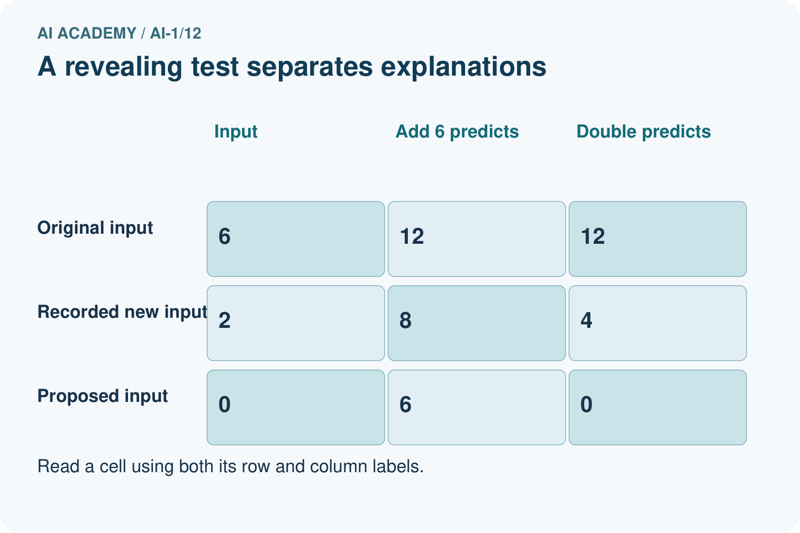
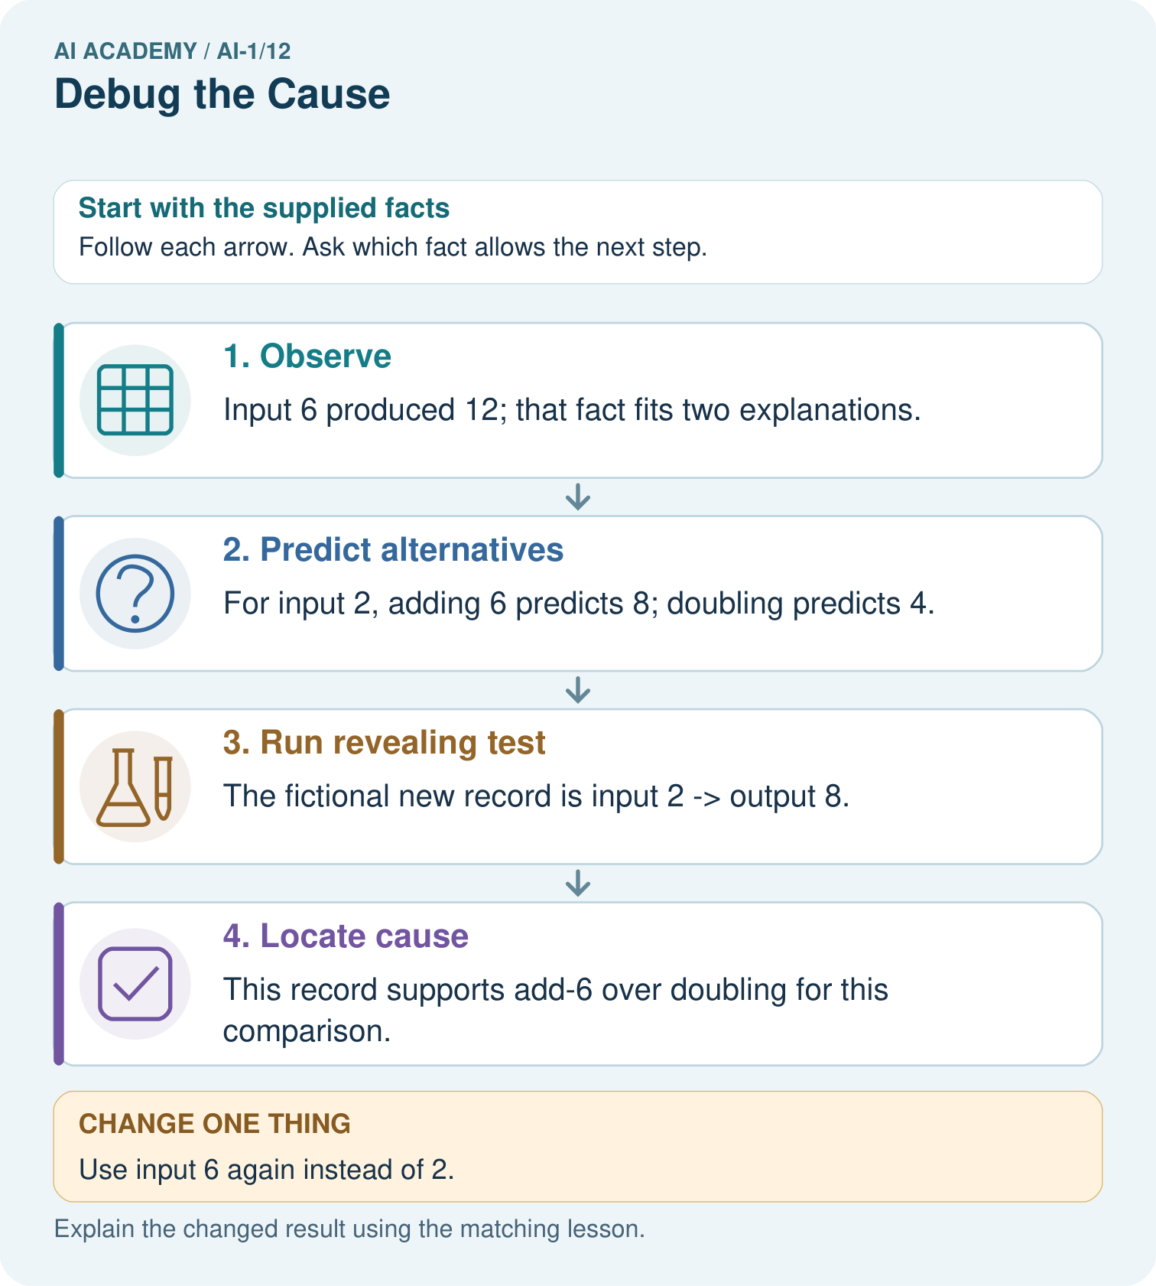
Propose input 0 and give both predicted outputs without inventing an observed result.

My picture-based explanation and changed-case prediction
________________________________________________________________
________________________________________________________________
________________________________________________________________
________________________________________________________________
________________________________________________________________
________________________________________________________________
Support used: alone / hint / worked example. This record is practice evidence.
Project connection: When the sorter fails, write competing explanations and predicted traces before changing code or instructions.

19. Project portfolio milestone
Project: Helpful Classroom Sorter
Current milestone: Make a transparent first version. Keep a trace of how one input becomes an output; explain the rule or learned component.
When the sorter fails, write competing explanations and predicted traces before changing code or instructions.
Evidence to keep | My record
This week’s input and deciding step
Prediction and actual result (or labelled paper trace)
One change since the previous checkpoint and why
One error or limit and the next test

Explain what this week adds to your project. Reuse last week’s record rather than starting again.
________________________________________________________________
________________________________________________________________
________________________________________________________________
________________________________________________________________
________________________________________________________________

