AI ACADEMY · WORKBOOK · ai-1/13

Learning from Examples
Project: Helpful Classroom Sorter

01. Recall and choose your starting point
Try the recall before opening notes. Then use a different colour or a labelled second line to correct your explanation.

Debug the Cause
Without opening the old lesson, explain one key idea from Debug the Cause. Give an example and a mistake that the idea helps you avoid.

My remembered idea, example and correction
________________________________________________________________
________________________________________________________________
________________________________________________________________

If/Then Decisions
Without opening the old lesson, explain one key idea from If/Then Decisions. Give an example and a mistake that the idea helps you avoid.

My remembered idea, example and correction
________________________________________________________________
________________________________________________________________
________________________________________________________________

Categories and Labels
Without opening the old lesson, explain one key idea from Categories and Labels. Give an example and a mistake that the idea helps you avoid.

My remembered idea, example and correction
________________________________________________________________
________________________________________________________________
________________________________________________________________

02. Practise with fading help
Use W2: Explain a tied fit for Fitting a pattern from examples. Record the answer once; the lesson and workbook refer to the same attempt.
Given inputs | Procedure I chose | Middle steps | Result and check

The step I completed without help, and the hint I needed
________________________________________________________________
________________________________________________________________
________________________________________________________________

03. Individual reasoning check
Use the worked case for Fitting a pattern from examples. Proposed explanation: “The lowest error count is added across candidates”. Decide whether this explanation is supported. Point to the step or supplied fact that decides; explain your repair if needed.

My explanation before partner discussion
________________________________________________________________
________________________________________________________________
________________________________________________________________
________________________________________________________________

04. Independent transfer case

Independent case: Fit a new distance task
Imaginary map markers have distances 1, 3, 5 and 7 units, with supplied labels near, far, far and far. Compare candidates that predict far when distance is at least 2, 4 or 6 units. List every prediction and error count, select the lowest-error candidate, then predict at distance 2 before any comparison label is supplied. Limit your conclusion.

My independent explanation, trace and limits
________________________________________________________________
________________________________________________________________
________________________________________________________________
________________________________________________________________
________________________________________________________________
________________________________________________________________
________________________________________________________________
Attempt this case before feedback. Record any help. Earlier examples below are further practice; a case already practised with feedback cannot establish fresh transfer.

05. Your learning target
Training cards show lengths 2,3 labelled S and 7,8 labelled L. Two proposed rules are 'L at 5 or above' and 'L at 7 or above'. Both fit training. Choose one new labelled card length that would distinguish them and explain what remains unknown.

06. Solve the given case
Training examples label smooth leaves S and toothed leaves T. A new leaf is toothed.
Predict and state the evidence limit.
Show your trace, calculation or evidence

Write or draw your reasoning and evidence.
________________________________________________________________
________________________________________________________________
________________________________________________________________
________________________________________________________________
________________________________________________________________

07. Check a changed case
A learner sees three red apples and no green apples, then calls a green apple not an apple. What missing evidence could help? How would you check improvement?
My independent answer and reason

Write or draw your reasoning and evidence.
________________________________________________________________
________________________________________________________________
________________________________________________________________
________________________________________________________________
________________________________________________________________

Week 13 Test and reflect

08. Design a revealing test
Create a changed input, boundary case or missing-information case. Write the expected answer or safe response before testing.
Test record | My evidence
Changed input or condition
Expected answer or fallback
Observed result
Why the result occurred

09. Project checkpoint
Create the first small labeled example set for the sorter and explain which visual differences it covers.
The project change and evidence I will keep

Write or draw your reasoning and evidence.
________________________________________________________________
________________________________________________________________
________________________________________________________________
________________________________________________________________
________________________________________________________________

10. Self check
I can explain the mechanism. I can show evidence. I can handle a changed case. I can name a limit. Mark each as not yet, with help or independently, and attach supporting work.
Teacher review ____________________ Next step ____________________

11. Transfer practice from the original programme
Training cards show lengths 2,3 labelled S and 7,8 labelled L. Two proposed rules are 'L at 5 or above' and 'L at 7 or above'. Both fit training. Choose one new labelled card length that would distinguish them and explain what remains unknown.

My independently reasoned answer
________________________________________________________________
________________________________________________________________
________________________________________________________________
________________________________________________________________
________________________________________________________________
________________________________________________________________
________________________________________________________________
Record support used: none, hint or teacher explanation.

12. W1 Count each candidate from zero
Heights 2, 4, 6 and 8 cm have labels short, short, tall and tall. Predict all four labels under threshold 3, then under threshold 7, using tall when height is at least the threshold. List the disagreeing examples and separate totals.

My reasoning and evidence
________________________________________________________________
________________________________________________________________
________________________________________________________________
________________________________________________________________
________________________________________________________________
________________________________________________________________
________________________________________________________________

13. W2 Explain a tied fit
Thresholds 5 and 6 both have zero disagreements on the W1 fitting set. The tie rule chooses the smaller threshold. Which is selected? Give a whole-number height where the two candidates disagree and both predictions. Explain what the tie rule does not prove.

My reasoning and evidence
________________________________________________________________
________________________________________________________________
________________________________________________________________
________________________________________________________________
________________________________________________________________
________________________________________________________________

14. W3 Update with an added example
Add height 5 cm labelled short to the four fitting examples. Recompute the disagreement totals for thresholds 3, 5, 6 and 7. Select the candidate with the fewest disagreements, keeping the smaller-threshold tie rule. Explain why the new label is part of fitting.

My reasoning and evidence
________________________________________________________________
________________________________________________________________
________________________________________________________________
________________________________________________________________
________________________________________________________________
________________________________________________________________

15. W4 Fit a new distance task
Imaginary map markers have distances 1, 3, 5 and 7 units, with supplied labels near, far, far and far. Compare candidates that predict far when distance is at least 2, 4 or 6 units. List every prediction and error count, select the lowest-error candidate, then predict at distance 2 before any comparison label is supplied. Limit your conclusion.

My reasoning and evidence
________________________________________________________________
________________________________________________________________
________________________________________________________________
________________________________________________________________
________________________________________________________________
________________________________________________________________
________________________________________________________________
________________________________________________________________

16. W5 Keep conflicting records visible
Two fitting records both have height 6 cm. One is labelled short and the other tall. A learner says a clever height-only rule can agree with both on every run. Explain the problem for a deterministic rule and name two checks to make before changing either record.

My reasoning and evidence
________________________________________________________________
________________________________________________________________
________________________________________________________________
________________________________________________________________
________________________________________________________________
________________________________________________________________

17. Feedback, return check and learning record
Evidence | My record
Worked alone / hint / model
First step I repaired and why
New case checked later; date and result
What I can now explain without notes
One remaining question
Revisit this idea with your teacher after a delay. Familiarity is different from explaining and using it on a changed case.

18. Pictorial case practice: Learning from Examples
A fictional classifier learns whether measured sticks are short or long.
Training lengths 2,4,8,10 cm have labels short,short,long,long.
Candidate boundaries: long at least 5 or at least 7. Lowest errors wins; tie chooses smaller boundary.
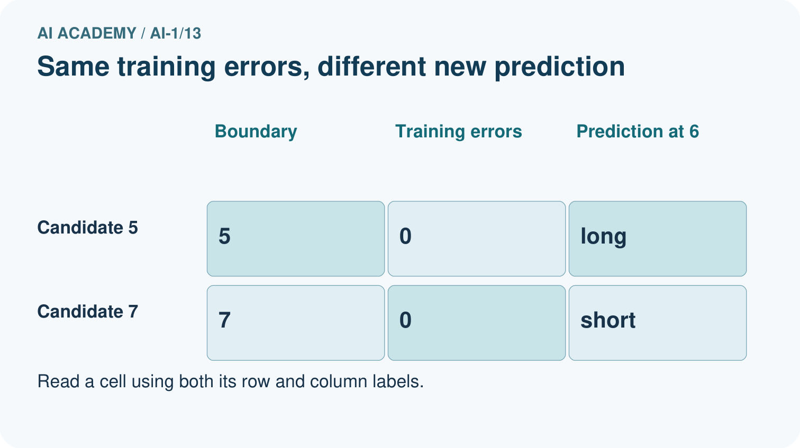
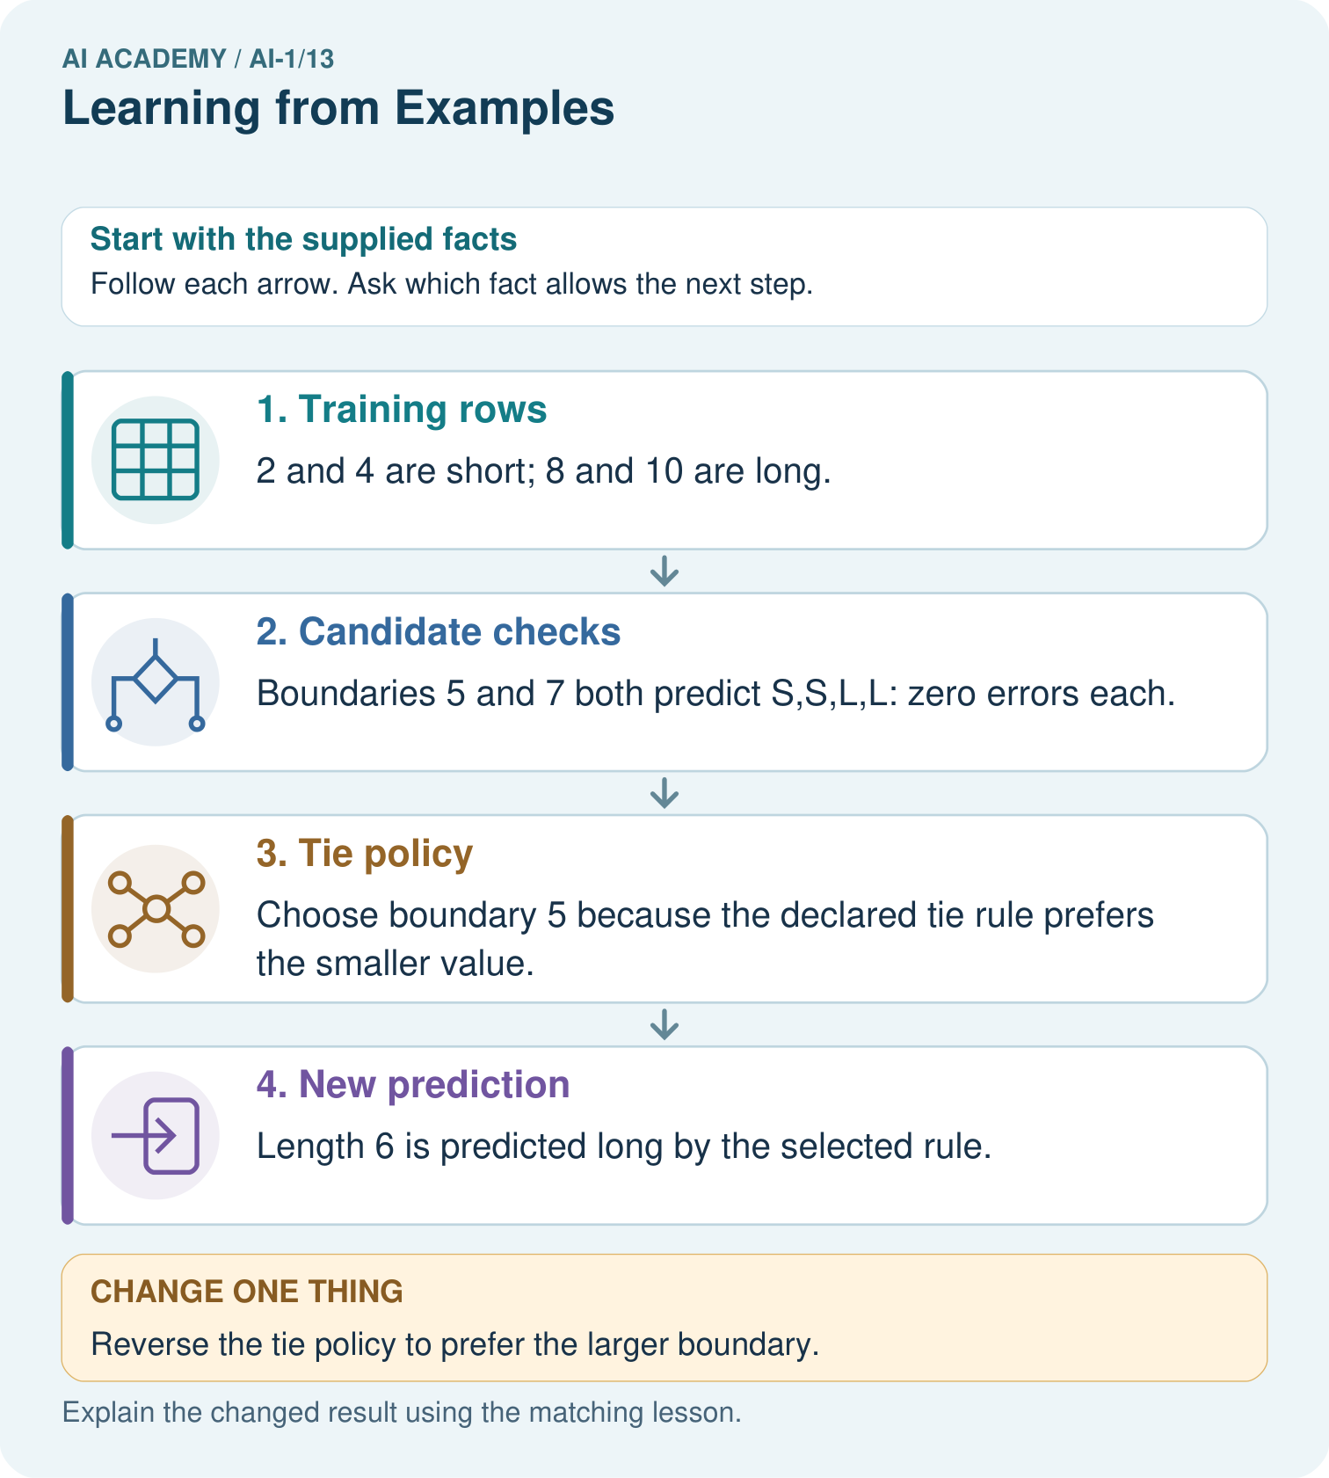
Which new measured length would reveal disagreement between the candidates?

My picture-based explanation and changed-case prediction
________________________________________________________________
________________________________________________________________
________________________________________________________________
________________________________________________________________
________________________________________________________________
________________________________________________________________
Support used: alone / hint / worked example. This record is practice evidence.
Project connection: Save candidate definitions, training errors and tie policy with any sorter model version.

19. Project portfolio milestone
Project: Helpful Classroom Sorter
Current milestone: Test changed cases. Keep normal, boundary and failure cases; compare expected and observed results.
Save candidate definitions, training errors and tie policy with any sorter model version.
Evidence to keep | My record
This week’s input and deciding step
Prediction and actual result (or labelled paper trace)
One change since the previous checkpoint and why
One error or limit and the next test

Explain what this week adds to your project. Reuse last week’s record rather than starting again.
________________________________________________________________
________________________________________________________________
________________________________________________________________
________________________________________________________________
________________________________________________________________

