AI ACADEMY · WORKBOOK · ai-1/15

Save New Examples for Testing
Project: Helpful Classroom Sorter

01. Recall and choose your starting point
Try the recall before opening notes. Then use a different colour or a labelled second line to correct your explanation.

Build a Human Classifier
Without opening the old lesson, explain one key idea from Build a Human Classifier. Give an example and a mistake that the idea helps you avoid.

My remembered idea, example and correction
________________________________________________________________
________________________________________________________________
________________________________________________________________

Debug the Cause
Without opening the old lesson, explain one key idea from Debug the Cause. Give an example and a mistake that the idea helps you avoid.

My remembered idea, example and correction
________________________________________________________________
________________________________________________________________
________________________________________________________________

Algorithms as Recipes
Without opening the old lesson, explain one key idea from Algorithms as Recipes. Give an example and a mistake that the idea helps you avoid.

My remembered idea, example and correction
________________________________________________________________
________________________________________________________________
________________________________________________________________

02. Practise with fading help
Use W2: Preserve the original result for Keeping final tests unseen. Record the answer once; the lesson and workbook refer to the same attempt.
Given inputs | Procedure I chose | Middle steps | Result and check

The step I completed without help, and the hint I needed
________________________________________________________________
________________________________________________________________
________________________________________________________________

03. Individual reasoning check
Use the worked case for Keeping final tests unseen. Proposed explanation: “A new file makes old records unseen”. Decide whether this explanation is supported. Point to the step or supplied fact that decides; explain your repair if needed.

My explanation before partner discussion
________________________________________________________________
________________________________________________________________
________________________________________________________________
________________________________________________________________

04. Independent transfer case

Independent case: Run a separate ribbon experiment
Before receiving any test labels, freeze RibbonA: whole cm lengths 1 through 12, long at least 6 cm and short otherwise. Save predictions for 5, 7, 9 and 11 cm. Ask your teacher to reveal the reserved labels, then record agreements, disagreements and a limited result statement. If you later choose threshold 8 after seeing these labels, explain how you must describe its result on the same records.

My independent explanation, trace and limits
________________________________________________________________
________________________________________________________________
________________________________________________________________
________________________________________________________________
________________________________________________________________
________________________________________________________________
________________________________________________________________
Attempt this case before feedback. Record any help. Earlier examples below are further practice; a case already practised with feedback cannot establish fresh transfer.

05. Your learning target
Eight cards are used to invent a rule. Four sealed cards are then opened; the team changes its rule after seeing errors. Can those four cards still be called an untouched final test? Plan what to do next.

06. Solve the given case
Cards A–F are used for practice. G and H remain sealed.
Which can provide a fresh test, and under what condition?
Show your trace, calculation or evidence

Write or draw your reasoning and evidence.
________________________________________________________________
________________________________________________________________
________________________________________________________________
________________________________________________________________
________________________________________________________________

07. Check a changed case
You teach a sorter using cards A, B and C. You keep D and E unseen. Which cards provide the fairer first test? What changes if you show D during teaching?
My independent answer and reason

Write or draw your reasoning and evidence.
________________________________________________________________
________________________________________________________________
________________________________________________________________
________________________________________________________________
________________________________________________________________

Week 15 Test and reflect

08. Design a revealing test
Create a changed input, boundary case or missing-information case. Write the expected answer or safe response before testing.
Test record | My evidence
Changed input or condition
Expected answer or fallback
Observed result
Why the result occurred

09. Project checkpoint
Create separate learn and test envelopes for the Classroom Sorter and label who may open each.
The project change and evidence I will keep

Write or draw your reasoning and evidence.
________________________________________________________________
________________________________________________________________
________________________________________________________________
________________________________________________________________
________________________________________________________________

10. Self check
I can explain the mechanism. I can show evidence. I can handle a changed case. I can name a limit. Mark each as not yet, with help or independently, and attach supporting work.
Teacher review ____________________ Next step ____________________

11. Transfer practice from the original programme
Eight cards are used to invent a rule. Four sealed cards are then opened; the team changes its rule after seeing errors. Can those four cards still be called an untouched final test? Plan what to do next.

My independently reasoned answer
________________________________________________________________
________________________________________________________________
________________________________________________________________
________________________________________________________________
________________________________________________________________
________________________________________________________________
________________________________________________________________
Record support used: none, hint or teacher explanation.

12. W1 Assign the evidence its role
For each event, state whether examples are being used for development or independent evaluation of a fixed model: comparing candidates on fitting labels; scoring a frozen model on previously reserved examples once; changing a threshold after reading a test score. Explain your last choice.

My reasoning and evidence
________________________________________________________________
________________________________________________________________
________________________________________________________________
________________________________________________________________
________________________________________________________________
________________________________________________________________

13. W2 Preserve the original result
TowerA uses threshold 5 on reserved heights 3, 5, 7 and 9 cm. The labels are short, short, tall and tall. Write its predictions, agreements and disagreement. Then state why TowerB with threshold 6, selected after seeing these labels, cannot claim four independent test successes on these same records.

My reasoning and evidence
________________________________________________________________
________________________________________________________________
________________________________________________________________
________________________________________________________________
________________________________________________________________
________________________________________________________________
________________________________________________________________

14. W3 Detect a less visible leak
A team leaves reserved labels out of its fitting table but tries six rules and reads a test score for each. It chooses the highest-scoring rule. Explain how information still reached model selection. Would renaming or reordering the same test records repair the problem?

My reasoning and evidence
________________________________________________________________
________________________________________________________________
________________________________________________________________
________________________________________________________________
________________________________________________________________
________________________________________________________________

15. W4 Run a separate ribbon experiment
Before receiving any test labels, freeze RibbonA: whole cm lengths 1 through 12, long at least 6 cm and short otherwise. Save predictions for 5, 7, 9 and 11 cm. Ask your teacher to reveal the reserved labels, then record agreements, disagreements and a limited result statement. If you later choose threshold 8 after seeing these labels, explain how you must describe its result on the same records.

My reasoning and evidence
________________________________________________________________
________________________________________________________________
________________________________________________________________
________________________________________________________________
________________________________________________________________
________________________________________________________________
________________________________________________________________
________________________________________________________________

16. W5 Audit a proposed final set
A class reserves ten copies of one easy development example in a new file. The model agrees with all ten labels. Explain two reasons this gives weak evidence about new cases, and propose a better final evaluation plan without promising perfect future performance.

My reasoning and evidence
________________________________________________________________
________________________________________________________________
________________________________________________________________
________________________________________________________________
________________________________________________________________
________________________________________________________________

17. Feedback, return check and learning record
Evidence | My record
Worked alone / hint / model
First step I repaired and why
New case checked later; date and result
What I can now explain without notes
One remaining question
Revisit this idea with your teacher after a delay. Familiarity is different from explaining and using it on a changed case.

18. Pictorial case practice: Save New Examples for Testing
A fictional envelope exercise evaluates a fixed pencil-length sorter.
Freeze PencilP: long at least 6 cm; short below 6.
Reserved valid lengths are 3,5,6,9 cm. Teacher envelope labels, revealed only after predictions, are short,long,long,long.
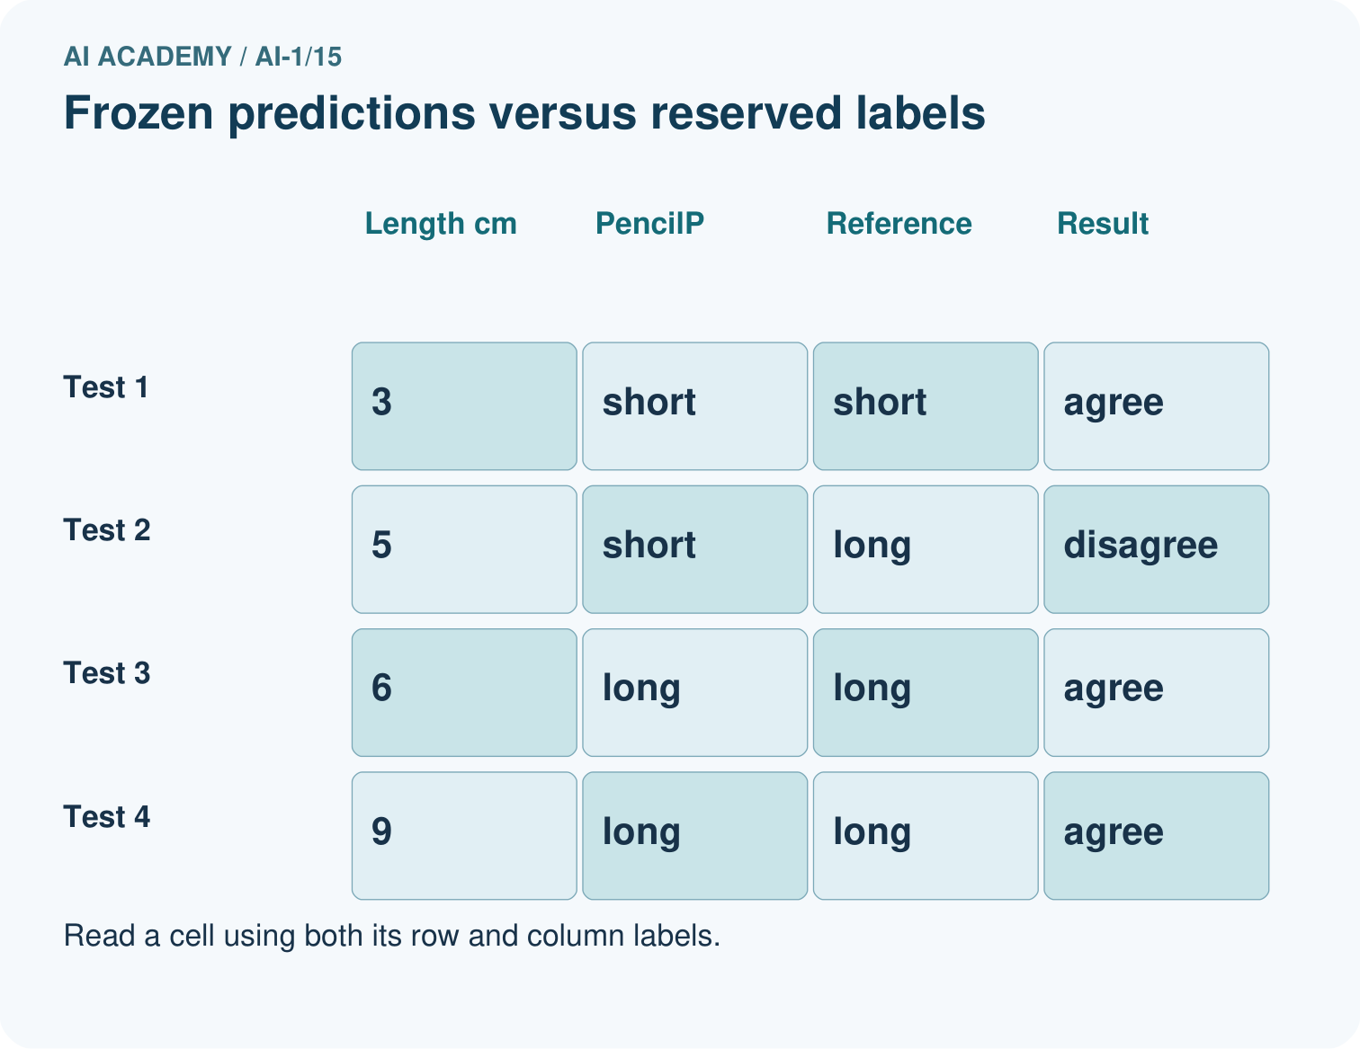
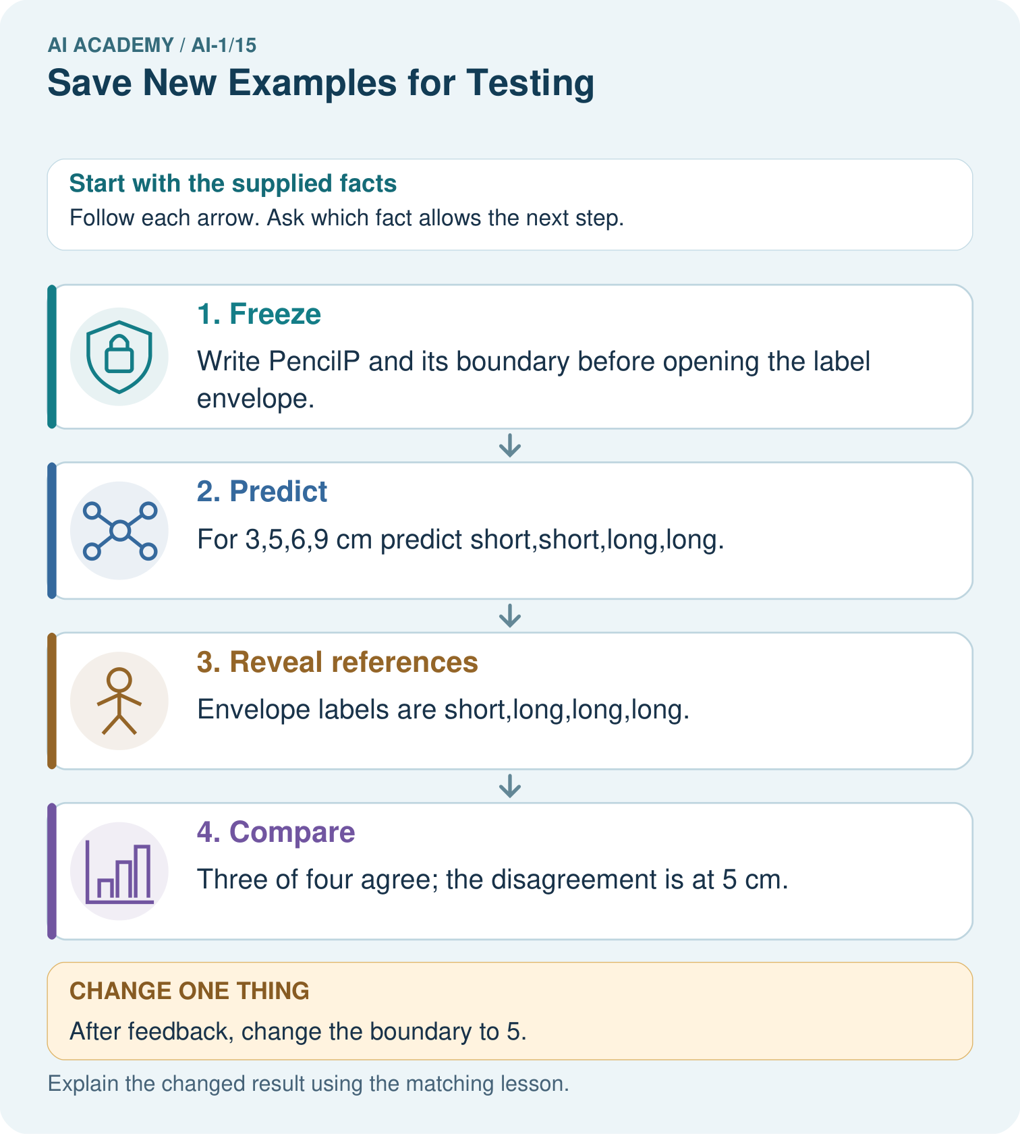
Does 4/4 on the replay replace the original 3/4 result? Explain.

My picture-based explanation and changed-case prediction
________________________________________________________________
________________________________________________________________
________________________________________________________________
________________________________________________________________
________________________________________________________________
________________________________________________________________
Support used: alone / hint / worked example. This record is practice evidence.
Project connection: Maintain dated sorter versions and separate development examples from reserved project-evaluation cases.

19. Project portfolio milestone
Project: Helpful Classroom Sorter
Current milestone: Test changed cases. Keep normal, boundary and failure cases; compare expected and observed results.
Maintain dated sorter versions and separate development examples from reserved project-evaluation cases.
Evidence to keep | My record
This week’s input and deciding step
Prediction and actual result (or labelled paper trace)
One change since the previous checkpoint and why
One error or limit and the next test

Explain what this week adds to your project. Reuse last week’s record rather than starting again.
________________________________________________________________
________________________________________________________________
________________________________________________________________
________________________________________________________________
________________________________________________________________

