AI ACADEMY · WORKBOOK · ai-1/21

Good Data, Bad Data
Project: Helpful Classroom Sorter

01. Recall and choose your starting point
Try the recall before opening notes. Then use a different colour or a labelled second line to correct your explanation.

Recommendations
Without opening the old lesson, explain one key idea from Recommendations. Give an example and a mistake that the idea helps you avoid.

My remembered idea, example and correction
________________________________________________________________
________________________________________________________________
________________________________________________________________

Confidence Is Not Correctness
Without opening the old lesson, explain one key idea from Confidence Is Not Correctness. Give an example and a mistake that the idea helps you avoid.

My remembered idea, example and correction
________________________________________________________________
________________________________________________________________
________________________________________________________________

Save New Examples for Testing
Without opening the old lesson, explain one key idea from Save New Examples for Testing. Give an example and a mistake that the idea helps you avoid.

My remembered idea, example and correction
________________________________________________________________
________________________________________________________________
________________________________________________________________

02. Practise with fading help
Use W2: Write a traceable correction for Data quality and documented repair. Record the answer once; the lesson and workbook refer to the same attempt.
Given inputs | Procedure I chose | Middle steps | Result and check

The step I completed without help, and the hint I needed
________________________________________________________________
________________________________________________________________
________________________________________________________________

03. Individual reasoning check
Use the worked case for Data quality and documented repair. Proposed explanation: “Every valid value is true”. Decide whether this explanation is supported. Point to the step or supplied fact that decides; explain your repair if needed.

My explanation before partner discussion
________________________________________________________________
________________________________________________________________
________________________________________________________________
________________________________________________________________

04. Independent transfer case

Independent case: Audit an independent paper-plane log
Each flight ID must be unique; distance is a whole number from 0 through 20 cm. Raw rows: F1 8 cm; F2 120 cm; F3 blank; F4 0 cm; another F1 8 cm. Source S1 confirms one F1 flight. S2 says F2 travelled 12 cm. S3 is blank. S4 confirms zero. Preserve the raw rows, describe supported repairs and give the number of distinct flights. Report how many assessed flights travelled at least 10 cm, including missing records separately.

My independent explanation, trace and limits
________________________________________________________________
________________________________________________________________
________________________________________________________________
________________________________________________________________
________________________________________________________________
________________________________________________________________
________________________________________________________________
Attempt this case before feedback. Record any help. Earlier examples below are further practice; a case already practised with feedback cannot establish fresh transfer.

05. Your learning target
A table lists leaf lengths 8 cm, 90 mm, blank and 700 cm. Propose a documented cleaning action for each row. Which values can you safely change immediately?

06. Solve the given case
Ordinary pencil lengths are recorded as 12 cm, 14 cm, blank and 130 cm.
What needs checking? May 130 silently become 13?
Show your trace, calculation or evidence

Write or draw your reasoning and evidence.
________________________________________________________________
________________________________________________________________
________________________________________________________________
________________________________________________________________
________________________________________________________________

07. Check a changed case
A table labels a cat photo dog and lists the same photo three times. Identify both data problems and one sensible repair for each.
My independent answer and reason

Write or draw your reasoning and evidence.
________________________________________________________________
________________________________________________________________
________________________________________________________________
________________________________________________________________
________________________________________________________________

Week 21 Test and reflect

08. Design a revealing test
Create a changed input, boundary case or missing-information case. Write the expected answer or safe response before testing.
Test record | My evidence
Changed input or condition
Expected answer or fallback
Observed result
Why the result occurred

09. Project checkpoint
Audit the sorter's example cards and add a reason for including each field and condition.
The project change and evidence I will keep

Write or draw your reasoning and evidence.
________________________________________________________________
________________________________________________________________
________________________________________________________________
________________________________________________________________
________________________________________________________________

10. Self check
I can explain the mechanism. I can show evidence. I can handle a changed case. I can name a limit. Mark each as not yet, with help or independently, and attach supporting work.
Teacher review ____________________ Next step ____________________

11. Transfer practice from the original programme
A table lists leaf lengths 8 cm, 90 mm, blank and 700 cm. Propose a documented cleaning action for each row. Which values can you safely change immediately?

My independently reasoned answer
________________________________________________________________
________________________________________________________________
________________________________________________________________
________________________________________________________________
________________________________________________________________
________________________________________________________________
________________________________________________________________
Record support used: none, hint or teacher explanation.

12. W1 Check a schema without guessing
Use the RampLog schema. State the issue or valid status for height 60, travel blank and travel 0. Give the range allowed for each numeric field and explain why a blank and zero require different treatment.

My reasoning and evidence
________________________________________________________________
________________________________________________________________
________________________________________________________________
________________________________________________________________
________________________________________________________________
________________________________________________________________

13. W2 Write a traceable correction
C2 says T2 height is 6 cm and travel is 5 cm; the export says height 60 cm. Write a change-log entry with ID, field, old and new values with units, evidence, reason, reviewer and date. Use a fictional reviewer and date. Explain where the raw export is kept.

My reasoning and evidence
________________________________________________________________
________________________________________________________________
________________________________________________________________
________________________________________________________________
________________________________________________________________
________________________________________________________________

14. W3 Distinguish duplicate rows from similar trials
The export repeats T1 with the same source C1, which confirms one trial. A different trial T5 also has height 4 and travel 3, with its own source C5 confirming a separate trial. Explain which rows count once and why T5 must remain separate.

My reasoning and evidence
________________________________________________________________
________________________________________________________________
________________________________________________________________
________________________________________________________________
________________________________________________________________
________________________________________________________________

15. W4 Audit an independent paper-plane log
Each flight ID must be unique; distance is a whole number from 0 through 20 cm. Raw rows: F1 8 cm; F2 120 cm; F3 blank; F4 0 cm; another F1 8 cm. Source S1 confirms one F1 flight. S2 says F2 travelled 12 cm. S3 is blank. S4 confirms zero. Preserve the raw rows, describe supported repairs and give the number of distinct flights. Report how many assessed flights travelled at least 10 cm, including missing records separately.

My reasoning and evidence
________________________________________________________________
________________________________________________________________
________________________________________________________________
________________________________________________________________
________________________________________________________________
________________________________________________________________
________________________________________________________________
________________________________________________________________

16. W5 Handle conflicting and converted evidence
Two signed cards disagree about the same F3 flight: one says 9 cm and the other 11 cm. Neither is established as the correction. What can you report for the at-least-10-cm question? Separately, a source for a new F5 flight explicitly records 100 mm. Convert it to centimetres and state the conversion evidence to retain.

My reasoning and evidence
________________________________________________________________
________________________________________________________________
________________________________________________________________
________________________________________________________________
________________________________________________________________
________________________________________________________________

17. Feedback, return check and learning record
Evidence | My record
Worked alone / hint / model
First step I repaired and why
New case checked later; date and result
What I can now explain without notes
One remaining question
Revisit this idea with your teacher after a delay. Familiarity is different from explaining and using it on a changed case.

18. Pictorial case practice: Good Data, Bad Data
A fictional toy-car distance table needs cleaning before use.
Contract: unique run ID; whole distance 0–30 cm. Raw rows: A=0 cm, B=200 mm, C=blank, another A=0 cm.
Source log confirms one A run and B’s original measurement of 200 mm; C has no measurement.
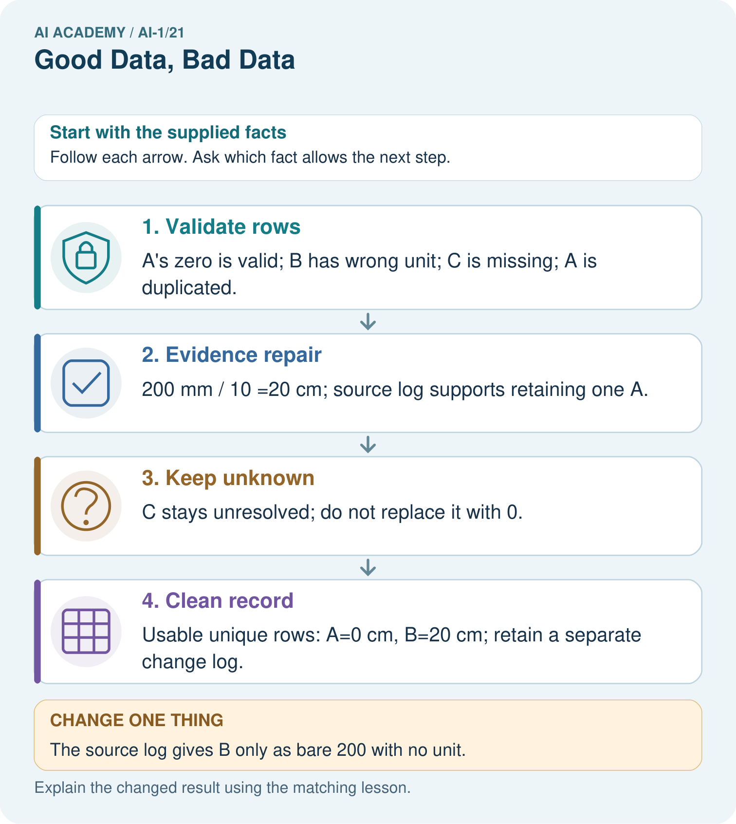
Which repairs are evidence-backed in the original case, and which row must remain unknown?

My picture-based explanation and changed-case prediction
________________________________________________________________
________________________________________________________________
________________________________________________________________
________________________________________________________________
________________________________________________________________
________________________________________________________________
Support used: alone / hint / worked example. This record is practice evidence.
Project connection: Keep raw sorter inputs, validated records and an evidence-linked repair log as different artifacts.

19. Project portfolio milestone
Project: Helpful Classroom Sorter
Current milestone: Evaluate and revise. Compare with your starting method, explain errors and record a justified revision.
Keep raw sorter inputs, validated records and an evidence-linked repair log as different artifacts.
Evidence to keep | My record
This week’s input and deciding step
Prediction and actual result (or labelled paper trace)
One change since the previous checkpoint and why
One error or limit and the next test

Explain what this week adds to your project. Reuse last week’s record rather than starting again.
________________________________________________________________
________________________________________________________________
________________________________________________________________
________________________________________________________________
________________________________________________________________

