AI ACADEMY · WORKBOOK · ai-1/24

Privacy by Choosing Less
Project: Helpful Classroom Sorter

01. Recall and choose your starting point
Try the recall before opening notes. Then use a different colour or a labelled second line to correct your explanation.

Fair for Whom?
Without opening the old lesson, explain one key idea from Fair for Whom?. Give an example and a mistake that the idea helps you avoid.

My remembered idea, example and correction
________________________________________________________________
________________________________________________________________
________________________________________________________________

Good Data, Bad Data
Without opening the old lesson, explain one key idea from Good Data, Bad Data. Give an example and a mistake that the idea helps you avoid.

My remembered idea, example and correction
________________________________________________________________
________________________________________________________________
________________________________________________________________

Confidence Is Not Correctness
Without opening the old lesson, explain one key idea from Confidence Is Not Correctness. Give an example and a mistake that the idea helps you avoid.

My remembered idea, example and correction
________________________________________________________________
________________________________________________________________
________________________________________________________________

02. Practise with fading help
Use W2: Challenge a claim of anonymity for Privacy and data minimisation. Record the answer once; the lesson and workbook refer to the same attempt.
Given inputs | Procedure I chose | Middle steps | Result and check

The step I completed without help, and the hint I needed
________________________________________________________________
________________________________________________________________
________________________________________________________________

03. Individual reasoning check
Use the worked case for Privacy and data minimisation. Proposed explanation: “More data always improves a task”. Decide whether this explanation is supported. Point to the step or supplied fact that decides; explain your repair if needed.

My explanation before partner discussion
________________________________________________________________
________________________________________________________________
________________________________________________________________
________________________________________________________________

04. Independent transfer case

Independent case: Design a different minimal-data task
A fictional library wants only the total number of books needing repair in each category: cover, page or binding. It does not need to contact borrowers. A draft repair sheet asks for borrower name, home address, book repair category and borrower photograph. Design a plan: state the purpose, required and removed fields, who handles source sheets, what totals are shared with the librarian, and who disposes of sheets at what agreed point. Use no real borrower details.

My independent explanation, trace and limits
________________________________________________________________
________________________________________________________________
________________________________________________________________
________________________________________________________________
________________________________________________________________
________________________________________________________________
________________________________________________________________
Attempt this case before feedback. Record any help. Earlier examples below are further practice; a case already practised with feedback cannot establish fresh transfer.

05. Your learning target
A book recommender requests genre, maximum pages, home address and a selfie. Keep only fields needed for genre and length matching. Explain one consequence of storing extra fields.

06. Solve the given case
A genre-based book helper asks for genre, home address and a photograph.
Which fields are necessary?
Show your trace, calculation or evidence

Write or draw your reasoning and evidence.
________________________________________________________________
________________________________________________________________
________________________________________________________________
________________________________________________________________
________________________________________________________________

07. Check a changed case
A book helper needs reading topic and approximate difficulty. Someone asks it to collect home address too. Which information can be left out, and why?
My independent answer and reason

Write or draw your reasoning and evidence.
________________________________________________________________
________________________________________________________________
________________________________________________________________
________________________________________________________________
________________________________________________________________

Week 24 Test and reflect

08. Design a revealing test
Create a changed input, boundary case or missing-information case. Write the expected answer or safe response before testing.
Test record | My evidence
Changed input or condition
Expected answer or fallback
Observed result
Why the result occurred

09. Project checkpoint
Cross out names, faces, and ownership details unless an explicit need survives review; set a deletion rule for sorter records.
The project change and evidence I will keep

Write or draw your reasoning and evidence.
________________________________________________________________
________________________________________________________________
________________________________________________________________
________________________________________________________________
________________________________________________________________

10. Self check
I can explain the mechanism. I can show evidence. I can handle a changed case. I can name a limit. Mark each as not yet, with help or independently, and attach supporting work.
Teacher review ____________________ Next step ____________________

11. Transfer practice from the original programme
A book recommender requests genre, maximum pages, home address and a selfie. Keep only fields needed for genre and length matching. Explain one consequence of storing extra fields.

My independently reasoned answer
________________________________________________________________
________________________________________________________________
________________________________________________________________
________________________________________________________________
________________________________________________________________
________________________________________________________________
________________________________________________________________
Record support used: none, hint or teacher explanation.

12. W1 Trim a form to its purpose
The fictional workshop vote asks for name, full date of birth, address, photograph and topic choice. Its only purpose is to count votes for drawing, music and coding. State which field to keep, which to remove and why. Explain why collecting the extra fields first is different from never collecting them.

My reasoning and evidence
________________________________________________________________
________________________________________________________________
________________________________________________________________
________________________________________________________________
________________________________________________________________
________________________________________________________________

13. W2 Challenge a claim of anonymity
A teacher replaces names with codes and keeps a separate code-to-name key. A pupil calls the records anonymous. Explain the problem. Then explain why removing names while leaving photographs would not settle the question either.

My reasoning and evidence
________________________________________________________________
________________________________________________________________
________________________________________________________________
________________________________________________________________
________________________________________________________________
________________________________________________________________

14. W3 Share the result the audience needs
The fictional class has drawing 8, music 7 and coding 5. Write the result needed to choose a workshop. A pupil suggests posting every vote slip online as proof. Explain a lower-exposure way to check and share the result. Why can a total about a one-person club still reveal a choice?

My reasoning and evidence
________________________________________________________________
________________________________________________________________
________________________________________________________________
________________________________________________________________
________________________________________________________________
________________________________________________________________

15. W4 Design a different minimal-data task
A fictional library wants only the total number of books needing repair in each category: cover, page or binding. It does not need to contact borrowers. A draft repair sheet asks for borrower name, home address, book repair category and borrower photograph. Design a plan: state the purpose, required and removed fields, who handles source sheets, what totals are shared with the librarian, and who disposes of sheets at what agreed point. Use no real borrower details.

My reasoning and evidence
________________________________________________________________
________________________________________________________________
________________________________________________________________
________________________________________________________________
________________________________________________________________
________________________________________________________________
________________________________________________________________
________________________________________________________________

16. W5 Respond to an unnecessary upload
Someone plans to upload the library repair sheet with borrower details to an unapproved AI tool to add three totals. Explain a smaller-input alternative and a no-upload method. If the sheet was already shared, state a suitable first response and one claim you must not make about deleting it.

My reasoning and evidence
________________________________________________________________
________________________________________________________________
________________________________________________________________
________________________________________________________________
________________________________________________________________
________________________________________________________________

17. Feedback, return check and learning record
Evidence | My record
Worked alone / hint / model
First step I repaired and why
New case checked later; date and result
What I can now explain without notes
One remaining question
Revisit this idea with your teacher after a delay. Familiarity is different from explaining and using it on a changed case.

18. Pictorial case practice: Privacy by Choosing Less
A fictional teacher wants to count broken craft tools by type, without contacting borrowers.
Needed output: totals for scissors, ruler and hole-punch repairs.
Draft form requests pupil name, birthday, tool type and repair-needed Yes/No. No borrower follow-up is required.
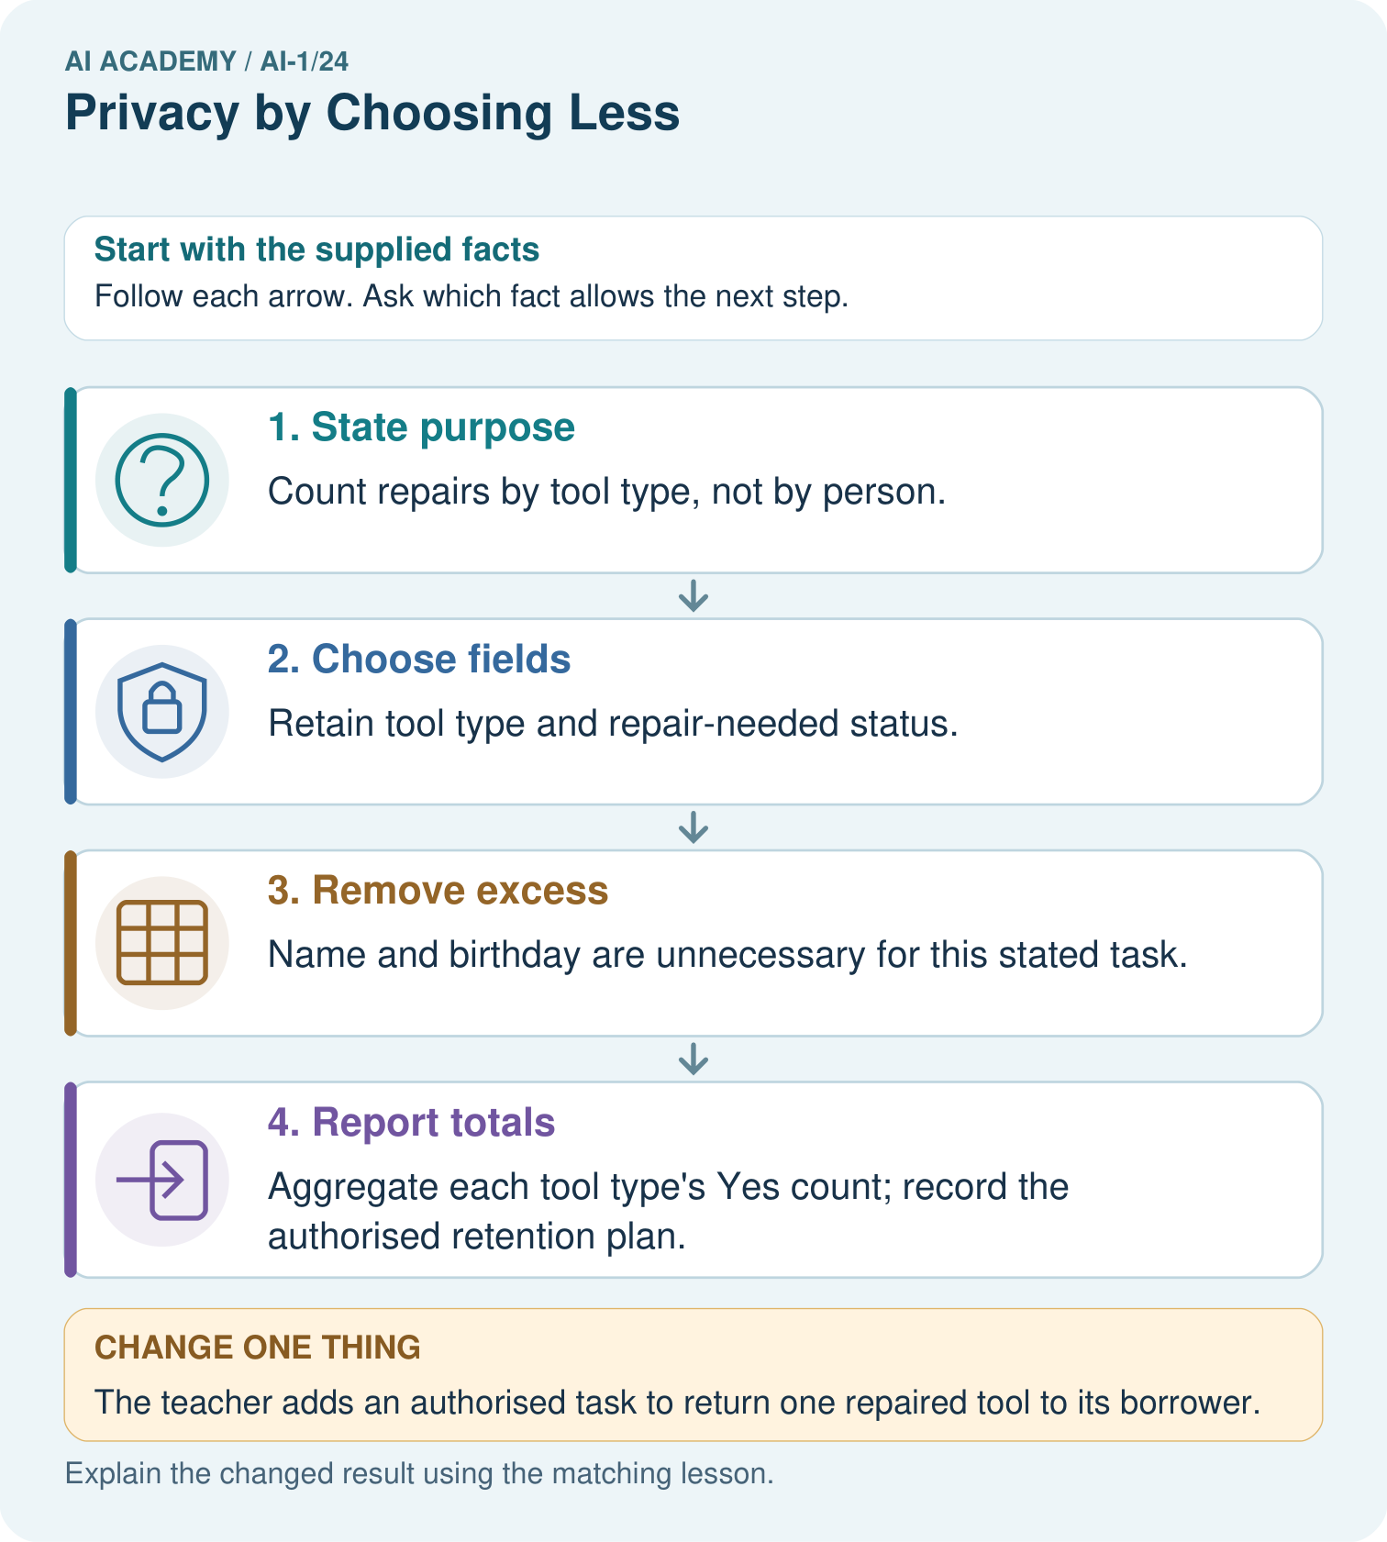
For the original task, does adding an anonymous-looking pupil code improve the repair count?

My picture-based explanation and changed-case prediction
________________________________________________________________
________________________________________________________________
________________________________________________________________
________________________________________________________________
________________________________________________________________
________________________________________________________________
Support used: alone / hint / worked example. This record is practice evidence.
Project connection: Write the sorter’s purpose, necessary fields, access rules and deletion point before collecting any real classroom information.

19. Project portfolio milestone
Project: Helpful Classroom Sorter
Current milestone: Evaluate and revise. Compare with your starting method, explain errors and record a justified revision.
Write the sorter’s purpose, necessary fields, access rules and deletion point before collecting any real classroom information.
Evidence to keep | My record
This week’s input and deciding step
Prediction and actual result (or labelled paper trace)
One change since the previous checkpoint and why
One error or limit and the next test

Explain what this week adds to your project. Reuse last week’s record rather than starting again.
________________________________________________________________
________________________________________________________________
________________________________________________________________
________________________________________________________________
________________________________________________________________

