AI ACADEMY · WORKBOOK · ai-1/27

Verify Important Outputs
Project: Helpful Classroom Sorter

01. Recall and choose your starting point
Try the recall before opening notes. Then use a different colour or a labelled second line to correct your explanation.

Prompts Are Design Instructions
Without opening the old lesson, explain one key idea from Prompts Are Design Instructions. Give an example and a mistake that the idea helps you avoid.

My remembered idea, example and correction
________________________________________________________________
________________________________________________________________
________________________________________________________________

Privacy by Choosing Less
Without opening the old lesson, explain one key idea from Privacy by Choosing Less. Give an example and a mistake that the idea helps you avoid.

My remembered idea, example and correction
________________________________________________________________
________________________________________________________________
________________________________________________________________

Good Data, Bad Data
Without opening the old lesson, explain one key idea from Good Data, Bad Data. Give an example and a mistake that the idea helps you avoid.

My remembered idea, example and correction
________________________________________________________________
________________________________________________________________
________________________________________________________________

02. Practise with fading help
Use W2: Repair a unit error for Verifying claims and quantities. Record the answer once; the lesson and workbook refer to the same attempt.
Given inputs | Procedure I chose | Middle steps | Result and check

The step I completed without help, and the hint I needed
________________________________________________________________
________________________________________________________________
________________________________________________________________

03. Individual reasoning check
Use the worked case for Verifying claims and quantities. Proposed explanation: “A citation proves every nearby claim”. Decide whether this explanation is supported. Point to the step or supplied fact that decides; explain your repair if needed.

My explanation before partner discussion
________________________________________________________________
________________________________________________________________
________________________________________________________________
________________________________________________________________

04. Independent transfer case

Independent case: Audit a new model with mass units
Fictional craft card M states five sealed bags of modelling material at exactly 250 g per bag. Three models each use 300 g, with no other loss. A draft says “M supplies 1250 g; the models use 900 g; 350 kg remains; every model will win a prize.” Check all four claims, show the remaining mass in grams, and explain the status of the prize claim. Use 1 kg = 1000 g.

My independent explanation, trace and limits
________________________________________________________________
________________________________________________________________
________________________________________________________________
________________________________________________________________
________________________________________________________________
________________________________________________________________
________________________________________________________________
Attempt this case before feedback. Record any help. Earlier examples below are further practice; a case already practised with feedback cannot establish fresh transfer.

05. Your learning target
A generated report says 18 of 24 tests passed, so success was 80%. Verify the claim in two ways and write a corrected sentence.

06. Solve the given case
An answer says six groups of four make 28.
Verify independently.
Show your trace, calculation or evidence

Write or draw your reasoning and evidence.
________________________________________________________________
________________________________________________________________
________________________________________________________________
________________________________________________________________
________________________________________________________________

07. Check a changed case
An assistant says the school library opens at 8, but today's official notice says 9. Which source should guide today's visit? Explain the check.
My independent answer and reason

Write or draw your reasoning and evidence.
________________________________________________________________
________________________________________________________________
________________________________________________________________
________________________________________________________________
________________________________________________________________

Week 27 Test and reflect

08. Design a revealing test
Create a changed input, boundary case or missing-information case. Write the expected answer or safe response before testing.
Test record | My evidence
Changed input or condition
Expected answer or fallback
Observed result
Why the result occurred

09. Project checkpoint
Require human confirmation for important sorter outputs and attach the evidence record used to approve each rule or label.
The project change and evidence I will keep

Write or draw your reasoning and evidence.
________________________________________________________________
________________________________________________________________
________________________________________________________________
________________________________________________________________
________________________________________________________________

10. Self check
I can explain the mechanism. I can show evidence. I can handle a changed case. I can name a limit. Mark each as not yet, with help or independently, and attach supporting work.
Teacher review ____________________ Next step ____________________

11. Transfer practice from the original programme
A generated report says 18 of 24 tests passed, so success was 80%. Verify the claim in two ways and write a corrected sentence.

My independently reasoned answer
________________________________________________________________
________________________________________________________________
________________________________________________________________
________________________________________________________________
________________________________________________________________
________________________________________________________________
________________________________________________________________
Record support used: none, hint or teacher explanation.

12. W1 Separate source facts from derived quantities
Using R, identify a directly stated fact and a quantity that must be calculated. Give the source or expression for each. Explain why a citation to R does not verify the claim that every participant will enjoy the activity.

My reasoning and evidence
________________________________________________________________
________________________________________________________________
________________________________________________________________
________________________________________________________________
________________________________________________________________
________________________________________________________________

13. W2 Repair a unit error
A report calculates 12 × 50 = 600 and labels the result metres. Use R to correct the unit, convert the result to metres and calculate the remaining length. Give a second arithmetic route or a check using starting, used and remaining lengths.

My reasoning and evidence
________________________________________________________________
________________________________________________________________
________________________________________________________________
________________________________________________________________
________________________________________________________________
________________________________________________________________

14. W3 Do not count copied claims as separate evidence
Three posters say 600 metres were used, but all copied one draft. A fourth poster cites card Z, which is unavailable. Explain why these posters do not settle the quantity. Name the available evidence and check you would use instead.

My reasoning and evidence
________________________________________________________________
________________________________________________________________
________________________________________________________________
________________________________________________________________
________________________________________________________________
________________________________________________________________

15. W4 Audit a new model with mass units
Fictional craft card M states five sealed bags of modelling material at exactly 250 g per bag. Three models each use 300 g, with no other loss. A draft says “M supplies 1250 g; the models use 900 g; 350 kg remains; every model will win a prize.” Check all four claims, show the remaining mass in grams, and explain the status of the prize claim. Use 1 kg = 1000 g.

My reasoning and evidence
________________________________________________________________
________________________________________________________________
________________________________________________________________
________________________________________________________________
________________________________________________________________
________________________________________________________________
________________________________________________________________
________________________________________________________________

16. W5 State what a missing source prevents you from knowing
Another draft claims that the amount left in W4 accounts for all real-world waste, citing a missing instruction card. Explain which result can still be checked from M and which claim remains unresolved. What information would be needed before revising the no-loss model?

My reasoning and evidence
________________________________________________________________
________________________________________________________________
________________________________________________________________
________________________________________________________________
________________________________________________________________
________________________________________________________________

17. Feedback, return check and learning record
Evidence | My record
Worked alone / hint / model
First step I repaired and why
New case checked later; date and result
What I can now explain without notes
One remaining question
Revisit this idea with your teacher after a delay. Familiarity is different from explaining and using it on a changed case.

18. Pictorial case practice: Verify Important Outputs
A fictional craft sheet calculates ribbon left after making bookmarks.
Four rolls each contain exactly 150 cm. Eight bookmarks use exactly 50 cm each.
No other ribbon loss is assumed; no competition result is recorded.
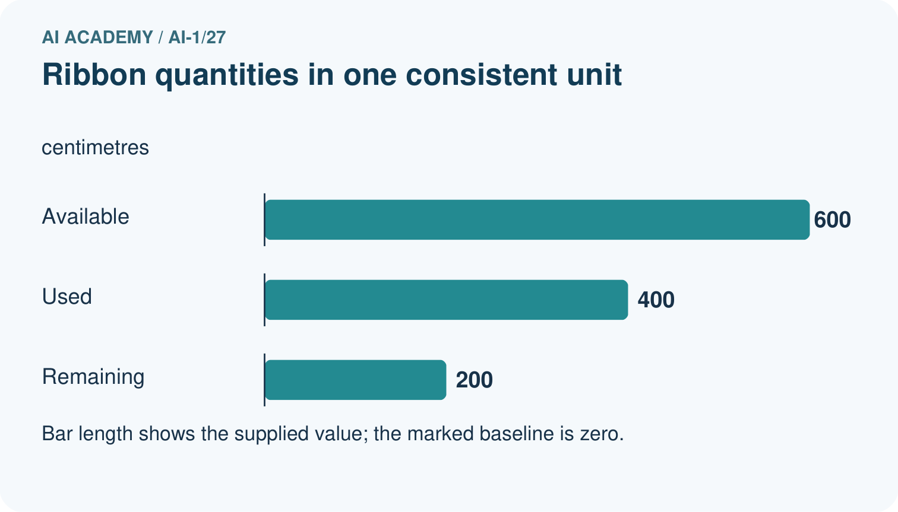
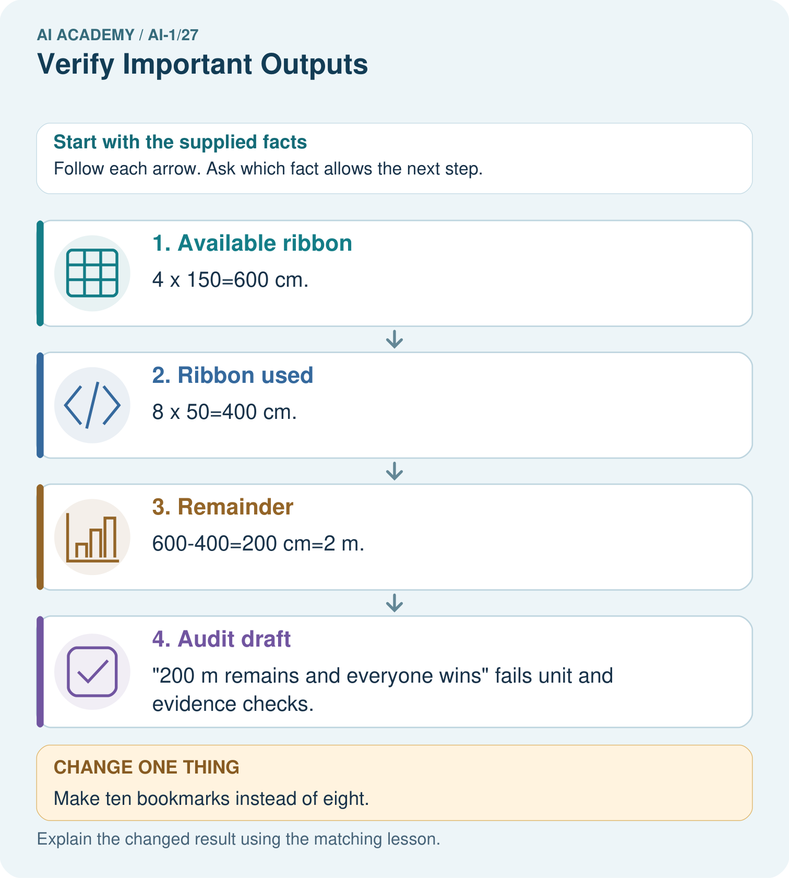
Correct the draft and identify which part needs another source rather than a calculation.

My picture-based explanation and changed-case prediction
________________________________________________________________
________________________________________________________________
________________________________________________________________
________________________________________________________________
________________________________________________________________
________________________________________________________________
Support used: alone / hint / worked example. This record is practice evidence.
Project connection: Check sorter calculations with explicit units and verify explanation claims against their actual catalogue evidence.

19. Project portfolio milestone
Project: Helpful Classroom Sorter
Current milestone: Prepare the demonstration. Gather reproducible instructions, evidence, access checks and remaining limitations.
Check sorter calculations with explicit units and verify explanation claims against their actual catalogue evidence.
Evidence to keep | My record
This week’s input and deciding step
Prediction and actual result (or labelled paper trace)
One change since the previous checkpoint and why
One error or limit and the next test

Explain what this week adds to your project. Reuse last week’s record rather than starting again.
________________________________________________________________
________________________________________________________________
________________________________________________________________
________________________________________________________________
________________________________________________________________

