AI ACADEMY · WORKBOOK · ai-1/32

Build a Paper Prototype
Project: Helpful Classroom Sorter

01. Recall and choose your starting point
Try the recall before opening notes. Then use a different colour or a labelled second line to correct your explanation.

Design the Decision Process
Without opening the old lesson, explain one key idea from Design the Decision Process. Give an example and a mistake that the idea helps you avoid.

My remembered idea, example and correction
________________________________________________________________
________________________________________________________________
________________________________________________________________

Find a Real Problem
Without opening the old lesson, explain one key idea from Find a Real Problem. Give an example and a mistake that the idea helps you avoid.

My remembered idea, example and correction
________________________________________________________________
________________________________________________________________
________________________________________________________________

Prompts Are Design Instructions
Without opening the old lesson, explain one key idea from Prompts Are Design Instructions. Give an example and a mistake that the idea helps you avoid.

My remembered idea, example and correction
________________________________________________________________
________________________________________________________________
________________________________________________________________

02. Practise with fading help
Use W2: Run and record the first match for Building and tracing a paper prototype. Record the answer once; the lesson and workbook refer to the same attempt.
Given inputs | Procedure I chose | Middle steps | Result and check

The step I completed without help, and the hint I needed
________________________________________________________________
________________________________________________________________
________________________________________________________________

03. Individual reasoning check
Use the worked case for Building and tracing a paper prototype. Proposed explanation: “A correct-looking answer is enough”. Decide whether this explanation is supported. Point to the step or supplied fact that decides; explain your repair if needed.

My explanation before partner discussion
________________________________________________________________
________________________________________________________________
________________________________________________________________
________________________________________________________________

04. Independent transfer case

Independent case: Build a new route through a small catalogue
Independently make and trace instruction cards for this paper equipment catalogue: E1 first, capacity 3 people; E2 second, capacity 6. Valid input is a whole group size from 1 to 8. Suggest the first item whose capacity is at least the group size; no booking occurs. Include invalid input and no match. Write expected results, then operate your cards for groups of 5 and 7. Record both runs and explain every stopping point.

My independent explanation, trace and limits
________________________________________________________________
________________________________________________________________
________________________________________________________________
________________________________________________________________
________________________________________________________________
________________________________________________________________
________________________________________________________________
Attempt this case before feedback. Record any help. Earlier examples below are further practice; a case already practised with feedback cannot establish fresh transfer.

05. Your learning target
Assign three people as input reader, rule follower and output recorder. Run the repaired sorter on paper, metal and an unreadable description. Record expected and observed outcomes. What does this prototype demonstrate?

06. Solve the given case
A paper prototype has input cards, decision cards and paper, plastic and review trays.
How can a learner simulate it?
Show your trace, calculation or evidence

Write or draw your reasoning and evidence.
________________________________________________________________
________________________________________________________________
________________________________________________________________
________________________________________________________________
________________________________________________________________

07. Check a changed case
Your paper prototype shows an input card, a decision card and an output card. Explain what a person must simulate and what the prototype cannot prove.
My independent answer and reason

Write or draw your reasoning and evidence.
________________________________________________________________
________________________________________________________________
________________________________________________________________
________________________________________________________________
________________________________________________________________

Week 32 Test and reflect

08. Design a revealing test
Create a changed input, boundary case or missing-information case. Write the expected answer or safe response before testing.
Test record | My evidence
Changed input or condition
Expected answer or fallback
Observed result
Why the result occurred

09. Project checkpoint
Build the complete paper sorter: input cards, process guide, output cards, not-sure card, and test log.
The project change and evidence I will keep

Write or draw your reasoning and evidence.
________________________________________________________________
________________________________________________________________
________________________________________________________________
________________________________________________________________
________________________________________________________________

10. Self check
I can explain the mechanism. I can show evidence. I can handle a changed case. I can name a limit. Mark each as not yet, with help or independently, and attach supporting work.
Teacher review ____________________ Next step ____________________

11. Transfer practice from the original programme
Assign three people as input reader, rule follower and output recorder. Run the repaired sorter on paper, metal and an unreadable description. Record expected and observed outcomes. What does this prototype demonstrate?

My independently reasoned answer
________________________________________________________________
________________________________________________________________
________________________________________________________________
________________________________________________________________
________________________________________________________________
________________________________________________________________
________________________________________________________________
Record support used: none, hint or teacher explanation.

12. W1 Assemble the runnable kit
Create P1 version 1 using the three instruction cards in the lesson. Copy catalogue B version 1 and make a request card, current-row marker and trace sheet. List what each item records. Explain which information stays fixed during one run and what changes.

My reasoning and evidence
________________________________________________________________
________________________________________________________________
________________________________________________________________
________________________________________________________________
________________________________________________________________
________________________________________________________________

13. W2 Run and record the first match
Use the manual checklist to predict P1’s output for 11 minutes No. Then ask a partner to operate your saved cards. Record the expected result separately from the observed steps and output, including the reason. Explain why the operator should stop without checking later rows.

My reasoning and evidence
________________________________________________________________
________________________________________________________________
________________________________________________________________
________________________________________________________________
________________________________________________________________
________________________________________________________________

14. W3 Locate the source of a wrong result
Saved instructions P0 say “start at B1; if B1 fails, report no match.” For the valid request 9 minutes No, an operator follows P0 exactly and reports no match. Identify the instruction defect and write the changed step. Explain how to label the correction and what to retain from the failed run.

My reasoning and evidence
________________________________________________________________
________________________________________________________________
________________________________________________________________
________________________________________________________________
________________________________________________________________
________________________________________________________________

15. W4 Build a new route through a small catalogue
Independently make and trace instruction cards for this paper equipment catalogue: E1 first, capacity 3 people; E2 second, capacity 6. Valid input is a whole group size from 1 to 8. Suggest the first item whose capacity is at least the group size; no booking occurs. Include invalid input and no match. Write expected results, then operate your cards for groups of 5 and 7. Record both runs and explain every stopping point.

My reasoning and evidence
________________________________________________________________
________________________________________________________________
________________________________________________________________
________________________________________________________________
________________________________________________________________
________________________________________________________________
________________________________________________________________
________________________________________________________________

16. W5 Make the evidence repeatable
A teammate keeps only a final “B2” answer and throws away the request and old instructions after editing them. Explain why another person cannot check this result. List what to save for each run and explain why an observed error must remain in the record.

My reasoning and evidence
________________________________________________________________
________________________________________________________________
________________________________________________________________
________________________________________________________________
________________________________________________________________
________________________________________________________________

17. Feedback, return check and learning record
Evidence | My record
Worked alone / hint / model
First step I repaired and why
New case checked later; date and result
What I can now explain without notes
One remaining question
Revisit this idea with your teacher after a delay. Familiarity is different from explaining and using it on a changed case.

18. Pictorial case practice: Build a Paper Prototype
A fictional team turns a storage-bin specification into movable instruction cards.
Bins X capacity 3 then Y capacity 7; valid count 1–9. Select first capacity at least count.
For request 4, write baseline Y before operating cards. Prototype cards mistakenly stop with X immediately.
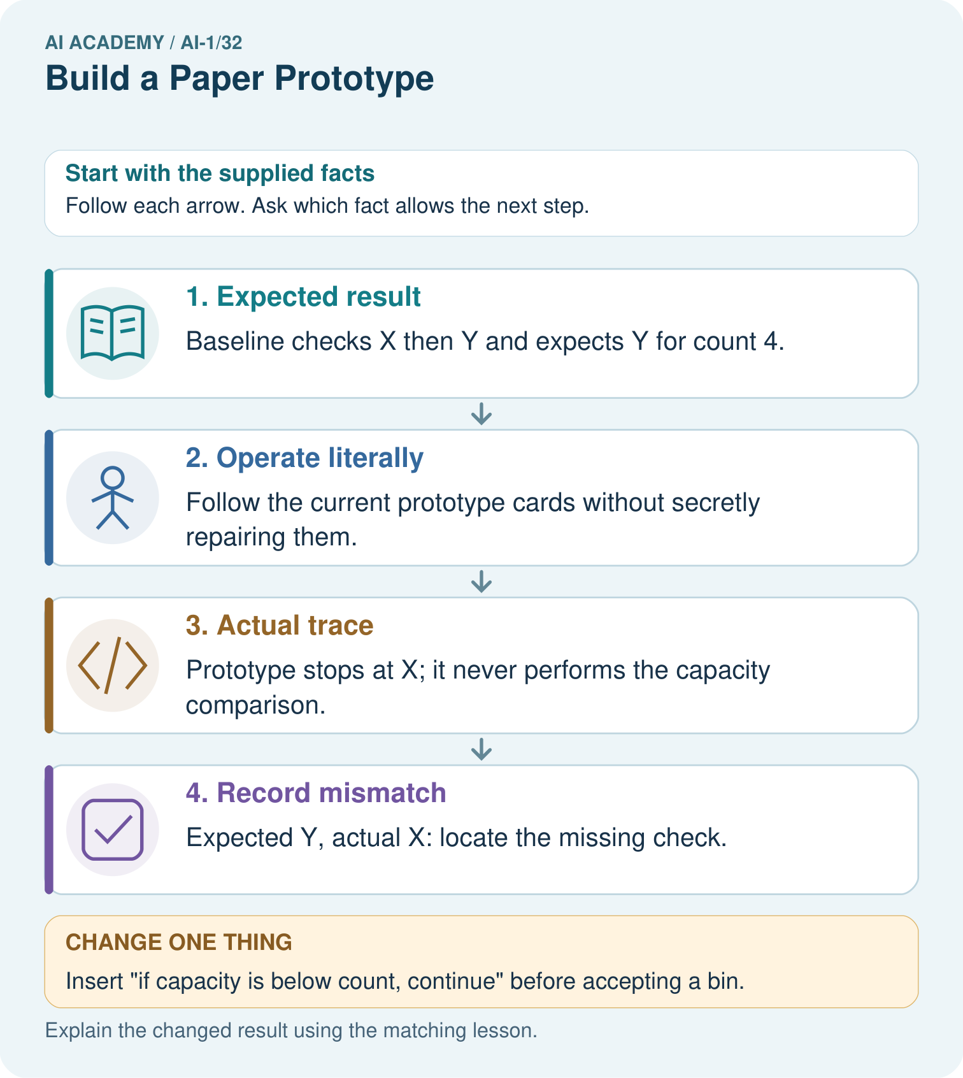
What should appear in the test log before and after the repair?

My picture-based explanation and changed-case prediction
________________________________________________________________
________________________________________________________________
________________________________________________________________
________________________________________________________________
________________________________________________________________
________________________________________________________________
Support used: alone / hint / worked example. This record is practice evidence.
Project connection: Save sorter instruction cards, dated versions and operator traces alongside the manual expected outputs.

19. Project portfolio milestone
Project: Helpful Classroom Sorter
Current milestone: Present and defend. Demonstrate the system, explain one failure and justify the next improvement with evidence.
Save sorter instruction cards, dated versions and operator traces alongside the manual expected outputs.
Evidence to keep | My record
This week’s input and deciding step
Prediction and actual result (or labelled paper trace)
One change since the previous checkpoint and why
One error or limit and the next test

Explain what this week adds to your project. Reuse last week’s record rather than starting again.
________________________________________________________________
________________________________________________________________
________________________________________________________________
________________________________________________________________
________________________________________________________________

