AI ACADEMY · WORKBOOK · ai-1/33

Test Normal Cases
Project: Helpful Classroom Sorter

01. Recall and choose your starting point
Try the recall before opening notes. Then use a different colour or a labelled second line to correct your explanation.

Build a Paper Prototype
Without opening the old lesson, explain one key idea from Build a Paper Prototype. Give an example and a mistake that the idea helps you avoid.

My remembered idea, example and correction
________________________________________________________________
________________________________________________________________
________________________________________________________________

Choose Inputs and Outputs
Without opening the old lesson, explain one key idea from Choose Inputs and Outputs. Give an example and a mistake that the idea helps you avoid.

My remembered idea, example and correction
________________________________________________________________
________________________________________________________________
________________________________________________________________

Verify Important Outputs
Without opening the old lesson, explain one key idea from Verify Important Outputs. Give an example and a mistake that the idea helps you avoid.

My remembered idea, example and correction
________________________________________________________________
________________________________________________________________
________________________________________________________________

02. Practise with fading help
Use W2: Run a fair comparison for Testing routine cases. Record the answer once; the lesson and workbook refer to the same attempt.
Given inputs | Procedure I chose | Middle steps | Result and check

The step I completed without help, and the hint I needed
________________________________________________________________
________________________________________________________________
________________________________________________________________

03. Individual reasoning check
Use the worked case for Testing routine cases. Proposed explanation: “A correct label is always a full pass”. Decide whether this explanation is supported. Point to the step or supplied fact that decides; explain your repair if needed.

My explanation before partner discussion
________________________________________________________________
________________________________________________________________
________________________________________________________________
________________________________________________________________

04. Independent transfer case

Independent case: Audit a new test record
Independently audit this fictional equipment selector. Catalogue E has E1 first with capacity 4 and E2 second with capacity 8. Valid group sizes are whole numbers 1 to 10. Select the first item with capacity at least the group size, or no match; invalid input needs clarification. The saved prototype reports E1 for group 3 with reason “4 holds 3”; E1 for group 6 with reason “4 holds 6”; no match for group 9 with reason “both too small”. Write all expected results, mark full passes, calculate the fraction and explain the failure. Give one untested input category. No booking occurs.

My independent explanation, trace and limits
________________________________________________________________
________________________________________________________________
________________________________________________________________
________________________________________________________________
________________________________________________________________
________________________________________________________________
________________________________________________________________
Attempt this case before feedback. Record any help. Earlier examples below are further practice; a case already practised with feedback cannot establish fresh transfer.

05. Your learning target
A sorter passes five routine cases and fails one. A team removes the failure as 'unusual' and reports 100%. Correct the report and propose a next test.

06. Solve the given case
Four routine cases are chosen before testing. Three are correct.
What can be reported?
Show your trace, calculation or evidence

Write or draw your reasoning and evidence.
________________________________________________________________
________________________________________________________________
________________________________________________________________
________________________________________________________________
________________________________________________________________

07. Check a changed case
Test a sorter on two clear pencil cards and two clear book cards. It gets one book wrong. Report the result and keep the failed case.
My independent answer and reason

Write or draw your reasoning and evidence.
________________________________________________________________
________________________________________________________________
________________________________________________________________
________________________________________________________________
________________________________________________________________

Week 33 Test and reflect

08. Design a revealing test
Create a changed input, boundary case or missing-information case. Write the expected answer or safe response before testing.
Test record | My evidence
Changed input or condition
Expected answer or fallback
Observed result
Why the result occurred

09. Project checkpoint
Create and run the sorter's normal-case test plan with unique IDs and version label.
The project change and evidence I will keep

Write or draw your reasoning and evidence.
________________________________________________________________
________________________________________________________________
________________________________________________________________
________________________________________________________________
________________________________________________________________

10. Self check
I can explain the mechanism. I can show evidence. I can handle a changed case. I can name a limit. Mark each as not yet, with help or independently, and attach supporting work.
Teacher review ____________________ Next step ____________________

11. Transfer practice from the original programme
A sorter passes five routine cases and fails one. A team removes the failure as 'unusual' and reports 100%. Correct the report and propose a next test.

My independently reasoned answer
________________________________________________________________
________________________________________________________________
________________________________________________________________
________________________________________________________________
________________________________________________________________
________________________________________________________________
________________________________________________________________
Record support used: none, hint or teacher explanation.

12. W1 Prepare the four cases
Create the test record for R1 11 Yes, R2 9 No, R3 6 No and R4 9 Yes. Before running anything, write each expected output, explanation and purpose using catalogue B version 1. Include blank places for observed output, observed reason, pass or fail and trace reference. State the version labels and pass criterion.

My reasoning and evidence
________________________________________________________________
________________________________________________________________
________________________________________________________________
________________________________________________________________
________________________________________________________________
________________________________________________________________

13. W2 Run a fair comparison
Operate your saved P1 cards and the manual baseline on all four R cases. Record actual results and traces on your sheet. Summarise full passes over all attempted cases for each method, name any failures and explain why a tie would not prove the prototype improves correctness. Do not invent an observed run.

My reasoning and evidence
________________________________________________________________
________________________________________________________________
________________________________________________________________
________________________________________________________________
________________________________________________________________
________________________________________________________________

14. W3 Keep the failed case in the total
Use the fictional Q version 0 record. Calculate its full-pass fraction and the baseline’s fraction. Explain why R4 fails and why dropping it to report 3 of 3 misrepresents the original four-case set. State what evidence you would inspect before changing Q.

My reasoning and evidence
________________________________________________________________
________________________________________________________________
________________________________________________________________
________________________________________________________________
________________________________________________________________
________________________________________________________________

15. W4 Audit a new test record
Independently audit this fictional equipment selector. Catalogue E has E1 first with capacity 4 and E2 second with capacity 8. Valid group sizes are whole numbers 1 to 10. Select the first item with capacity at least the group size, or no match; invalid input needs clarification. The saved prototype reports E1 for group 3 with reason “4 holds 3”; E1 for group 6 with reason “4 holds 6”; no match for group 9 with reason “both too small”. Write all expected results, mark full passes, calculate the fraction and explain the failure. Give one untested input category. No booking occurs.

My reasoning and evidence
________________________________________________________________
________________________________________________________________
________________________________________________________________
________________________________________________________________
________________________________________________________________
________________________________________________________________
________________________________________________________________
________________________________________________________________

16. W5 State what the evidence leaves open
Explain why catalogue B cannot produce B3 or B4 as its first fitting output even if you try many ordinary requests. Distinguish checking a row during a failed search from successfully selecting it. Write a limited conclusion for a P1 run that passed all four R cases and name a useful next test category.

My reasoning and evidence
________________________________________________________________
________________________________________________________________
________________________________________________________________
________________________________________________________________
________________________________________________________________
________________________________________________________________

17. Feedback, return check and learning record
Evidence | My record
Worked alone / hint / model
First step I repaired and why
New case checked later; date and result
What I can now explain without notes
One remaining question
Revisit this idea with your teacher after a delay. Familiarity is different from explaining and using it on a changed case.

18. Pictorial case practice: Test Normal Cases
A fictional pencil-pouch finder has been run on four ordinary requests.
Catalogue: P1 capacity 3, P2 capacity 7; first fitting pouch. Valid whole counts 1–9.
Requests 2,4,6,8; recorded outputs P1,P2,P1,none. These are invented records, not class results.
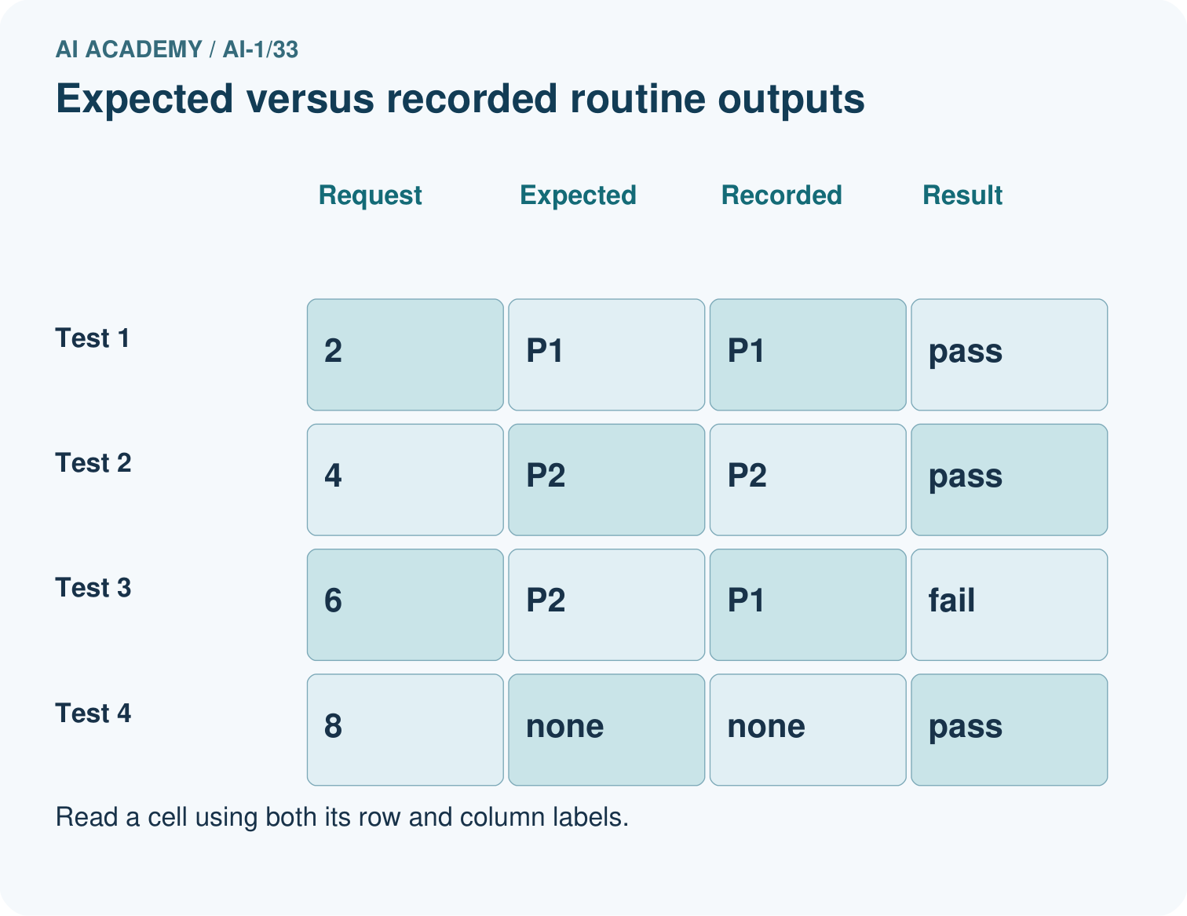
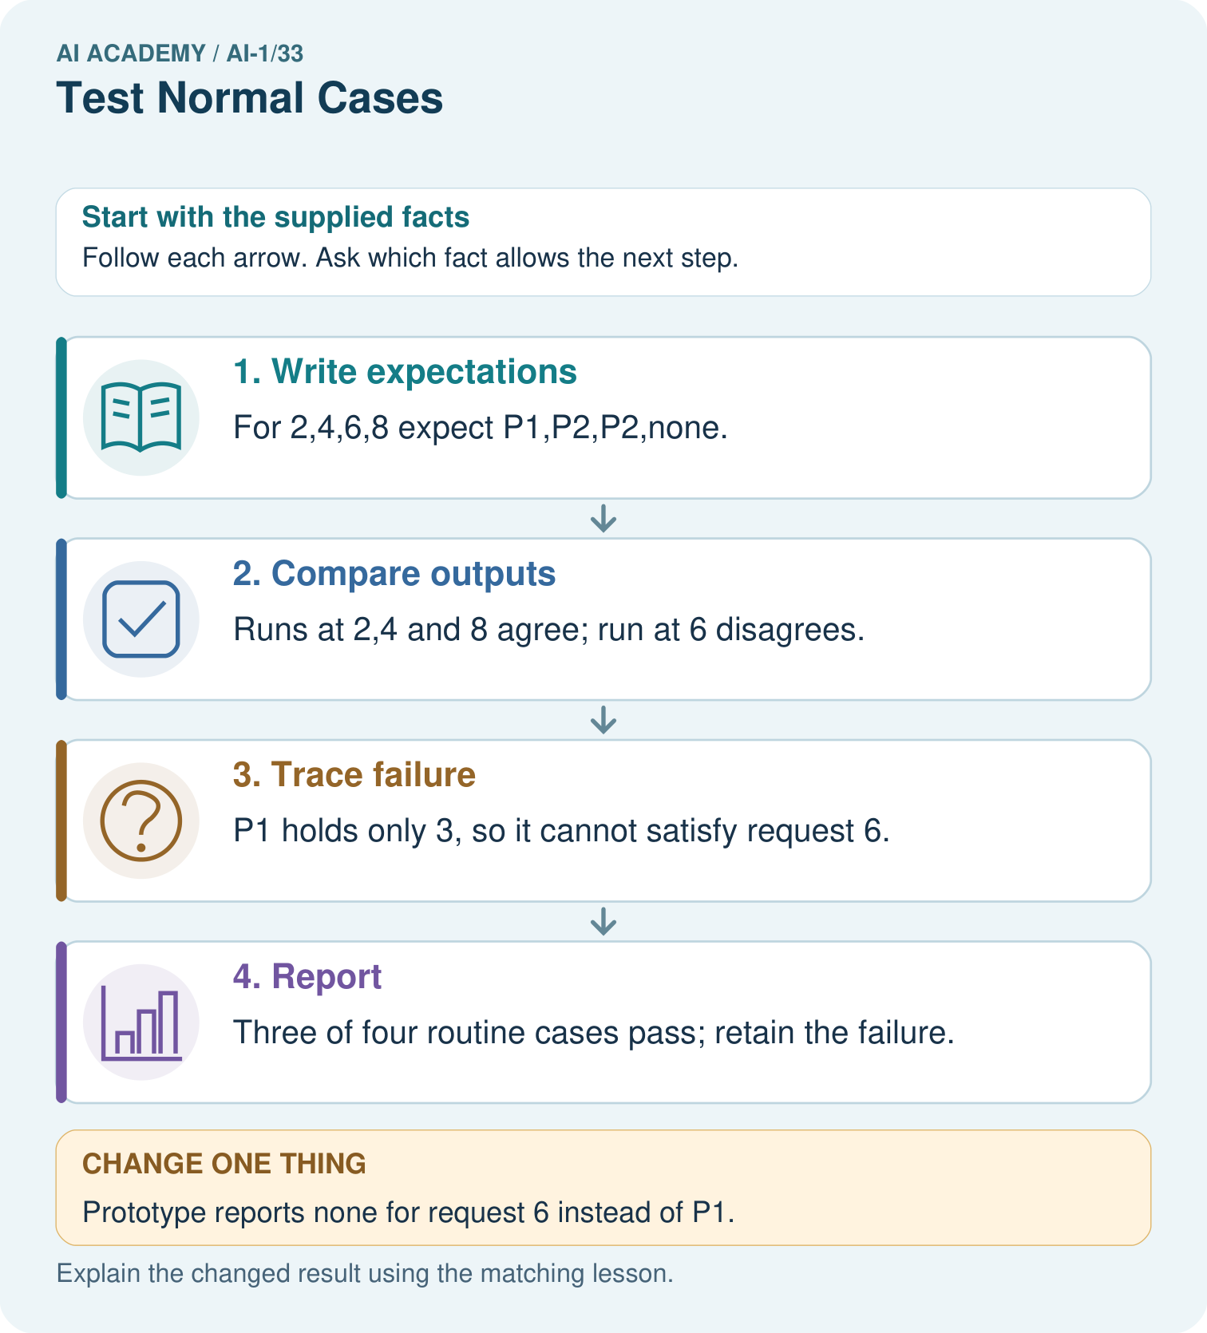
Why is none correct for 8 but incorrect for 6? Use both capacity cards.

My picture-based explanation and changed-case prediction
________________________________________________________________
________________________________________________________________
________________________________________________________________
________________________________________________________________
________________________________________________________________
________________________________________________________________
Support used: alone / hint / worked example. This record is practice evidence.
Project connection: Maintain sorter tests with input, independently derived expectation, actual output, version and full-pass judgment.

19. Project portfolio milestone
Project: Helpful Classroom Sorter
Current milestone: Present and defend. Demonstrate the system, explain one failure and justify the next improvement with evidence.
Maintain sorter tests with input, independently derived expectation, actual output, version and full-pass judgment.
Evidence to keep | My record
This week’s input and deciding step
Prediction and actual result (or labelled paper trace)
One change since the previous checkpoint and why
One error or limit and the next test

Explain what this week adds to your project. Reuse last week’s record rather than starting again.
________________________________________________________________
________________________________________________________________
________________________________________________________________
________________________________________________________________
________________________________________________________________

