AI ACADEMY · WORKBOOK · ai-1/36

Expo and Defense
Project: Helpful Classroom Sorter

01. Recall and choose your starting point
Try the recall before opening notes. Then use a different colour or a labelled second line to correct your explanation.

Improve One Cause
Without opening the old lesson, explain one key idea from Improve One Cause. Give an example and a mistake that the idea helps you avoid.

My remembered idea, example and correction
________________________________________________________________
________________________________________________________________
________________________________________________________________

Test Normal Cases
Without opening the old lesson, explain one key idea from Test Normal Cases. Give an example and a mistake that the idea helps you avoid.

My remembered idea, example and correction
________________________________________________________________
________________________________________________________________
________________________________________________________________

Choose Inputs and Outputs
Without opening the old lesson, explain one key idea from Choose Inputs and Outputs. Give an example and a mistake that the idea helps you avoid.

My remembered idea, example and correction
________________________________________________________________
________________________________________________________________
________________________________________________________________

02. Practise with fading help
Use W2: Keep the final evaluation record for Evaluating and explaining your project. Record the answer once; the lesson and workbook refer to the same attempt.
Given inputs | Procedure I chose | Middle steps | Result and check

The step I completed without help, and the hint I needed
________________________________________________________________
________________________________________________________________
________________________________________________________________

03. Individual reasoning check
Use the worked case for Evaluating and explaining your project. Proposed explanation: “A polished presentation proves the system works”. Decide whether this explanation is supported. Point to the step or supplied fact that decides; explain your repair if needed.

My explanation before partner discussion
________________________________________________________________
________________________________________________________________
________________________________________________________________
________________________________________________________________

04. Independent transfer case

Independent case: Judge a different project independently
A fictional library adviser and its manual baseline face the same 6 reserved cases. The candidate has 4 full passes; the baseline has 5. One additional planned case is unrun by both. No speed data was collected. The team says “ours is faster and more reliable everywhere” and repairs it after seeing the failures. Explain what the counts support, two unsupported claims and how to label a rerun of the revealed cases.

My independent explanation, trace and limits
________________________________________________________________
________________________________________________________________
________________________________________________________________
________________________________________________________________
________________________________________________________________
________________________________________________________________
________________________________________________________________
Attempt this case before feedback. Record any help. Earlier examples below are further practice; a case already practised with feedback cannot establish fresh transfer.

05. Your learning target
Defend a sorter with 10/12 routine successes and 2/4 mixed-material successes. Report overall and separate results, show one failure and propose a justified next step. What claim would overstate the evidence?

06. Solve the given case
The expo poster says always correct after six classroom passes.
Write a defensible claim.
Show your trace, calculation or evidence

Write or draw your reasoning and evidence.
________________________________________________________________
________________________________________________________________
________________________________________________________________
________________________________________________________________
________________________________________________________________

07. Check a changed case
At the expo, a team says our sorter never fails after testing four cards. Replace the claim with an evidence-based statement and name a next test.
My independent answer and reason

Write or draw your reasoning and evidence.
________________________________________________________________
________________________________________________________________
________________________________________________________________
________________________________________________________________
________________________________________________________________

Week 36 Test and reflect

08. Design a revealing test
Create a changed input, boundary case or missing-information case. Write the expected answer or safe response before testing.
Test record | My evidence
Changed input or condition
Expected answer or fallback
Observed result
Why the result occurred

09. Project checkpoint
Present the final Classroom Sorter portfolio and complete the AI-1 certification defense.
The project change and evidence I will keep

Write or draw your reasoning and evidence.
________________________________________________________________
________________________________________________________________
________________________________________________________________
________________________________________________________________
________________________________________________________________

10. Self check
I can explain the mechanism. I can show evidence. I can handle a changed case. I can name a limit. Mark each as not yet, with help or independently, and attach supporting work.
Teacher review ____________________ Next step ____________________

11. Transfer practice from the original programme
Defend a sorter with 10/12 routine successes and 2/4 mixed-material successes. Report overall and separate results, show one failure and propose a justified next step. What claim would overstate the evidence?

My independently reasoned answer
________________________________________________________________
________________________________________________________________
________________________________________________________________
________________________________________________________________
________________________________________________________________
________________________________________________________________
________________________________________________________________
Record support used: none, hint or teacher explanation.

12. W1 Record the fixed candidate
Before final cases are revealed, record your version label, where its complete instructions are saved, the agreed input and matching rules, the manual baseline and any known limitation. Confirm that the instructions stay unchanged while the assigned catalogue is used as input.

My reasoning and evidence
________________________________________________________________
________________________________________________________________
________________________________________________________________
________________________________________________________________
________________________________________________________________
________________________________________________________________

13. W2 Keep the final evaluation record
Use a separate sheet for the teacher’s reserved cases. For every case record its ID and inputs, catalogue and candidate labels, both methods’ observed outputs and reasons, and results after checking. Preserve failure traces. Here summarise each method’s full passes over attempted cases and list unrun cases. State what the comparison supports.

My reasoning and evidence
________________________________________________________________
________________________________________________________________
________________________________________________________________
________________________________________________________________
________________________________________________________________
________________________________________________________________

14. W3 Prepare your evidence defence
Write a two-minute explanation of the problem, one trace, your actual comparison, a limitation and a next action. Explain why this is a written-rule design rather than a model trained on examples. State which personal information is unnecessary and who decides whether to act.

My reasoning and evidence
________________________________________________________________
________________________________________________________________
________________________________________________________________
________________________________________________________________
________________________________________________________________
________________________________________________________________
________________________________________________________________

15. W4 Judge a different project independently
A fictional library adviser and its manual baseline face the same 6 reserved cases. The candidate has 4 full passes; the baseline has 5. One additional planned case is unrun by both. No speed data was collected. The team says “ours is faster and more reliable everywhere” and repairs it after seeing the failures. Explain what the counts support, two unsupported claims and how to label a rerun of the revealed cases.

My reasoning and evidence
________________________________________________________________
________________________________________________________________
________________________________________________________________
________________________________________________________________
________________________________________________________________
________________________________________________________________
________________________________________________________________

16. W5 Write your final conclusion
Use your own records to complete: Under these conditions, our saved version showed… The baseline showed… We still do not know… Our next action is… Include one privacy or human-control choice. If a case failed, explain its consequence without deleting the result.

My reasoning and evidence
________________________________________________________________
________________________________________________________________
________________________________________________________________
________________________________________________________________
________________________________________________________________
________________________________________________________________

17. Feedback, return check and learning record
Evidence | My record
Worked alone / hint / model
First step I repaired and why
New case checked later; date and result
What I can now explain without notes
One remaining question
Revisit this idea with your teacher after a delay. Familiarity is different from explaining and using it on a changed case.

18. Pictorial case practice: Expo and Defense
A fictional paper sorter team prepares an exhibition evidence board.
Both prototype and manual baseline attempt the same 10 reserved cases. Prototype passes 8; baseline passes 9.
Two additional planned cases are unrun. No timing or pupil-satisfaction measures were collected.
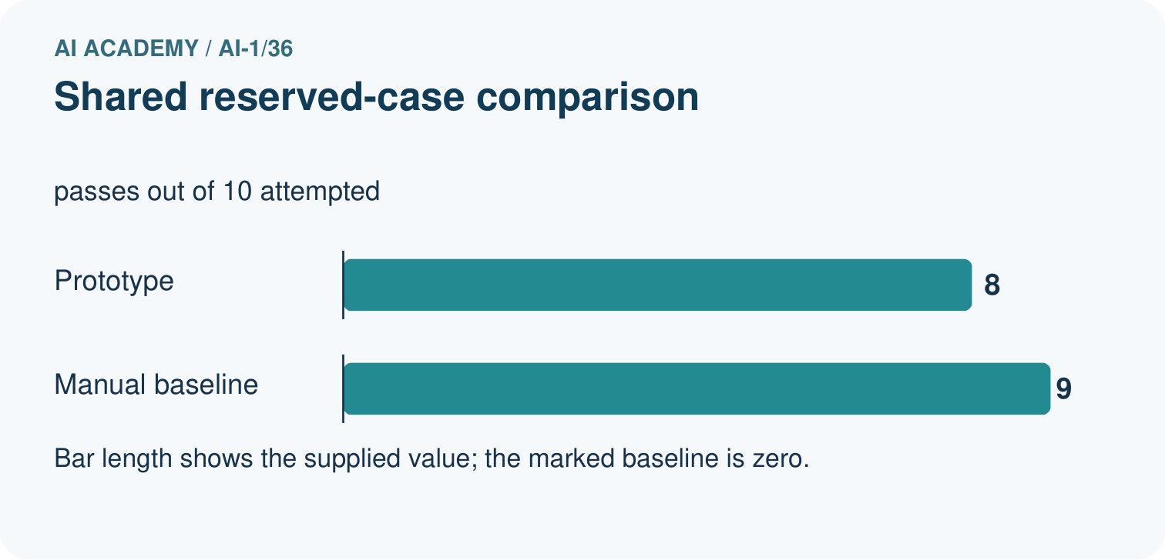
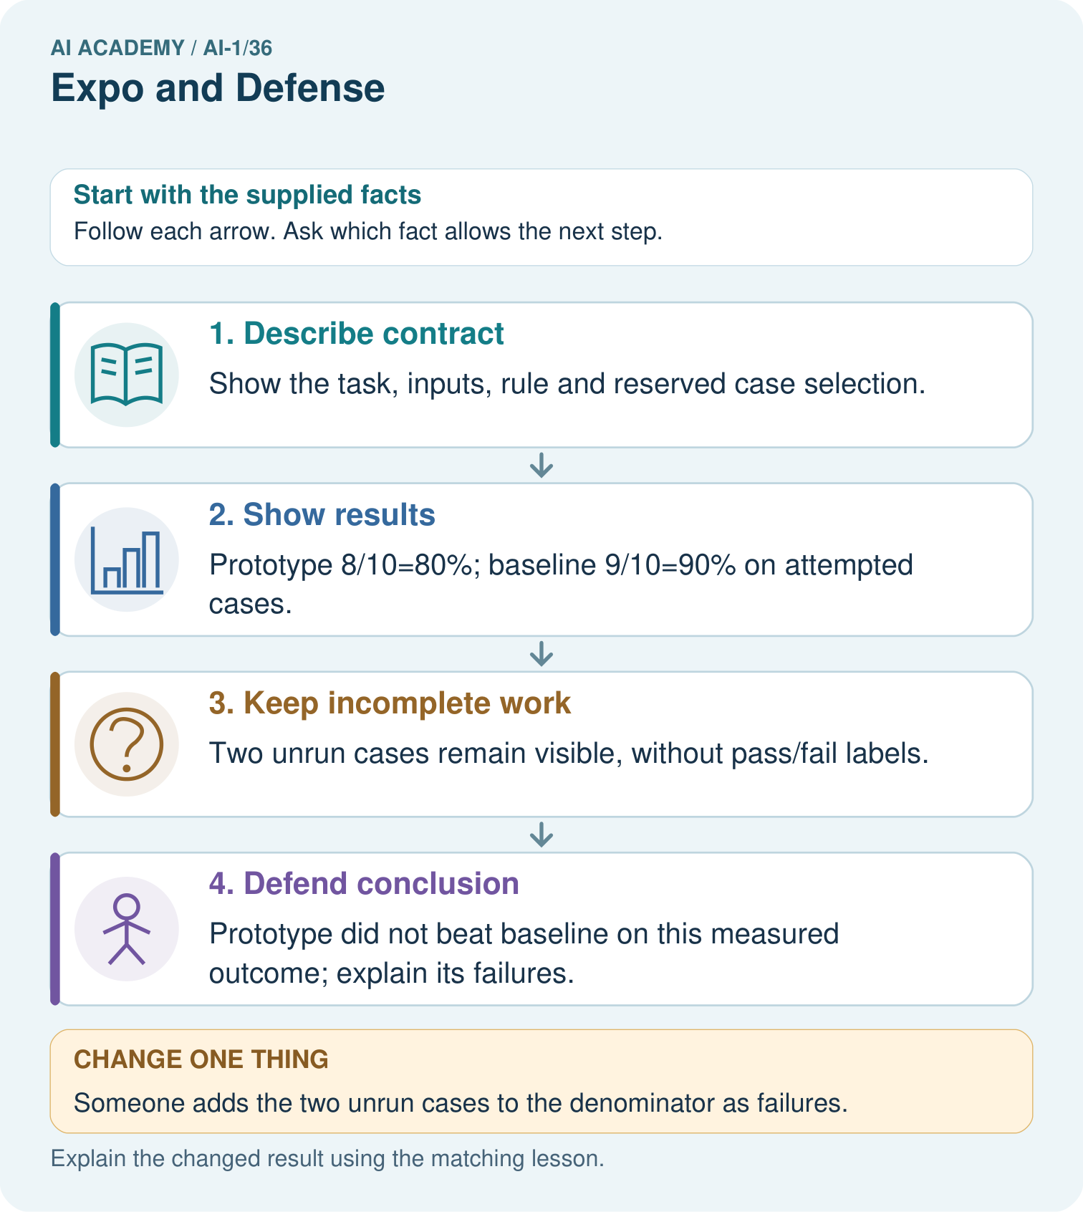
Write one defensible success statement and one claim the evidence cannot support.

My picture-based explanation and changed-case prediction
________________________________________________________________
________________________________________________________________
________________________________________________________________
________________________________________________________________
________________________________________________________________
________________________________________________________________
Support used: alone / hint / worked example. This record is practice evidence.
Project connection: Present the Helpful Classroom Sorter’s versions, test records, baseline, failures and next investigation as an evidence portfolio.

19. Project portfolio milestone
Project: Helpful Classroom Sorter
Current milestone: Present and defend. Demonstrate the system, explain one failure and justify the next improvement with evidence.
Present the Helpful Classroom Sorter’s versions, test records, baseline, failures and next investigation as an evidence portfolio.
Evidence to keep | My record
This week’s input and deciding step
Prediction and actual result (or labelled paper trace)
One change since the previous checkpoint and why
One error or limit and the next test

Explain what this week adds to your project. Reuse last week’s record rather than starting again.
________________________________________________________________
________________________________________________________________
________________________________________________________________
________________________________________________________________
________________________________________________________________

