AI ACADEMY · WORKBOOK · ai-2/6

Debugging Strategies
Project: Transparent Book Recommender

01. Recall and choose your starting point
Try the recall before opening notes. Then use a different colour or a labelled second line to correct your explanation.

Loops and Stopping
Without opening the old lesson, explain one key idea from Loops and Stopping. Give an example and a mistake that the idea helps you avoid.

My remembered idea, example and correction
________________________________________________________________
________________________________________________________________
________________________________________________________________

Branching Logic
Without opening the old lesson, explain one key idea from Branching Logic. Give an example and a mistake that the idea helps you avoid.

My remembered idea, example and correction
________________________________________________________________
________________________________________________________________
________________________________________________________________

02. Practise with fading help
Use W2: Find a revealing case for Testing and debugging functions. Record the answer once; the lesson and workbook refer to the same attempt.
Given inputs | Procedure I chose | Middle steps | Result and check

The step I completed without help, and the hint I needed
________________________________________________________________
________________________________________________________________
________________________________________________________________

03. Individual reasoning check
Use the worked case for Testing and debugging functions. Proposed explanation: “A successful run proves the conclusion”. Decide whether this explanation is supported. Point to the step or supplied fact that decides; explain your repair if needed.

My explanation before partner discussion
________________________________________________________________
________________________________________________________________
________________________________________________________________
________________________________________________________________

04. Independent transfer case

Independent case: Test a new function independently
Define stock(packs, loose) to return packs * 4 + loose. Create expected tests for (2, 3), (0, 3), (2, 0), then show which detects a faulty packs + loose body.

My independent explanation, trace and limits
________________________________________________________________
________________________________________________________________
________________________________________________________________
________________________________________________________________
________________________________________________________________
________________________________________________________________
________________________________________________________________
Attempt this case before feedback. Record any help. Earlier examples below are further practice; a case already practised with feedback cannot establish fresh transfer.

05. Your learning target
Intended score is 3 per matching trait. Bug: score starts at 3 and adds 3 for each match. Give expected and actual results for 0,1,2 matches and repair the cause.

06. Solve the given case
Award two points per matching trait. A bug awards two for every trait.
Test one match and one nonmatch.
Show your trace, calculation or evidence

Write or draw your reasoning and evidence.
________________________________________________________________
________________________________________________________________
________________________________________________________________
________________________________________________________________
________________________________________________________________

07. Check a changed case
A loop should run four times but runs five. You change its colour and stopping condition at once. Which single change is relevant to test first?
My independent answer and reason

Write or draw your reasoning and evidence.
________________________________________________________________
________________________________________________________________
________________________________________________________________
________________________________________________________________
________________________________________________________________

Week 6 Test and reflect

08. Design a revealing test
Create a changed input, boundary case or missing-information case. Write the expected answer or safe response before testing.
Test record | My evidence
Changed input or condition
Expected answer or fallback
Observed result
Why the result occurred

09. Project checkpoint
When a ranking surprises you, inspect feature values, weights, arithmetic, and sorting separately.
The project change and evidence I will keep

Write or draw your reasoning and evidence.
________________________________________________________________
________________________________________________________________
________________________________________________________________
________________________________________________________________
________________________________________________________________

10. Self check
I can explain the mechanism. I can show evidence. I can handle a changed case. I can name a limit. Mark each as not yet, with help or independently, and attach supporting work.
Teacher review ____________________ Next step ____________________

11. Transfer practice from the original programme
Intended score is 3 per matching trait. Bug: score starts at 3 and adds 3 for each match. Give expected and actual results for 0,1,2 matches and repair the cause.

My independently reasoned answer
________________________________________________________________
________________________________________________________________
________________________________________________________________
________________________________________________________________
________________________________________________________________
________________________________________________________________
________________________________________________________________
Record support used: none, hint or teacher explanation.

12. W1 Write expectations
Give expected results for remaining(6, 2), remaining(6, 6) and remaining(6, 0).

My reasoning and evidence
________________________________________________________________
________________________________________________________________
________________________________________________________________
________________________________________________________________
________________________________________________________________
________________________________________________________________

13. W2 Find a revealing case
A faulty function always returns 4. Which of your three cases pass and fail?

My reasoning and evidence
________________________________________________________________
________________________________________________________________
________________________________________________________________
________________________________________________________________
________________________________________________________________
________________________________________________________________

14. W3 Repair and retest
A faulty function adds capacity and used. For (6, 2), state actual and expected. Repair it and name a regression case.

My reasoning and evidence
________________________________________________________________
________________________________________________________________
________________________________________________________________
________________________________________________________________
________________________________________________________________
________________________________________________________________

15. W4 Test a new function independently
Define stock(packs, loose) to return packs * 4 + loose. Create expected tests for (2, 3), (0, 3), (2, 0), then show which detects a faulty packs + loose body.

My reasoning and evidence
________________________________________________________________
________________________________________________________________
________________________________________________________________
________________________________________________________________
________________________________________________________________
________________________________________________________________
________________________________________________________________
________________________________________________________________

16. W5 Limit the conclusion
All three stock tests pass. Does that prove correct handling of negative counts?

My reasoning and evidence
________________________________________________________________
________________________________________________________________
________________________________________________________________
________________________________________________________________
________________________________________________________________
________________________________________________________________

17. Feedback, return check and learning record
Evidence | My record
Worked alone / hint / model
First step I repaired and why
New case checked later; date and result
What I can now explain without notes
One remaining question
Revisit this idea with your teacher after a delay. Familiarity is different from explaining and using it on a changed case.

18. Pictorial case practice: Debugging Strategies
A fictional shelf function should count books in complete bundles plus loose books.
Correct definition: shelf(bundle_count,loose) returns bundle_count*6+loose.
Faulty copied body returns (bundle_count+loose)*6. Predict tests before running.
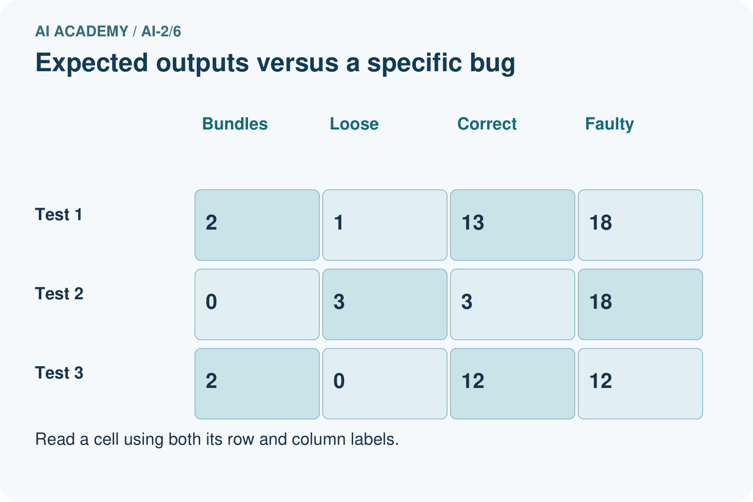
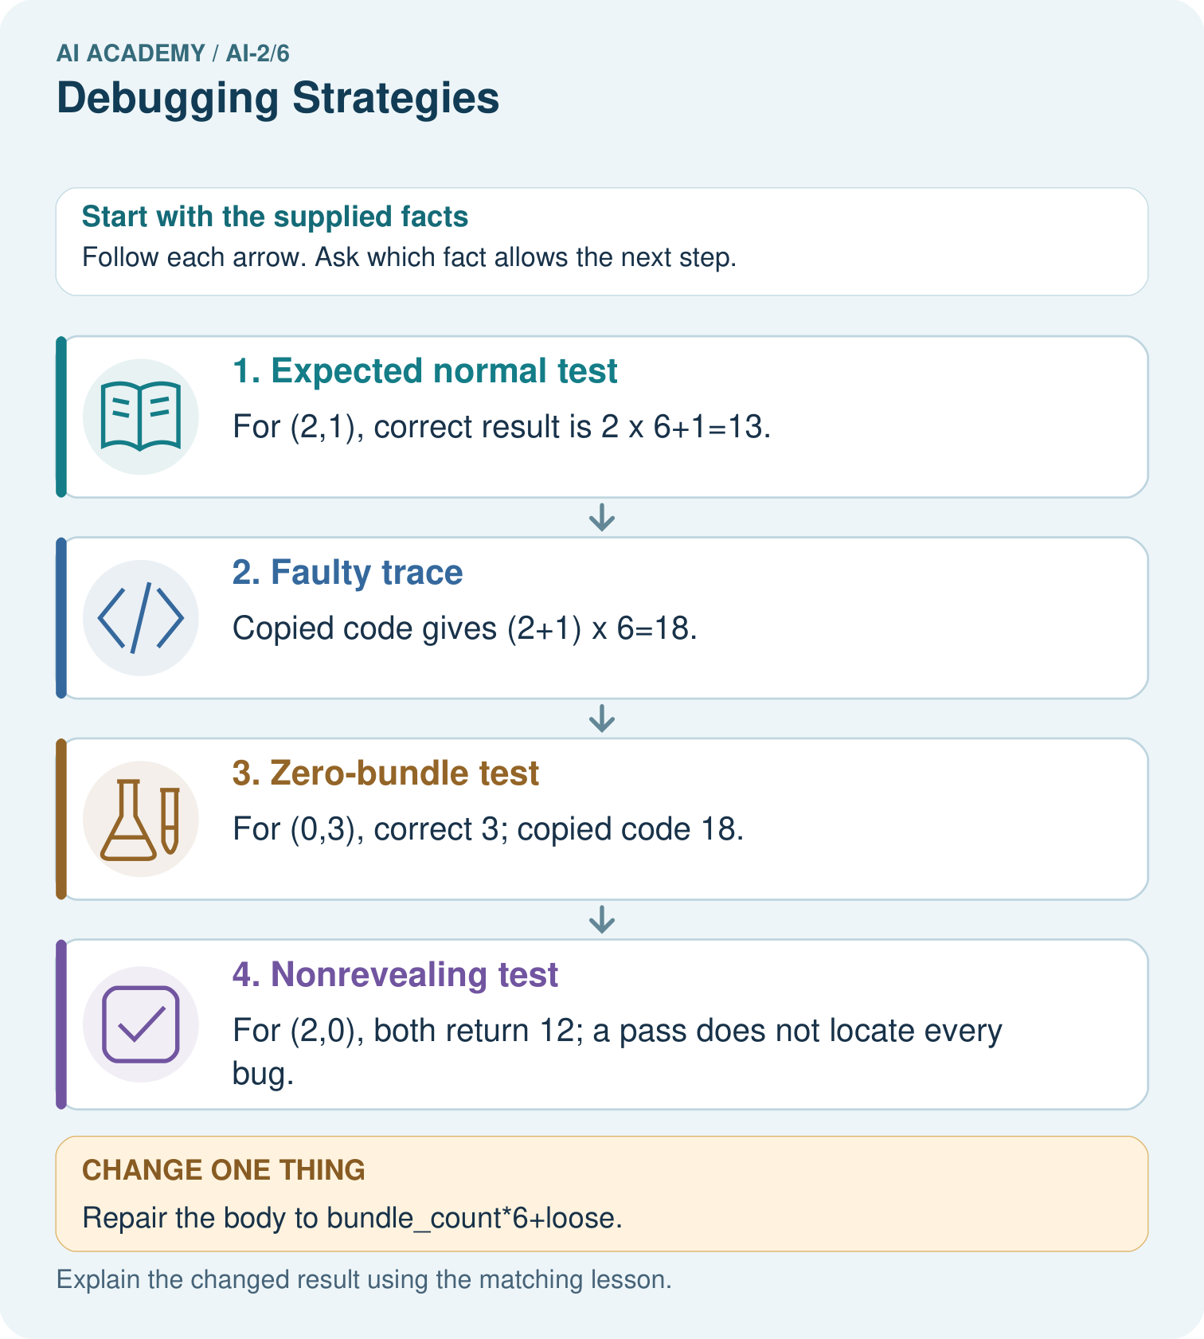
Which test most directly isolates the handling of loose books, and what should it produce?

My picture-based explanation and changed-case prediction
________________________________________________________________
________________________________________________________________
________________________________________________________________
________________________________________________________________
________________________________________________________________
________________________________________________________________
Support used: alone / hint / worked example. This record is practice evidence.
Project connection: Test the recommender’s helper functions with normal, zero and boundary inputs before debugging the whole application.

19. Project portfolio milestone
Project: Transparent Book Recommender
Current milestone: Frame the need. Name the user, the problem, allowed inputs and a safe simple starting method.
Test the recommender’s helper functions with normal, zero and boundary inputs before debugging the whole application.
Evidence to keep | My record
This week’s input and deciding step
Prediction and actual result (or labelled paper trace)
One change since the previous checkpoint and why
One error or limit and the next test

Explain what this week adds to your project. Reuse last week’s record rather than starting again.
________________________________________________________________
________________________________________________________________
________________________________________________________________
________________________________________________________________
________________________________________________________________

