AI ACADEMY · WORKBOOK · ai-2/13

Types of Classification Error
Project: Transparent Book Recommender

01. Recall and choose your starting point
Try the recall before opening notes. Then use a different colour or a labelled second line to correct your explanation.

Accuracy as a Fraction
Without opening the old lesson, explain one key idea from Accuracy as a Fraction. Give an example and a mistake that the idea helps you avoid.

My remembered idea, example and correction
________________________________________________________________
________________________________________________________________
________________________________________________________________

Human Classifier Simulation
Without opening the old lesson, explain one key idea from Human Classifier Simulation. Give an example and a mistake that the idea helps you avoid.

My remembered idea, example and correction
________________________________________________________________
________________________________________________________________
________________________________________________________________

Rows Columns and Data Types
Without opening the old lesson, explain one key idea from Rows Columns and Data Types. Give an example and a mistake that the idea helps you avoid.

My remembered idea, example and correction
________________________________________________________________
________________________________________________________________
________________________________________________________________

02. Practise with fading help
Use W2: Explain the two error types for Confusion matrices. Record the answer once; the lesson and workbook refer to the same attempt.
Given inputs | Procedure I chose | Middle steps | Result and check

The step I completed without help, and the hint I needed
________________________________________________________________
________________________________________________________________
________________________________________________________________

03. Individual reasoning check
Use the worked case for Confusion matrices. Proposed explanation: “Positive means good”. Decide whether this explanation is supported. Point to the step or supplied fact that decides; explain your repair if needed.

My explanation before partner discussion
________________________________________________________________
________________________________________________________________
________________________________________________________________
________________________________________________________________

04. Independent transfer case

Independent case: Count a fresh evaluation independently
Each pair below is reference then prediction: R1 clear/clear, R2 clear/blocked, R3 clear/blocked, R4 blocked/blocked, R5 blocked/clear, R6 blocked/blocked. Use clear then blocked on both axes and reference rows. Build the matrix, give row and column totals, name TP,TN,FP,FN with blocked positive, and calculate accuracy.

My independent explanation, trace and limits
________________________________________________________________
________________________________________________________________
________________________________________________________________
________________________________________________________________
________________________________________________________________
________________________________________________________________
________________________________________________________________
Attempt this case before feedback. Record any help. Earlier examples below are further practice; a case already practised with feedback cannot establish fresh transfer.

05. Your learning target
Positive means 'should recommend'. A book that should be recommended is rejected; a book that should not be recommended is accepted. Name both errors and explain who experiences each consequence.

06. Solve the given case
Positive means should recommend. Actual/predicted pairs are yes/yes, no/yes, yes/no, no/no.
Name the four outcomes.
Show your trace, calculation or evidence

Write or draw your reasoning and evidence.
________________________________________________________________
________________________________________________________________
________________________________________________________________
________________________________________________________________
________________________________________________________________

07. Check a changed case
Positive means sports. A sports book predicted other and a non-sports book predicted sports occur. Name each error and its consequence for the sports shelf.
My independent answer and reason

Write or draw your reasoning and evidence.
________________________________________________________________
________________________________________________________________
________________________________________________________________
________________________________________________________________
________________________________________________________________

Week 13 Test and reflect

08. Design a revealing test
Create a changed input, boundary case or missing-information case. Write the expected answer or safe response before testing.
Test record | My evidence
Changed input or condition
Expected answer or fallback
Observed result
Why the result occurred

09. Project checkpoint
Separate recommending an unsuitable book from failing to surface a suitable one.
The project change and evidence I will keep

Write or draw your reasoning and evidence.
________________________________________________________________
________________________________________________________________
________________________________________________________________
________________________________________________________________
________________________________________________________________

10. Self check
I can explain the mechanism. I can show evidence. I can handle a changed case. I can name a limit. Mark each as not yet, with help or independently, and attach supporting work.
Teacher review ____________________ Next step ____________________

11. Transfer practice from the original programme
Positive means 'should recommend'. A book that should be recommended is rejected; a book that should not be recommended is accepted. Name both errors and explain who experiences each consequence.

My independently reasoned answer
________________________________________________________________
________________________________________________________________
________________________________________________________________
________________________________________________________________
________________________________________________________________
________________________________________________________________
________________________________________________________________
Record support used: none, hint or teacher explanation.

12. W1 Build the count matrix
Use all eight worked IDs. Draw a matrix with reference rows and prediction columns, both ordered clear then blocked. Place the IDs in cells before writing the counts.

My reasoning and evidence
________________________________________________________________
________________________________________________________________
________________________________________________________________
________________________________________________________________
________________________________________________________________
________________________________________________________________

13. W2 Explain the two error types
Declare blocked positive. Give TP,TN,FP,FN counts and explain V3 and V4 in plain language. Does positive mean a desirable outcome?

My reasoning and evidence
________________________________________________________________
________________________________________________________________
________________________________________________________________
________________________________________________________________
________________________________________________________________
________________________________________________________________

14. W3 Audit totals and equal accuracy
Give the worked row totals, column totals, total count and accuracy. Compare its errors with [[3,0],[3,2]] using the same axes and eight reference records.

My reasoning and evidence
________________________________________________________________
________________________________________________________________
________________________________________________________________
________________________________________________________________
________________________________________________________________
________________________________________________________________

15. W4 Count a fresh evaluation independently
Each pair below is reference then prediction: R1 clear/clear, R2 clear/blocked, R3 clear/blocked, R4 blocked/blocked, R5 blocked/clear, R6 blocked/blocked. Use clear then blocked on both axes and reference rows. Build the matrix, give row and column totals, name TP,TN,FP,FN with blocked positive, and calculate accuracy.

My reasoning and evidence
________________________________________________________________
________________________________________________________________
________________________________________________________________
________________________________________________________________
________________________________________________________________
________________________________________________________________
________________________________________________________________
________________________________________________________________

16. W5 Interpret a zero count carefully
A report gives zero false positives but omits the evaluated sample size, axes and class definitions. What information is missing, and why does zero not prove that future false alarms are impossible?

My reasoning and evidence
________________________________________________________________
________________________________________________________________
________________________________________________________________
________________________________________________________________
________________________________________________________________
________________________________________________________________

17. Feedback, return check and learning record
Evidence | My record
Worked alone / hint / model
First step I repaired and why
New case checked later; date and result
What I can now explain without notes
One remaining question
Revisit this idea with your teacher after a delay. Familiarity is different from explaining and using it on a changed case.

18. Pictorial case practice: Types of Classification Error
A fictional book-condition checker predicts repair or sound.
Use reference rows and prediction columns in order sound,repair. Repair is positive.
Six reference/prediction pairs: sound/sound twice; sound/repair once; repair/sound once; repair/repair twice.
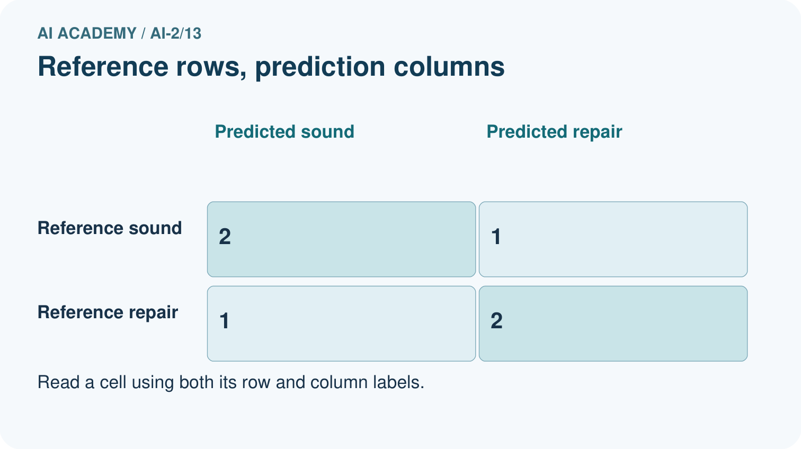
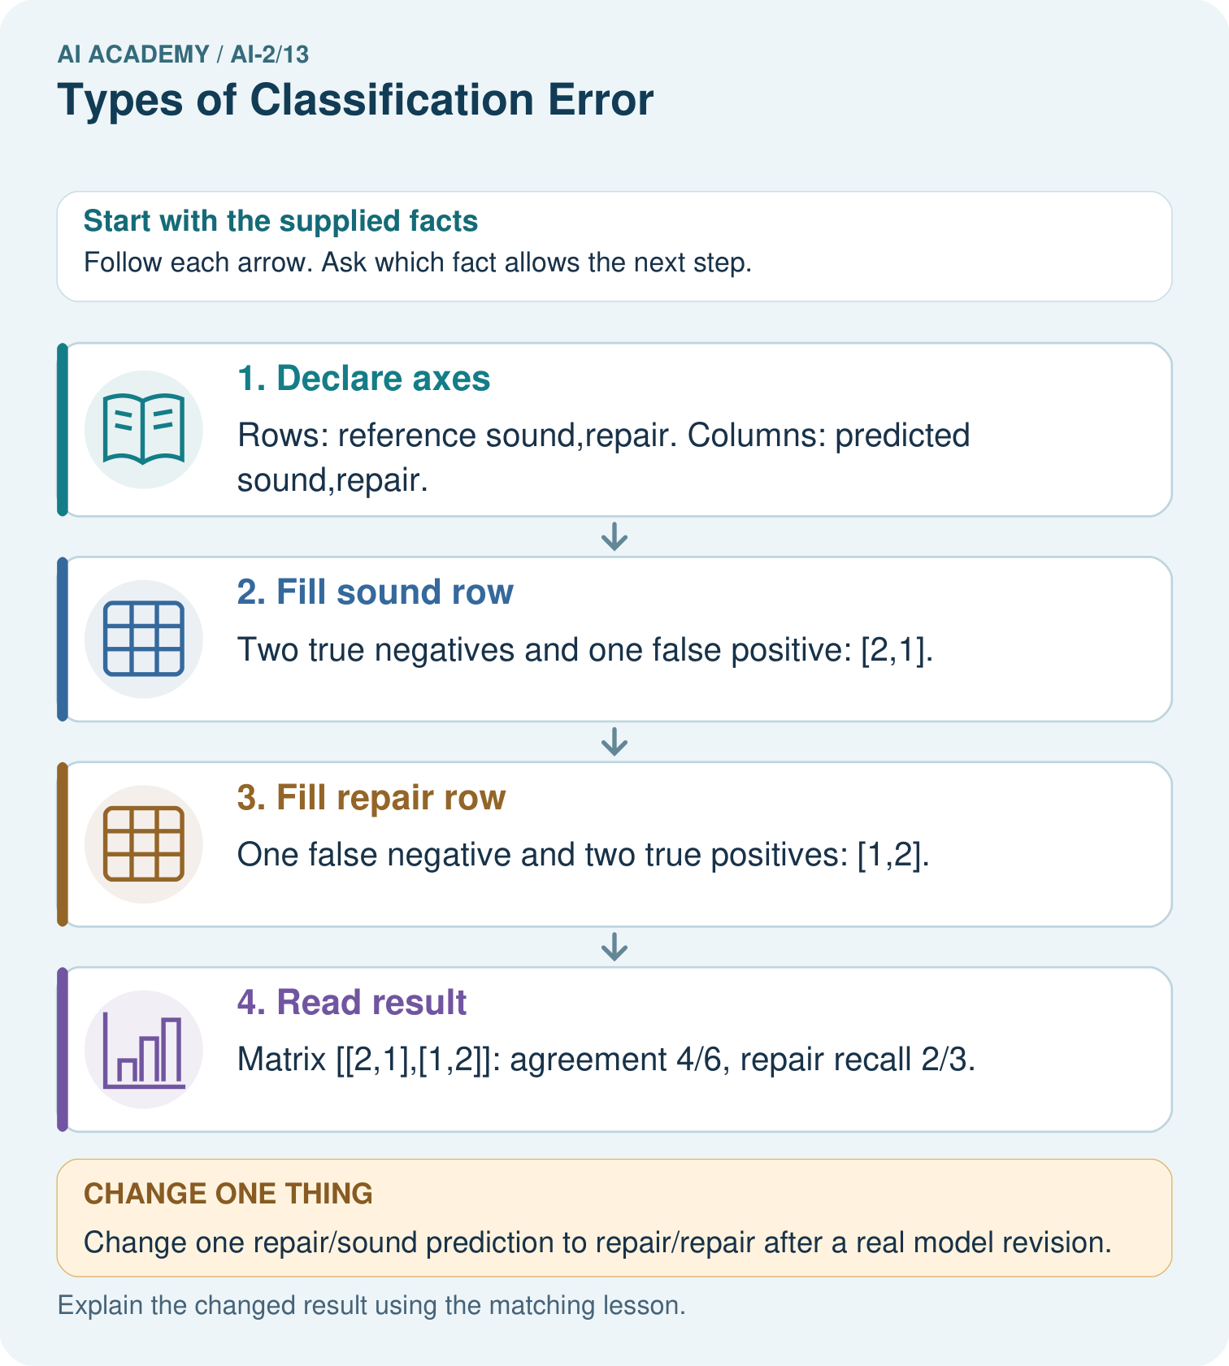
Which error causes a sound book to be sent for unnecessary repair review?

My picture-based explanation and changed-case prediction
________________________________________________________________
________________________________________________________________
________________________________________________________________
________________________________________________________________
________________________________________________________________
________________________________________________________________
Support used: alone / hint / worked example. This record is practice evidence.
Project connection: Use a confusion table when evaluating recommender category predictions and attach concrete consequences to each error.

19. Project portfolio milestone
Project: Transparent Book Recommender
Current milestone: Test changed cases. Keep normal, boundary and failure cases; compare expected and observed results.
Use a confusion table when evaluating recommender category predictions and attach concrete consequences to each error.
Evidence to keep | My record
This week’s input and deciding step
Prediction and actual result (or labelled paper trace)
One change since the previous checkpoint and why
One error or limit and the next test

Explain what this week adds to your project. Reuse last week’s record rather than starting again.
________________________________________________________________
________________________________________________________________
________________________________________________________________
________________________________________________________________
________________________________________________________________

