AI ACADEMY · WORKBOOK · ai-2/15

Choose Informative Questions
Project: Transparent Book Recommender

01. Recall and choose your starting point
Try the recall before opening notes. Then use a different colour or a labelled second line to correct your explanation.

Decision Trees
Without opening the old lesson, explain one key idea from Decision Trees. Give an example and a mistake that the idea helps you avoid.

My remembered idea, example and correction
________________________________________________________________
________________________________________________________________
________________________________________________________________

Accuracy as a Fraction
Without opening the old lesson, explain one key idea from Accuracy as a Fraction. Give an example and a mistake that the idea helps you avoid.

My remembered idea, example and correction
________________________________________________________________
________________________________________________________________
________________________________________________________________

Features and Distractors
Without opening the old lesson, explain one key idea from Features and Distractors. Give an example and a mistake that the idea helps you avoid.

My remembered idea, example and correction
________________________________________________________________
________________________________________________________________
________________________________________________________________

02. Practise with fading help
Use W2: Verify the candidate scores for Fitting a decision tree. Record the answer once; the lesson and workbook refer to the same attempt.
Given inputs | Procedure I chose | Middle steps | Result and check

The step I completed without help, and the hint I needed
________________________________________________________________
________________________________________________________________
________________________________________________________________

03. Individual reasoning check
Use the worked case for Fitting a decision tree. Proposed explanation: “A near branch must predict blocked”. Decide whether this explanation is supported. Point to the step or supplied fact that decides; explain your repair if needed.

My explanation before partner discussion
________________________________________________________________
________________________________________________________________
________________________________________________________________
________________________________________________________________

04. Independent transfer case

Independent case: Changed independent case
Ten cards have six pet subjects and four space subjects; all are green. Compare asking “green?” with asking “pet?” to identify a card. Give the largest remaining group and one limitation.

My independent explanation, trace and limits
________________________________________________________________
________________________________________________________________
________________________________________________________________
________________________________________________________________
________________________________________________________________
________________________________________________________________
________________________________________________________________
Attempt this case before feedback. Record any help. Earlier examples below are further practice; a case already practised with feedback cannot establish fresh transfer.

05. Your learning target
Six cards contain three animal and three space books; all have blue covers. Compare asking 'blue cover?' with 'animal subject?'. Is the better question guaranteed to work on inaccurately tagged books?

06. Solve the given case
Eight blue cards contain four circles and four triangles; target is shape.
Which question is more useful: blue or circle?
Show your trace, calculation or evidence

Write or draw your reasoning and evidence.
________________________________________________________________
________________________________________________________________
________________________________________________________________
________________________________________________________________
________________________________________________________________

07. Check a changed case
Cards are two cats and two dogs, all red. Which question helps separate species: is it red or does it bark? State your assumption.
My independent answer and reason

Write or draw your reasoning and evidence.
________________________________________________________________
________________________________________________________________
________________________________________________________________
________________________________________________________________
________________________________________________________________

Week 15 Test and reflect

08. Design a revealing test
Create a changed input, boundary case or missing-information case. Write the expected answer or safe response before testing.
Test record | My evidence
Changed input or condition
Expected answer or fallback
Observed result
Why the result occurred

09. Project checkpoint
Ask first about preferences that remove the largest number of unsuitable books.
The project change and evidence I will keep

Write or draw your reasoning and evidence.
________________________________________________________________
________________________________________________________________
________________________________________________________________
________________________________________________________________
________________________________________________________________

10. Self check
I can explain the mechanism. I can show evidence. I can handle a changed case. I can name a limit. Mark each as not yet, with help or independently, and attach supporting work.
Teacher review ____________________ Next step ____________________

11. Transfer practice from the original programme
Six cards contain three animal and three space books; all have blue covers. Compare asking 'blue cover?' with 'animal subject?'. Is the better question guaranteed to work on inaccurately tagged books?

My independently reasoned answer
________________________________________________________________
________________________________________________________________
________________________________________________________________
________________________________________________________________
________________________________________________________________
________________________________________________________________
________________________________________________________________
Record support used: none, hint or teacher explanation.

12. W1 Name the parts and decisions
Identify the root, its two branches, leaf predictions and depth of the worked fitted tree. Which parts were selected using training labels?

My reasoning and evidence
________________________________________________________________
________________________________________________________________
________________________________________________________________
________________________________________________________________
________________________________________________________________
________________________________________________________________

13. W2 Verify the candidate scores
For each near branch and each tall branch, count blocked and clear labels and choose a leaf. Give the total errors for each candidate question.

My reasoning and evidence
________________________________________________________________
________________________________________________________________
________________________________________________________________
________________________________________________________________
________________________________________________________________
________________________________________________________________

14. W3 Separate fitting from prediction
A learner sees a blocked validation case with near=0 and changes that leaf to blocked before reporting the score. Explain what changed and how to report the original fitted tree fairly.

My reasoning and evidence
________________________________________________________________
________________________________________________________________
________________________________________________________________
________________________________________________________________
________________________________________________________________
________________________________________________________________

15. W4 Fit a new tree independently
New training rows (near,tall,label) are (1,0,clear),(1,1,clear),(1,0,clear),(0,1,blocked),(0,0,blocked),(0,1,clear). Use the same candidate order and tie policies. Give both candidates’ leaves and errors, then select the tree. Validation rows are (1,1,clear),(0,0,blocked),(0,1,clear),(1,0,blocked). List tree predictions and compare accuracy with the training-majority baseline.

My reasoning and evidence
________________________________________________________________
________________________________________________________________
________________________________________________________________
________________________________________________________________
________________________________________________________________
________________________________________________________________
________________________________________________________________
________________________________________________________________

16. W5 Audit a tie and a claim
If near and tall make the same training error count, which question does this code retain and why? Does retaining that question prove it will be better on future trips?

My reasoning and evidence
________________________________________________________________
________________________________________________________________
________________________________________________________________
________________________________________________________________
________________________________________________________________
________________________________________________________________

17. Feedback, return check and learning record
Evidence | My record
Worked alone / hint / model
First step I repaired and why
New case checked later; date and result
What I can now explain without notes
One remaining question
Revisit this idea with your teacher after a delay. Familiarity is different from explaining and using it on a changed case.

18. Pictorial case practice: Choose Informative Questions
A fictional guessing game has eight catalogue cards and asks yes/no questions to narrow the target.
Cards: four mystery, four science; six paperback, two hardback; all English.
Compare worst-case remaining group size after asking mystery?, paperback? or English?. No claim about unequal target probabilities is made.
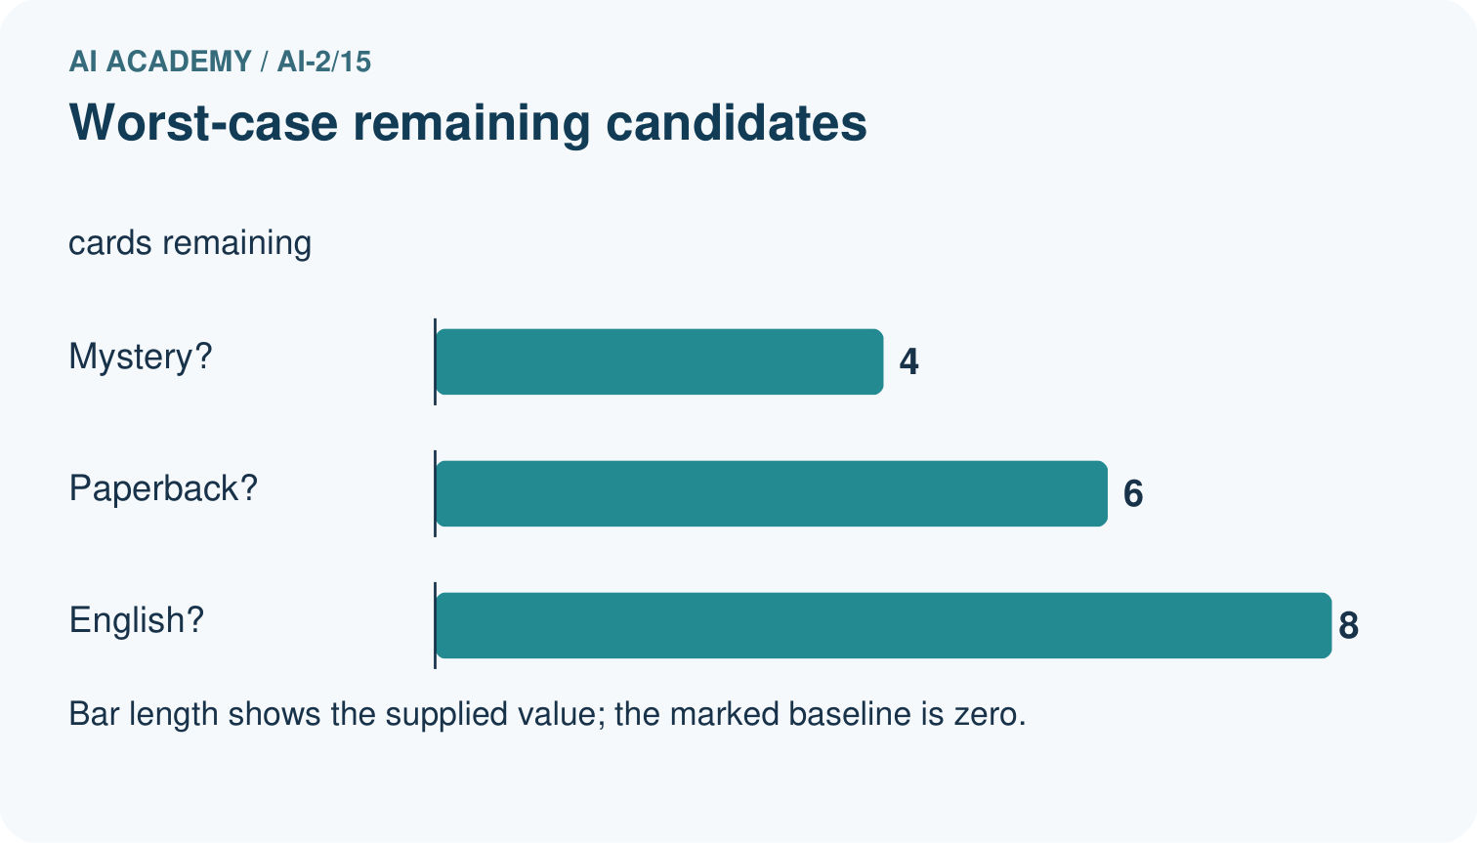
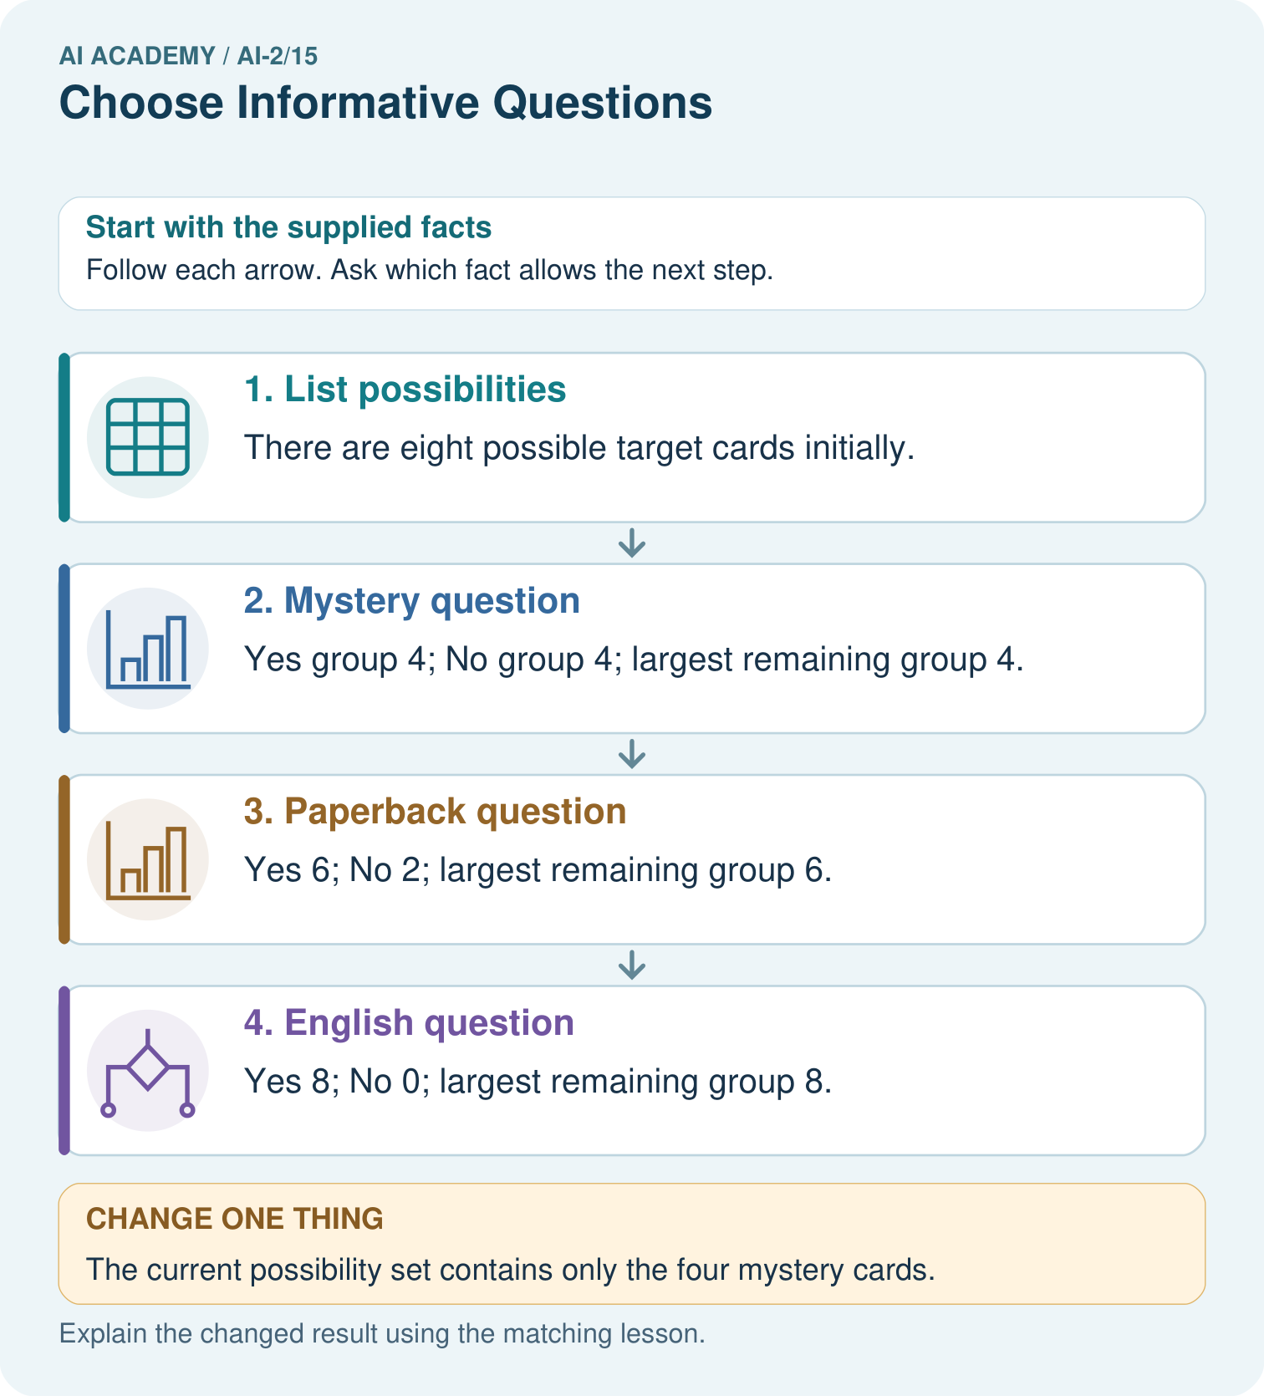
Choose the best original question and explain why its more balanced split matters here.

My picture-based explanation and changed-case prediction
________________________________________________________________
________________________________________________________________
________________________________________________________________
________________________________________________________________
________________________________________________________________
________________________________________________________________
Support used: alone / hint / worked example. This record is practice evidence.
Project connection: Choose recommender questions that distinguish feasible options, documenting the decision criterion rather than asking unnecessary personal details.

19. Project portfolio milestone
Project: Transparent Book Recommender
Current milestone: Test changed cases. Keep normal, boundary and failure cases; compare expected and observed results.
Choose recommender questions that distinguish feasible options, documenting the decision criterion rather than asking unnecessary personal details.
Evidence to keep | My record
This week’s input and deciding step
Prediction and actual result (or labelled paper trace)
One change since the previous checkpoint and why
One error or limit and the next test

Explain what this week adds to your project. Reuse last week’s record rather than starting again.
________________________________________________________________
________________________________________________________________
________________________________________________________________
________________________________________________________________
________________________________________________________________

