AI ACADEMY · WORKBOOK · ai-2/20

Repair Bias in Data
Project: Transparent Book Recommender

01. Recall and choose your starting point
Try the recall before opening notes. Then use a different colour or a labelled second line to correct your explanation.

Sampling and Representation
Without opening the old lesson, explain one key idea from Sampling and Representation. Give an example and a mistake that the idea helps you avoid.

My remembered idea, example and correction
________________________________________________________________
________________________________________________________________
________________________________________________________________

Noise and Outliers
Without opening the old lesson, explain one key idea from Noise and Outliers. Give an example and a mistake that the idea helps you avoid.

My remembered idea, example and correction
________________________________________________________________
________________________________________________________________
________________________________________________________________

Decision Trees
Without opening the old lesson, explain one key idea from Decision Trees. Give an example and a mistake that the idea helps you avoid.

My remembered idea, example and correction
________________________________________________________________
________________________________________________________________
________________________________________________________________

02. Practise with fading help
Use W2: Combine counts for Selection bias and coverage. Record the answer once; the lesson and workbook refer to the same attempt.
Given inputs | Procedure I chose | Middle steps | Result and check

The step I completed without help, and the hint I needed
________________________________________________________________
________________________________________________________________
________________________________________________________________

03. Individual reasoning check
Use the worked case for Selection bias and coverage. Proposed explanation: “A successful run proves the conclusion”. Decide whether this explanation is supported. Point to the step or supplied fact that decides; explain your repair if needed.

My explanation before partner discussion
________________________________________________________________
________________________________________________________________
________________________________________________________________
________________________________________________________________

04. Independent transfer case

Independent case: Audit independently
A survey has 18 Yes of 20 club members and 2 Yes of 10 others. Compute both group rates and combined rate. Explain why 20/30 does not automatically describe the whole grade.

My independent explanation, trace and limits
________________________________________________________________
________________________________________________________________
________________________________________________________________
________________________________________________________________
________________________________________________________________
________________________________________________________________
________________________________________________________________
Attempt this case before feedback. Record any help. Earlier examples below are further practice; a case already practised with feedback cannot establish fresh transfer.

05. Your learning target
A catalogue has 30 adventure titles and 2 poetry titles. A recommender rarely suggests poetry. Design a repair and an evaluation that distinguishes catalogue coverage from scoring preference.

06. Solve the given case
Training has eighteen adventure readers and two poetry readers; many intended users prefer poetry.
Propose repair and evaluation.
Show your trace, calculation or evidence

Write or draw your reasoning and evidence.
________________________________________________________________
________________________________________________________________
________________________________________________________________
________________________________________________________________
________________________________________________________________

07. Check a changed case
A dataset has 18 adventure readers and 2 poetry readers. A recommender ignores poetry preferences. What would you inspect and test after a repair?
My independent answer and reason

Write or draw your reasoning and evidence.
________________________________________________________________
________________________________________________________________
________________________________________________________________
________________________________________________________________
________________________________________________________________

Week 20 Test and reflect

08. Design a revealing test
Create a changed input, boundary case or missing-information case. Write the expected answer or safe response before testing.
Test record | My evidence
Changed input or condition
Expected answer or fallback
Observed result
Why the result occurred

09. Project checkpoint
Change feature coverage or weights only after locating which reader profiles are underserved.
The project change and evidence I will keep

Write or draw your reasoning and evidence.
________________________________________________________________
________________________________________________________________
________________________________________________________________
________________________________________________________________
________________________________________________________________

10. Self check
I can explain the mechanism. I can show evidence. I can handle a changed case. I can name a limit. Mark each as not yet, with help or independently, and attach supporting work.
Teacher review ____________________ Next step ____________________

11. Transfer practice from the original programme
A catalogue has 30 adventure titles and 2 poetry titles. A recommender rarely suggests poetry. Design a repair and an evaluation that distinguishes catalogue coverage from scoring preference.

My independently reasoned answer
________________________________________________________________
________________________________________________________________
________________________________________________________________
________________________________________________________________
________________________________________________________________
________________________________________________________________
________________________________________________________________
Record support used: none, hint or teacher explanation.

12. W1 Locate undercoverage
A morning-only survey claims to represent all library visitors. Which visitors may be missed?

My reasoning and evidence
________________________________________________________________
________________________________________________________________
________________________________________________________________
________________________________________________________________
________________________________________________________________
________________________________________________________________

13. W2 Combine counts
Group A has 3 Yes of 4 and B has 2 Yes of 6. Find the combined proportion.

My reasoning and evidence
________________________________________________________________
________________________________________________________________
________________________________________________________________
________________________________________________________________
________________________________________________________________
________________________________________________________________

14. W3 Repair the collection
A form is shared only in the robotics club. How can the process better cover the grade?

My reasoning and evidence
________________________________________________________________
________________________________________________________________
________________________________________________________________
________________________________________________________________
________________________________________________________________
________________________________________________________________

15. W4 Audit independently
A survey has 18 Yes of 20 club members and 2 Yes of 10 others. Compute both group rates and combined rate. Explain why 20/30 does not automatically describe the whole grade.

My reasoning and evidence
________________________________________________________________
________________________________________________________________
________________________________________________________________
________________________________________________________________
________________________________________________________________
________________________________________________________________
________________________________________________________________
________________________________________________________________

16. W5 Avoid causal claims
Club members favor coding more often. Does club membership necessarily cause that preference?

My reasoning and evidence
________________________________________________________________
________________________________________________________________
________________________________________________________________
________________________________________________________________
________________________________________________________________
________________________________________________________________

17. Feedback, return check and learning record
Evidence | My record
Worked alone / hint / model
First step I repaired and why
New case checked later; date and result
What I can now explain without notes
One remaining question
Revisit this idea with your teacher after a delay. Familiarity is different from explaining and using it on a changed case.

18. Pictorial case practice: Repair Bias in Data
A fictional school polls learners about adding comic recommendations.
Library-club respondents: 12 Yes out of 15. Other respondents: 3 Yes out of 15.
The full grade has 30 club members and 90 others. These respondents were volunteers, not random selections.
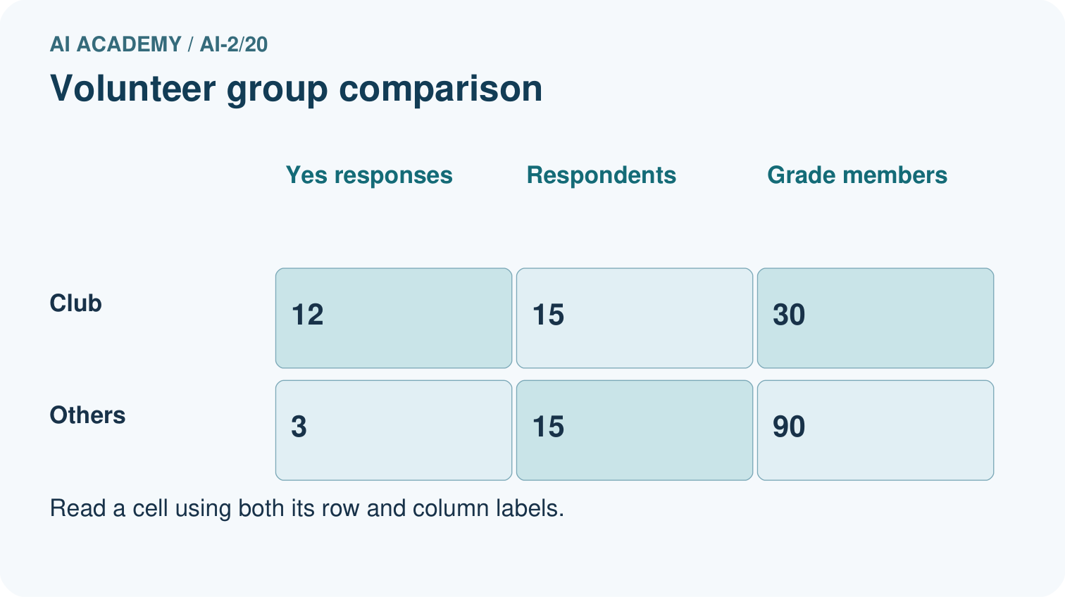
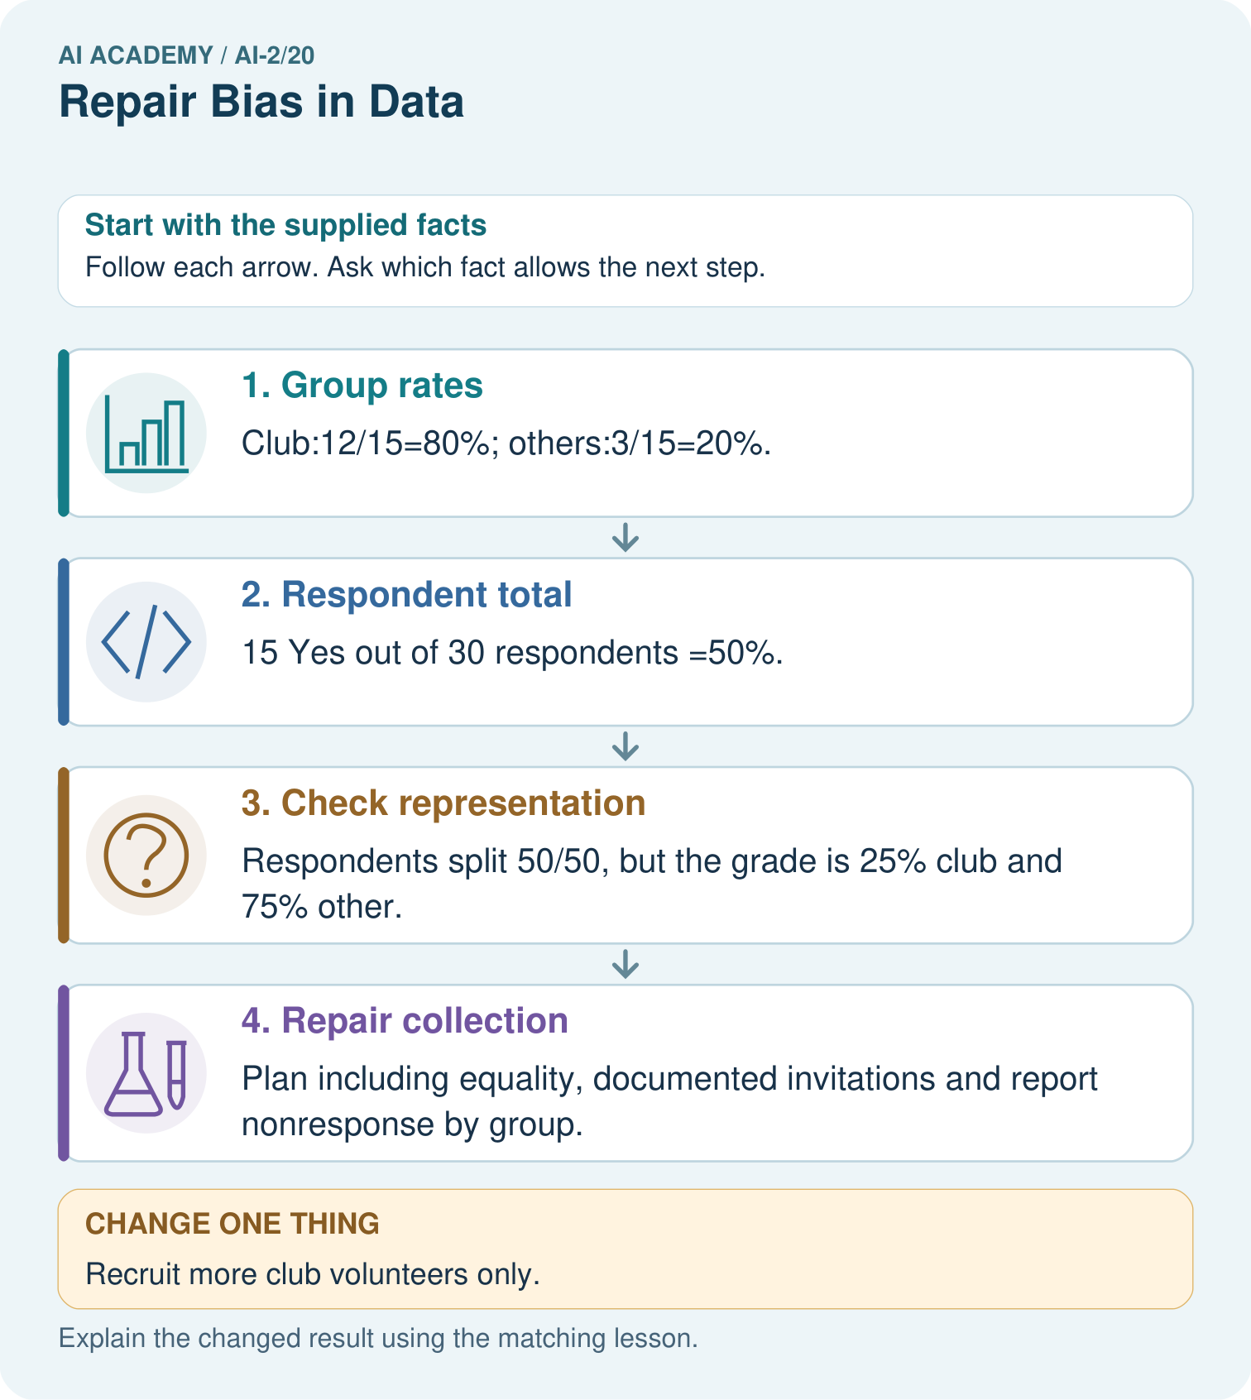
Why must 35% be labelled an illustration rather than the measured grade-wide Yes rate?

My picture-based explanation and changed-case prediction
________________________________________________________________
________________________________________________________________
________________________________________________________________
________________________________________________________________
________________________________________________________________
________________________________________________________________
Support used: alone / hint / worked example. This record is practice evidence.
Project connection: Broaden recommender feedback collection and show respondent group coverage before making user-preference claims.

19. Project portfolio milestone
Project: Transparent Book Recommender
Current milestone: Evaluate and revise. Compare with your starting method, explain errors and record a justified revision.
Broaden recommender feedback collection and show respondent group coverage before making user-preference claims.
Evidence to keep | My record
This week’s input and deciding step
Prediction and actual result (or labelled paper trace)
One change since the previous checkpoint and why
One error or limit and the next test

Explain what this week adds to your project. Reuse last week’s record rather than starting again.
________________________________________________________________
________________________________________________________________
________________________________________________________________
________________________________________________________________
________________________________________________________________

