AI ACADEMY · WORKBOOK · ai-2/24

Feedback Loops
Project: Transparent Book Recommender

01. Recall and choose your starting point
Try the recall before opening notes. Then use a different colour or a labelled second line to correct your explanation.

Recommendation Scores
Without opening the old lesson, explain one key idea from Recommendation Scores. Give an example and a mistake that the idea helps you avoid.

My remembered idea, example and correction
________________________________________________________________
________________________________________________________________
________________________________________________________________

Similarity by Selected Traits
Without opening the old lesson, explain one key idea from Similarity by Selected Traits. Give an example and a mistake that the idea helps you avoid.

My remembered idea, example and correction
________________________________________________________________
________________________________________________________________
________________________________________________________________

Missing Data
Without opening the old lesson, explain one key idea from Missing Data. Give an example and a mistake that the idea helps you avoid.

My remembered idea, example and correction
________________________________________________________________
________________________________________________________________
________________________________________________________________

02. Practise with fading help
Use W2: Handle no match for Implementing a recommender. Record the answer once; the lesson and workbook refer to the same attempt.
Given inputs | Procedure I chose | Middle steps | Result and check

The step I completed without help, and the hint I needed
________________________________________________________________
________________________________________________________________
________________________________________________________________

03. Individual reasoning check
Use the worked case for Implementing a recommender. Proposed explanation: “A successful run proves the conclusion”. Decide whether this explanation is supported. Point to the step or supplied fact that decides; explain your repair if needed.

My explanation before partner discussion
________________________________________________________________
________________________________________________________________
________________________________________________________________
________________________________________________________________

04. Independent transfer case

Independent case: Implement independently
Use the function with X (fun 4, learning 1, minutes 12), Y (3,3,10), Z (5,5,13), limit 12. Predict the winner, reverse the list and retest. Also test limit 9.

My independent explanation, trace and limits
________________________________________________________________
________________________________________________________________
________________________________________________________________
________________________________________________________________
________________________________________________________________
________________________________________________________________
________________________________________________________________
Attempt this case before feedback. Record any help. Earlier examples below are further practice; a case already practised with feedback cannot establish fresh transfer.

05. Your learning target
A recommender shows poetry in 2 slots and adventure in 20. Poetry gets 1 click; adventure gets 6. Compute clicks per shown slot and explain why neither rate alone proves preference.

06. Solve the given case
A recommender shows only adventure books, uses clicks to learn and then shows more adventure.
Explain the feedback loop.
Show your trace, calculation or evidence

Write or draw your reasoning and evidence.
________________________________________________________________
________________________________________________________________
________________________________________________________________
________________________________________________________________
________________________________________________________________

07. Check a changed case
Only space books are shown, so nearly every click is on space. Can these clicks prove readers dislike other topics? Explain the loop.
My independent answer and reason

Write or draw your reasoning and evidence.
________________________________________________________________
________________________________________________________________
________________________________________________________________
________________________________________________________________
________________________________________________________________

Week 24 Test and reflect

08. Design a revealing test
Create a changed input, boundary case or missing-information case. Write the expected answer or safe response before testing.
Test record | My evidence
Changed input or condition
Expected answer or fallback
Observed result
Why the result occurred

09. Project checkpoint
Reserve some varied suggestions and distinguish ‘not shown’ from ‘not liked.’
The project change and evidence I will keep

Write or draw your reasoning and evidence.
________________________________________________________________
________________________________________________________________
________________________________________________________________
________________________________________________________________
________________________________________________________________

10. Self check
I can explain the mechanism. I can show evidence. I can handle a changed case. I can name a limit. Mark each as not yet, with help or independently, and attach supporting work.
Teacher review ____________________ Next step ____________________

11. Transfer practice from the original programme
A recommender shows poetry in 2 slots and adventure in 20. Poetry gets 1 click; adventure gets 6. Compute clicks per shown slot and explain why neither rate alone proves preference.

My independently reasoned answer
________________________________________________________________
________________________________________________________________
________________________________________________________________
________________________________________________________________
________________________________________________________________
________________________________________________________________
________________________________________________________________
Record support used: none, hint or teacher explanation.

12. W1 Trace selection
Why does A win the worked example even though B is processed first?

My reasoning and evidence
________________________________________________________________
________________________________________________________________
________________________________________________________________
________________________________________________________________
________________________________________________________________
________________________________________________________________

13. W2 Handle no match
State recommend([], 10) and the worked items with limit 8.

My reasoning and evidence
________________________________________________________________
________________________________________________________________
________________________________________________________________
________________________________________________________________
________________________________________________________________
________________________________________________________________

14. W3 Repair order dependence
A tied selection changes after reversing input order. Identify the likely missing policy and test.

My reasoning and evidence
________________________________________________________________
________________________________________________________________
________________________________________________________________
________________________________________________________________
________________________________________________________________
________________________________________________________________

15. W4 Implement independently
Use the function with X (fun 4, learning 1, minutes 12), Y (3,3,10), Z (5,5,13), limit 12. Predict the winner, reverse the list and retest. Also test limit 9.

My reasoning and evidence
________________________________________________________________
________________________________________________________________
________________________________________________________________
________________________________________________________________
________________________________________________________________
________________________________________________________________
________________________________________________________________
________________________________________________________________

16. W5 Explain the result
Write a one-sentence explanation of X winning without calling it objectively best.

My reasoning and evidence
________________________________________________________________
________________________________________________________________
________________________________________________________________
________________________________________________________________
________________________________________________________________
________________________________________________________________

17. Feedback, return check and learning record
Evidence | My record
Worked alone / hint / model
First step I repaired and why
New case checked later; date and result
What I can now explain without notes
One remaining question
Revisit this idea with your teacher after a delay. Familiarity is different from explaining and using it on a changed case.

18. Pictorial case practice: Feedback Loops
A fictional catalogue repeatedly recommends two books using observed clicks.
Initially each click count is 0. Equal counts choose earlier ID A over B.
Only the recommended book is shown. In an invented three-round record, A is shown and clicked each round; B is never shown.
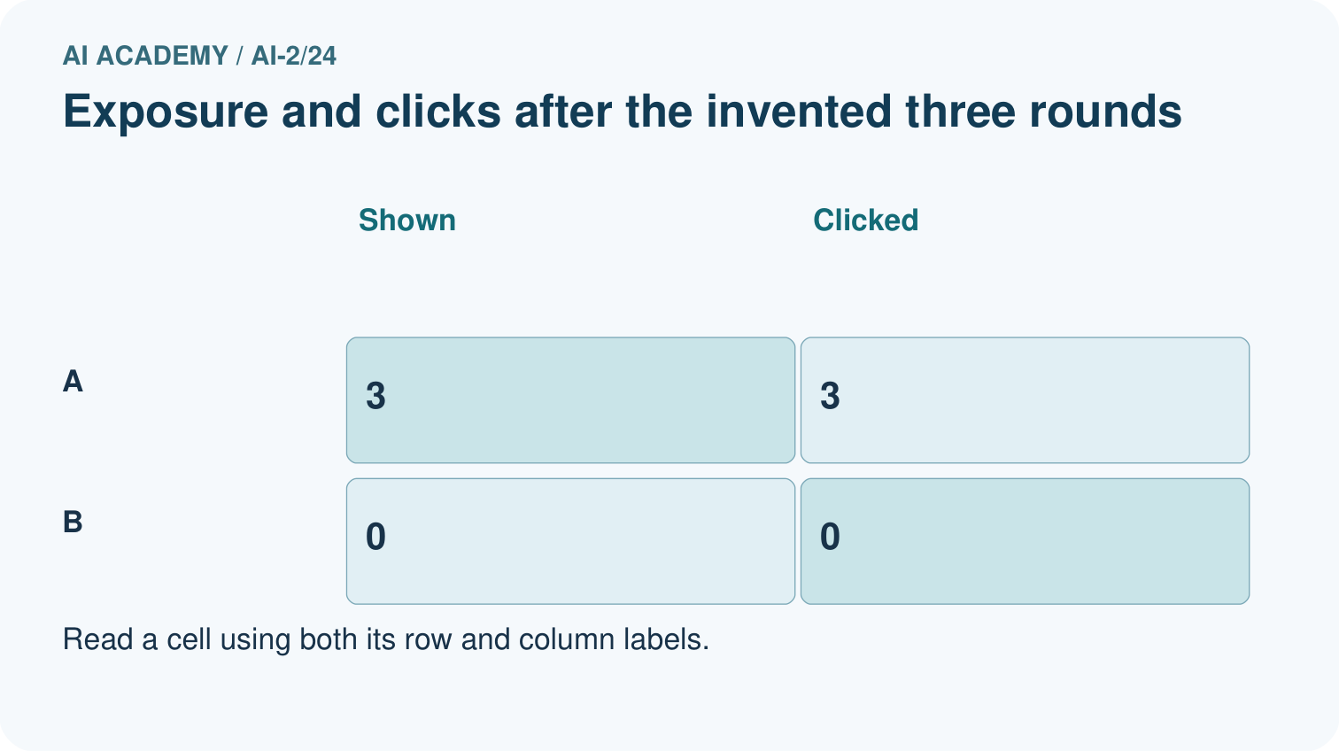
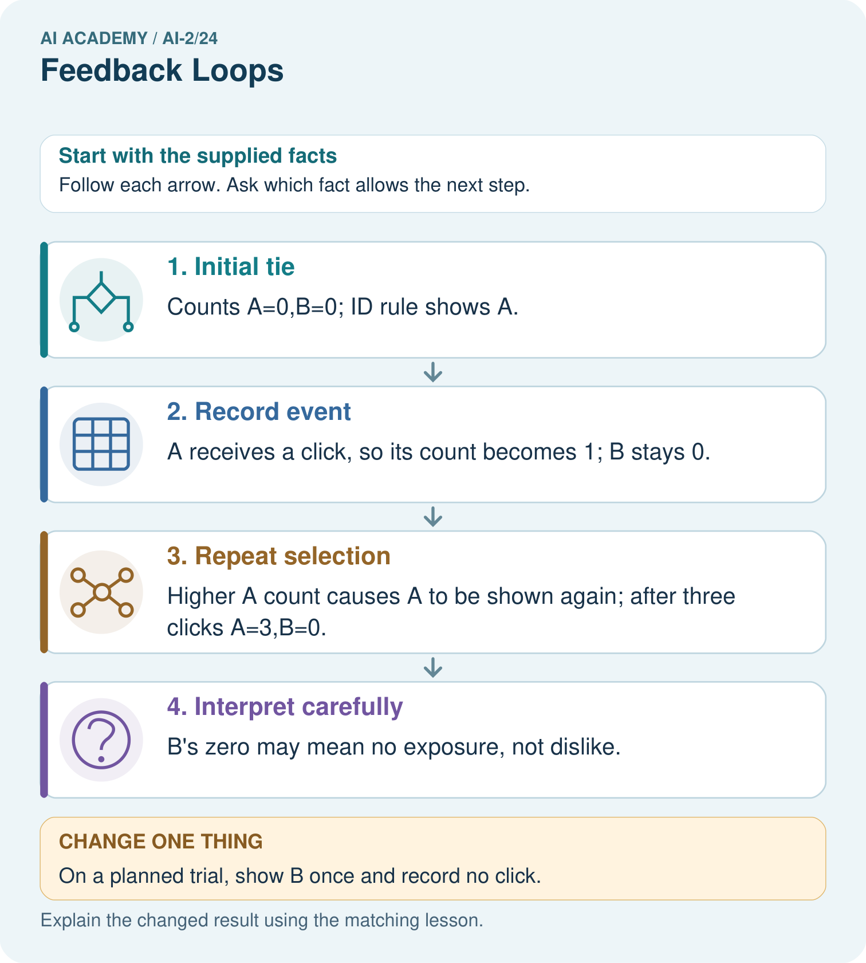
What extra field would reveal why comparing raw clicks is misleading?

My picture-based explanation and changed-case prediction
________________________________________________________________
________________________________________________________________
________________________________________________________________
________________________________________________________________
________________________________________________________________
________________________________________________________________
Support used: alone / hint / worked example. This record is practice evidence.
Project connection: Log recommender exposure, choice and explicit feedback separately; consider whether its own policy narrows future evidence.

19. Project portfolio milestone
Project: Transparent Book Recommender
Current milestone: Evaluate and revise. Compare with your starting method, explain errors and record a justified revision.
Log recommender exposure, choice and explicit feedback separately; consider whether its own policy narrows future evidence.
Evidence to keep | My record
This week’s input and deciding step
Prediction and actual result (or labelled paper trace)
One change since the previous checkpoint and why
One error or limit and the next test

Explain what this week adds to your project. Reuse last week’s record rather than starting again.
________________________________________________________________
________________________________________________________________
________________________________________________________________
________________________________________________________________
________________________________________________________________

