AI ACADEMY · WORKBOOK · ai-2/27

Predictive vs Generative
Project: Transparent Book Recommender

01. Recall and choose your starting point
Try the recall before opening notes. Then use a different colour or a labelled second line to correct your explanation.

Image and Voice Pipelines
Without opening the old lesson, explain one key idea from Image and Voice Pipelines. Give an example and a mistake that the idea helps you avoid.

My remembered idea, example and correction
________________________________________________________________
________________________________________________________________
________________________________________________________________

Feedback Loops
Without opening the old lesson, explain one key idea from Feedback Loops. Give an example and a mistake that the idea helps you avoid.

My remembered idea, example and correction
________________________________________________________________
________________________________________________________________
________________________________________________________________

Similarity by Selected Traits
Without opening the old lesson, explain one key idea from Similarity by Selected Traits. Give an example and a mistake that the idea helps you avoid.

My remembered idea, example and correction
________________________________________________________________
________________________________________________________________
________________________________________________________________

02. Practise with fading help
Use W2: Compute the distribution for Generative and predictive objectives. Record the answer once; the lesson and workbook refer to the same attempt.
Given inputs | Procedure I chose | Middle steps | Result and check

The step I completed without help, and the hint I needed
________________________________________________________________
________________________________________________________________
________________________________________________________________

03. Individual reasoning check
Use the worked case for Generative and predictive objectives. Proposed explanation: “Generative models do not predict”. Decide whether this explanation is supported. Point to the step or supplied fact that decides; explain your repair if needed.

My explanation before partner discussion
________________________________________________________________
________________________________________________________________
________________________________________________________________
________________________________________________________________

04. Independent transfer case

Independent case: Analyse a new corpus independently
For prefix The signal is, counts are high 2, low 5, unknown 3. Compute all probabilities and the most frequent continuation. A current measurement reports high. State what the most frequent continuation does and does not establish.

My independent explanation, trace and limits
________________________________________________________________
________________________________________________________________
________________________________________________________________
________________________________________________________________
________________________________________________________________
________________________________________________________________
________________________________________________________________
Attempt this case before feedback. Record any help. Earlier examples below are further practice; a case already practised with feedback cannot establish fresh transfer.

05. Your learning target
A tool retrieves a book description, predicts a genre, then writes a new blurb. Identify each operation and give one distinct failure to check at each stage.

06. Solve the given case
A labels genre; B writes a new blurb; C computes 24/6.
Distinguish operations.
Show your trace, calculation or evidence

Write or draw your reasoning and evidence.
________________________________________________________________
________________________________________________________________
________________________________________________________________
________________________________________________________________
________________________________________________________________

07. Check a changed case
One model labels a review positive or negative; another writes a new review. Which classifies and which generates? Must generated text be true?
My independent answer and reason

Write or draw your reasoning and evidence.
________________________________________________________________
________________________________________________________________
________________________________________________________________
________________________________________________________________
________________________________________________________________

Week 27 Test and reflect

08. Design a revealing test
Create a changed input, boundary case or missing-information case. Write the expected answer or safe response before testing.
Test record | My evidence
Changed input or condition
Expected answer or fallback
Observed result
Why the result occurred

09. Project checkpoint
Keep scoring predictive and explanations templated or carefully generated and verified.
The project change and evidence I will keep

Write or draw your reasoning and evidence.
________________________________________________________________
________________________________________________________________
________________________________________________________________
________________________________________________________________
________________________________________________________________

10. Self check
I can explain the mechanism. I can show evidence. I can handle a changed case. I can name a limit. Mark each as not yet, with help or independently, and attach supporting work.
Teacher review ____________________ Next step ____________________

11. Transfer practice from the original programme
A tool retrieves a book description, predicts a genre, then writes a new blurb. Identify each operation and give one distinct failure to check at each stage.

My independently reasoned answer
________________________________________________________________
________________________________________________________________
________________________________________________________________
________________________________________________________________
________________________________________________________________
________________________________________________________________
________________________________________________________________
Record support used: none, hint or teacher explanation.

12. W1 Identify the objective
Classify these components by target: label a message request/report; continue a prefix with a sequence; retrieve a stored sensor record. Explain why the application may combine them.

My reasoning and evidence
________________________________________________________________
________________________________________________________________
________________________________________________________________
________________________________________________________________
________________________________________________________________
________________________________________________________________

13. W2 Compute the distribution
For The marker is, calculate the three empirical probabilities, their sum and their meaning.

My reasoning and evidence
________________________________________________________________
________________________________________________________________
________________________________________________________________
________________________________________________________________
________________________________________________________________
________________________________________________________________

14. W3 Follow the prefix
After red is selected, the expanded-prefix table gives end 0.8 and today 0.2. Explain why these values cannot be substituted for the red/blue/green probabilities.

My reasoning and evidence
________________________________________________________________
________________________________________________________________
________________________________________________________________
________________________________________________________________
________________________________________________________________
________________________________________________________________

15. W4 Analyse a new corpus independently
For prefix The signal is, counts are high 2, low 5, unknown 3. Compute all probabilities and the most frequent continuation. A current measurement reports high. State what the most frequent continuation does and does not establish.

My reasoning and evidence
________________________________________________________________
________________________________________________________________
________________________________________________________________
________________________________________________________________
________________________________________________________________
________________________________________________________________
________________________________________________________________
________________________________________________________________

16. W5 Design a useful evaluation
A system reports current room status using retrieved measurements and generated sentences. Name checks for evidence, response quality and permission.

My reasoning and evidence
________________________________________________________________
________________________________________________________________
________________________________________________________________
________________________________________________________________
________________________________________________________________
________________________________________________________________

17. Feedback, return check and learning record
Evidence | My record
Worked alone / hint / model
First step I repaired and why
New case checked later; date and result
What I can now explain without notes
One remaining question
Revisit this idea with your teacher after a delay. Familiarity is different from explaining and using it on a changed case.

18. Pictorial case practice: Predictive vs Generative
A fictional toy generator predicts the next word after “The box is”.
Observed training continuations: full 6, empty 3, unknown 1.
Use counts divided by total 10. The current physical box is separately checked and found empty.
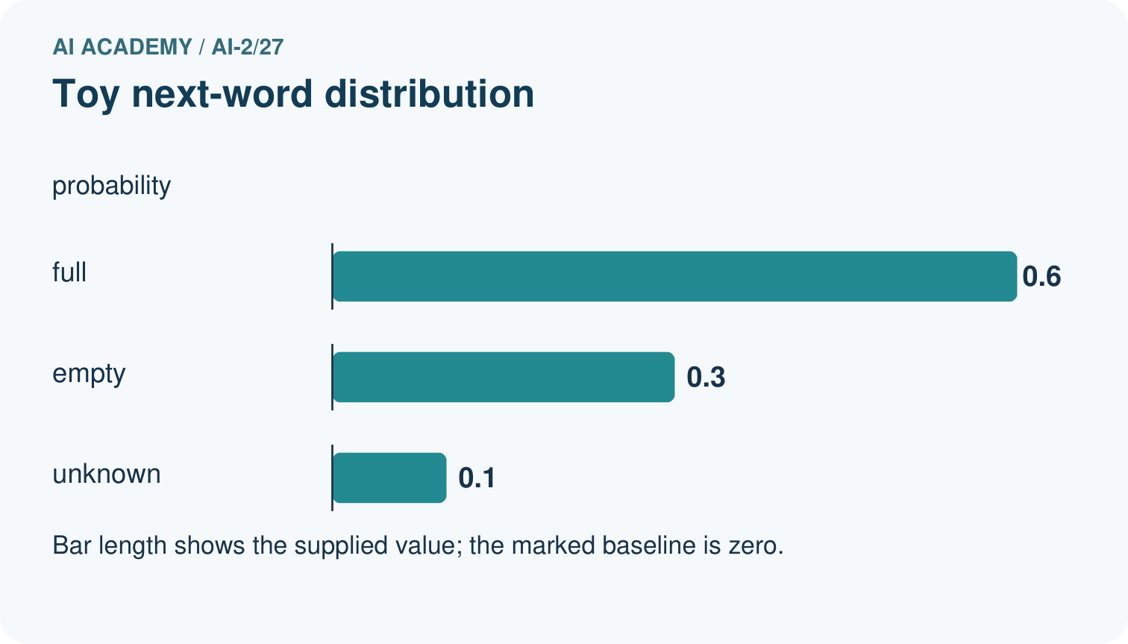
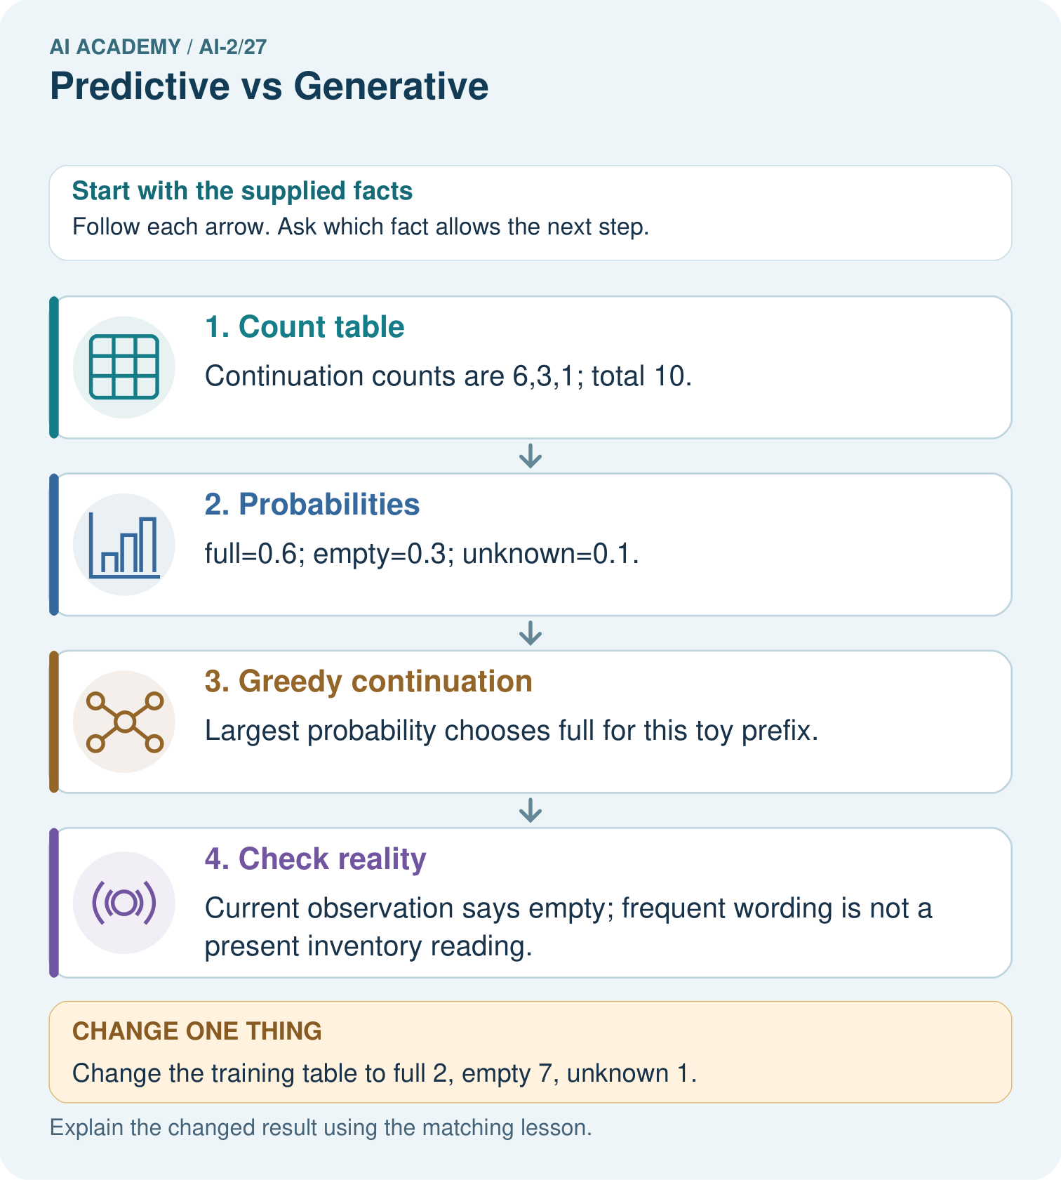
Does matching the physical box in the changed table prove the generator measures boxes?

My picture-based explanation and changed-case prediction
________________________________________________________________
________________________________________________________________
________________________________________________________________
________________________________________________________________
________________________________________________________________
________________________________________________________________
Support used: alone / hint / worked example. This record is practice evidence.
Project connection: Use approved book facts for recommender explanations; generated fluency is not a replacement for catalogue evidence.

19. Project portfolio milestone
Project: Transparent Book Recommender
Current milestone: Prepare the demonstration. Gather reproducible instructions, evidence, access checks and remaining limitations.
Use approved book facts for recommender explanations; generated fluency is not a replacement for catalogue evidence.
Evidence to keep | My record
This week’s input and deciding step
Prediction and actual result (or labelled paper trace)
One change since the previous checkpoint and why
One error or limit and the next test

Explain what this week adds to your project. Reuse last week’s record rather than starting again.
________________________________________________________________
________________________________________________________________
________________________________________________________________
________________________________________________________________
________________________________________________________________

