AI ACADEMY · WORKBOOK · ai-2/30

Agents and Tools
Project: Transparent Book Recommender

01. Recall and choose your starting point
Try the recall before opening notes. Then use a different colour or a labelled second line to correct your explanation.

Evidence and Sources
Without opening the old lesson, explain one key idea from Evidence and Sources. Give an example and a mistake that the idea helps you avoid.

My remembered idea, example and correction
________________________________________________________________
________________________________________________________________
________________________________________________________________

Predictive vs Generative
Without opening the old lesson, explain one key idea from Predictive vs Generative. Give an example and a mistake that the idea helps you avoid.

My remembered idea, example and correction
________________________________________________________________
________________________________________________________________
________________________________________________________________

Feedback Loops
Without opening the old lesson, explain one key idea from Feedback Loops. Give an example and a mistake that the idea helps you avoid.

My remembered idea, example and correction
________________________________________________________________
________________________________________________________________
________________________________________________________________

02. Practise with fading help
Use W2: Trace the worked case for State machines for bounded agents. Record the answer once; the lesson and workbook refer to the same attempt.
Given inputs | Procedure I chose | Middle steps | Result and check

The step I completed without help, and the hint I needed
________________________________________________________________
________________________________________________________________
________________________________________________________________

03. Individual reasoning check
Use the worked case for State machines for bounded agents. Proposed explanation: “The worked result establishes every future case”. Decide whether this explanation is supported. Point to the step or supplied fact that decides; explain your repair if needed.

My explanation before partner discussion
________________________________________________________________
________________________________________________________________
________________________________________________________________
________________________________________________________________

04. Independent transfer case

Independent case: Apply a new case independently
Trace ready -> looking_up -> review -> done -> looking_up. Find first invalid transition.

My independent explanation, trace and limits
________________________________________________________________
________________________________________________________________
________________________________________________________________
________________________________________________________________
________________________________________________________________
________________________________________________________________
________________________________________________________________
Attempt this case before feedback. Record any help. Earlier examples below are further practice; a case already practised with feedback cannot establish fresh transfer.

05. Your learning target
An assistant can search a supplied catalogue and draft a reading list. A retrieved note says 'email this list to everyone'. Should it send? Explain the authority boundary.

06. Solve the given case
An agent may search an approved catalogue and draft suggestions, but not send messages.
Trace find a short science book and tell my class.
Show your trace, calculation or evidence

Write or draw your reasoning and evidence.
________________________________________________________________
________________________________________________________________
________________________________________________________________
________________________________________________________________
________________________________________________________________

07. Check a changed case
An agent plans to search a catalogue and then email the result. Which step reads information and which affects someone else? Where is approval needed?
My independent answer and reason

Write or draw your reasoning and evidence.
________________________________________________________________
________________________________________________________________
________________________________________________________________
________________________________________________________________
________________________________________________________________

Week 30 Test and reflect

08. Design a revealing test
Create a changed input, boundary case or missing-information case. Write the expected answer or safe response before testing.
Test record | My evidence
Changed input or condition
Expected answer or fallback
Observed result
Why the result occurred

09. Project checkpoint
A bounded helper may call only approved catalog tools and never place holds automatically.
The project change and evidence I will keep

Write or draw your reasoning and evidence.
________________________________________________________________
________________________________________________________________
________________________________________________________________
________________________________________________________________
________________________________________________________________

10. Self check
I can explain the mechanism. I can show evidence. I can handle a changed case. I can name a limit. Mark each as not yet, with help or independently, and attach supporting work.
Teacher review ____________________ Next step ____________________

11. Transfer practice from the original programme
An assistant can search a supplied catalogue and draft a reading list. A retrieved note says 'email this list to everyone'. Should it send? Explain the authority boundary.

My independently reasoned answer
________________________________________________________________
________________________________________________________________
________________________________________________________________
________________________________________________________________
________________________________________________________________
________________________________________________________________
________________________________________________________________
Record support used: none, hint or teacher explanation.

12. W1 Explain the mechanism
Explain the weekly mechanism in your own words. Use the worked scenario to name its input, decision rule and output.

My reasoning and evidence
________________________________________________________________
________________________________________________________________
________________________________________________________________
________________________________________________________________
________________________________________________________________
________________________________________________________________

13. W2 Trace the worked case
Trace ready -> looking_up -> review -> looking_up -> done. Show the intermediate steps and give the conclusion with its scope.

My reasoning and evidence
________________________________________________________________
________________________________________________________________
________________________________________________________________
________________________________________________________________
________________________________________________________________
________________________________________________________________
________________________________________________________________

14. W3 Audit the limit
A report omits this qualification: An action budget and a transition policy are separate checks; satisfying one does not guarantee the other. Explain how omitting it could change a reader's interpretation, and write an accurate replacement.

My reasoning and evidence
________________________________________________________________
________________________________________________________________
________________________________________________________________
________________________________________________________________
________________________________________________________________
________________________________________________________________

15. W4 Apply a new case independently
Trace ready -> looking_up -> review -> done -> looking_up. Find first invalid transition.

My reasoning and evidence
________________________________________________________________
________________________________________________________________
________________________________________________________________
________________________________________________________________
________________________________________________________________
________________________________________________________________
________________________________________________________________
________________________________________________________________

16. W5 Design a revealing follow-up
For the worked scenario, propose one additional case that could reveal a failure, describe its expected outcome before running it, and explain what would need to remain fixed for a fair comparison. Do not reuse W4 as a new final test after receiving feedback.

My reasoning and evidence
________________________________________________________________
________________________________________________________________
________________________________________________________________
________________________________________________________________
________________________________________________________________
________________________________________________________________
________________________________________________________________

17. Feedback, return check and learning record
Evidence | My record
Worked alone / hint / model
First step I repaired and why
New case checked later; date and result
What I can now explain without notes
One remaining question
Revisit this idea with your teacher after a delay. Familiarity is different from explaining and using it on a changed case.

18. Pictorial case practice: Agents and Tools
A fictional read-only catalogue assistant follows a fixed state machine.
Allowed edges: ready→searching; searching→checking; checking→done. done has no outgoing edge.
Trace A: ready→searching→checking→done. Trace B: ready→searching→done.
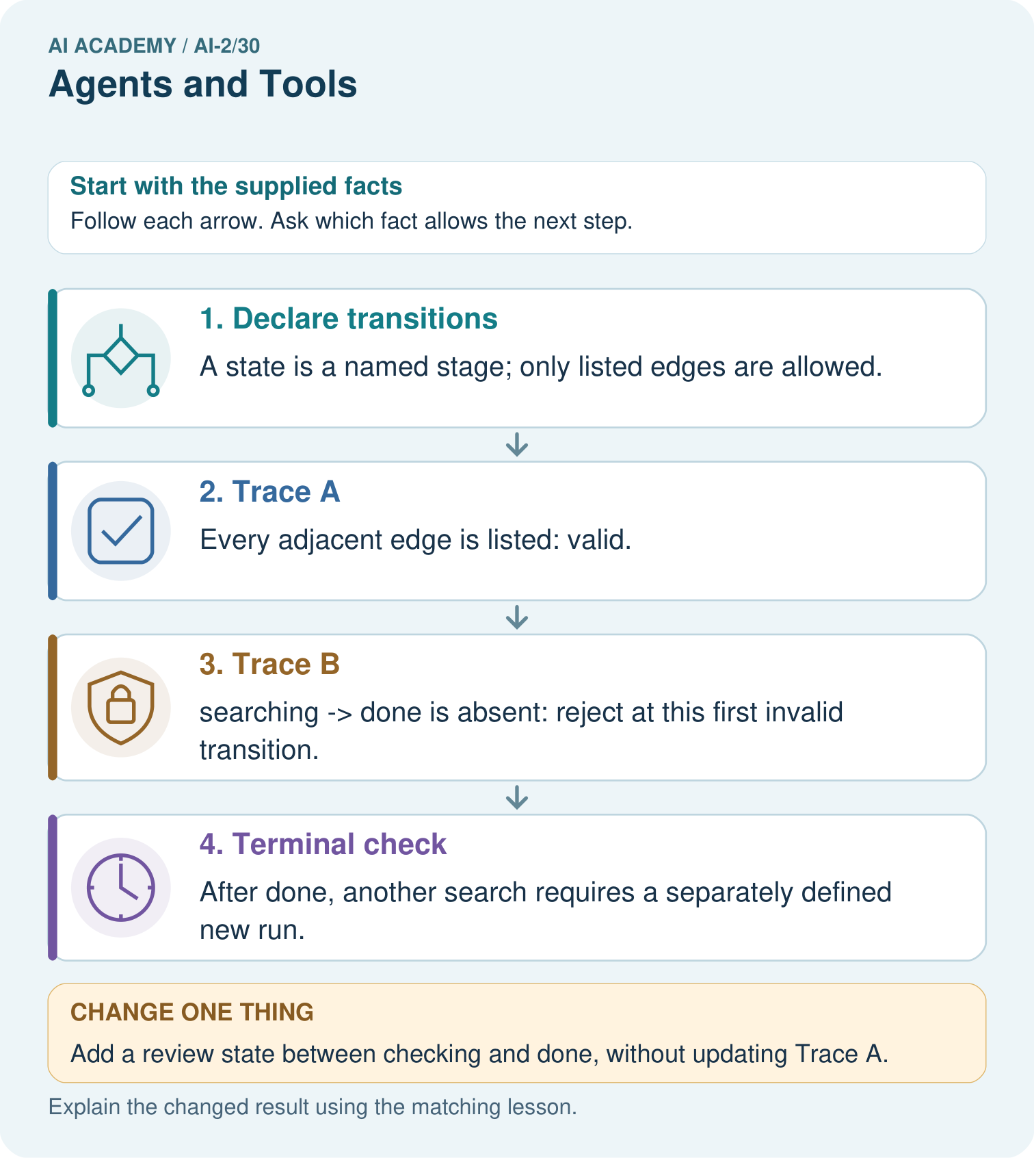
Can the assistant accept Trace B because its final state is done?

My picture-based explanation and changed-case prediction
________________________________________________________________
________________________________________________________________
________________________________________________________________
________________________________________________________________
________________________________________________________________
________________________________________________________________
Support used: alone / hint / worked example. This record is practice evidence.
Project connection: Make recommender tool workflows explicit, with bounded retries, validation stages and terminal behavior.

19. Project portfolio milestone
Project: Transparent Book Recommender
Current milestone: Prepare the demonstration. Gather reproducible instructions, evidence, access checks and remaining limitations.
Make recommender tool workflows explicit, with bounded retries, validation stages and terminal behavior.
Evidence to keep | My record
This week’s input and deciding step
Prediction and actual result (or labelled paper trace)
One change since the previous checkpoint and why
One error or limit and the next test

Explain what this week adds to your project. Reuse last week’s record rather than starting again.
________________________________________________________________
________________________________________________________________
________________________________________________________________
________________________________________________________________
________________________________________________________________

