AI ACADEMY · WORKBOOK · ai-2/32

Project Problem and Success Test
Project: Transparent Book Recommender

01. Recall and choose your starting point
Try the recall before opening notes. Then use a different colour or a labelled second line to correct your explanation.

Permissions and Human Review
Without opening the old lesson, explain one key idea from Permissions and Human Review. Give an example and a mistake that the idea helps you avoid.

My remembered idea, example and correction
________________________________________________________________
________________________________________________________________
________________________________________________________________

Evidence and Sources
Without opening the old lesson, explain one key idea from Evidence and Sources. Give an example and a mistake that the idea helps you avoid.

My remembered idea, example and correction
________________________________________________________________
________________________________________________________________
________________________________________________________________

Image and Voice Pipelines
Without opening the old lesson, explain one key idea from Image and Voice Pipelines. Give an example and a mistake that the idea helps you avoid.

My remembered idea, example and correction
________________________________________________________________
________________________________________________________________
________________________________________________________________

02. Practise with fading help
Use W2: Write an acceptance case for Planning the application. Record the answer once; the lesson and workbook refer to the same attempt.
Given inputs | Procedure I chose | Middle steps | Result and check

The step I completed without help, and the hint I needed
________________________________________________________________
________________________________________________________________
________________________________________________________________

03. Individual reasoning check
Use the worked case for Planning the application. Proposed explanation: “A successful run proves the conclusion”. Decide whether this explanation is supported. Point to the step or supplied fact that decides; explain your repair if needed.

My explanation before partner discussion
________________________________________________________________
________________________________________________________________
________________________________________________________________
________________________________________________________________

04. Independent transfer case

Independent case: Plan independently
Plan a 15-minute fictional club chooser. Specify schema, score, duration limit, tie rule, invalid-data behavior, output and three acceptance cases.

My independent explanation, trace and limits
________________________________________________________________
________________________________________________________________
________________________________________________________________
________________________________________________________________
________________________________________________________________
________________________________________________________________
________________________________________________________________
Attempt this case before feedback. Record any help. Earlier examples below are further practice; a case already practised with feedback cannot establish fresh transfer.

05. Your learning target
Specify three acceptance tests for a recommender: a normal match, a tied score and no qualifying book. Include expected behaviour before implementation.

06. Solve the given case
A project recommends from ten approved books using genre and length.
Define acceptance tests.
Show your trace, calculation or evidence

Write or draw your reasoning and evidence.
________________________________________________________________
________________________________________________________________
________________________________________________________________
________________________________________________________________
________________________________________________________________

07. Check a changed case
Define a testable goal for a book recommender serving readers who want short space books. Include a concrete success condition.
My independent answer and reason

Write or draw your reasoning and evidence.
________________________________________________________________
________________________________________________________________
________________________________________________________________
________________________________________________________________
________________________________________________________________

Week 32 Test and reflect

08. Design a revealing test
Create a changed input, boundary case or missing-information case. Write the expected answer or safe response before testing.
Test record | My evidence
Changed input or condition
Expected answer or fallback
Observed result
Why the result occurred

09. Project checkpoint
Freeze the brief before building so later choices can be traced to requirements.
The project change and evidence I will keep

Write or draw your reasoning and evidence.
________________________________________________________________
________________________________________________________________
________________________________________________________________
________________________________________________________________
________________________________________________________________

10. Self check
I can explain the mechanism. I can show evidence. I can handle a changed case. I can name a limit. Mark each as not yet, with help or independently, and attach supporting work.
Teacher review ____________________ Next step ____________________

11. Transfer practice from the original programme
Specify three acceptance tests for a recommender: a normal match, a tied score and no qualifying book. Include expected behaviour before implementation.

My independently reasoned answer
________________________________________________________________
________________________________________________________________
________________________________________________________________
________________________________________________________________
________________________________________________________________
________________________________________________________________
________________________________________________________________
Record support used: none, hint or teacher explanation.

12. W1 Name the user need
State the purpose and decision owner of the worked chooser.

My reasoning and evidence
________________________________________________________________
________________________________________________________________
________________________________________________________________
________________________________________________________________
________________________________________________________________
________________________________________________________________

13. W2 Write an acceptance case
Give a tie case for A and B with score 8 each and valid durations.

My reasoning and evidence
________________________________________________________________
________________________________________________________________
________________________________________________________________
________________________________________________________________
________________________________________________________________
________________________________________________________________

14. W3 Repair vague scope
Replace the requirement always choose the best activity with a checkable one.

My reasoning and evidence
________________________________________________________________
________________________________________________________________
________________________________________________________________
________________________________________________________________
________________________________________________________________
________________________________________________________________

15. W4 Plan independently
Plan a 15-minute fictional club chooser. Specify schema, score, duration limit, tie rule, invalid-data behavior, output and three acceptance cases.

My reasoning and evidence
________________________________________________________________
________________________________________________________________
________________________________________________________________
________________________________________________________________
________________________________________________________________
________________________________________________________________
________________________________________________________________
________________________________________________________________

16. W5 State non-goals
Name two capabilities excluded from this prototype and explain why.

My reasoning and evidence
________________________________________________________________
________________________________________________________________
________________________________________________________________
________________________________________________________________
________________________________________________________________
________________________________________________________________

17. A reproducible data investigation — W1 State the question
Write the worked investigation question so its population of records is clear.

My reasoning and evidence
________________________________________________________________
________________________________________________________________
________________________________________________________________
________________________________________________________________
________________________________________________________________
________________________________________________________________

18. A reproducible data investigation — W2 Trace exclusions
Classify 0, None, -2 and 60 under the schema.

My reasoning and evidence
________________________________________________________________
________________________________________________________________
________________________________________________________________
________________________________________________________________
________________________________________________________________
________________________________________________________________

19. A reproducible data investigation — W3 Repair a denominator
A report divides a valid total of 24 by six supplied rows, though only three are valid. Correct the valid-record mean.

My reasoning and evidence
________________________________________________________________
________________________________________________________________
________________________________________________________________
________________________________________________________________
________________________________________________________________
________________________________________________________________

20. A reproducible data investigation — W4 Investigate independently
Analyze raw durations [6, 12, None, 0, 70, 18] with the same schema. Report question, accepted list, rejections, mean and one limitation.

My reasoning and evidence
________________________________________________________________
________________________________________________________________
________________________________________________________________
________________________________________________________________
________________________________________________________________
________________________________________________________________
________________________________________________________________
________________________________________________________________

21. A reproducible data investigation — W5 Support reproduction
A report gives only mean 9. What additional evidence lets a peer reproduce it?

My reasoning and evidence
________________________________________________________________
________________________________________________________________
________________________________________________________________
________________________________________________________________
________________________________________________________________
________________________________________________________________

22. Feedback, return check and learning record
Evidence | My record
Worked alone / hint / model
First step I repaired and why
New case checked later; date and result
What I can now explain without notes
One remaining question
Revisit this idea with your teacher after a delay. Familiarity is different from explaining and using it on a changed case.

23. Pictorial case practice: Project Problem and Success Test
A fictional reading-break chooser needs a transparent contract.
Items have id text, minutes integer 0–30, interest integer 0–5. Request limit is integer 0–30.
Eligible if minutes<=limit; score=interest; highest wins; ties choose alphabetically smaller ID; invalid rows excluded and counted.
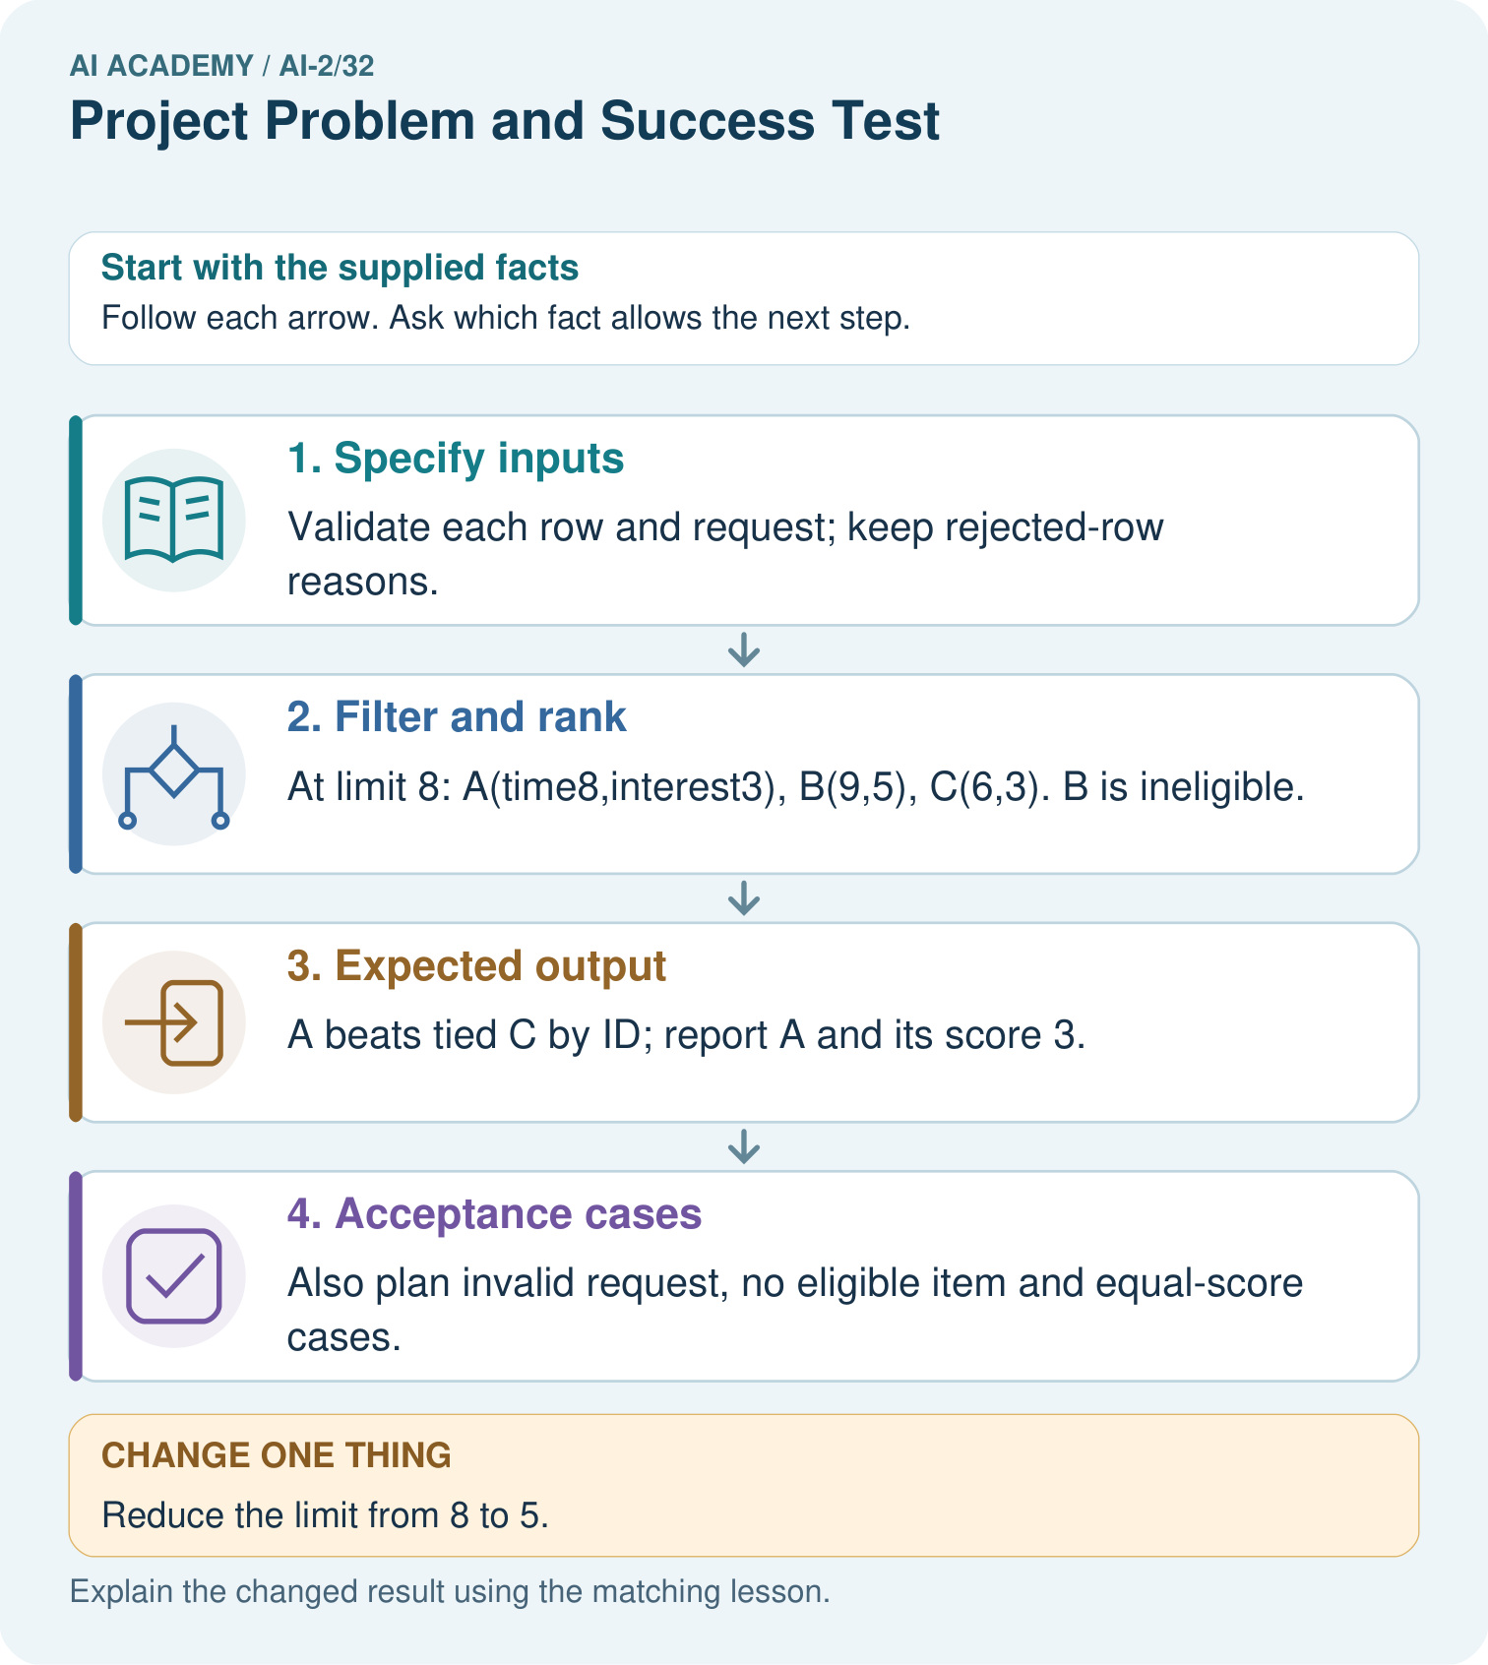
Write an equality test and explain which requirement it checks.

My picture-based explanation and changed-case prediction
________________________________________________________________
________________________________________________________________
________________________________________________________________
________________________________________________________________
________________________________________________________________
________________________________________________________________
Support used: alone / hint / worked example. This record is practice evidence.
Project connection: Retain the Transparent Book Recommender’s schema, constraints, score, tie rule and acceptance table as its build specification.

24. Project portfolio milestone
Project: Transparent Book Recommender
Current milestone: Present and defend. Demonstrate the system, explain one failure and justify the next improvement with evidence.
Retain the Transparent Book Recommender’s schema, constraints, score, tie rule and acceptance table as its build specification.
Evidence to keep | My record
This week’s input and deciding step
Prediction and actual result (or labelled paper trace)
One change since the previous checkpoint and why
One error or limit and the next test

Explain what this week adds to your project. Reuse last week’s record rather than starting again.
________________________________________________________________
________________________________________________________________
________________________________________________________________
________________________________________________________________
________________________________________________________________

