AI ACADEMY · WORKBOOK · ai-2/36

Capstone Expo
Project: Transparent Book Recommender

01. Recall and choose your starting point
Try the recall before opening notes. Then use a different colour or a labelled second line to correct your explanation.

Improve and Challenge
Without opening the old lesson, explain one key idea from Improve and Challenge. Give an example and a mistake that the idea helps you avoid.

My remembered idea, example and correction
________________________________________________________________
________________________________________________________________
________________________________________________________________

Build the Recommender
Without opening the old lesson, explain one key idea from Build the Recommender. Give an example and a mistake that the idea helps you avoid.

My remembered idea, example and correction
________________________________________________________________
________________________________________________________________
________________________________________________________________

Agents and Tools
Without opening the old lesson, explain one key idea from Agents and Tools. Give an example and a mistake that the idea helps you avoid.

My remembered idea, example and correction
________________________________________________________________
________________________________________________________________
________________________________________________________________

02. Practise with fading help
Use W2: Check report consistency for Defending the data application. Record the answer once; the lesson and workbook refer to the same attempt.
Given inputs | Procedure I chose | Middle steps | Result and check

The step I completed without help, and the hint I needed
________________________________________________________________
________________________________________________________________
________________________________________________________________

03. Individual reasoning check
Use the worked case for Defending the data application. Proposed explanation: “A successful run proves the conclusion”. Decide whether this explanation is supported. Point to the step or supplied fact that decides; explain your repair if needed.

My explanation before partner discussion
________________________________________________________________
________________________________________________________________
________________________________________________________________
________________________________________________________________

04. Independent transfer case

Independent case: Defend a new case independently
Limit is 10. A has minutes 10, fun 2, learning 4; B has 9,3,2; C has 11,5,5; D has 8,"4",2. Validate, rank, give counts, explain the winner, then reverse the input order. Present without hints.

My independent explanation, trace and limits
________________________________________________________________
________________________________________________________________
________________________________________________________________
________________________________________________________________
________________________________________________________________
________________________________________________________________
________________________________________________________________
Attempt this case before feedback. Record any help. Earlier examples below are further practice; a case already practised with feedback cannot establish fresh transfer.

05. Your learning target
Present a recommender that gets 8/10 final requests right. One failure invents a title; another violates a hard page limit. Is '80%, ready for everyone' justified? Propose release criteria.

06. Solve the given case
An expo claim says the recommender knows everybody's favourite book after twelve tests.
Rewrite the defence.
Show your trace, calculation or evidence

Write or draw your reasoning and evidence.
________________________________________________________________
________________________________________________________________
________________________________________________________________
________________________________________________________________
________________________________________________________________

07. Check a changed case
Your demo recommends the right book once. An audience member asks why they should trust it. Name evidence and one limitation you should present.
My independent answer and reason

Write or draw your reasoning and evidence.
________________________________________________________________
________________________________________________________________
________________________________________________________________
________________________________________________________________
________________________________________________________________

Week 36 Test and reflect

08. Design a revealing test
Create a changed input, boundary case or missing-information case. Write the expected answer or safe response before testing.
Test record | My evidence
Changed input or condition
Expected answer or fallback
Observed result
Why the result occurred

09. Project checkpoint
Final evidence bundle: brief, data, scoring logic, tests, improvement record, and product card.
The project change and evidence I will keep

Write or draw your reasoning and evidence.
________________________________________________________________
________________________________________________________________
________________________________________________________________
________________________________________________________________
________________________________________________________________

10. Self check
I can explain the mechanism. I can show evidence. I can handle a changed case. I can name a limit. Mark each as not yet, with help or independently, and attach supporting work.
Teacher review ____________________ Next step ____________________

11. Transfer practice from the original programme
Present a recommender that gets 8/10 final requests right. One failure invents a title; another violates a hard page limit. Is '80%, ready for everyone' justified? Propose release criteria.

My independently reasoned answer
________________________________________________________________
________________________________________________________________
________________________________________________________________
________________________________________________________________
________________________________________________________________
________________________________________________________________
________________________________________________________________
Record support used: none, hint or teacher explanation.

12. W1 Assemble evidence
List the files or records a peer needs to reproduce the chooser result.

My reasoning and evidence
________________________________________________________________
________________________________________________________________
________________________________________________________________
________________________________________________________________
________________________________________________________________
________________________________________________________________

13. W2 Check report consistency
A report says supplied 5, accepted 4 and rejected 2. Identify the inconsistency.

My reasoning and evidence
________________________________________________________________
________________________________________________________________
________________________________________________________________
________________________________________________________________
________________________________________________________________
________________________________________________________________

14. W3 Repair a claim
A presentation says the project proves students learn better. What claim does a successful rule-based demo support instead?

My reasoning and evidence
________________________________________________________________
________________________________________________________________
________________________________________________________________
________________________________________________________________
________________________________________________________________
________________________________________________________________

15. W4 Defend a new case independently
Limit is 10. A has minutes 10, fun 2, learning 4; B has 9,3,2; C has 11,5,5; D has 8,"4",2. Validate, rank, give counts, explain the winner, then reverse the input order. Present without hints.

My reasoning and evidence
________________________________________________________________
________________________________________________________________
________________________________________________________________
________________________________________________________________
________________________________________________________________
________________________________________________________________
________________________________________________________________
________________________________________________________________

16. W5 State the next evidence need
After passing the new case, what remains unproven and what is a reasonable next step?

My reasoning and evidence
________________________________________________________________
________________________________________________________________
________________________________________________________________
________________________________________________________________
________________________________________________________________
________________________________________________________________

17. Feedback, return check and learning record
Evidence | My record
Worked alone / hint / model
First step I repaired and why
New case checked later; date and result
What I can now explain without notes
One remaining question
Revisit this idea with your teacher after a delay. Familiarity is different from explaining and using it on a changed case.

18. Pictorial case practice: Capstone Expo
A fictional team presents its transparent book recommender on a reserved catalogue.
Request maximum 120 pages; score=2×interest+illustrated, where illustrated is 1 for True and 0 for False; tie by ID.
A pages120 interest3 True; B pages100 interest4 False; C pages121 interest5 True; D pages90 interest"4" True. Numeric fields require exact integers.
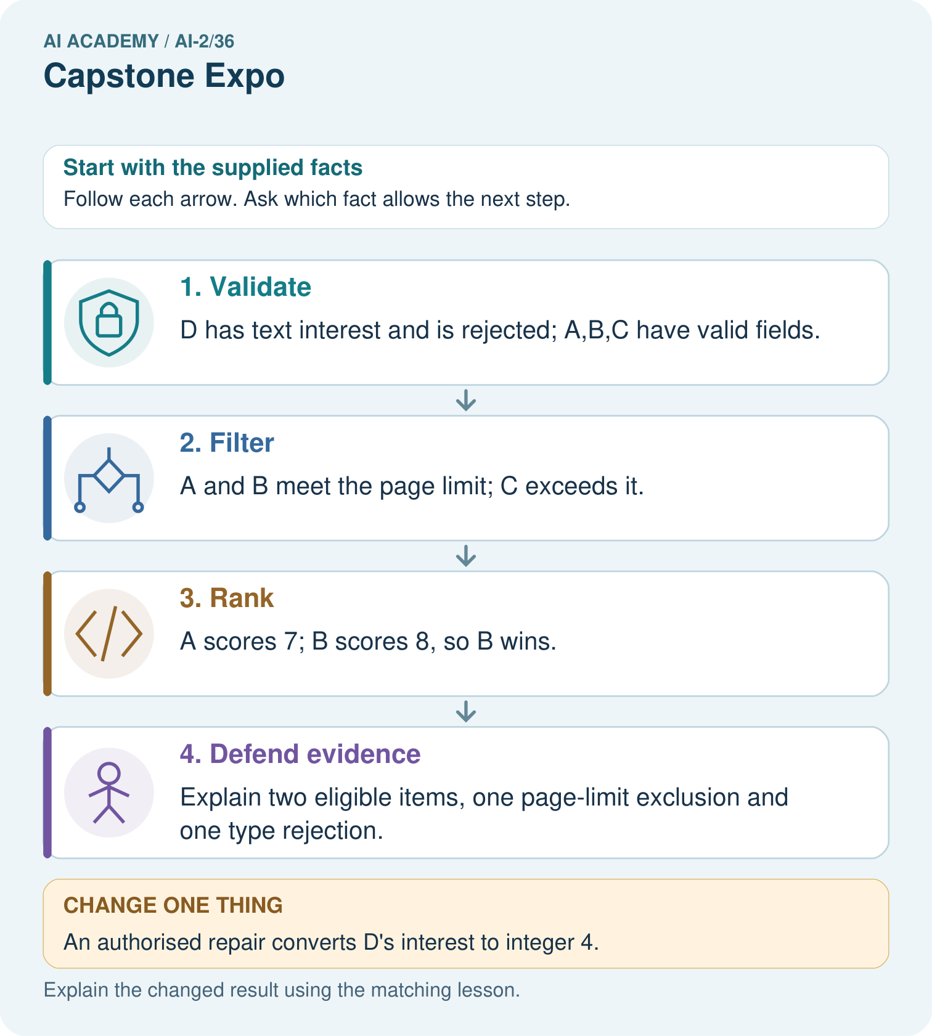
Give the original winning ID, its score, and counts of eligible, excluded and invalid rows.

My picture-based explanation and changed-case prediction
________________________________________________________________
________________________________________________________________
________________________________________________________________
________________________________________________________________
________________________________________________________________
________________________________________________________________
Support used: alone / hint / worked example. This record is practice evidence.
Project connection: Present the Transparent Book Recommender’s code, baseline, full-case traces, reserved results and limitations, without claiming fictional results as pupil work.

19. Project portfolio milestone
Project: Transparent Book Recommender
Current milestone: Present and defend. Demonstrate the system, explain one failure and justify the next improvement with evidence.
Present the Transparent Book Recommender’s code, baseline, full-case traces, reserved results and limitations, without claiming fictional results as pupil work.
Evidence to keep | My record
This week’s input and deciding step
Prediction and actual result (or labelled paper trace)
One change since the previous checkpoint and why
One error or limit and the next test

Explain what this week adds to your project. Reuse last week’s record rather than starting again.
________________________________________________________________
________________________________________________________________
________________________________________________________________
________________________________________________________________
________________________________________________________________

