AI ACADEMY · WORKBOOK · ai-3/8

Structured Output and Schemas
Project: Verified Study Buddy

01. Recall and choose your starting point
Try the recall before opening notes. Then use a different colour or a labelled second line to correct your explanation.

Iterative Prompting
Without opening the old lesson, explain one key idea from Iterative Prompting. Give an example and a mistake that the idea helps you avoid.

My remembered idea, example and correction
________________________________________________________________
________________________________________________________________
________________________________________________________________

Prompt as a Contract
Without opening the old lesson, explain one key idea from Prompt as a Contract. Give an example and a mistake that the idea helps you avoid.

My remembered idea, example and correction
________________________________________________________________
________________________________________________________________
________________________________________________________________

A Distribution of Possibilities
Without opening the old lesson, explain one key idea from A Distribution of Possibilities. Give an example and a mistake that the idea helps you avoid.

My remembered idea, example and correction
________________________________________________________________
________________________________________________________________
________________________________________________________________

02. Practise with fading help
Use W2: Audit types and fields for Structured outputs and validation. Record the answer once; the lesson and workbook refer to the same attempt.
Given inputs | Procedure I chose | Middle steps | Result and check

The step I completed without help, and the hint I needed
________________________________________________________________
________________________________________________________________
________________________________________________________________

03. Individual reasoning check
Use the worked case for Structured outputs and validation. Proposed explanation: “Valid JSON means correct answer”. Decide whether this explanation is supported. Point to the step or supplied fact that decides; explain your repair if needed.

My explanation before partner discussion
________________________________________________________________
________________________________________________________________
________________________________________________________________
________________________________________________________________

04. Independent transfer case

Independent case: Validate new objects independently
Sources A approve room F and B register F capacity 9. Object X has supported,F,9,[A,B] with exactly the required fields. Y replaces 9 with "9". Z keeps integer 9 but names room G. Trace the first failing layer for each and explain the difference.

My independent explanation, trace and limits
________________________________________________________________
________________________________________________________________
________________________________________________________________
________________________________________________________________
________________________________________________________________
________________________________________________________________
________________________________________________________________
Attempt this case before feedback. Record any help. Earlier examples below are further practice; a case already practised with feedback cannot establish fresh transfer.

05. Your learning target
Schema requires title:text and pages:number. Output is {"title":"Cloud","pages":"80"}. Fix its structural error. Would the repaired object prove the book really has 80 pages?

06. Solve the given case
Schema requires title text and pages number. Output is {"title":"River","pages":"80"}.
Diagnose the shape error.
Show your trace, calculation or evidence

Write or draw your reasoning and evidence.
________________________________________________________________
________________________________________________________________
________________________________________________________________
________________________________________________________________
________________________________________________________________

07. Check a changed case
A required schema has title as text and count as an integer. The output is {"title":"Seeds","count":"three"}. Identify the error and give a valid replacement.
My independent answer and reason

Write or draw your reasoning and evidence.
________________________________________________________________
________________________________________________________________
________________________________________________________________
________________________________________________________________
________________________________________________________________

Week 8 Test and reflect

08. Design a revealing test
Create a changed input, boundary case or missing-information case. Write the expected answer or safe response before testing.
Test record | My evidence
Changed input or condition
Expected answer or fallback
Observed result
Why the result occurred

09. Project checkpoint
Require answer, source snippet, citation, uncertainty, and next-question fields.
The project change and evidence I will keep

Write or draw your reasoning and evidence.
________________________________________________________________
________________________________________________________________
________________________________________________________________
________________________________________________________________
________________________________________________________________

10. Self check
I can explain the mechanism. I can show evidence. I can handle a changed case. I can name a limit. Mark each as not yet, with help or independently, and attach supporting work.
Teacher review ____________________ Next step ____________________

11. Transfer practice from the original programme
Schema requires title:text and pages:number. Output is {"title":"Cloud","pages":"80"}. Fix its structural error. Would the repaired object prove the book really has 80 pages?

My independently reasoned answer
________________________________________________________________
________________________________________________________________
________________________________________________________________
________________________________________________________________
________________________________________________________________
________________________________________________________________
________________________________________________________________
Record support used: none, hint or teacher explanation.

12. W1 Distinguish the layers
Explain what parsing, schema checks and source support each establish.

My reasoning and evidence
________________________________________________________________
________________________________________________________________
________________________________________________________________
________________________________________________________________
________________________________________________________________
________________________________________________________________

13. W2 Audit types and fields
Why do string "12",boolean true,missing capacity and an extra action field violate this contract?

My reasoning and evidence
________________________________________________________________
________________________________________________________________
________________________________________________________________
________________________________________________________________
________________________________________________________________
________________________________________________________________

14. W3 Check a citation-like ID
Sources P,Q support B capacity 12. A schema-valid object cites P,Q but gives 99. Which layer rejects it?

My reasoning and evidence
________________________________________________________________
________________________________________________________________
________________________________________________________________
________________________________________________________________
________________________________________________________________
________________________________________________________________

15. W4 Validate new objects independently
Sources A approve room F and B register F capacity 9. Object X has supported,F,9,[A,B] with exactly the required fields. Y replaces 9 with "9". Z keeps integer 9 but names room G. Trace the first failing layer for each and explain the difference.

My reasoning and evidence
________________________________________________________________
________________________________________________________________
________________________________________________________________
________________________________________________________________
________________________________________________________________
________________________________________________________________
________________________________________________________________
________________________________________________________________

16. W5 Keep permissions separate
A fully valid supported reporting object is returned. May the application automatically book the room? Explain.

My reasoning and evidence
________________________________________________________________
________________________________________________________________
________________________________________________________________
________________________________________________________________
________________________________________________________________
________________________________________________________________

17. Feedback, return check and learning record
Evidence | My record
Worked alone / hint / model
First step I repaired and why
New case checked later; date and result
What I can now explain without notes
One remaining question
Revisit this idea with your teacher after a delay. Familiarity is different from explaining and using it on a changed case.

18. Pictorial case practice: Structured Output and Schemas
A fictional Study Buddy returns a machine-readable book fact.
Schema: exactly title text, pages integer, source_id text. Approved record R: River Notes, 64 pages.
X={"title":"River Notes","pages":64,"source_id":"R"}; Y uses pages:"64"; Z uses pages:46 with otherwise identical fields.
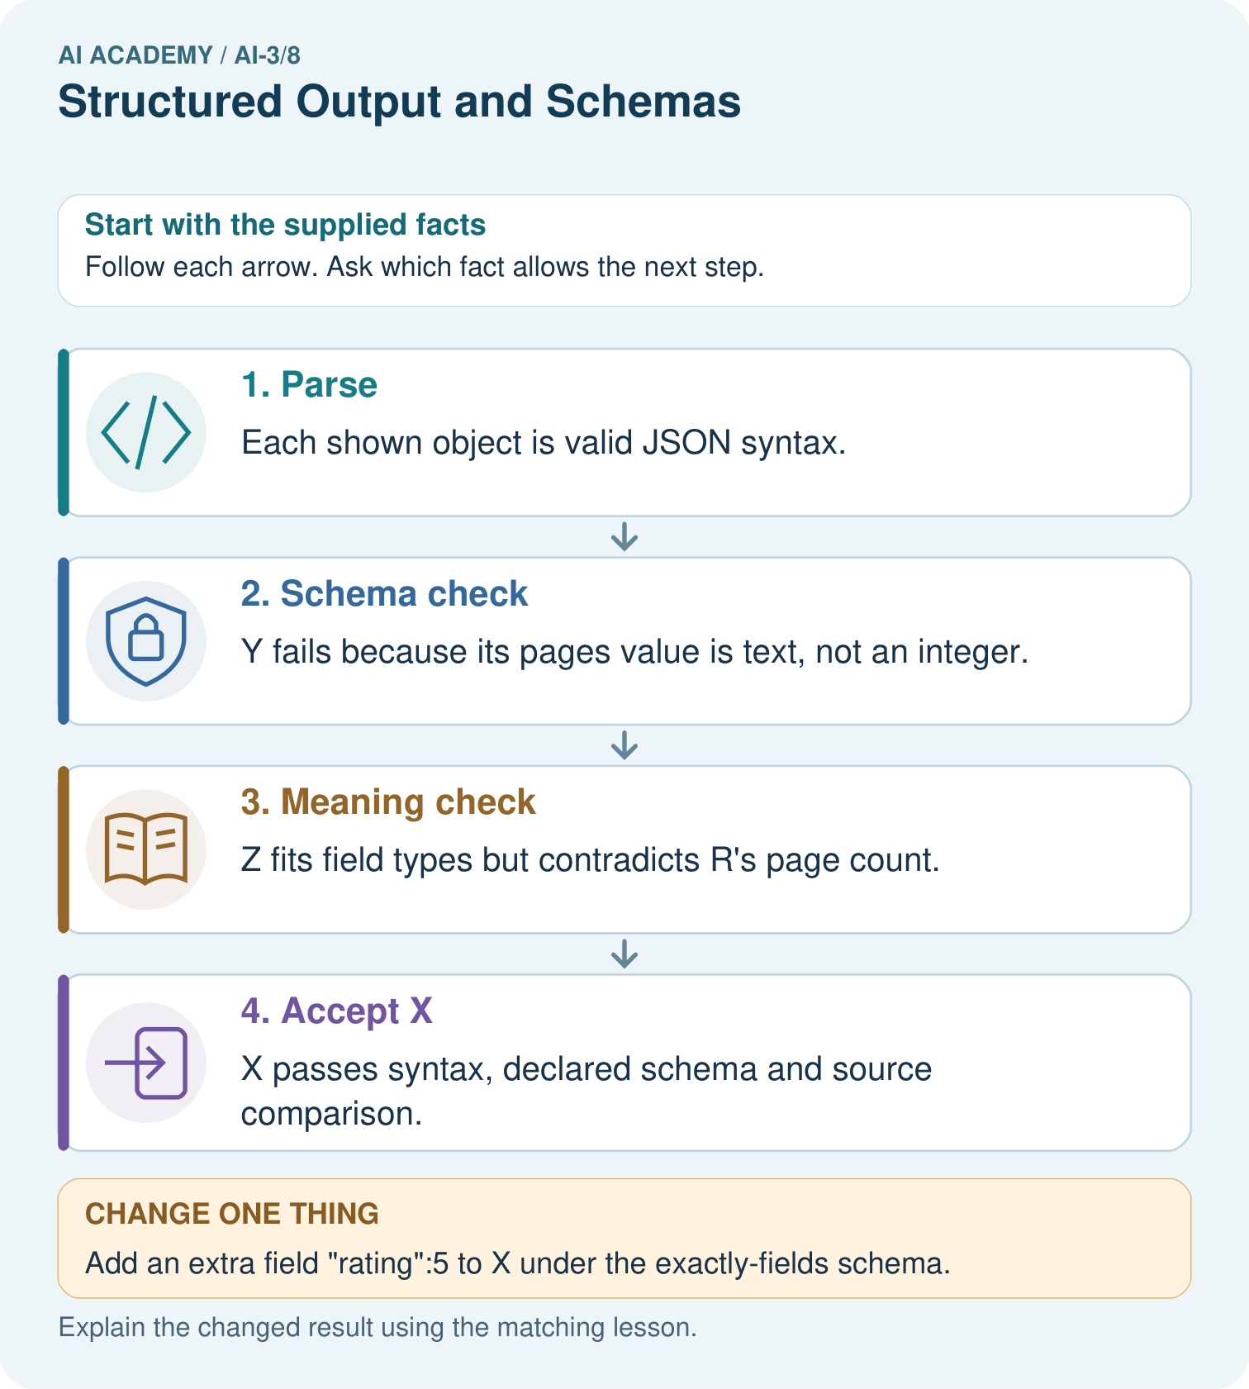
Which object demonstrates that valid JSON and valid types are insufficient for truth?

My picture-based explanation and changed-case prediction
________________________________________________________________
________________________________________________________________
________________________________________________________________
________________________________________________________________
________________________________________________________________
________________________________________________________________
Support used: alone / hint / worked example. This record is practice evidence.
Project connection: Validate Study Buddy outputs before another program consumes them; retain source IDs and separate syntax/type/support failures.

19. Project portfolio milestone
Project: Verified Study Buddy
Current milestone: Make a transparent first version. Keep a trace of how one input becomes an output; explain the rule or learned component.
Validate Study Buddy outputs before another program consumes them; retain source IDs and separate syntax/type/support failures.
Evidence to keep | My record
This week’s input and deciding step
Prediction and actual result (or labelled paper trace)
One change since the previous checkpoint and why
One error or limit and the next test

Explain what this week adds to your project. Reuse last week’s record rather than starting again.
________________________________________________________________
________________________________________________________________
________________________________________________________________
________________________________________________________________
________________________________________________________________

