AI ACADEMY · WORKBOOK · ai-3/10

Image Generation Models
Project: Verified Study Buddy

01. Recall and choose your starting point
Try the recall before opening notes. Then use a different colour or a labelled second line to correct your explanation.

Prompt Evaluation
Without opening the old lesson, explain one key idea from Prompt Evaluation. Give an example and a mistake that the idea helps you avoid.

My remembered idea, example and correction
________________________________________________________________
________________________________________________________________
________________________________________________________________

Iterative Prompting
Without opening the old lesson, explain one key idea from Iterative Prompting. Give an example and a mistake that the idea helps you avoid.

My remembered idea, example and correction
________________________________________________________________
________________________________________________________________
________________________________________________________________

Sampling and Variability
Without opening the old lesson, explain one key idea from Sampling and Variability. Give an example and a mistake that the idea helps you avoid.

My remembered idea, example and correction
________________________________________________________________
________________________________________________________________
________________________________________________________________

02. Practise with fading help
Use W2: Trace the worked case for Image generation and provenance. Record the answer once; the lesson and workbook refer to the same attempt.
Given inputs | Procedure I chose | Middle steps | Result and check

The step I completed without help, and the hint I needed
________________________________________________________________
________________________________________________________________
________________________________________________________________

03. Individual reasoning check
Use the worked case for Image generation and provenance. Proposed explanation: “The worked result establishes every future case”. Decide whether this explanation is supported. Point to the step or supplied fact that decides; explain your repair if needed.

My explanation before partner discussion
________________________________________________________________
________________________________________________________________
________________________________________________________________
________________________________________________________________

04. Independent transfer case

Independent case: Apply a new case independently
A generated diagram requires two arrows and labels input/output. It has two arrows but swapped labels. Metadata records generation, yet the caption says experimental observation. Audit.

My independent explanation, trace and limits
________________________________________________________________
________________________________________________________________
________________________________________________________________
________________________________________________________________
________________________________________________________________
________________________________________________________________
________________________________________________________________
Attempt this case before feedback. Record any help. Earlier examples below are further practice; a case already practised with feedback cannot establish fresh transfer.

05. Your learning target
An image generator produces a convincing picture of a school greenhouse on Mars. A student calls it photographic evidence. Explain what the image can and cannot establish.

06. Solve the given case
A generator creates a realistic fictional bicycle beside a tree.
How does this differ from event photography?
Show your trace, calculation or evidence

Write or draw your reasoning and evidence.
________________________________________________________________
________________________________________________________________
________________________________________________________________
________________________________________________________________
________________________________________________________________

07. Check a changed case
An image model draws a plant with seven roots after a request for exactly four. What does this show, and where should an exact count diagram be made?
My independent answer and reason

Write or draw your reasoning and evidence.
________________________________________________________________
________________________________________________________________
________________________________________________________________
________________________________________________________________
________________________________________________________________

Week 10 Test and reflect

08. Design a revealing test
Create a changed input, boundary case or missing-information case. Write the expected answer or safe response before testing.
Test record | My evidence
Changed input or condition
Expected answer or fallback
Observed result
Why the result occurred

09. Project checkpoint
Treat generated diagrams as illustrations; pair factual claims with approved sources.
The project change and evidence I will keep

Write or draw your reasoning and evidence.
________________________________________________________________
________________________________________________________________
________________________________________________________________
________________________________________________________________
________________________________________________________________

10. Self check
I can explain the mechanism. I can show evidence. I can handle a changed case. I can name a limit. Mark each as not yet, with help or independently, and attach supporting work.
Teacher review ____________________ Next step ____________________

11. Transfer practice from the original programme
An image generator produces a convincing picture of a school greenhouse on Mars. A student calls it photographic evidence. Explain what the image can and cannot establish.

My independently reasoned answer
________________________________________________________________
________________________________________________________________
________________________________________________________________
________________________________________________________________
________________________________________________________________
________________________________________________________________
________________________________________________________________
Record support used: none, hint or teacher explanation.

12. W1 Explain the mechanism
Explain the weekly mechanism in your own words. Use the worked scenario to name its input, decision rule and output.

My reasoning and evidence
________________________________________________________________
________________________________________________________________
________________________________________________________________
________________________________________________________________
________________________________________________________________
________________________________________________________________

13. W2 Trace the worked case
A fictional poster requires exactly three labelled circles. Generated image shows four circles and one unreadable label. A caption calls it a photograph of a real lesson. Show the intermediate steps and give the conclusion with its scope.

My reasoning and evidence
________________________________________________________________
________________________________________________________________
________________________________________________________________
________________________________________________________________
________________________________________________________________
________________________________________________________________
________________________________________________________________

14. W3 Audit the limit
A report omits this qualification: Provenance tracks production history; it does not prove the content is accurate or establish every legal permission. Explain how omitting it could change a reader's interpretation, and write an accurate replacement.

My reasoning and evidence
________________________________________________________________
________________________________________________________________
________________________________________________________________
________________________________________________________________
________________________________________________________________
________________________________________________________________

15. W4 Apply a new case independently
A generated diagram requires two arrows and labels input/output. It has two arrows but swapped labels. Metadata records generation, yet the caption says experimental observation. Audit.

My reasoning and evidence
________________________________________________________________
________________________________________________________________
________________________________________________________________
________________________________________________________________
________________________________________________________________
________________________________________________________________
________________________________________________________________
________________________________________________________________

16. W5 Design a revealing follow-up
For the worked scenario, propose one additional case that could reveal a failure, describe its expected outcome before running it, and explain what would need to remain fixed for a fair comparison. Do not reuse W4 as a new final test after receiving feedback.

My reasoning and evidence
________________________________________________________________
________________________________________________________________
________________________________________________________________
________________________________________________________________
________________________________________________________________
________________________________________________________________
________________________________________________________________

17. Feedback, return check and learning record
Evidence | My record
Worked alone / hint / model
First step I repaired and why
New case checked later; date and result
What I can now explain without notes
One remaining question
Revisit this idea with your teacher after a delay. Familiarity is different from explaining and using it on a changed case.

18. Pictorial case practice: Image Generation Models
A fictional lesson poster illustrates one family of image-generation approaches.
Toy 2×2 noisy numerical grid: [[0.2,0.8],[0.6,0.3]]. A specified illustrative denoising step gives [[0.1,0.9],[0.4,0.2]].
These supplied arrays illustrate steps only; they are not outputs from a real trained diffusion model.
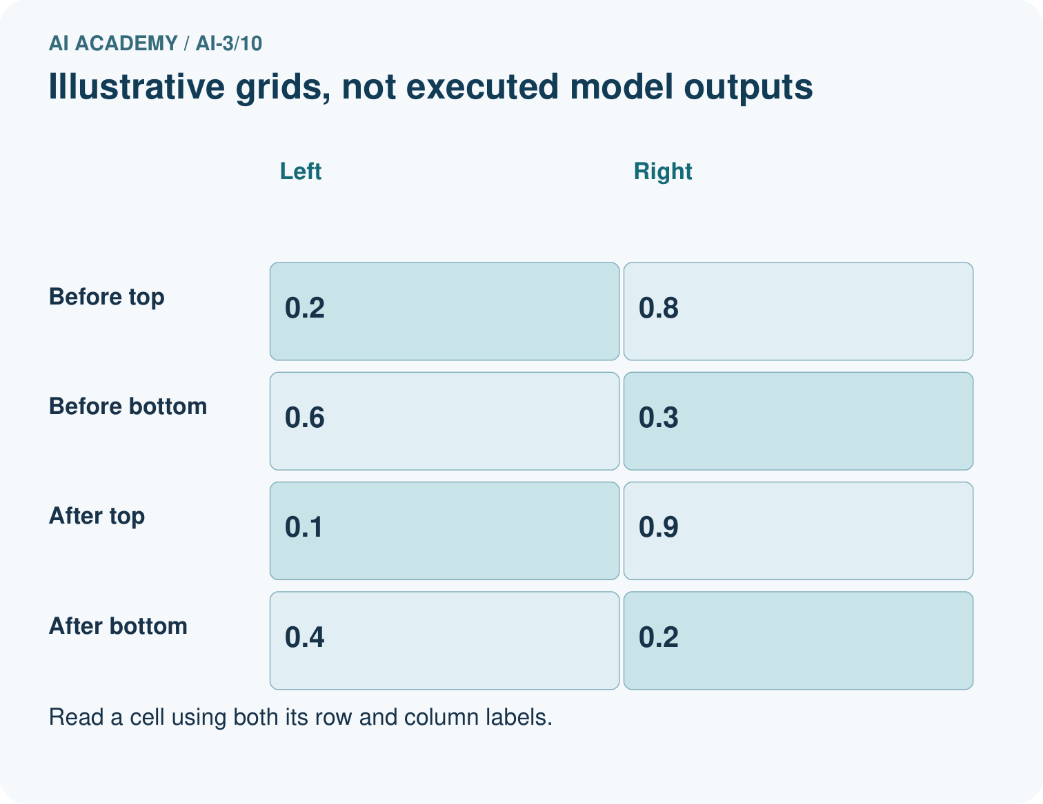
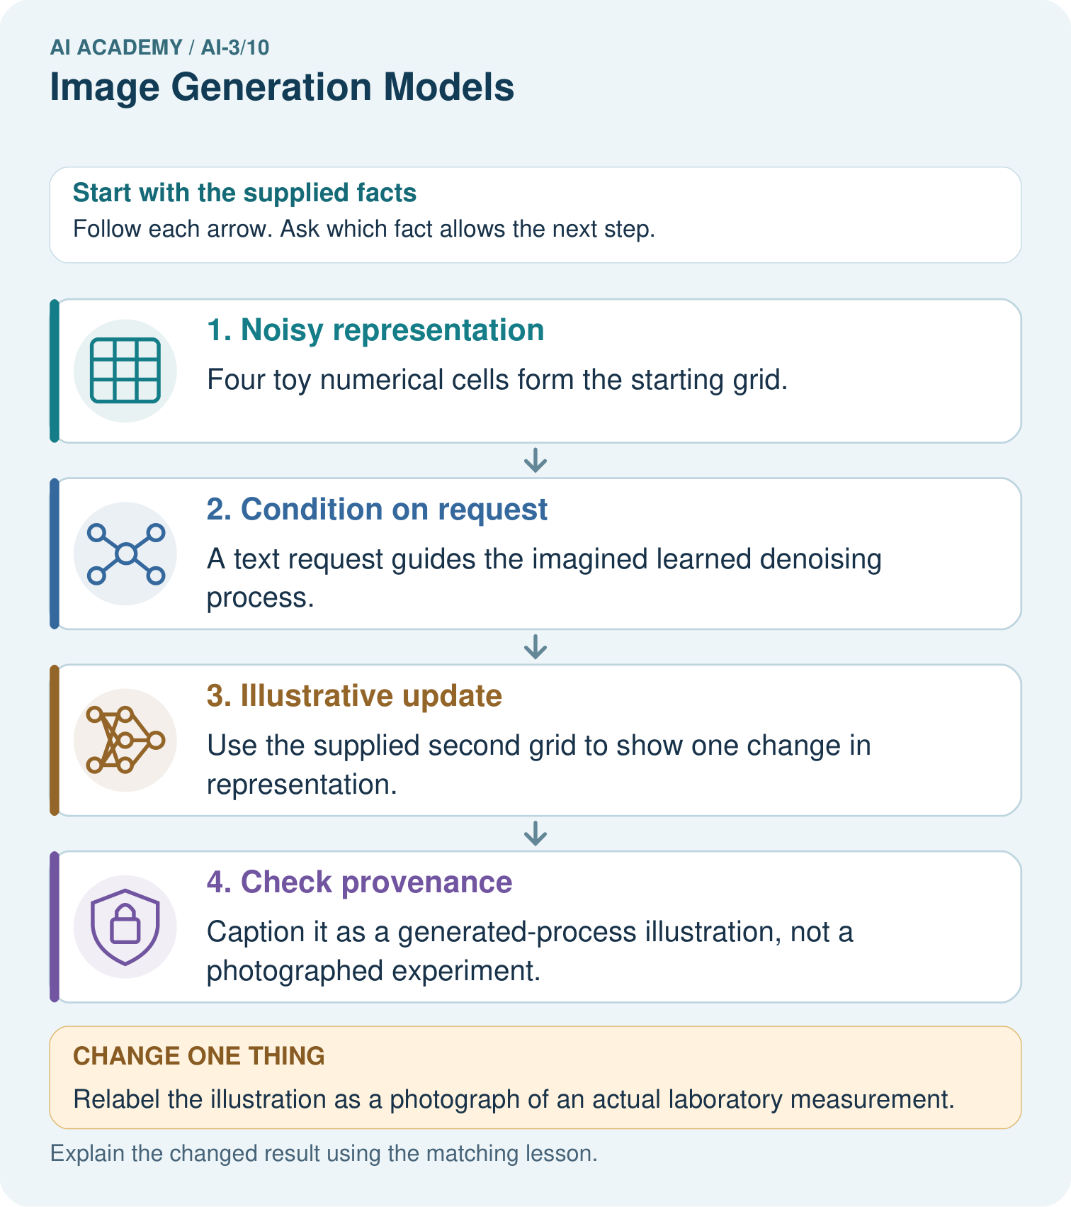
What may these two grids explain, and what can they not establish about a real generator?

My picture-based explanation and changed-case prediction
________________________________________________________________
________________________________________________________________
________________________________________________________________
________________________________________________________________
________________________________________________________________
________________________________________________________________
Support used: alone / hint / worked example. This record is practice evidence.
Project connection: Use Study Buddy generated diagrams only with clear provenance and checked educational labels.

19. Project portfolio milestone
Project: Verified Study Buddy
Current milestone: Make a transparent first version. Keep a trace of how one input becomes an output; explain the rule or learned component.
Use Study Buddy generated diagrams only with clear provenance and checked educational labels.
Evidence to keep | My record
This week’s input and deciding step
Prediction and actual result (or labelled paper trace)
One change since the previous checkpoint and why
One error or limit and the next test

Explain what this week adds to your project. Reuse last week’s record rather than starting again.
________________________________________________________________
________________________________________________________________
________________________________________________________________
________________________________________________________________
________________________________________________________________

