AI ACADEMY · WORKBOOK · ai-3/12

Speech and Audio Systems
Project: Verified Study Buddy

01. Recall and choose your starting point
Try the recall before opening notes. Then use a different colour or a labelled second line to correct your explanation.

Visual Composition
Without opening the old lesson, explain one key idea from Visual Composition. Give an example and a mistake that the idea helps you avoid.

My remembered idea, example and correction
________________________________________________________________
________________________________________________________________
________________________________________________________________

Prompt Evaluation
Without opening the old lesson, explain one key idea from Prompt Evaluation. Give an example and a mistake that the idea helps you avoid.

My remembered idea, example and correction
________________________________________________________________
________________________________________________________________
________________________________________________________________

Examples and Rubrics
Without opening the old lesson, explain one key idea from Examples and Rubrics. Give an example and a mistake that the idea helps you avoid.

My remembered idea, example and correction
________________________________________________________________
________________________________________________________________
________________________________________________________________

02. Practise with fading help
Use W2: Trace the worked case for Speech pipelines and multimodal evidence. Record the answer once; the lesson and workbook refer to the same attempt.
Given inputs | Procedure I chose | Middle steps | Result and check

The step I completed without help, and the hint I needed
________________________________________________________________
________________________________________________________________
________________________________________________________________

03. Individual reasoning check
Use the worked case for Speech pipelines and multimodal evidence. Proposed explanation: “The worked result establishes every future case”. Decide whether this explanation is supported. Point to the step or supplied fact that decides; explain your repair if needed.

My explanation before partner discussion
________________________________________________________________
________________________________________________________________
________________________________________________________________
________________________________________________________________

04. Independent transfer case

Independent case: Changed independent case
Known audio says “nineteen minus six”. Transcription says “ninety minus six”; the calculator returns84. Locate the first error and propose a check.

My independent explanation, trace and limits
________________________________________________________________
________________________________________________________________
________________________________________________________________
________________________________________________________________
________________________________________________________________
________________________________________________________________
________________________________________________________________
Attempt this case before feedback. Record any help. Earlier examples below are further practice; a case already practised with feedback cannot establish fresh transfer.

05. Your learning target
Audio says 'sixteen divided by four'; transcript says 'sixty divided by four'; calculator returns 15. Which stage first fails? What would a useful confirmation show?

06. Solve the given case
A speech tool hears fifteen as fifty, then calculates correctly using fifty.
Where did the error enter?
Show your trace, calculation or evidence

Write or draw your reasoning and evidence.
________________________________________________________________
________________________________________________________________
________________________________________________________________
________________________________________________________________
________________________________________________________________

07. Check a changed case
A recording says fifteen, but the transcript says fifty. The summary repeats fifty. Where did the error enter, and what should be checked first?
My independent answer and reason

Write or draw your reasoning and evidence.
________________________________________________________________
________________________________________________________________
________________________________________________________________
________________________________________________________________
________________________________________________________________

Week 12 Test and reflect

08. Design a revealing test
Create a changed input, boundary case or missing-information case. Write the expected answer or safe response before testing.
Test record | My evidence
Changed input or condition
Expected answer or fallback
Observed result
Why the result occurred

09. Project checkpoint
Show transcripts and require confirmation before saving memory or using tools.
The project change and evidence I will keep

Write or draw your reasoning and evidence.
________________________________________________________________
________________________________________________________________
________________________________________________________________
________________________________________________________________
________________________________________________________________

10. Self check
I can explain the mechanism. I can show evidence. I can handle a changed case. I can name a limit. Mark each as not yet, with help or independently, and attach supporting work.
Teacher review ____________________ Next step ____________________

11. Transfer practice from the original programme
Audio says 'sixteen divided by four'; transcript says 'sixty divided by four'; calculator returns 15. Which stage first fails? What would a useful confirmation show?

My independently reasoned answer
________________________________________________________________
________________________________________________________________
________________________________________________________________
________________________________________________________________
________________________________________________________________
________________________________________________________________
________________________________________________________________
Record support used: none, hint or teacher explanation.

12. W1 Explain the mechanism
Explain the weekly mechanism in your own words. Use the worked scenario to name its input, decision rule and output.

My reasoning and evidence
________________________________________________________________
________________________________________________________________
________________________________________________________________
________________________________________________________________
________________________________________________________________
________________________________________________________________

13. W2 Trace the worked case
Audio transcript reads fifteen boxes; a clear written inventory says fifty boxes. The original audio is unavailable and the assistant reports fifteen as certain. Show the intermediate steps and give the conclusion with its scope.

My reasoning and evidence
________________________________________________________________
________________________________________________________________
________________________________________________________________
________________________________________________________________
________________________________________________________________
________________________________________________________________
________________________________________________________________

14. W3 Audit the limit
A report omits this qualification: A stage-level accuracy or authority policy does not establish every modality agrees or every downstream claim is supported. Explain how omitting it could change a reader's interpretation, and write an accurate replacement.

My reasoning and evidence
________________________________________________________________
________________________________________________________________
________________________________________________________________
________________________________________________________________
________________________________________________________________
________________________________________________________________

15. W4 Apply a new case independently
Transcript says room E; a current written approval says room F. The task requires current approved room. Written approval is declared authoritative; trace the response and the transcription limit.

My reasoning and evidence
________________________________________________________________
________________________________________________________________
________________________________________________________________
________________________________________________________________
________________________________________________________________
________________________________________________________________
________________________________________________________________
________________________________________________________________

16. W5 Design a revealing follow-up
For the worked scenario, propose one additional case that could reveal a failure, describe its expected outcome before running it, and explain what would need to remain fixed for a fair comparison. Do not reuse W4 as a new final test after receiving feedback.

My reasoning and evidence
________________________________________________________________
________________________________________________________________
________________________________________________________________
________________________________________________________________
________________________________________________________________
________________________________________________________________
________________________________________________________________

17. Feedback, return check and learning record
Evidence | My record
Worked alone / hint / model
First step I repaired and why
New case checked later; date and result
What I can now explain without notes
One remaining question
Revisit this idea with your teacher after a delay. Familiarity is different from explaining and using it on a changed case.

18. Pictorial case practice: Speech and Audio Systems
A fictional learner dictates a calculation to a voice assistant.
Known audio phrase: “thirteen plus seven”. Transcript: “thirty plus seven”. Calculator returns 37.
Synthetic voice says “thirty-seven”. The example supplies ground truth; no real audio was analysed.
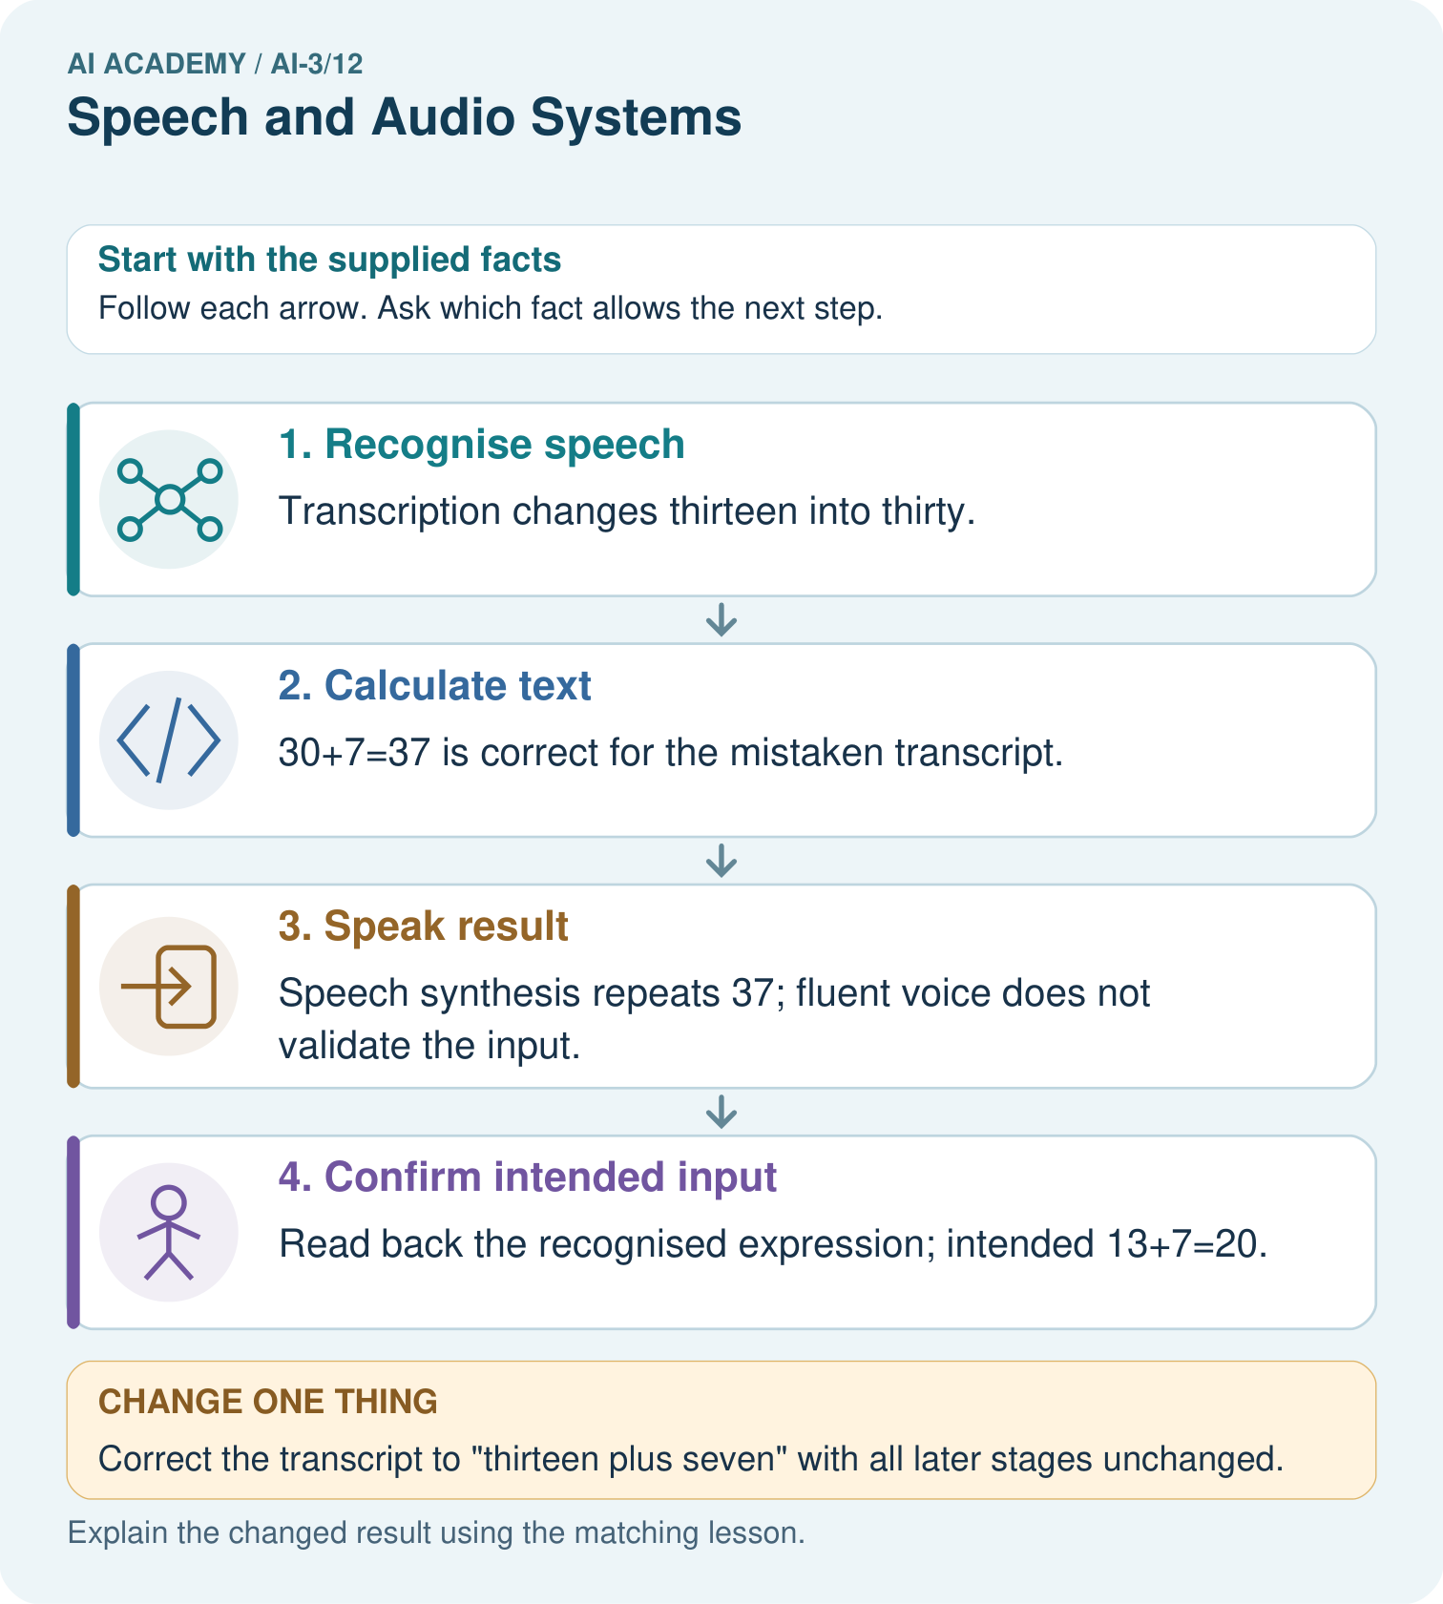
Which stage was initially wrong, and which stage was correctly operating on a wrong input?

My picture-based explanation and changed-case prediction
________________________________________________________________
________________________________________________________________
________________________________________________________________
________________________________________________________________
________________________________________________________________
________________________________________________________________
Support used: alone / hint / worked example. This record is practice evidence.
Project connection: Show Study Buddy recognised questions before calculating or retrieving important answers, especially numbers and dates.

19. Project portfolio milestone
Project: Verified Study Buddy
Current milestone: Make a transparent first version. Keep a trace of how one input becomes an output; explain the rule or learned component.
Show Study Buddy recognised questions before calculating or retrieving important answers, especially numbers and dates.
Evidence to keep | My record
This week’s input and deciding step
Prediction and actual result (or labelled paper trace)
One change since the previous checkpoint and why
One error or limit and the next test

Explain what this week adds to your project. Reuse last week’s record rather than starting again.
________________________________________________________________
________________________________________________________________
________________________________________________________________
________________________________________________________________
________________________________________________________________

