AI ACADEMY · WORKBOOK · ai-3/14

Hallucination Failure Types
Project: Verified Study Buddy

01. Recall and choose your starting point
Try the recall before opening notes. Then use a different colour or a labelled second line to correct your explanation.

Multimodal Evidence
Without opening the old lesson, explain one key idea from Multimodal Evidence. Give an example and a mistake that the idea helps you avoid.

My remembered idea, example and correction
________________________________________________________________
________________________________________________________________
________________________________________________________________

Visual Composition
Without opening the old lesson, explain one key idea from Visual Composition. Give an example and a mistake that the idea helps you avoid.

My remembered idea, example and correction
________________________________________________________________
________________________________________________________________
________________________________________________________________

Structured Output and Schemas
Without opening the old lesson, explain one key idea from Structured Output and Schemas. Give an example and a mistake that the idea helps you avoid.

My remembered idea, example and correction
________________________________________________________________
________________________________________________________________
________________________________________________________________

02. Practise with fading help
Use W2: Trace the worked case for Generation failures and verification. Record the answer once; the lesson and workbook refer to the same attempt.
Given inputs | Procedure I chose | Middle steps | Result and check

The step I completed without help, and the hint I needed
________________________________________________________________
________________________________________________________________
________________________________________________________________

03. Individual reasoning check
Use the worked case for Generation failures and verification. Proposed explanation: “The worked result establishes every future case”. Decide whether this explanation is supported. Point to the step or supplied fact that decides; explain your repair if needed.

My explanation before partner discussion
________________________________________________________________
________________________________________________________________
________________________________________________________________
________________________________________________________________

04. Independent transfer case

Independent case: Apply a new case independently
Source S: trip is 18 km; vehicle speed is 6 km/h, constant, excluding stops. Answer says 2 hours, 18 km and includes lunch. Audit and recalculate.

My independent explanation, trace and limits
________________________________________________________________
________________________________________________________________
________________________________________________________________
________________________________________________________________
________________________________________________________________
________________________________________________________________
________________________________________________________________
Attempt this case before feedback. Record any help. Earlier examples below are further practice; a case already practised with feedback cannot establish fresh transfer.

05. Your learning target
A generated answer contains a nonexistent quote, a real source unrelated to the claim and a correct sum using the wrong input. Classify the three failures and their repairs.

06. Solve the given case
An answer invents a quotation, cites a source lacking it and supplies an impossible date.
Separate the failures and checks.
Show your trace, calculation or evidence

Write or draw your reasoning and evidence.
________________________________________________________________
________________________________________________________________
________________________________________________________________
________________________________________________________________
________________________________________________________________

07. Check a changed case
An answer gives a book title that does not exist and quotes words absent from the cited passage. Identify two failures and a repair.
My independent answer and reason

Write or draw your reasoning and evidence.
________________________________________________________________
________________________________________________________________
________________________________________________________________
________________________________________________________________
________________________________________________________________

Week 14 Test and reflect

08. Design a revealing test
Create a changed input, boundary case or missing-information case. Write the expected answer or safe response before testing.
Test record | My evidence
Changed input or condition
Expected answer or fallback
Observed result
Why the result occurred

09. Project checkpoint
Study Buddy must distinguish source-backed claims, calculations, and unverified generation.
The project change and evidence I will keep

Write or draw your reasoning and evidence.
________________________________________________________________
________________________________________________________________
________________________________________________________________
________________________________________________________________
________________________________________________________________

10. Self check
I can explain the mechanism. I can show evidence. I can handle a changed case. I can name a limit. Mark each as not yet, with help or independently, and attach supporting work.
Teacher review ____________________ Next step ____________________

11. Transfer practice from the original programme
A generated answer contains a nonexistent quote, a real source unrelated to the claim and a correct sum using the wrong input. Classify the three failures and their repairs.

My independently reasoned answer
________________________________________________________________
________________________________________________________________
________________________________________________________________
________________________________________________________________
________________________________________________________________
________________________________________________________________
________________________________________________________________
Record support used: none, hint or teacher explanation.

12. W1 Explain the mechanism
Explain the weekly mechanism in your own words. Use the worked scenario to name its input, decision rule and output.

My reasoning and evidence
________________________________________________________________
________________________________________________________________
________________________________________________________________
________________________________________________________________
________________________________________________________________
________________________________________________________________

13. W2 Trace the worked case
Source R says room B seats 12 and the meeting starts at 15:00. Generated answer says B seats 20, starts at 15:00 and includes free lunch. Show the intermediate steps and give the conclusion with its scope.

My reasoning and evidence
________________________________________________________________
________________________________________________________________
________________________________________________________________
________________________________________________________________
________________________________________________________________
________________________________________________________________
________________________________________________________________

14. W3 Audit the limit
A report omits this qualification: Source agreement and arithmetic validity are separate checks; missing evidence is not proof of the opposite claim. Explain how omitting it could change a reader's interpretation, and write an accurate replacement.

My reasoning and evidence
________________________________________________________________
________________________________________________________________
________________________________________________________________
________________________________________________________________
________________________________________________________________
________________________________________________________________

15. W4 Apply a new case independently
Source S: trip is 18 km; vehicle speed is 6 km/h, constant, excluding stops. Answer says 2 hours, 18 km and includes lunch. Audit and recalculate.

My reasoning and evidence
________________________________________________________________
________________________________________________________________
________________________________________________________________
________________________________________________________________
________________________________________________________________
________________________________________________________________
________________________________________________________________
________________________________________________________________

16. W5 Design a revealing follow-up
For the worked scenario, propose one additional case that could reveal a failure, describe its expected outcome before running it, and explain what would need to remain fixed for a fair comparison. Do not reuse W4 as a new final test after receiving feedback.

My reasoning and evidence
________________________________________________________________
________________________________________________________________
________________________________________________________________
________________________________________________________________
________________________________________________________________
________________________________________________________________
________________________________________________________________

17. Feedback, return check and learning record
Evidence | My record
Worked alone / hint / model
First step I repaired and why
New case checked later; date and result
What I can now explain without notes
One remaining question
Revisit this idea with your teacher after a delay. Familiarity is different from explaining and using it on a changed case.

18. Pictorial case practice: Hallucination Failure Types
A fictional Study Buddy drafts a field-trip summary from one approved record.
Source S: trail length 12 km; planned constant speed 4 km/h, excluding stops; departure 09:00.
Draft: “The walk takes two hours, starts at 09:00 and includes free lunch.” No lunch record is supplied.
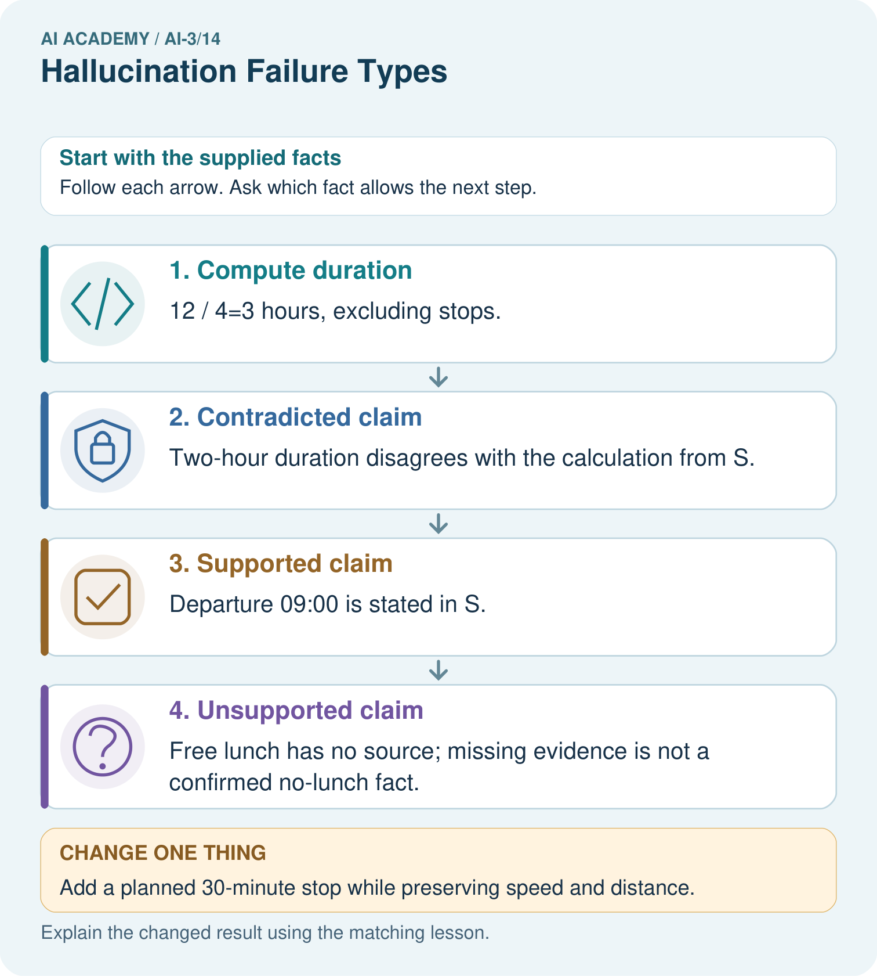
Can we conclude there will definitely be no lunch from S alone?

My picture-based explanation and changed-case prediction
________________________________________________________________
________________________________________________________________
________________________________________________________________
________________________________________________________________
________________________________________________________________
________________________________________________________________
Support used: alone / hint / worked example. This record is practice evidence.
Project connection: Audit Study Buddy outputs claim by claim, recording contradiction, missing support and correct calculations separately.

19. Project portfolio milestone
Project: Verified Study Buddy
Current milestone: Test changed cases. Keep normal, boundary and failure cases; compare expected and observed results.
Audit Study Buddy outputs claim by claim, recording contradiction, missing support and correct calculations separately.
Evidence to keep | My record
This week’s input and deciding step
Prediction and actual result (or labelled paper trace)
One change since the previous checkpoint and why
One error or limit and the next test

Explain what this week adds to your project. Reuse last week’s record rather than starting again.
________________________________________________________________
________________________________________________________________
________________________________________________________________
________________________________________________________________
________________________________________________________________

