AI ACADEMY · WORKBOOK · ai-3/15

Source Quality
Project: Verified Study Buddy

01. Recall and choose your starting point
Try the recall before opening notes. Then use a different colour or a labelled second line to correct your explanation.

Hallucination Failure Types
Without opening the old lesson, explain one key idea from Hallucination Failure Types. Give an example and a mistake that the idea helps you avoid.

My remembered idea, example and correction
________________________________________________________________
________________________________________________________________
________________________________________________________________

Speech and Audio Systems
Without opening the old lesson, explain one key idea from Speech and Audio Systems. Give an example and a mistake that the idea helps you avoid.

My remembered idea, example and correction
________________________________________________________________
________________________________________________________________
________________________________________________________________

Prompt Evaluation
Without opening the old lesson, explain one key idea from Prompt Evaluation. Give an example and a mistake that the idea helps you avoid.

My remembered idea, example and correction
________________________________________________________________
________________________________________________________________
________________________________________________________________

02. Practise with fading help
Use W2: Trace the worked case for Conflicting and time-sensitive sources. Record the answer once; the lesson and workbook refer to the same attempt.
Given inputs | Procedure I chose | Middle steps | Result and check

The step I completed without help, and the hint I needed
________________________________________________________________
________________________________________________________________
________________________________________________________________

03. Individual reasoning check
Use the worked case for Conflicting and time-sensitive sources. Proposed explanation: “The worked result establishes every future case”. Decide whether this explanation is supported. Point to the step or supplied fact that decides; explain your repair if needed.

My explanation before partner discussion
________________________________________________________________
________________________________________________________________
________________________________________________________________
________________________________________________________________

04. Independent transfer case

Independent case: Apply a new case independently
Original allows capacity 14. Signed amendment lowers it to 9 effective day 5. Query concerns days 4 and 6. Trace both and preserve versions.

My independent explanation, trace and limits
________________________________________________________________
________________________________________________________________
________________________________________________________________
________________________________________________________________
________________________________________________________________
________________________________________________________________
________________________________________________________________
Attempt this case before feedback. Record any help. Earlier examples below are further practice; a case already practised with feedback cannot establish fresh transfer.

05. Your learning target
A school notice updated Friday conflicts with a blog quoting Monday's notice about a room change. Which source should you inspect first, and why is newest alone not enough?

06. Solve the given case
An original experiment report and an anonymous unlinked summary describe a method.
Where should verification begin?
Show your trace, calculation or evidence

Write or draw your reasoning and evidence.
________________________________________________________________
________________________________________________________________
________________________________________________________________
________________________________________________________________
________________________________________________________________

07. Check a changed case
For a school's current opening time, compare an undated repost with a dated notice issued by the school. Which is the stronger starting source, and what must still be checked?
My independent answer and reason

Write or draw your reasoning and evidence.
________________________________________________________________
________________________________________________________________
________________________________________________________________
________________________________________________________________
________________________________________________________________

Week 15 Test and reflect

08. Design a revealing test
Create a changed input, boundary case or missing-information case. Write the expected answer or safe response before testing.
Test record | My evidence
Changed input or condition
Expected answer or fallback
Observed result
Why the result occurred

09. Project checkpoint
Use an approved source list and record why each source fits the learner’s question.
The project change and evidence I will keep

Write or draw your reasoning and evidence.
________________________________________________________________
________________________________________________________________
________________________________________________________________
________________________________________________________________
________________________________________________________________

10. Self check
I can explain the mechanism. I can show evidence. I can handle a changed case. I can name a limit. Mark each as not yet, with help or independently, and attach supporting work.
Teacher review ____________________ Next step ____________________

11. Transfer practice from the original programme
A school notice updated Friday conflicts with a blog quoting Monday's notice about a room change. Which source should you inspect first, and why is newest alone not enough?

My independently reasoned answer
________________________________________________________________
________________________________________________________________
________________________________________________________________
________________________________________________________________
________________________________________________________________
________________________________________________________________
________________________________________________________________
Record support used: none, hint or teacher explanation.

12. W1 Explain the mechanism
Explain the weekly mechanism in your own words. Use the worked scenario to name its input, decision rule and output.

My reasoning and evidence
________________________________________________________________
________________________________________________________________
________________________________________________________________
________________________________________________________________
________________________________________________________________
________________________________________________________________

13. W2 Trace the worked case
Notice N says room A from Monday. Signed amendment M references N and changes to B effective Wednesday. Query asks Tuesday, then Thursday. Show the intermediate steps and give the conclusion with its scope.

My reasoning and evidence
________________________________________________________________
________________________________________________________________
________________________________________________________________
________________________________________________________________
________________________________________________________________
________________________________________________________________
________________________________________________________________

14. W3 Audit the limit
A report omits this qualification: An unspecified authority or effective-time rule leaves a conflict unresolved; do not invent precedence. Explain how omitting it could change a reader's interpretation, and write an accurate replacement.

My reasoning and evidence
________________________________________________________________
________________________________________________________________
________________________________________________________________
________________________________________________________________
________________________________________________________________
________________________________________________________________

15. W4 Apply a new case independently
Original allows capacity 14. Signed amendment lowers it to 9 effective day 5. Query concerns days 4 and 6. Trace both and preserve versions.

My reasoning and evidence
________________________________________________________________
________________________________________________________________
________________________________________________________________
________________________________________________________________
________________________________________________________________
________________________________________________________________
________________________________________________________________
________________________________________________________________

16. W5 Design a revealing follow-up
For the worked scenario, propose one additional case that could reveal a failure, describe its expected outcome before running it, and explain what would need to remain fixed for a fair comparison. Do not reuse W4 as a new final test after receiving feedback.

My reasoning and evidence
________________________________________________________________
________________________________________________________________
________________________________________________________________
________________________________________________________________
________________________________________________________________
________________________________________________________________
________________________________________________________________

17. Feedback, return check and learning record
Evidence | My record
Worked alone / hint / model
First step I repaired and why
New case checked later; date and result
What I can now explain without notes
One remaining question
Revisit this idea with your teacher after a delay. Familiarity is different from explaining and using it on a changed case.

18. Pictorial case practice: Source Quality
A fictional Study Buddy answers which room a club is authorised to use.
Signed notice A: Hall 1 from day 1. Signed amendment B references A and changes to Hall 3 effective day 8.
An old copy of A is reuploaded on day 10. B remains the authoritative amendment. Queries concern day 6 and day 9.
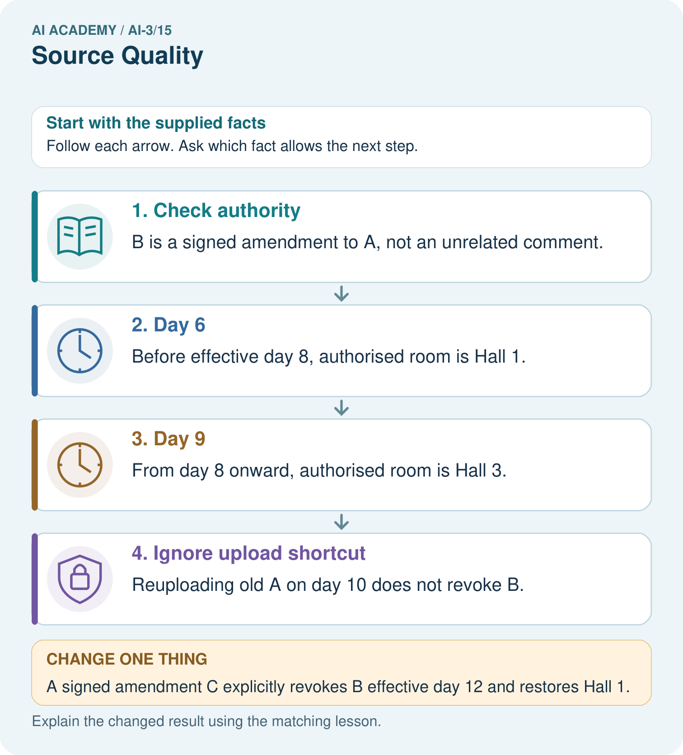
Which source fields must be checked before answering day 9?

My picture-based explanation and changed-case prediction
________________________________________________________________
________________________________________________________________
________________________________________________________________
________________________________________________________________
________________________________________________________________
________________________________________________________________
Support used: alone / hint / worked example. This record is practice evidence.
Project connection: Store Study Buddy source identity, version, authority and effective date, especially for schedules or changing classroom rules.

19. Project portfolio milestone
Project: Verified Study Buddy
Current milestone: Test changed cases. Keep normal, boundary and failure cases; compare expected and observed results.
Store Study Buddy source identity, version, authority and effective date, especially for schedules or changing classroom rules.
Evidence to keep | My record
This week’s input and deciding step
Prediction and actual result (or labelled paper trace)
One change since the previous checkpoint and why
One error or limit and the next test

Explain what this week adds to your project. Reuse last week’s record rather than starting again.
________________________________________________________________
________________________________________________________________
________________________________________________________________
________________________________________________________________
________________________________________________________________

