AI ACADEMY · WORKBOOK · ai-3/16

Verify Numbers and Dates
Project: Verified Study Buddy

01. Recall and choose your starting point
Try the recall before opening notes. Then use a different colour or a labelled second line to correct your explanation.

Source Quality
Without opening the old lesson, explain one key idea from Source Quality. Give an example and a mistake that the idea helps you avoid.

My remembered idea, example and correction
________________________________________________________________
________________________________________________________________
________________________________________________________________

Multimodal Evidence
Without opening the old lesson, explain one key idea from Multimodal Evidence. Give an example and a mistake that the idea helps you avoid.

My remembered idea, example and correction
________________________________________________________________
________________________________________________________________
________________________________________________________________

Image Generation Models
Without opening the old lesson, explain one key idea from Image Generation Models. Give an example and a mistake that the idea helps you avoid.

My remembered idea, example and correction
________________________________________________________________
________________________________________________________________
________________________________________________________________

02. Practise with fading help
Use W2: Trace the worked case for Claim support and citation evaluation. Record the answer once; the lesson and workbook refer to the same attempt.
Given inputs | Procedure I chose | Middle steps | Result and check

The step I completed without help, and the hint I needed
________________________________________________________________
________________________________________________________________
________________________________________________________________

03. Individual reasoning check
Use the worked case for Claim support and citation evaluation. Proposed explanation: “The worked result establishes every future case”. Decide whether this explanation is supported. Point to the step or supplied fact that decides; explain your repair if needed.

My explanation before partner discussion
________________________________________________________________
________________________________________________________________
________________________________________________________________
________________________________________________________________

04. Independent transfer case

Independent case: Changed independent case
A draft claims18 of24 learners is60%, and gives an April31 deadline. Check both statements without inventing a deadline.

My independent explanation, trace and limits
________________________________________________________________
________________________________________________________________
________________________________________________________________
________________________________________________________________
________________________________________________________________
________________________________________________________________
________________________________________________________________
Attempt this case before feedback. Record any help. Earlier examples below are further practice; a case already practised with feedback cannot establish fresh transfer.

05. Your learning target
A report says 21/28=70% and gives February 30 as the deadline. Correct what can be computed and identify what must be checked externally.

06. Solve the given case
An answer says 15/20=80% and sets a deadline of February 30.
Verify both.
Show your trace, calculation or evidence

Write or draw your reasoning and evidence.
________________________________________________________________
________________________________________________________________
________________________________________________________________
________________________________________________________________
________________________________________________________________

07. Check a changed case
A report says 12 of 40 responses is 40%. Recalculate and state the correction with the denominator.
My independent answer and reason

Write or draw your reasoning and evidence.
________________________________________________________________
________________________________________________________________
________________________________________________________________
________________________________________________________________
________________________________________________________________

Week 16 Test and reflect

08. Design a revealing test
Create a changed input, boundary case or missing-information case. Write the expected answer or safe response before testing.
Test record | My evidence
Changed input or condition
Expected answer or fallback
Observed result
Why the result occurred

09. Project checkpoint
Route arithmetic to a calculator and dates to direct sources before presenting them.
The project change and evidence I will keep

Write or draw your reasoning and evidence.
________________________________________________________________
________________________________________________________________
________________________________________________________________
________________________________________________________________
________________________________________________________________

10. Self check
I can explain the mechanism. I can show evidence. I can handle a changed case. I can name a limit. Mark each as not yet, with help or independently, and attach supporting work.
Teacher review ____________________ Next step ____________________

11. Transfer practice from the original programme
A report says 21/28=70% and gives February 30 as the deadline. Correct what can be computed and identify what must be checked externally.

My independently reasoned answer
________________________________________________________________
________________________________________________________________
________________________________________________________________
________________________________________________________________
________________________________________________________________
________________________________________________________________
________________________________________________________________
Record support used: none, hint or teacher explanation.

12. W1 Explain the mechanism
Explain the weekly mechanism in your own words. Use the worked scenario to name its input, decision rule and output.

My reasoning and evidence
________________________________________________________________
________________________________________________________________
________________________________________________________________
________________________________________________________________
________________________________________________________________
________________________________________________________________

13. W2 Trace the worked case
An answer has four factual claims. Three have citations, but only two are supported by their cited passages. All links exist. Show the intermediate steps and give the conclusion with its scope.

My reasoning and evidence
________________________________________________________________
________________________________________________________________
________________________________________________________________
________________________________________________________________
________________________________________________________________
________________________________________________________________
________________________________________________________________

14. W3 Audit the limit
A report omits this qualification: Citation counts do not establish truth beyond the supplied sources or the correctness of uncited claims. Explain how omitting it could change a reader's interpretation, and write an accurate replacement.

My reasoning and evidence
________________________________________________________________
________________________________________________________________
________________________________________________________________
________________________________________________________________
________________________________________________________________
________________________________________________________________

15. W4 Apply a new case independently
Five claims; four cited; three supported by cited passages; one cited ID is nonexistent. Compute support and citation presence and explain link limits.

My reasoning and evidence
________________________________________________________________
________________________________________________________________
________________________________________________________________
________________________________________________________________
________________________________________________________________
________________________________________________________________
________________________________________________________________
________________________________________________________________

16. W5 Design a revealing follow-up
For the worked scenario, propose one additional case that could reveal a failure, describe its expected outcome before running it, and explain what would need to remain fixed for a fair comparison. Do not reuse W4 as a new final test after receiving feedback.

My reasoning and evidence
________________________________________________________________
________________________________________________________________
________________________________________________________________
________________________________________________________________
________________________________________________________________
________________________________________________________________
________________________________________________________________

17. Feedback, return check and learning record
Evidence | My record
Worked alone / hint / model
First step I repaired and why
New case checked later; date and result
What I can now explain without notes
One remaining question
Revisit this idea with your teacher after a delay. Familiarity is different from explaining and using it on a changed case.

18. Pictorial case practice: Verify Numbers and Dates
A fictional Study Buddy checks a science-club summary against supplied counts and calendar facts.
Record: 15 of 20 fictional model trials passed. Draft: “70% passed; the meeting is on June 31.”
June has 30 days. No authoritative record gives the intended meeting date.
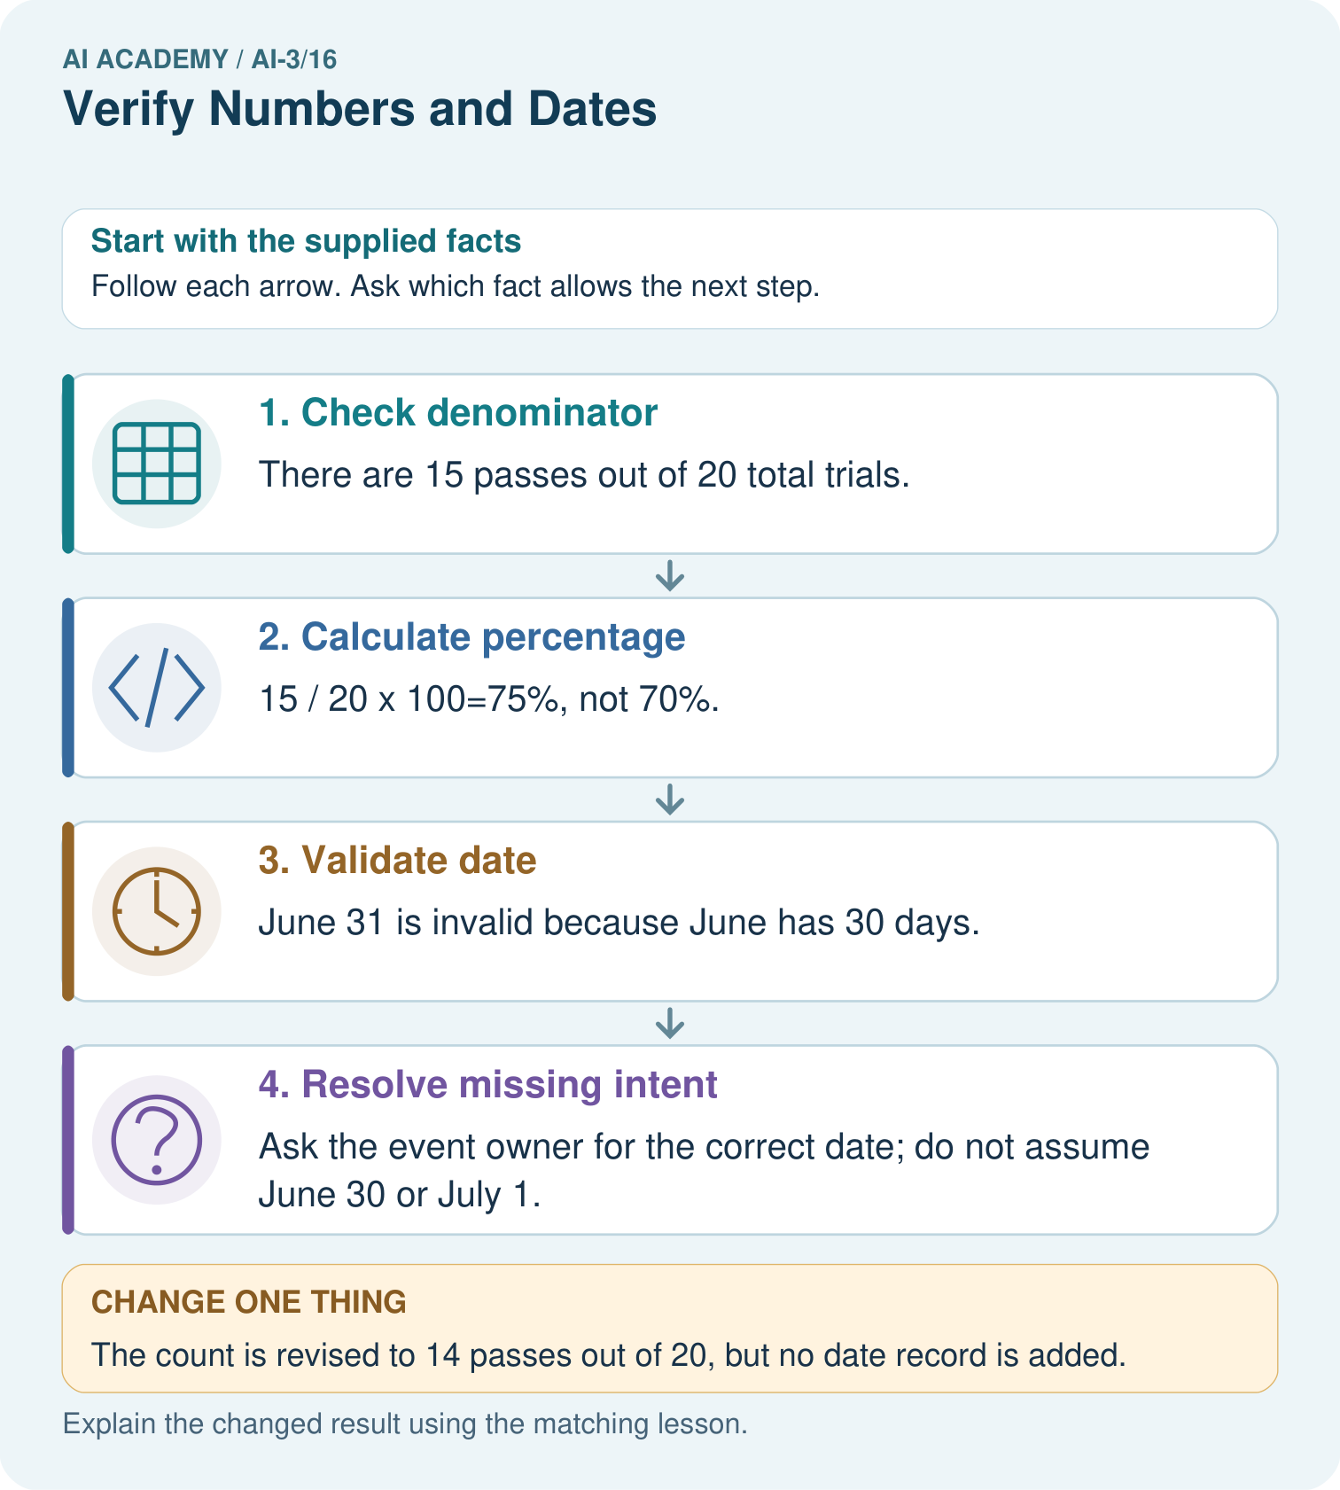
Which part can be corrected immediately from existing evidence, and which needs follow-up?

My picture-based explanation and changed-case prediction
________________________________________________________________
________________________________________________________________
________________________________________________________________
________________________________________________________________
________________________________________________________________
________________________________________________________________
Support used: alone / hint / worked example. This record is practice evidence.
Project connection: Make Study Buddy check quantities, units, dates and source support separately; record unresolved fields instead of guessing.

19. Project portfolio milestone
Project: Verified Study Buddy
Current milestone: Test changed cases. Keep normal, boundary and failure cases; compare expected and observed results.
Make Study Buddy check quantities, units, dates and source support separately; record unresolved fields instead of guessing.
Evidence to keep | My record
This week’s input and deciding step
Prediction and actual result (or labelled paper trace)
One change since the previous checkpoint and why
One error or limit and the next test

Explain what this week adds to your project. Reuse last week’s record rather than starting again.
________________________________________________________________
________________________________________________________________
________________________________________________________________
________________________________________________________________
________________________________________________________________

