AI ACADEMY · WORKBOOK · ai-3/18

Retrieval Augmented Generation
Project: Verified Study Buddy

01. Recall and choose your starting point
Try the recall before opening notes. Then use a different colour or a labelled second line to correct your explanation.

Model Memory vs Retrieval
Without opening the old lesson, explain one key idea from Model Memory vs Retrieval. Give an example and a mistake that the idea helps you avoid.

My remembered idea, example and correction
________________________________________________________________
________________________________________________________________
________________________________________________________________

Source Quality
Without opening the old lesson, explain one key idea from Source Quality. Give an example and a mistake that the idea helps you avoid.

My remembered idea, example and correction
________________________________________________________________
________________________________________________________________
________________________________________________________________

Speech and Audio Systems
Without opening the old lesson, explain one key idea from Speech and Audio Systems. Give an example and a mistake that the idea helps you avoid.

My remembered idea, example and correction
________________________________________________________________
________________________________________________________________
________________________________________________________________

02. Practise with fading help
Use W2: Trace the worked case for Building a grounded answer. Record the answer once; the lesson and workbook refer to the same attempt.
Given inputs | Procedure I chose | Middle steps | Result and check

The step I completed without help, and the hint I needed
________________________________________________________________
________________________________________________________________
________________________________________________________________

03. Individual reasoning check
Use the worked case for Building a grounded answer. Proposed explanation: “The worked result establishes every future case”. Decide whether this explanation is supported. Point to the step or supplied fact that decides; explain your repair if needed.

My explanation before partner discussion
________________________________________________________________
________________________________________________________________
________________________________________________________________
________________________________________________________________

04. Independent transfer case

Independent case: Apply a new case independently
Source A approves room H; B lists H capacity 7, except maintenance limit 4. Maintenance status is unknown. Write a grounded response.

My independent explanation, trace and limits
________________________________________________________________
________________________________________________________________
________________________________________________________________
________________________________________________________________
________________________________________________________________
________________________________________________________________
________________________________________________________________
Attempt this case before feedback. Record any help. Earlier examples below are further practice; a case already practised with feedback cannot establish fresh transfer.

05. Your learning target
Sources: A='Library opens 9'; B='Cafe opens 8'; C='Library closes 5'. A question asks when the library opens. The retriever returns only B and C. What should the generator do?

06. Solve the given case
Note A says library opens at 9. Note B says returns go in the blue box.
Answer opening time with evidence.
Show your trace, calculation or evidence

Write or draw your reasoning and evidence.
________________________________________________________________
________________________________________________________________
________________________________________________________________
________________________________________________________________
________________________________________________________________

07. Check a changed case
A retrieved passage says the club meets Tuesday; it says nothing about cost. The assistant answers Tuesday, free entry. Which part is grounded and what should replace the unsupported part?
My independent answer and reason

Write or draw your reasoning and evidence.
________________________________________________________________
________________________________________________________________
________________________________________________________________
________________________________________________________________
________________________________________________________________

Week 18 Test and reflect

08. Design a revealing test
Create a changed input, boundary case or missing-information case. Write the expected answer or safe response before testing.
Test record | My evidence
Changed input or condition
Expected answer or fallback
Observed result
Why the result occurred

09. Project checkpoint
Implement question → retrieve → inspect → answer → cite → verify as the core architecture.
The project change and evidence I will keep

Write or draw your reasoning and evidence.
________________________________________________________________
________________________________________________________________
________________________________________________________________
________________________________________________________________
________________________________________________________________

10. Self check
I can explain the mechanism. I can show evidence. I can handle a changed case. I can name a limit. Mark each as not yet, with help or independently, and attach supporting work.
Teacher review ____________________ Next step ____________________

11. Transfer practice from the original programme
Sources: A='Library opens 9'; B='Cafe opens 8'; C='Library closes 5'. A question asks when the library opens. The retriever returns only B and C. What should the generator do?

My independently reasoned answer
________________________________________________________________
________________________________________________________________
________________________________________________________________
________________________________________________________________
________________________________________________________________
________________________________________________________________
________________________________________________________________
Record support used: none, hint or teacher explanation.

12. W1 Explain the mechanism
Explain the weekly mechanism in your own words. Use the worked scenario to name its input, decision rule and output.

My reasoning and evidence
________________________________________________________________
________________________________________________________________
________________________________________________________________
________________________________________________________________
________________________________________________________________
________________________________________________________________

13. W2 Trace the worked case
Current source P approves room C; Q lists C capacity 10. Draft says room C is approved, seats 10 and offers lunch. Show the intermediate steps and give the conclusion with its scope.

My reasoning and evidence
________________________________________________________________
________________________________________________________________
________________________________________________________________
________________________________________________________________
________________________________________________________________
________________________________________________________________
________________________________________________________________

14. W3 Audit the limit
A report omits this qualification: Grounding requires support for the exact claim, including conditions; attaching a source name is insufficient. Explain how omitting it could change a reader's interpretation, and write an accurate replacement.

My reasoning and evidence
________________________________________________________________
________________________________________________________________
________________________________________________________________
________________________________________________________________
________________________________________________________________
________________________________________________________________

15. W4 Apply a new case independently
Source A approves room H; B lists H capacity 7, except maintenance limit 4. Maintenance status is unknown. Write a grounded response.

My reasoning and evidence
________________________________________________________________
________________________________________________________________
________________________________________________________________
________________________________________________________________
________________________________________________________________
________________________________________________________________
________________________________________________________________
________________________________________________________________

16. W5 Design a revealing follow-up
For the worked scenario, propose one additional case that could reveal a failure, describe its expected outcome before running it, and explain what would need to remain fixed for a fair comparison. Do not reuse W4 as a new final test after receiving feedback.

My reasoning and evidence
________________________________________________________________
________________________________________________________________
________________________________________________________________
________________________________________________________________
________________________________________________________________
________________________________________________________________
________________________________________________________________

17. Chunking and document structure — W1 Explain the mechanism
Explain the weekly mechanism in your own words. Use the worked scenario to name its input, decision rule and output.

My reasoning and evidence
________________________________________________________________
________________________________________________________________
________________________________________________________________
________________________________________________________________
________________________________________________________________
________________________________________________________________

18. Chunking and document structure — W2 Trace the worked case
A notice says capacity 20, followed by during maintenance capacity 8. Separate chunks contain each sentence but retrieval returns only the first. Show the intermediate steps and give the conclusion with its scope.

My reasoning and evidence
________________________________________________________________
________________________________________________________________
________________________________________________________________
________________________________________________________________
________________________________________________________________
________________________________________________________________
________________________________________________________________

19. Chunking and document structure — W3 Audit the limit
A report omits this qualification: Smaller chunks can improve selectivity while losing necessary qualifiers; chunk size alone is not retrieval quality. Explain how omitting it could change a reader's interpretation, and write an accurate replacement.

My reasoning and evidence
________________________________________________________________
________________________________________________________________
________________________________________________________________
________________________________________________________________
________________________________________________________________
________________________________________________________________

20. Chunking and document structure — W4 Apply a new case independently
A rule section says rooms close at 17:00; an exception paragraph says Friday closes at 16:00. The question is Friday closing. Design a complete chunk reference.

My reasoning and evidence
________________________________________________________________
________________________________________________________________
________________________________________________________________
________________________________________________________________
________________________________________________________________
________________________________________________________________
________________________________________________________________
________________________________________________________________

21. Chunking and document structure — W5 Design a revealing follow-up
For the worked scenario, propose one additional case that could reveal a failure, describe its expected outcome before running it, and explain what would need to remain fixed for a fair comparison. Do not reuse W4 as a new final test after receiving feedback.

My reasoning and evidence
________________________________________________________________
________________________________________________________________
________________________________________________________________
________________________________________________________________
________________________________________________________________
________________________________________________________________
________________________________________________________________

22. Lexical and vector retrieval — W1 Explain the mechanism
Explain the weekly mechanism in your own words. Use the worked scenario to name its input, decision rule and output.

My reasoning and evidence
________________________________________________________________
________________________________________________________________
________________________________________________________________
________________________________________________________________
________________________________________________________________
________________________________________________________________

23. Lexical and vector retrieval — W2 Trace the worked case
Query terms red sensor. D1 text red sensor manual; D2 text red paint. Their lexical scores are 2 and 1. Vector query [1, 0], D1=[.4, .9], D2=[.8, .1]. Show the intermediate steps and give the conclusion with its scope.

My reasoning and evidence
________________________________________________________________
________________________________________________________________
________________________________________________________________
________________________________________________________________
________________________________________________________________
________________________________________________________________
________________________________________________________________

24. Lexical and vector retrieval — W3 Audit the limit
A report omits this qualification: Similarity and relevance are different quantities; exact terminology, metadata and permissions may be necessary. Explain how omitting it could change a reader's interpretation, and write an accurate replacement.

My reasoning and evidence
________________________________________________________________
________________________________________________________________
________________________________________________________________
________________________________________________________________
________________________________________________________________
________________________________________________________________

25. Lexical and vector retrieval — W4 Apply a new case independently
Query terms blue battery. E1 text blue battery guide, vector [.2, .8]; E2 text blue ribbon, vector [.9, .1]. Query vector [1, 0]. Compute both rankings.

My reasoning and evidence
________________________________________________________________
________________________________________________________________
________________________________________________________________
________________________________________________________________
________________________________________________________________
________________________________________________________________
________________________________________________________________
________________________________________________________________

26. Lexical and vector retrieval — W5 Design a revealing follow-up
For the worked scenario, propose one additional case that could reveal a failure, describe its expected outcome before running it, and explain what would need to remain fixed for a fair comparison. Do not reuse W4 as a new final test after receiving feedback.

My reasoning and evidence
________________________________________________________________
________________________________________________________________
________________________________________________________________
________________________________________________________________
________________________________________________________________
________________________________________________________________
________________________________________________________________

27. Feedback, return check and learning record
Evidence | My record
Worked alone / hint / model
First step I repaired and why
New case checked later; date and result
What I can now explain without notes
One remaining question
Revisit this idea with your teacher after a delay. Familiarity is different from explaining and using it on a changed case.

28. Pictorial case practice: Retrieval Augmented Generation
Turn a short science source into an answer with a visible claim-to-source map.
Approved note S4 says: ice is solid water; warming can melt ice into liquid water. No temperature or speed is supplied.
All inputs and outcomes in this worked example are invented classroom data; no real model run is claimed.
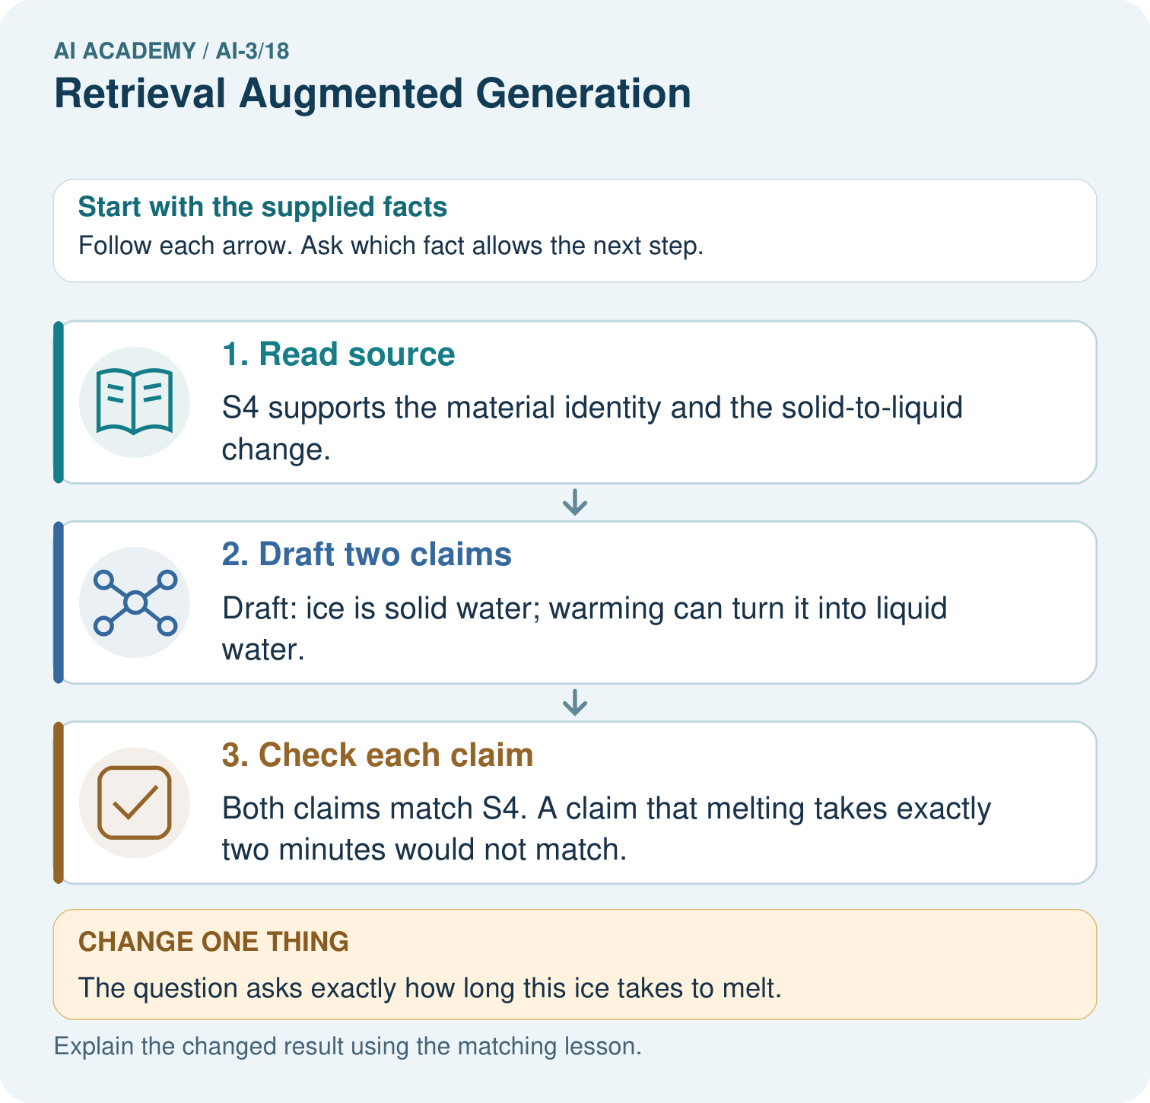
Which part of the source supports a two-minute melting claim? Point to the relevant step in the picture, then write the changed result and the rule or evidence that supports it.

My picture-based explanation and changed-case prediction
________________________________________________________________
________________________________________________________________
________________________________________________________________
________________________________________________________________
________________________________________________________________
________________________________________________________________
Support used: alone / hint / worked example. This record is practice evidence.
Project connection: For your Verified Study Buddy, save the input, procedure, observed result and limitation of this check. Label this worked example as practice; use a different, previously unreviewed case when checking independent understanding.

29. Project portfolio milestone
Project: Verified Study Buddy
Current milestone: Test changed cases. Keep normal, boundary and failure cases; compare expected and observed results.
For your Verified Study Buddy, save the input, procedure, observed result and limitation of this check. Label this worked example as practice; use a different, previously unreviewed case when checking independent understanding.
Evidence to keep | My record
This week’s input and deciding step
Prediction and actual result (or labelled paper trace)
One change since the previous checkpoint and why
One error or limit and the next test

Explain what this week adds to your project. Reuse last week’s record rather than starting again.
________________________________________________________________
________________________________________________________________
________________________________________________________________
________________________________________________________________
________________________________________________________________

