AI ACADEMY · WORKBOOK · ai-3/21

Tools and APIs
Project: Verified Study Buddy

01. Recall and choose your starting point
Try the recall before opening notes. Then use a different colour or a labelled second line to correct your explanation.

Conversation State and Memory
Without opening the old lesson, explain one key idea from Conversation State and Memory. Give an example and a mistake that the idea helps you avoid.

My remembered idea, example and correction
________________________________________________________________
________________________________________________________________
________________________________________________________________

Retrieval Augmented Generation
Without opening the old lesson, explain one key idea from Retrieval Augmented Generation. Give an example and a mistake that the idea helps you avoid.

My remembered idea, example and correction
________________________________________________________________
________________________________________________________________
________________________________________________________________

Source Quality
Without opening the old lesson, explain one key idea from Source Quality. Give an example and a mistake that the idea helps you avoid.

My remembered idea, example and correction
________________________________________________________________
________________________________________________________________
________________________________________________________________

02. Practise with fading help
Use W2: Trace the worked case for Tools and API contracts. Record the answer once; the lesson and workbook refer to the same attempt.
Given inputs | Procedure I chose | Middle steps | Result and check

The step I completed without help, and the hint I needed
________________________________________________________________
________________________________________________________________
________________________________________________________________

03. Individual reasoning check
Use the worked case for Tools and API contracts. Proposed explanation: “The worked result establishes every future case”. Decide whether this explanation is supported. Point to the step or supplied fact that decides; explain your repair if needed.

My explanation before partner discussion
________________________________________________________________
________________________________________________________________
________________________________________________________________
________________________________________________________________

04. Independent transfer case

Independent case: Apply a new case independently
Tool accepts room_id string. Calls are {room_id:7}, {room_id:K} and {room_id:K, delete:true}. Validate; K is absent from the registry.

My independent explanation, trace and limits
________________________________________________________________
________________________________________________________________
________________________________________________________________
________________________________________________________________
________________________________________________________________
________________________________________________________________
________________________________________________________________
Attempt this case before feedback. Record any help. Earlier examples below are further practice; a case already practised with feedback cannot establish fresh transfer.

05. Your learning target
A tool can calculate or search supplied notes. The request is 'What is 17×6, and where do roots take up water?' Assign each subtask and describe output checks.

06. Solve the given case
An assistant has calculator and source-search tools. Request: 12 times 9 and habitat definition from a class pack.
Choose and verify tools.
Show your trace, calculation or evidence

Write or draw your reasoning and evidence.
________________________________________________________________
________________________________________________________________
________________________________________________________________
________________________________________________________________
________________________________________________________________

07. Check a changed case
A tool can look up book availability and also place an order. The user asks only whether a book is available. Which action is authorized?
My independent answer and reason

Write or draw your reasoning and evidence.
________________________________________________________________
________________________________________________________________
________________________________________________________________
________________________________________________________________
________________________________________________________________

Week 21 Test and reflect

08. Design a revealing test
Create a changed input, boundary case or missing-information case. Write the expected answer or safe response before testing.
Test record | My evidence
Changed input or condition
Expected answer or fallback
Observed result
Why the result occurred

09. Project checkpoint
Allow only retrieval and calculator tools with validated arguments and visible results.
The project change and evidence I will keep

Write or draw your reasoning and evidence.
________________________________________________________________
________________________________________________________________
________________________________________________________________
________________________________________________________________
________________________________________________________________

10. Self check
I can explain the mechanism. I can show evidence. I can handle a changed case. I can name a limit. Mark each as not yet, with help or independently, and attach supporting work.
Teacher review ____________________ Next step ____________________

11. Transfer practice from the original programme
A tool can calculate or search supplied notes. The request is 'What is 17×6, and where do roots take up water?' Assign each subtask and describe output checks.

My independently reasoned answer
________________________________________________________________
________________________________________________________________
________________________________________________________________
________________________________________________________________
________________________________________________________________
________________________________________________________________
________________________________________________________________
Record support used: none, hint or teacher explanation.

12. W1 Explain the mechanism
Explain the weekly mechanism in your own words. Use the worked scenario to name its input, decision rule and output.

My reasoning and evidence
________________________________________________________________
________________________________________________________________
________________________________________________________________
________________________________________________________________
________________________________________________________________
________________________________________________________________

13. W2 Trace the worked case
Proposed call lookup_room has room_id=B and extra argument book=true. Show the intermediate steps and give the conclusion with its scope.

My reasoning and evidence
________________________________________________________________
________________________________________________________________
________________________________________________________________
________________________________________________________________
________________________________________________________________
________________________________________________________________
________________________________________________________________

14. W3 Audit the limit
A report omits this qualification: A successful tool result supports only its declared data and operation; it does not authorise subsequent side effects. Explain how omitting it could change a reader's interpretation, and write an accurate replacement.

My reasoning and evidence
________________________________________________________________
________________________________________________________________
________________________________________________________________
________________________________________________________________
________________________________________________________________
________________________________________________________________

15. W4 Apply a new case independently
Tool accepts room_id string. Calls are {room_id:7}, {room_id:K} and {room_id:K, delete:true}. Validate; K is absent from the registry.

My reasoning and evidence
________________________________________________________________
________________________________________________________________
________________________________________________________________
________________________________________________________________
________________________________________________________________
________________________________________________________________
________________________________________________________________
________________________________________________________________

16. W5 Design a revealing follow-up
For the worked scenario, propose one additional case that could reveal a failure, describe its expected outcome before running it, and explain what would need to remain fixed for a fair comparison. Do not reuse W4 as a new final test after receiving feedback.

My reasoning and evidence
________________________________________________________________
________________________________________________________________
________________________________________________________________
________________________________________________________________
________________________________________________________________
________________________________________________________________
________________________________________________________________

17. Feedback, return check and learning record
Evidence | My record
Worked alone / hint / model
First step I repaired and why
New case checked later; date and result
What I can now explain without notes
One remaining question
Revisit this idea with your teacher after a delay. Familiarity is different from explaining and using it on a changed case.

18. Pictorial case practice: Tools and APIs
Check a library lookup call before it reaches a tool.
lookup_book accepts exactly one field: book_id, a string. Registry IDs are C7 and M2. The proposed call is {book_id: C7}.
All inputs and outcomes in this worked example are invented classroom data; no real model run is claimed.
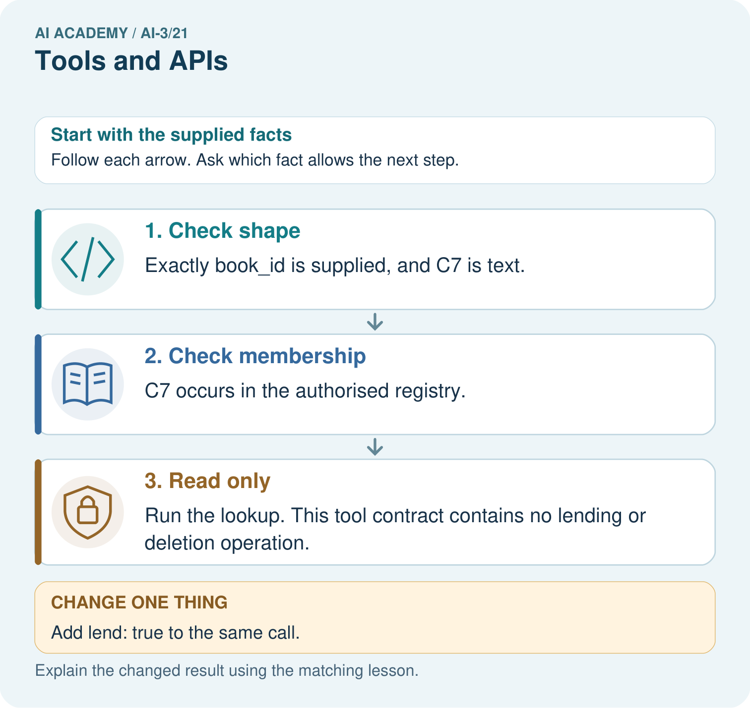
Does a valid C7 ID permit the extra lending action? Point to the relevant step in the picture, then write the changed result and the rule or evidence that supports it.

My picture-based explanation and changed-case prediction
________________________________________________________________
________________________________________________________________
________________________________________________________________
________________________________________________________________
________________________________________________________________
________________________________________________________________
Support used: alone / hint / worked example. This record is practice evidence.
Project connection: For your Verified Study Buddy, save the input, procedure, observed result and limitation of this check. Label this worked example as practice; use a different, previously unreviewed case when checking independent understanding.

19. Project portfolio milestone
Project: Verified Study Buddy
Current milestone: Evaluate and revise. Compare with your starting method, explain errors and record a justified revision.
For your Verified Study Buddy, save the input, procedure, observed result and limitation of this check. Label this worked example as practice; use a different, previously unreviewed case when checking independent understanding.
Evidence to keep | My record
This week’s input and deciding step
Prediction and actual result (or labelled paper trace)
One change since the previous checkpoint and why
One error or limit and the next test

Explain what this week adds to your project. Reuse last week’s record rather than starting again.
________________________________________________________________
________________________________________________________________
________________________________________________________________
________________________________________________________________
________________________________________________________________

